1. NSABBS0001 4

2. NSABBS0002 6

3. NSABBS0003 8

4. NSABBS0004 10

5. NSABBS0005 12

6. NSABBS0006 14

7. NSABHC0001 16

8. NSABHC0002 18

9. NSABHC0003 20

10. NSABHC0004 22

11. NSABHC0005 24

12. NSABHC0006 26

13. NSABHC0007 28

14. NSABHC0008 30

15. NSABHC0009 32

16. NSABHC0010 34

17. NSABHC0011 36

18. NSABHC0012 38

19. NSABHC0013 40

20. NSABHC0014 42

21. NSABHC0015 44

22. NSABHC0016 46

23. NSABHC0017 48

24. NSABHC0018 50

25. NSABHC0019 52

26. NSABHC0020 54

27. NSABHC0021 56

28. NSABHC0022 58

29. NSABHC0023 60

30. NSABHC0024 62

31. NSABHC0025 64

32. NSABHC0026 66

33. NSABHC0028 68

34. NSABHC0029 70

35. NSACHC0001 72

36. NSACHC0002 74

37. NSACHC0003 76

38. NSACHC0004 78

39. NSACOP0001 80

40. NSACOP0002 82

41. NSAMDD0001 84

42. NSAMDD0002 86

43. NSAMDD0003 88

44. NSAMDD0004 90

45. NSAMDD0005 92

46. NSAMDD0006 94

47. NSAMDD0007 96

48. NSAMDD0008 98

49. NSAMDD0009 100

50. NSAMDD0010 102

51. NSAMDD0011 104

52. NSAMDD0012 106

53. NSAMDD0013 108

54. NSAMDD0014 110

55. NSAMDD0015 112

56. NSAMDD0016 114

57. NSAMDD0017 116

58. NSAMDD0018 118

59. NSAMDD0019 120

60. NSAMDD0020 122

61. NSAMDD0021 124

62. NSAMDD0022 126

63. NSAMDD0023 128

64. NSAMDD0024 130

65. NSAMDD0025 132

66. NSAMDD0026 134

67. NSAMDD0027 136

68. NSAMDD0028 138

69. NSAMDD0029 140

70. NSAMDD0030 142

71. NSAMDD0031 144

72. NSAMDD0032 146

73. NSAMUL0001 148

74. NSAMUL0002 150

75. NSAMUL0003 152

76. NSAMUL0004 154

77. NSANAN0001 156

78. NSANAN0002 158

79. NSANET0001 160

80. NSANSS0001 162

81. NSANSS0002 164

82. NSTNSS0001 166

83. NSTSYB0001 168

84. NSTSYB0002 170

85. NSTSYB0003 172

86. NSTSYB0004 174

87. NSTSYB0005 176

88. NSTSYB0006 178

89. NSTSYB0007 180

90. NSTSYB0008 182

91. NSTSYB0009 184

# NSABBS0001

| Min. | 1st Qu. | Median | Mean | 3rd Qu. | Max. |
| --- | --- | --- | --- | --- | --- |
| 22.35206 | 43.17948 | 49.9376 | 49.24158 | 54.90303 | 71.8722 |

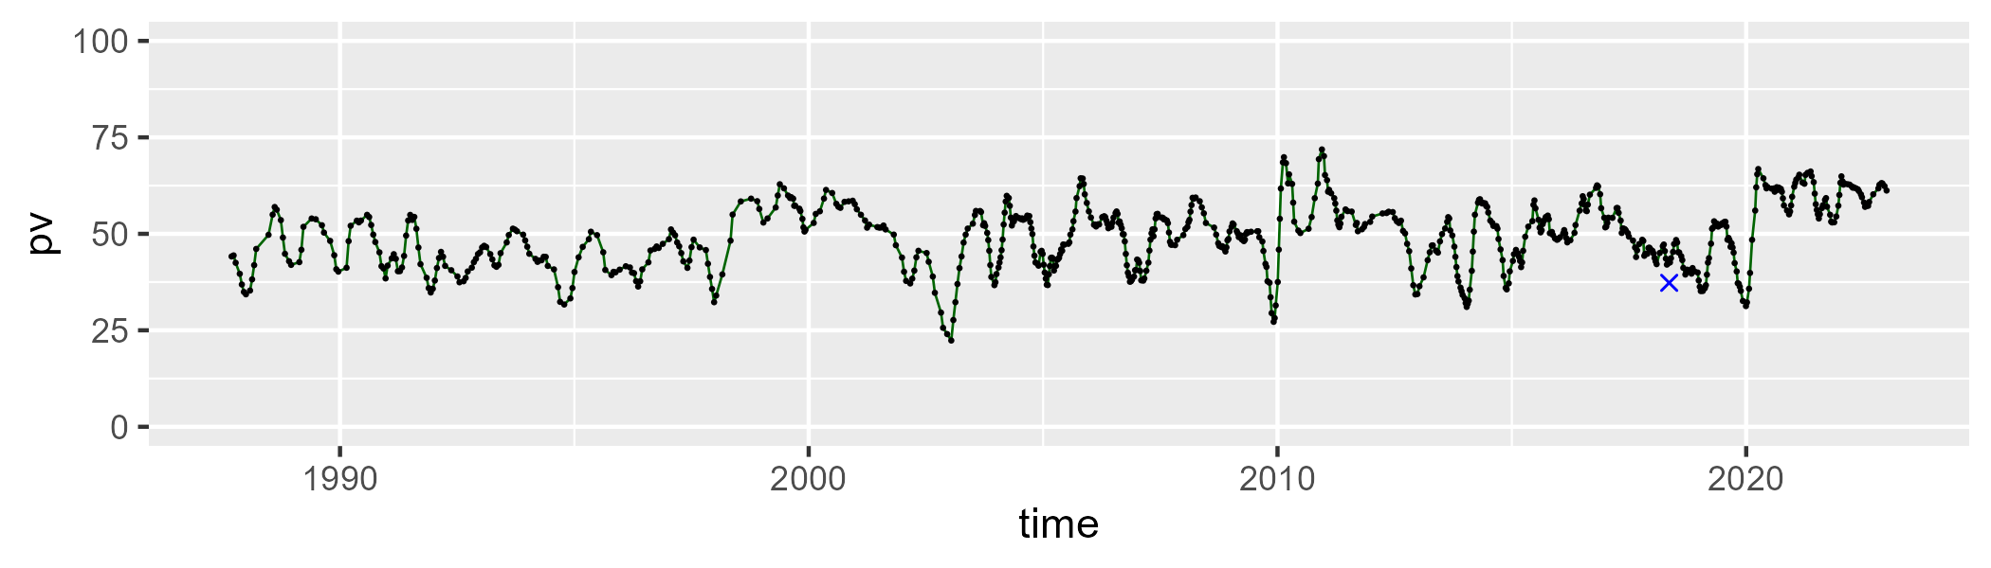

| Min. | 1st Qu. | Median | Mean | 3rd Qu. | Max. |
| --- | --- | --- | --- | --- | --- |
| 24.4035 | 37.73847 | 42.02654 | 41.74025 | 45.89721 | 60.27897 |

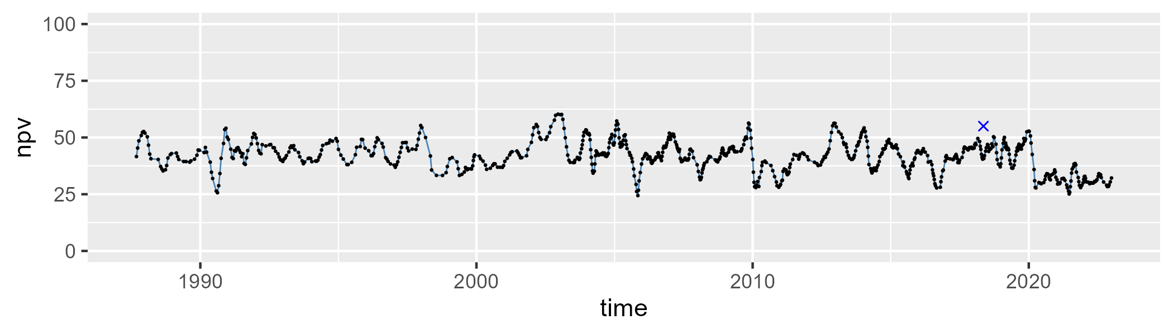

| Min. | 1st Qu. | Median | Mean | 3rd Qu. | Max. |
| --- | --- | --- | --- | --- | --- |
| 0 | 4.68828 | 6.921352 | 7.764458 | 10.44237 | 22.37433 |

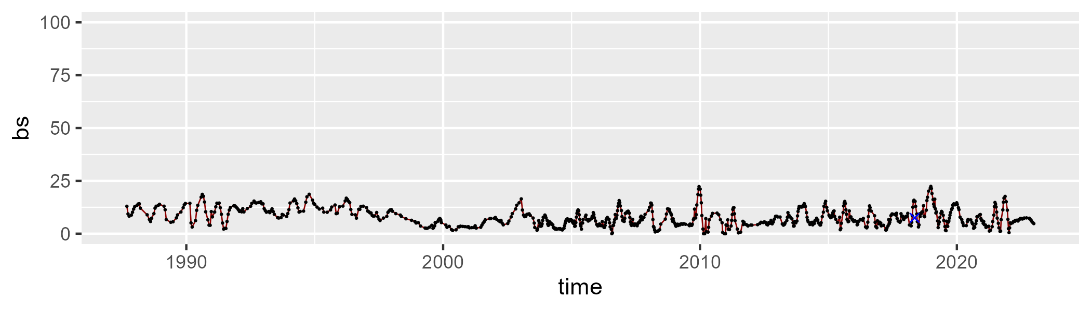

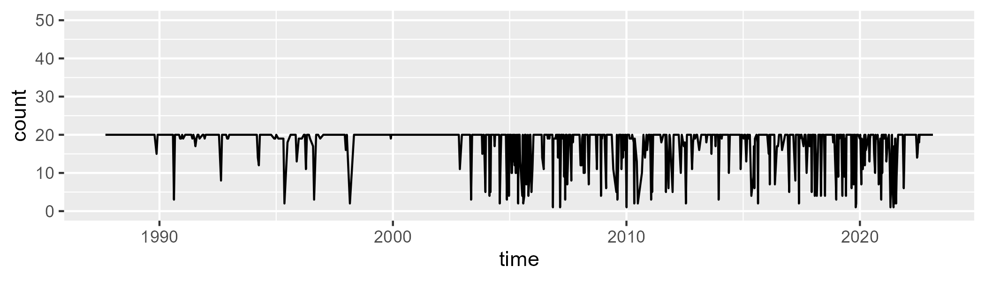

Min. : 1.00 1st Qu.:19.00 Median :20.00 Mean :17.89 3rd Qu.:20.00 Max. :20.00

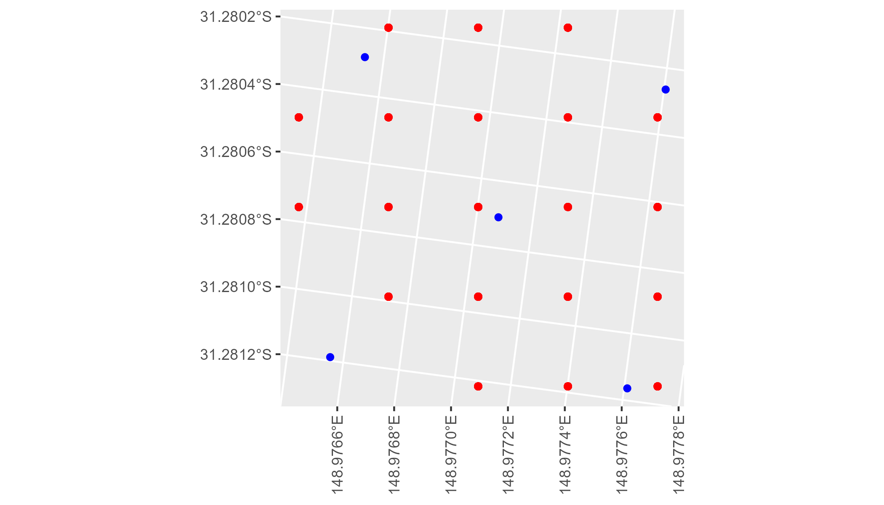

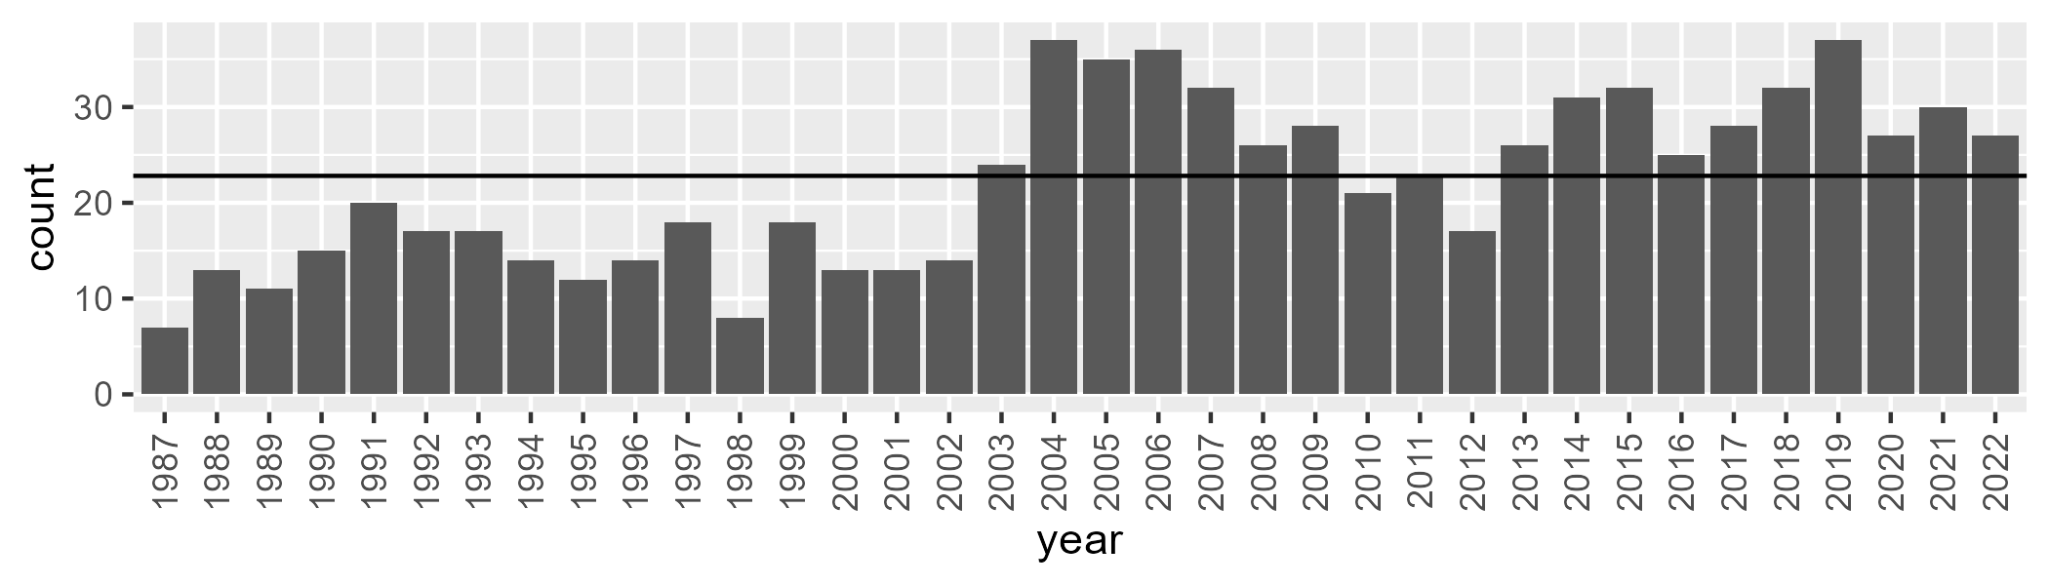

Number of samples: 798

# NSABBS0002

| Min. | 1st Qu. | Median | Mean | 3rd Qu. | Max. |
| --- | --- | --- | --- | --- | --- |
| 19.33834 | 42.75807 | 48.57609 | 47.31193 | 53.46529 | 63.98668 |

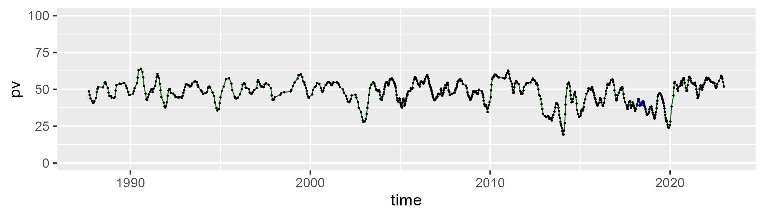

| Min. | 1st Qu. | Median | Mean | 3rd Qu. | Max. |
| --- | --- | --- | --- | --- | --- |
| 27.19977 | 39.7403 | 43.46597 | 43.95978 | 48.67043 | 60.91674 |

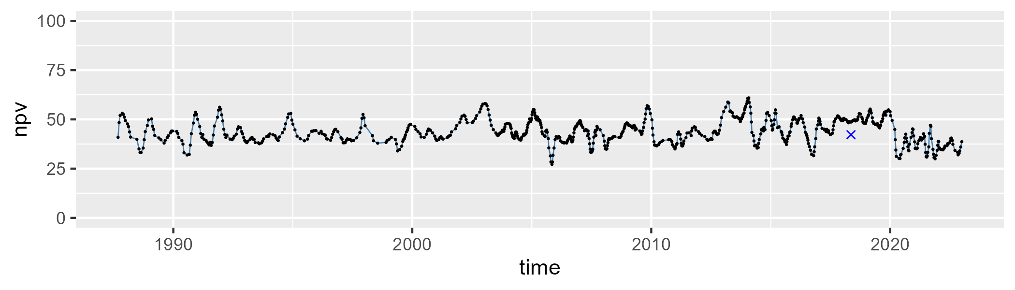

| Min. | 1st Qu. | Median | Mean | 3rd Qu. | Max. |
| --- | --- | --- | --- | --- | --- |
| 0 | 4.567276 | 6.880015 | 7.50548 | 9.556792 | 23.72444 |

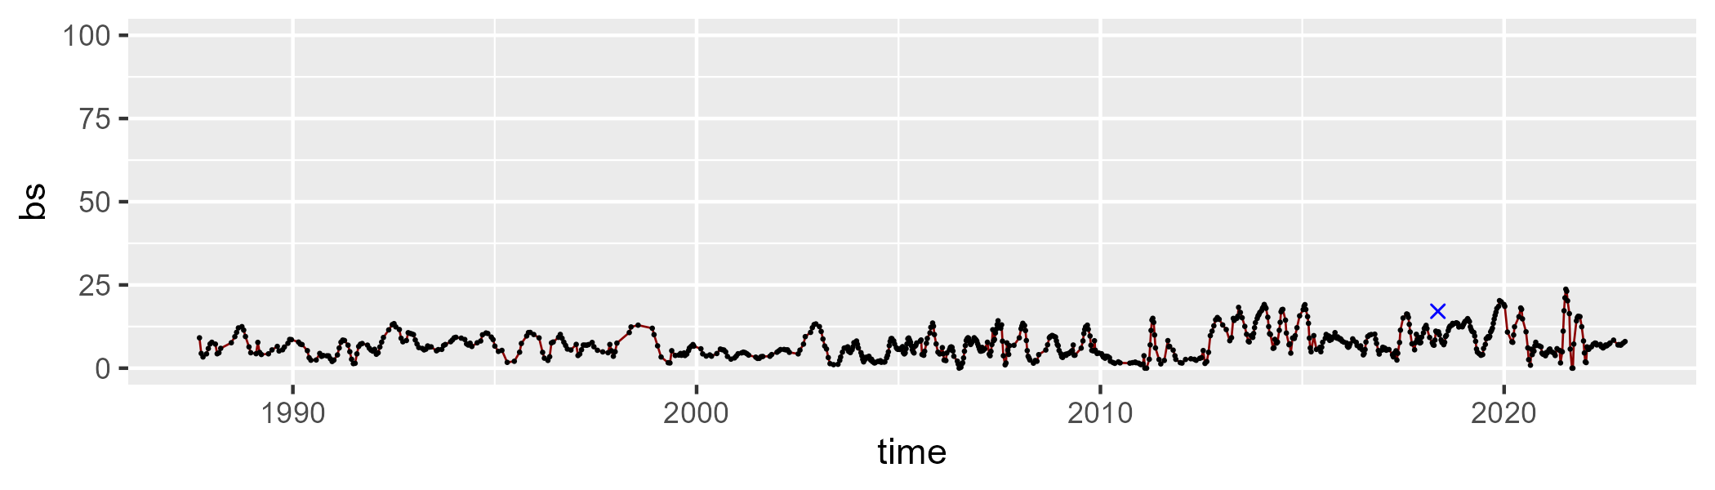

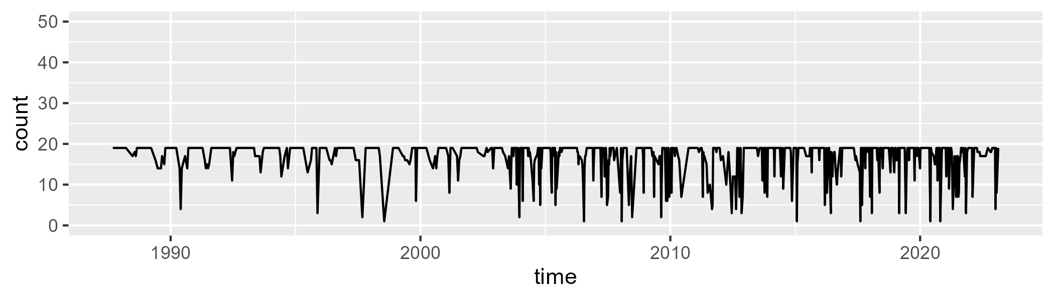

Min. : 1.00 1st Qu.:17.00 Median :19.00 Mean :16.98 3rd Qu.:19.00 Max. :19.00

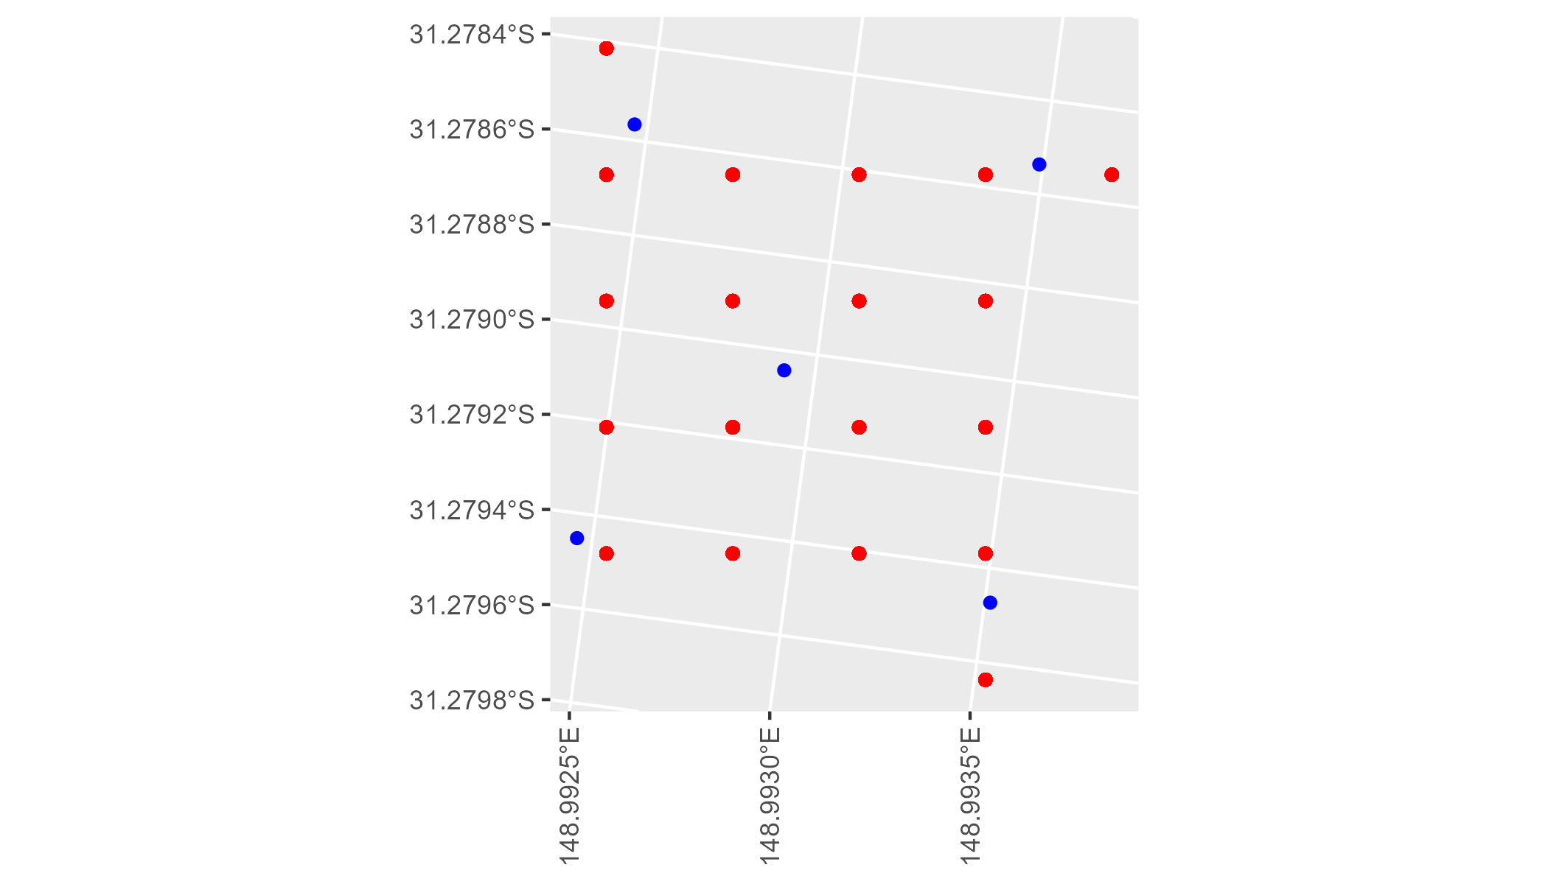

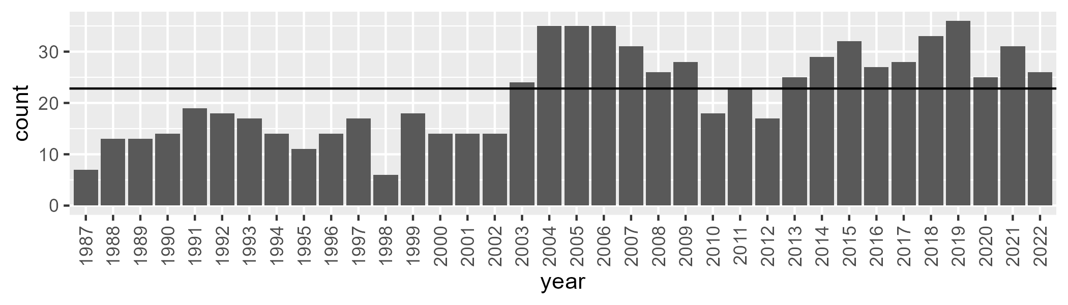

Number of samples: 787

# NSABBS0003

| Min. | 1st Qu. | Median | Mean | 3rd Qu. | Max. |
| --- | --- | --- | --- | --- | --- |
| 26.1368 | 37.1297 | 41.48983 | 41.31449 | 45.3418 | 57.95896 |

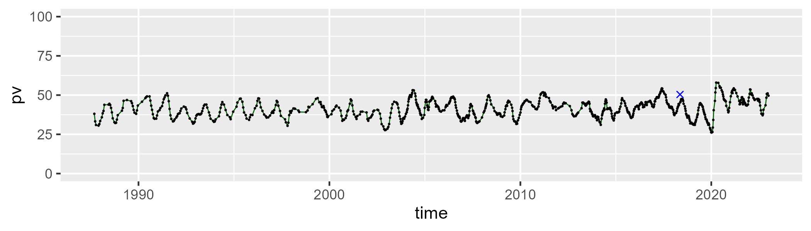

| Min. | 1st Qu. | Median | Mean | 3rd Qu. | Max. |
| --- | --- | --- | --- | --- | --- |
| 28.3209 | 44.8286 | 48.97558 | 48.96378 | 53.51428 | 63.89729 |

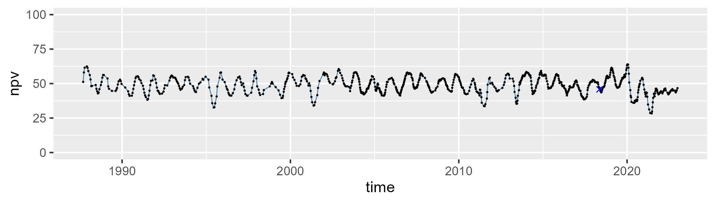

| Min. | 1st Qu. | Median | Mean | 3rd Qu. | Max. |
| --- | --- | --- | --- | --- | --- |
| 0.9589891 | 6.107094 | 7.906744 | 8.525134 | 10.06292 | 29.70273 |

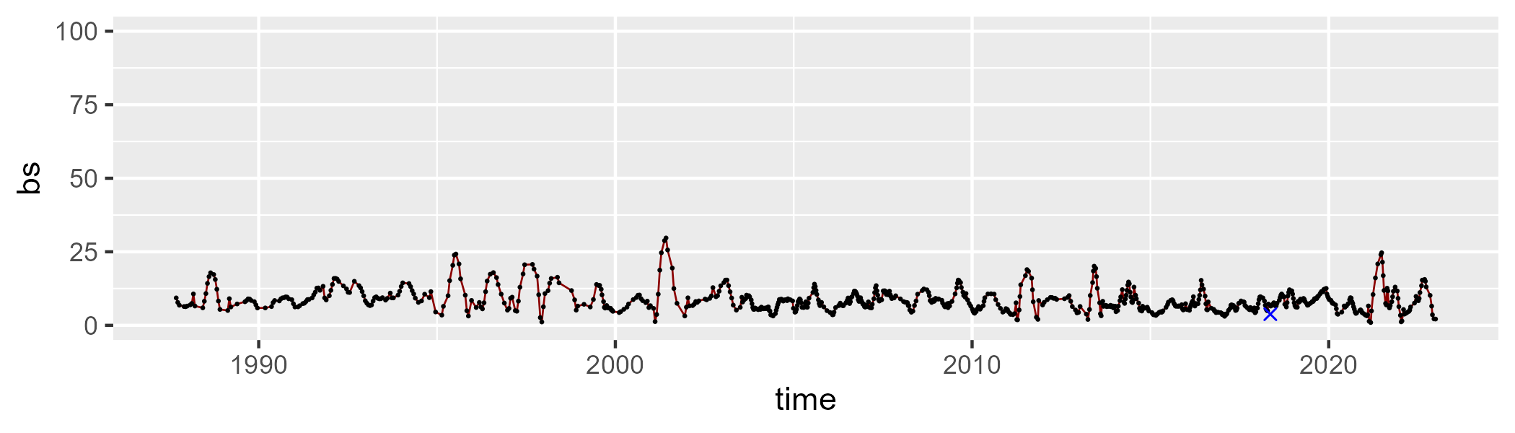

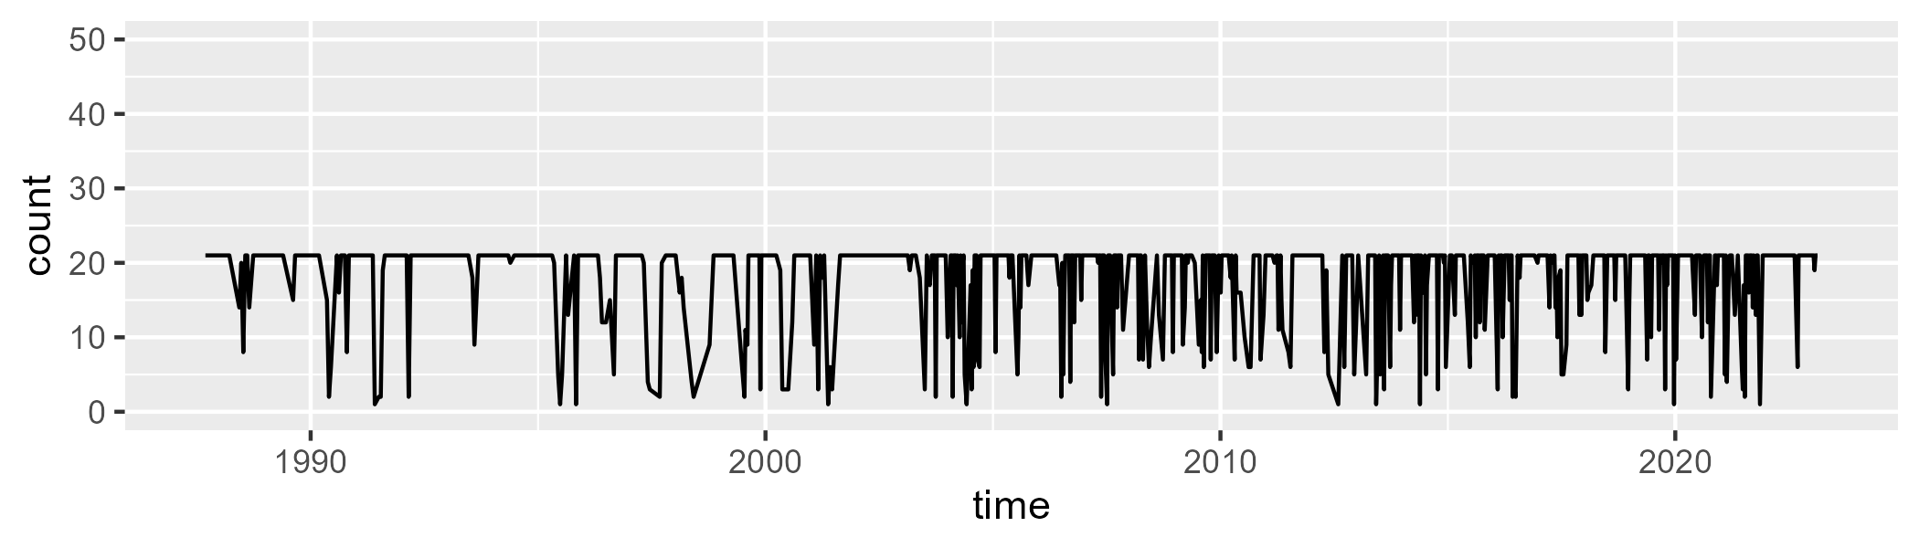

Min. : 1.00 1st Qu.:19.00 Median :21.00 Mean :18.11 3rd Qu.:21.00 Max. :21.00

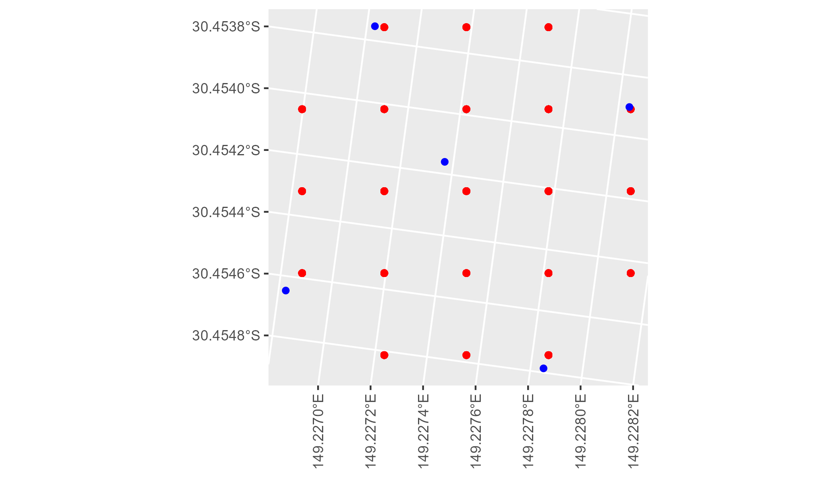

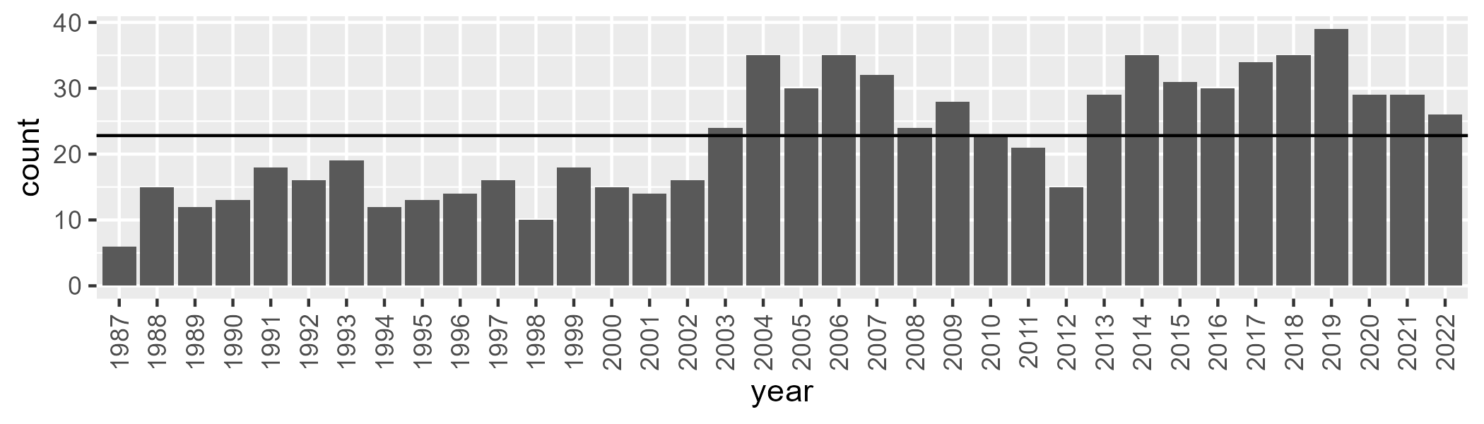

Number of samples: 811

# NSABBS0004

| Min. | 1st Qu. | Median | Mean | 3rd Qu. | Max. |
| --- | --- | --- | --- | --- | --- |
| 31.28743 | 40.76495 | 45.70973 | 45.72381 | 50.44345 | 61.79584 |

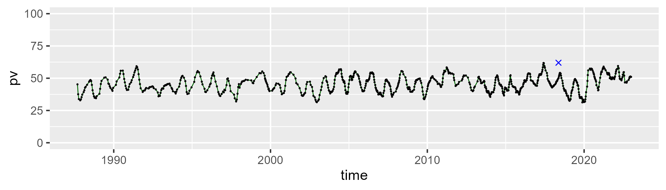

| Min. | 1st Qu. | Median | Mean | 3rd Qu. | Max. |
| --- | --- | --- | --- | --- | --- |
| 28.84077 | 41.36529 | 46.04614 | 46.0583 | 50.85513 | 60.37647 |

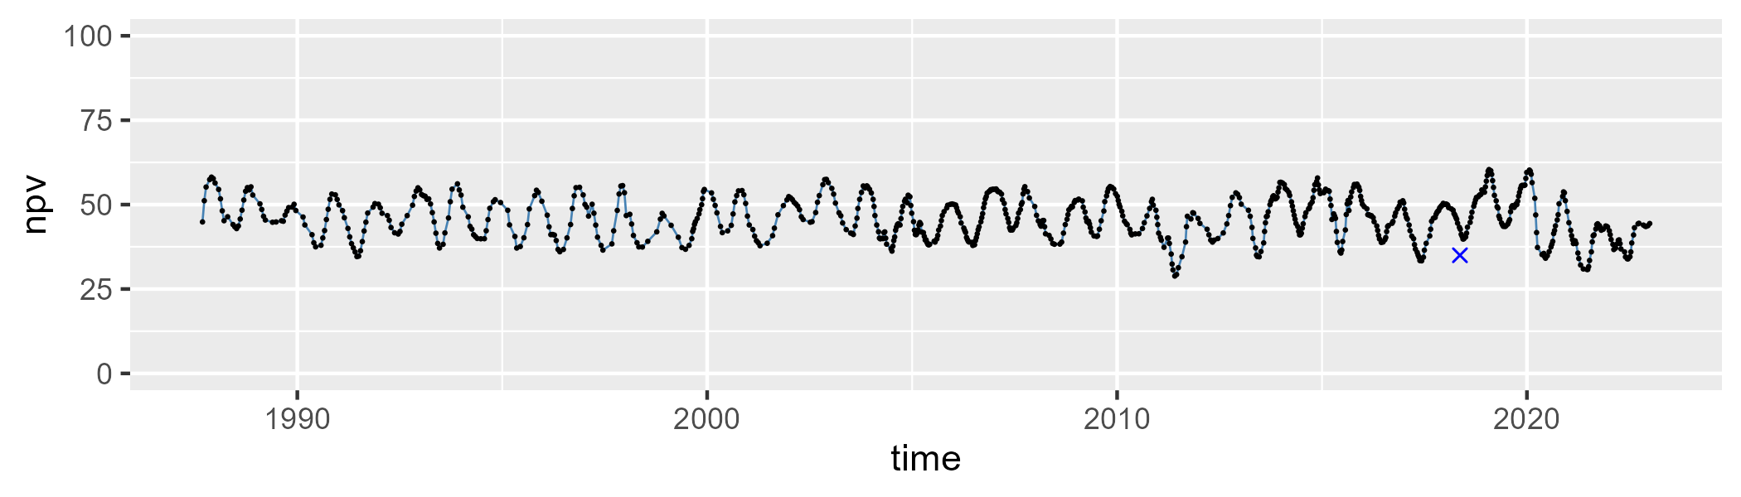

| Min. | 1st Qu. | Median | Mean | 3rd Qu. | Max. |
| --- | --- | --- | --- | --- | --- |
| 0 | 4.990455 | 6.463575 | 6.973133 | 8.261359 | 23.25329 |

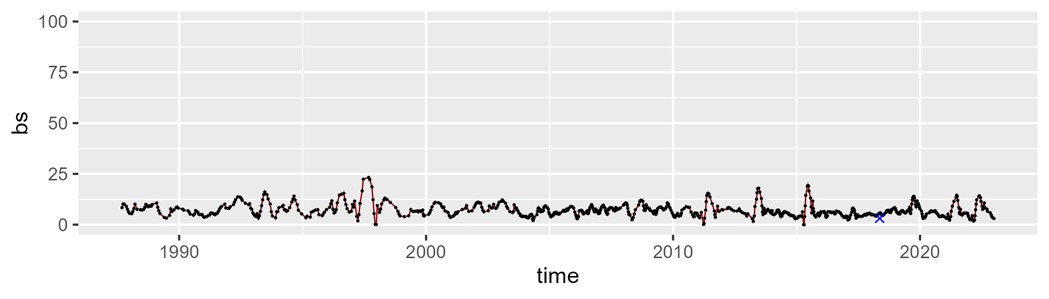

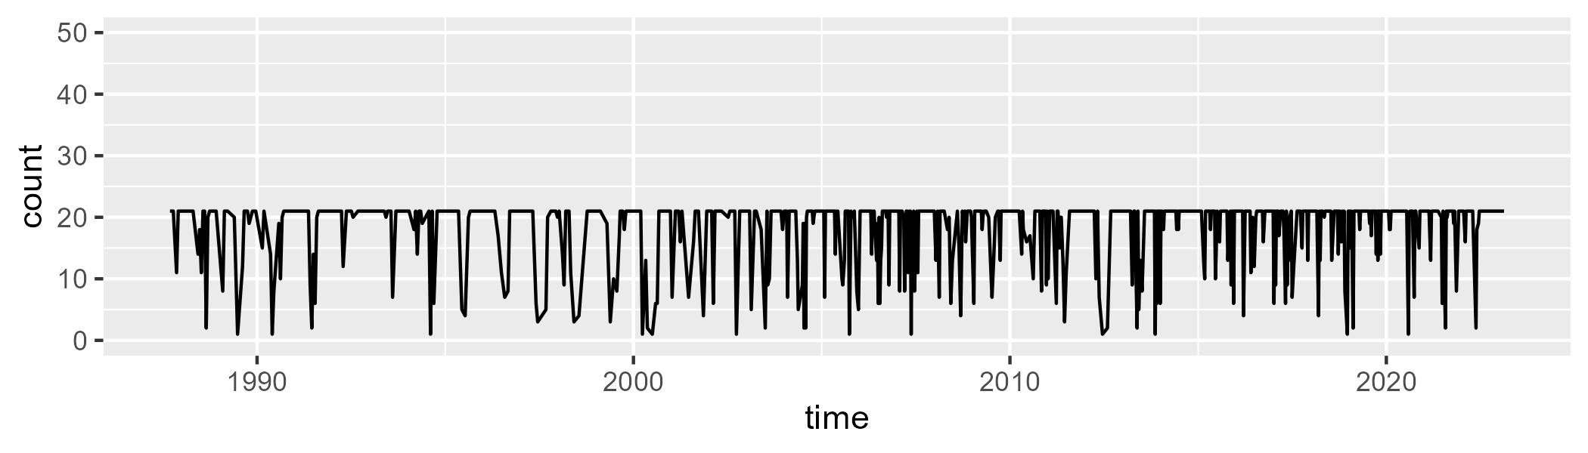

Min. : 1.00 1st Qu.:20.00 Median :21.00 Mean :18.45 3rd Qu.:21.00 Max. :21.00

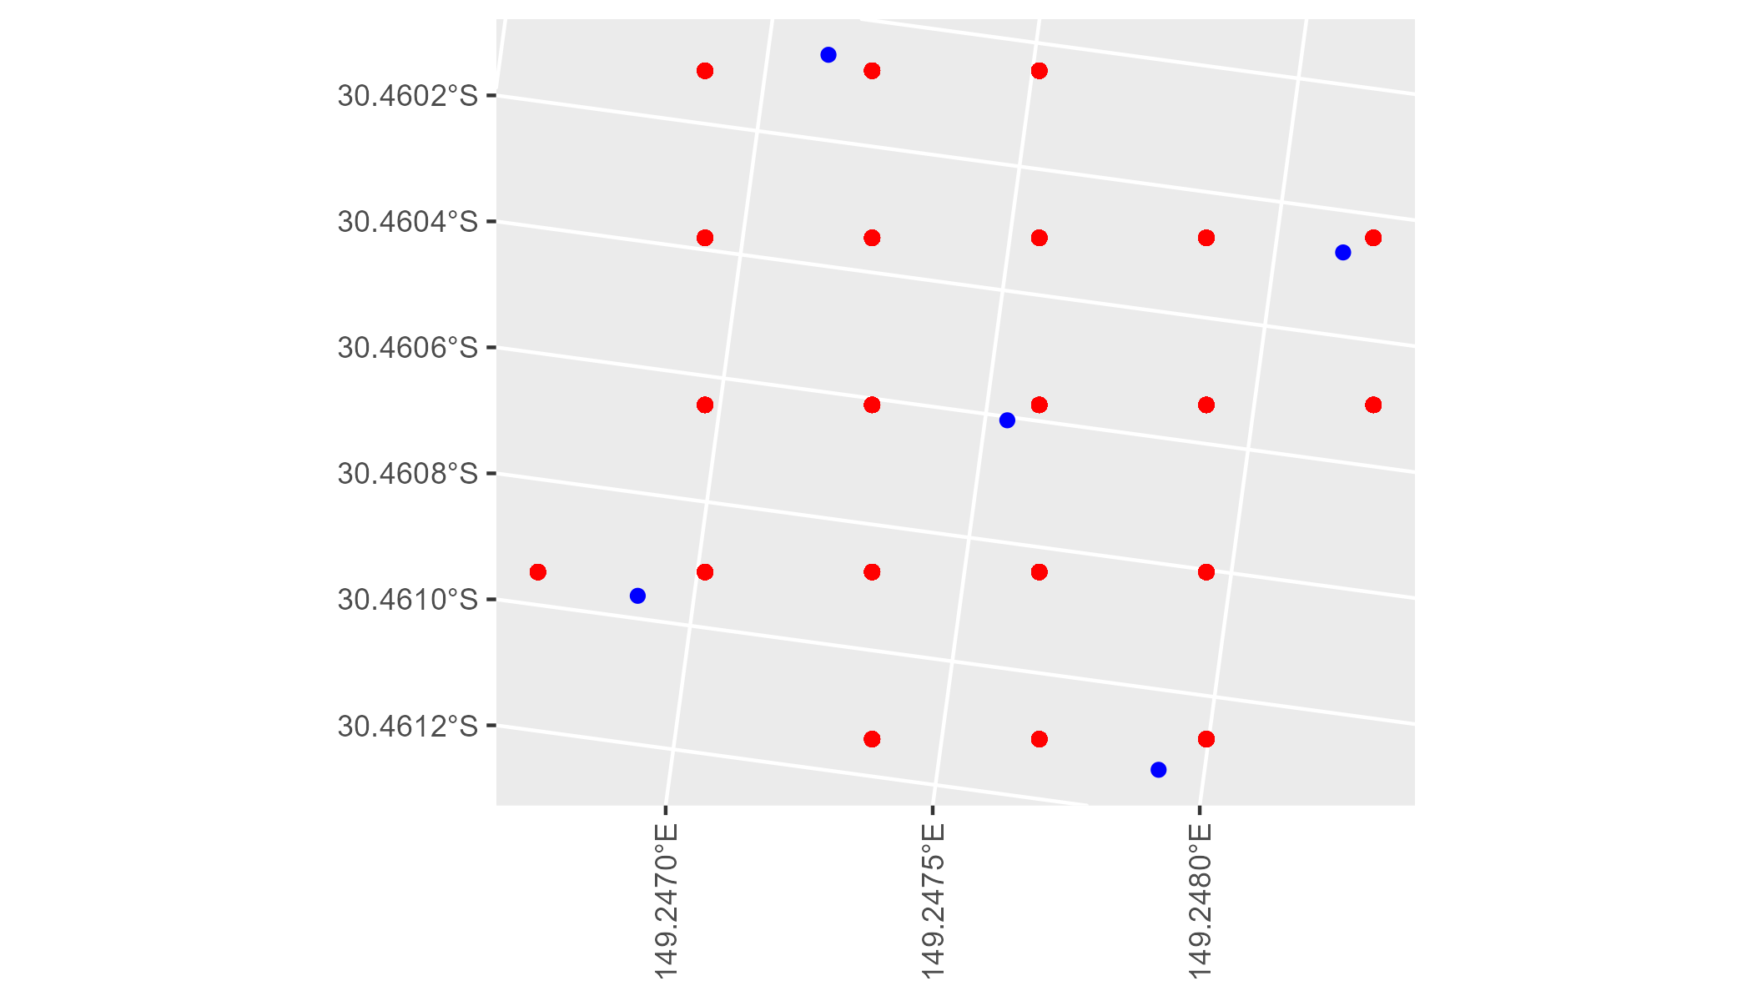

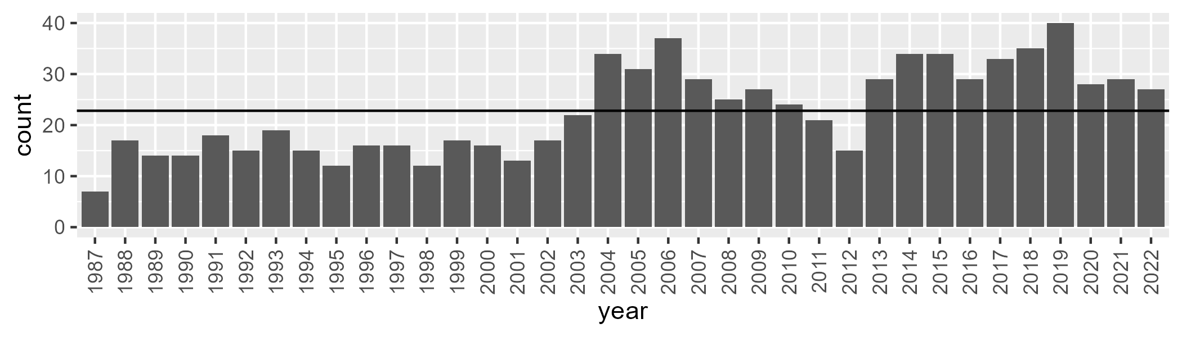

Number of samples: 821

# NSABBS0005

| Min. | 1st Qu. | Median | Mean | 3rd Qu. | Max. |
| --- | --- | --- | --- | --- | --- |
| 28.22557 | 38.42301 | 42.42021 | 42.5039 | 46.3232 | 59.39489 |

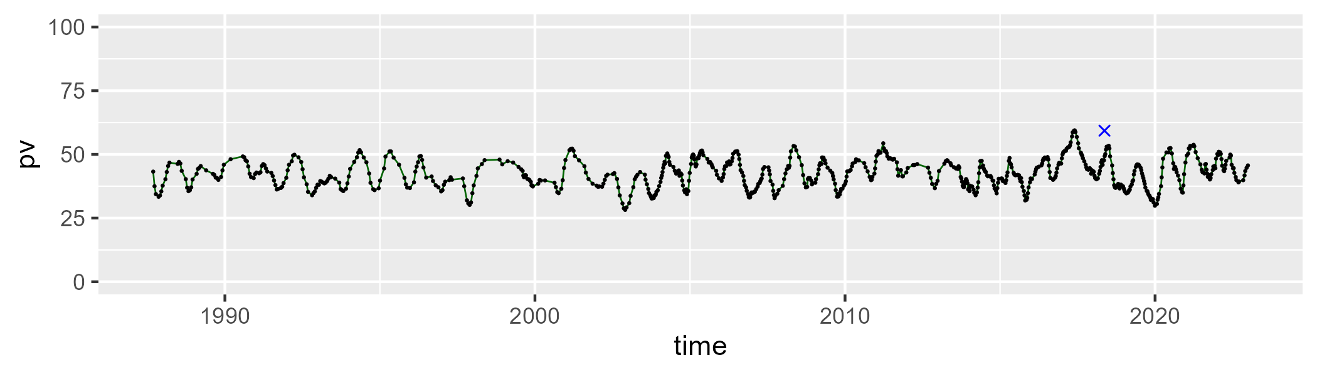

| Min. | 1st Qu. | Median | Mean | 3rd Qu. | Max. |
| --- | --- | --- | --- | --- | --- |
| 29.38724 | 43.76295 | 48.32434 | 48.34297 | 52.97601 | 62.87957 |

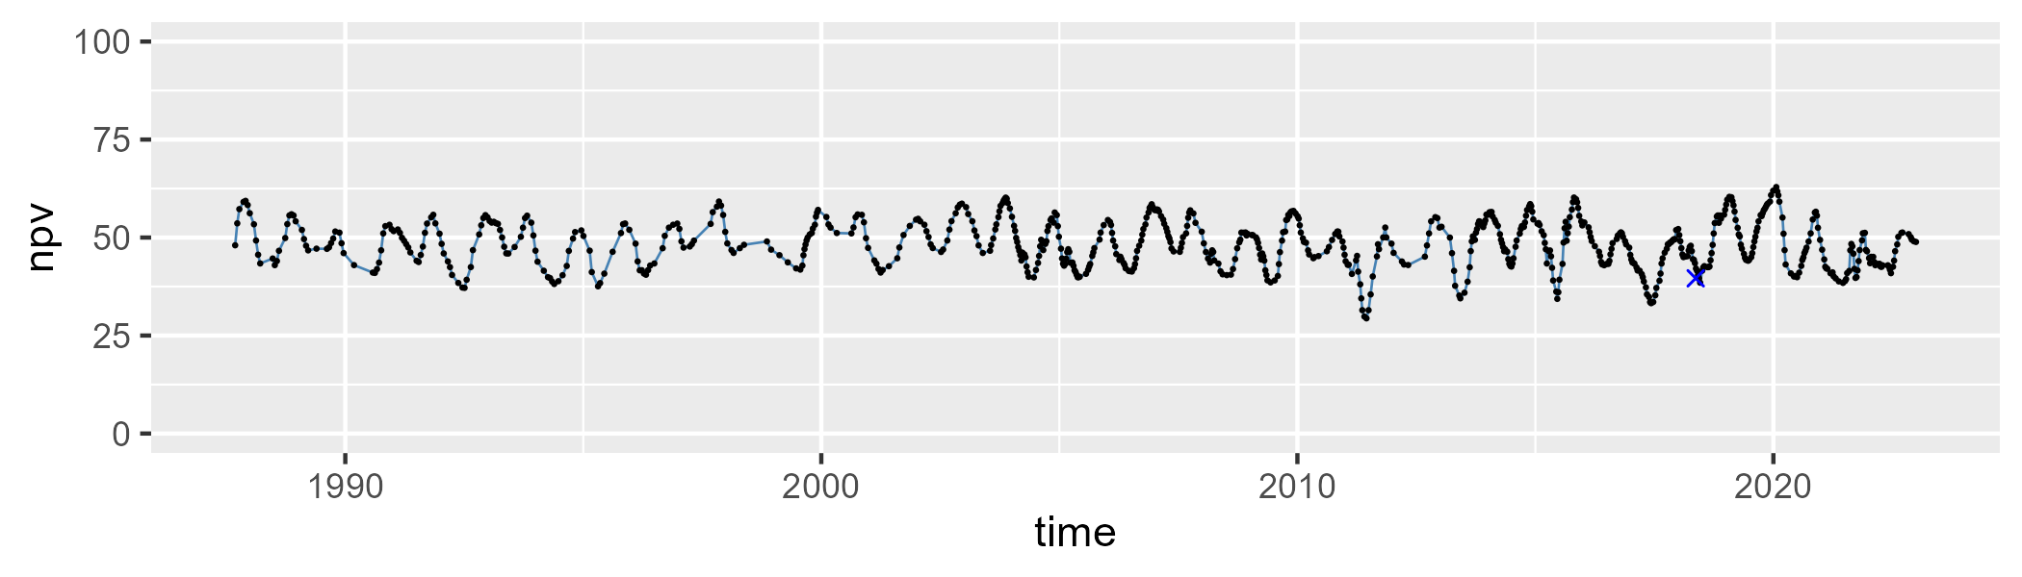

| Min. | 1st Qu. | Median | Mean | 3rd Qu. | Max. |
| --- | --- | --- | --- | --- | --- |
| 0.1655999 | 5.852254 | 7.498785 | 7.963201 | 9.345682 | 22.2818 |

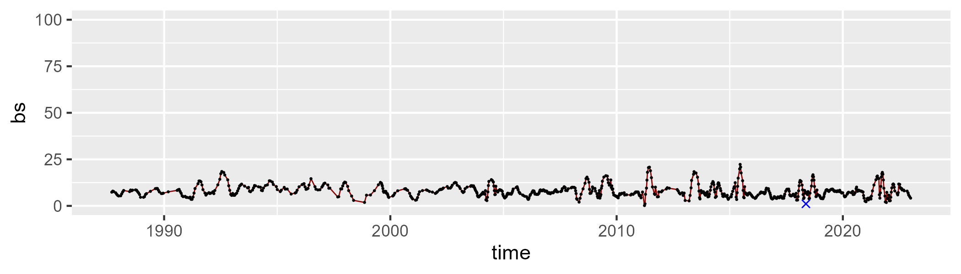

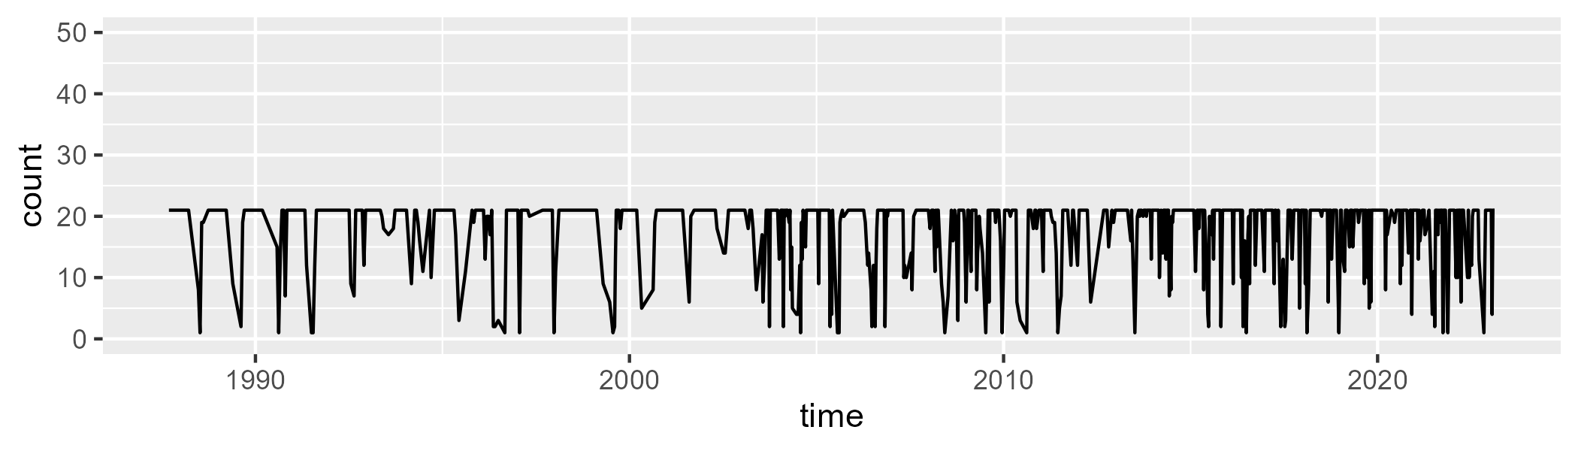

Min. : 1.00 1st Qu.:18.00 Median :21.00 Mean :17.89 3rd Qu.:21.00 Max. :21.00

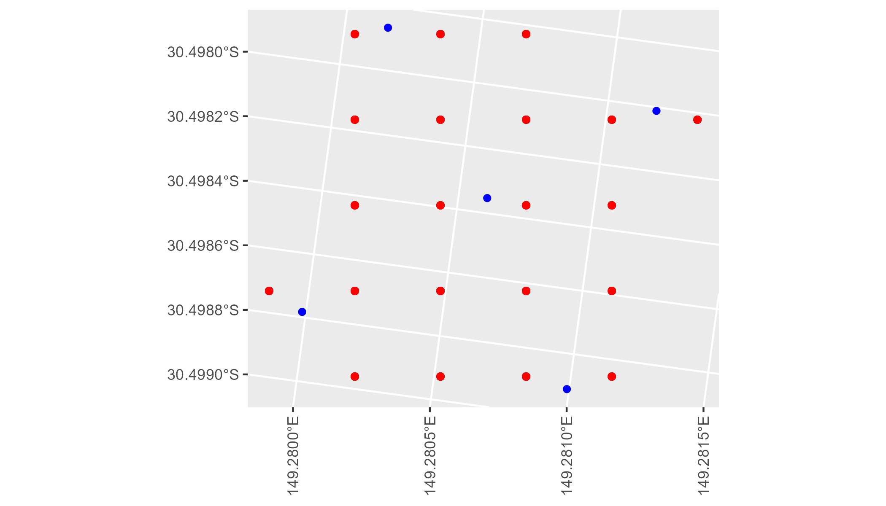

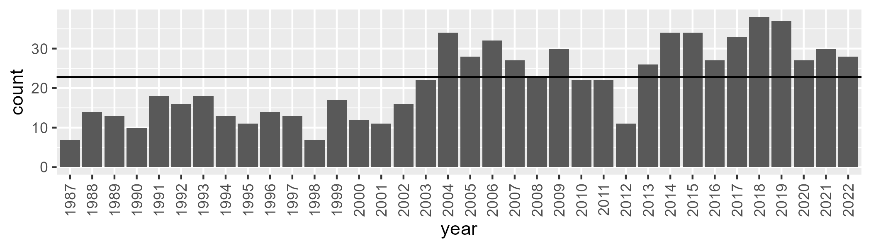

Number of samples: 775

# NSABBS0006

| Min. | 1st Qu. | Median | Mean | 3rd Qu. | Max. |
| --- | --- | --- | --- | --- | --- |
| 32.39048 | 40.77204 | 45.12855 | 45.11717 | 49.32434 | 59.55956 |

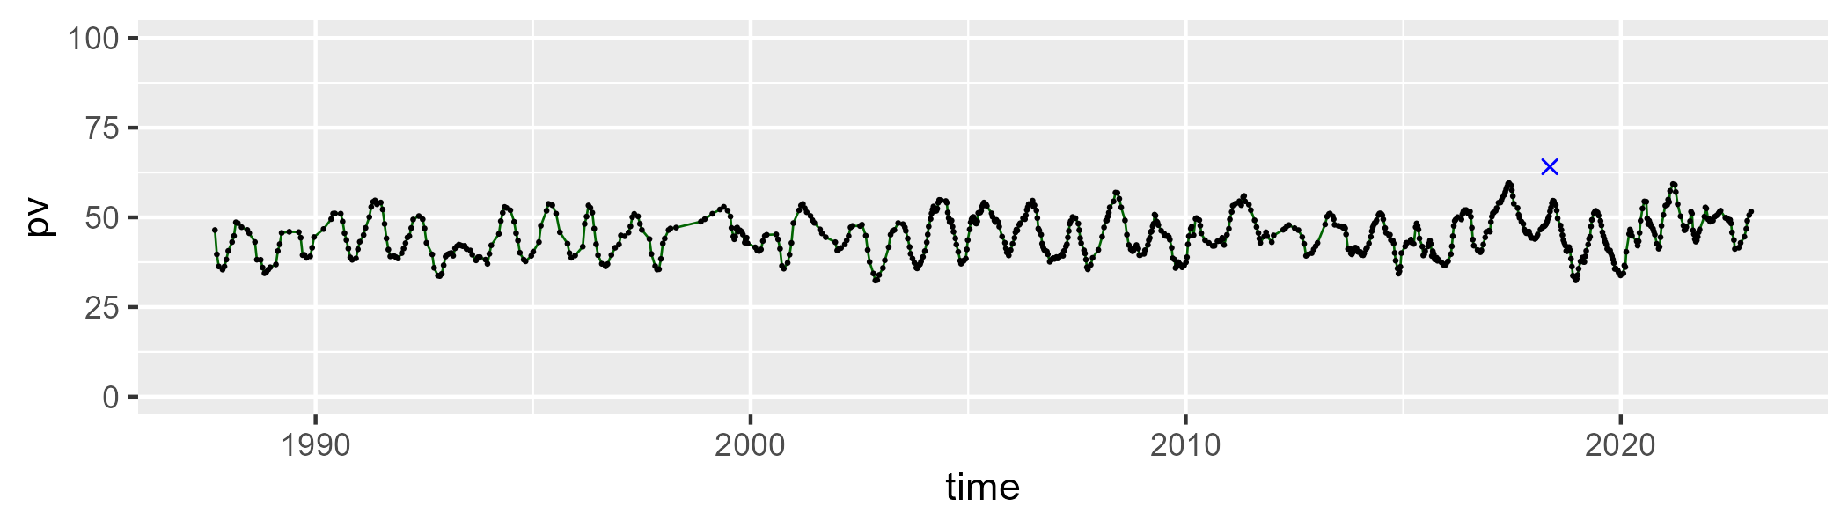

| Min. | 1st Qu. | Median | Mean | 3rd Qu. | Max. |
| --- | --- | --- | --- | --- | --- |
| 26.45003 | 41.7597 | 46.29871 | 46.2329 | 50.71816 | 59.15475 |

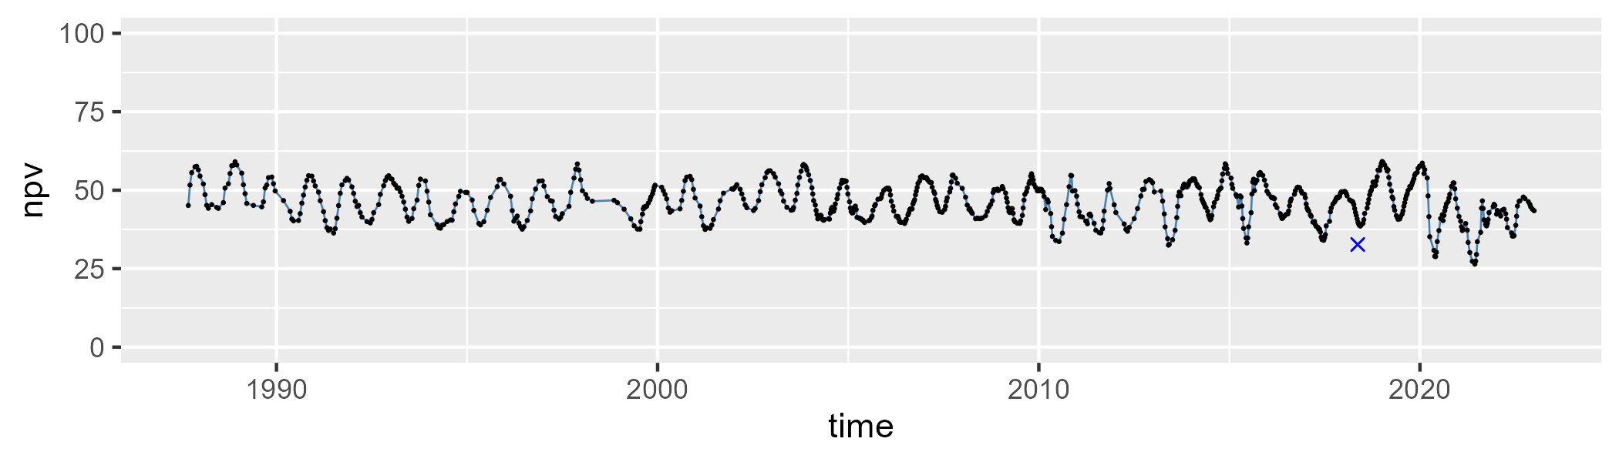

| Min. | 1st Qu. | Median | Mean | 3rd Qu. | Max. |
| --- | --- | --- | --- | --- | --- |
| 0 | 5.136889 | 6.709708 | 7.443251 | 8.53724 | 27.57504 |

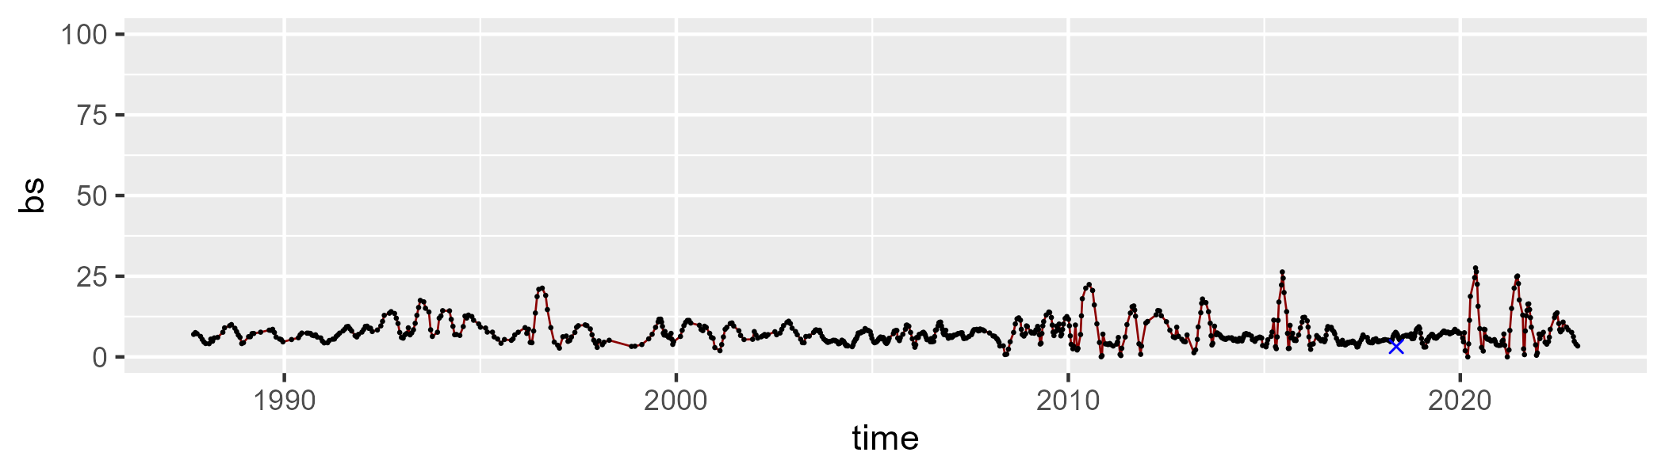

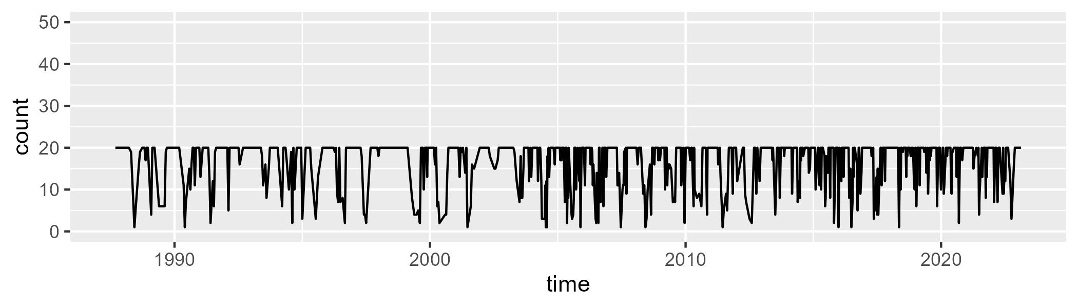

Min. : 1.00 1st Qu.:14.00 Median :20.00 Mean :16.65 3rd Qu.:20.00 Max. :20.00

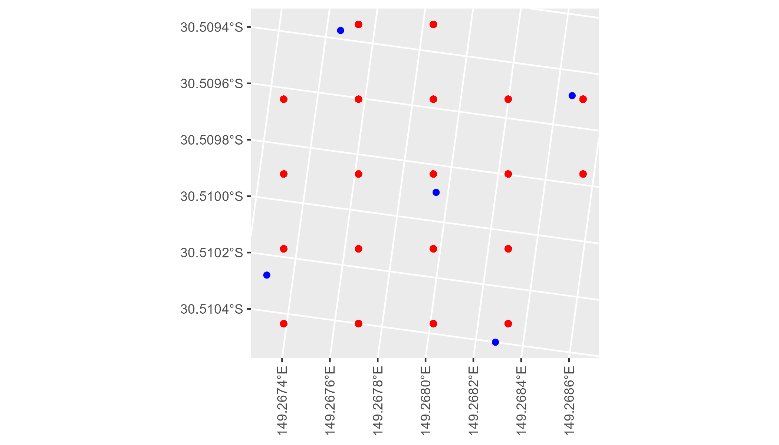

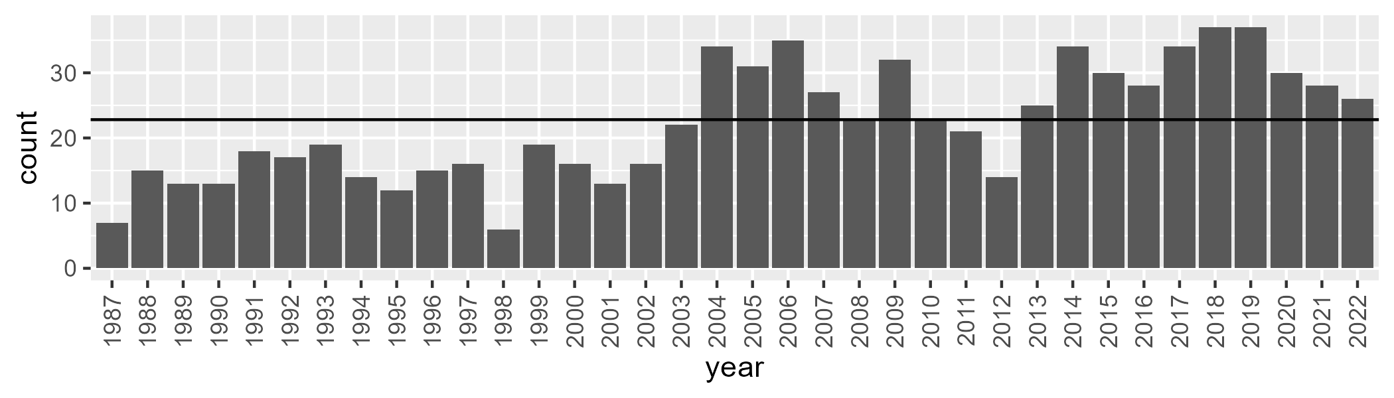

Number of samples: 800

# NSABHC0001

| Min. | 1st Qu. | Median | Mean | 3rd Qu. | Max. |
| --- | --- | --- | --- | --- | --- |
| 1.45547 | 5.983014 | 8.593046 | 9.969215 | 12.98363 | 29.7399 |

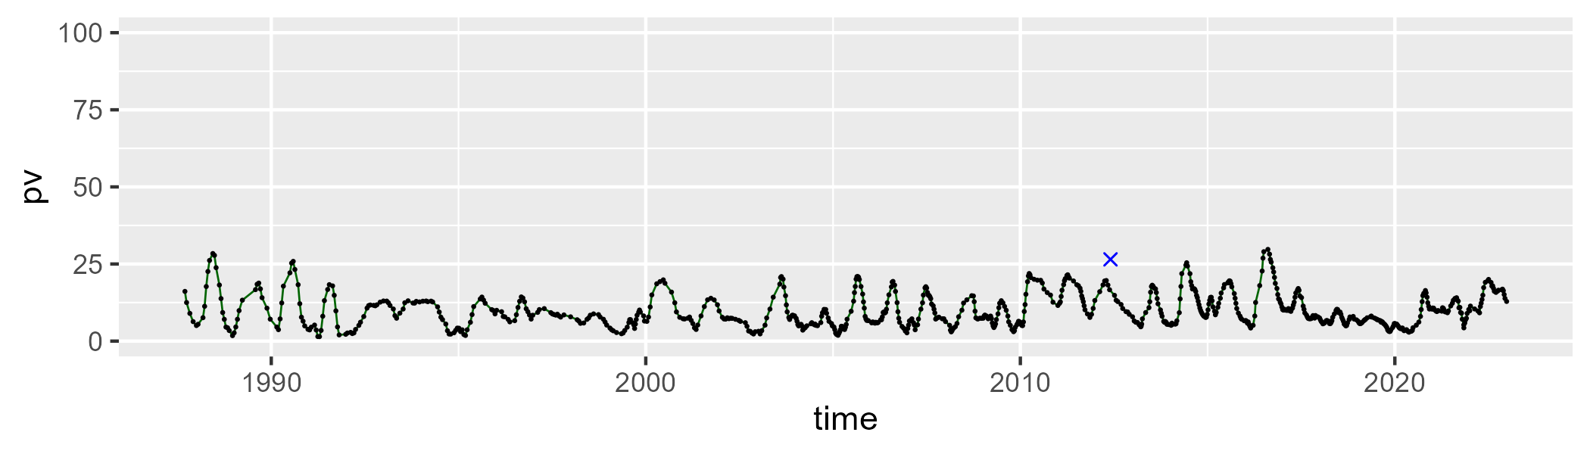

| Min. | 1st Qu. | Median | Mean | 3rd Qu. | Max. |
| --- | --- | --- | --- | --- | --- |
| 20.66301 | 32.57253 | 37.19718 | 37.66085 | 42.37338 | 57.82453 |

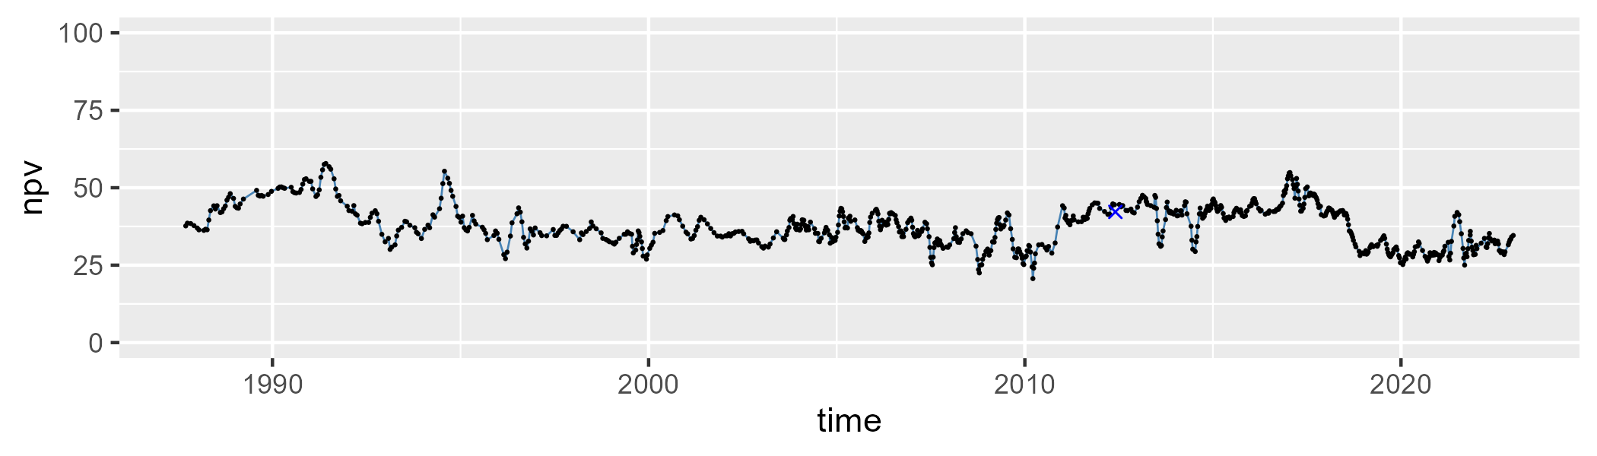

| Min. | 1st Qu. | Median | Mean | 3rd Qu. | Max. |
| --- | --- | --- | --- | --- | --- |
| 24.50739 | 45.34134 | 51.51019 | 50.86006 | 57.10369 | 67.65883 |

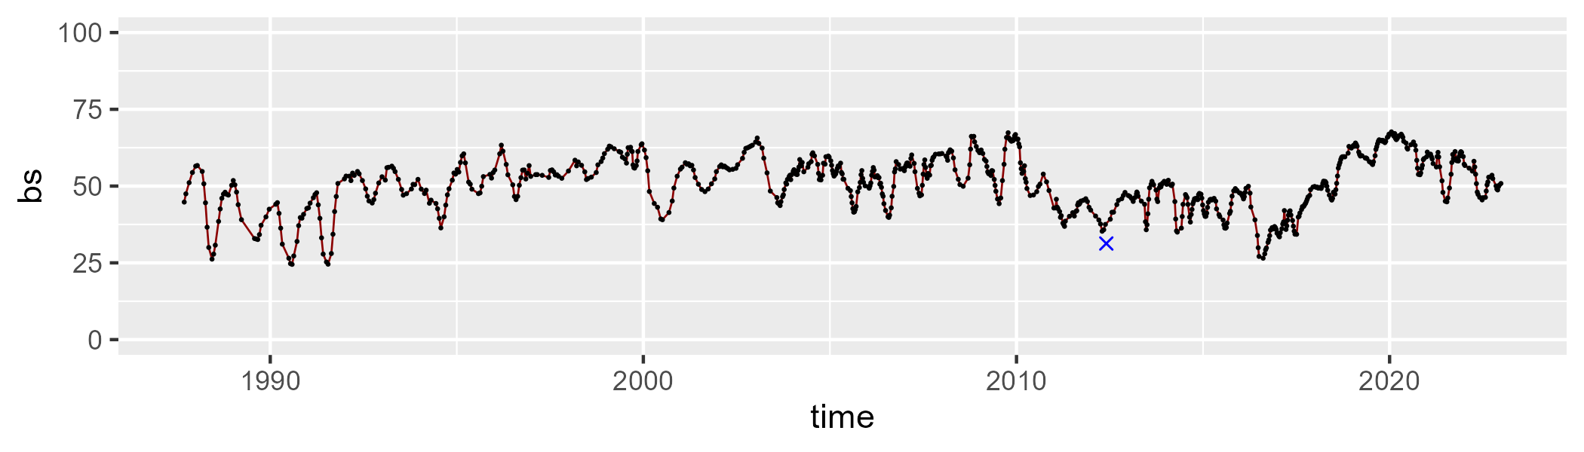

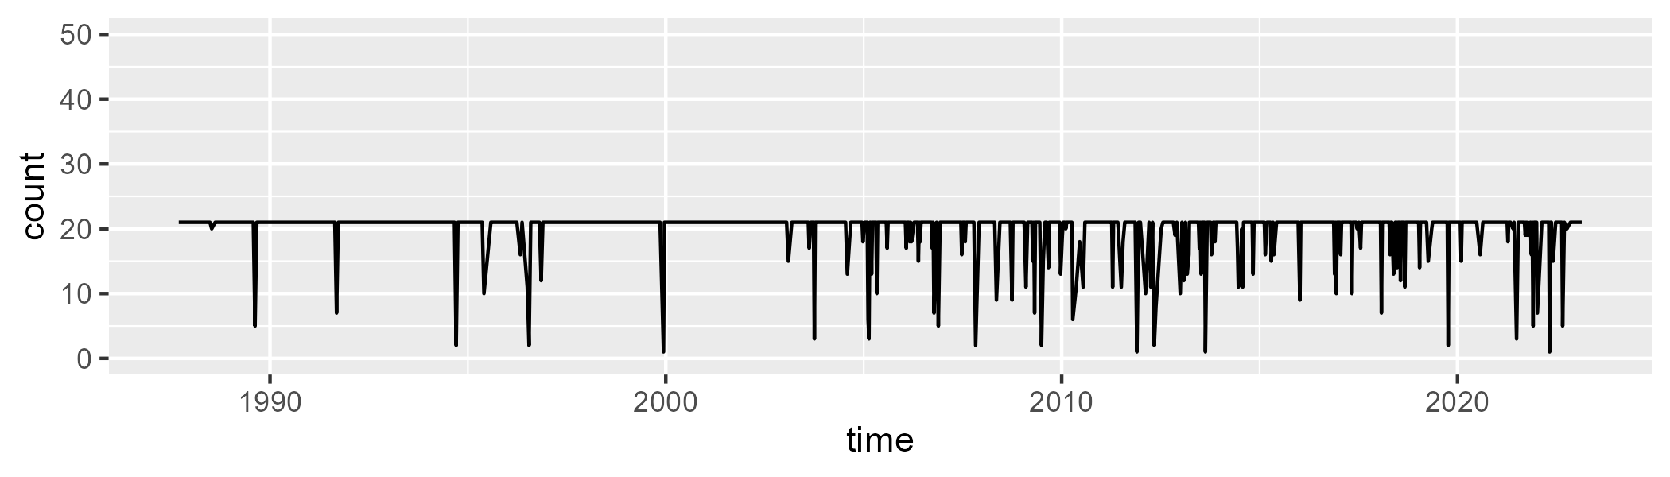

Min. : 1.00 1st Qu.:21.00 Median :21.00 Mean :19.88 3rd Qu.:21.00 Max. :21.00

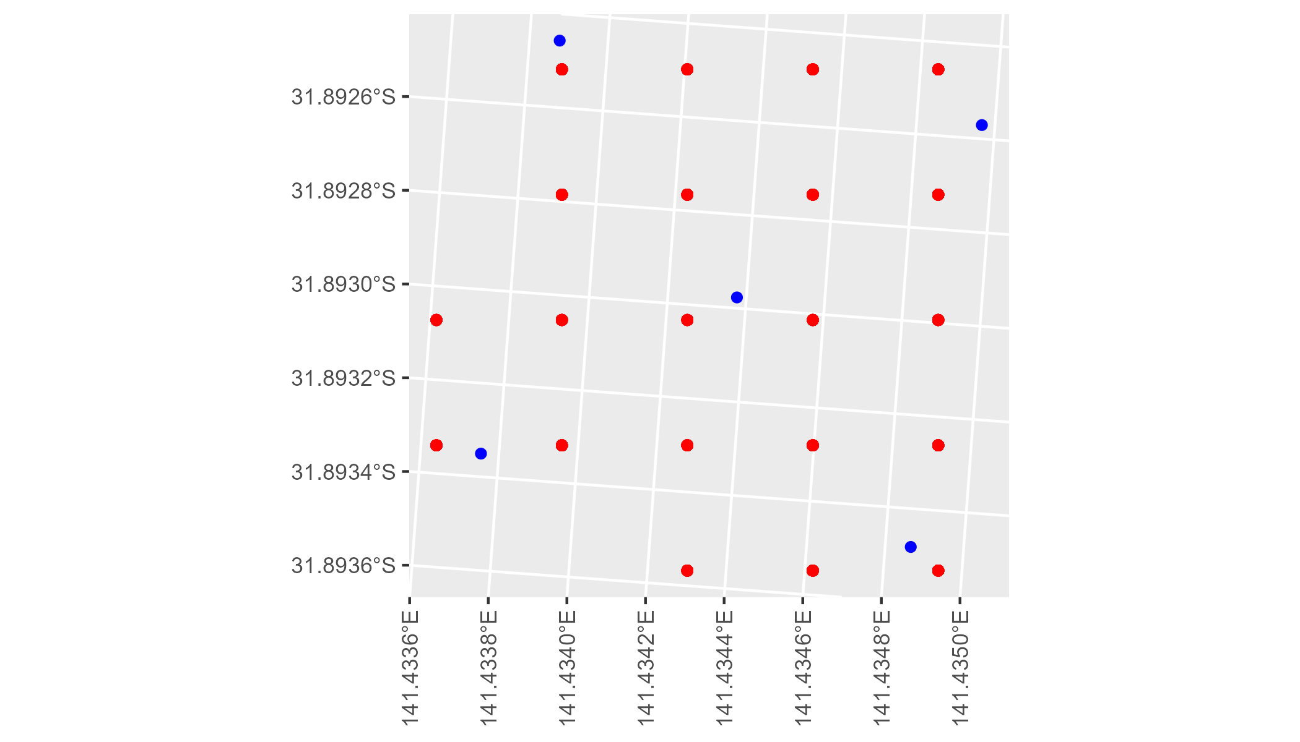

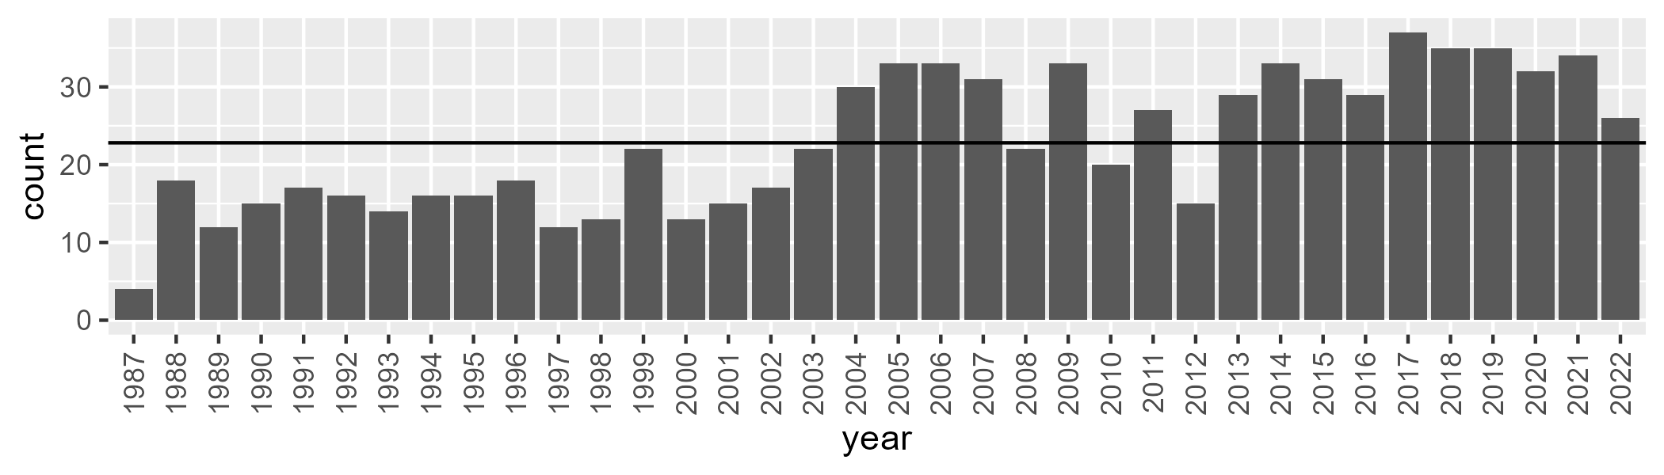

Number of samples: 825

# NSABHC0002

| Min. | 1st Qu. | Median | Mean | 3rd Qu. | Max. |
| --- | --- | --- | --- | --- | --- |
| 1.621601 | 5.467288 | 7.991031 | 9.558508 | 12.68227 | 31.24945 |

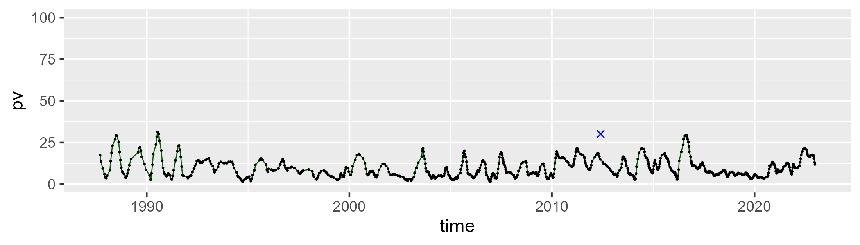

| Min. | 1st Qu. | Median | Mean | 3rd Qu. | Max. |
| --- | --- | --- | --- | --- | --- |
| 25.67568 | 35.75812 | 39.95969 | 40.14664 | 45.19902 | 54.30151 |

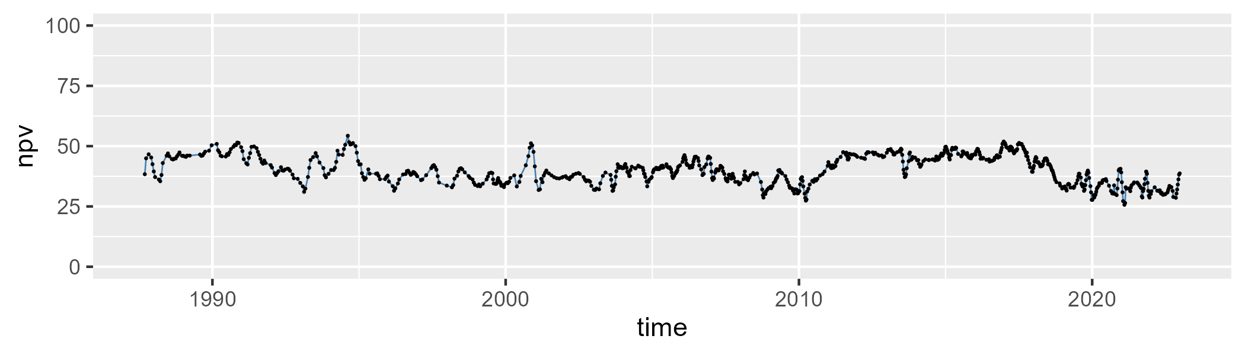

| Min. | 1st Qu. | Median | Mean | 3rd Qu. | Max. |
| --- | --- | --- | --- | --- | --- |
| 21.18385 | 43.6005 | 49.64028 | 48.80679 | 55.40443 | 65.9698 |

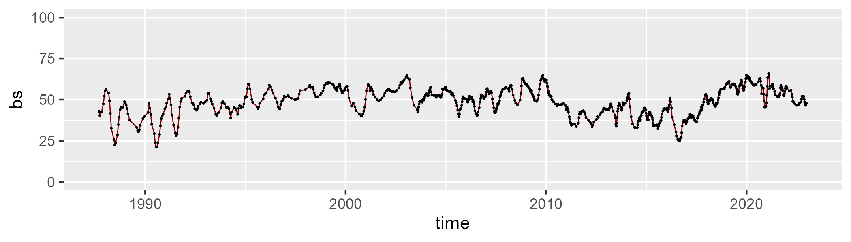

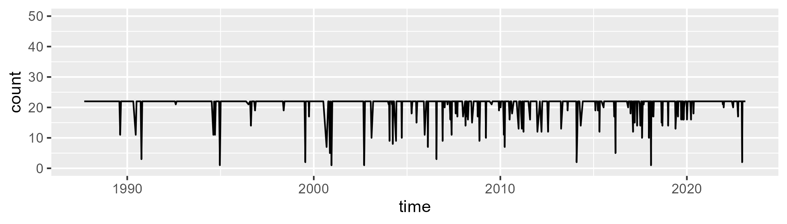

Min. : 1 1st Qu.:22 Median :22 Mean :21 3rd Qu.:22 Max. :22

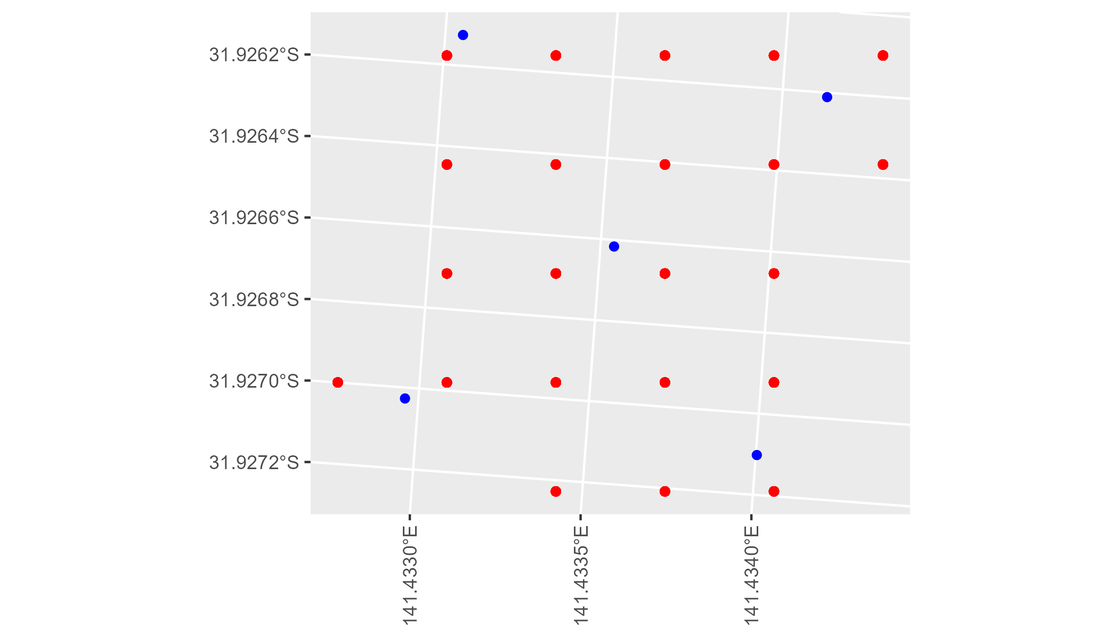

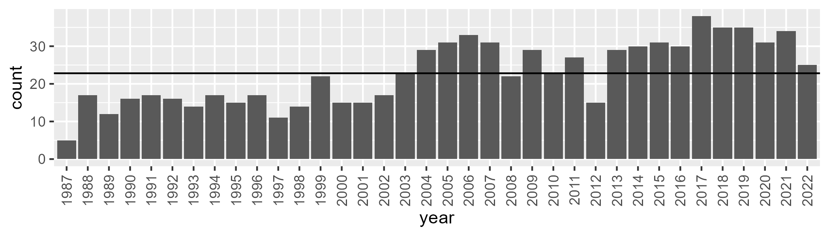

Number of samples: 821

# NSABHC0003

| Min. | 1st Qu. | Median | Mean | 3rd Qu. | Max. |
| --- | --- | --- | --- | --- | --- |
| 1.757797 | 6.290367 | 8.18575 | 9.2154 | 11.50187 | 22.87685 |

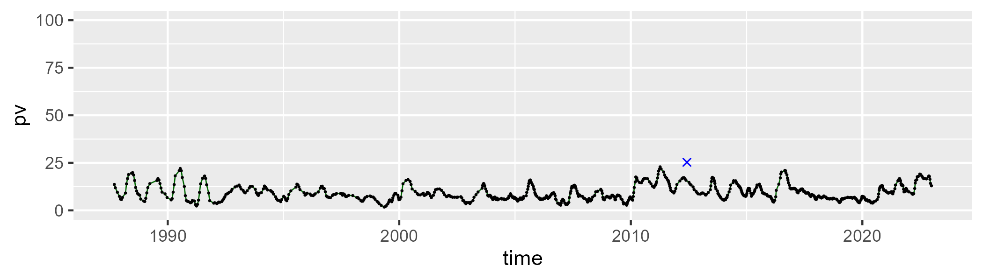

| Min. | 1st Qu. | Median | Mean | 3rd Qu. | Max. |
| --- | --- | --- | --- | --- | --- |
| 15.07192 | 26.29254 | 30.05406 | 30.06807 | 33.33161 | 46.31279 |

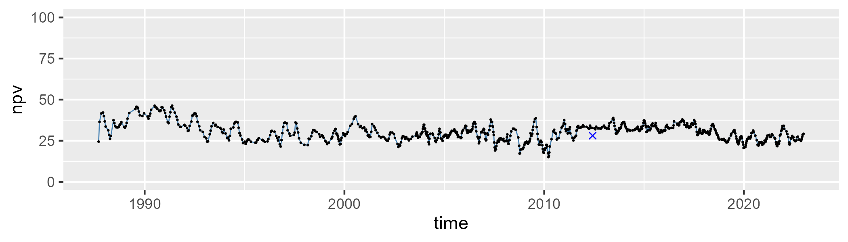

| Min. | 1st Qu. | Median | Mean | 3rd Qu. | Max. |
| --- | --- | --- | --- | --- | --- |
| 31.25981 | 54.81822 | 59.85558 | 59.16059 | 64.25424 | 74.28035 |

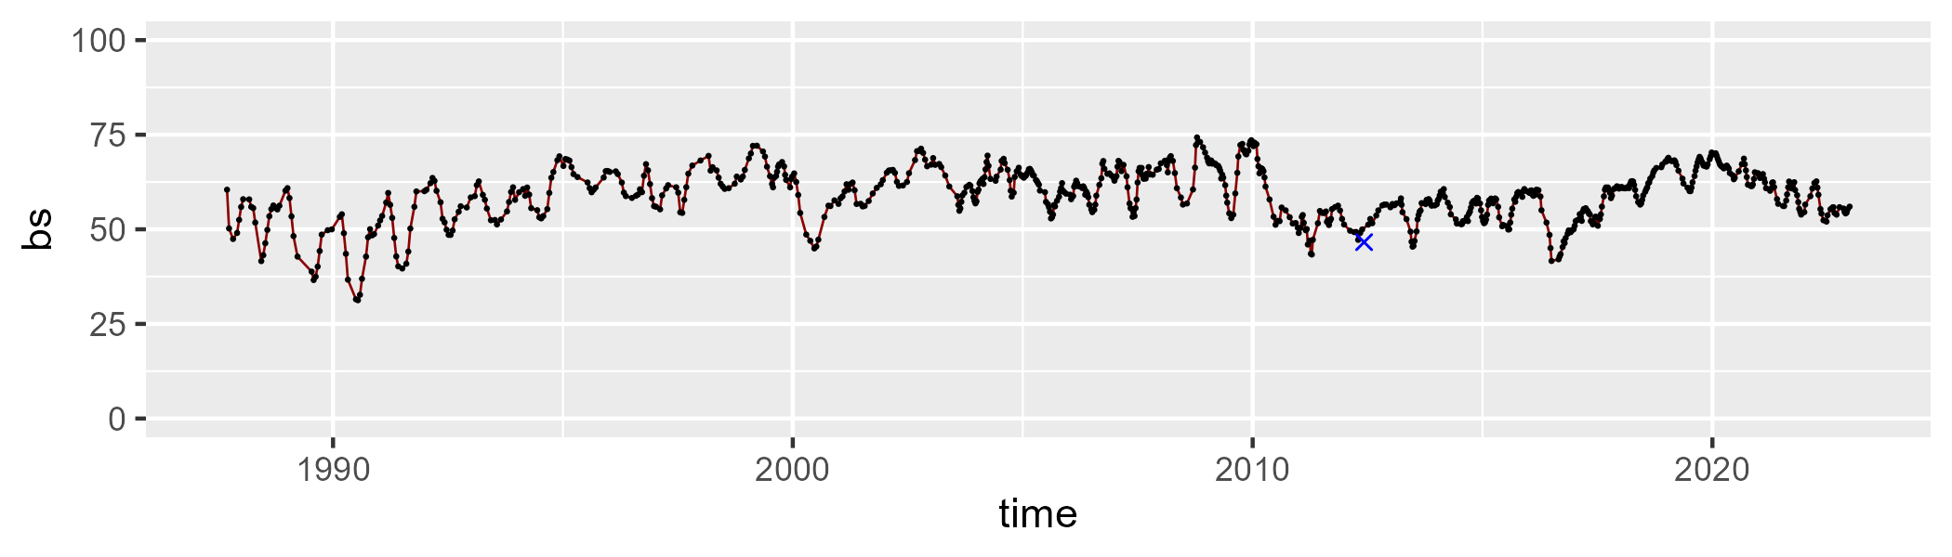

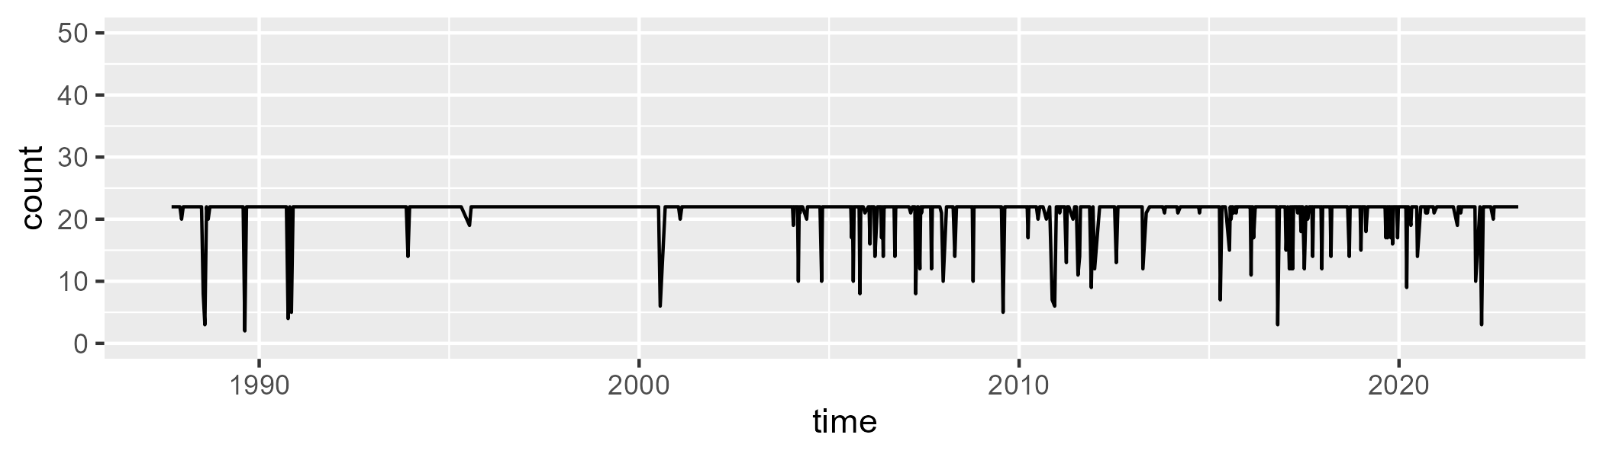

Min. : 2.0 1st Qu.:22.0 Median :22.0 Mean :21.2 3rd Qu.:22.0 Max. :22.0

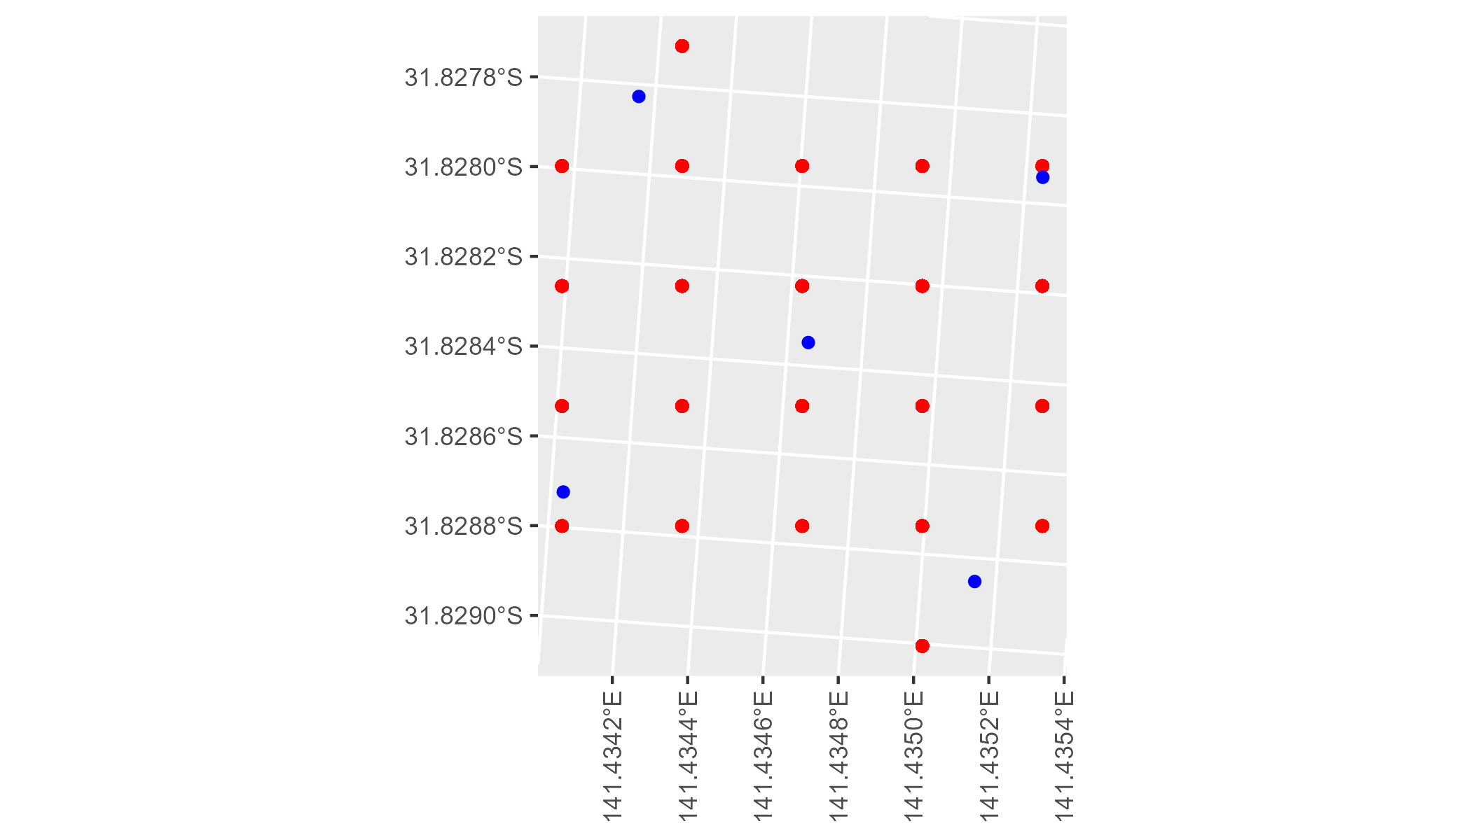

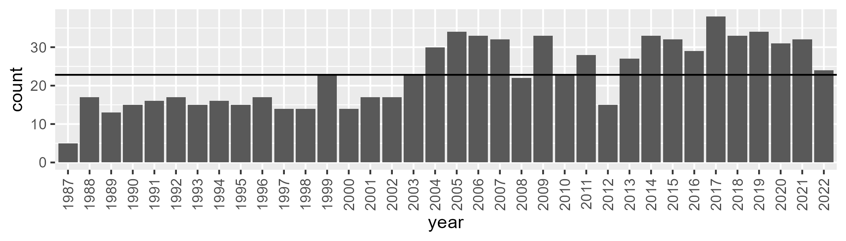

Number of samples: 831

# NSABHC0004

| Min. | 1st Qu. | Median | Mean | 3rd Qu. | Max. |
| --- | --- | --- | --- | --- | --- |
| 0 | 4.857753 | 8.578973 | 12.86841 | 18.45174 | 50.75105 |

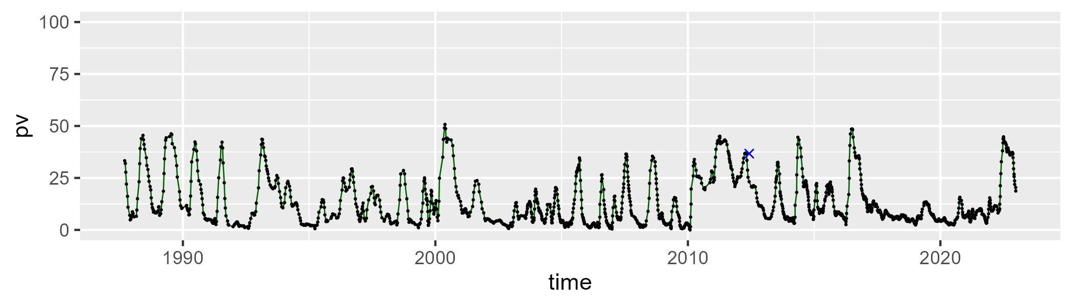

| Min. | 1st Qu. | Median | Mean | 3rd Qu. | Max. |
| --- | --- | --- | --- | --- | --- |
| 11.91434 | 36.66734 | 42.41553 | 41.26113 | 47.28096 | 65.79595 |

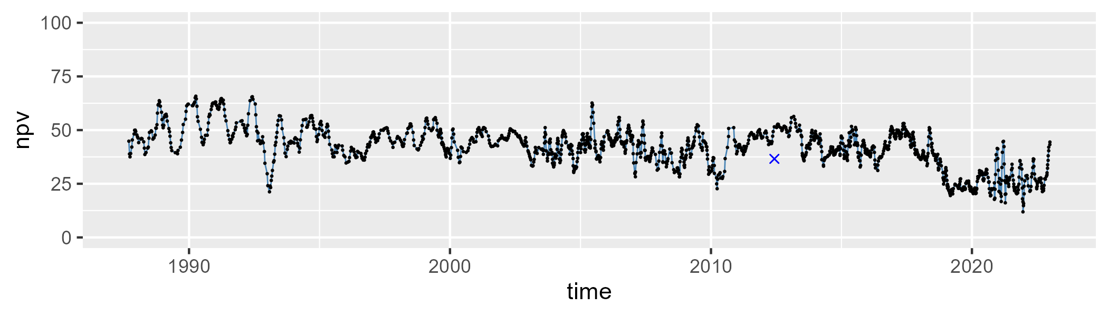

| Min. | 1st Qu. | Median | Mean | 3rd Qu. | Max. |
| --- | --- | --- | --- | --- | --- |
| 7.818109 | 34.848 | 45.69544 | 44.41572 | 52.72587 | 73.19772 |

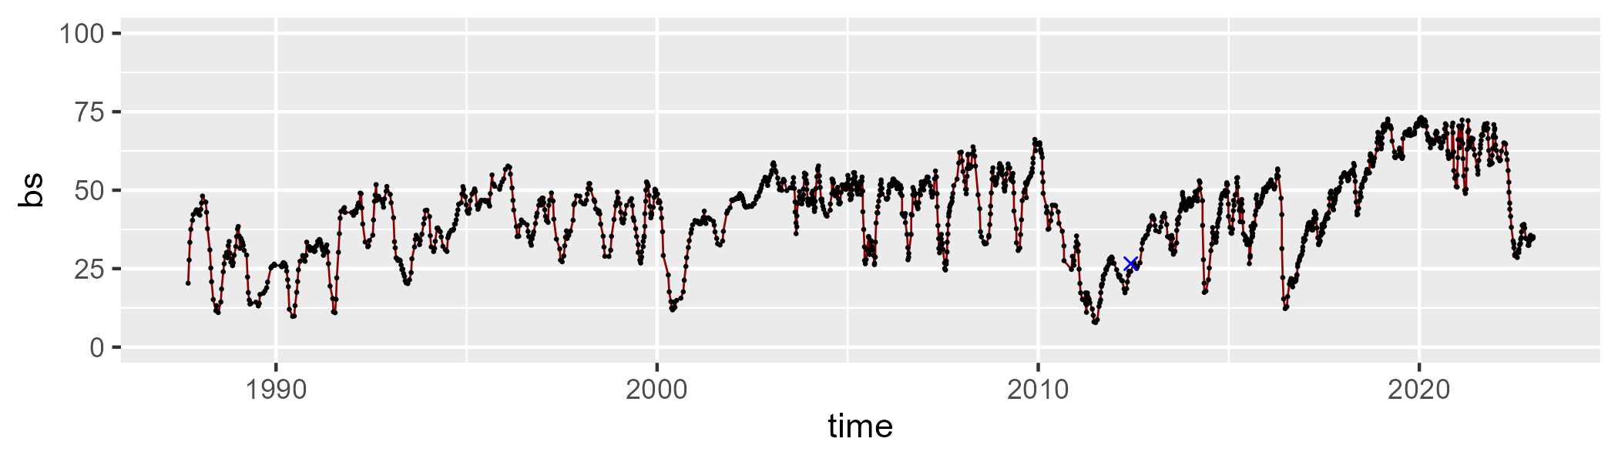

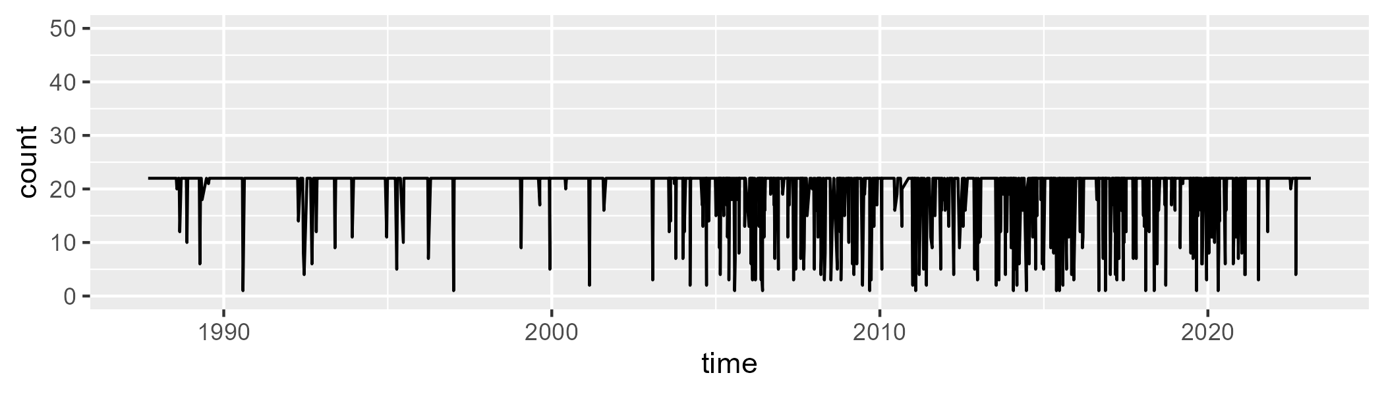

Min. : 1.00 1st Qu.:22.00 Median :22.00 Mean :20.14 3rd Qu.:22.00 Max. :22.00

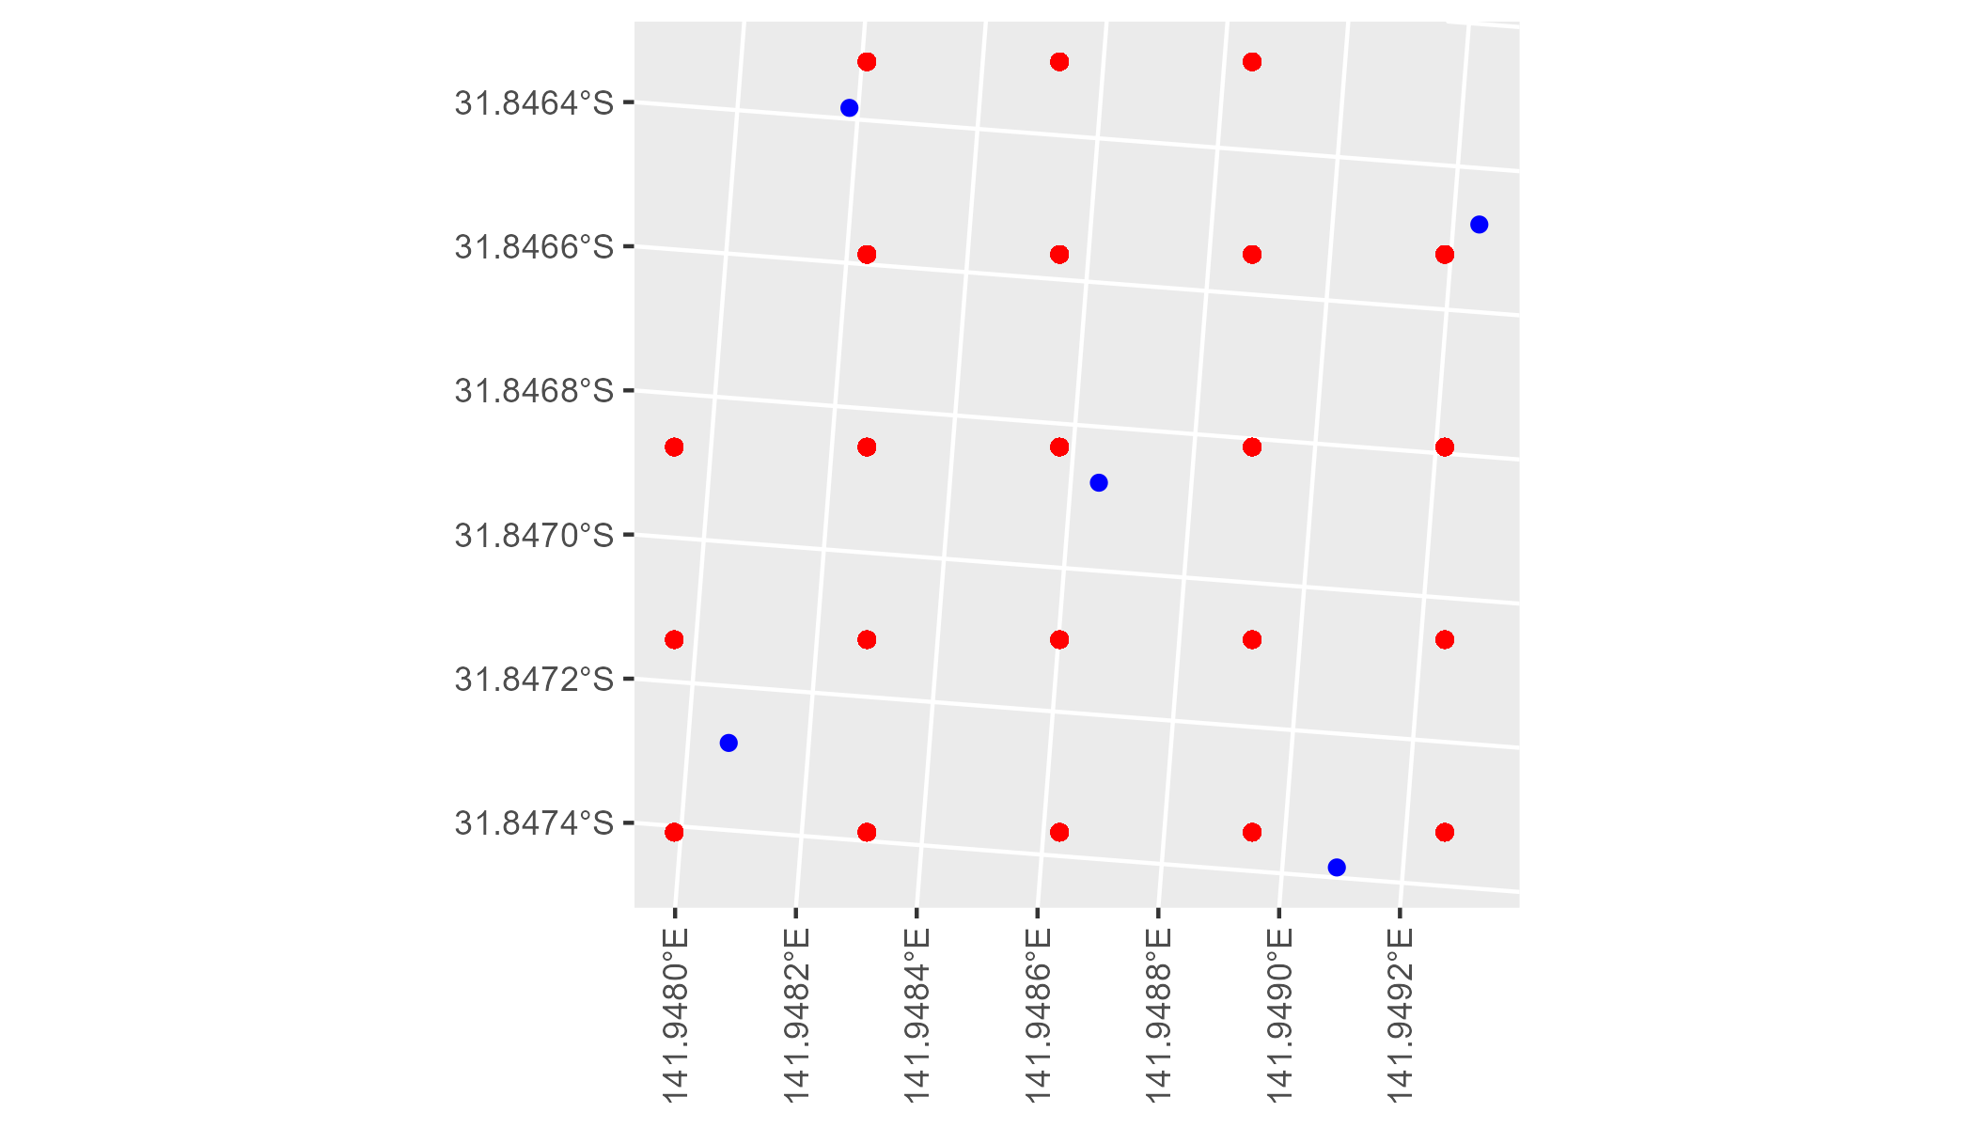

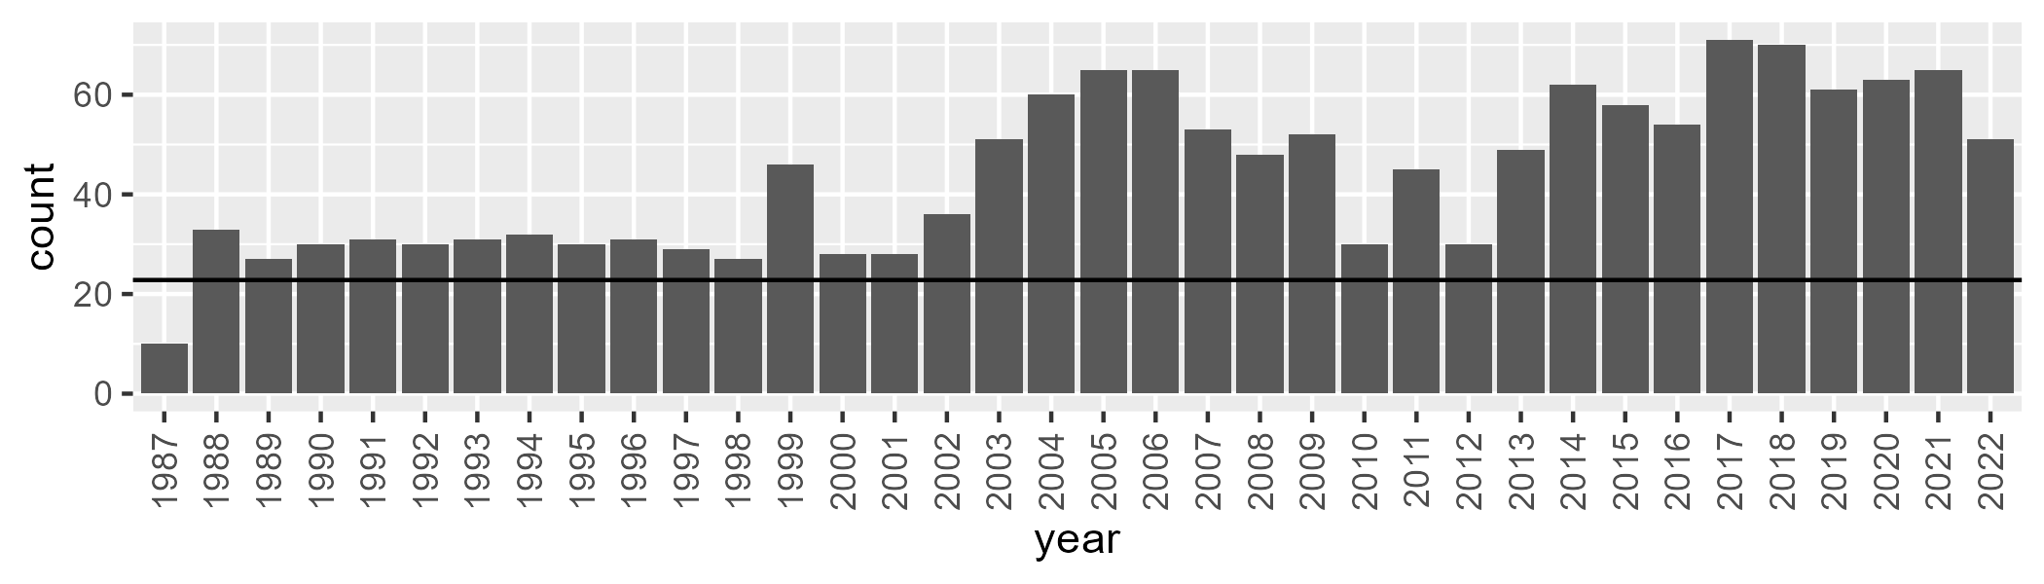

Number of samples: 1582

# NSABHC0005

| Min. | 1st Qu. | Median | Mean | 3rd Qu. | Max. |
| --- | --- | --- | --- | --- | --- |
| 0 | 1.252491 | 3.415126 | 8.354855 | 12.23617 | 57.55333 |

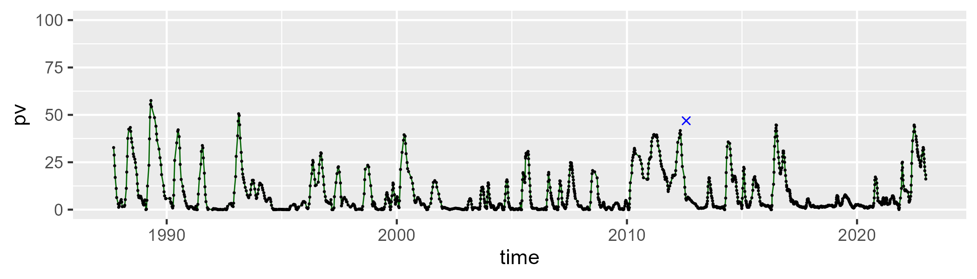

| Min. | 1st Qu. | Median | Mean | 3rd Qu. | Max. |
| --- | --- | --- | --- | --- | --- |
| 11.81514 | 36.35914 | 45.32172 | 44.76015 | 53.75308 | 75.60756 |

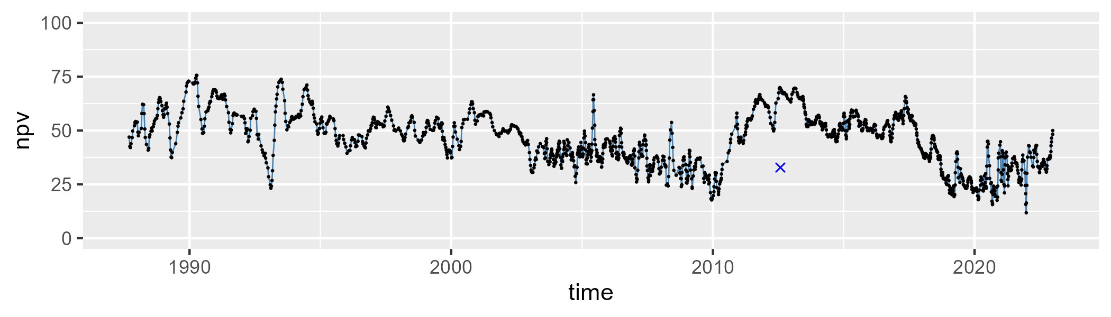

| Min. | 1st Qu. | Median | Mean | 3rd Qu. | Max. |
| --- | --- | --- | --- | --- | --- |
| 3.808857 | 33.21314 | 46.28065 | 45.52561 | 58.34576 | 81.21123 |

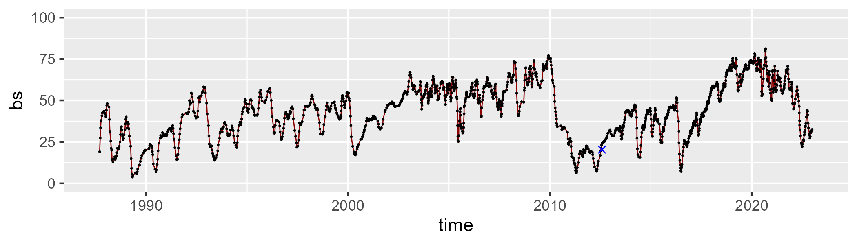

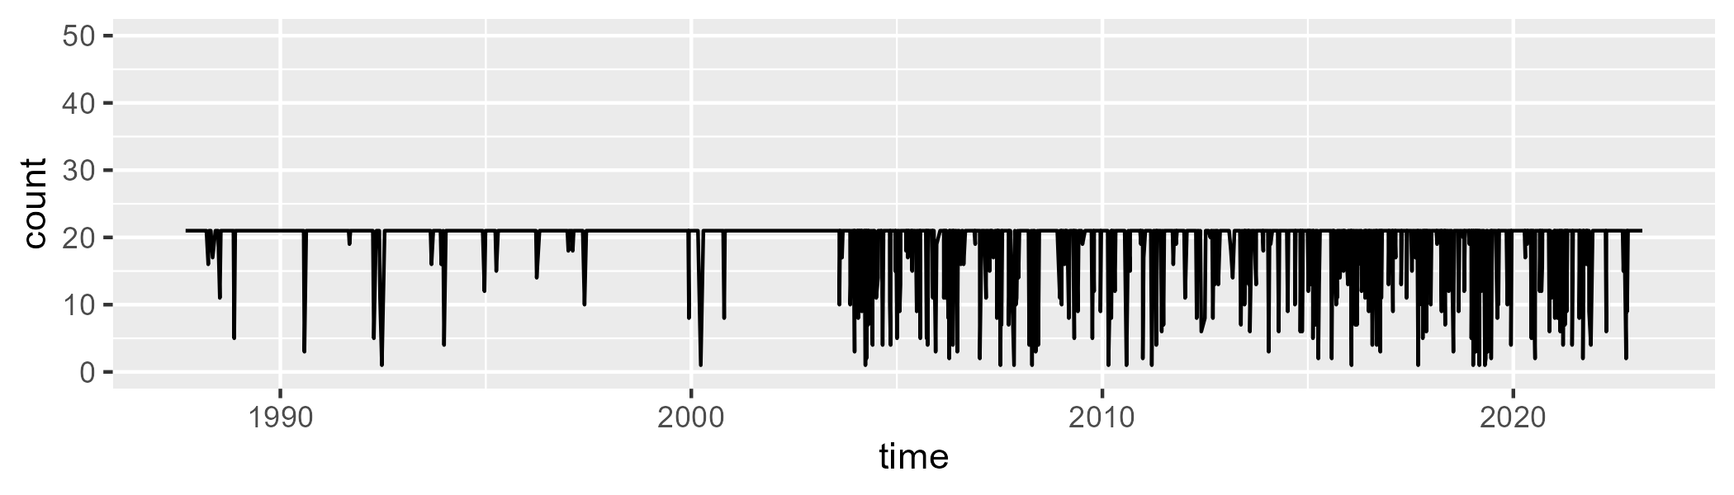

Min. : 1.00 1st Qu.:21.00 Median :21.00 Mean :19.42 3rd Qu.:21.00 Max. :21.00

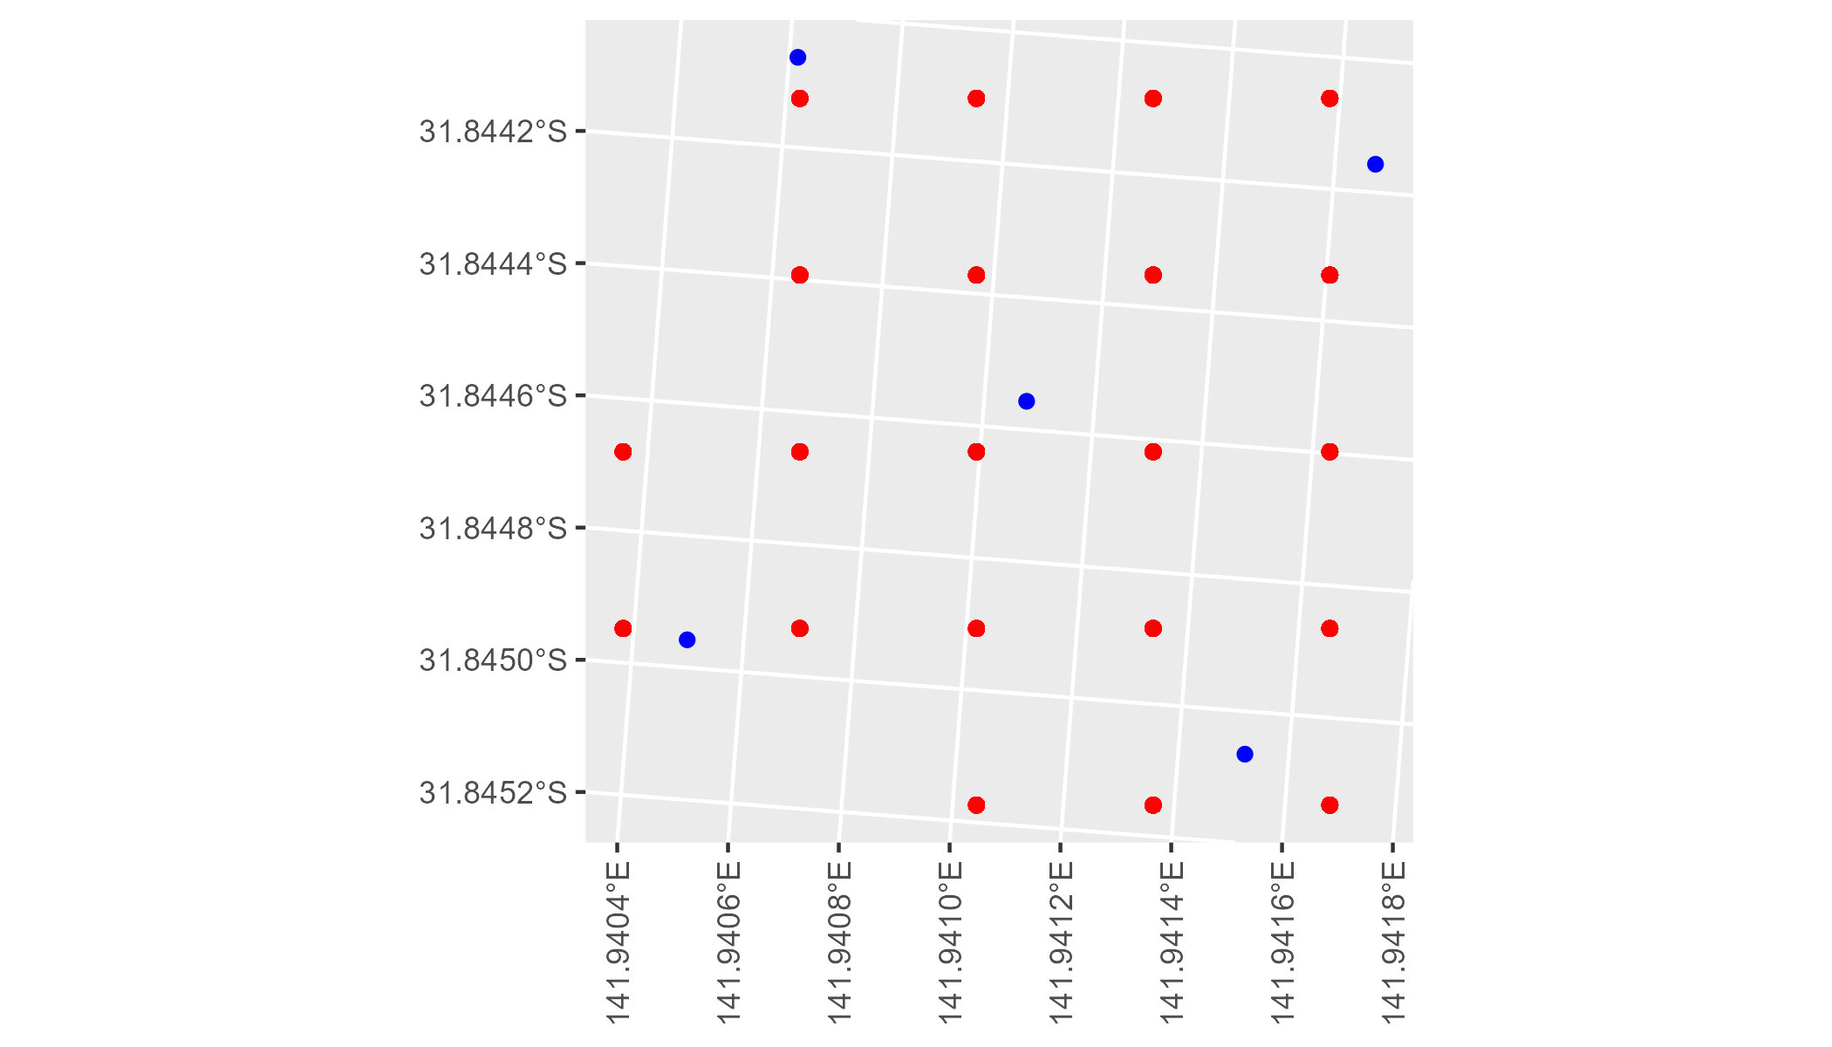

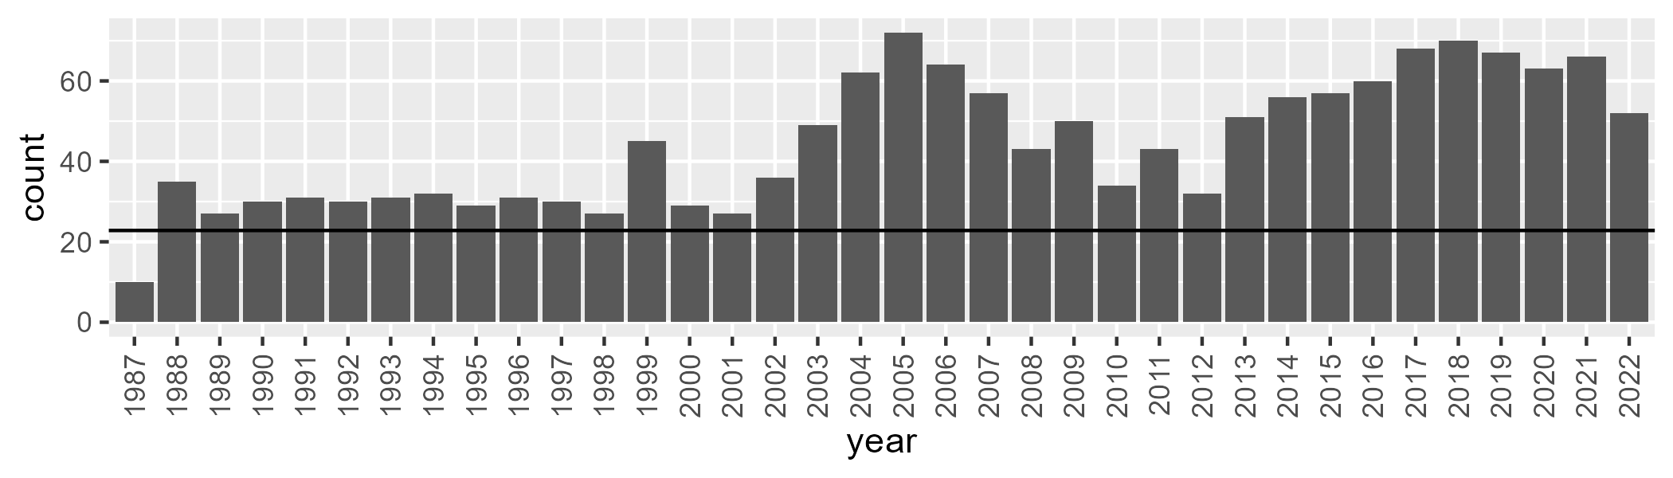

Number of samples: 1596

# NSABHC0006

| Min. | 1st Qu. | Median | Mean | 3rd Qu. | Max. |
| --- | --- | --- | --- | --- | --- |
| 0 | 2.681317 | 6.225643 | 9.577117 | 14.24469 | 42.44822 |

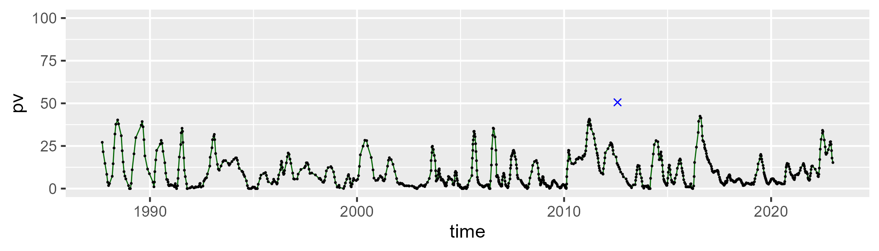

| Min. | 1st Qu. | Median | Mean | 3rd Qu. | Max. |
| --- | --- | --- | --- | --- | --- |
| 11.89023 | 34.90716 | 43.49714 | 43.19773 | 51.89462 | 70.27762 |

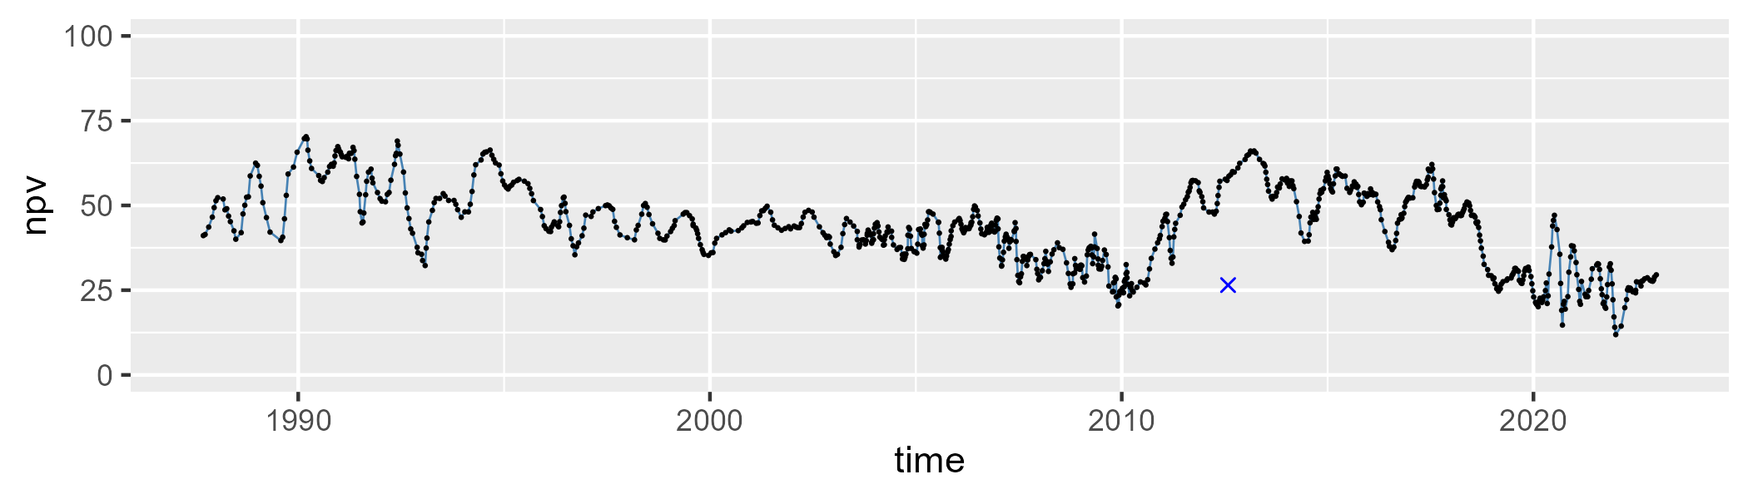

| Min. | 1st Qu. | Median | Mean | 3rd Qu. | Max. |
| --- | --- | --- | --- | --- | --- |
| 13.15374 | 34.12777 | 46.2804 | 45.83336 | 55.92027 | 76.30039 |

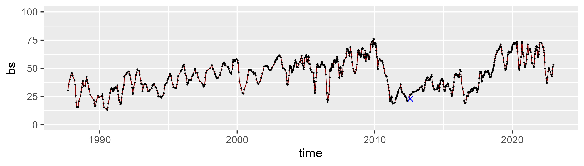

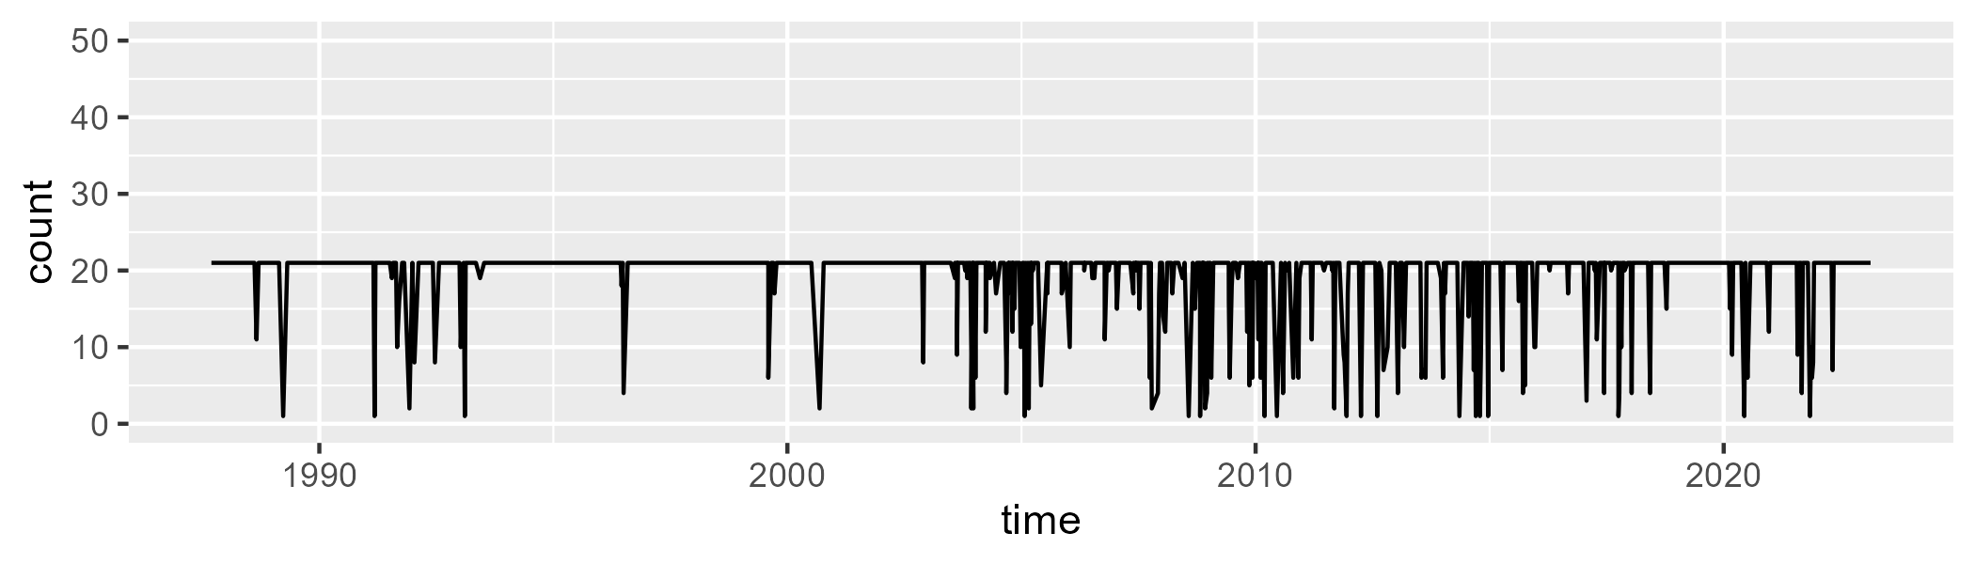

Min. : 1.00 1st Qu.:21.00 Median :21.00 Mean :19.19 3rd Qu.:21.00 Max. :21.00

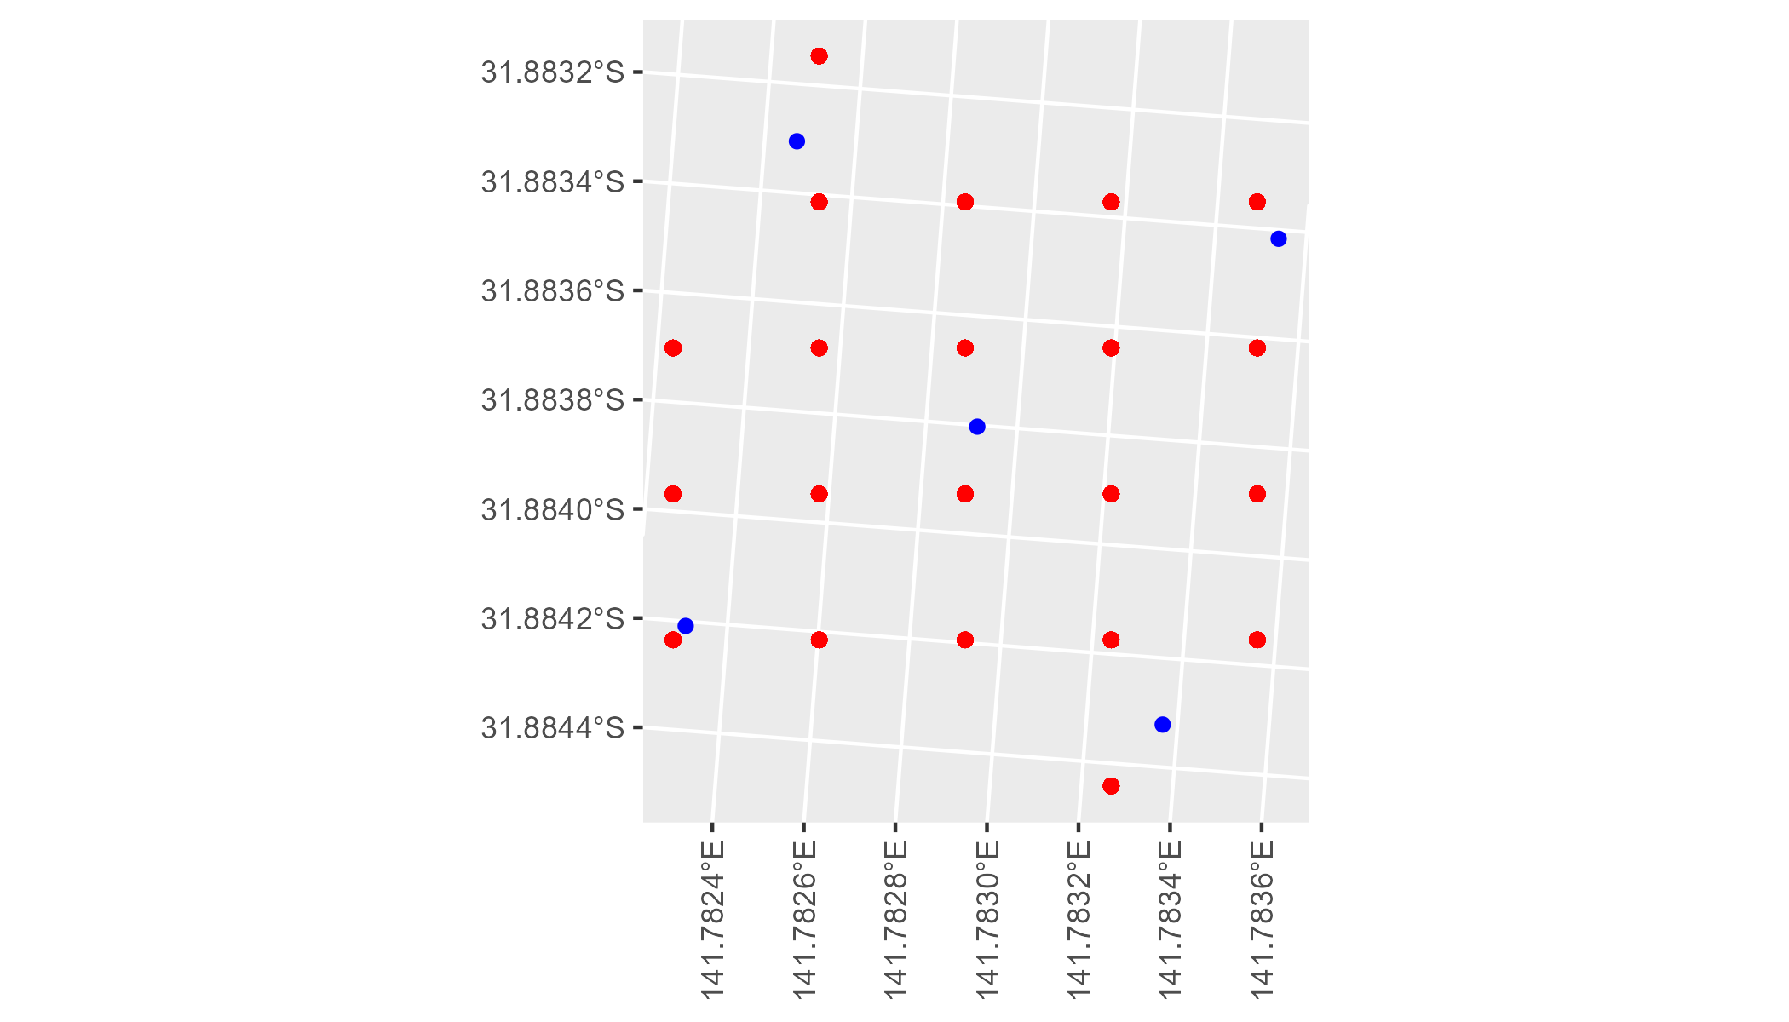

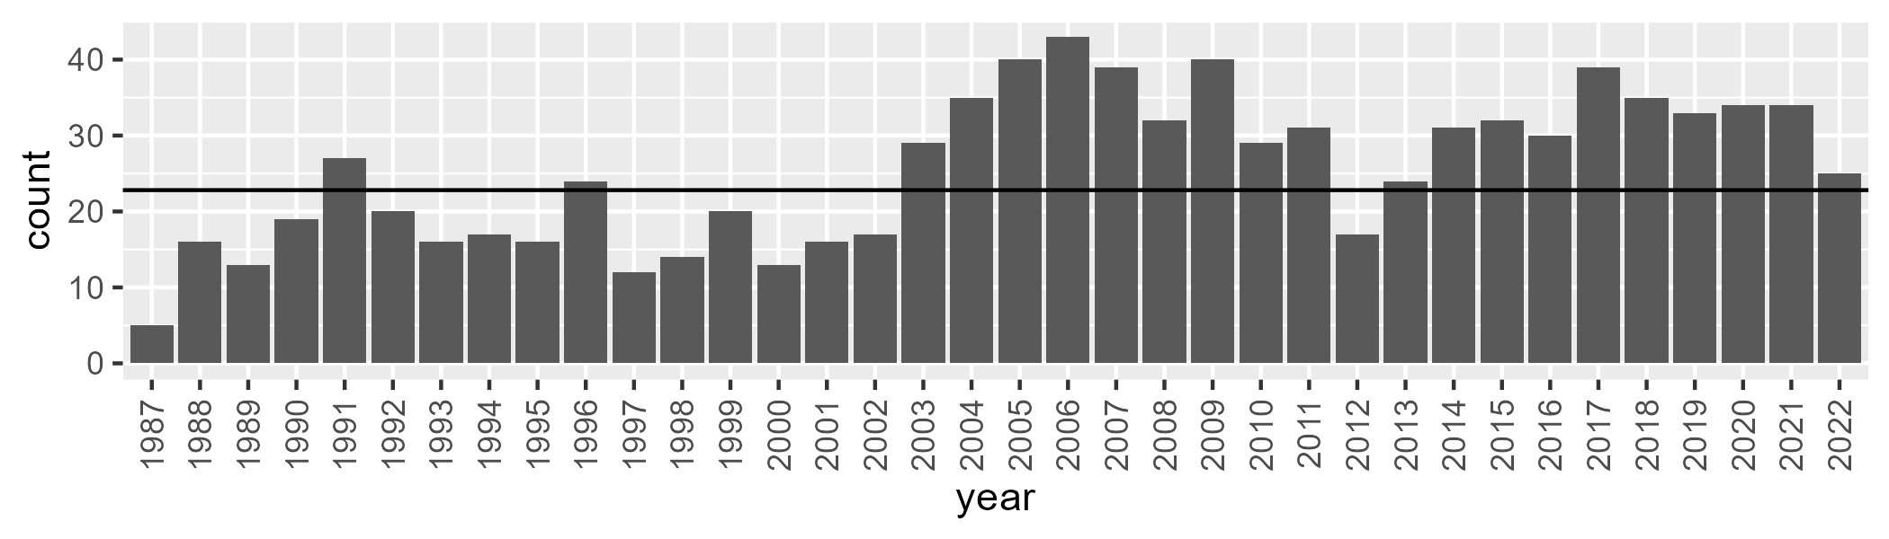

Number of samples: 917

# NSABHC0007

| Min. | 1st Qu. | Median | Mean | 3rd Qu. | Max. |
| --- | --- | --- | --- | --- | --- |
| 0 | 4.558793 | 7.997801 | 10.56812 | 14.56428 | 36.57168 |

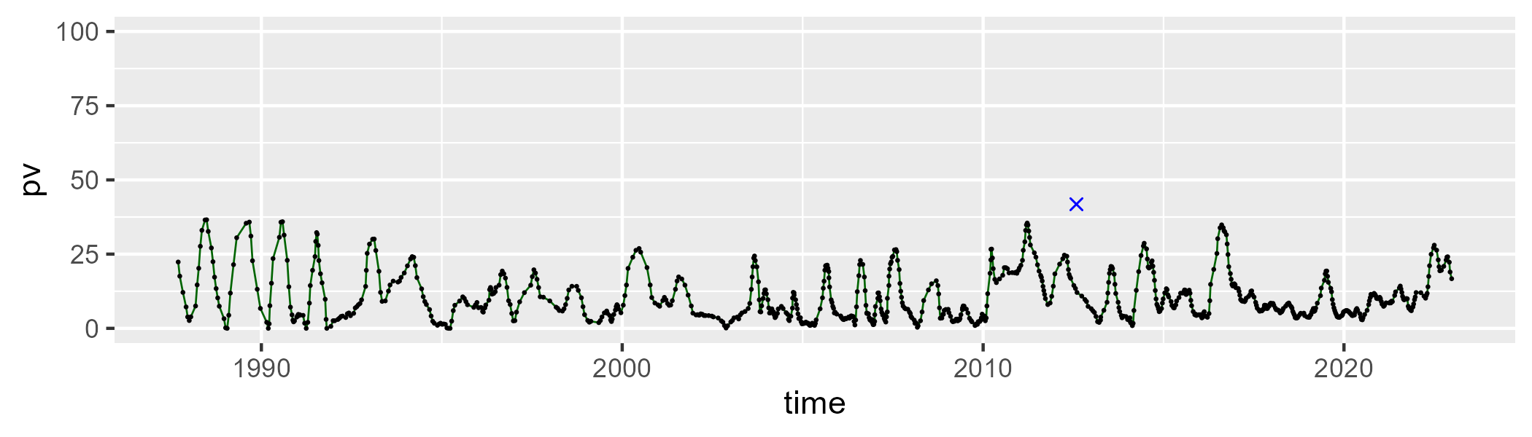

| Min. | 1st Qu. | Median | Mean | 3rd Qu. | Max. |
| --- | --- | --- | --- | --- | --- |
| 18.3738 | 35.07974 | 40.20163 | 40.26486 | 45.38255 | 69.14335 |

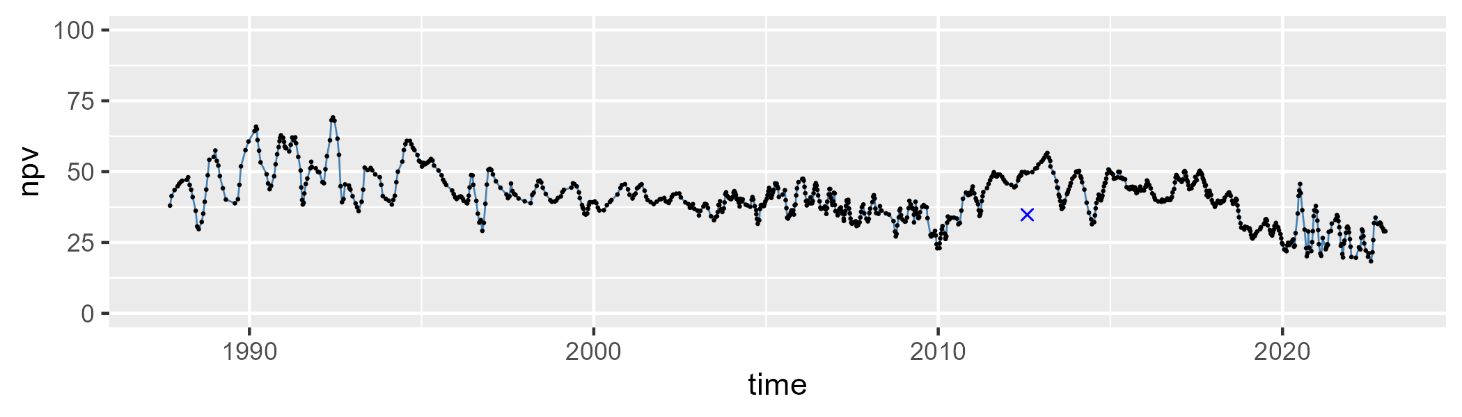

| Min. | 1st Qu. | Median | Mean | 3rd Qu. | Max. |
| --- | --- | --- | --- | --- | --- |
| 17.12052 | 39.9865 | 48.12722 | 47.70971 | 54.96579 | 71.34796 |

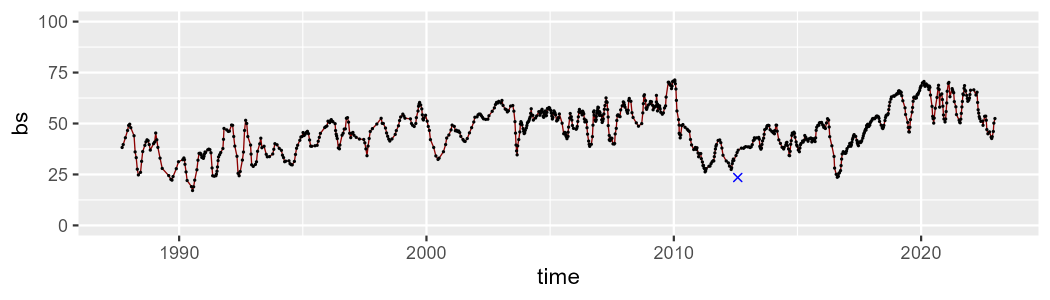

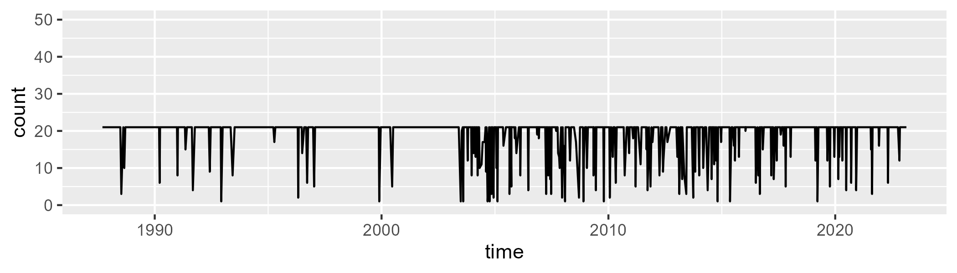

Min. : 1.00 1st Qu.:21.00 Median :21.00 Mean :19.19 3rd Qu.:21.00 Max. :21.00

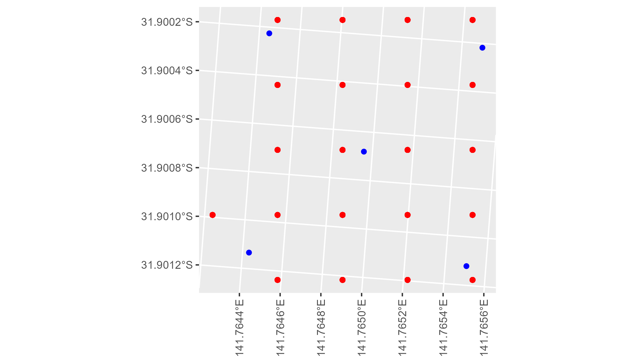

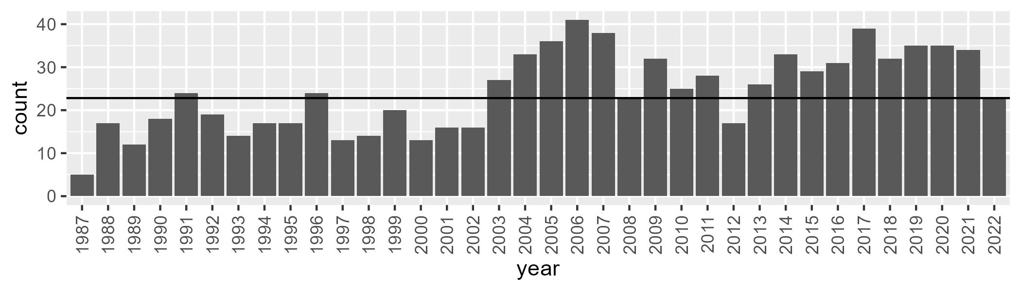

Number of samples: 876

# NSABHC0008

| Min. | 1st Qu. | Median | Mean | 3rd Qu. | Max. |
| --- | --- | --- | --- | --- | --- |
| 0 | 5.807983 | 8.40226 | 9.778445 | 12.83765 | 27.07984 |

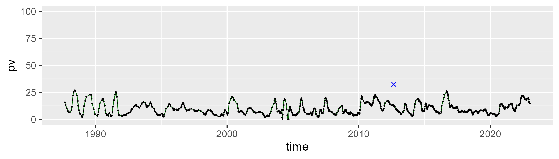

| Min. | 1st Qu. | Median | Mean | 3rd Qu. | Max. |
| --- | --- | --- | --- | --- | --- |
| 25.82939 | 35.02817 | 39.1586 | 38.93015 | 42.39114 | 54.01119 |

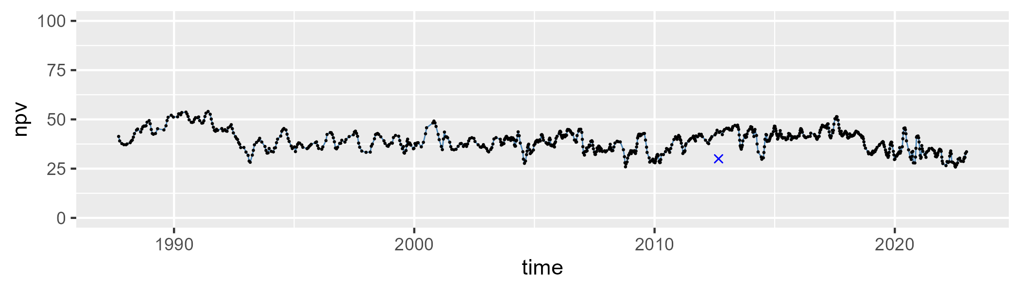

| Min. | 1st Qu. | Median | Mean | 3rd Qu. | Max. |
| --- | --- | --- | --- | --- | --- |
| 23.00938 | 45.6725 | 49.97474 | 49.77367 | 54.72843 | 69.80907 |

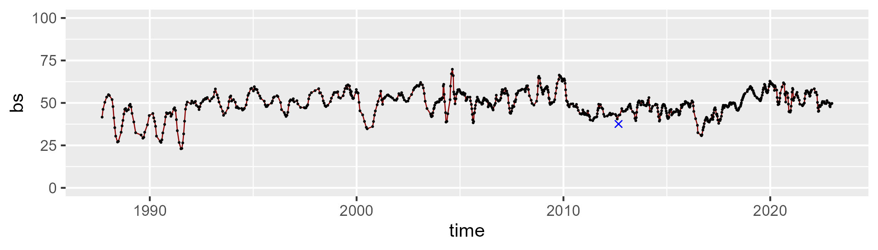

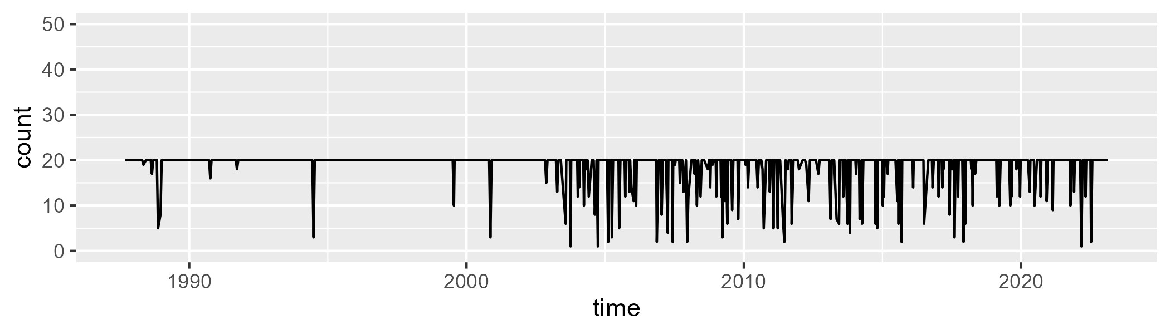

Min. : 1.00 1st Qu.:20.00 Median :20.00 Mean :18.64 3rd Qu.:20.00 Max. :20.00

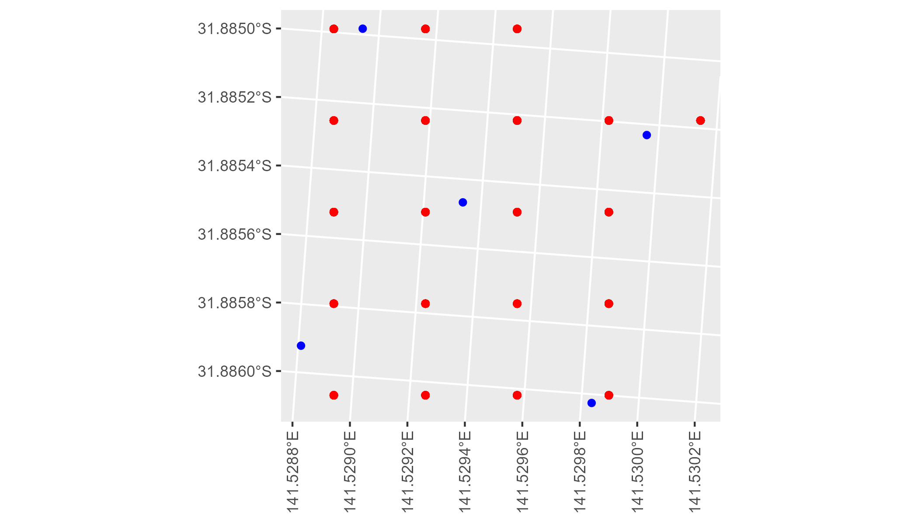

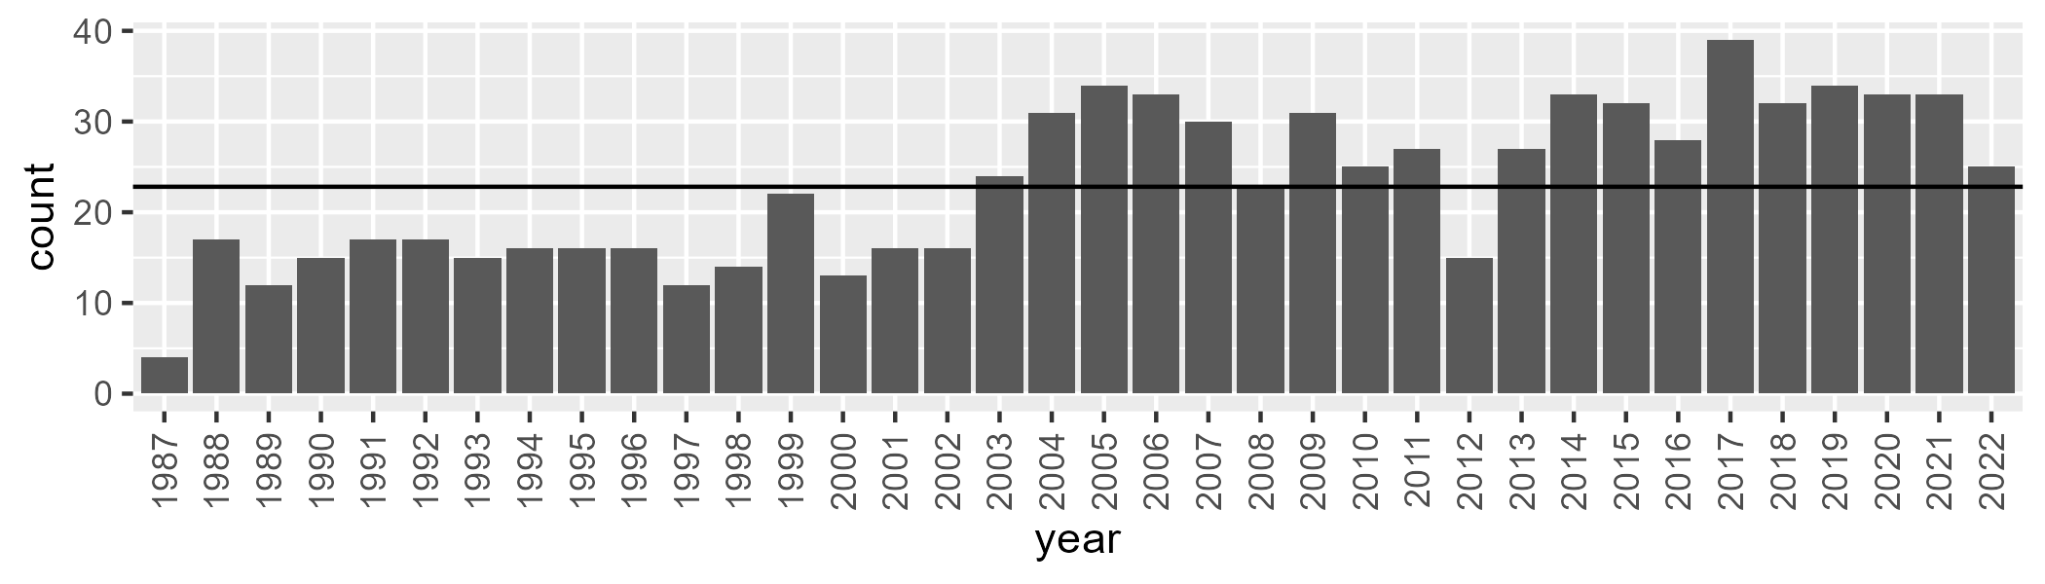

Number of samples: 827

# NSABHC0009

| Min. | 1st Qu. | Median | Mean | 3rd Qu. | Max. |
| --- | --- | --- | --- | --- | --- |
| 0 | 0.9512082 | 3.136944 | 5.288704 | 8.182442 | 29.37862 |

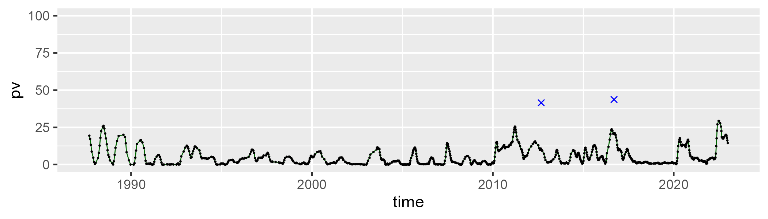

| Min. | 1st Qu. | Median | Mean | 3rd Qu. | Max. |
| --- | --- | --- | --- | --- | --- |
| 26.10827 | 42.06177 | 45.90926 | 46.1174 | 50.26625 | 71.92415 |

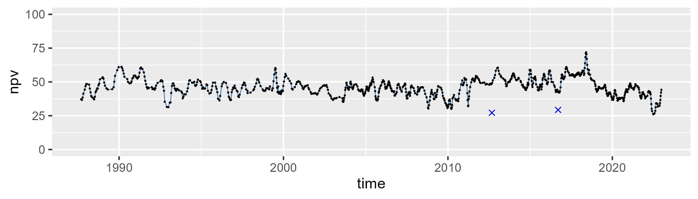

| Min. | 1st Qu. | Median | Mean | 3rd Qu. | Max. |
| --- | --- | --- | --- | --- | --- |
| 25.34103 | 41.90004 | 48.20821 | 47.32089 | 52.63658 | 69.00412 |

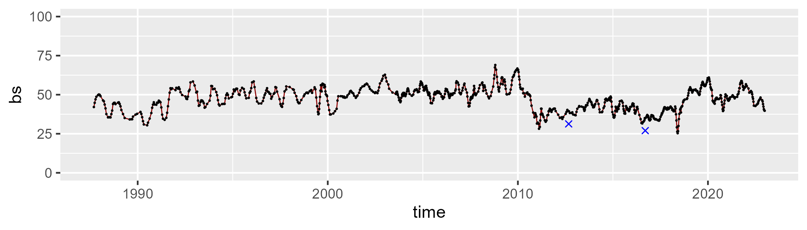

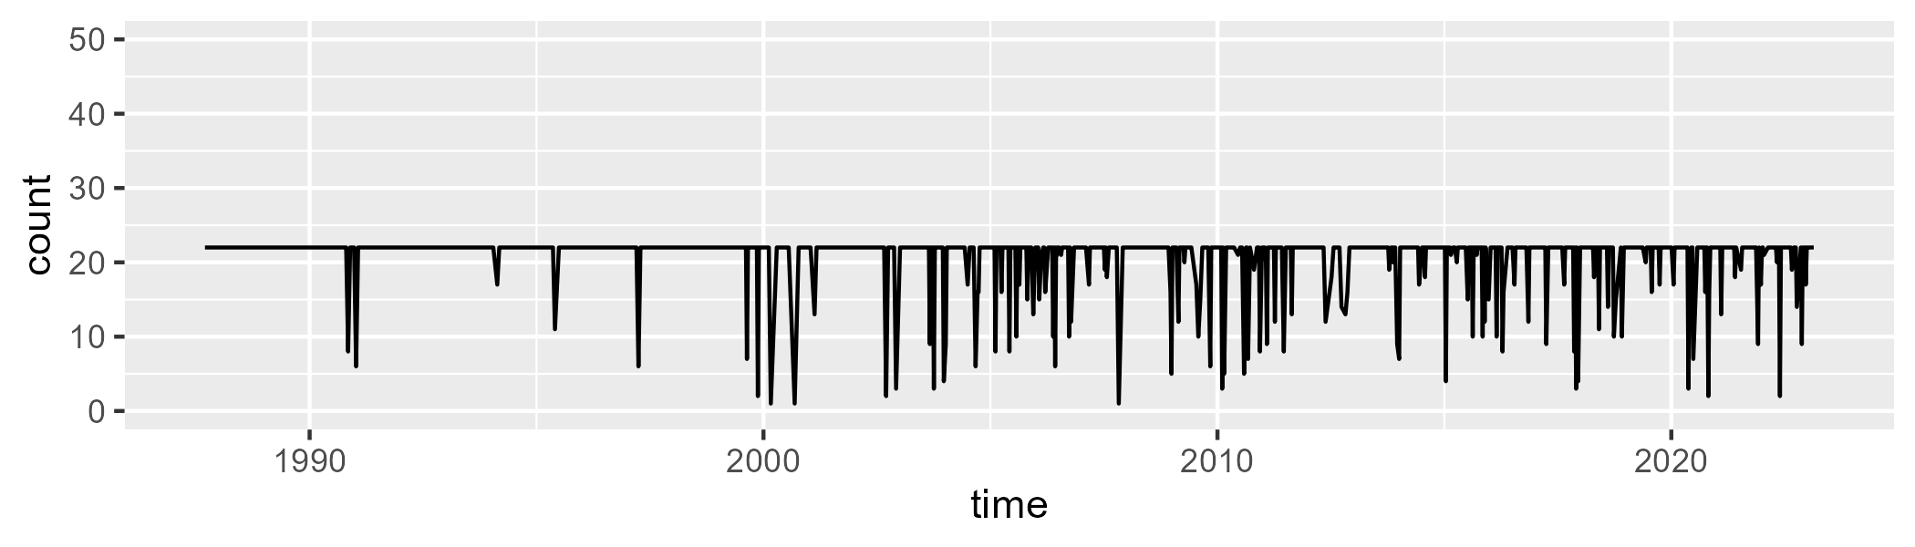

Min. : 1.00 1st Qu.:22.00 Median :22.00 Mean :20.68 3rd Qu.:22.00 Max. :22.00

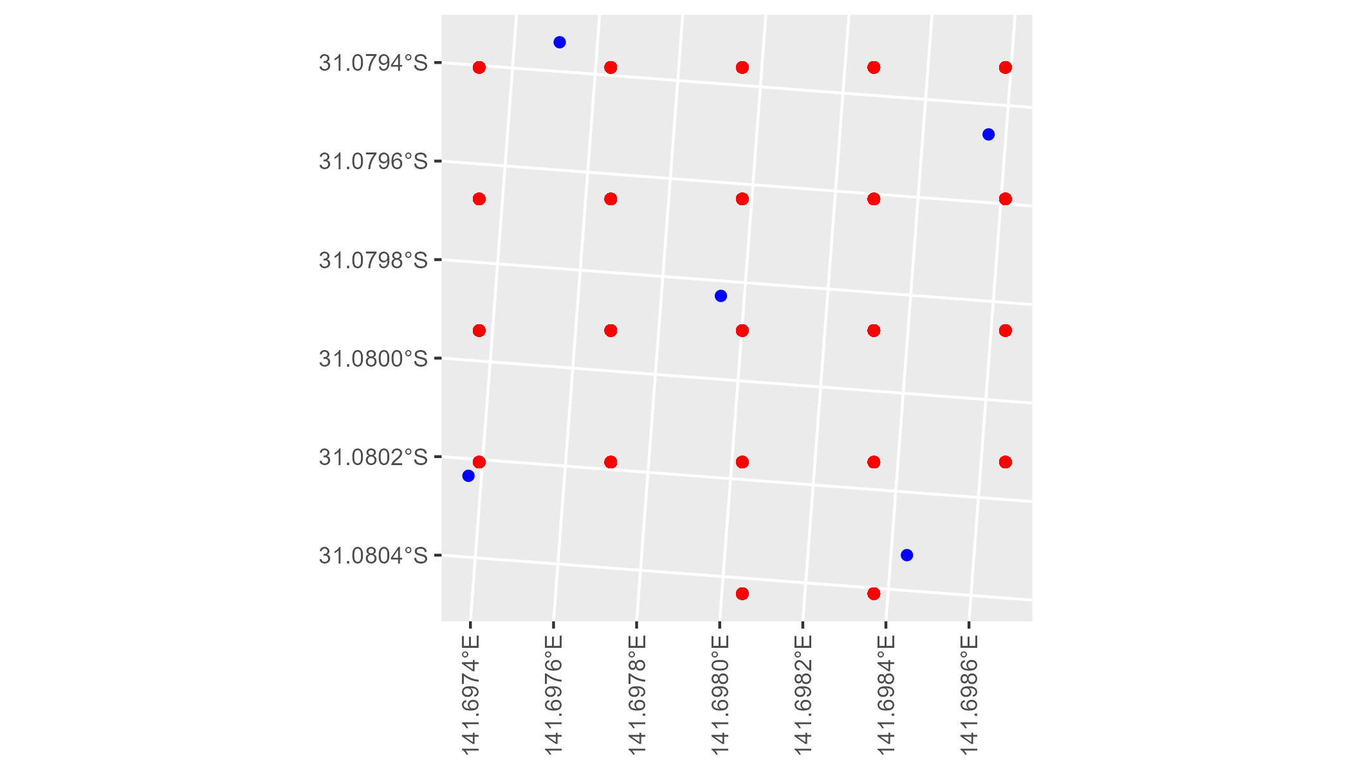

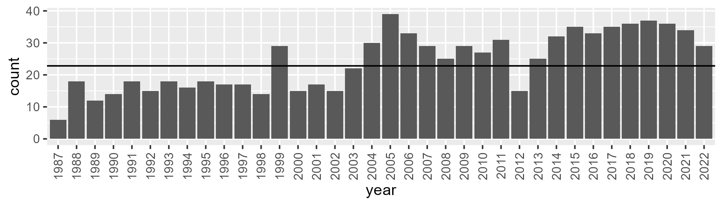

Number of samples: 871

# NSABHC0010

| Min. | 1st Qu. | Median | Mean | 3rd Qu. | Max. |
| --- | --- | --- | --- | --- | --- |
| 0 | 0.07610656 | 0.890645 | 1.431124 | 1.787304 | 11.50389 |

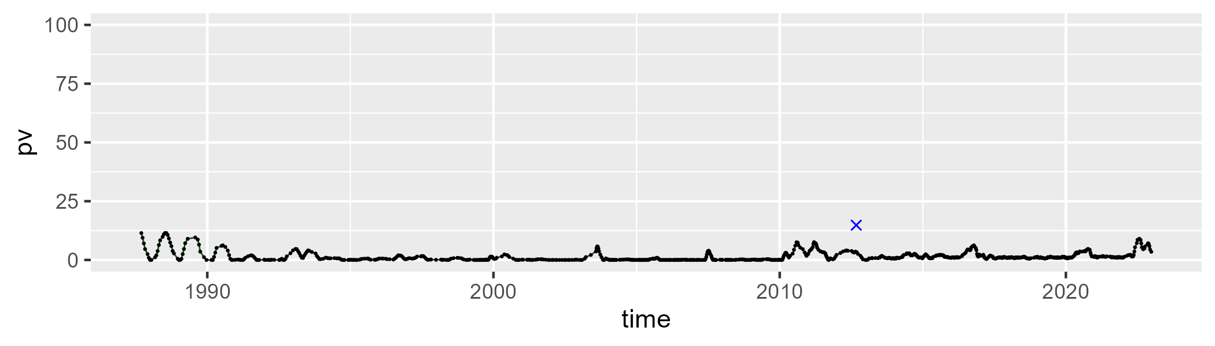

| Min. | 1st Qu. | Median | Mean | 3rd Qu. | Max. |
| --- | --- | --- | --- | --- | --- |
| 19.09739 | 28.21412 | 30.95392 | 31.20008 | 33.83412 | 51.35346 |

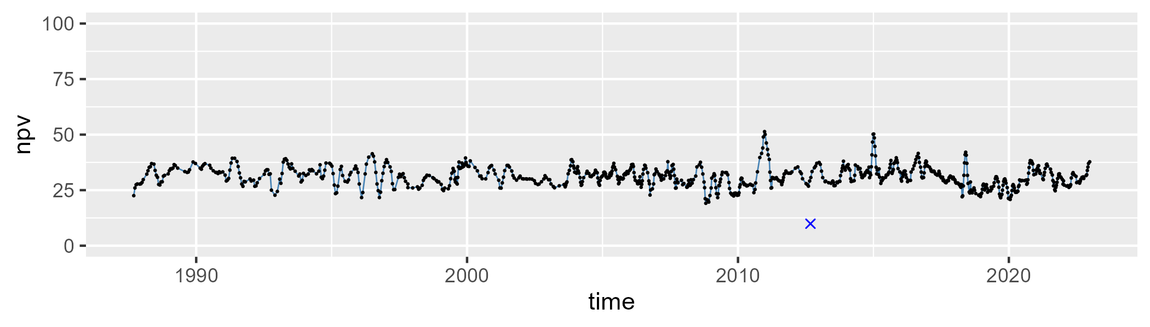

| Min. | 1st Qu. | Median | Mean | 3rd Qu. | Max. |
| --- | --- | --- | --- | --- | --- |
| 45.01183 | 63.05835 | 66.39743 | 66.19448 | 69.51969 | 80.13804 |

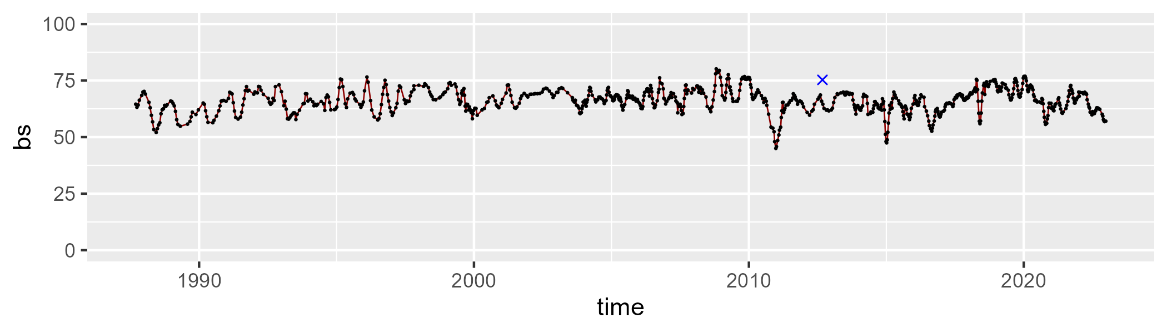

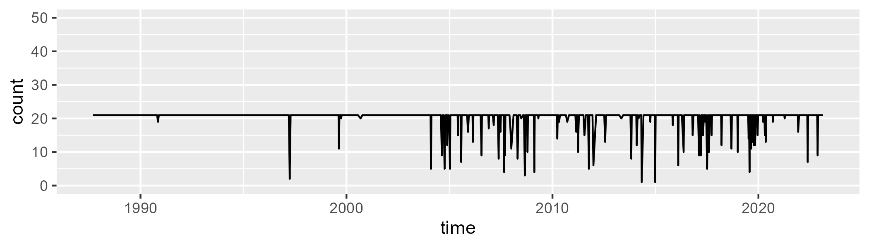

Min. : 1.00 1st Qu.:21.00 Median :21.00 Mean :20.22 3rd Qu.:21.00 Max. :21.00

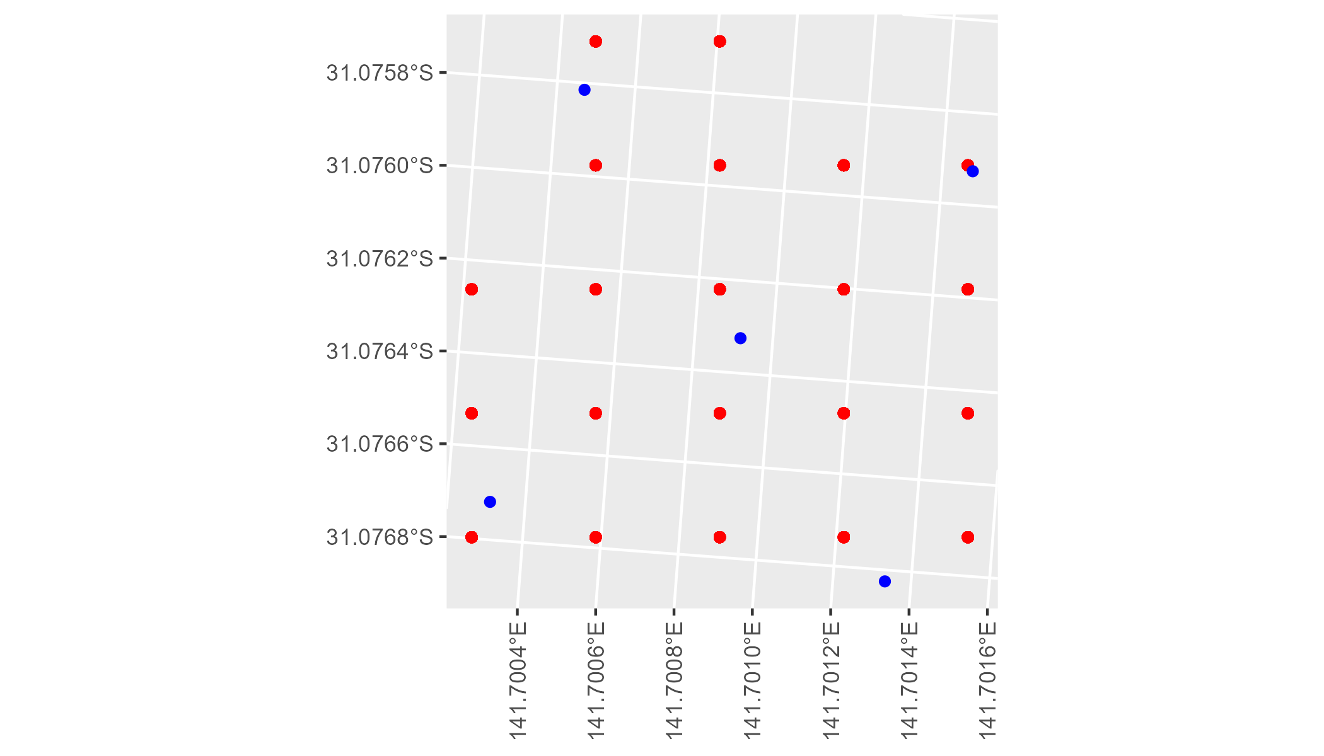

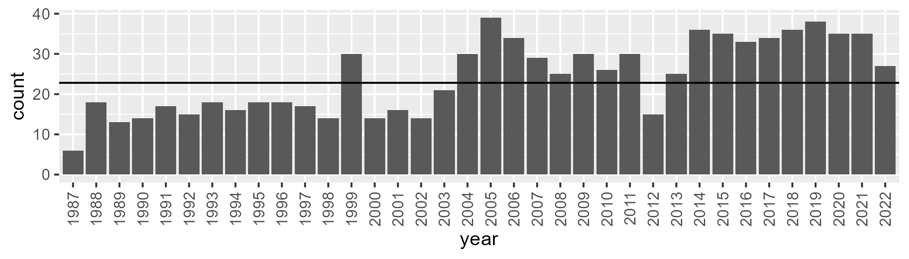

Number of samples: 871

# NSABHC0011

| Min. | 1st Qu. | Median | Mean | 3rd Qu. | Max. |
| --- | --- | --- | --- | --- | --- |
| 0 | 1.706161 | 4.071633 | 7.569812 | 10.22038 | 43.34018 |

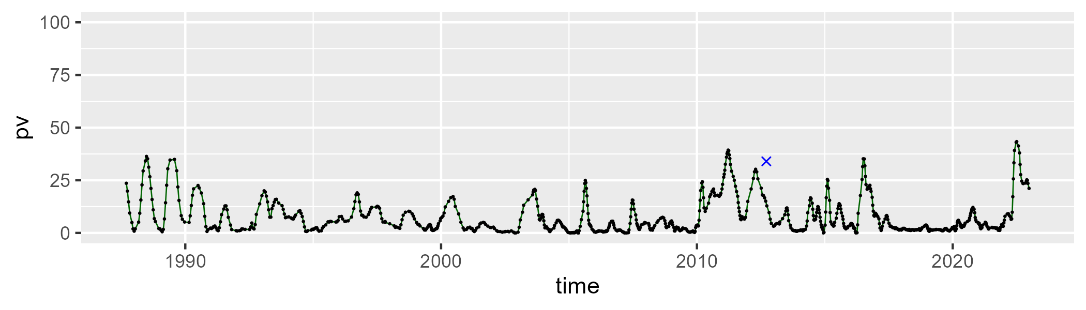

| Min. | 1st Qu. | Median | Mean | 3rd Qu. | Max. |
| --- | --- | --- | --- | --- | --- |
| 16.97838 | 31.34237 | 37.77384 | 37.18052 | 42.71692 | 59.70362 |

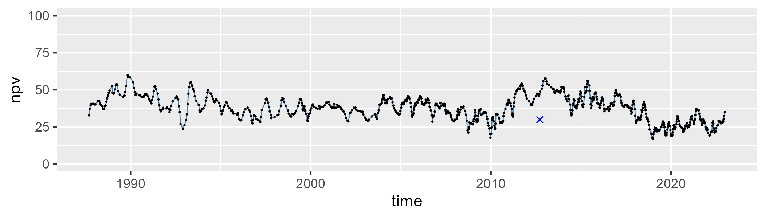

| Min. | 1st Qu. | Median | Mean | 3rd Qu. | Max. |
| --- | --- | --- | --- | --- | --- |
| 17.42017 | 46.53226 | 54.99369 | 53.76552 | 62.36423 | 77.7077 |

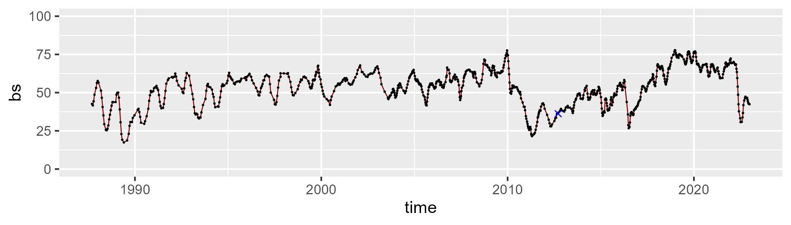

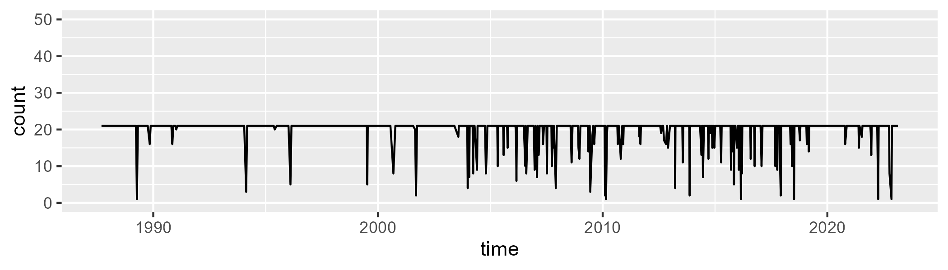

Min. : 1.00 1st Qu.:21.00 Median :21.00 Mean :19.97 3rd Qu.:21.00 Max. :21.00

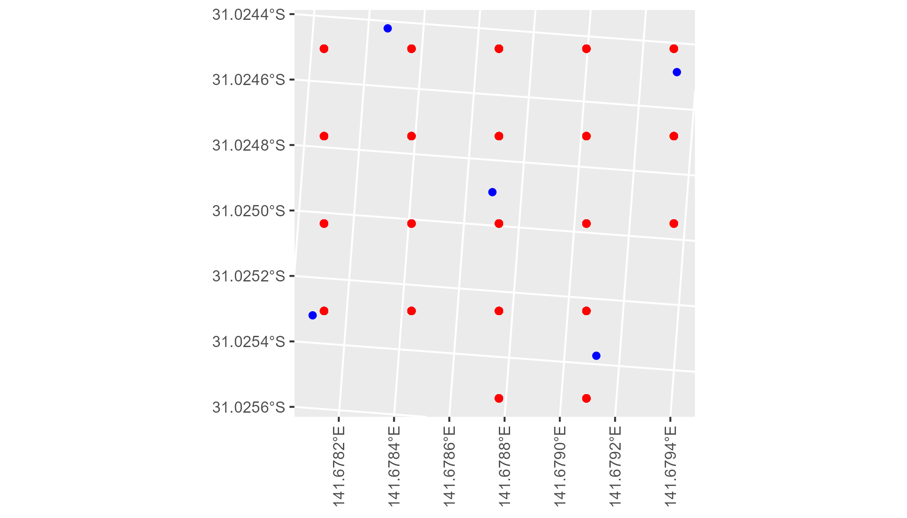

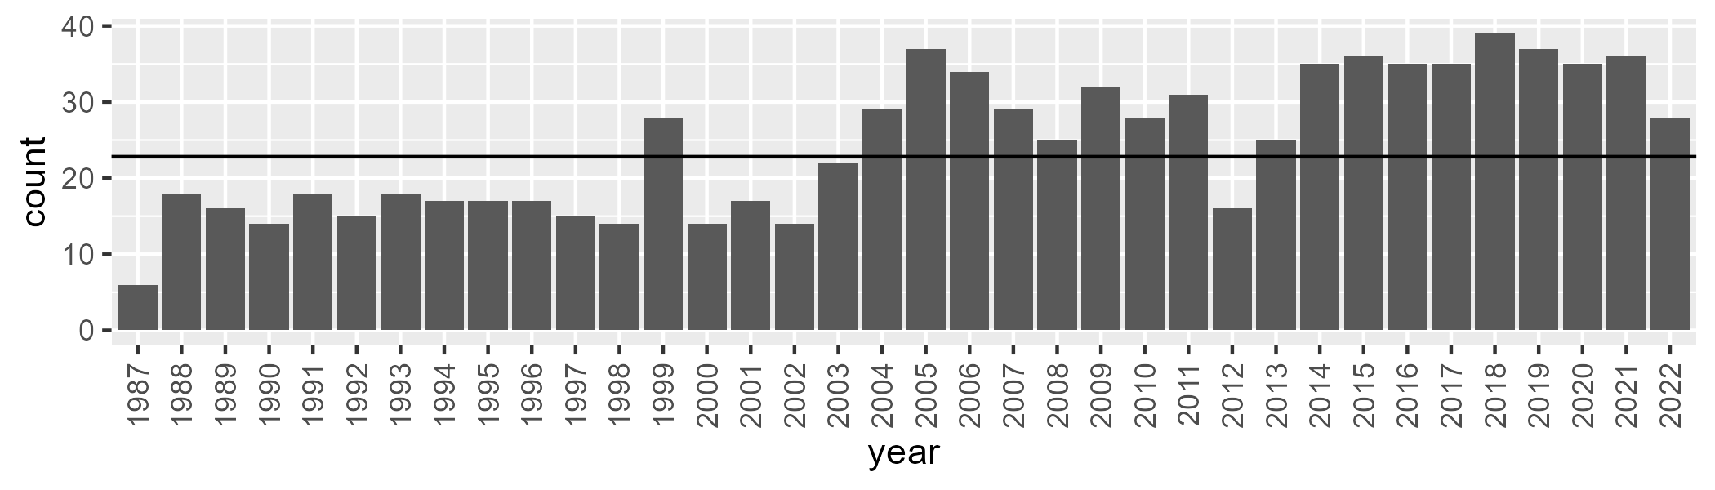

Number of samples: 882

# NSABHC0012

| Min. | 1st Qu. | Median | Mean | 3rd Qu. | Max. |
| --- | --- | --- | --- | --- | --- |
| 0 | 2.214939 | 5.816749 | 8.131977 | 11.48676 | 42.13949 |

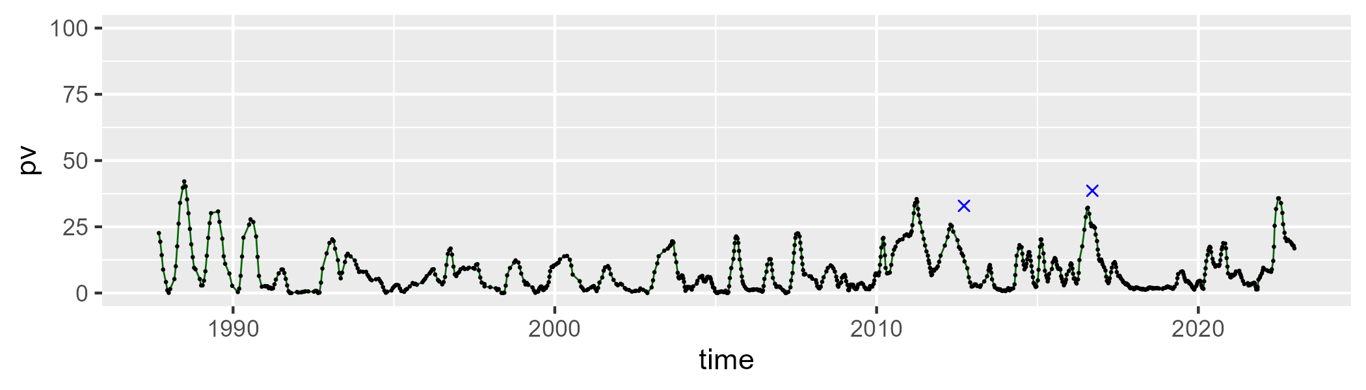

| Min. | 1st Qu. | Median | Mean | 3rd Qu. | Max. |
| --- | --- | --- | --- | --- | --- |
| 8.312862 | 28.10154 | 34.5414 | 34.55077 | 40.80786 | 58.80619 |

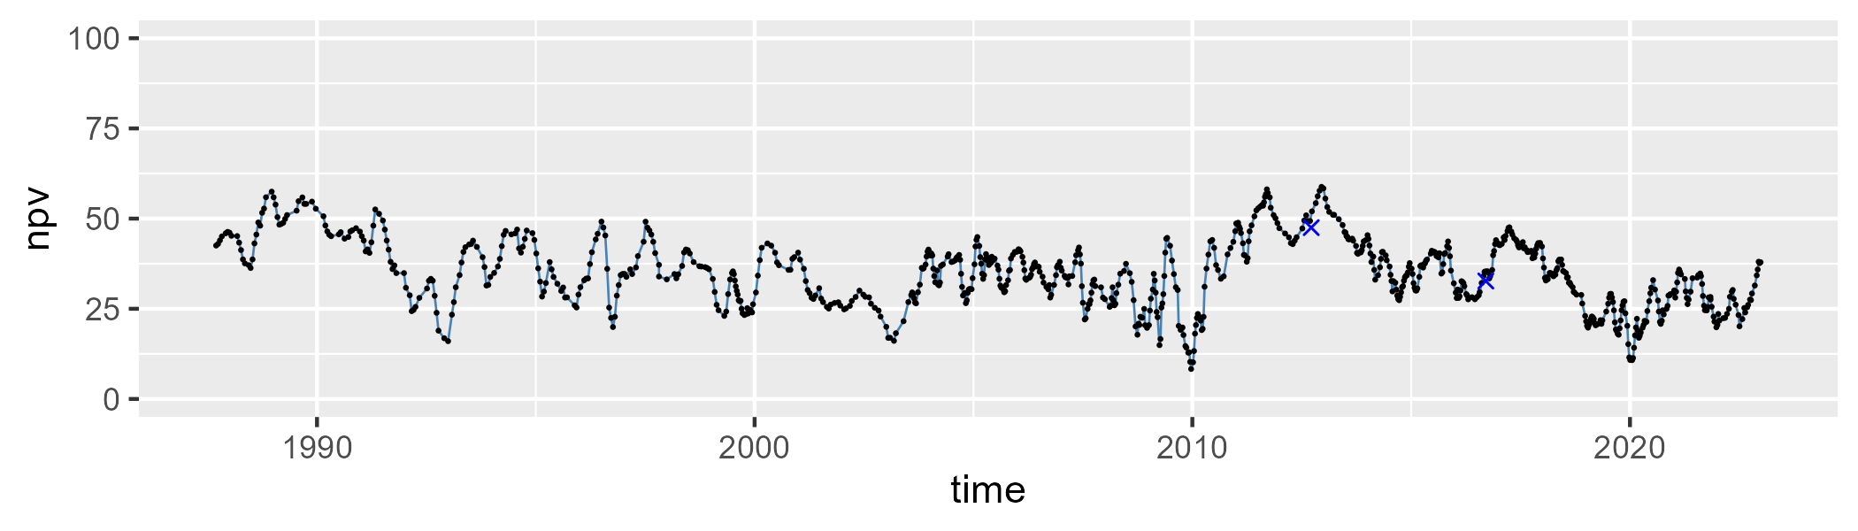

| Min. | 1st Qu. | Median | Mean | 3rd Qu. | Max. |
| --- | --- | --- | --- | --- | --- |
| 15.7674 | 48.69333 | 56.77645 | 55.82118 | 64.03437 | 83.06183 |

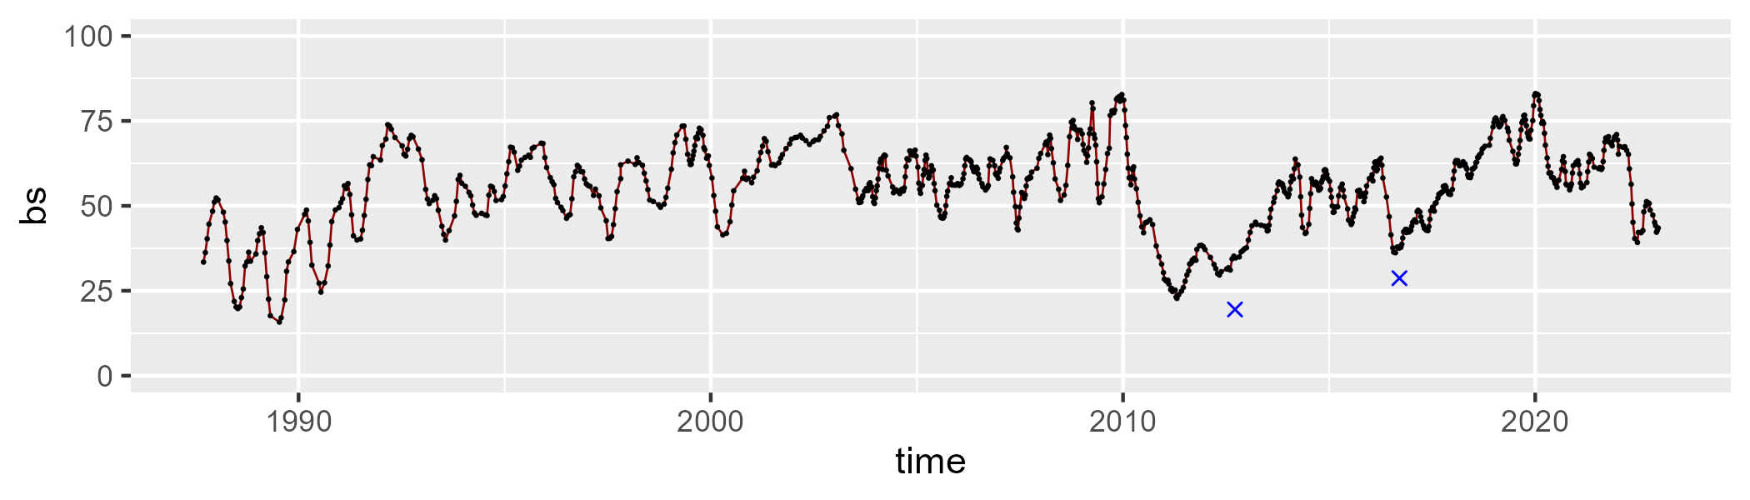

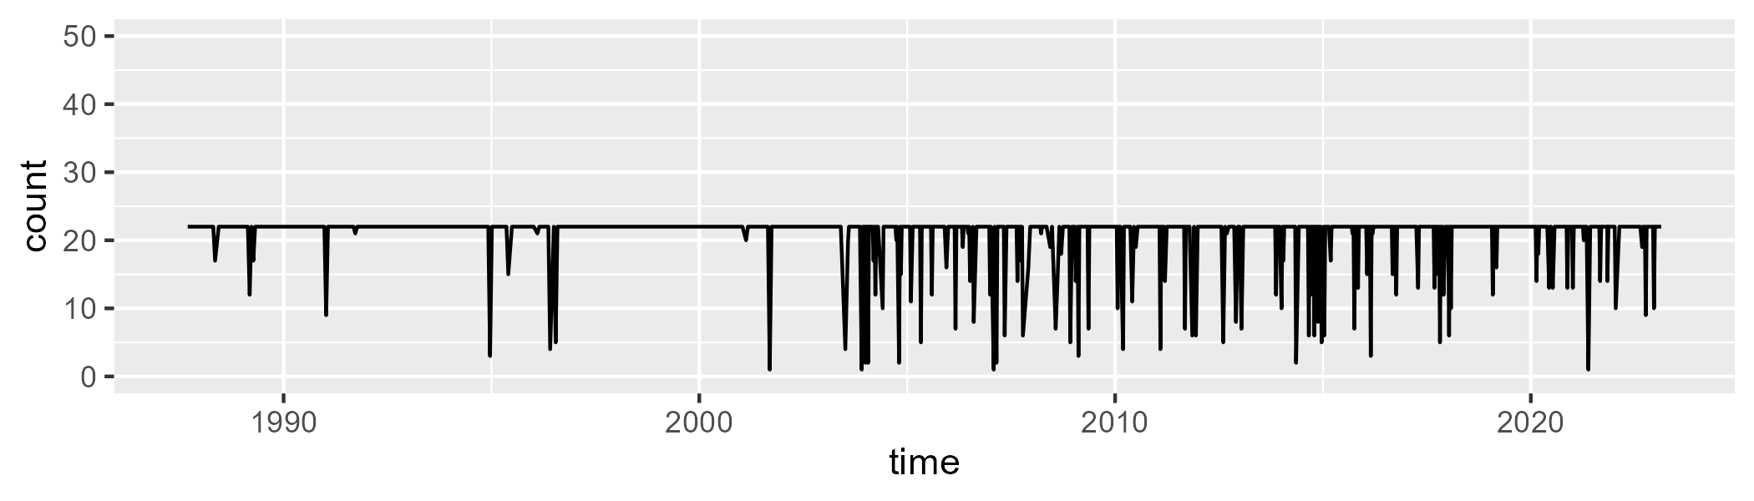

Min. : 1.0 1st Qu.:22.0 Median :22.0 Mean :20.7 3rd Qu.:22.0 Max. :22.0

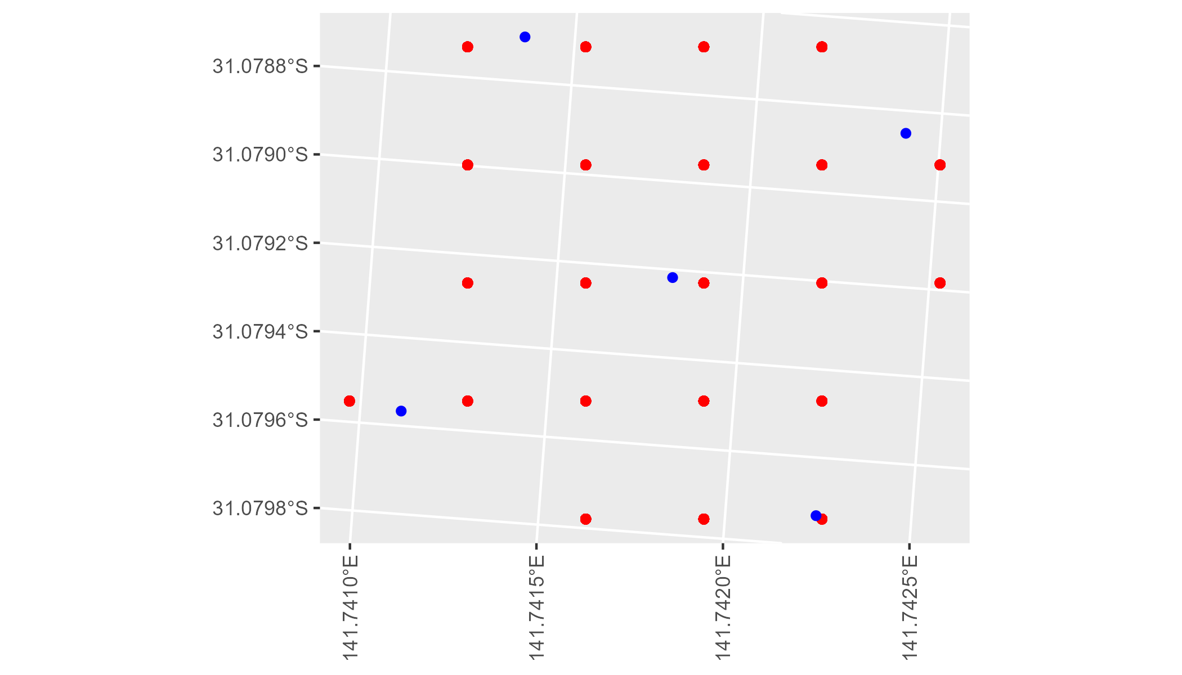

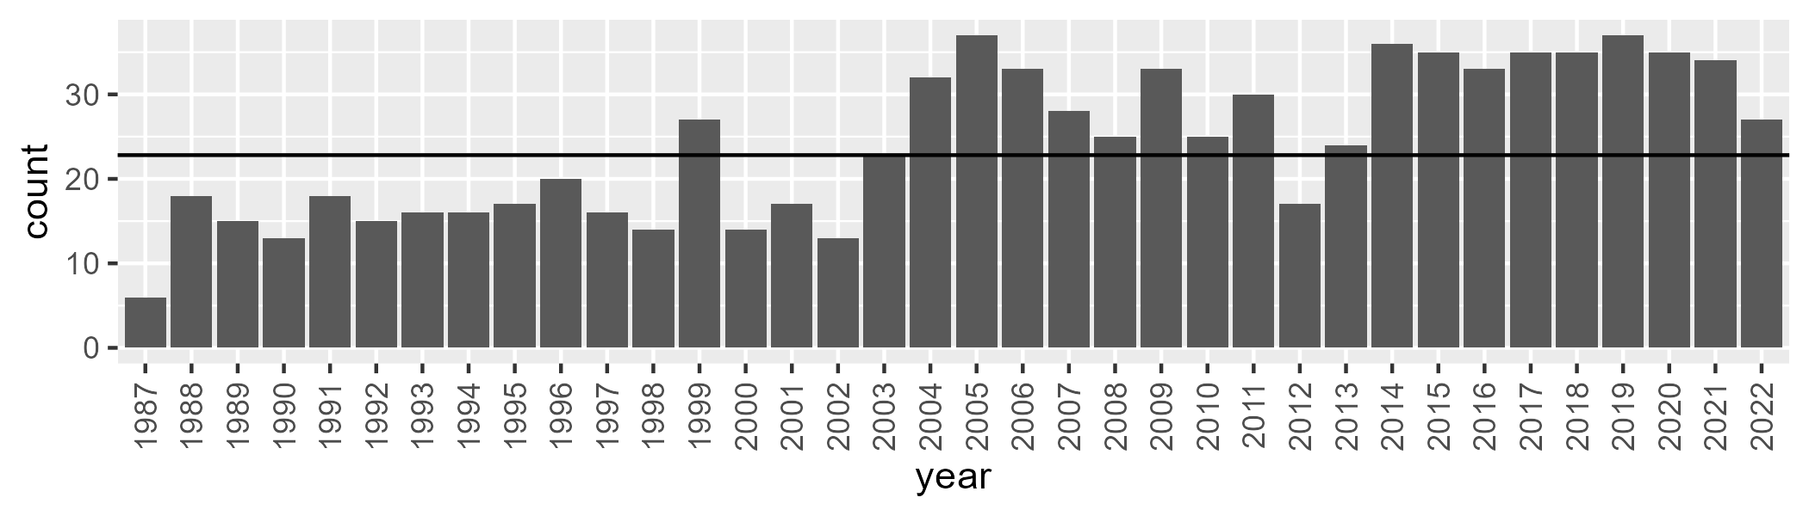

Number of samples: 869

# NSABHC0013

| Min. | 1st Qu. | Median | Mean | 3rd Qu. | Max. |
| --- | --- | --- | --- | --- | --- |
| 0 | 2.226181 | 3.880451 | 5.724014 | 8.169123 | 25.79827 |

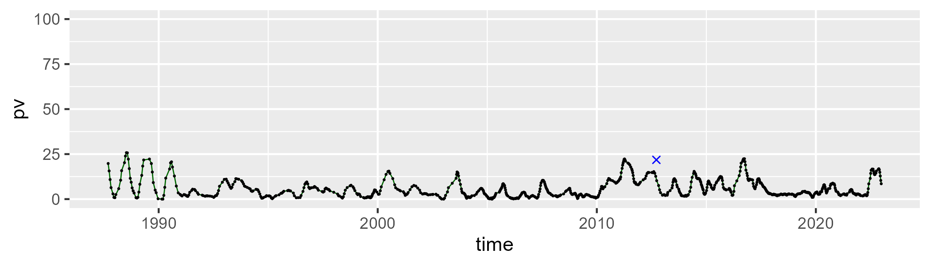

| Min. | 1st Qu. | Median | Mean | 3rd Qu. | Max. |
| --- | --- | --- | --- | --- | --- |
| 3.255395 | 19.11424 | 24.44897 | 25.4668 | 30.9147 | 47.94389 |

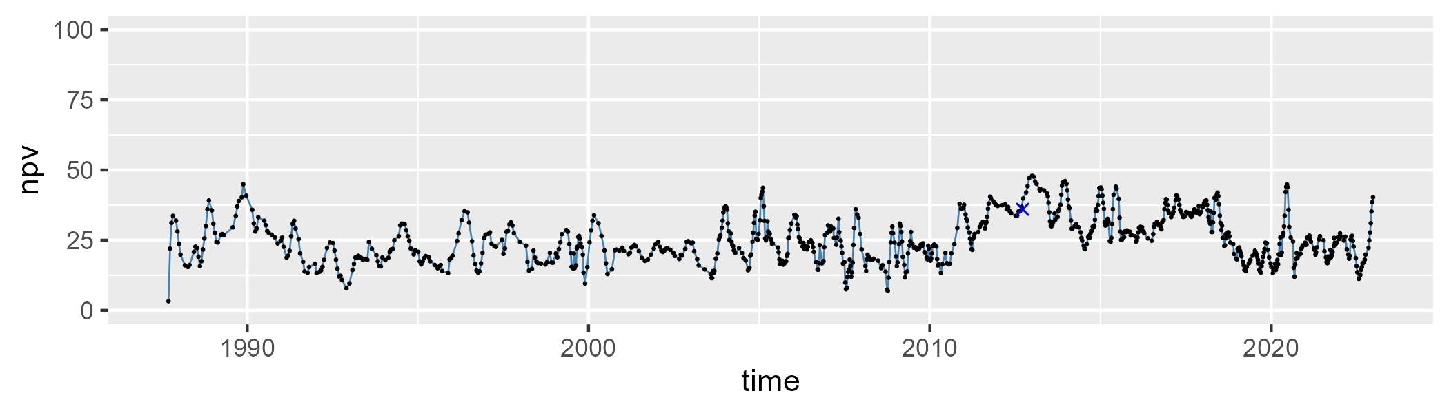

| Min. | 1st Qu. | Median | Mean | 3rd Qu. | Max. |
| --- | --- | --- | --- | --- | --- |
| 45.27127 | 59.87825 | 69.92559 | 67.37627 | 74.81448 | 85.62229 |

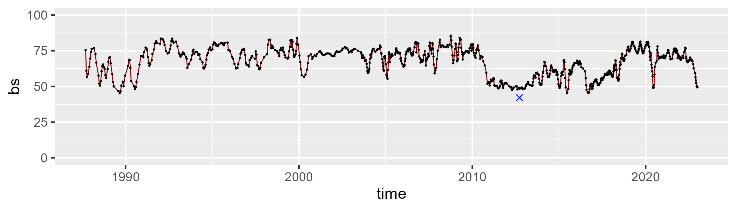

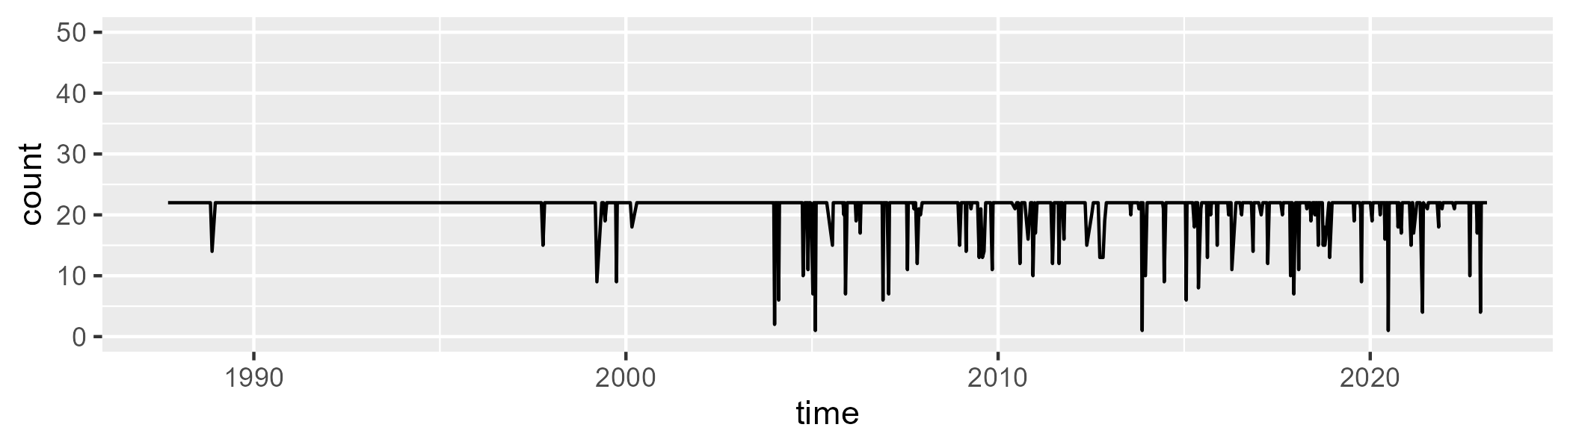

Min. : 1.00 1st Qu.:22.00 Median :22.00 Mean :21.15 3rd Qu.:22.00 Max. :22.00

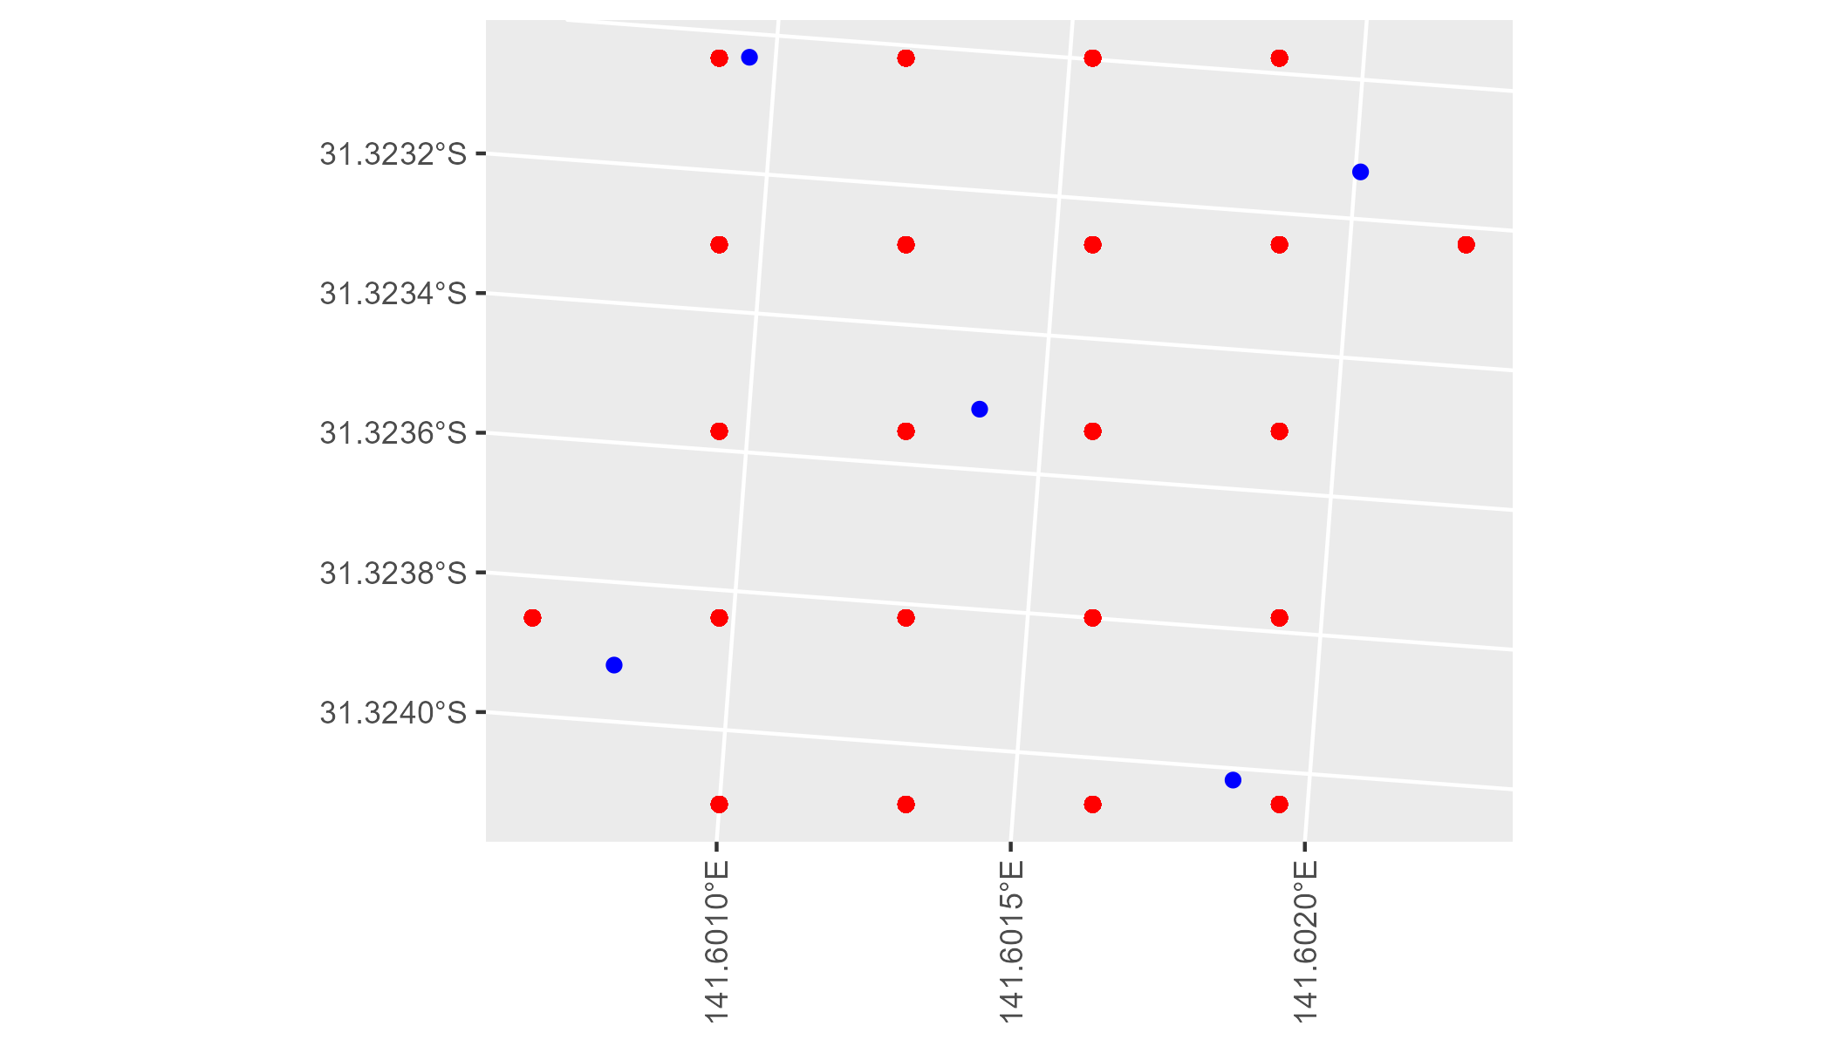

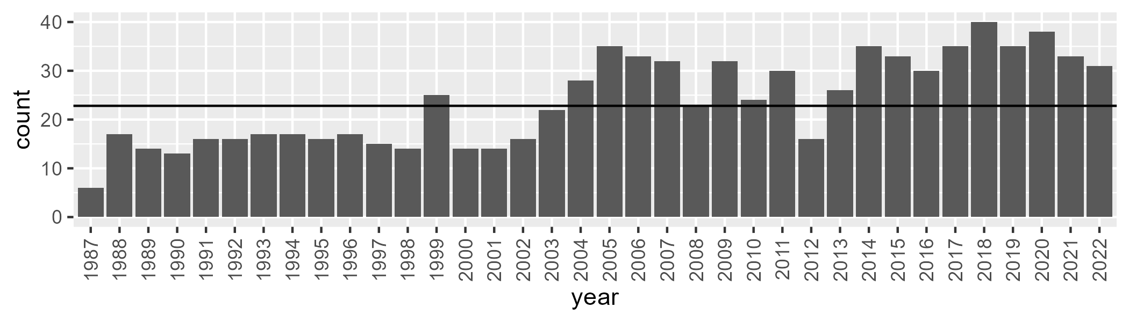

Number of samples: 858

# NSABHC0014

| Min. | 1st Qu. | Median | Mean | 3rd Qu. | Max. |
| --- | --- | --- | --- | --- | --- |
| 0 | 1.65039 | 3.011199 | 4.510188 | 6.598996 | 18.65043 |

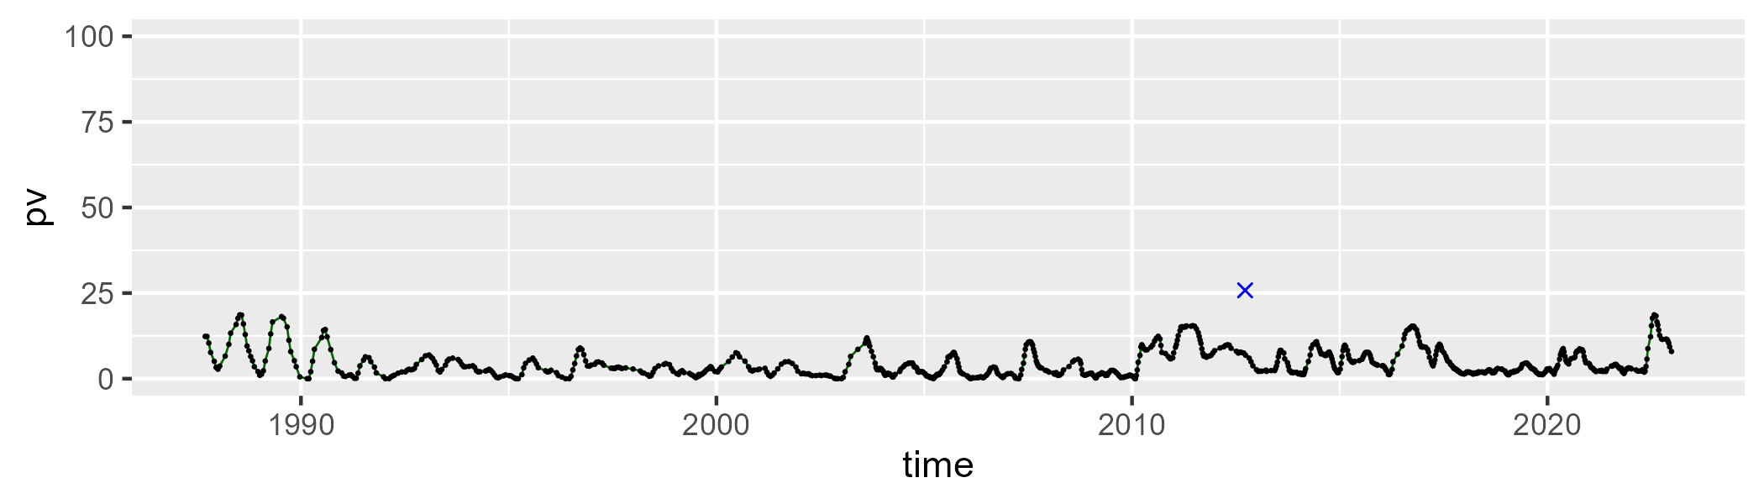

| Min. | 1st Qu. | Median | Mean | 3rd Qu. | Max. |
| --- | --- | --- | --- | --- | --- |
| 24.56388 | 31.6923 | 34.70225 | 35.03663 | 38.10073 | 49.30802 |

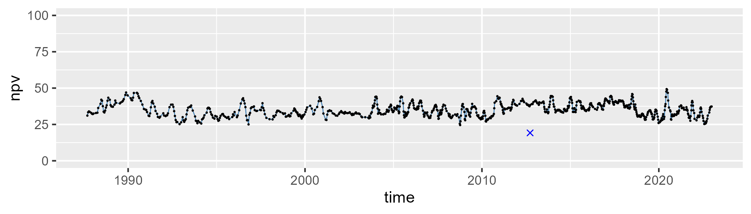

| Min. | 1st Qu. | Median | Mean | 3rd Qu. | Max. |
| --- | --- | --- | --- | --- | --- |
| 38.30695 | 55.03174 | 59.55078 | 58.98939 | 63.90186 | 70.79159 |

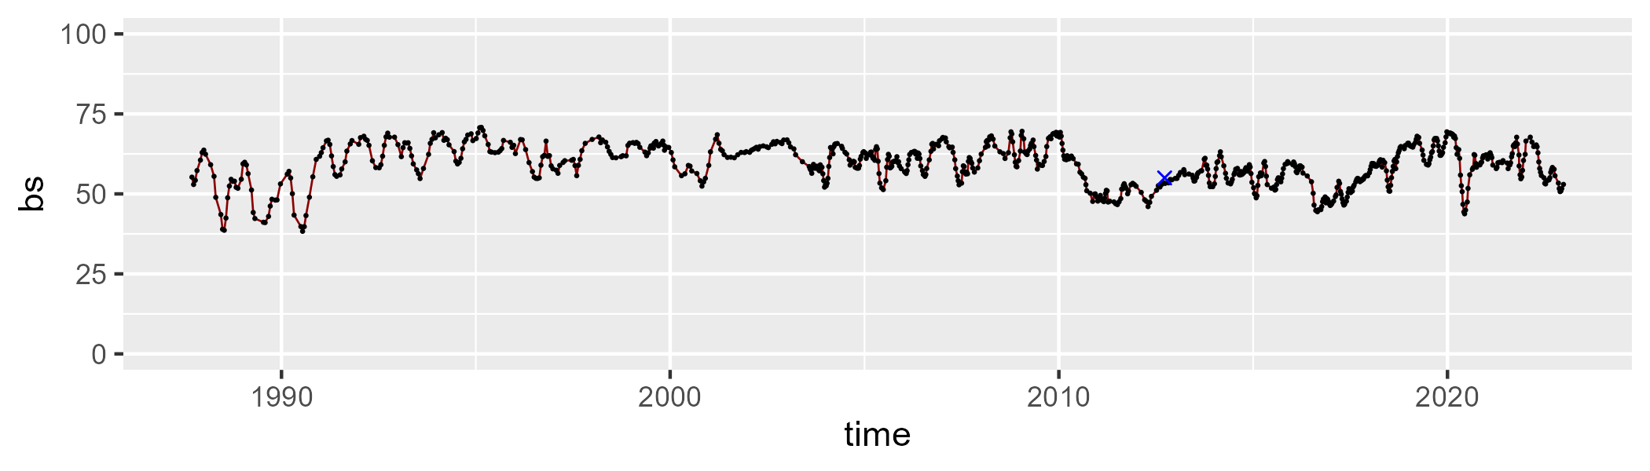

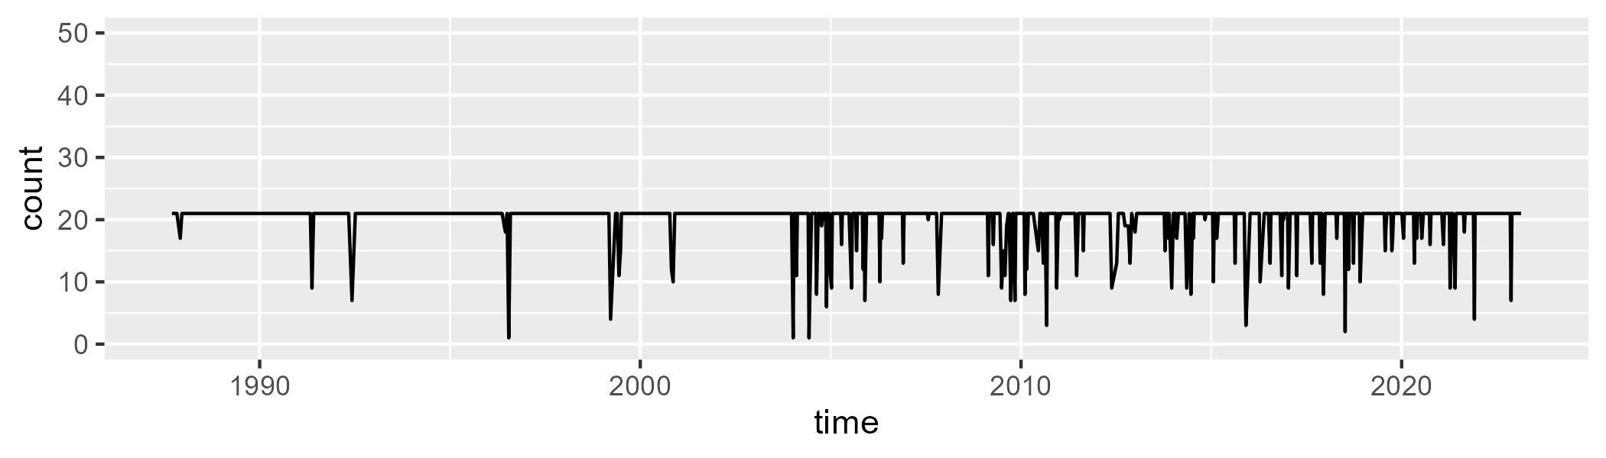

Min. : 1.00 1st Qu.:21.00 Median :21.00 Mean :20.02 3rd Qu.:21.00 Max. :21.00

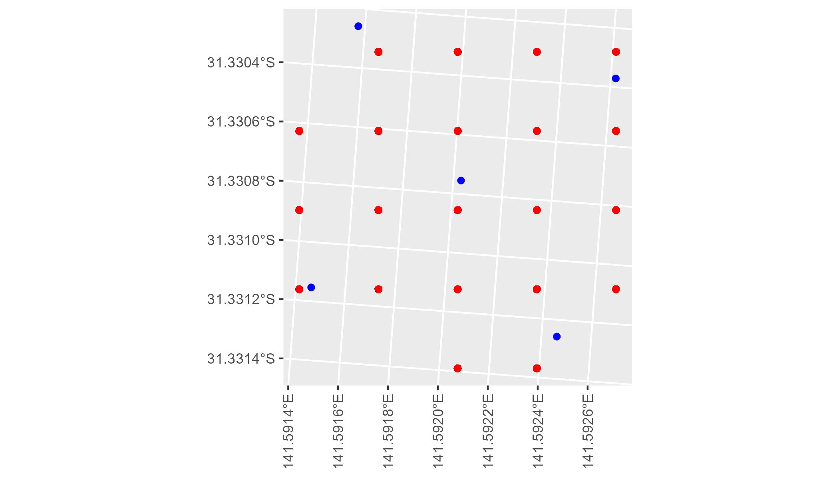

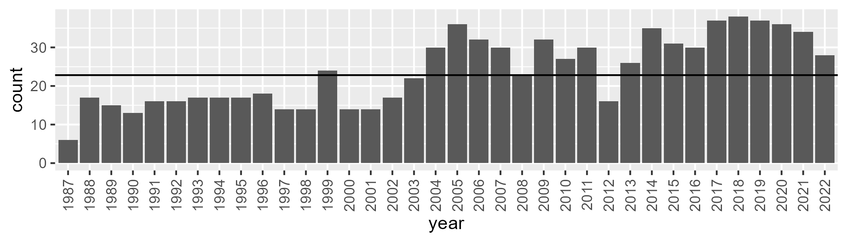

Number of samples: 859

# NSABHC0015

| Min. | 1st Qu. | Median | Mean | 3rd Qu. | Max. |
| --- | --- | --- | --- | --- | --- |
| 0 | 4.704679 | 7.680264 | 10.46663 | 13.65881 | 45.81449 |

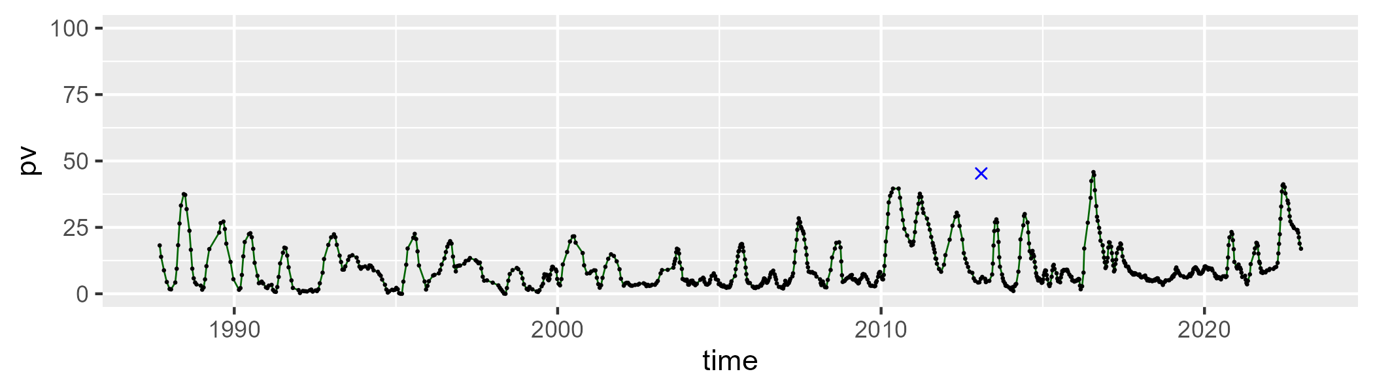

| Min. | 1st Qu. | Median | Mean | 3rd Qu. | Max. |
| --- | --- | --- | --- | --- | --- |
| 5.159279 | 27.33891 | 33.47382 | 34.14826 | 42.13283 | 58.5673 |

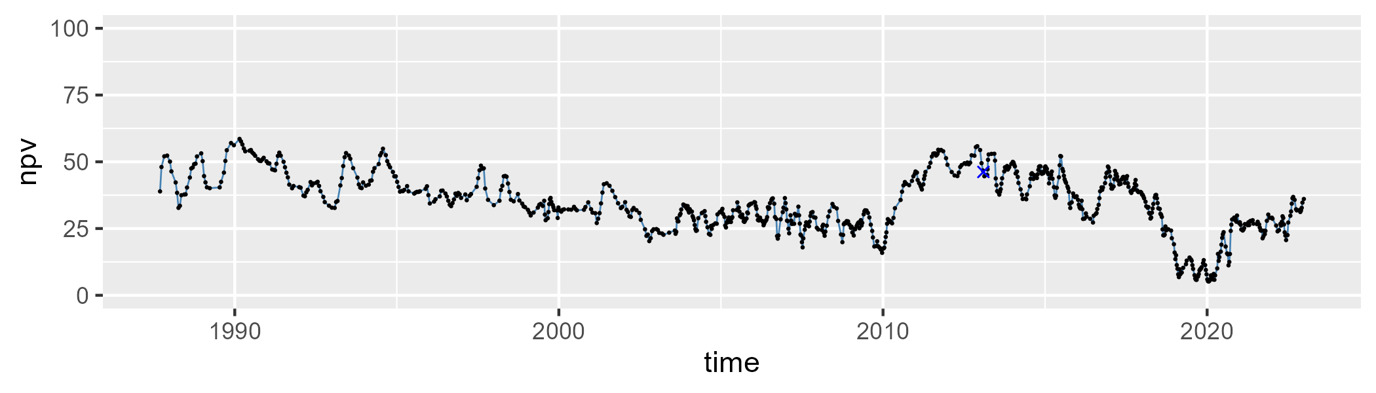

| Min. | 1st Qu. | Median | Mean | 3rd Qu. | Max. |
| --- | --- | --- | --- | --- | --- |
| 20.64013 | 43.77019 | 54.62233 | 53.87571 | 64.37938 | 83.88176 |

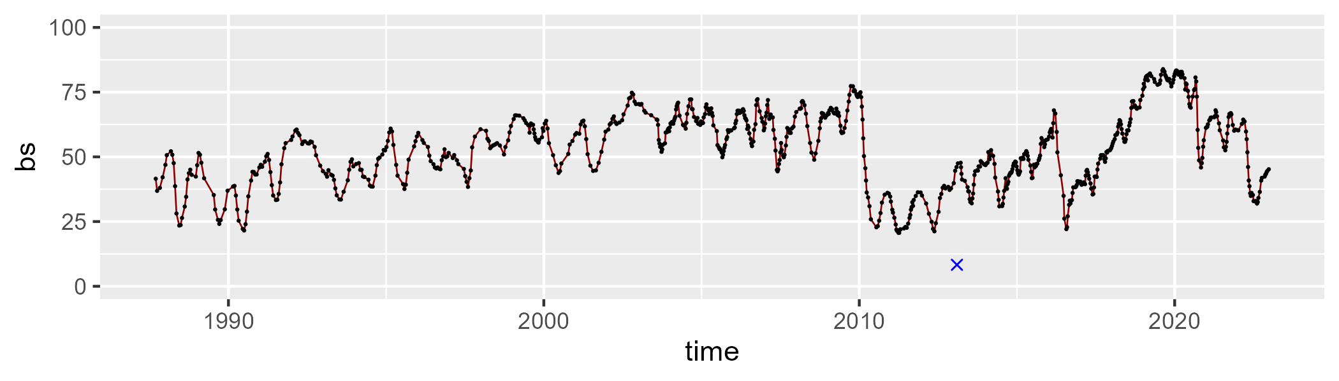

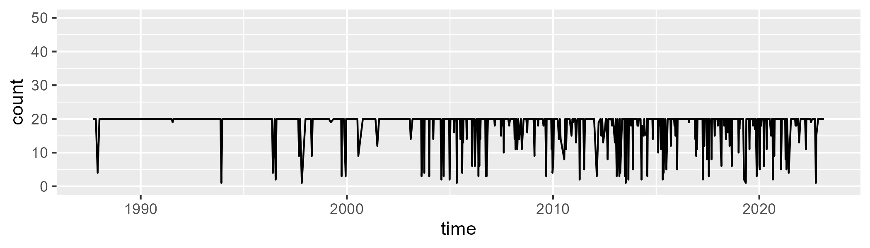

Min. : 1.00 1st Qu.:20.00 Median :20.00 Mean :18.29 3rd Qu.:20.00 Max. :20.00

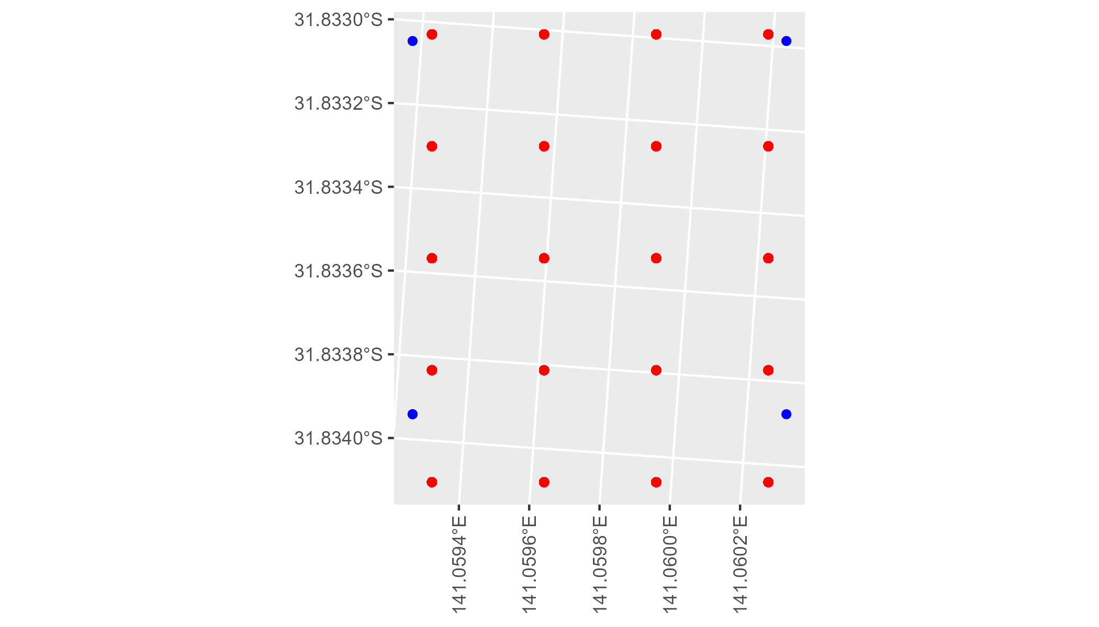

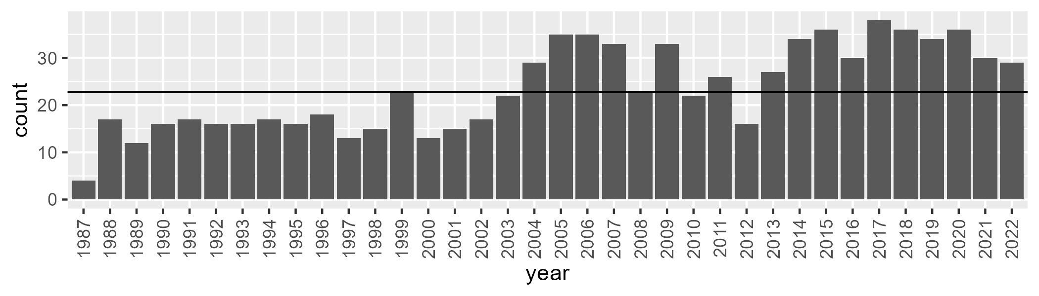

Number of samples: 849

# NSABHC0016

| Min. | 1st Qu. | Median | Mean | 3rd Qu. | Max. |
| --- | --- | --- | --- | --- | --- |
| 0.00769406 | 5.275218 | 7.69835 | 10.24196 | 13.26778 | 42.12035 |

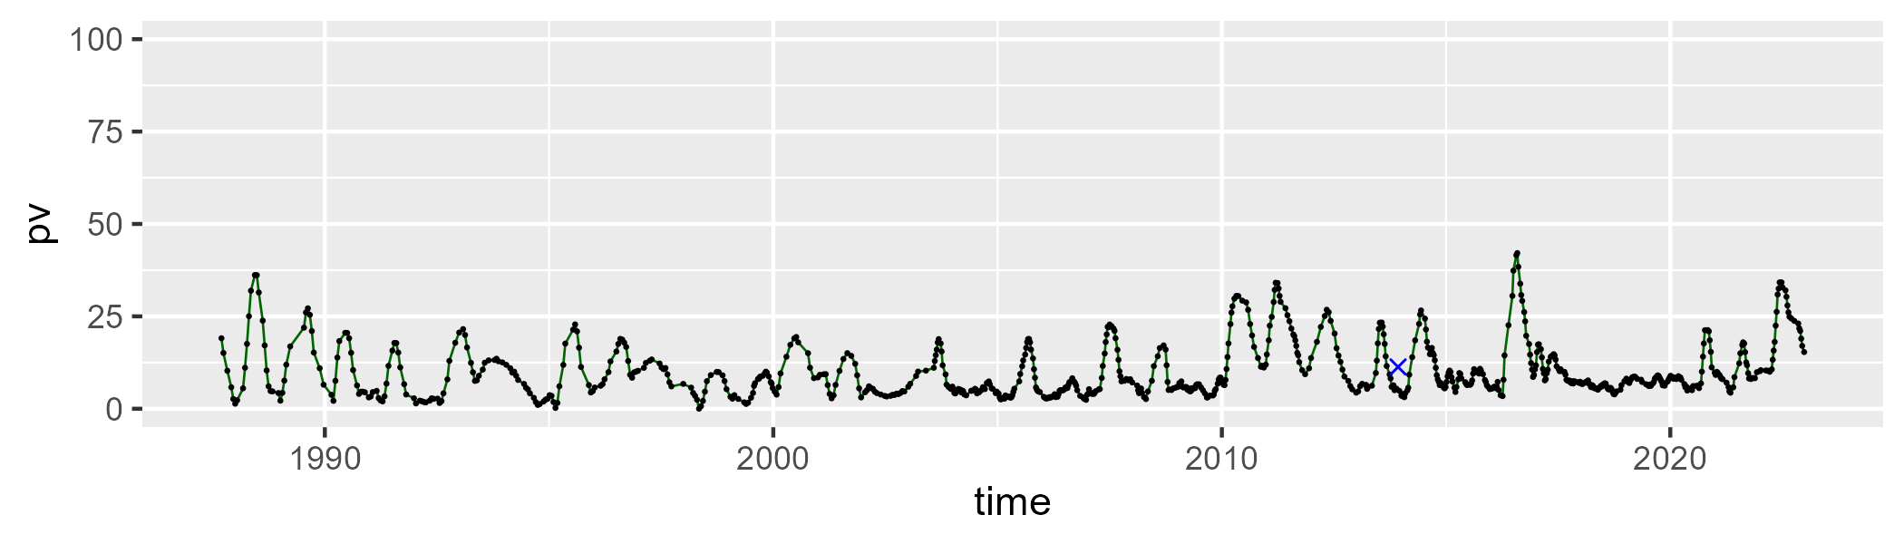

| Min. | 1st Qu. | Median | Mean | 3rd Qu. | Max. |
| --- | --- | --- | --- | --- | --- |
| 7.082645 | 24.79645 | 30.51001 | 31.22217 | 38.52947 | 57.59401 |

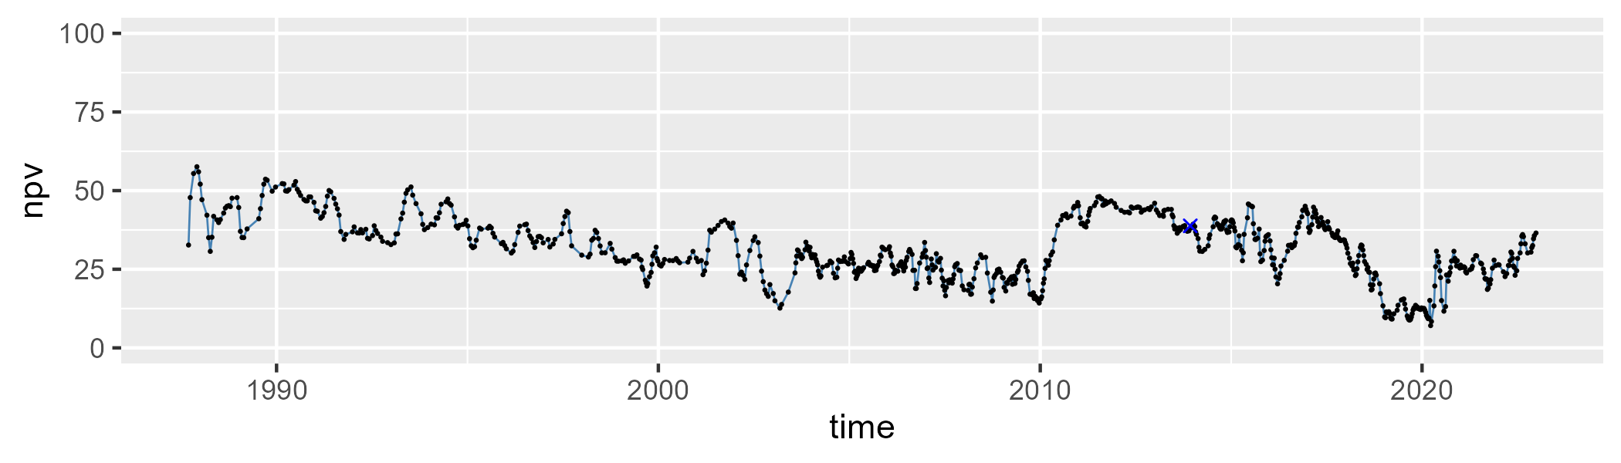

| Min. | 1st Qu. | Median | Mean | 3rd Qu. | Max. |
| --- | --- | --- | --- | --- | --- |
| 21.36917 | 47.07607 | 58.71108 | 56.99808 | 67.32697 | 82.76087 |

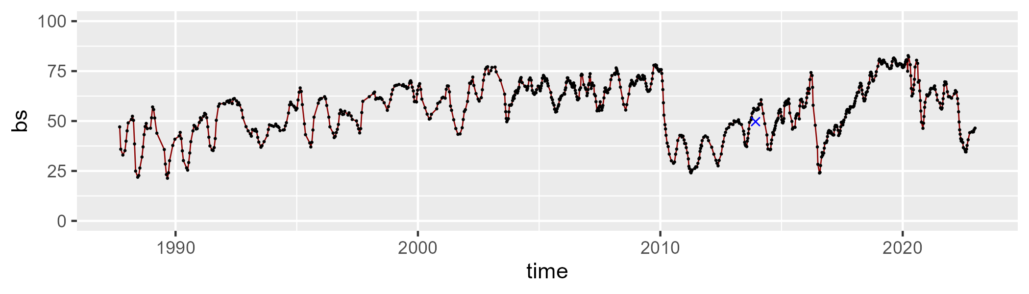

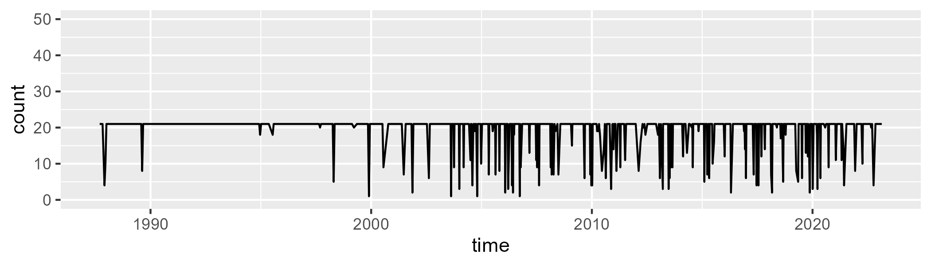

Min. : 1.00 1st Qu.:21.00 Median :21.00 Mean :19.43 3rd Qu.:21.00 Max. :21.00

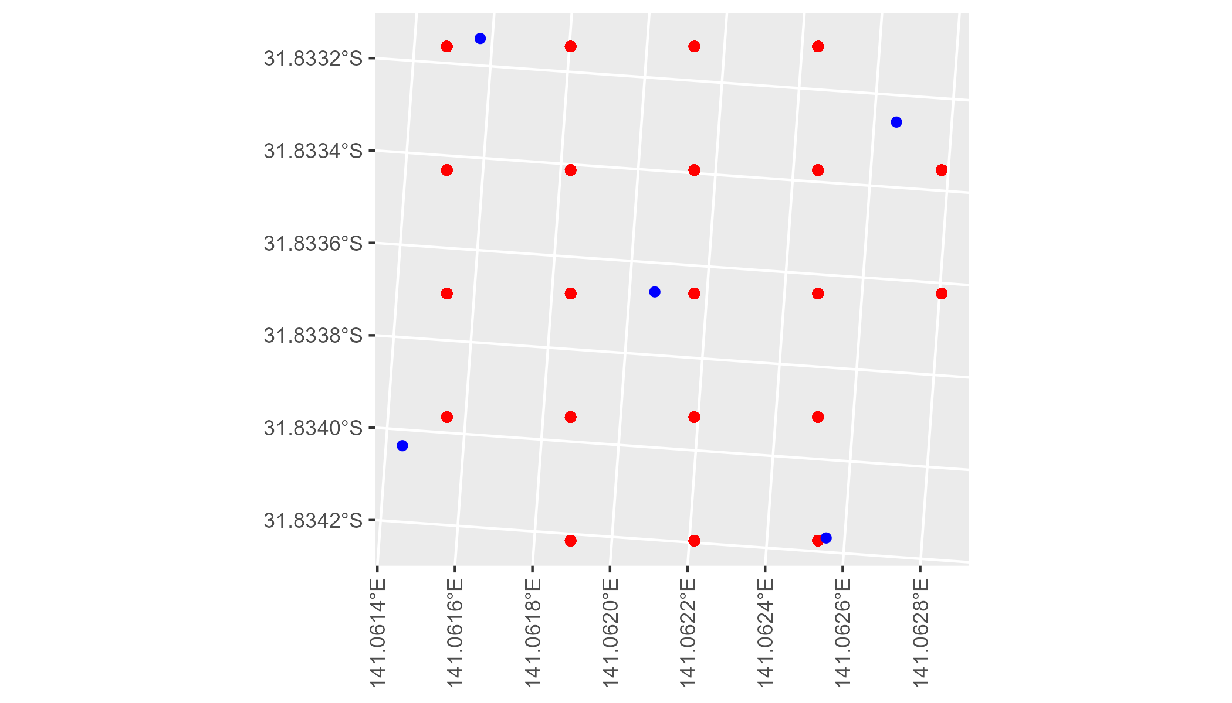

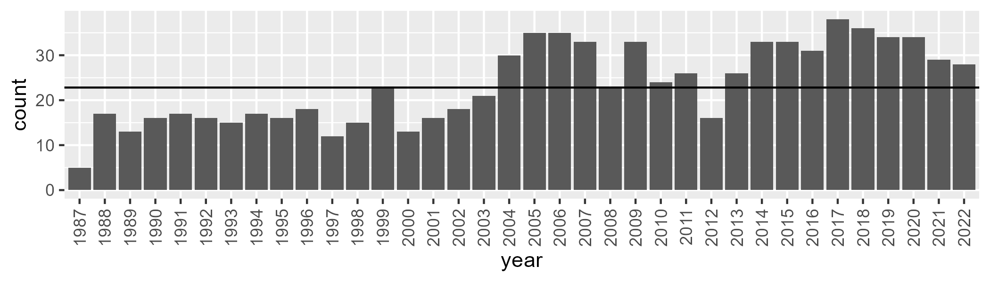

Number of samples: 845

# NSABHC0017

| Min. | 1st Qu. | Median | Mean | 3rd Qu. | Max. |
| --- | --- | --- | --- | --- | --- |
| 0 | 1.346135 | 3.235445 | 5.871414 | 9.003161 | 34.25264 |

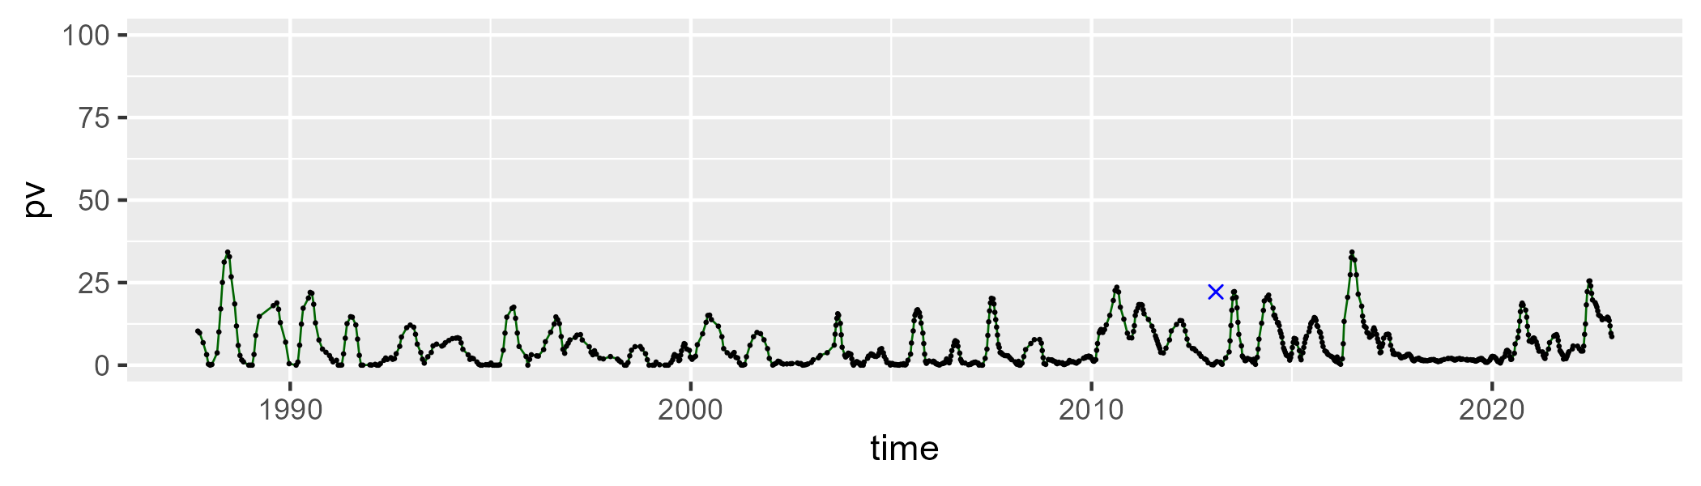

| Min. | 1st Qu. | Median | Mean | 3rd Qu. | Max. |
| --- | --- | --- | --- | --- | --- |
| 17.79188 | 36.23891 | 40.73272 | 40.57519 | 46.84675 | 65.45156 |

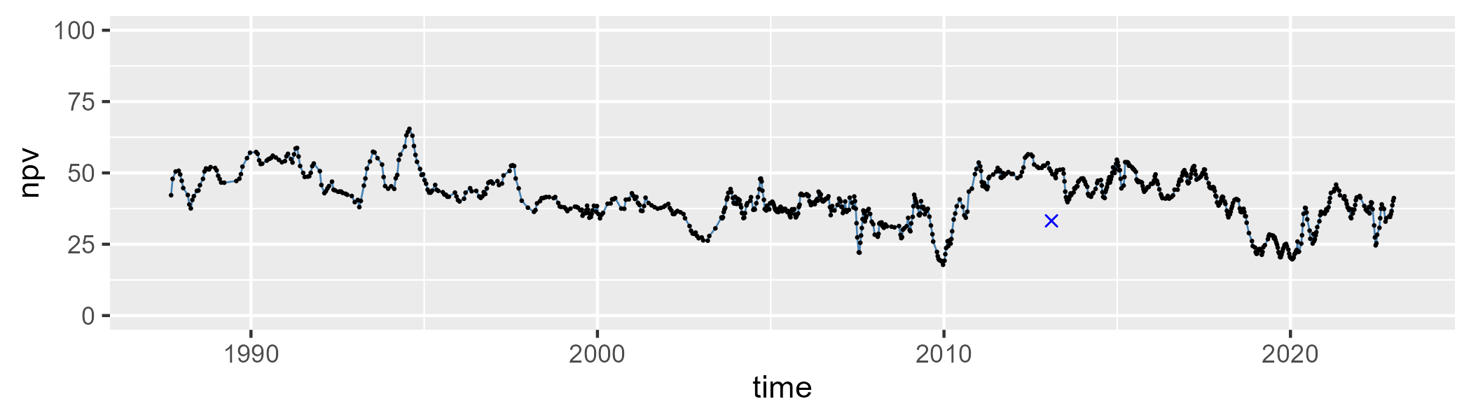

| Min. | 1st Qu. | Median | Mean | 3rd Qu. | Max. |
| --- | --- | --- | --- | --- | --- |
| 20.7759 | 43.66006 | 52.04695 | 52.16782 | 59.90885 | 78.14462 |

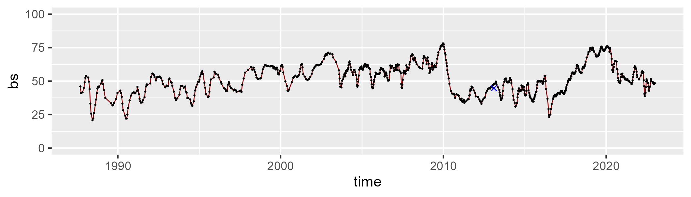

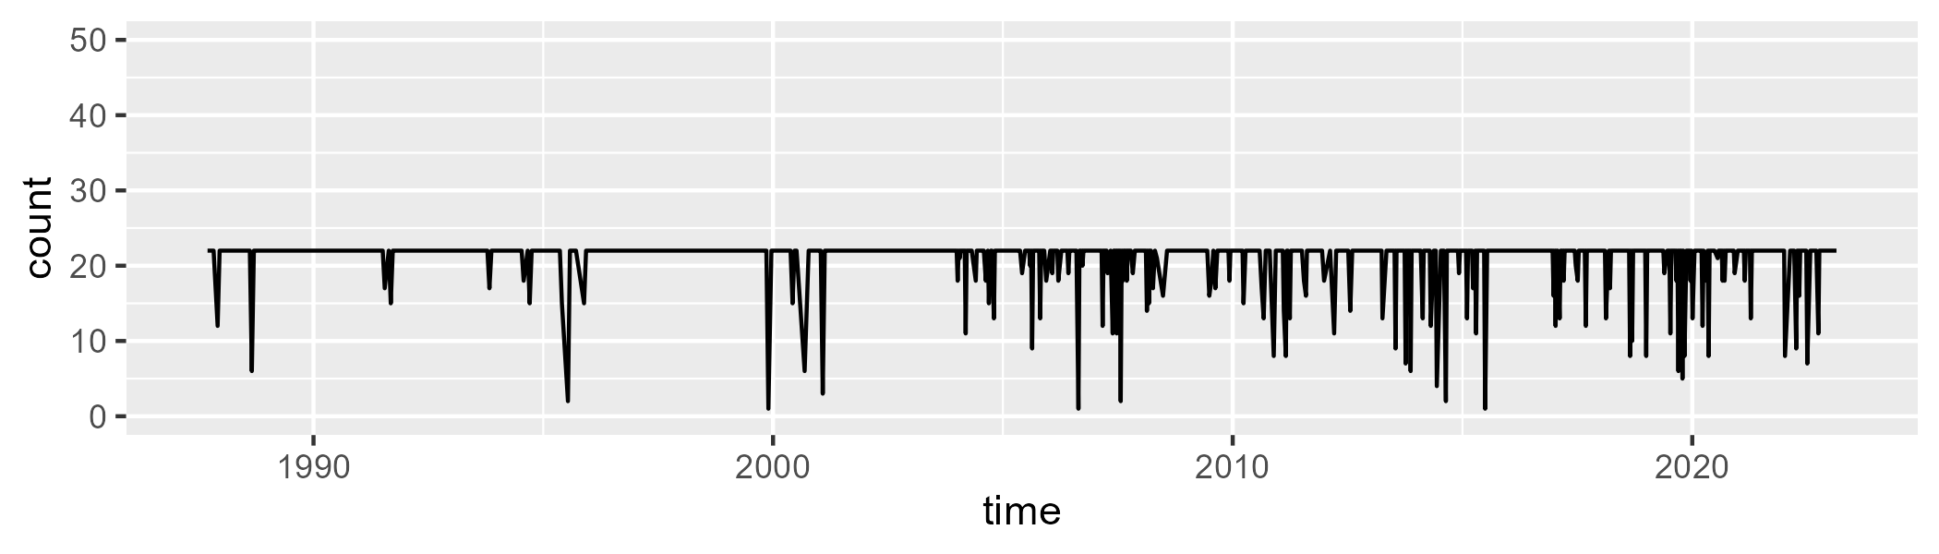

Min. : 1.00 1st Qu.:22.00 Median :22.00 Mean :20.91 3rd Qu.:22.00 Max. :22.00

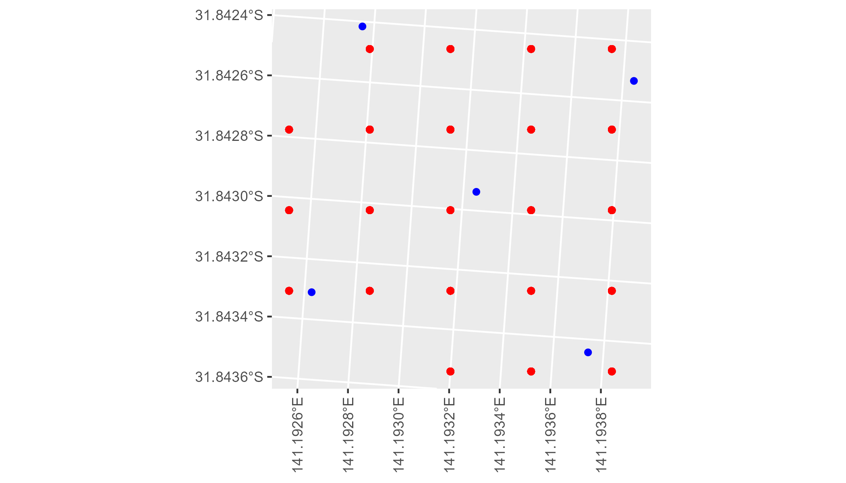

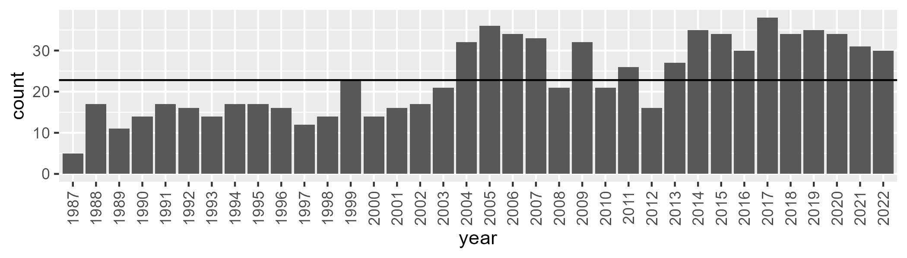

Number of samples: 840

# NSABHC0018

| Min. | 1st Qu. | Median | Mean | 3rd Qu. | Max. |
| --- | --- | --- | --- | --- | --- |
| 0 | 4.572312 | 7.049352 | 10.46657 | 13.36887 | 50.70243 |

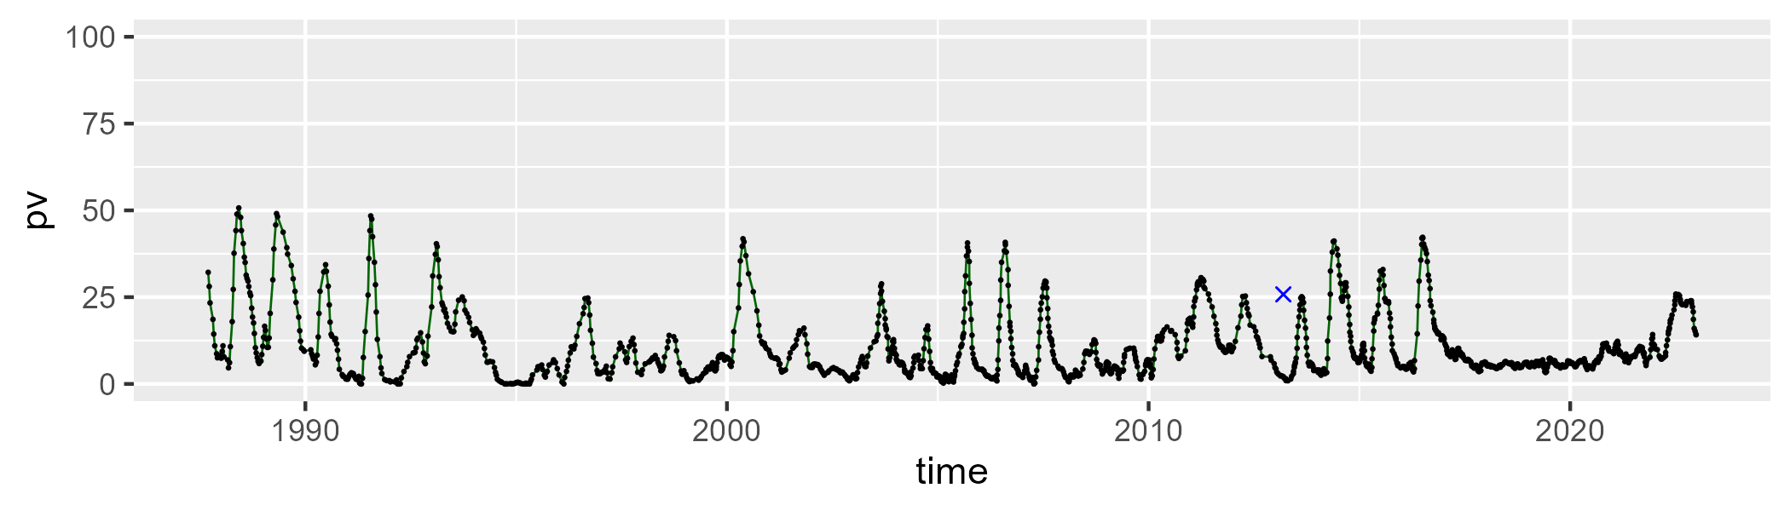

| Min. | 1st Qu. | Median | Mean | 3rd Qu. | Max. |
| --- | --- | --- | --- | --- | --- |
| 12.5323 | 36.26041 | 44.14364 | 43.47458 | 51.84092 | 76.90956 |

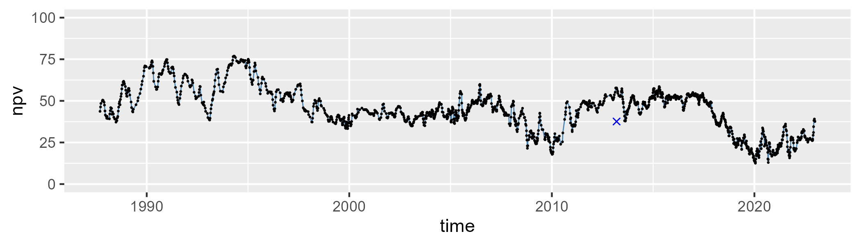

| Min. | 1st Qu. | Median | Mean | 3rd Qu. | Max. |
| --- | --- | --- | --- | --- | --- |
| 1.70219 | 33.92909 | 44.63756 | 44.66042 | 56.17838 | 79.65668 |

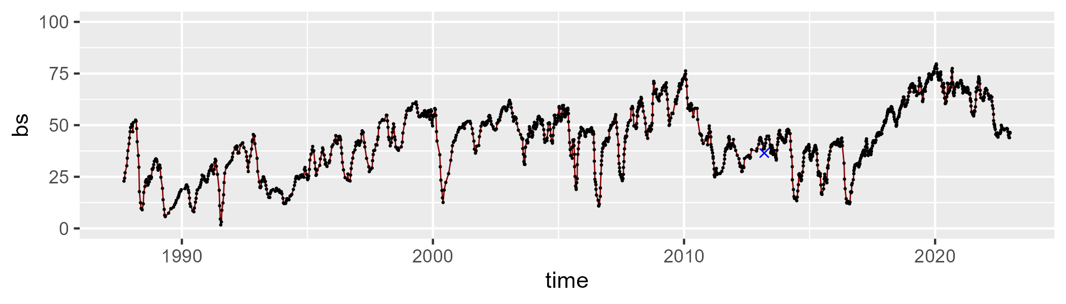

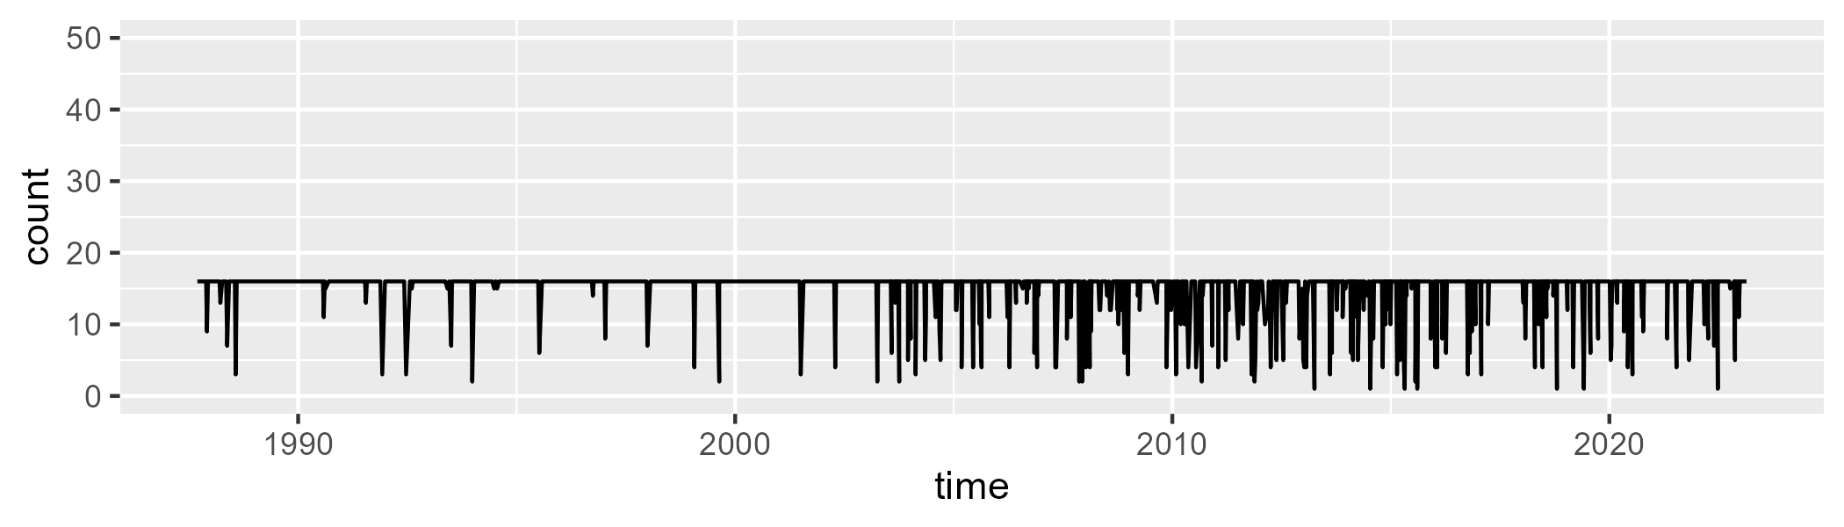

Min. : 1.00 1st Qu.:16.00 Median :16.00 Mean :15.04 3rd Qu.:16.00 Max. :16.00

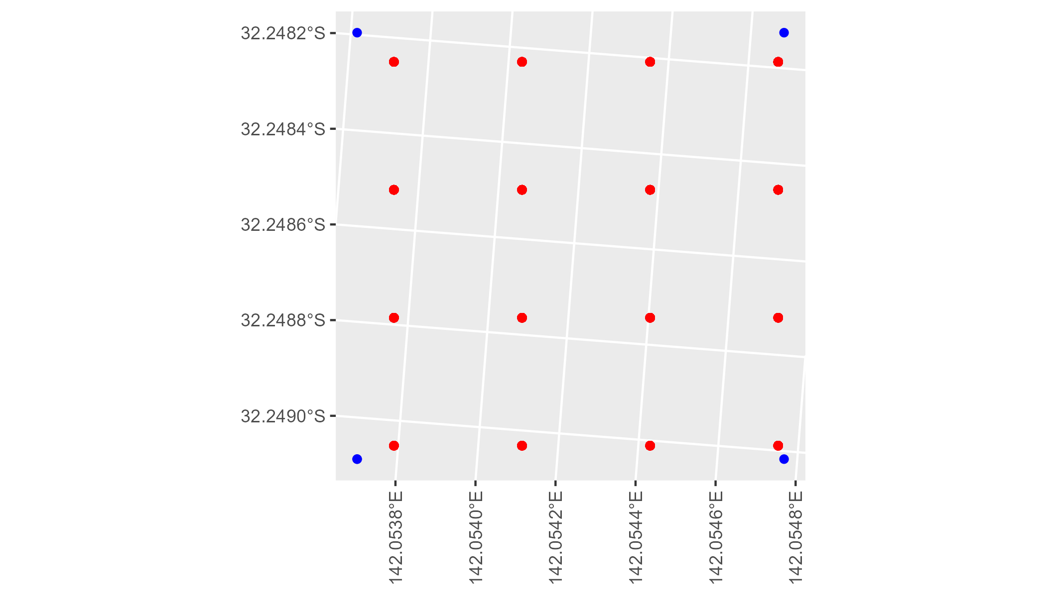

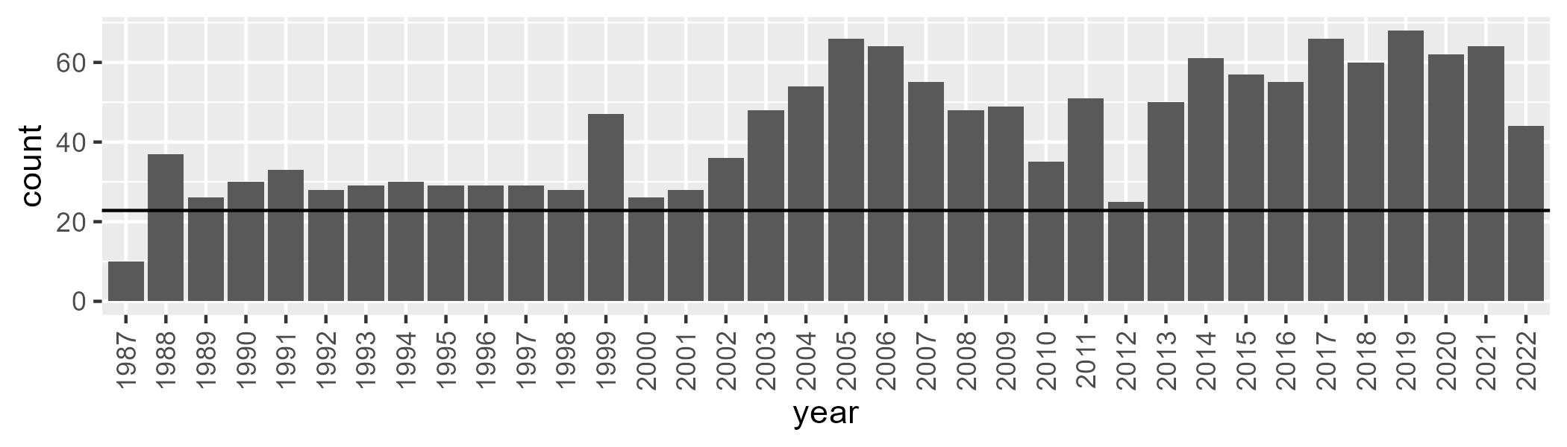

Number of samples: 1557

# NSABHC0019

| Min. | 1st Qu. | Median | Mean | 3rd Qu. | Max. |
| --- | --- | --- | --- | --- | --- |
| 0.09450706 | 5.086619 | 6.994209 | 10.20748 | 13.42381 | 40.79928 |

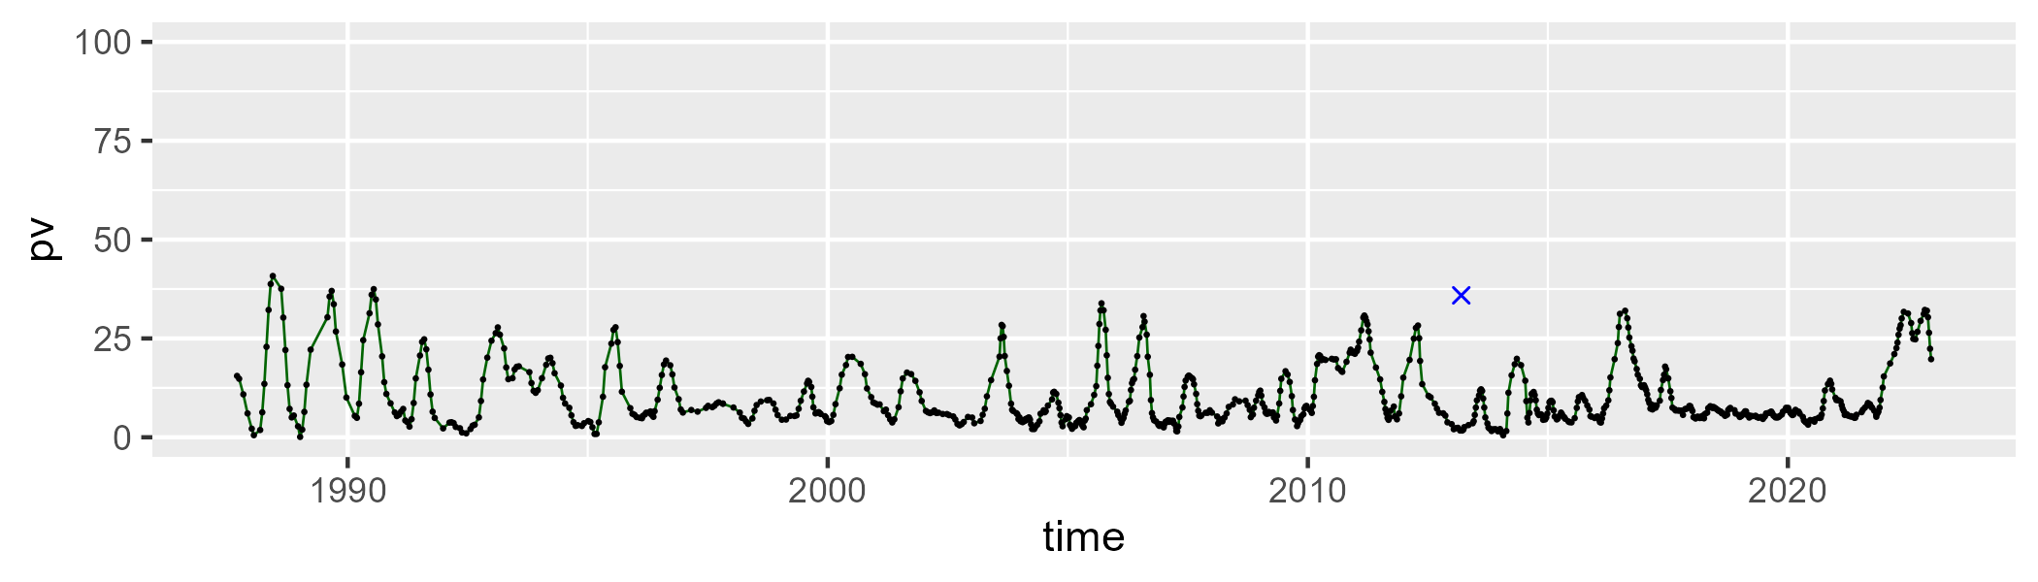

| Min. | 1st Qu. | Median | Mean | 3rd Qu. | Max. |
| --- | --- | --- | --- | --- | --- |
| 20.07543 | 36.94132 | 43.22489 | 42.46918 | 49.14942 | 63.23193 |

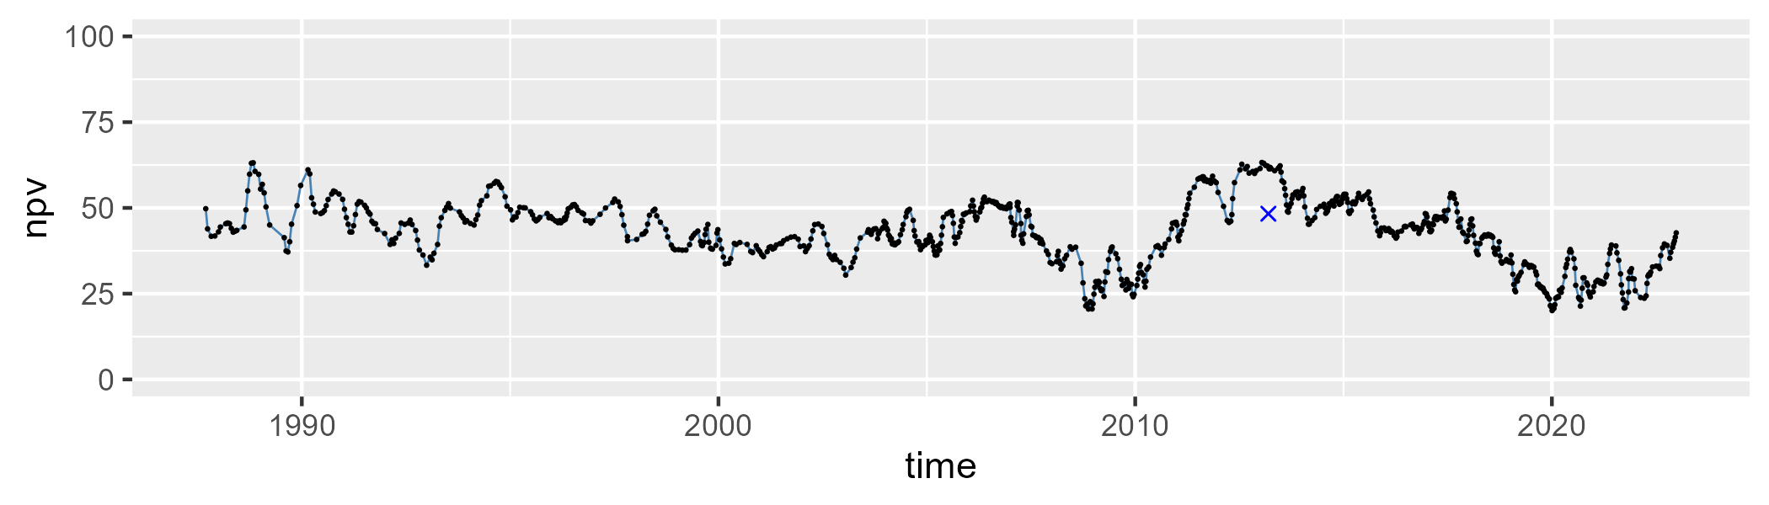

| Min. | 1st Qu. | Median | Mean | 3rd Qu. | Max. |
| --- | --- | --- | --- | --- | --- |
| 12.14747 | 36.81977 | 45.91344 | 45.90366 | 54.90634 | 71.98069 |

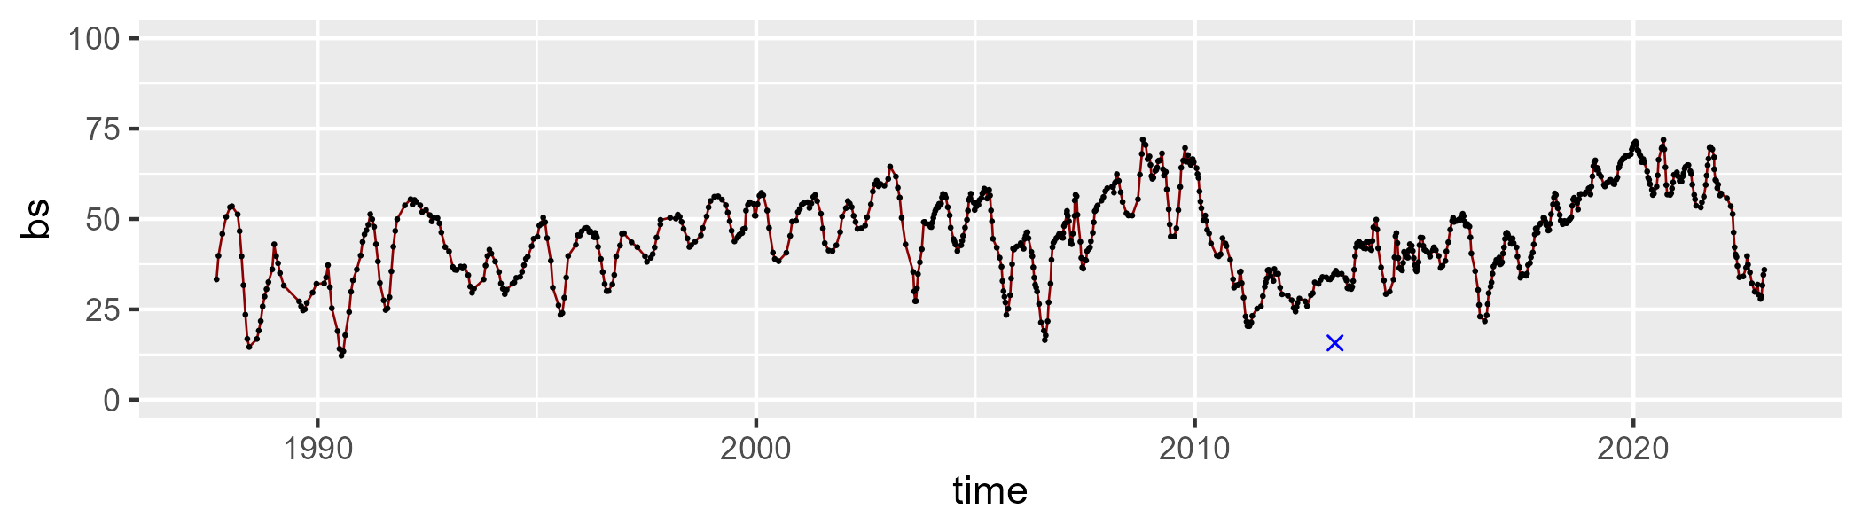

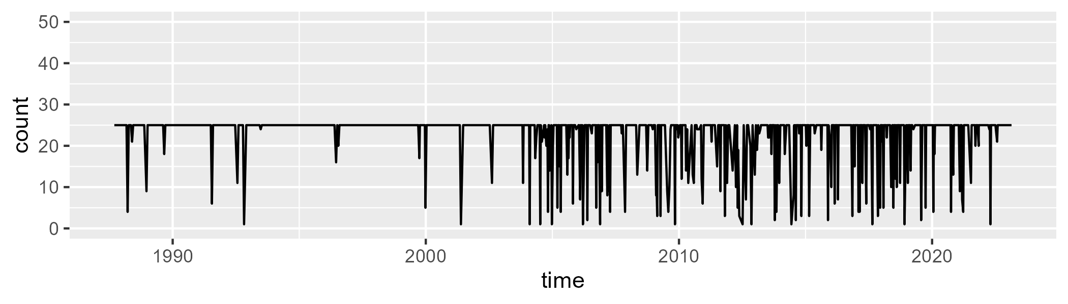

Min. : 1.00 1st Qu.:25.00 Median :25.00 Mean :22.67 3rd Qu.:25.00 Max. :25.00

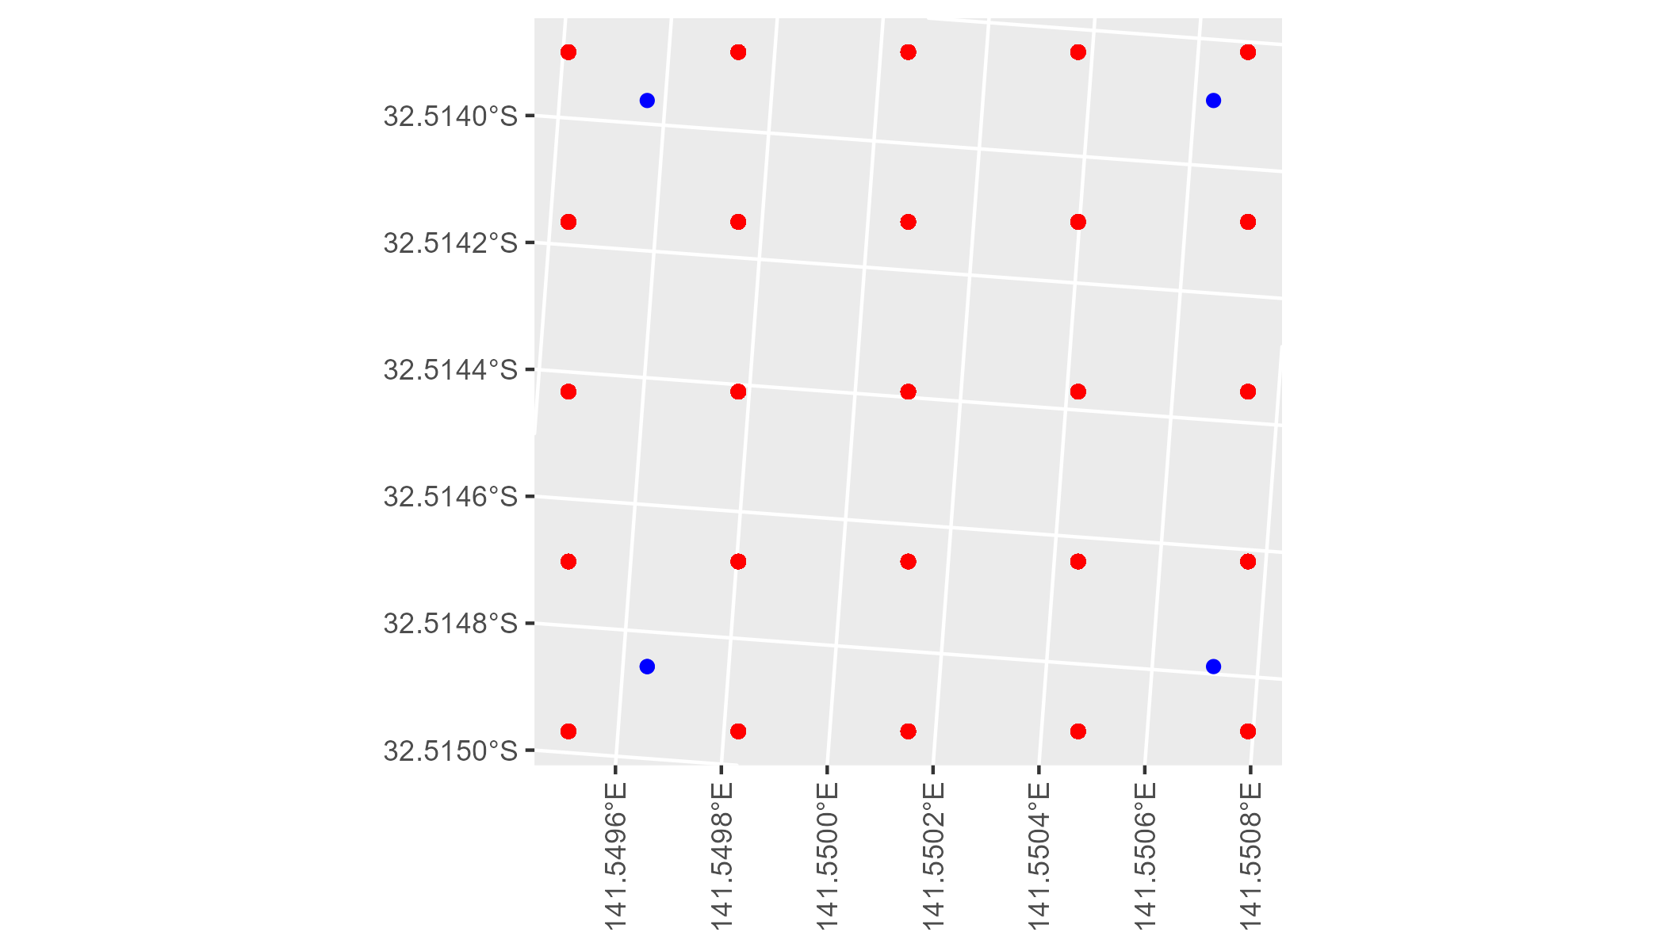

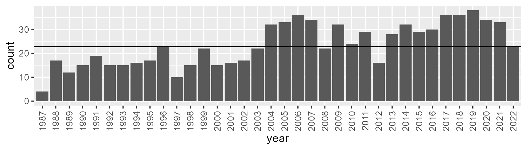

Number of samples: 847

# NSABHC0020

| Min. | 1st Qu. | Median | Mean | 3rd Qu. | Max. |
| --- | --- | --- | --- | --- | --- |
| 0 | 6.315526 | 8.943473 | 11.25709 | 14.13309 | 34.44898 |

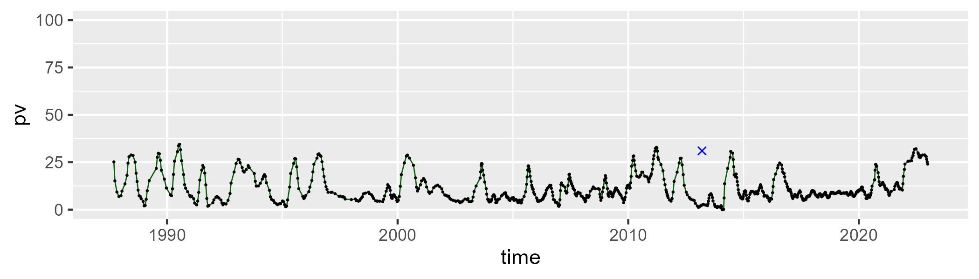

| Min. | 1st Qu. | Median | Mean | 3rd Qu. | Max. |
| --- | --- | --- | --- | --- | --- |
| 7.069054 | 27.91731 | 34.30016 | 35.27186 | 42.58374 | 63.96366 |

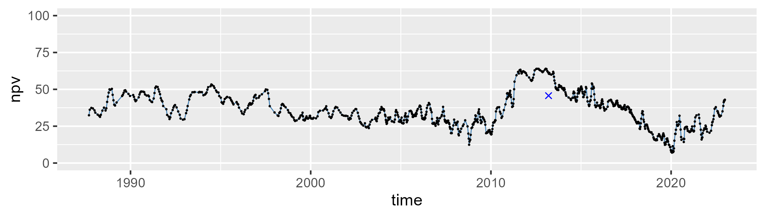

| Min. | 1st Qu. | Median | Mean | 3rd Qu. | Max. |
| --- | --- | --- | --- | --- | --- |
| 15.27424 | 42.84741 | 53.80609 | 51.97741 | 62.44291 | 80.66228 |

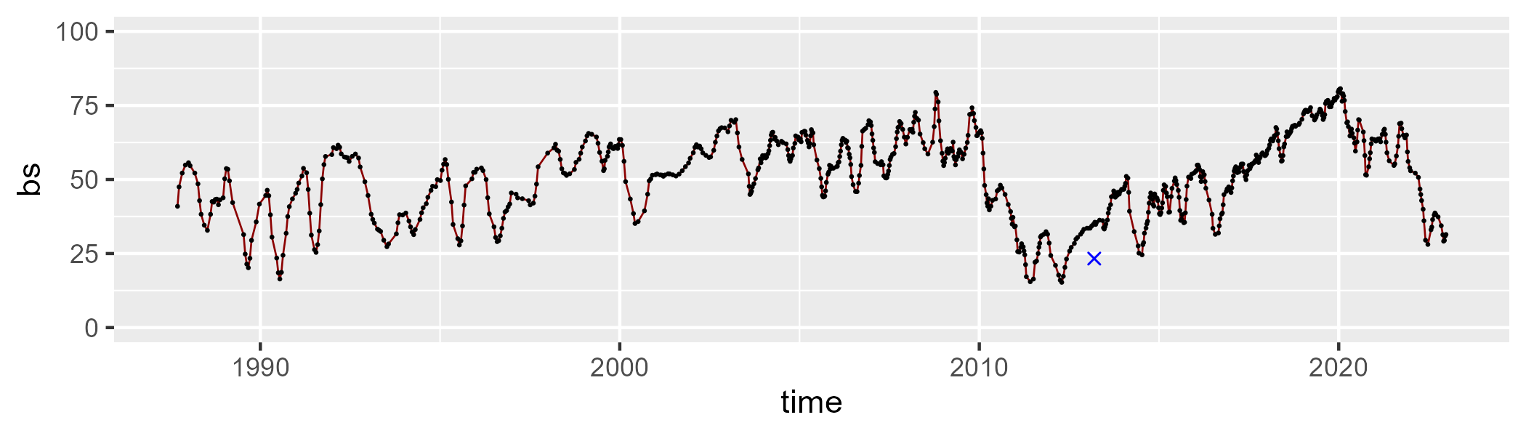

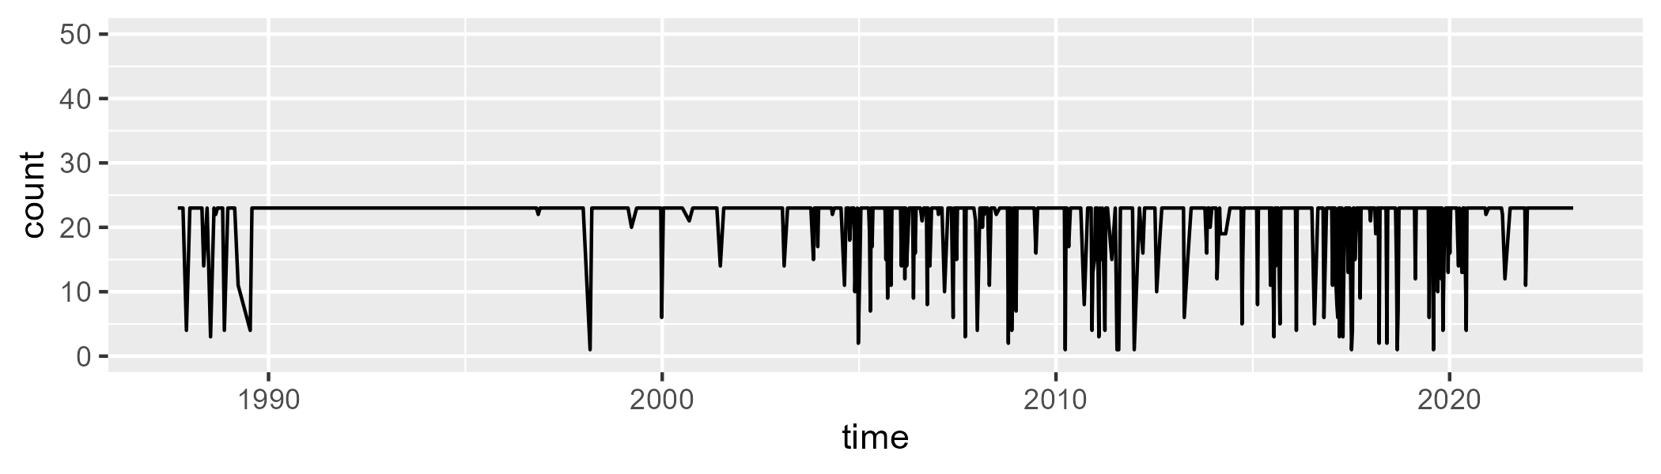

Min. : 1.00 1st Qu.:23.00 Median :23.00 Mean :21.25 3rd Qu.:23.00 Max. :23.00

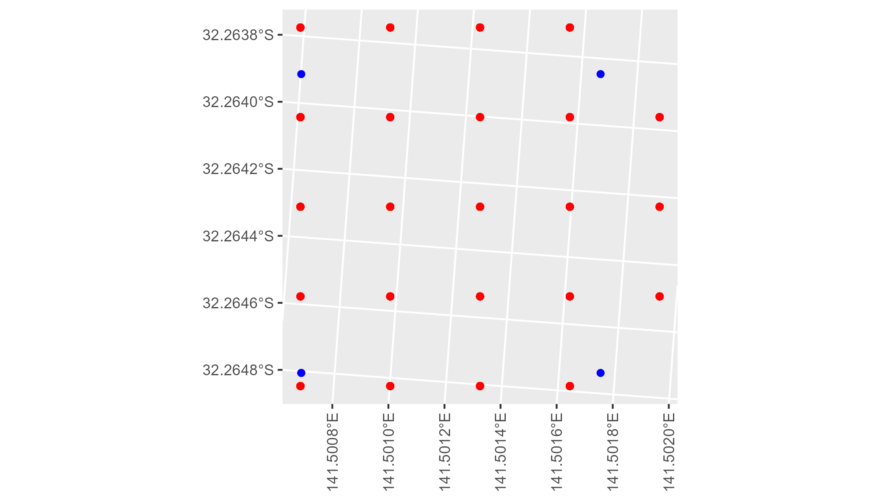

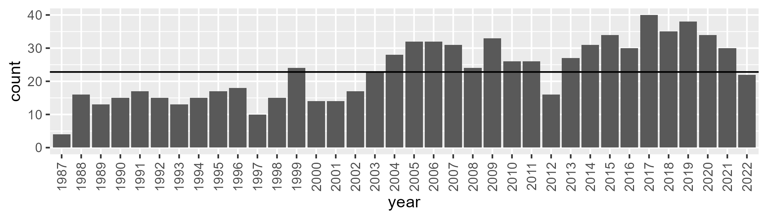

Number of samples: 829

# NSABHC0021

| Min. | 1st Qu. | Median | Mean | 3rd Qu. | Max. |
| --- | --- | --- | --- | --- | --- |
| 0 | 0.9304557 | 2.20819 | 6.295942 | 8.043014 | 46.54953 |

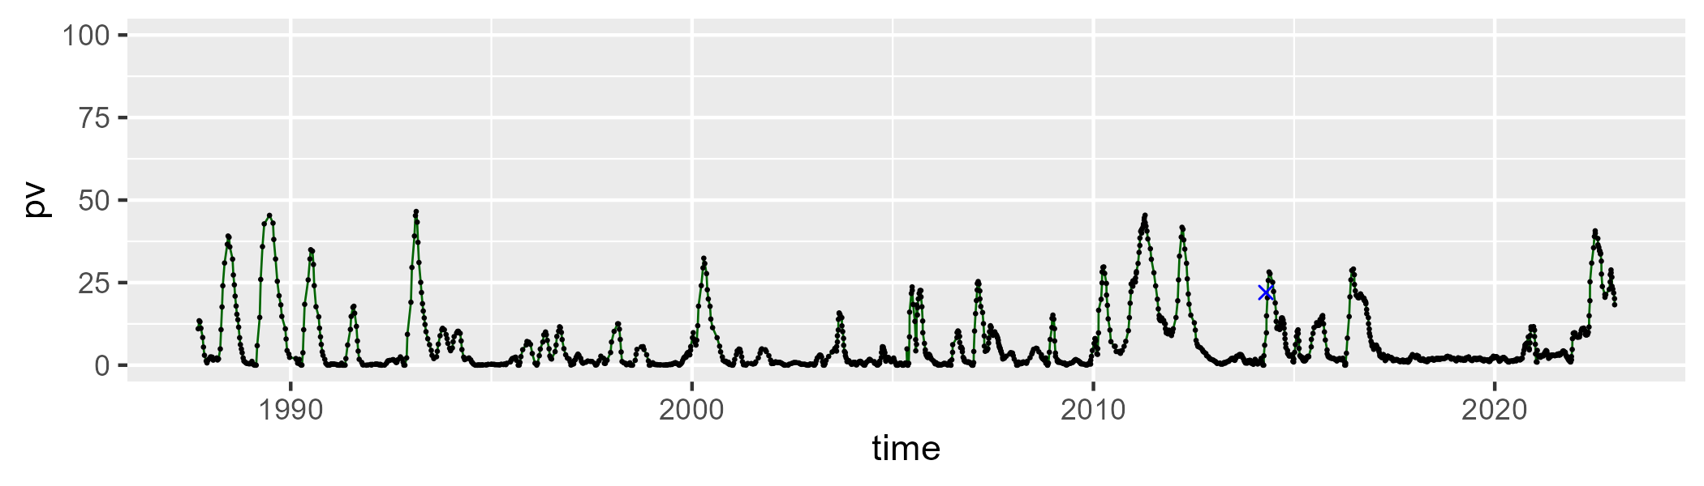

| Min. | 1st Qu. | Median | Mean | 3rd Qu. | Max. |
| --- | --- | --- | --- | --- | --- |
| 15.58523 | 34.30265 | 41.47285 | 41.84671 | 49.86604 | 75.47557 |

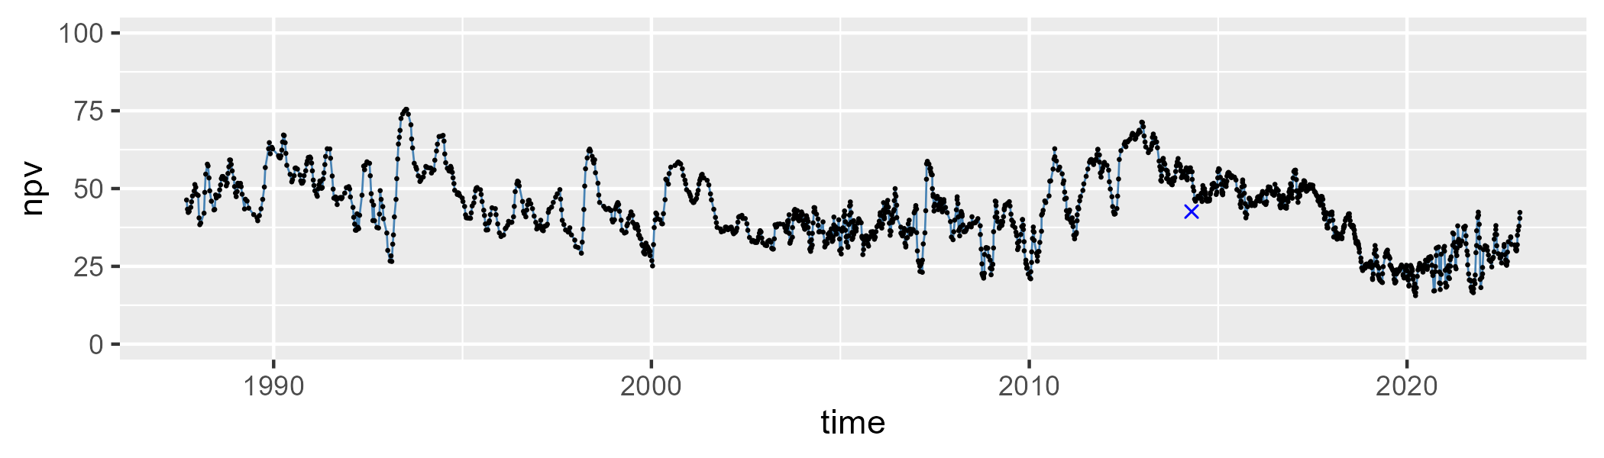

| Min. | 1st Qu. | Median | Mean | 3rd Qu. | Max. |
| --- | --- | --- | --- | --- | --- |
| 9.249352 | 40.53915 | 52.11619 | 50.48838 | 60.9014 | 80.22792 |

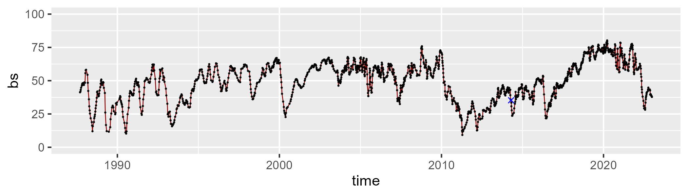

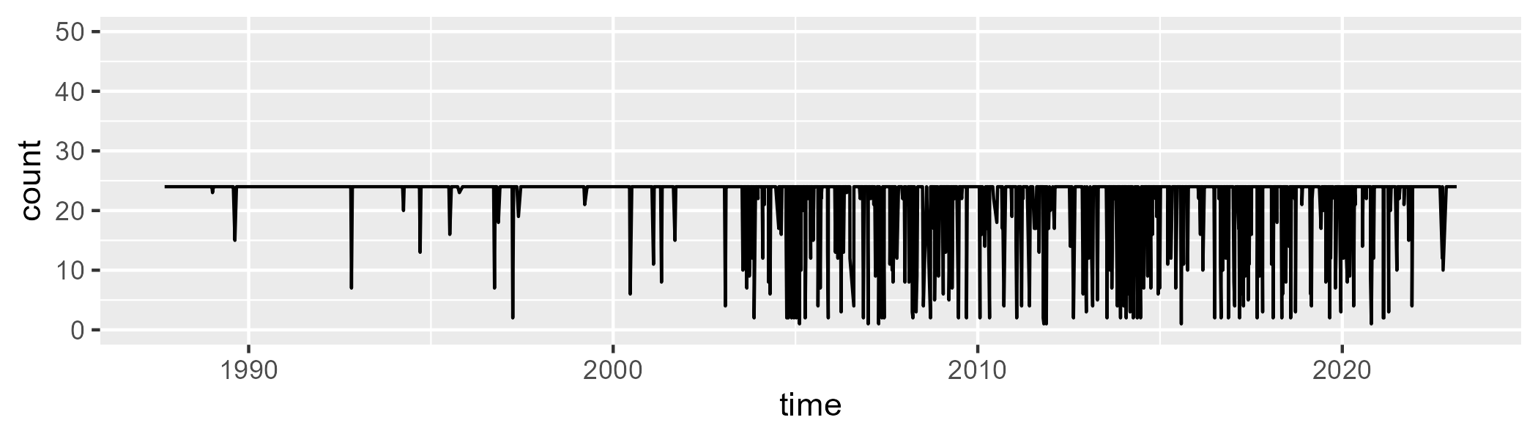

Min. : 1.00 1st Qu.:24.00 Median :24.00 Mean :21.93 3rd Qu.:24.00 Max. :24.00

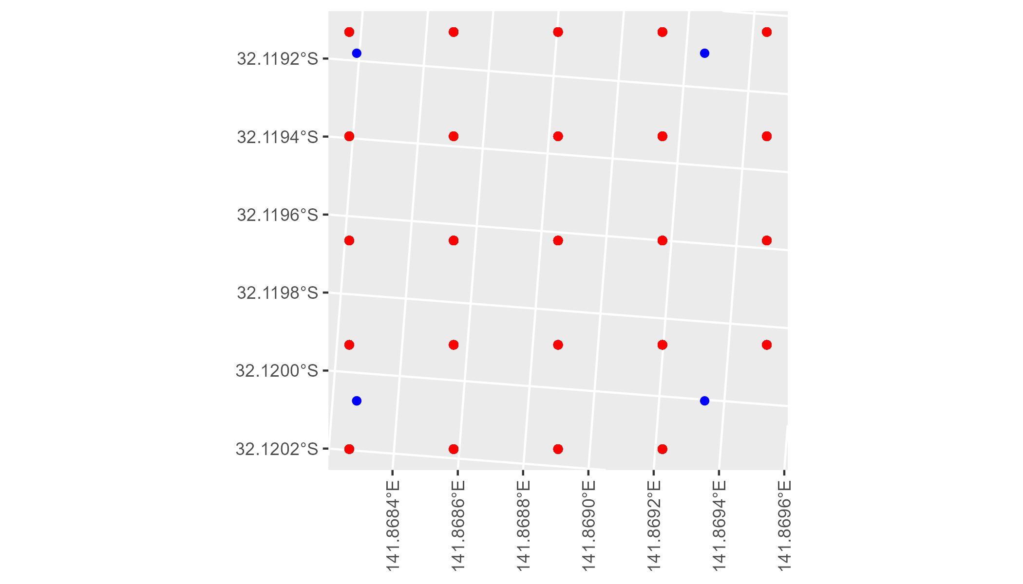

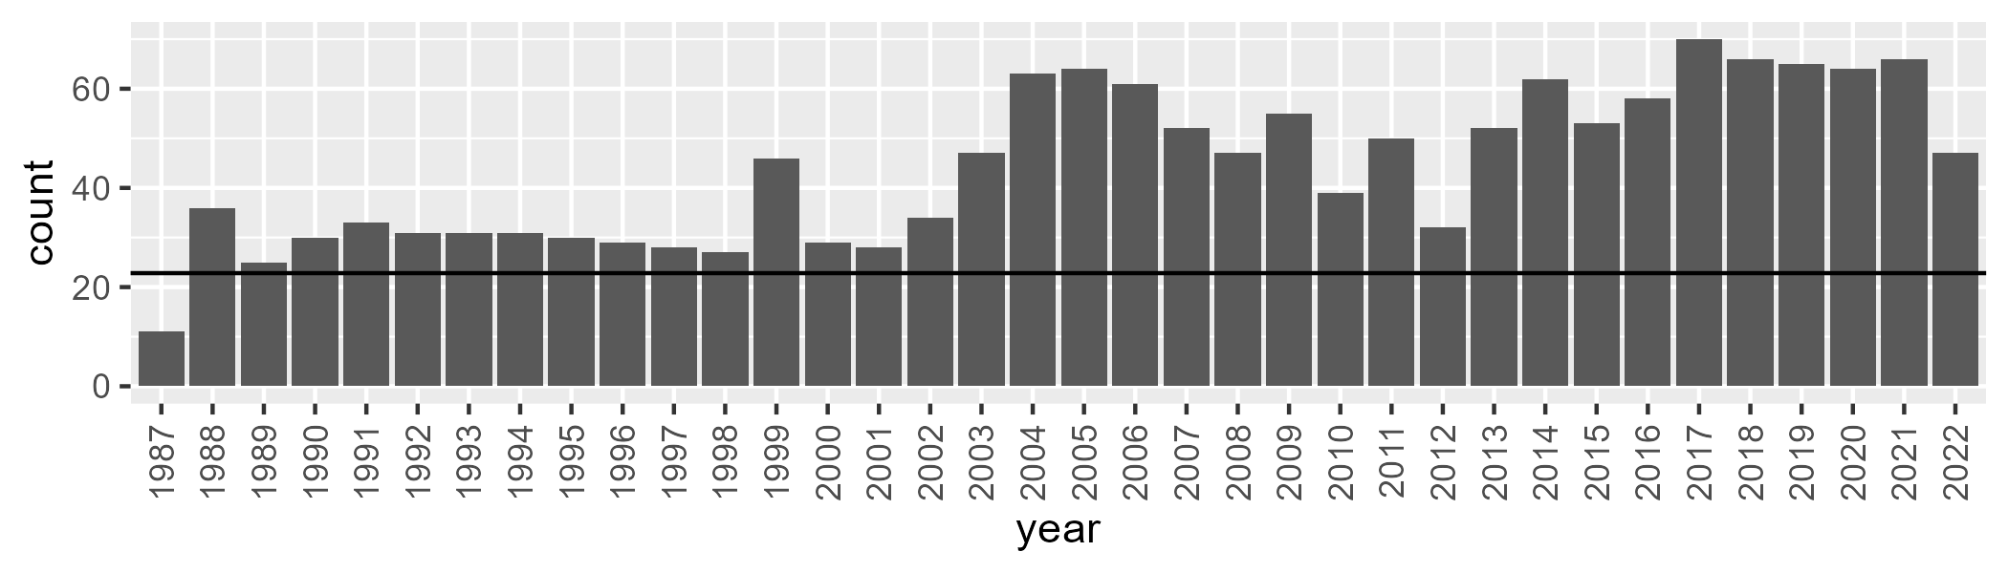

Number of samples: 1592

# NSABHC0022

| Min. | 1st Qu. | Median | Mean | 3rd Qu. | Max. |
| --- | --- | --- | --- | --- | --- |
| 0 | 1.246181 | 2.723994 | 5.107865 | 7.689153 | 26.7738 |

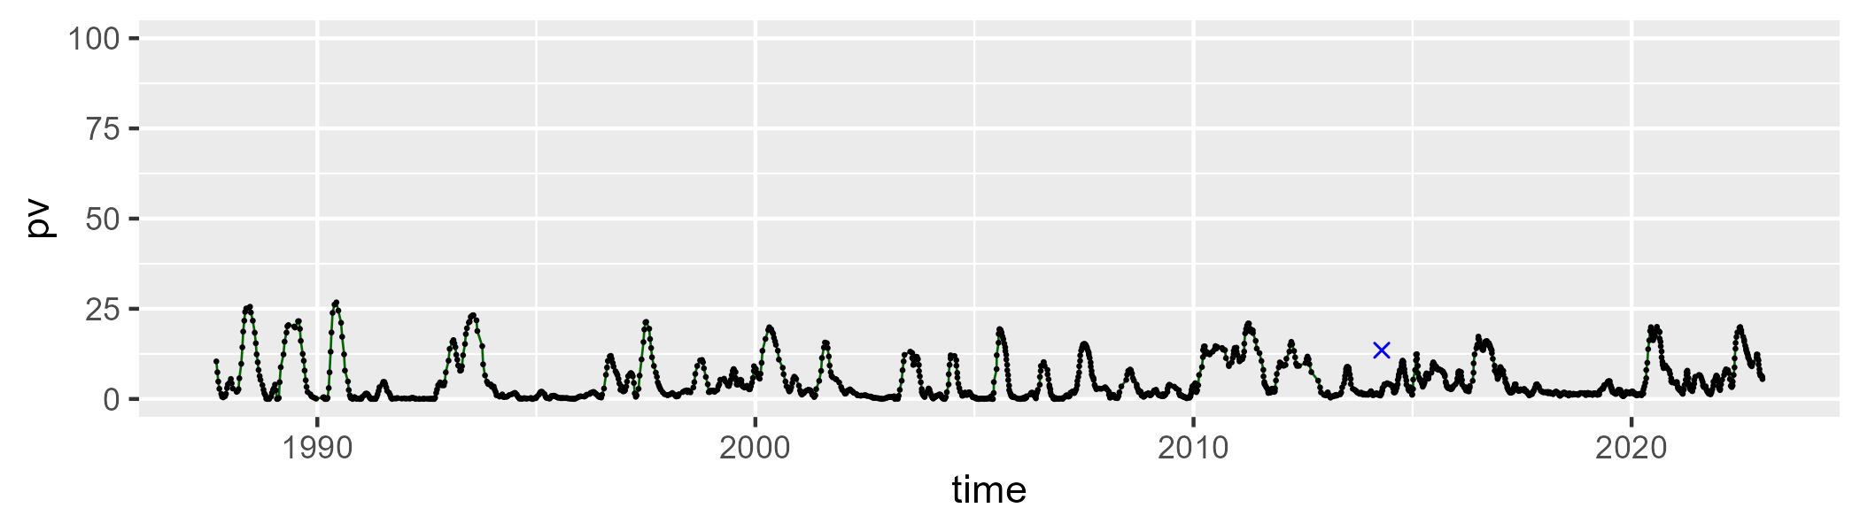

| Min. | 1st Qu. | Median | Mean | 3rd Qu. | Max. |
| --- | --- | --- | --- | --- | --- |
| 15.15049 | 29.05707 | 34.22677 | 34.29153 | 39.43051 | 60.8913 |

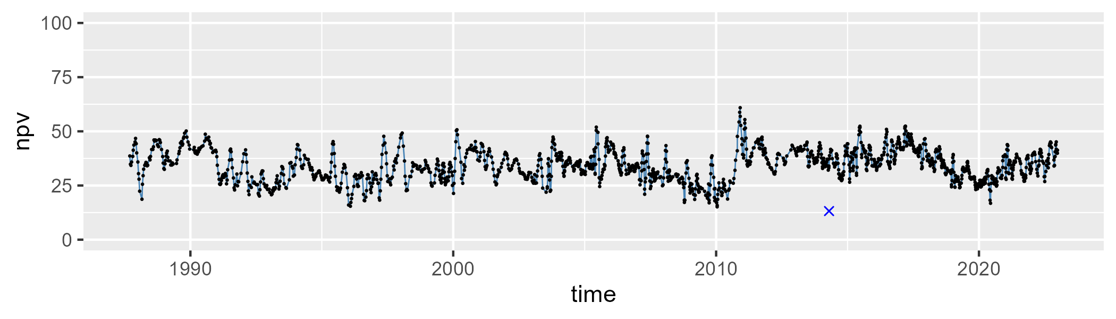

| Min. | 1st Qu. | Median | Mean | 3rd Qu. | Max. |
| --- | --- | --- | --- | --- | --- |
| 25.307 | 53.59209 | 59.78516 | 59.18542 | 65.46015 | 82.6997 |

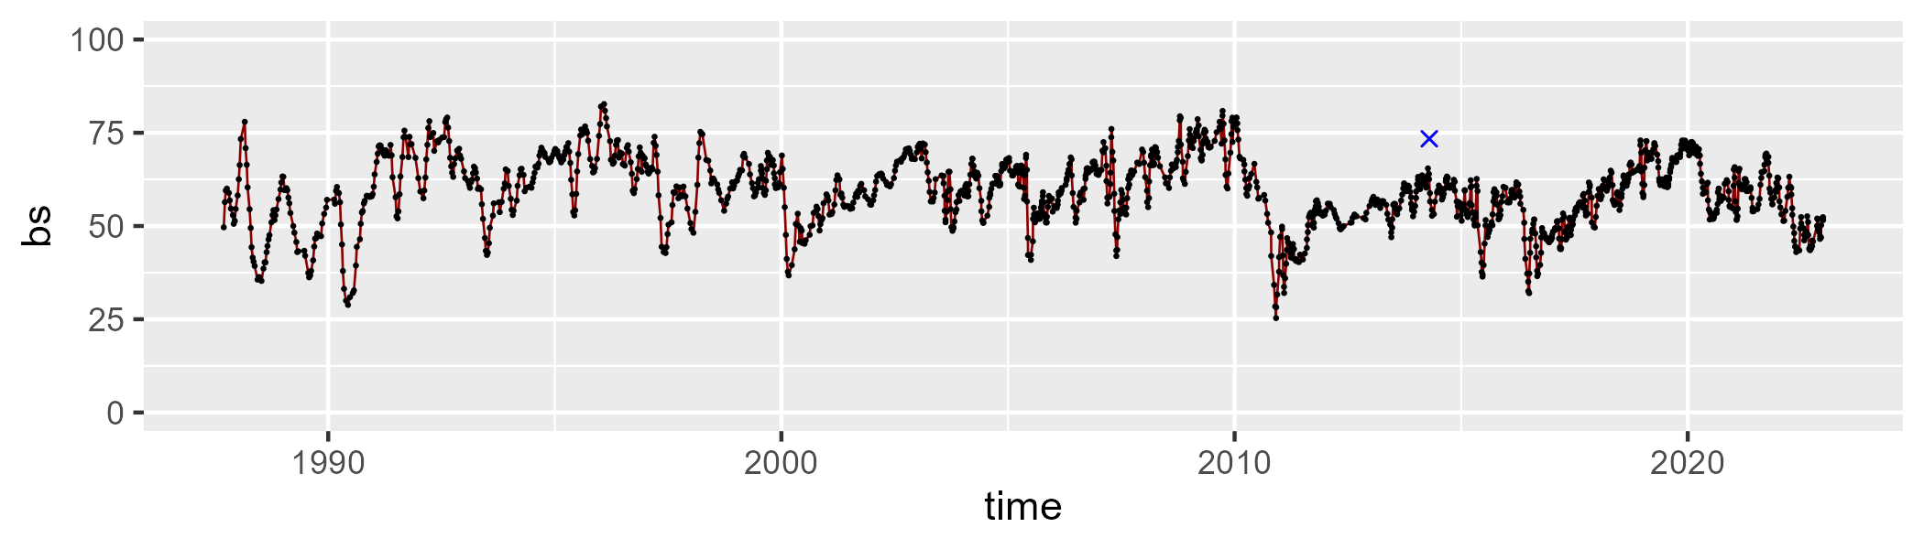

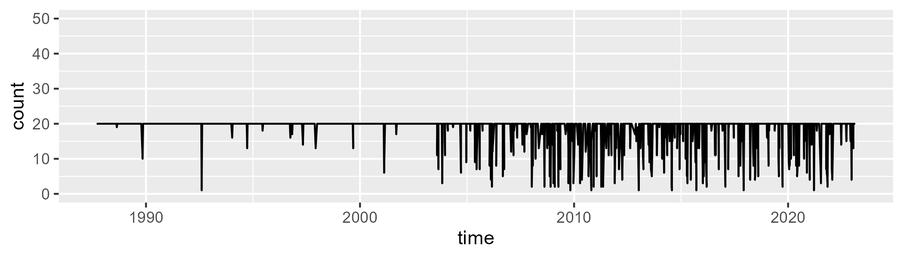

Min. : 1.00 1st Qu.:20.00 Median :20.00 Mean :18.79 3rd Qu.:20.00 Max. :20.00

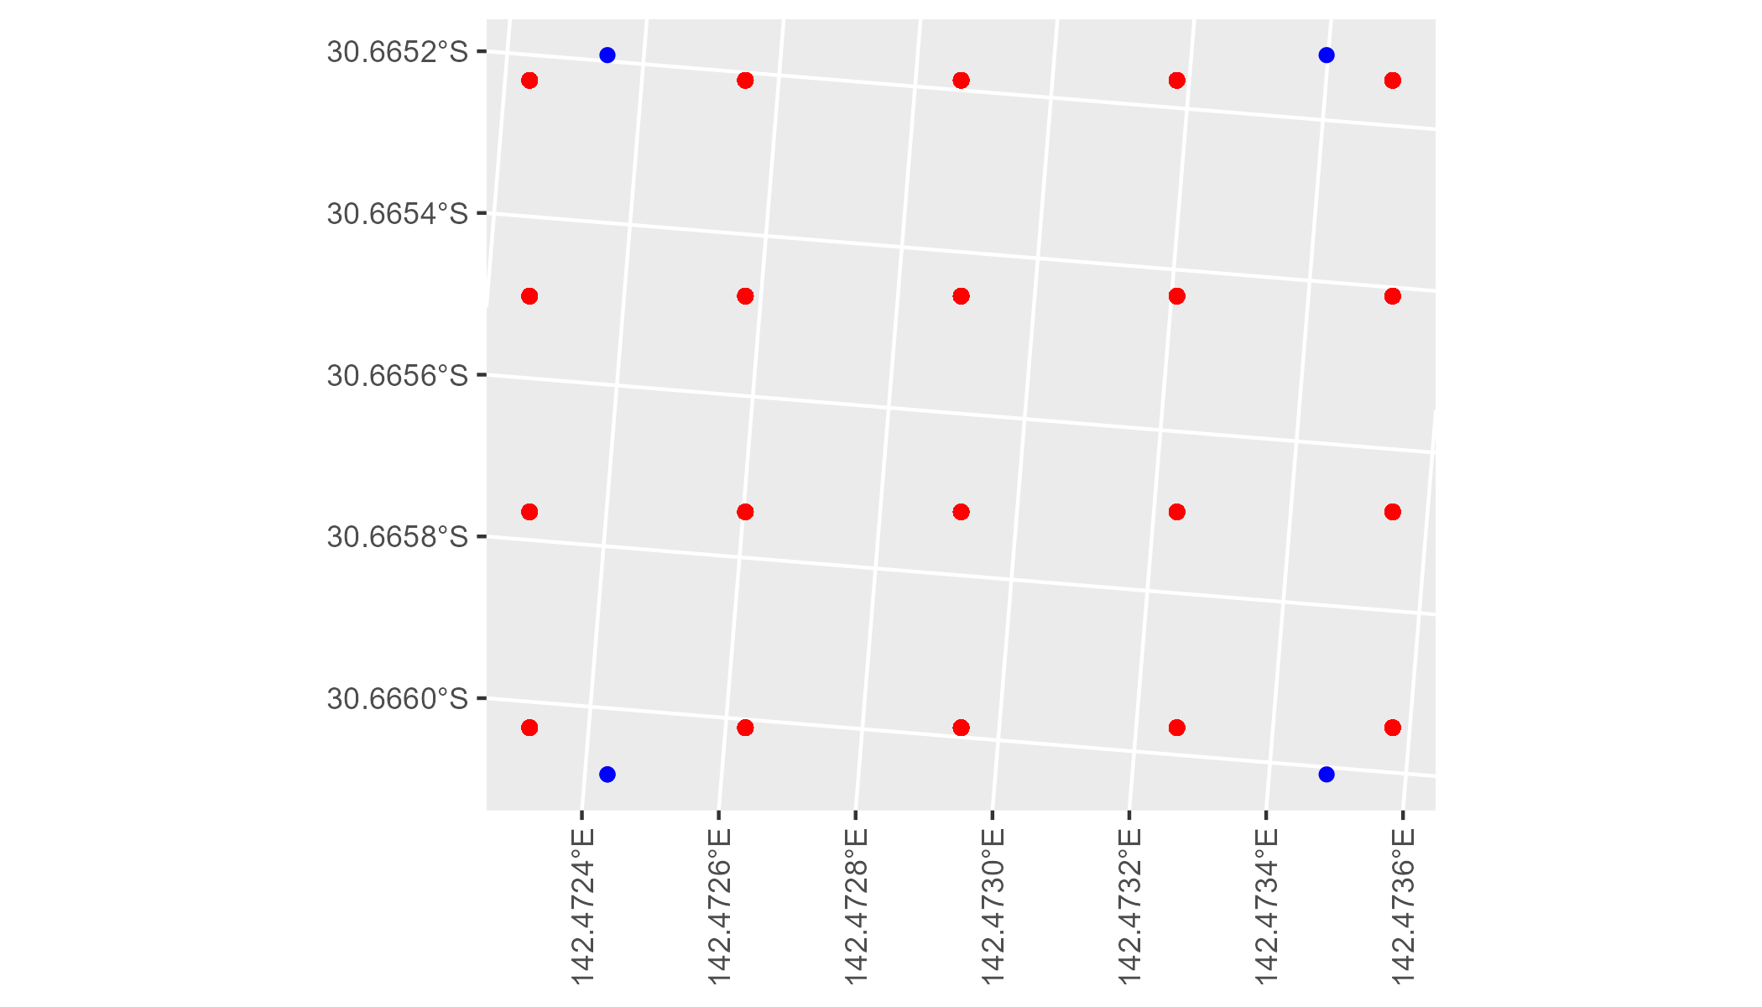

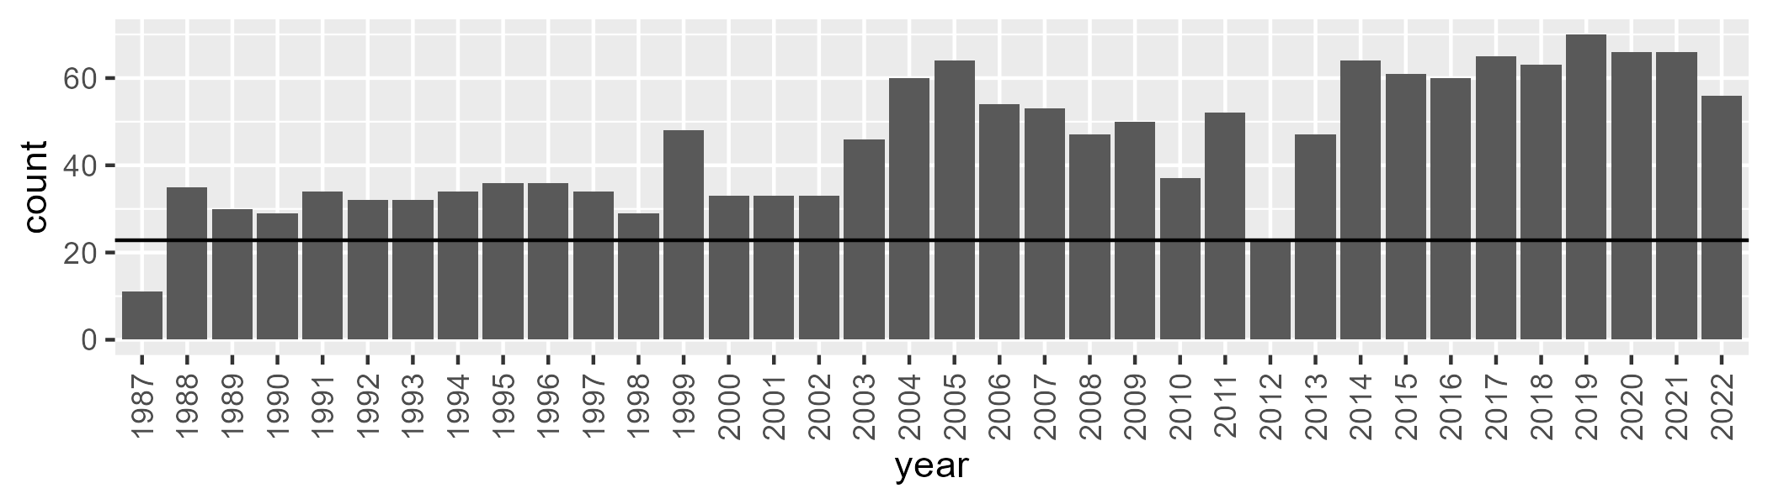

Number of samples: 1623

# NSABHC0023

| Min. | 1st Qu. | Median | Mean | 3rd Qu. | Max. |
| --- | --- | --- | --- | --- | --- |
| 1.957129 | 10.11596 | 13.7056 | 15.11964 | 19.01648 | 41.67287 |

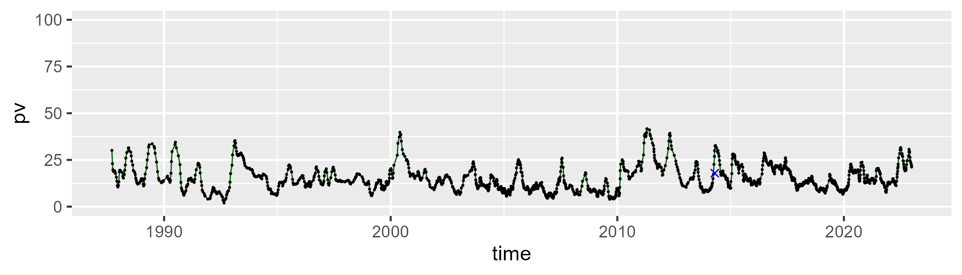

| Min. | 1st Qu. | Median | Mean | 3rd Qu. | Max. |
| --- | --- | --- | --- | --- | --- |
| 19.71195 | 36.89155 | 40.83507 | 40.783 | 44.84533 | 57.14659 |

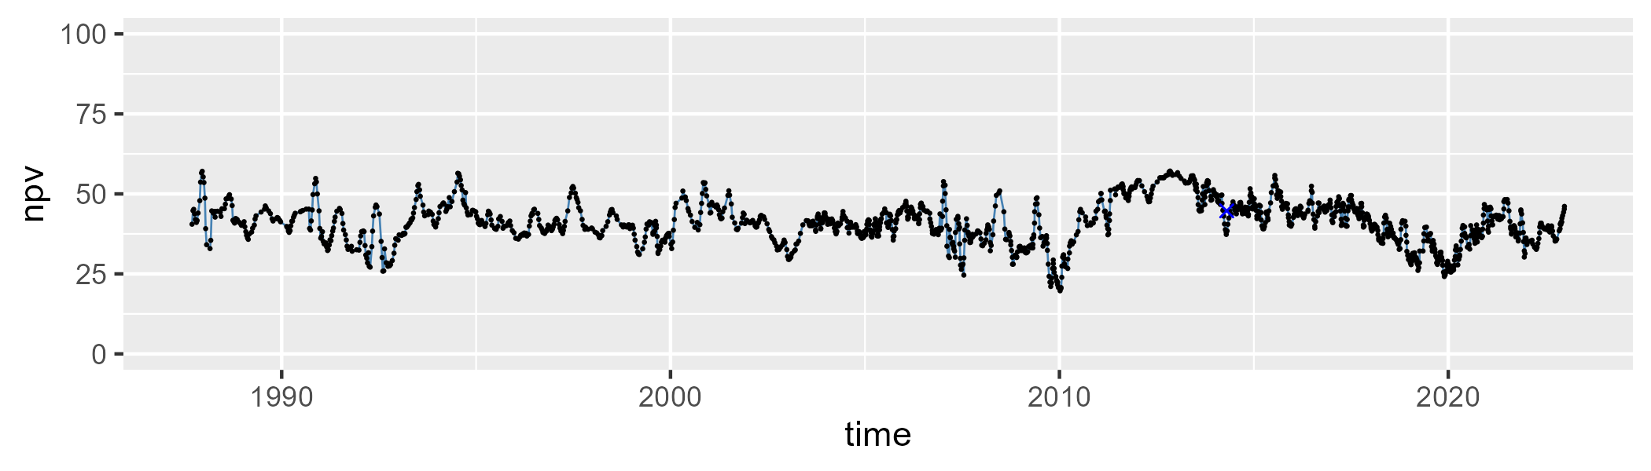

| Min. | 1st Qu. | Median | Mean | 3rd Qu. | Max. |
| --- | --- | --- | --- | --- | --- |
| 6.225858 | 36.0676 | 43.19569 | 42.71812 | 49.53344 | 72.66119 |

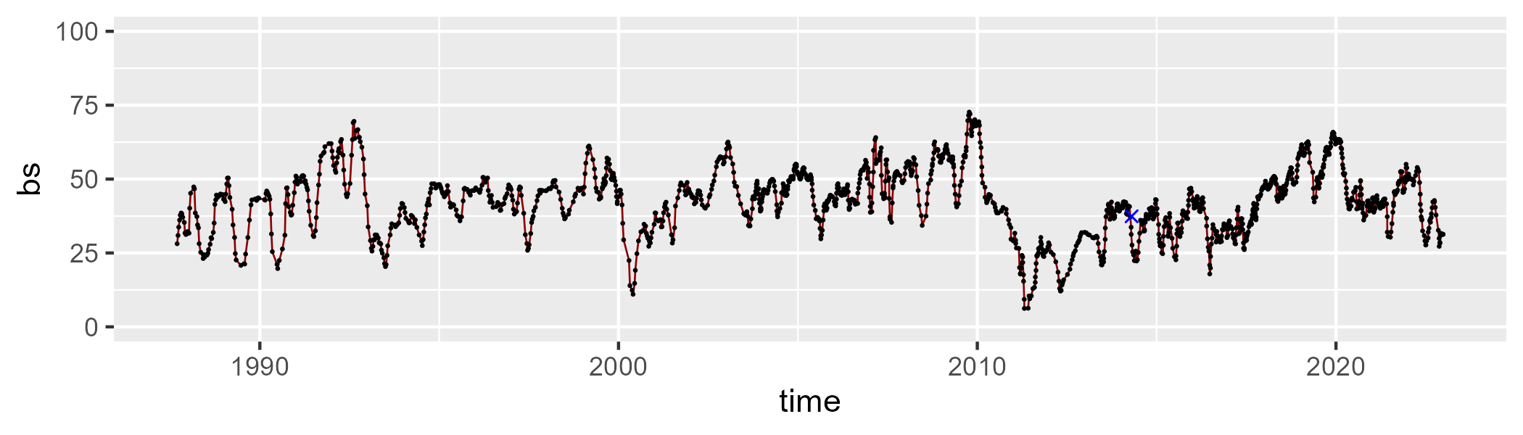

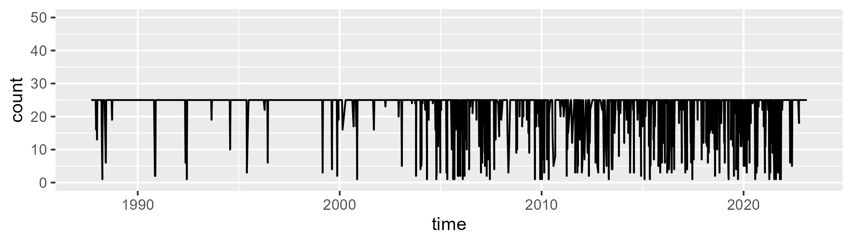

Min. : 1.00 1st Qu.:25.00 Median :25.00 Mean :22.56 3rd Qu.:25.00 Max. :25.00

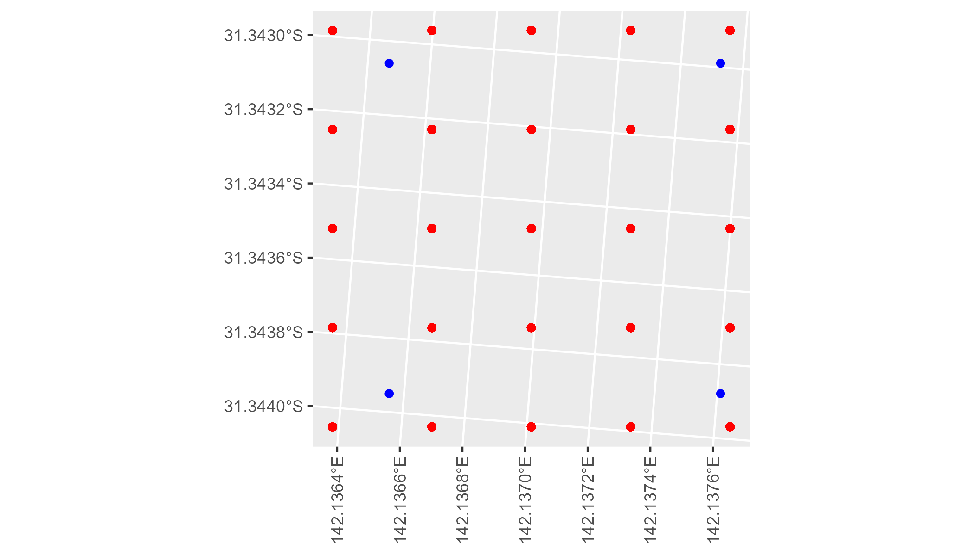

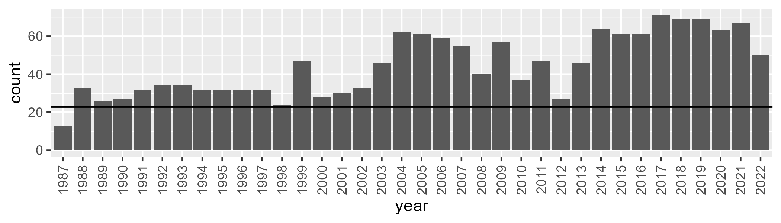

Number of samples: 1601

# NSABHC0024

| Min. | 1st Qu. | Median | Mean | 3rd Qu. | Max. |
| --- | --- | --- | --- | --- | --- |
| 2.750639 | 8.399182 | 11.83226 | 13.38805 | 17.02616 | 39.95419 |

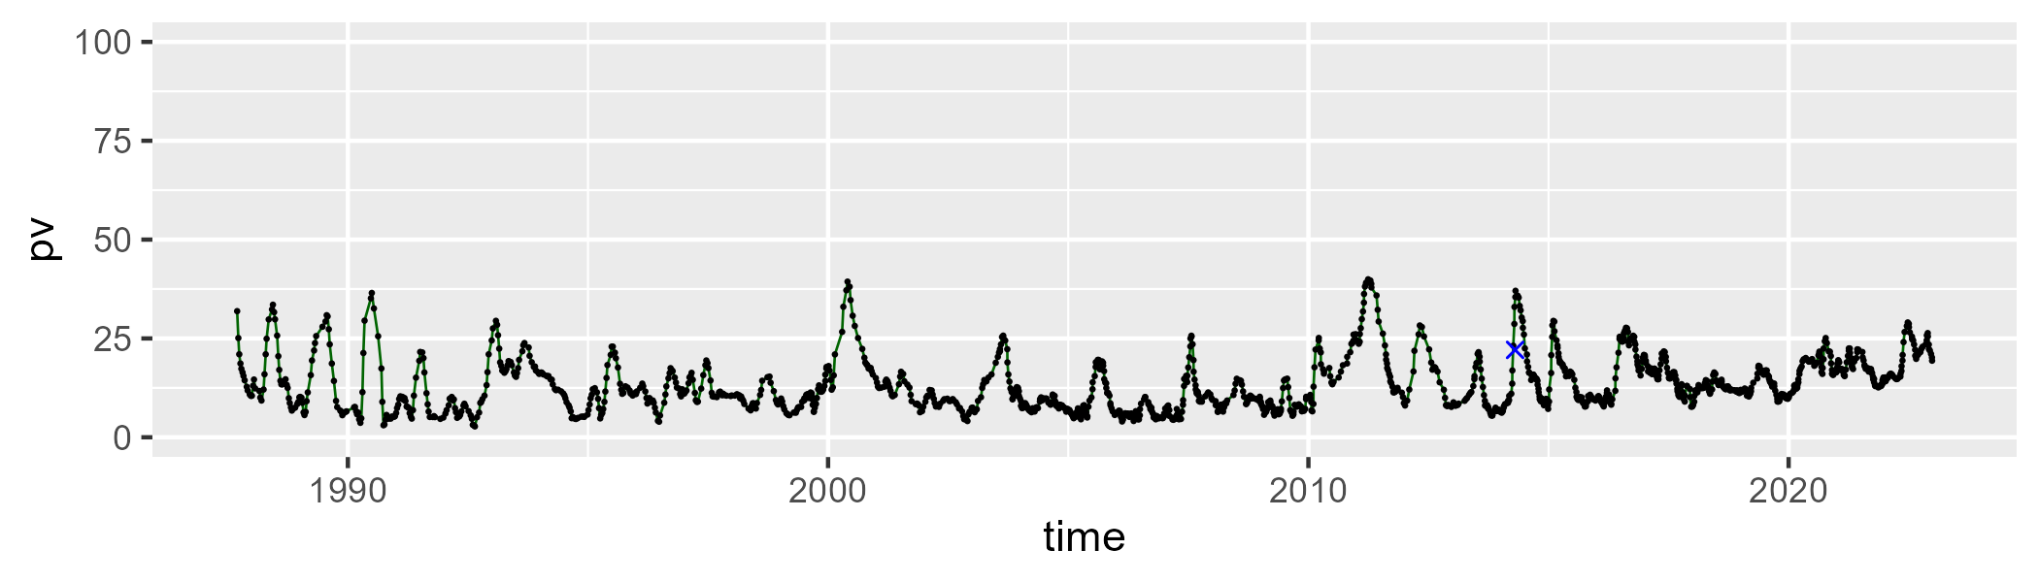

| Min. | 1st Qu. | Median | Mean | 3rd Qu. | Max. |
| --- | --- | --- | --- | --- | --- |
| 10.75689 | 31.55531 | 37.57296 | 36.90778 | 43.00893 | 59.35544 |

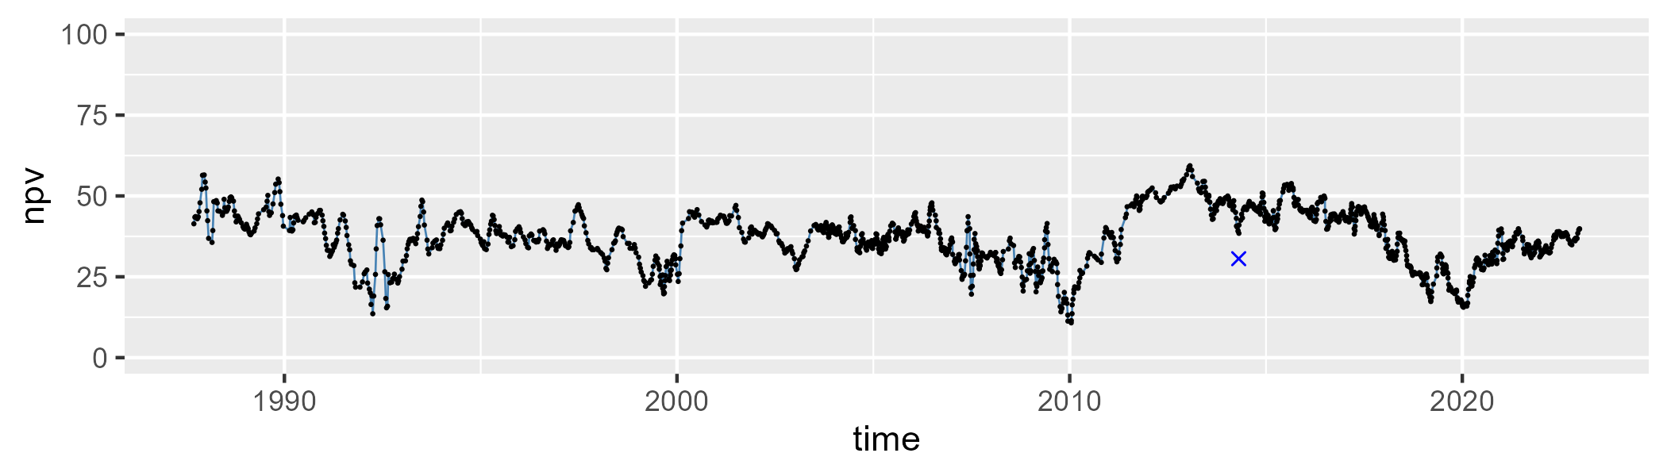

| Min. | 1st Qu. | Median | Mean | 3rd Qu. | Max. |
| --- | --- | --- | --- | --- | --- |
| 14.99131 | 40.38115 | 48.81011 | 48.27019 | 55.98401 | 79.79593 |

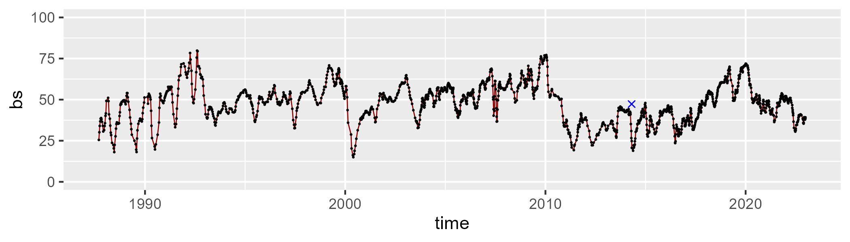

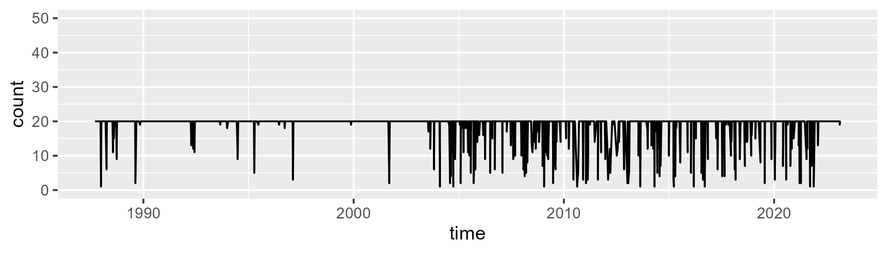

Min. : 1.00 1st Qu.:20.00 Median :20.00 Mean :18.79 3rd Qu.:20.00 Max. :20.00

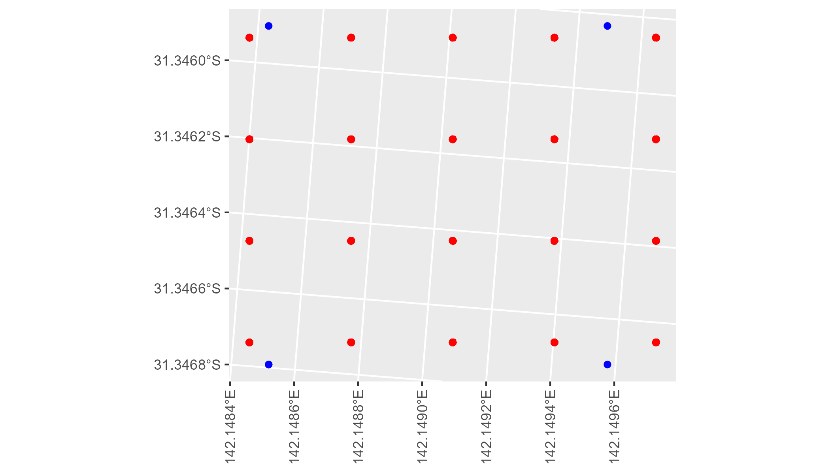

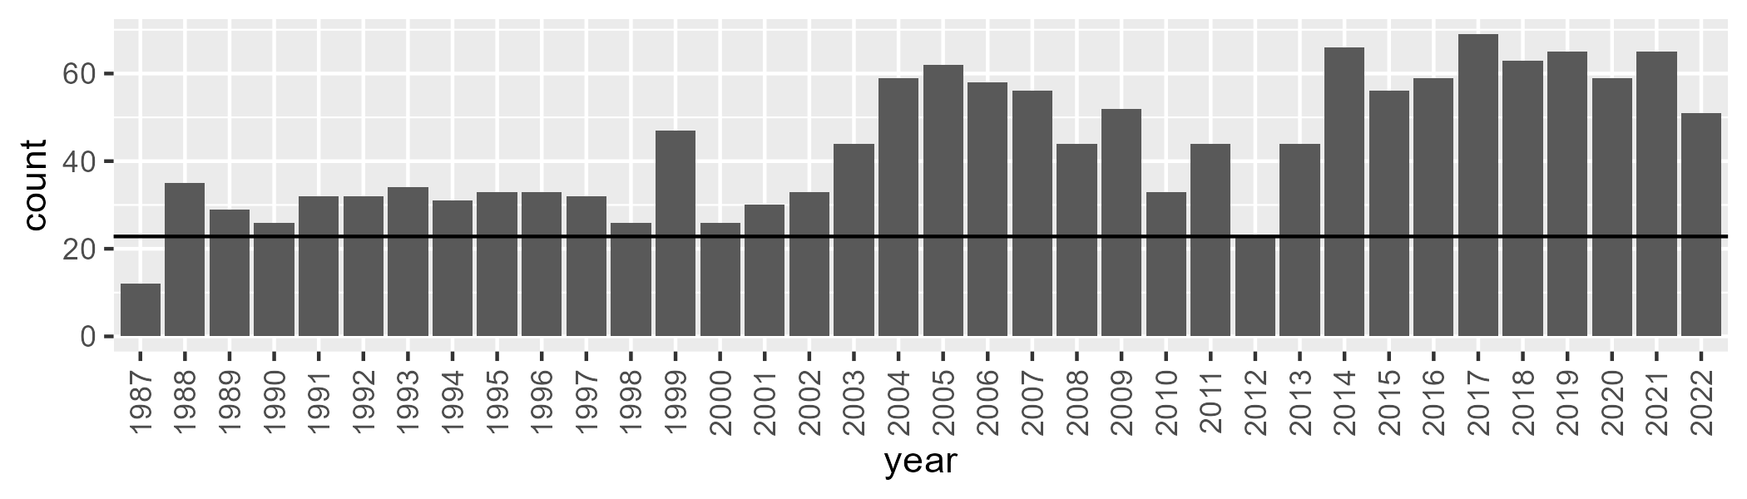

Number of samples: 1563

# NSABHC0025

| Min. | 1st Qu. | Median | Mean | 3rd Qu. | Max. |
| --- | --- | --- | --- | --- | --- |
| 0 | 1.379702 | 3.20928 | 6.835967 | 9.82121 | 40.44316 |

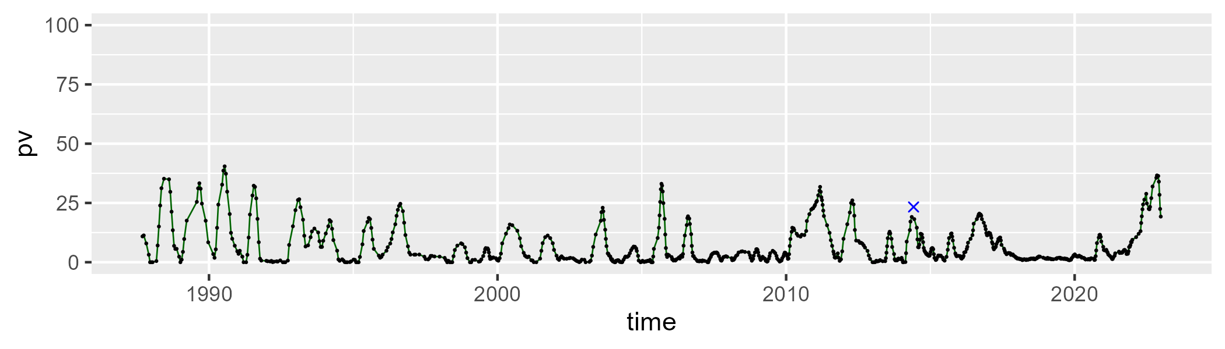

| Min. | 1st Qu. | Median | Mean | 3rd Qu. | Max. |
| --- | --- | --- | --- | --- | --- |
| 15.63772 | 34.96706 | 44.63721 | 43.90851 | 52.47982 | 71.42461 |

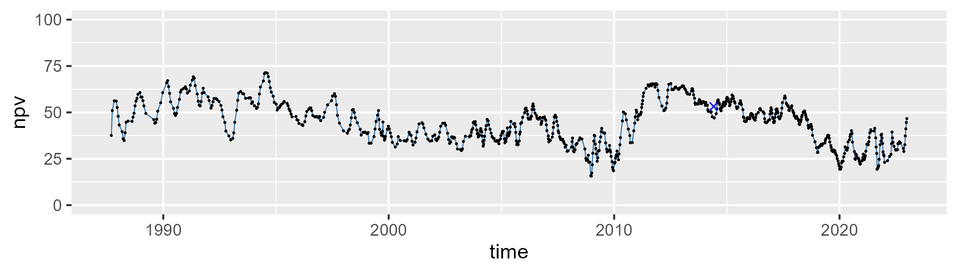

| Min. | 1st Qu. | Median | Mean | 3rd Qu. | Max. |
| --- | --- | --- | --- | --- | --- |
| 9.984452 | 36.48401 | 48.08038 | 47.89199 | 60.06642 | 77.25641 |

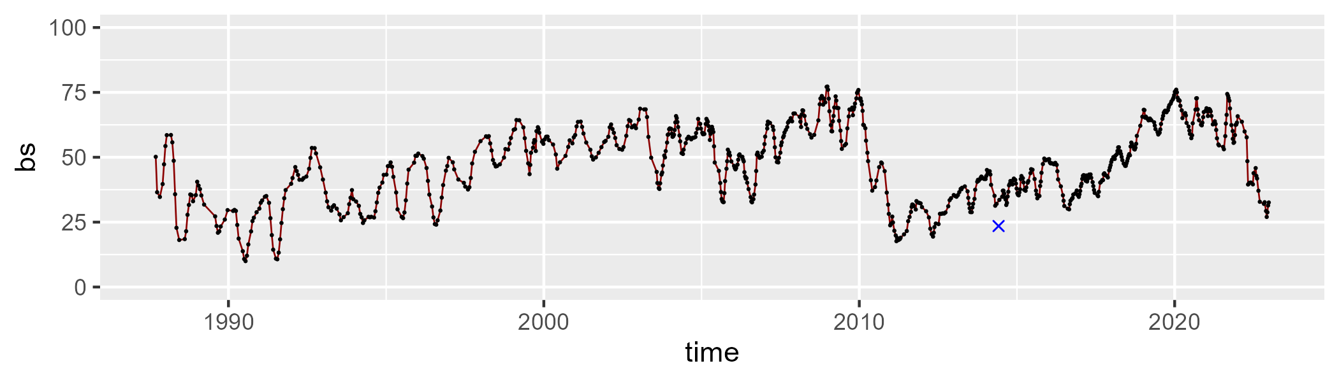

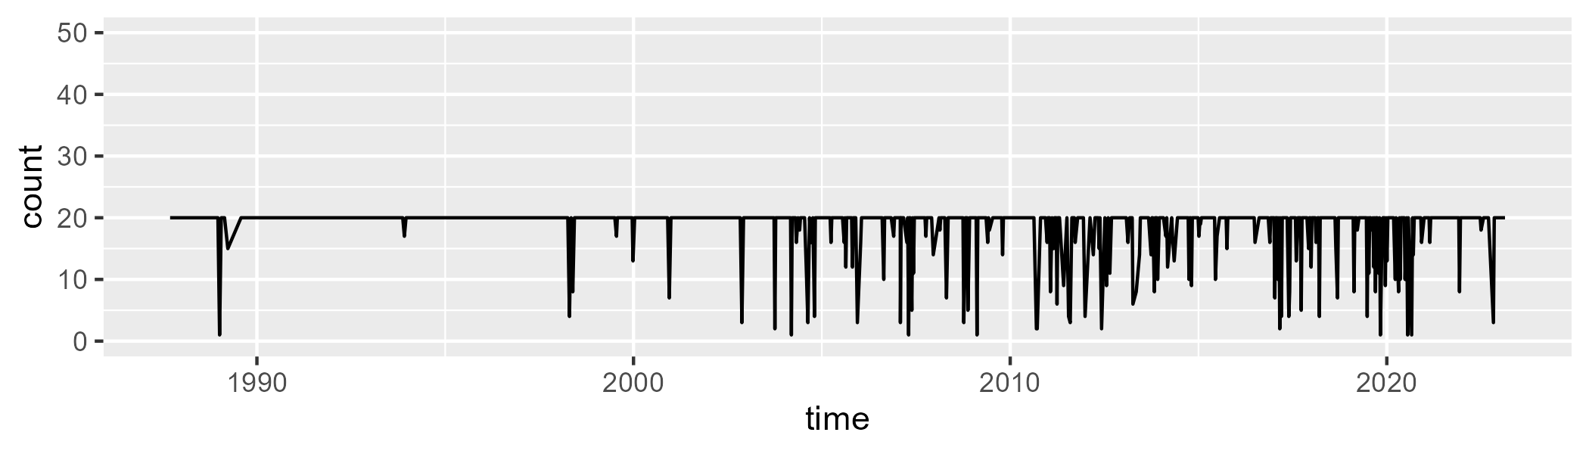

Min. : 1.00 1st Qu.:20.00 Median :20.00 Mean :18.66 3rd Qu.:20.00 Max. :20.00

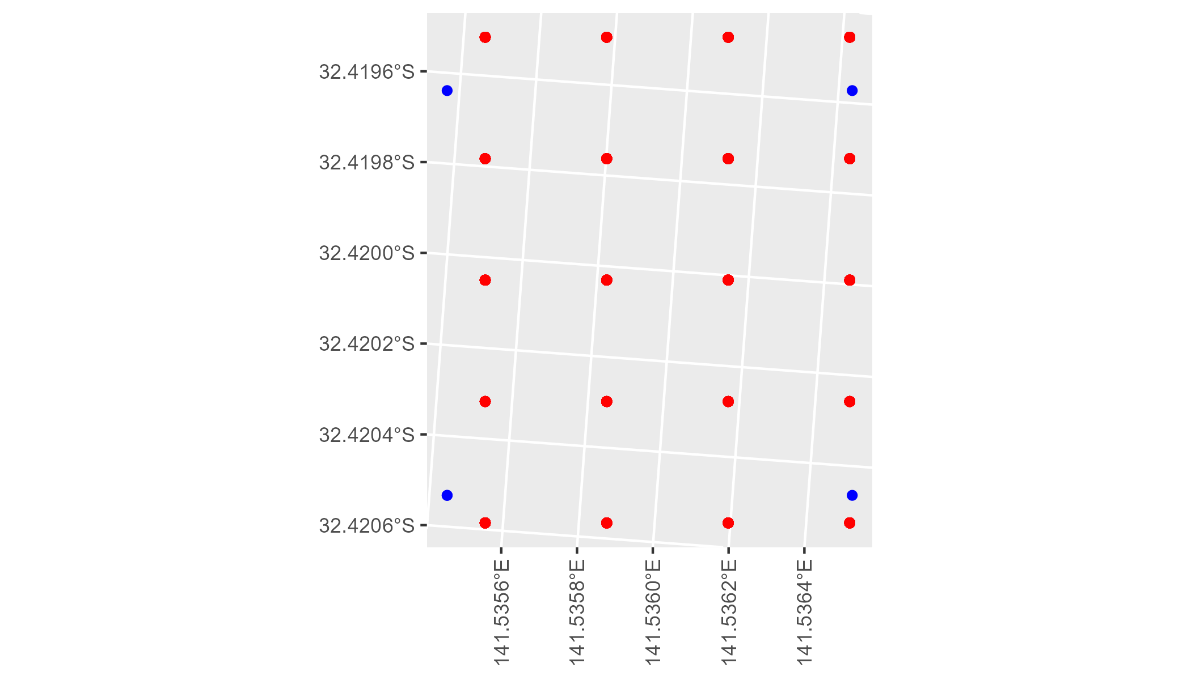

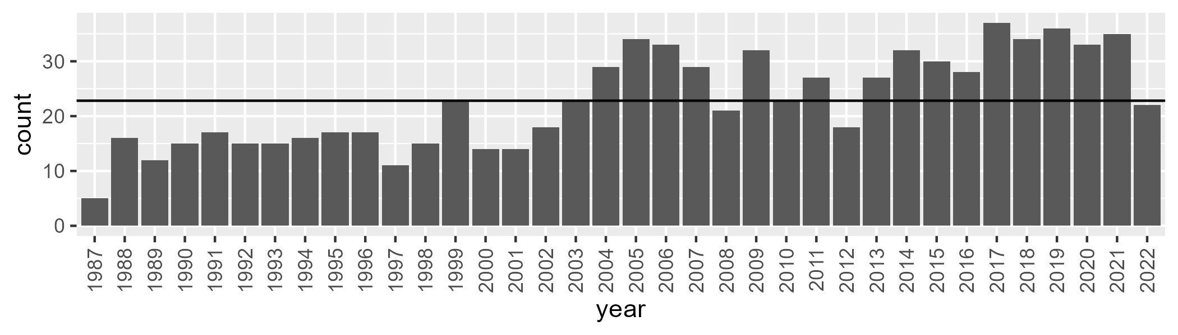

Number of samples: 823

# NSABHC0026

| Min. | 1st Qu. | Median | Mean | 3rd Qu. | Max. |
| --- | --- | --- | --- | --- | --- |
| 0.01899911 | 7.134506 | 11.10194 | 15.01679 | 19.9419 | 66.47343 |

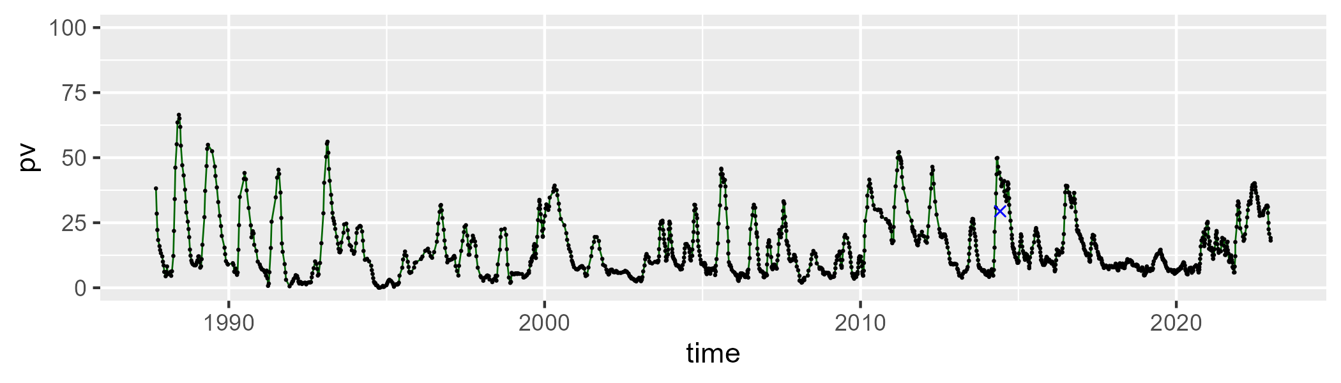

| Min. | 1st Qu. | Median | Mean | 3rd Qu. | Max. |
| --- | --- | --- | --- | --- | --- |
| 19.87267 | 35.38707 | 43.20906 | 42.97859 | 50.22065 | 70.10027 |

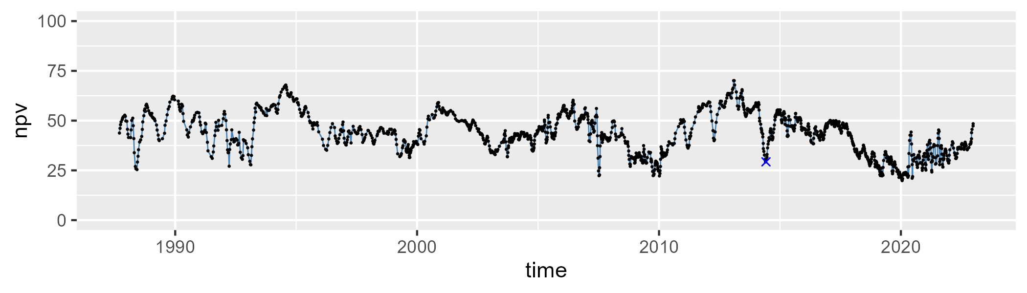

| Min. | 1st Qu. | Median | Mean | 3rd Qu. | Max. |
| --- | --- | --- | --- | --- | --- |
| 3.969588 | 30.49033 | 40.77366 | 40.61024 | 50.97967 | 71.82753 |

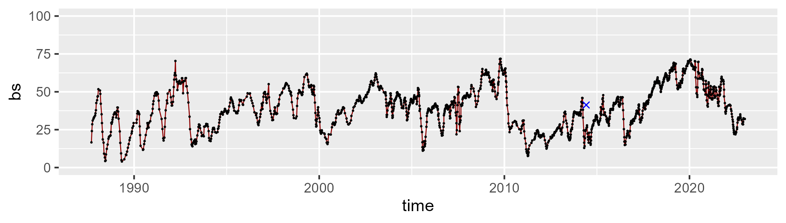

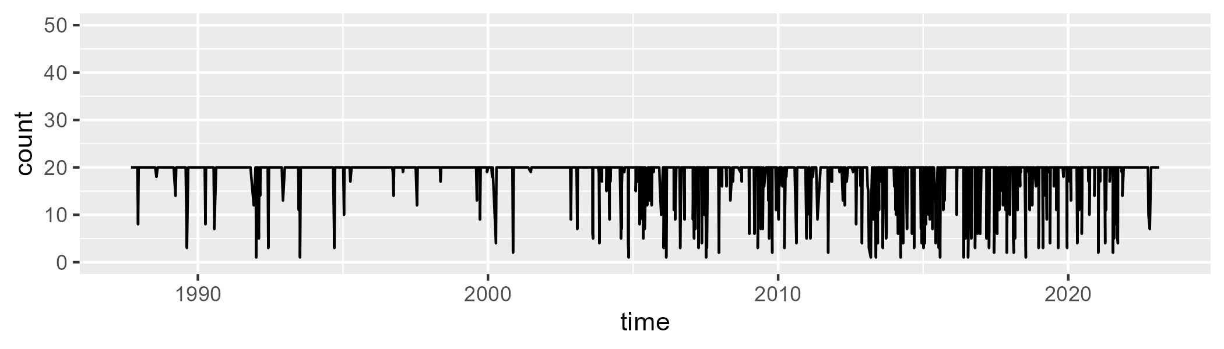

Min. : 1.0 1st Qu.:20.0 Median :20.0 Mean :18.5 3rd Qu.:20.0 Max. :20.0

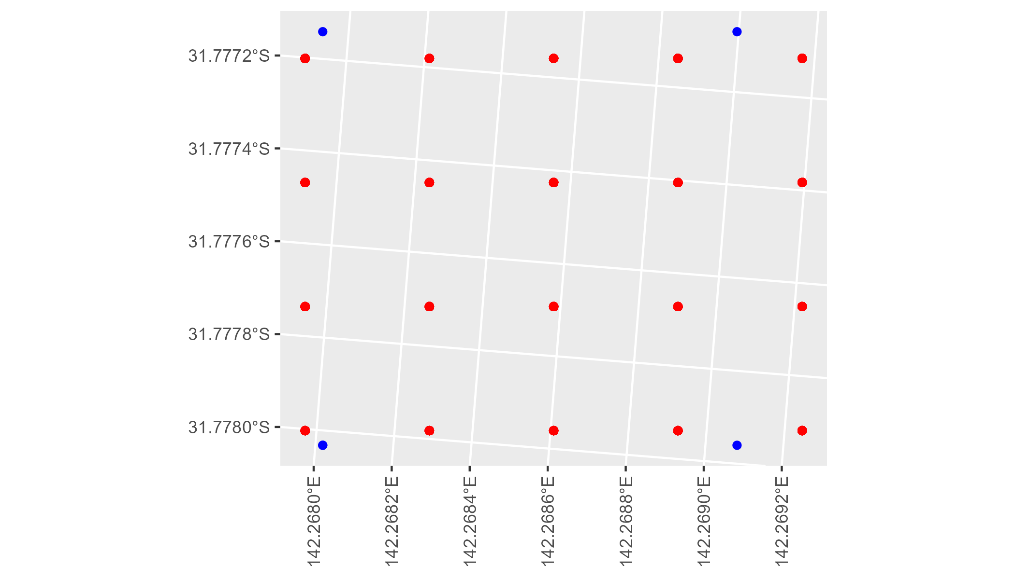

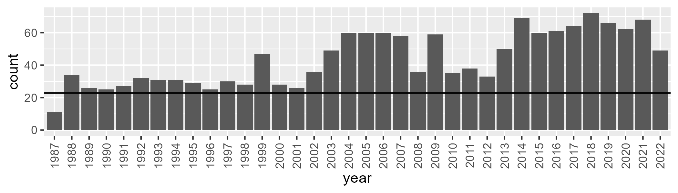

Number of samples: 1575

# NSABHC0028

| Min. | 1st Qu. | Median | Mean | 3rd Qu. | Max. |
| --- | --- | --- | --- | --- | --- |
| 2.992564 | 7.505113 | 10.3708 | 10.93329 | 13.66688 | 25.841 |

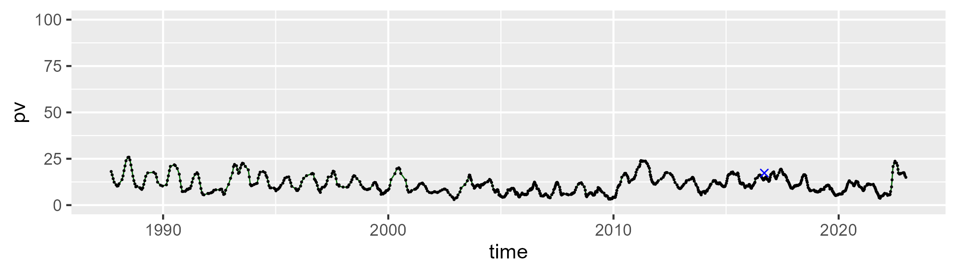

| Min. | 1st Qu. | Median | Mean | 3rd Qu. | Max. |
| --- | --- | --- | --- | --- | --- |
| 25.70556 | 35.68475 | 38.42688 | 38.16836 | 40.78171 | 48.18221 |

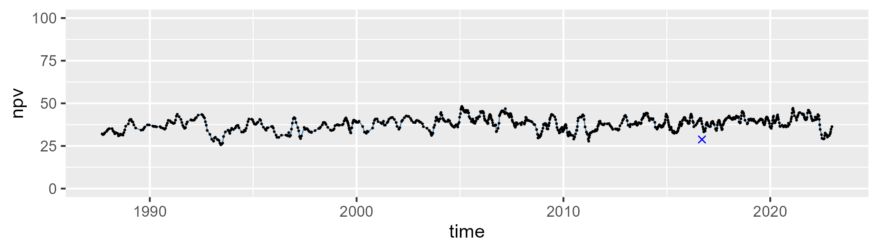

| Min. | 1st Qu. | Median | Mean | 3rd Qu. | Max. |
| --- | --- | --- | --- | --- | --- |
| 39.90367 | 46.90711 | 49.3394 | 49.51463 | 51.75882 | 64.06612 |

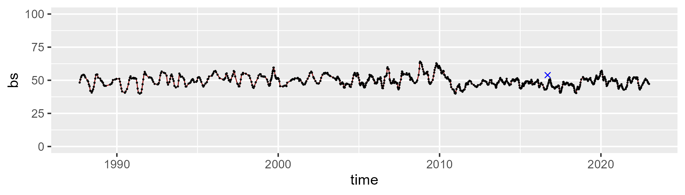

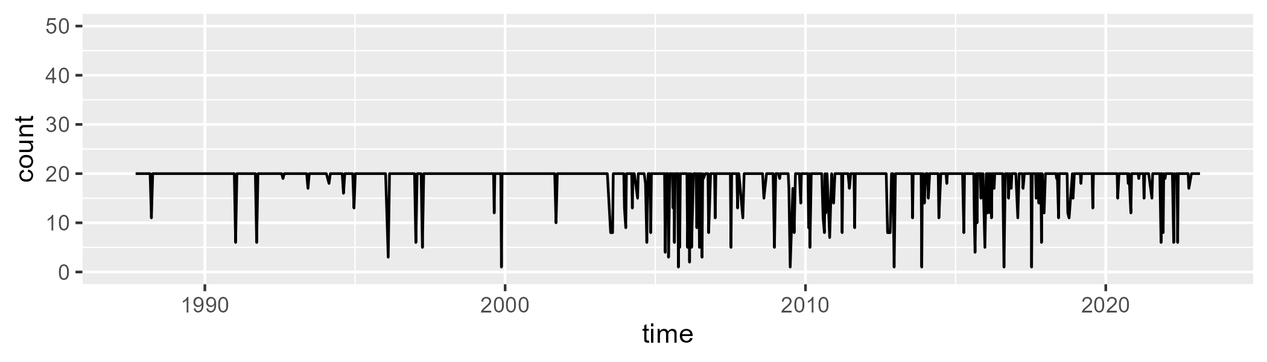

Min. : 1.0 1st Qu.:20.0 Median :20.0 Mean :18.8 3rd Qu.:20.0 Max. :20.0

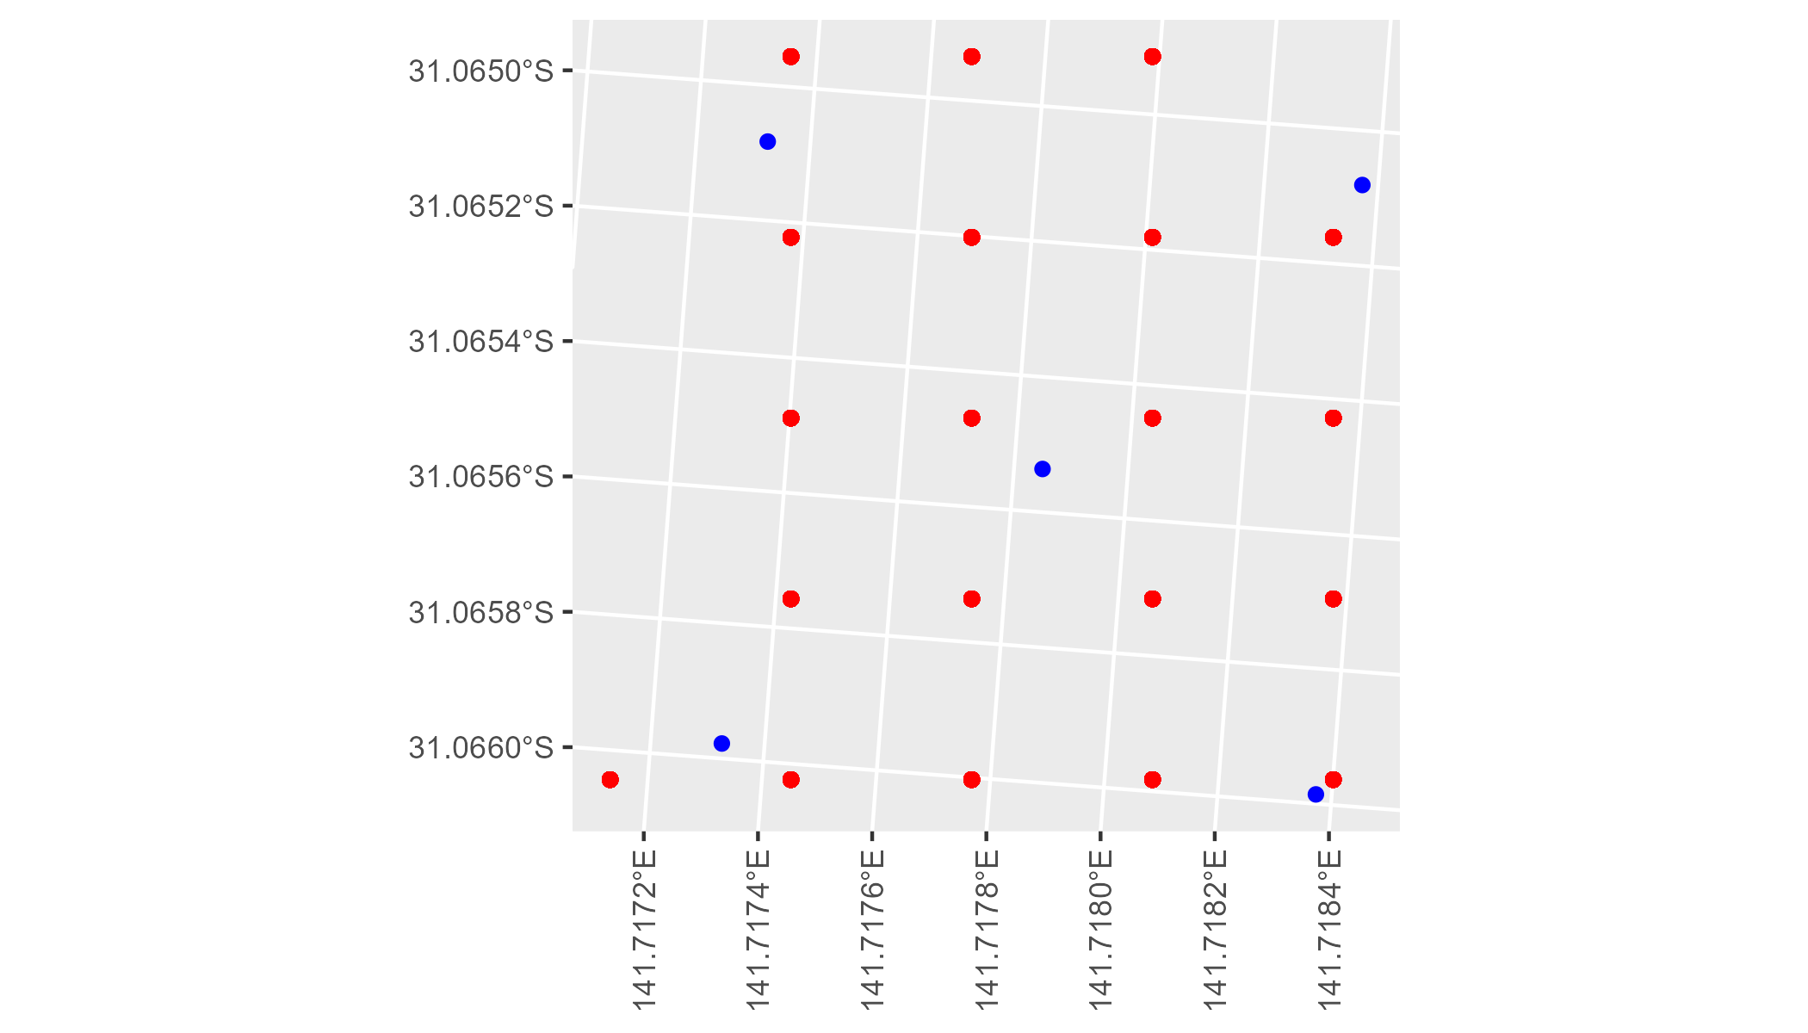

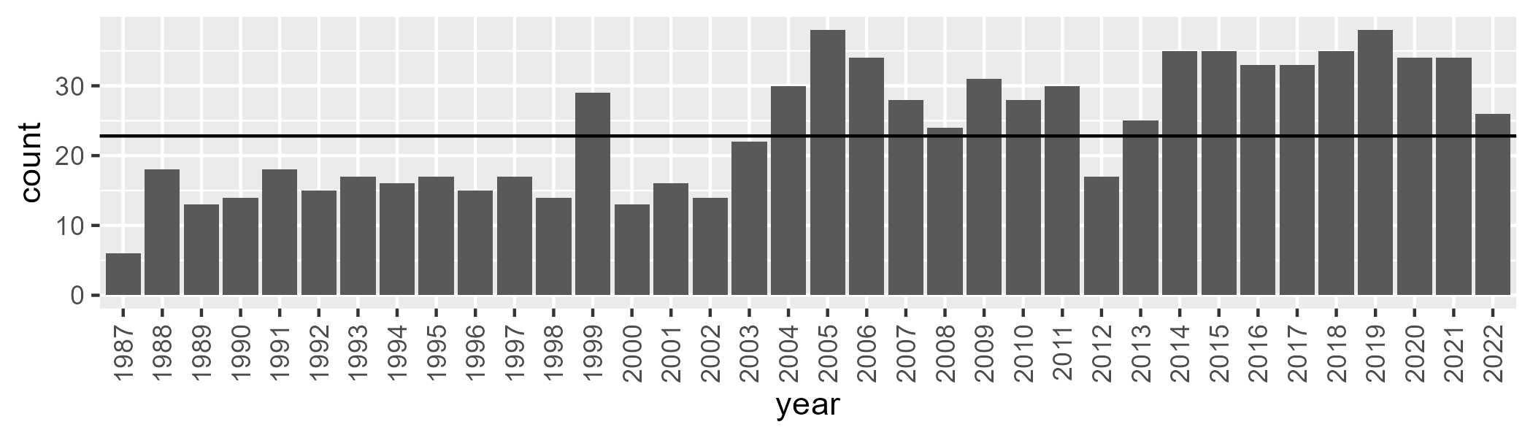

Number of samples: 862

# NSABHC0029

| Min. | 1st Qu. | Median | Mean | 3rd Qu. | Max. |
| --- | --- | --- | --- | --- | --- |
| 8.403459 | 31.04448 | 39.13681 | 38.06373 | 45.362 | 66.56536 |

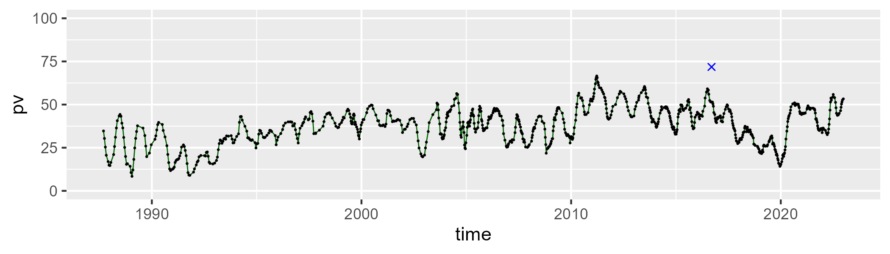

| Min. | 1st Qu. | Median | Mean | 3rd Qu. | Max. |
| --- | --- | --- | --- | --- | --- |
| 20.84369 | 33.43973 | 37.14382 | 37.699 | 41.1216 | 54.43448 |

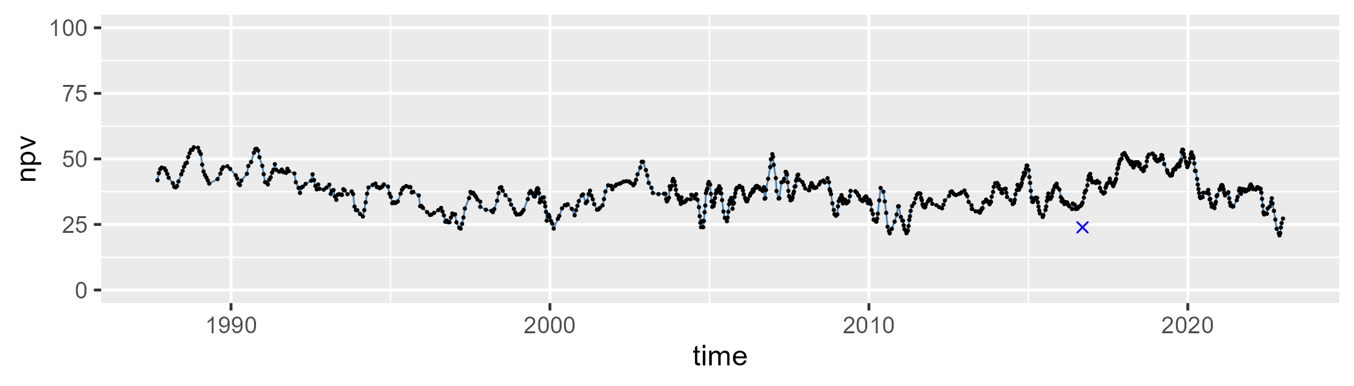

| Min. | 1st Qu. | Median | Mean | 3rd Qu. | Max. |
| --- | --- | --- | --- | --- | --- |
| 2.990203 | 16.49402 | 21.67552 | 22.69945 | 28.0947 | 45.02686 |

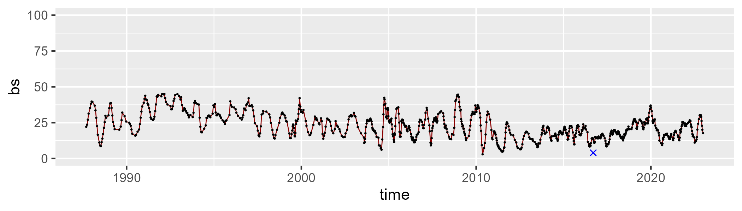

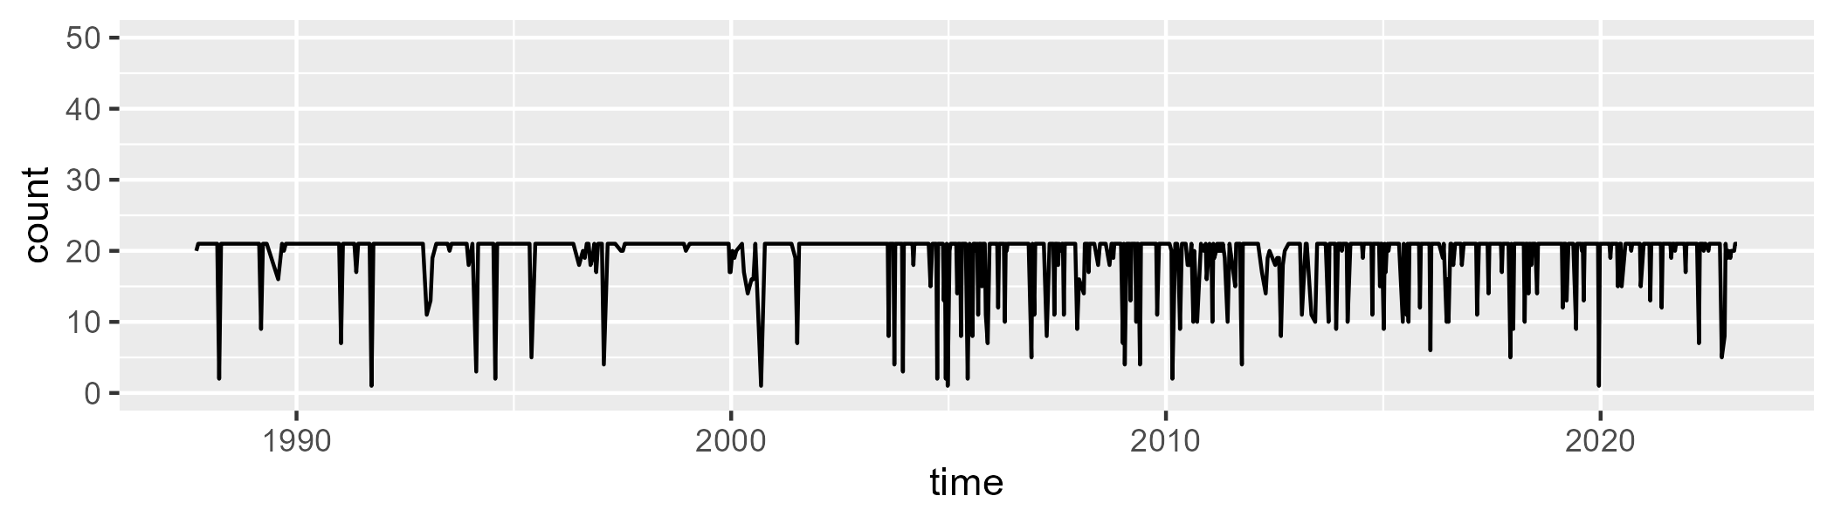

Min. : 1.00 1st Qu.:21.00 Median :21.00 Mean :19.54 3rd Qu.:21.00 Max. :21.00

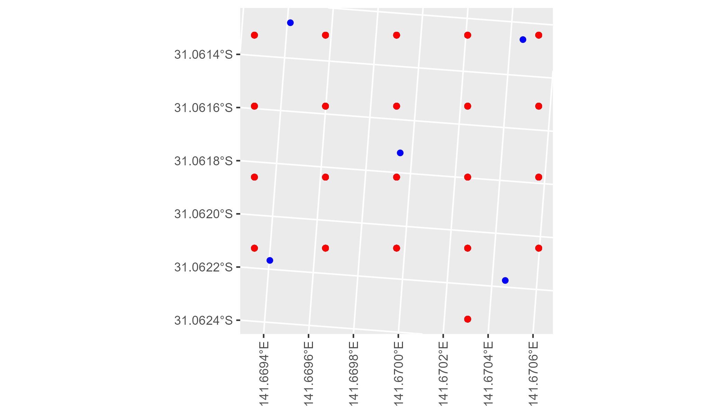

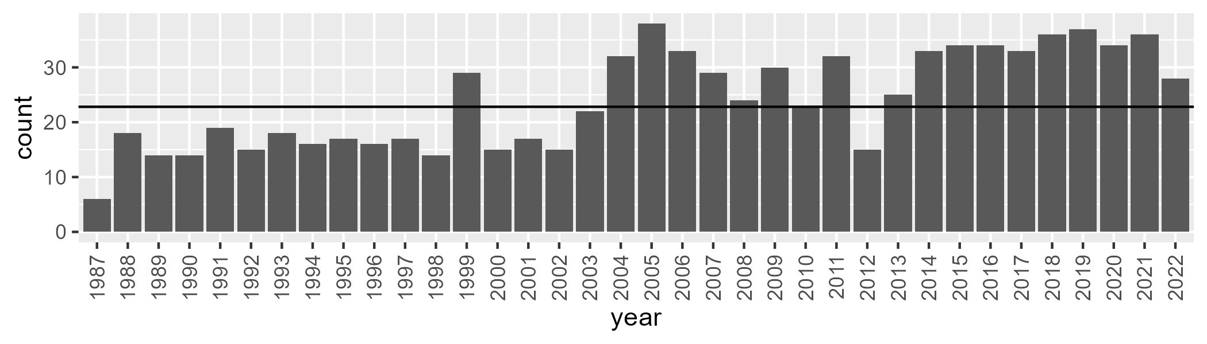

Number of samples: 868

# NSACHC0001

| Min. | 1st Qu. | Median | Mean | 3rd Qu. | Max. |
| --- | --- | --- | --- | --- | --- |
| 0 | 1.267497 | 4.034056 | 6.17056 | 9.075584 | 39.00424 |

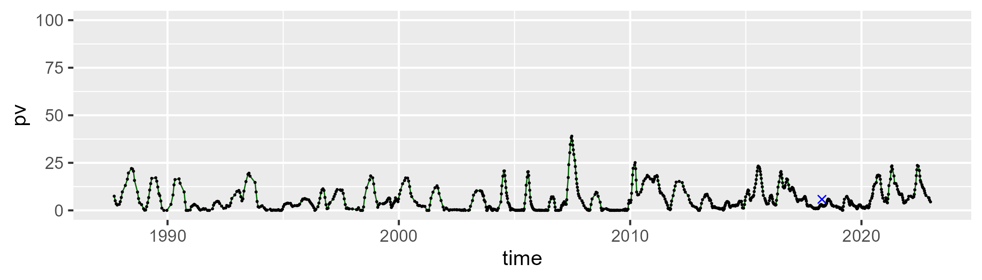

| Min. | 1st Qu. | Median | Mean | 3rd Qu. | Max. |
| --- | --- | --- | --- | --- | --- |
| 23.02053 | 34.54135 | 40.73844 | 40.91784 | 45.63386 | 67.9007 |

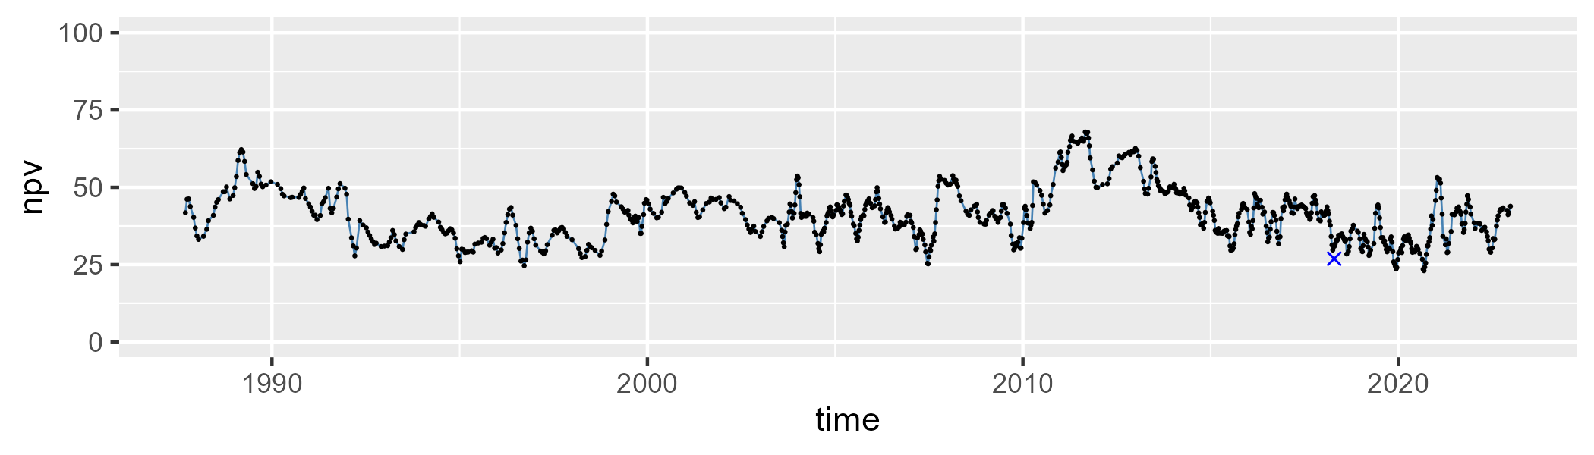

| Min. | 1st Qu. | Median | Mean | 3rd Qu. | Max. |
| --- | --- | --- | --- | --- | --- |
| 21.65816 | 46.31283 | 52.47169 | 51.56543 | 58.02425 | 72.55872 |

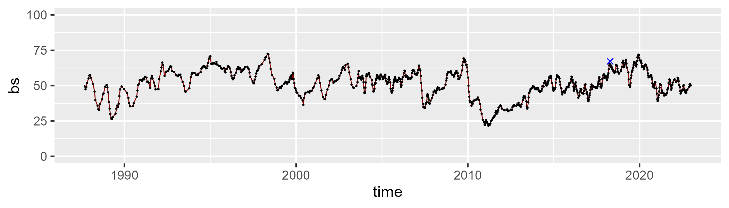

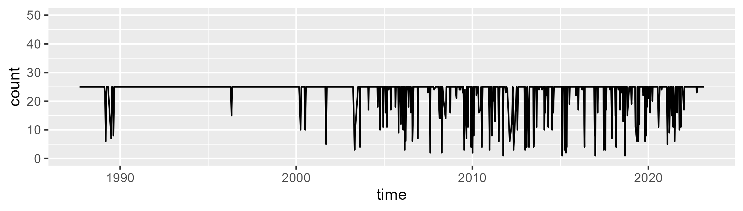

Min. : 1.00 1st Qu.:25.00 Median :25.00 Mean :23.12 3rd Qu.:25.00 Max. :25.00

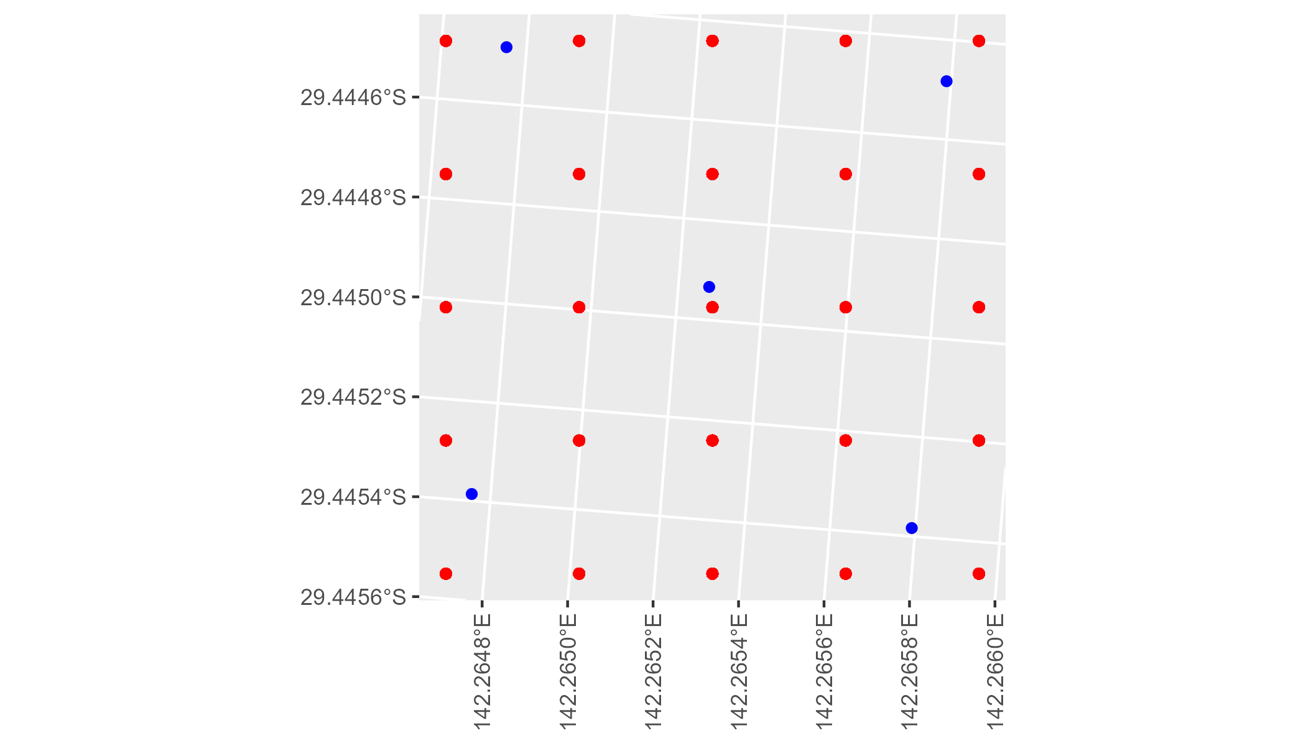

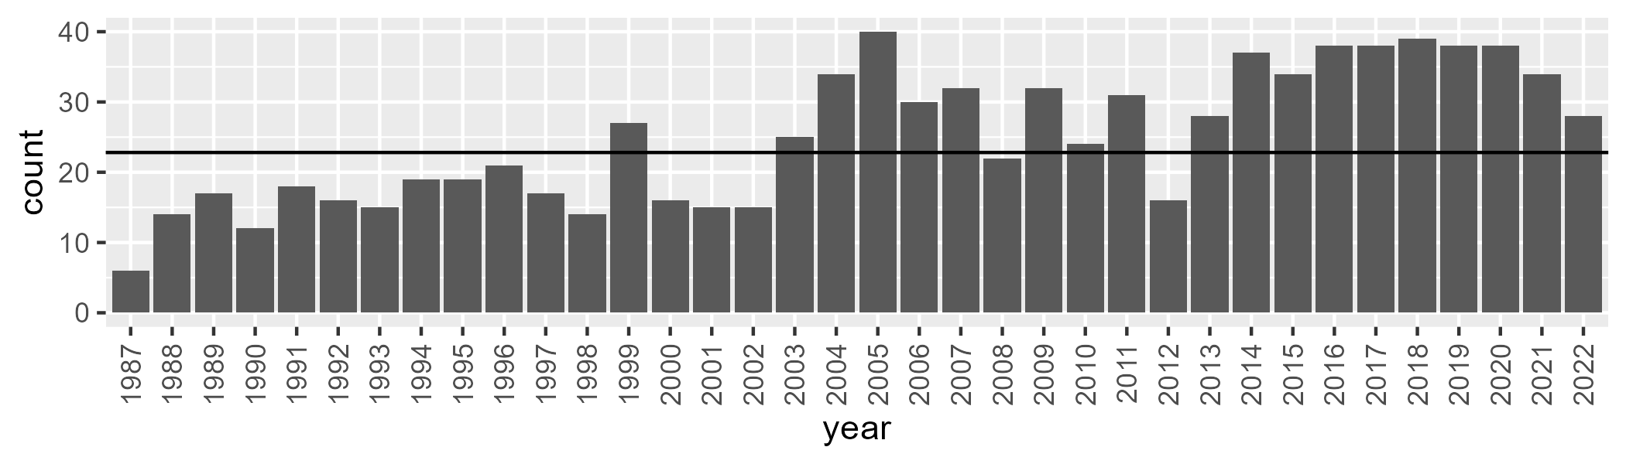

Number of samples: 899

# NSACHC0002

| Min. | 1st Qu. | Median | Mean | 3rd Qu. | Max. |
| --- | --- | --- | --- | --- | --- |
| 0 | 8.001554 | 14.6338 | 17.0232 | 24.01998 | 57.32679 |

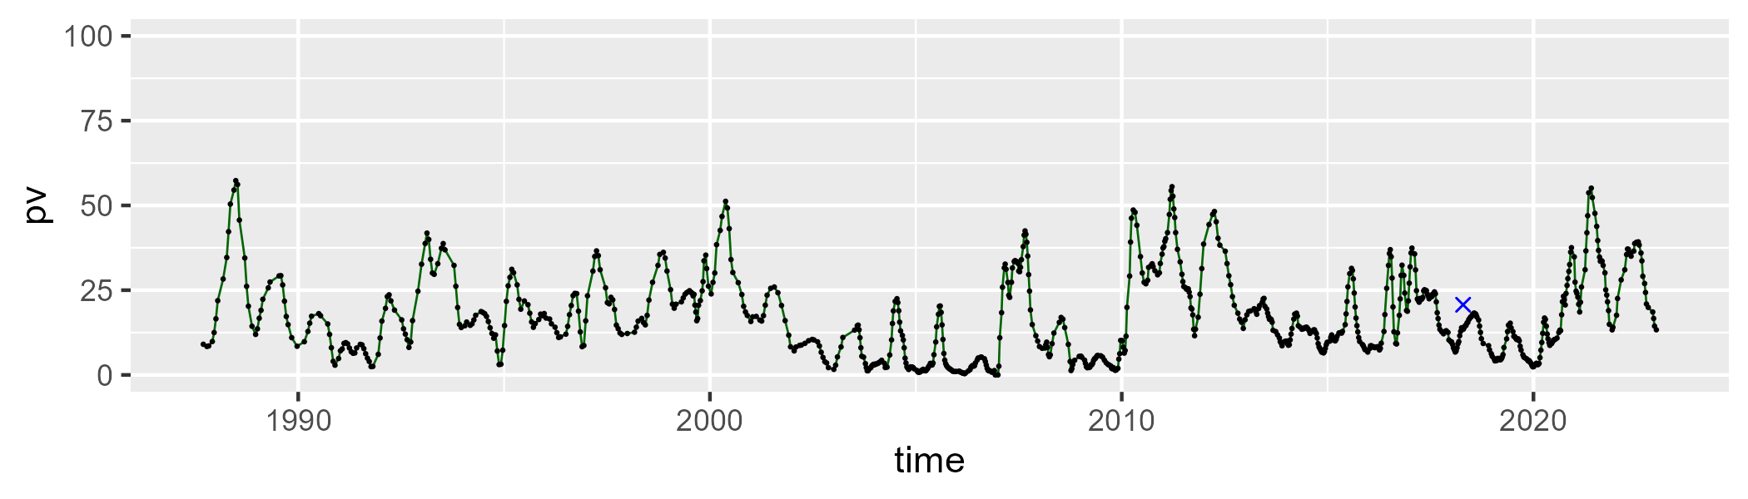

| Min. | 1st Qu. | Median | Mean | 3rd Qu. | Max. |
| --- | --- | --- | --- | --- | --- |
| 20.19135 | 38.20686 | 43.5323 | 42.86898 | 48.14882 | 65.47269 |

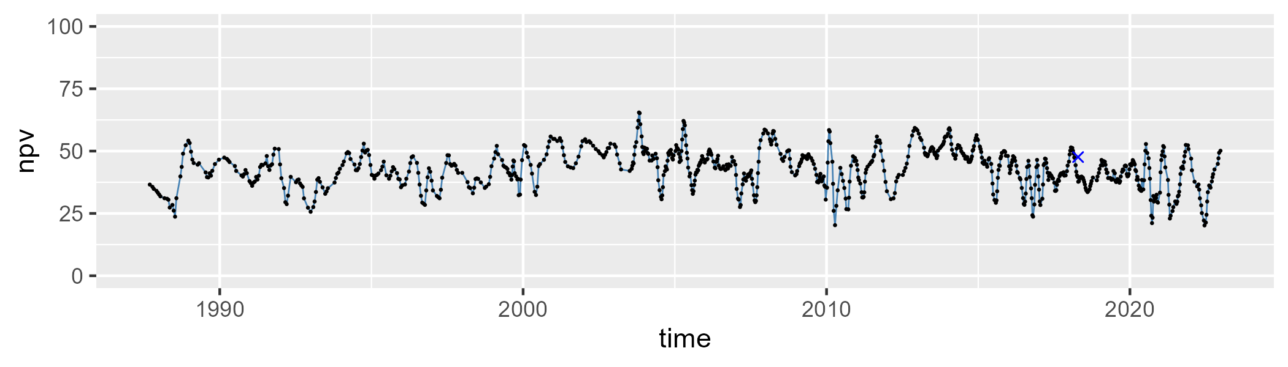

| Min. | 1st Qu. | Median | Mean | 3rd Qu. | Max. |
| --- | --- | --- | --- | --- | --- |
| 10.72333 | 31.63182 | 39.43663 | 38.72266 | 46.80926 | 59.63868 |

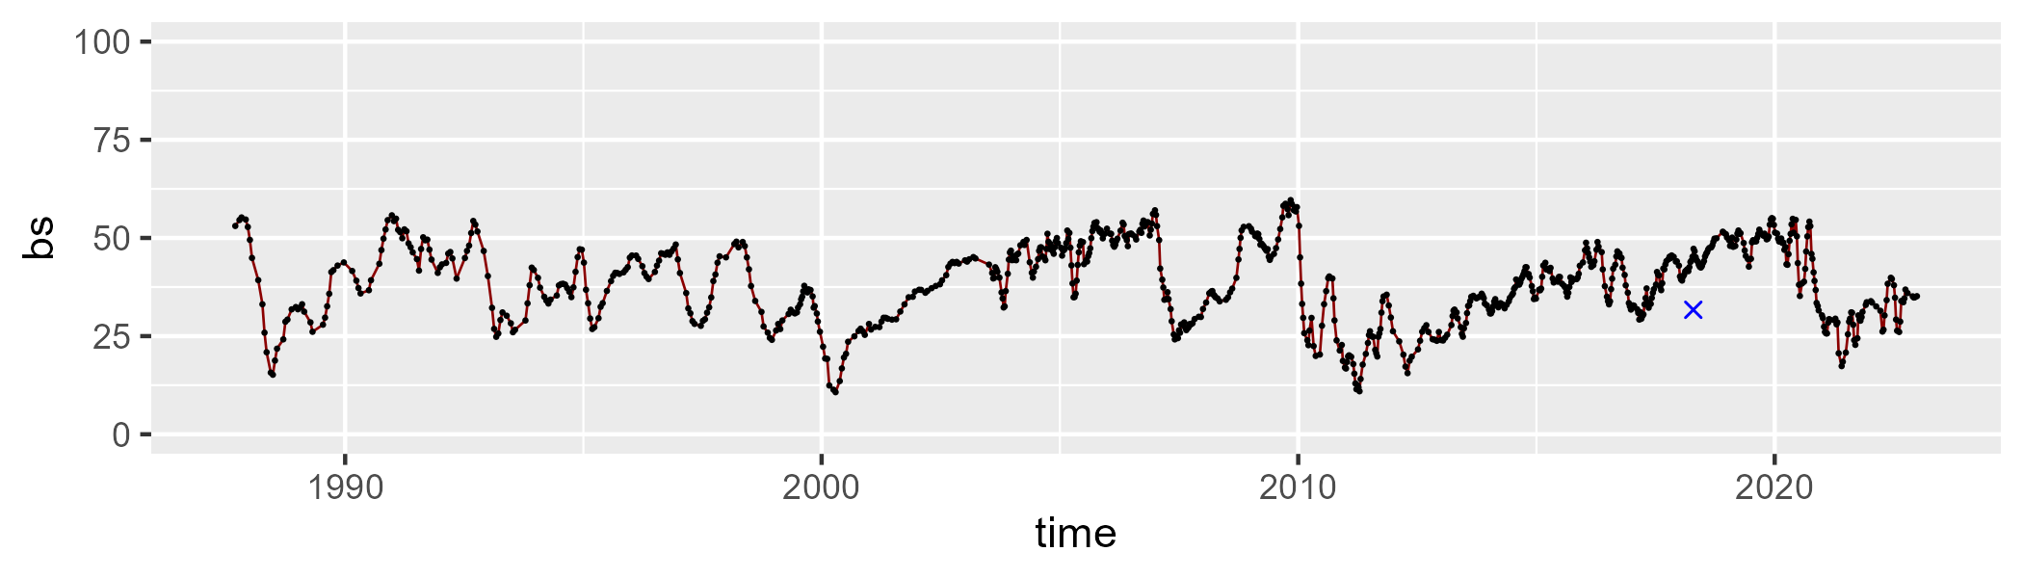

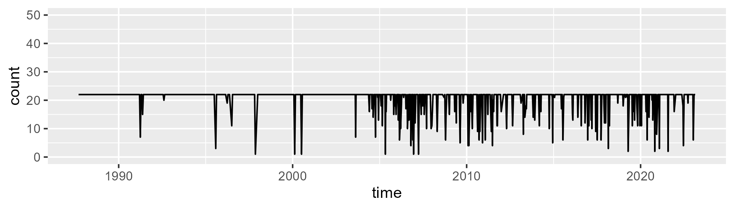

Min. : 1.0 1st Qu.:22.0 Median :22.0 Mean :20.5 3rd Qu.:22.0 Max. :22.0

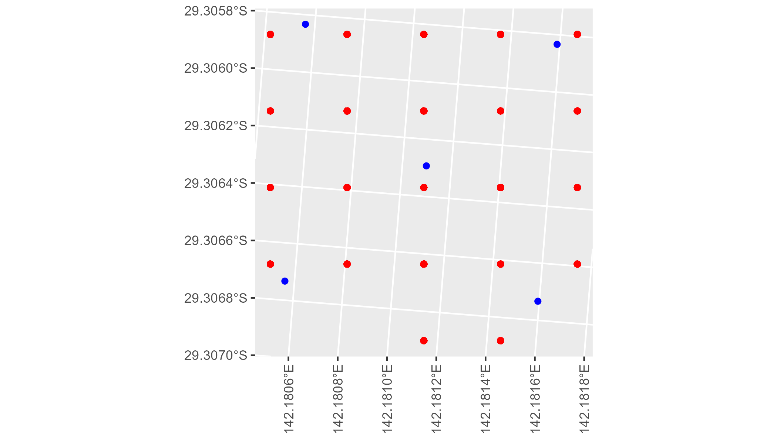

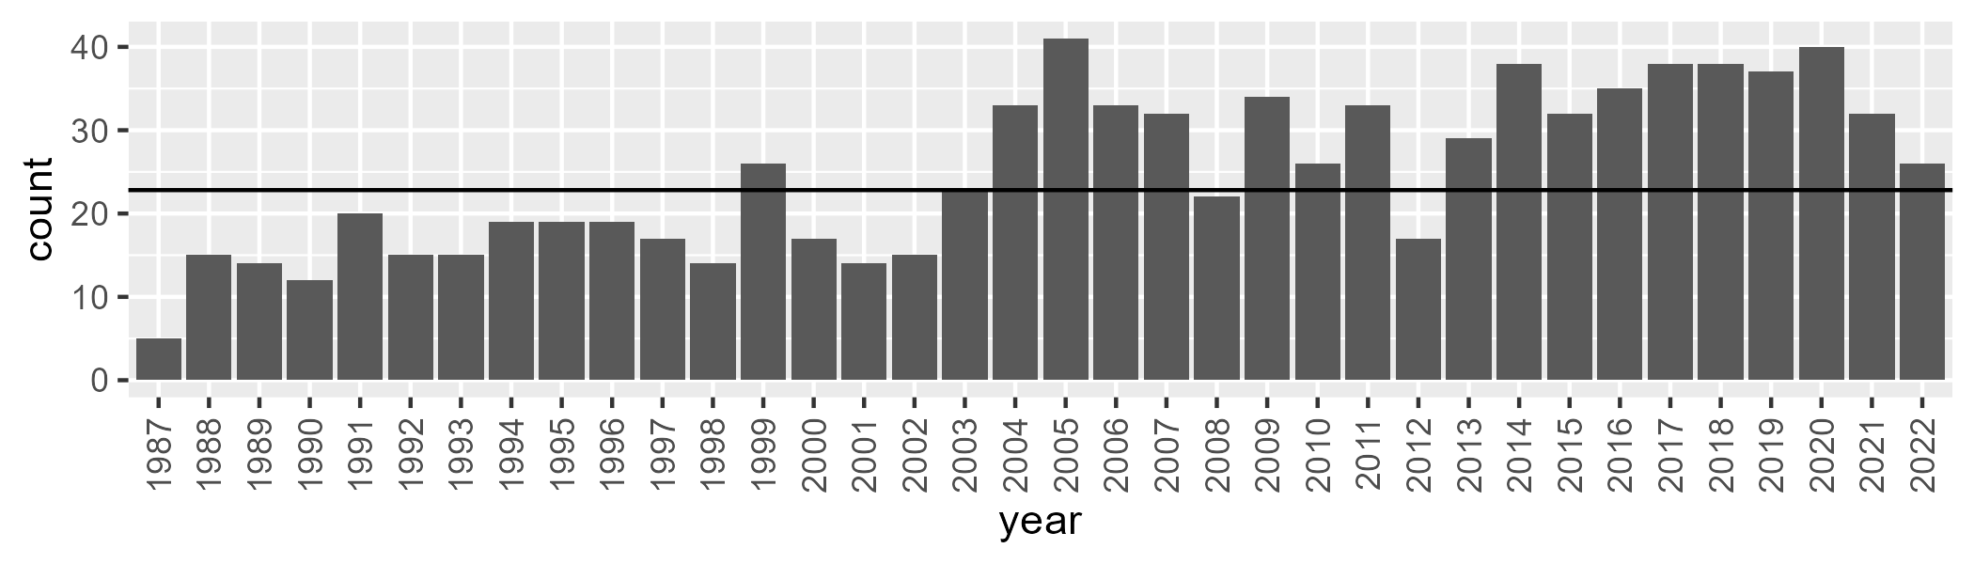

Number of samples: 895

# NSACHC0003

| Min. | 1st Qu. | Median | Mean | 3rd Qu. | Max. |
| --- | --- | --- | --- | --- | --- |
| 0 | 10.83038 | 19.09216 | 20.7576 | 29.59841 | 57.10079 |

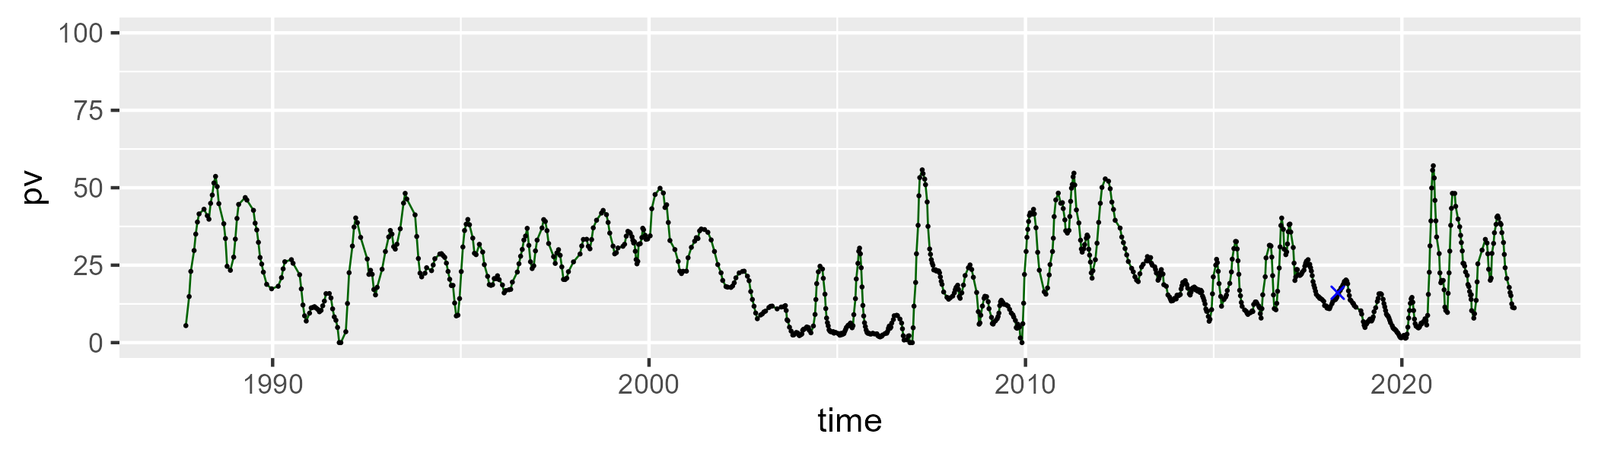

| Min. | 1st Qu. | Median | Mean | 3rd Qu. | Max. |
| --- | --- | --- | --- | --- | --- |
| 18.04161 | 40.87529 | 46.63104 | 46.27469 | 52.23914 | 68.11273 |

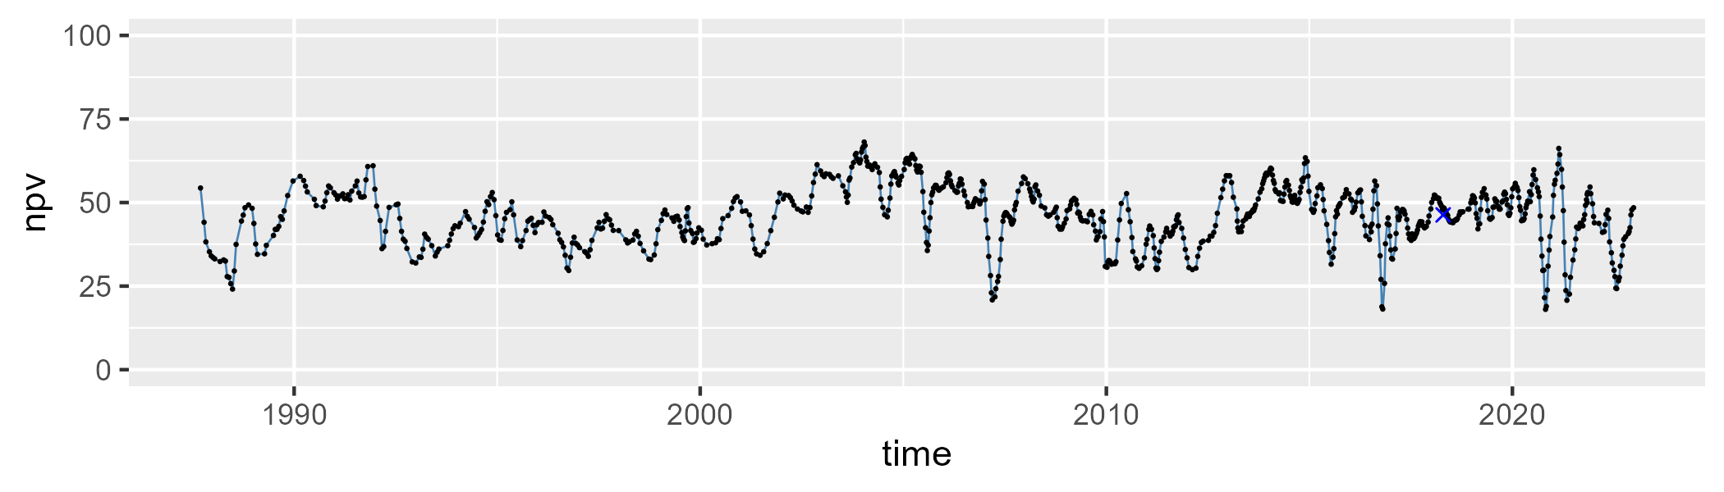

| Min. | 1st Qu. | Median | Mean | 3rd Qu. | Max. |
| --- | --- | --- | --- | --- | --- |
| 10.8011 | 26.33919 | 31.28877 | 31.57989 | 36.84778 | 55.03251 |

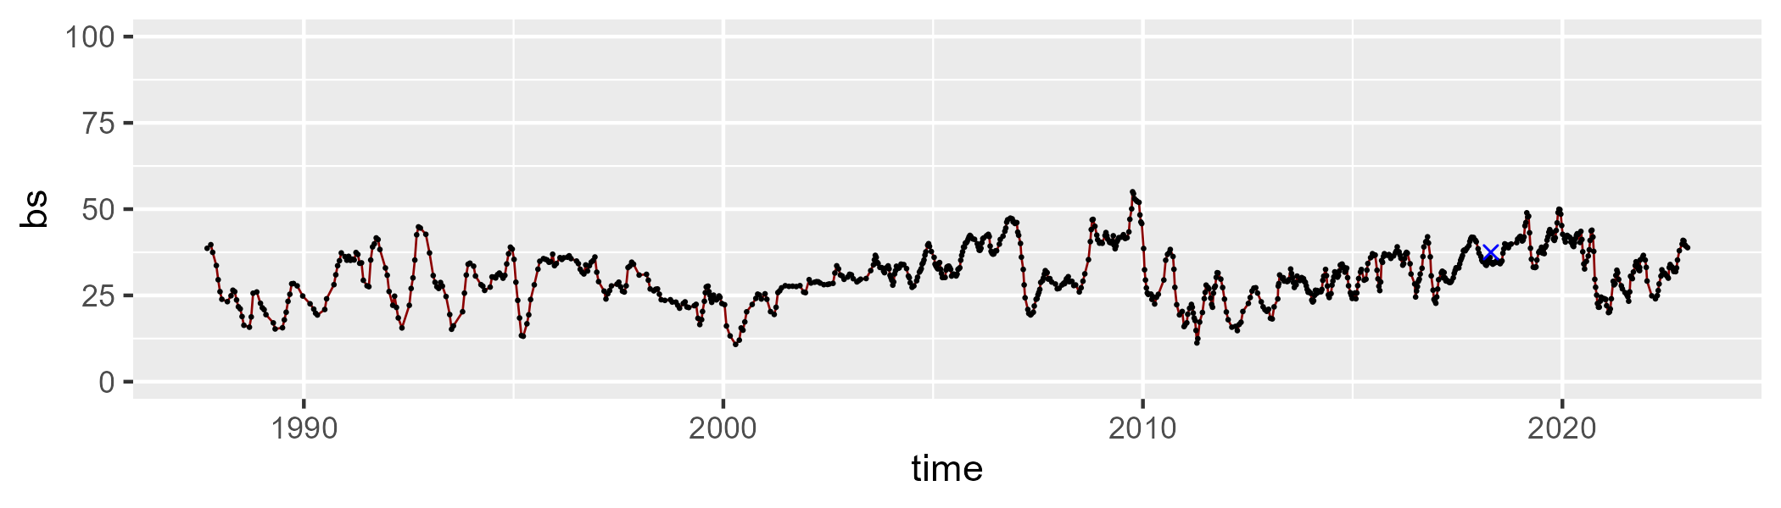

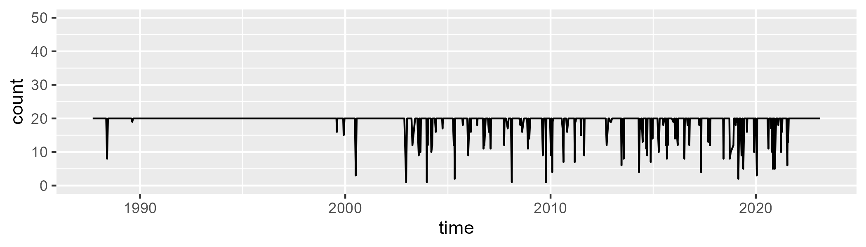

Min. : 1.0 1st Qu.:20.0 Median :20.0 Mean :19.1 3rd Qu.:20.0 Max. :20.0

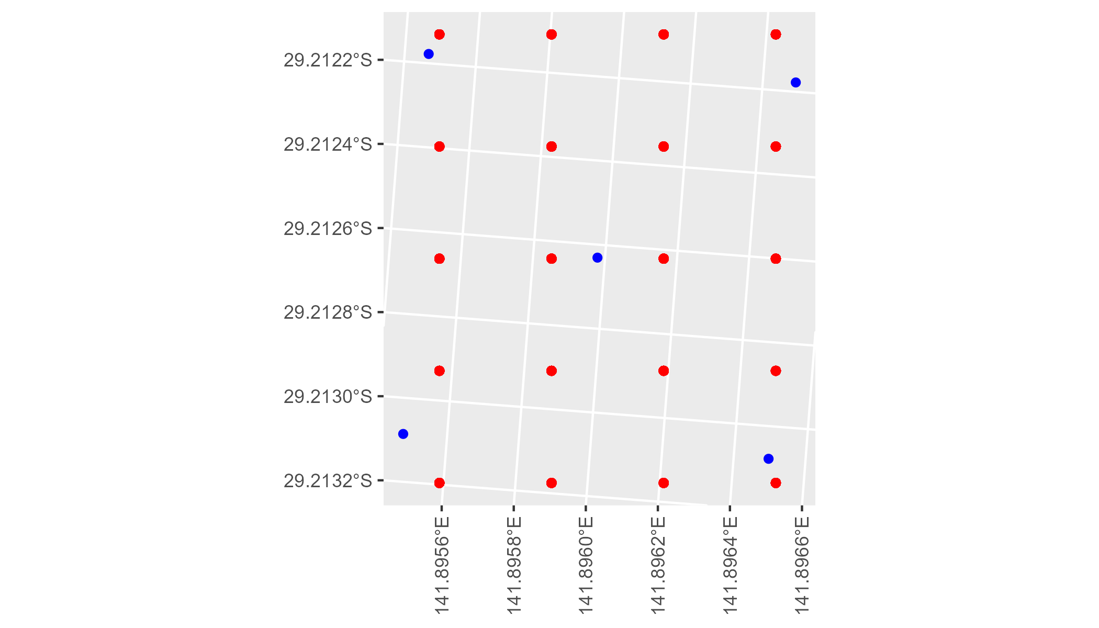

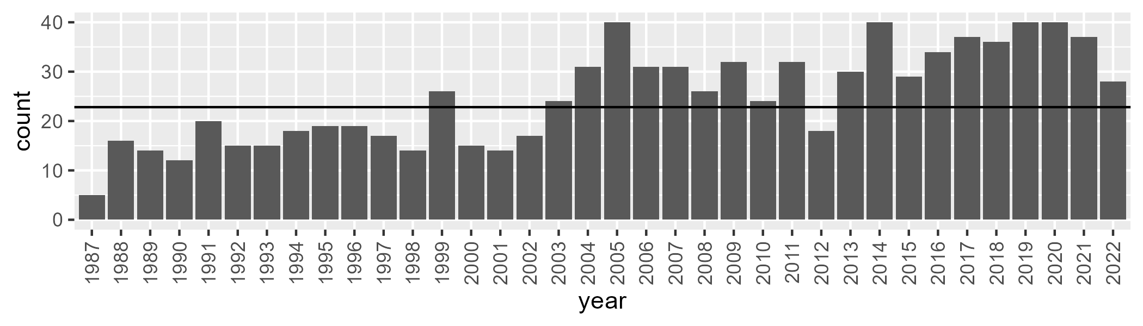

Number of samples: 896

# NSACHC0004

| Min. | 1st Qu. | Median | Mean | 3rd Qu. | Max. |
| --- | --- | --- | --- | --- | --- |
| 0 | 3.912283 | 6.646436 | 7.975702 | 10.34937 | 32.24974 |

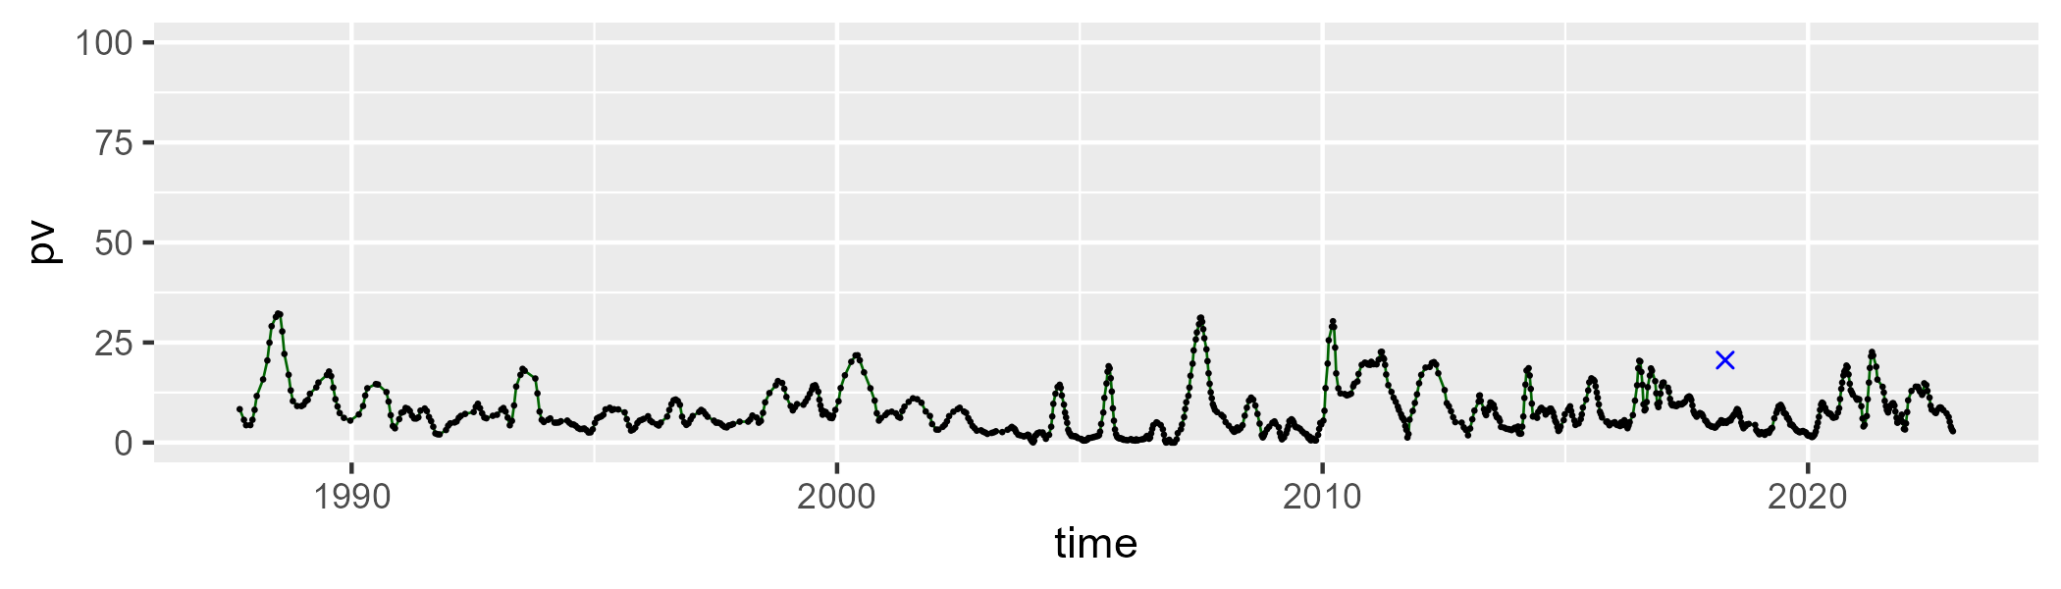

| Min. | 1st Qu. | Median | Mean | 3rd Qu. | Max. |
| --- | --- | --- | --- | --- | --- |
| 22.38088 | 35.87585 | 39.73733 | 40.26278 | 43.6761 | 62.92889 |

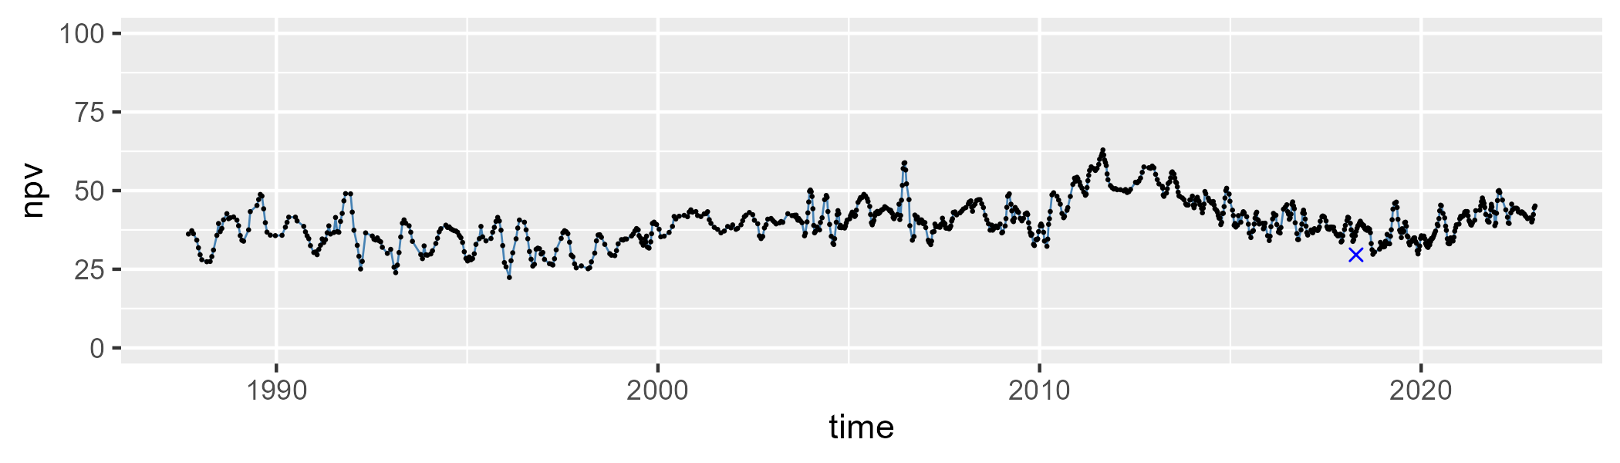

| Min. | 1st Qu. | Median | Mean | 3rd Qu. | Max. |
| --- | --- | --- | --- | --- | --- |
| 24.48141 | 45.68911 | 51.3457 | 50.30103 | 56.34989 | 69.47241 |

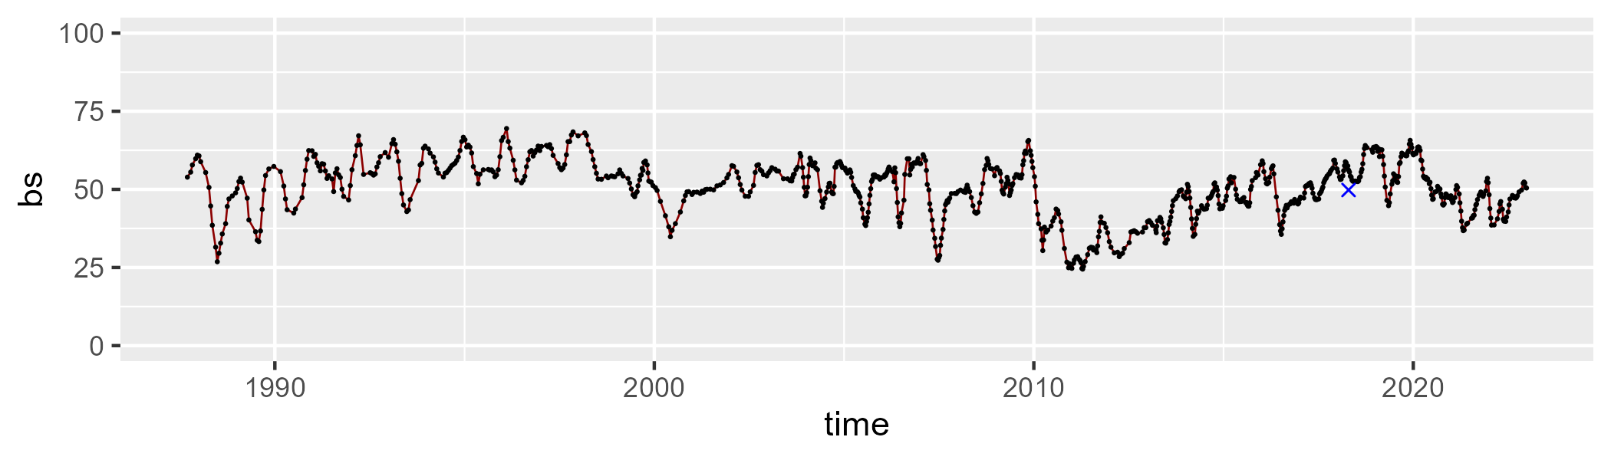

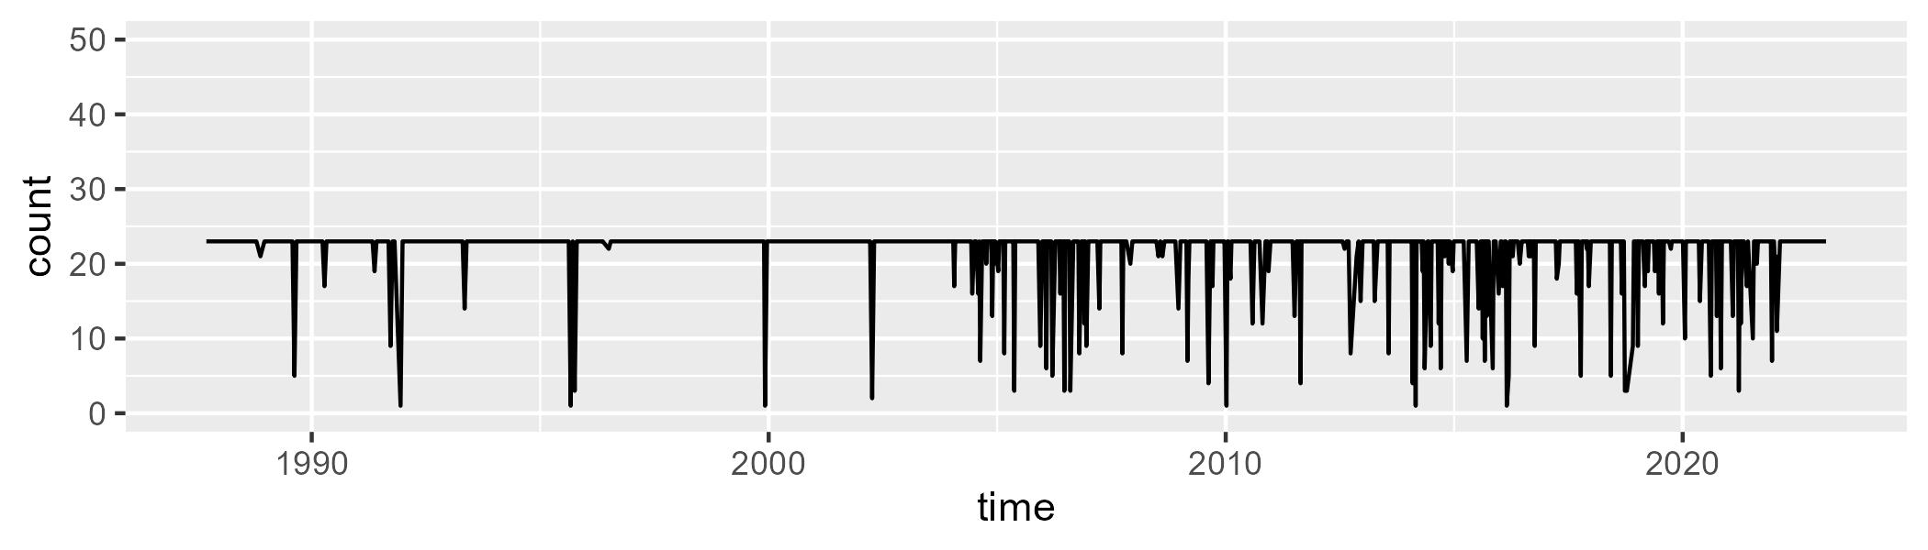

Min. : 1.00 1st Qu.:23.00 Median :23.00 Mean :21.66 3rd Qu.:23.00 Max. :23.00

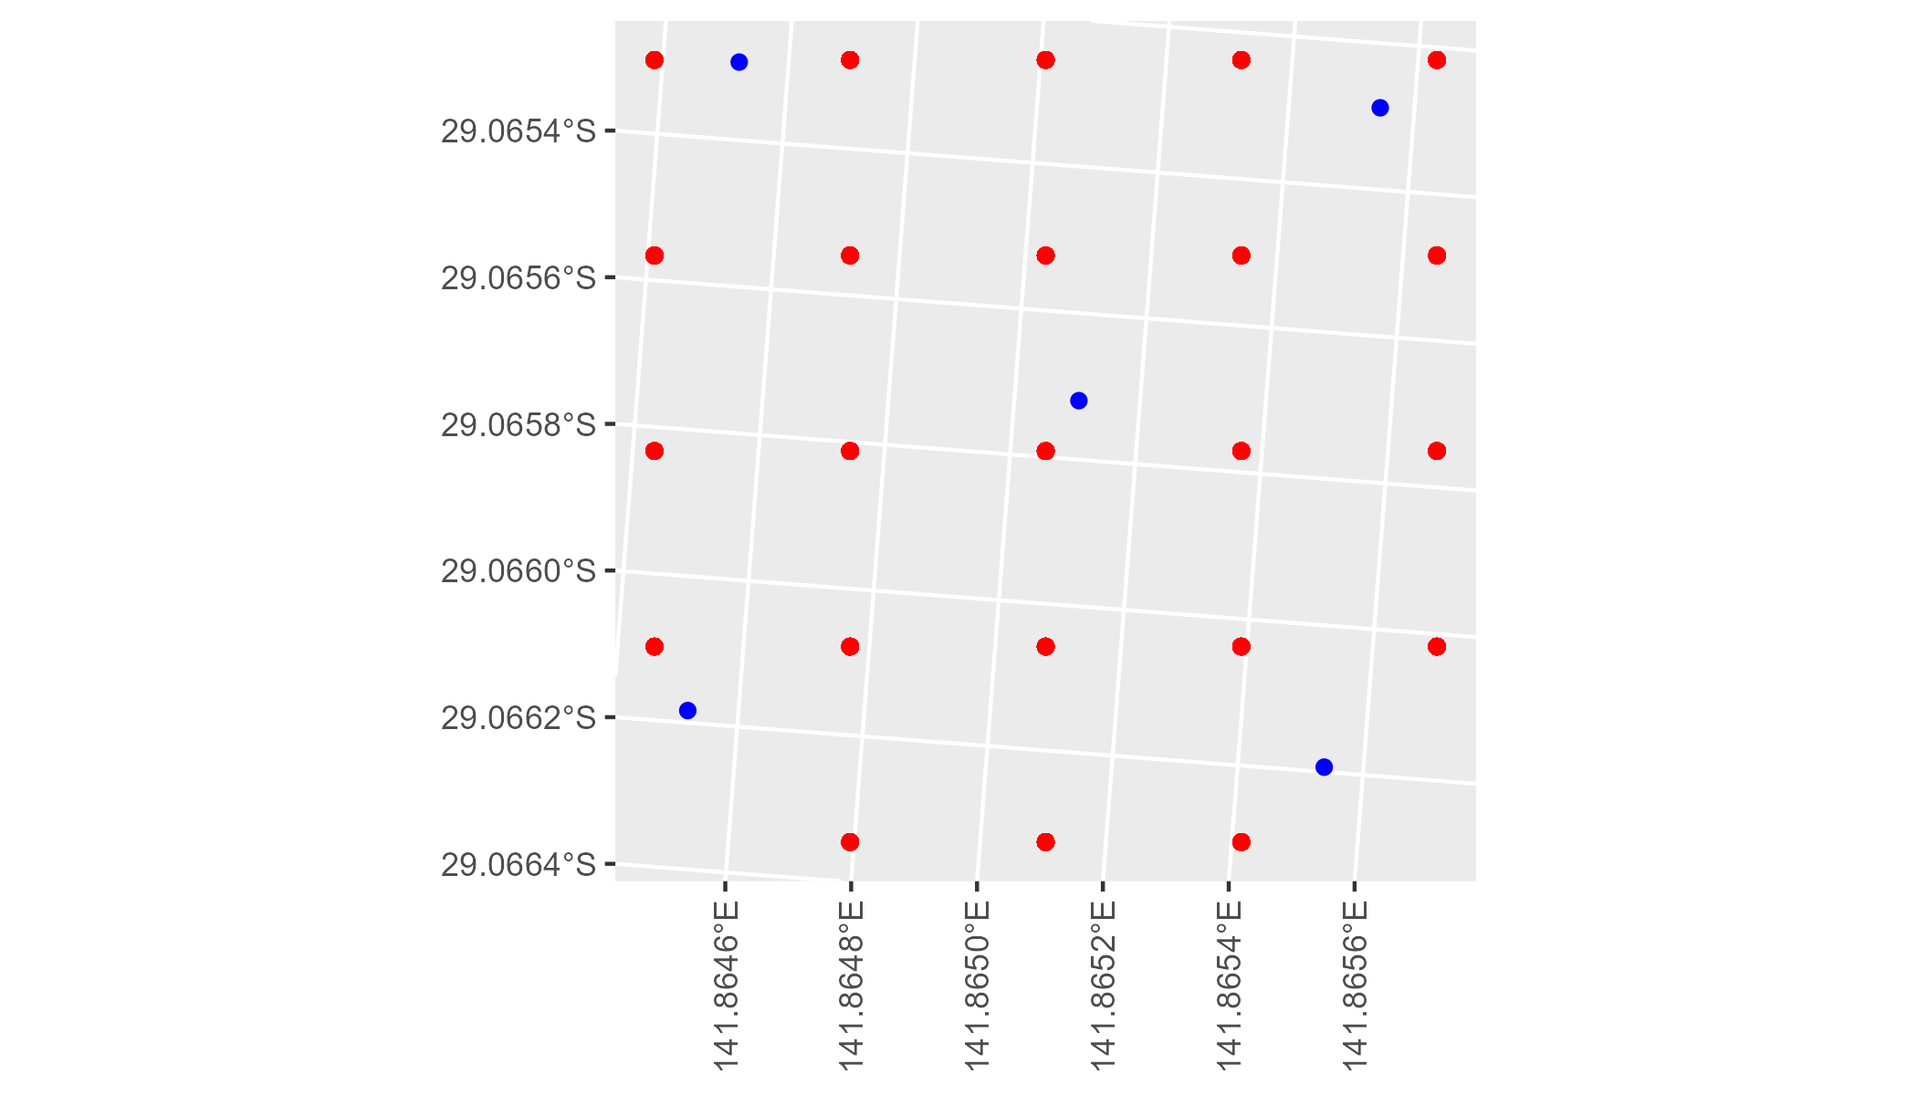

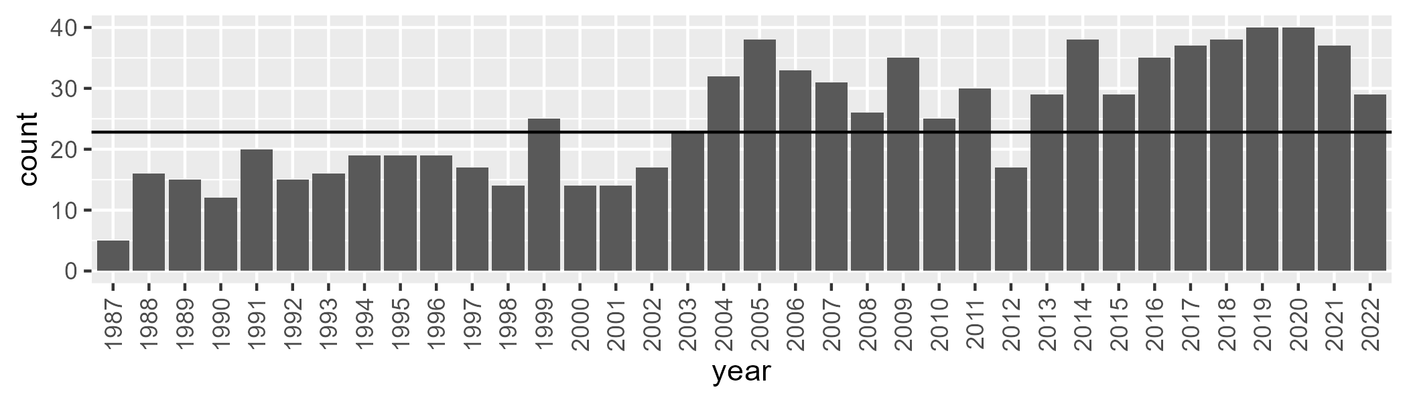

Number of samples: 899

# NSACOP0001

| Min. | 1st Qu. | Median | Mean | 3rd Qu. | Max. |
| --- | --- | --- | --- | --- | --- |
| 12.17353 | 22.78549 | 29.86815 | 32.68172 | 40.97324 | 71.15608 |

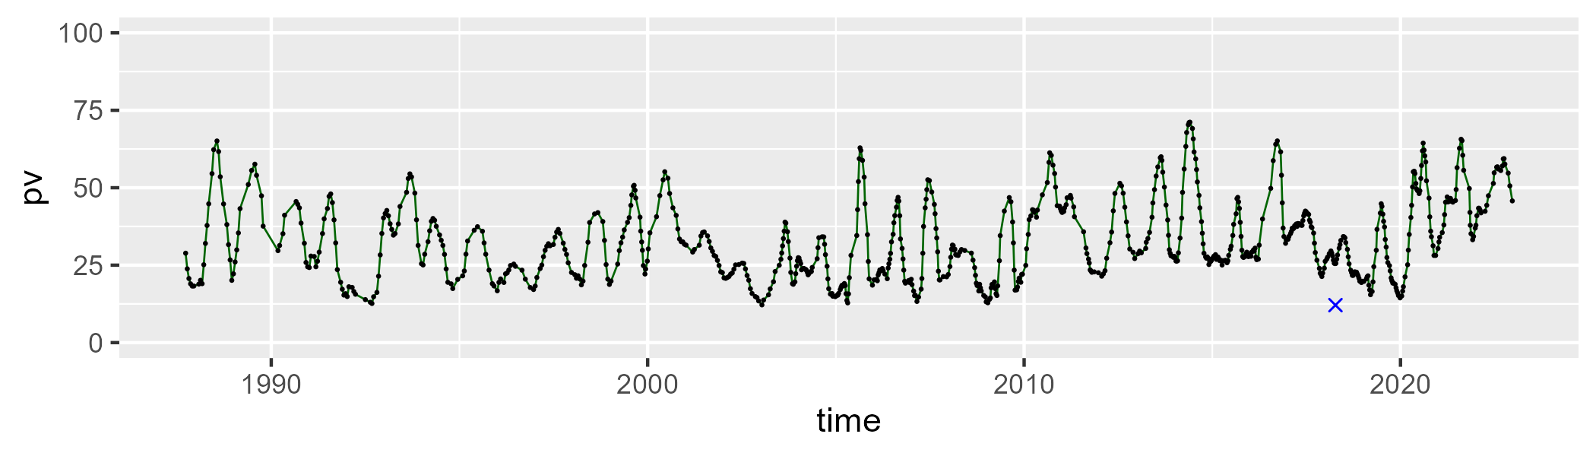

| Min. | 1st Qu. | Median | Mean | 3rd Qu. | Max. |
| --- | --- | --- | --- | --- | --- |
| 20.98127 | 46.57702 | 51.05692 | 49.78872 | 54.78689 | 64.37913 |

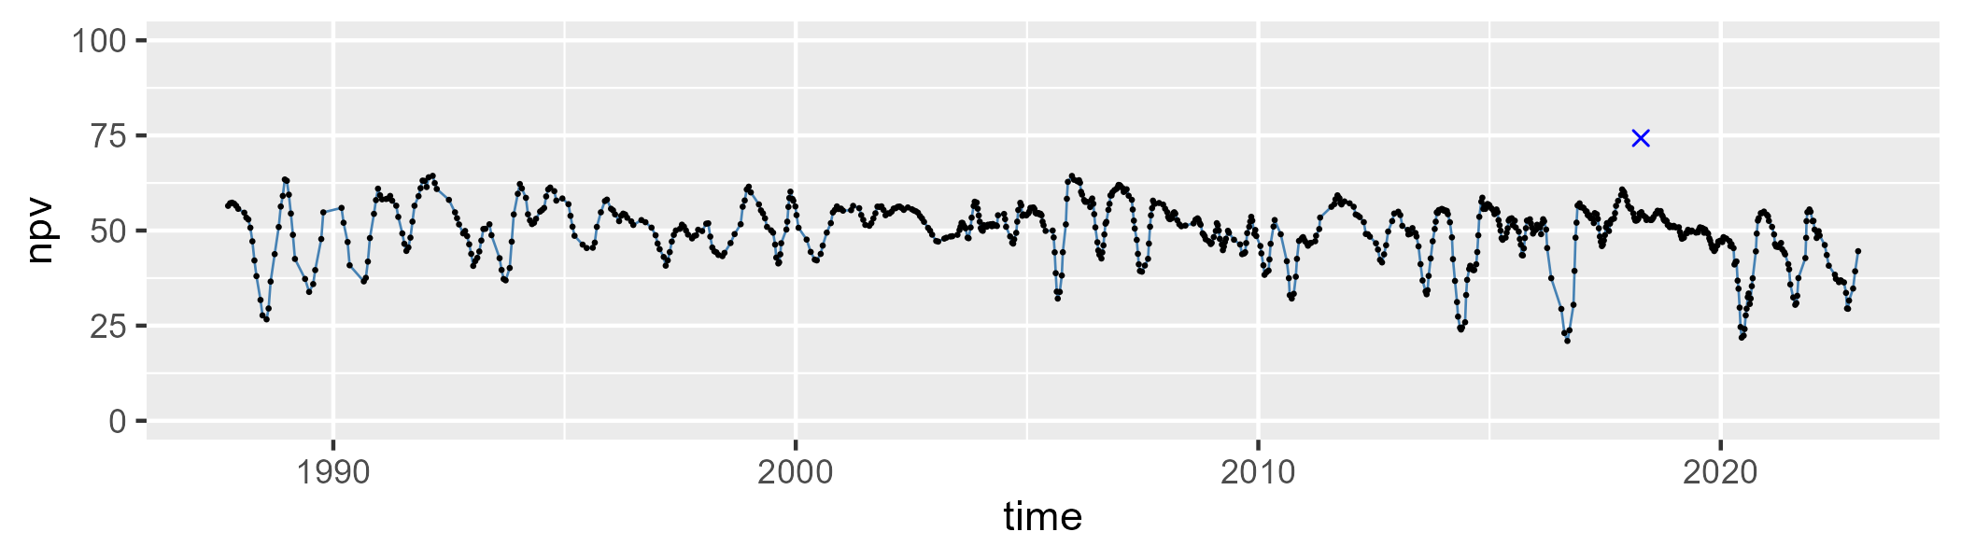

| Min. | 1st Qu. | Median | Mean | 3rd Qu. | Max. |
| --- | --- | --- | --- | --- | --- |
| 0.03033349 | 9.69465 | 15.77952 | 16.40301 | 21.80844 | 39.16095 |

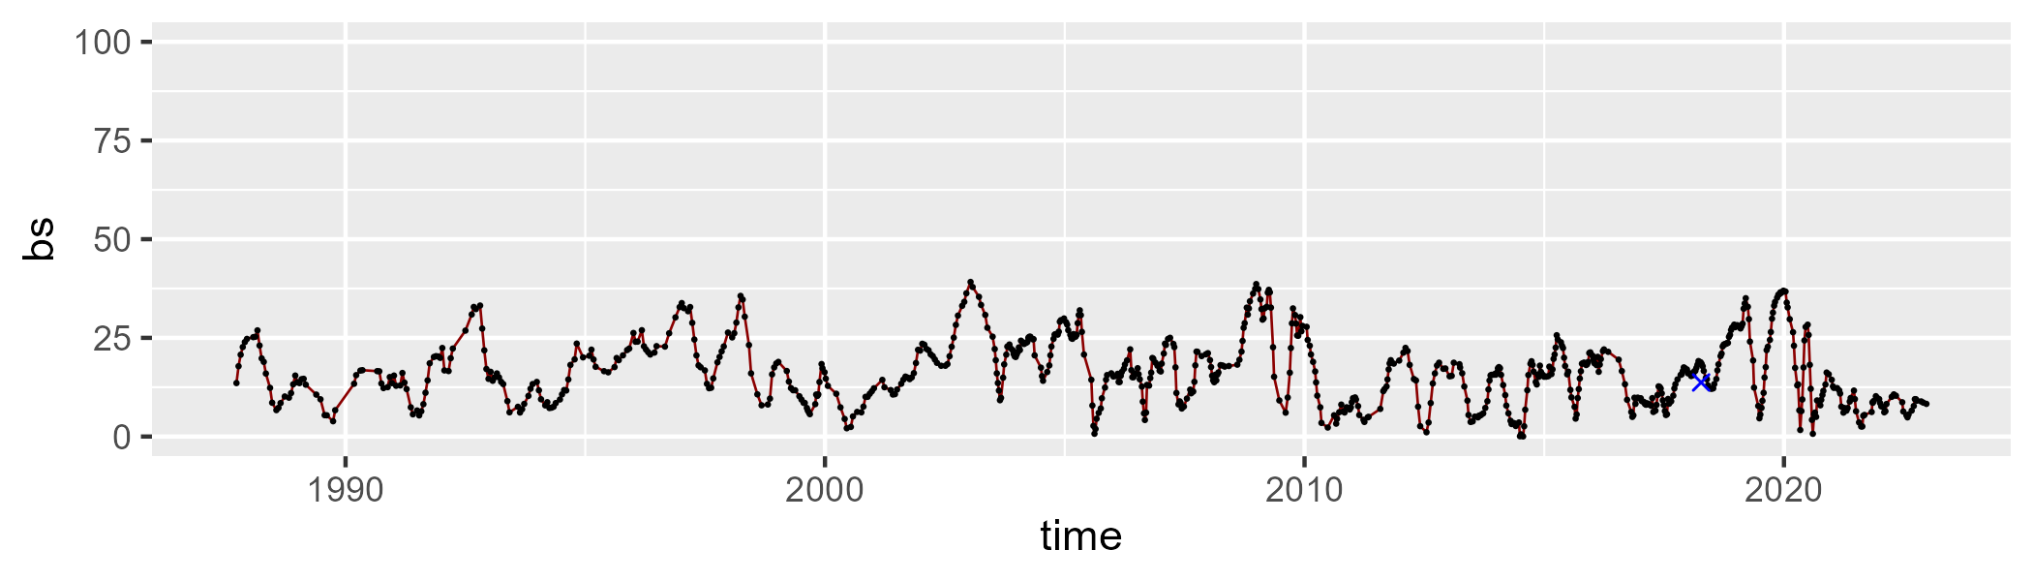

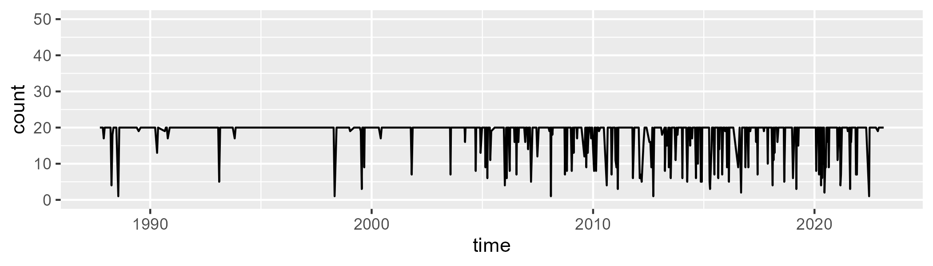

Min. : 1.00 1st Qu.:20.00 Median :20.00 Mean :18.48 3rd Qu.:20.00 Max. :20.00

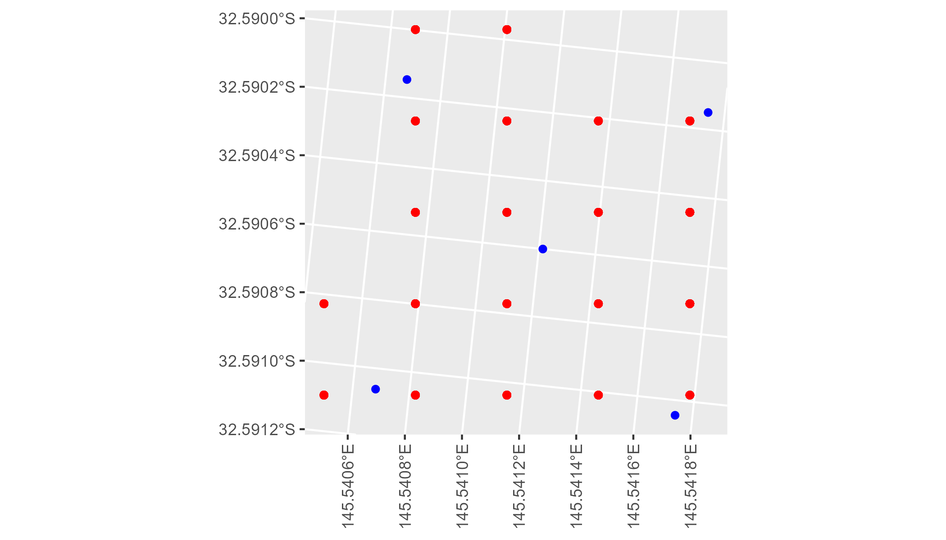

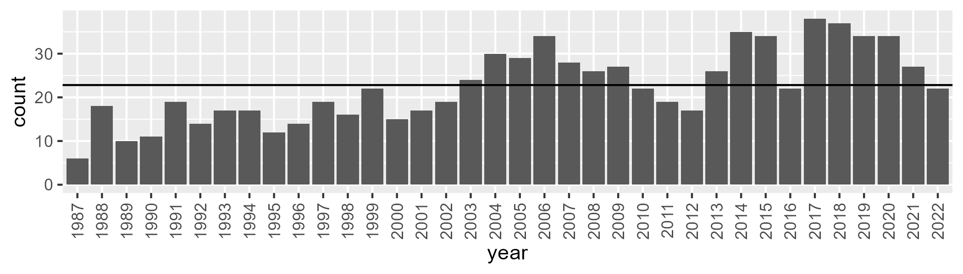

Number of samples: 811

# NSACOP0002

| Min. | 1st Qu. | Median | Mean | 3rd Qu. | Max. |
| --- | --- | --- | --- | --- | --- |
| 20.59781 | 27.25578 | 30.81385 | 31.58832 | 35.67235 | 47.65907 |

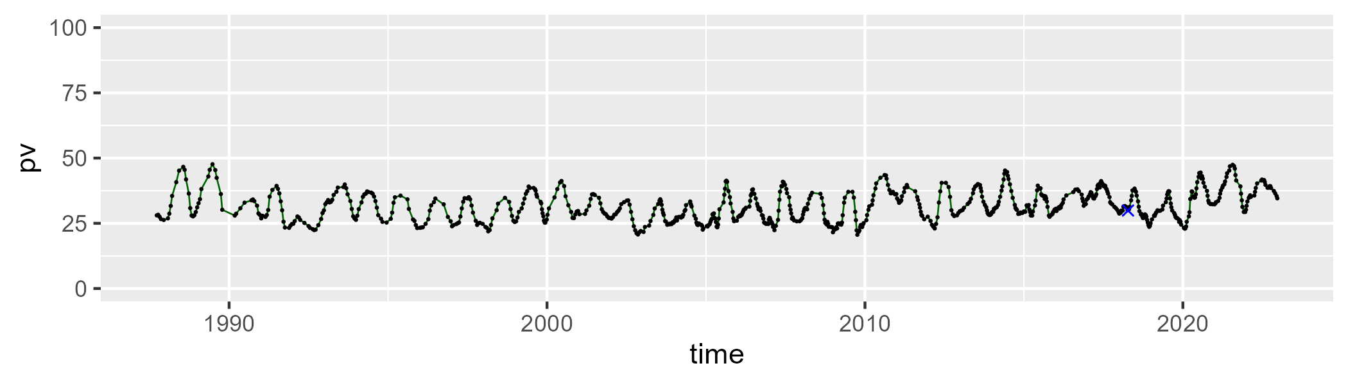

| Min. | 1st Qu. | Median | Mean | 3rd Qu. | Max. |
| --- | --- | --- | --- | --- | --- |
| 41.70026 | 51.10487 | 52.80945 | 52.64782 | 54.50856 | 59.83527 |

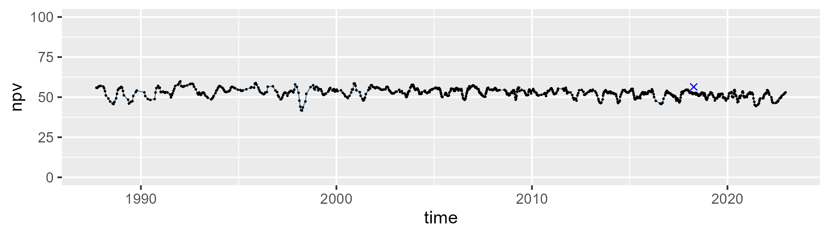

| Min. | 1st Qu. | Median | Mean | 3rd Qu. | Max. |
| --- | --- | --- | --- | --- | --- |
| 3.290977 | 11.16796 | 14.72613 | 14.72944 | 17.70226 | 34.7202 |

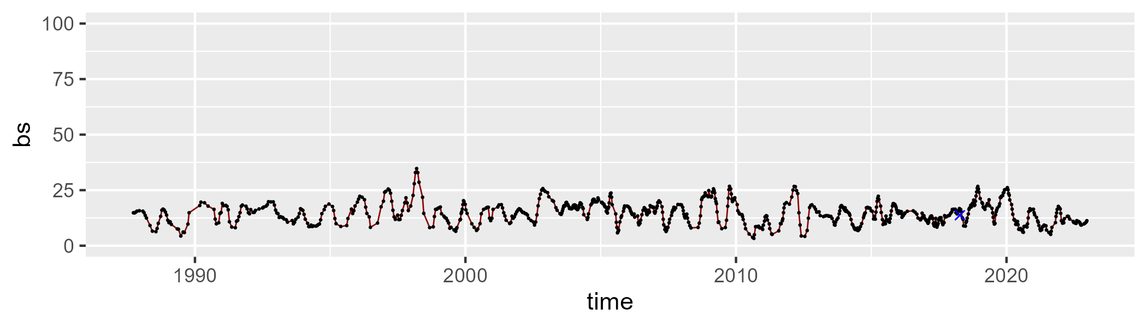

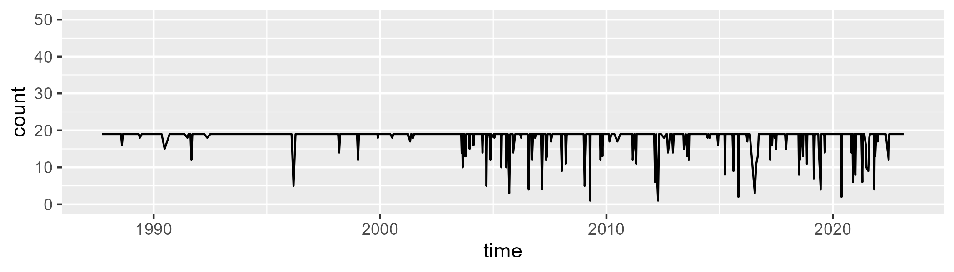

Min. : 1.00 1st Qu.:19.00 Median :19.00 Mean :18.19 3rd Qu.:19.00 Max. :19.00

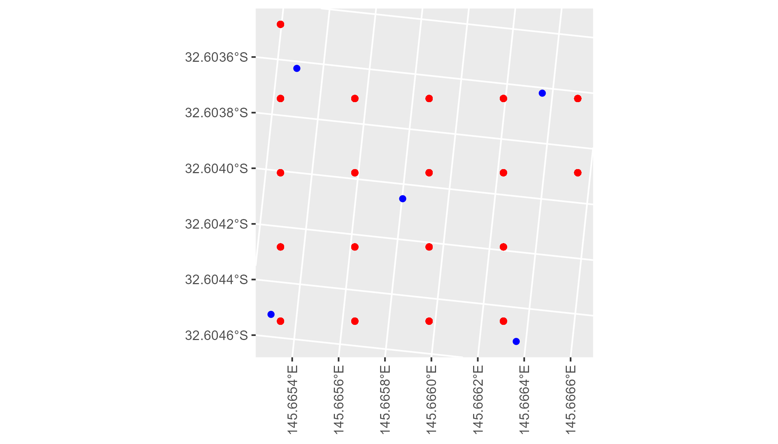

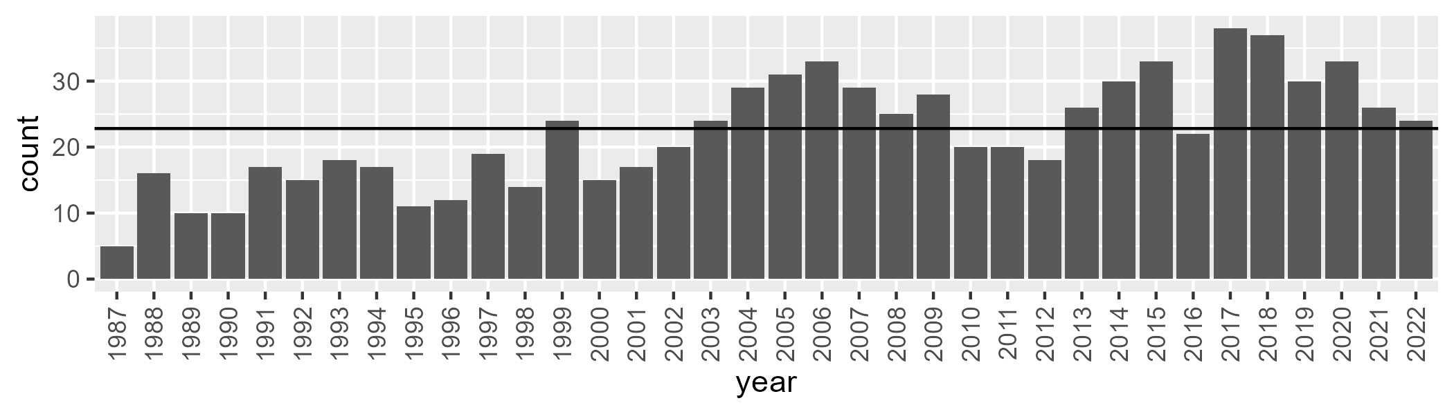

Number of samples: 796

# NSAMDD0001

| Min. | 1st Qu. | Median | Mean | 3rd Qu. | Max. |
| --- | --- | --- | --- | --- | --- |
| 0 | 6.873942 | 13.30629 | 18.99766 | 27.99627 | 71.71159 |

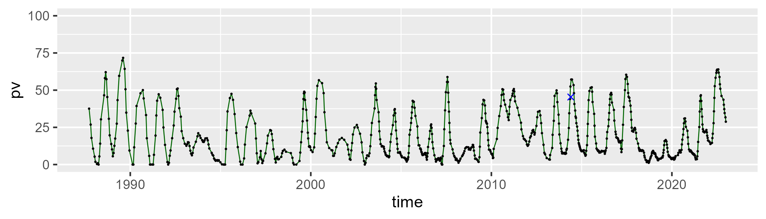

| Min. | 1st Qu. | Median | Mean | 3rd Qu. | Max. |
| --- | --- | --- | --- | --- | --- |
| 14.32638 | 43.53171 | 50.51783 | 50.73313 | 56.89346 | 84.34662 |

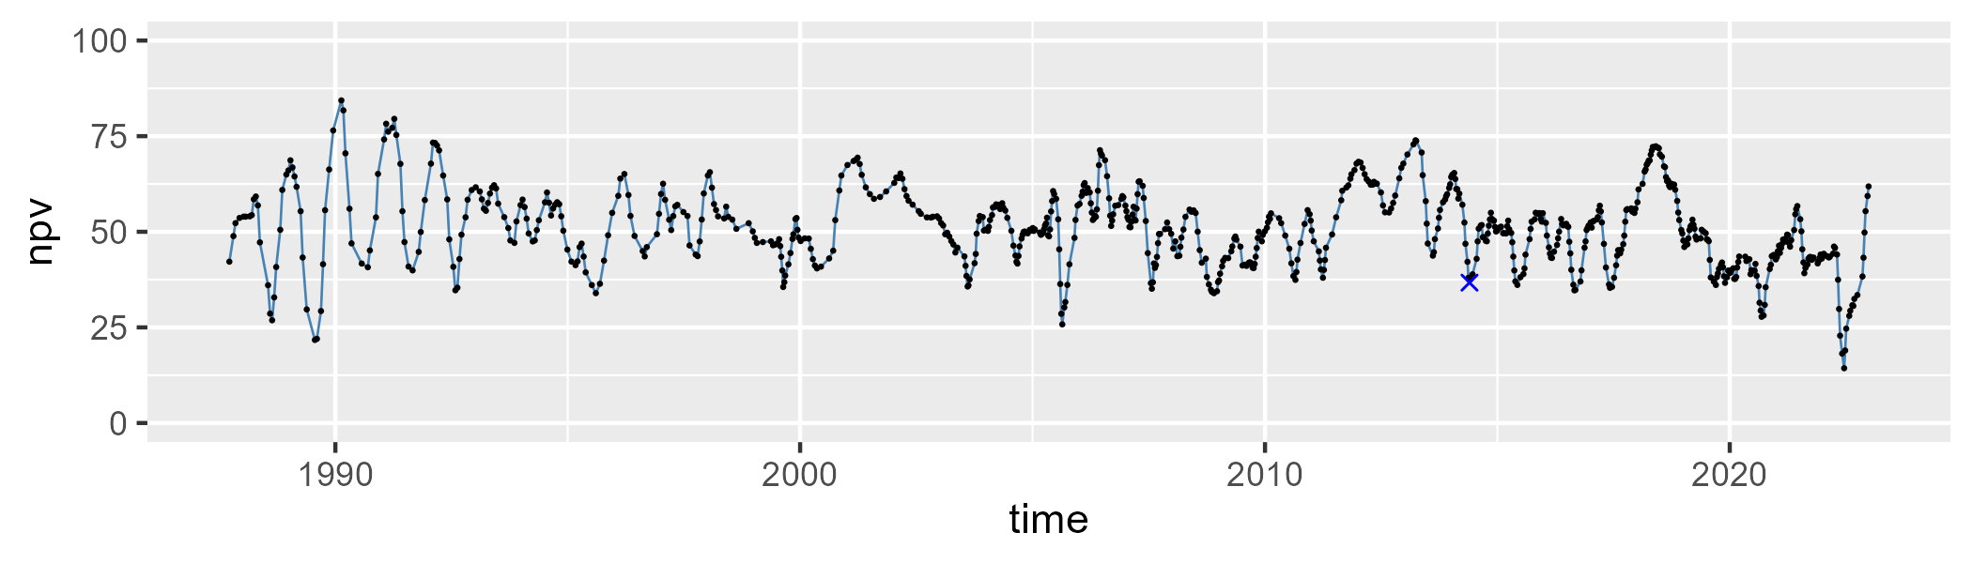

| Min. | 1st Qu. | Median | Mean | 3rd Qu. | Max. |
| --- | --- | --- | --- | --- | --- |
| 1.292702 | 18.1496 | 29.54775 | 28.94513 | 39.08117 | 59.36561 |

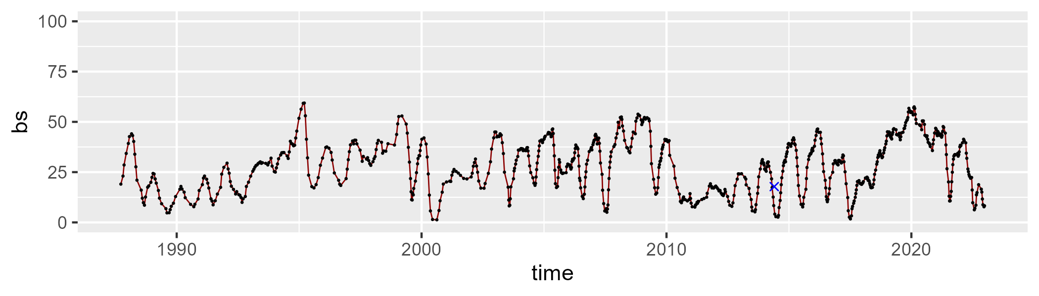

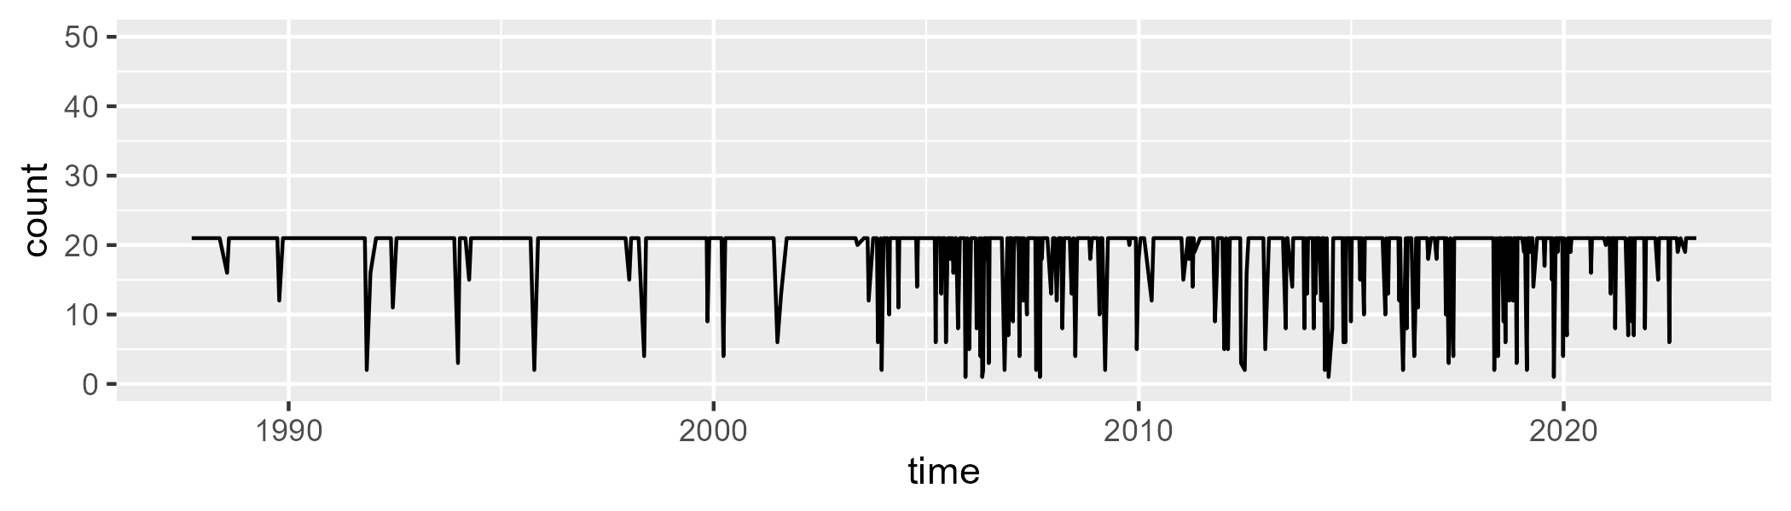

Min. : 1.00 1st Qu.:21.00 Median :21.00 Mean :19.17 3rd Qu.:21.00 Max. :21.00

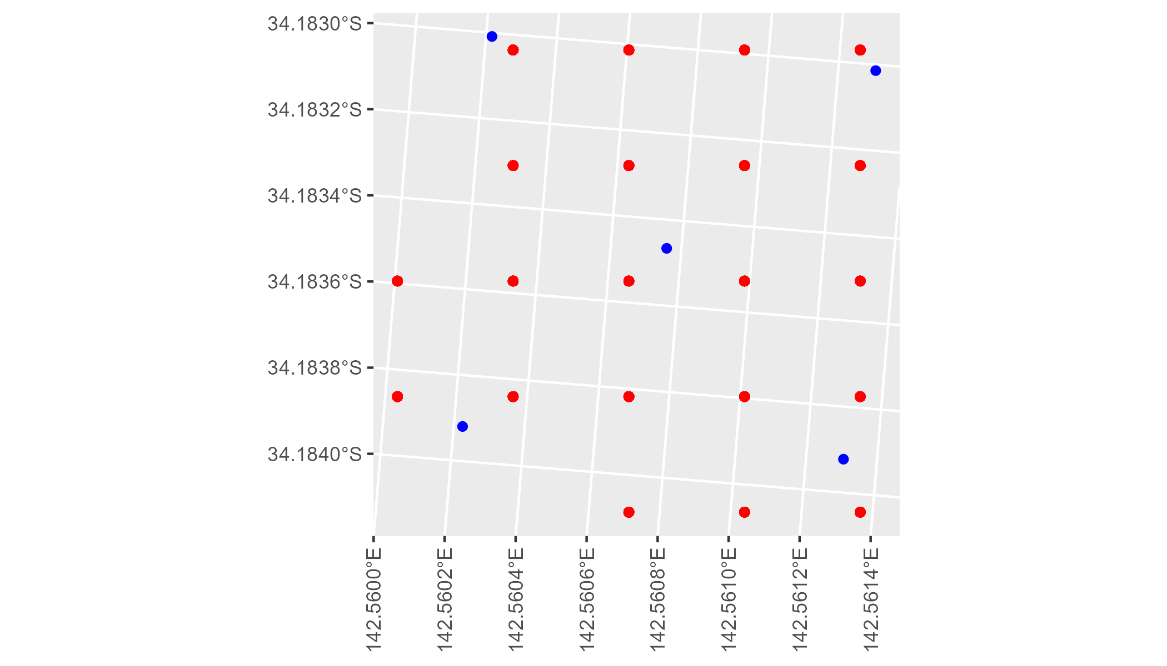

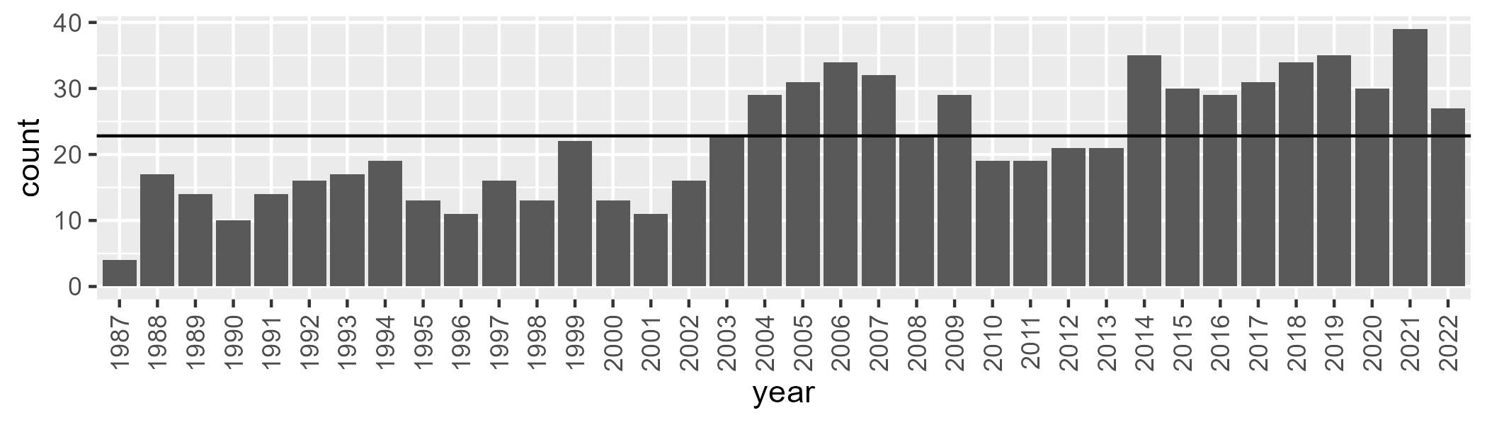

Number of samples: 797

# NSAMDD0002

| Min. | 1st Qu. | Median | Mean | 3rd Qu. | Max. |
| --- | --- | --- | --- | --- | --- |
| 14.60686 | 25.22791 | 29.5916 | 29.55249 | 33.14328 | 45.48441 |

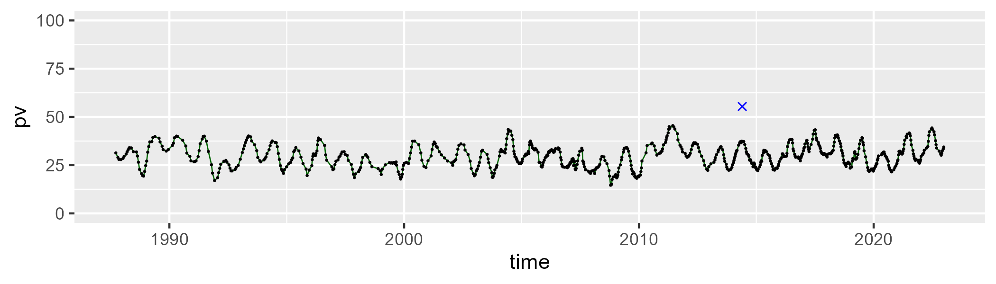

| Min. | 1st Qu. | Median | Mean | 3rd Qu. | Max. |
| --- | --- | --- | --- | --- | --- |
| 36.1344 | 46.80994 | 49.33743 | 48.98358 | 51.2609 | 63.99101 |

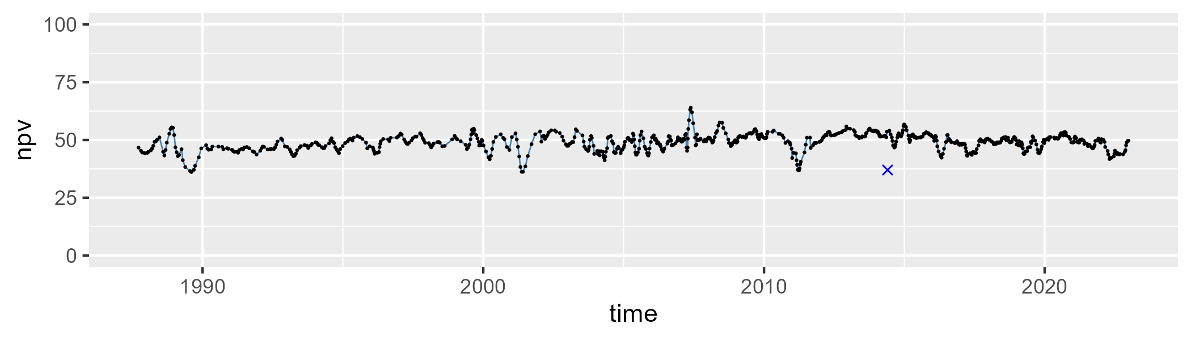

| Min. | 1st Qu. | Median | Mean | 3rd Qu. | Max. |
| --- | --- | --- | --- | --- | --- |
| 3.871151 | 16.41757 | 20.22446 | 20.21268 | 24.24391 | 38.02611 |

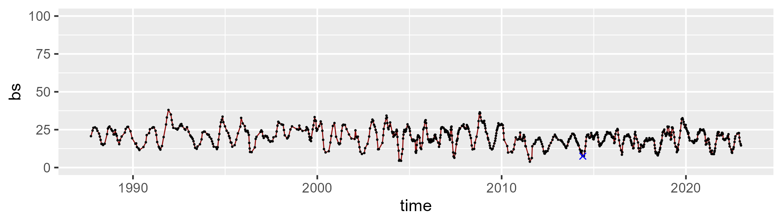

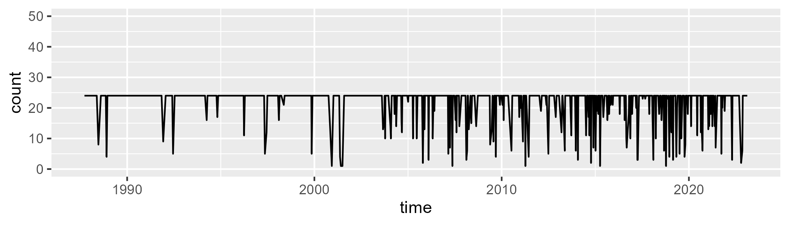

Min. : 1.00 1st Qu.:24.00 Median :24.00 Mean :21.91 3rd Qu.:24.00 Max. :24.00

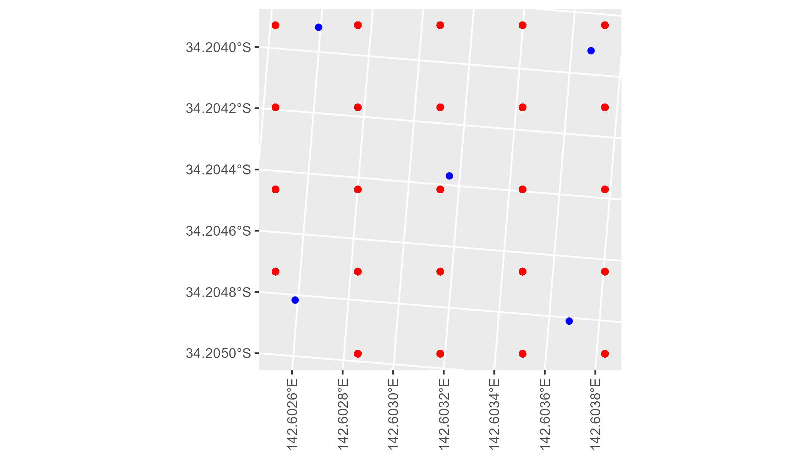

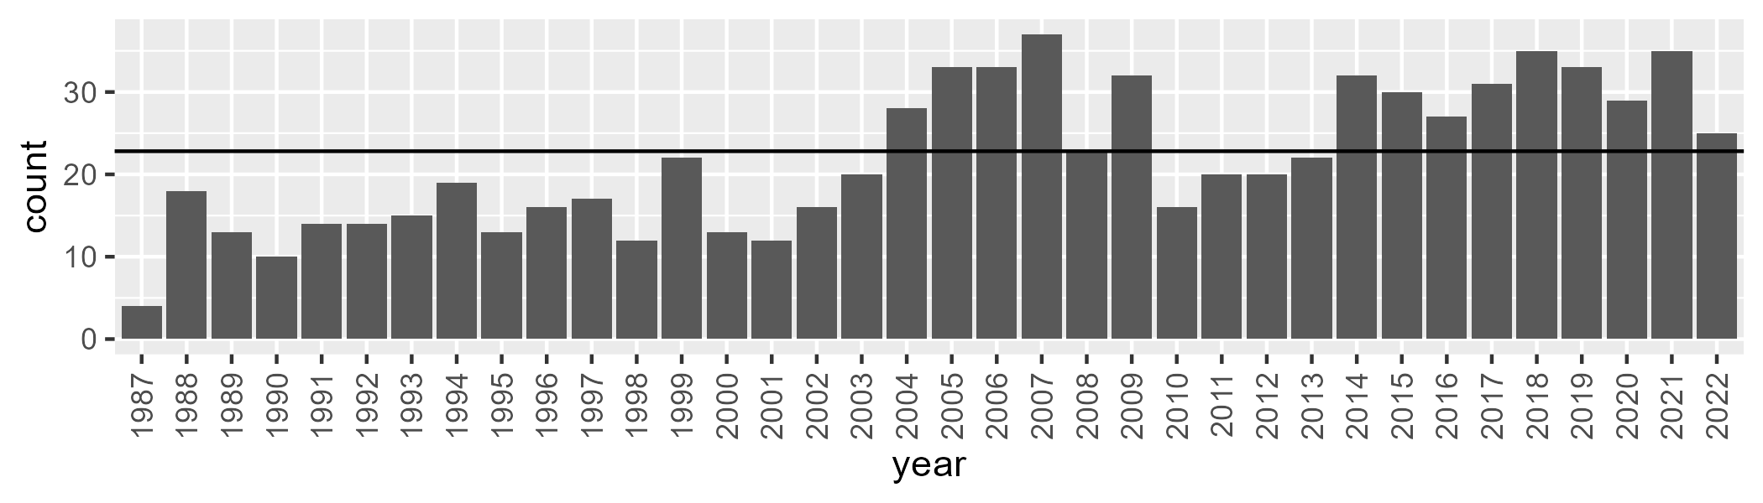

Number of samples: 789

# NSAMDD0003

| Min. | 1st Qu. | Median | Mean | 3rd Qu. | Max. |
| --- | --- | --- | --- | --- | --- |
| 10.22499 | 23.16411 | 28.70814 | 28.94161 | 33.39823 | 55.45533 |

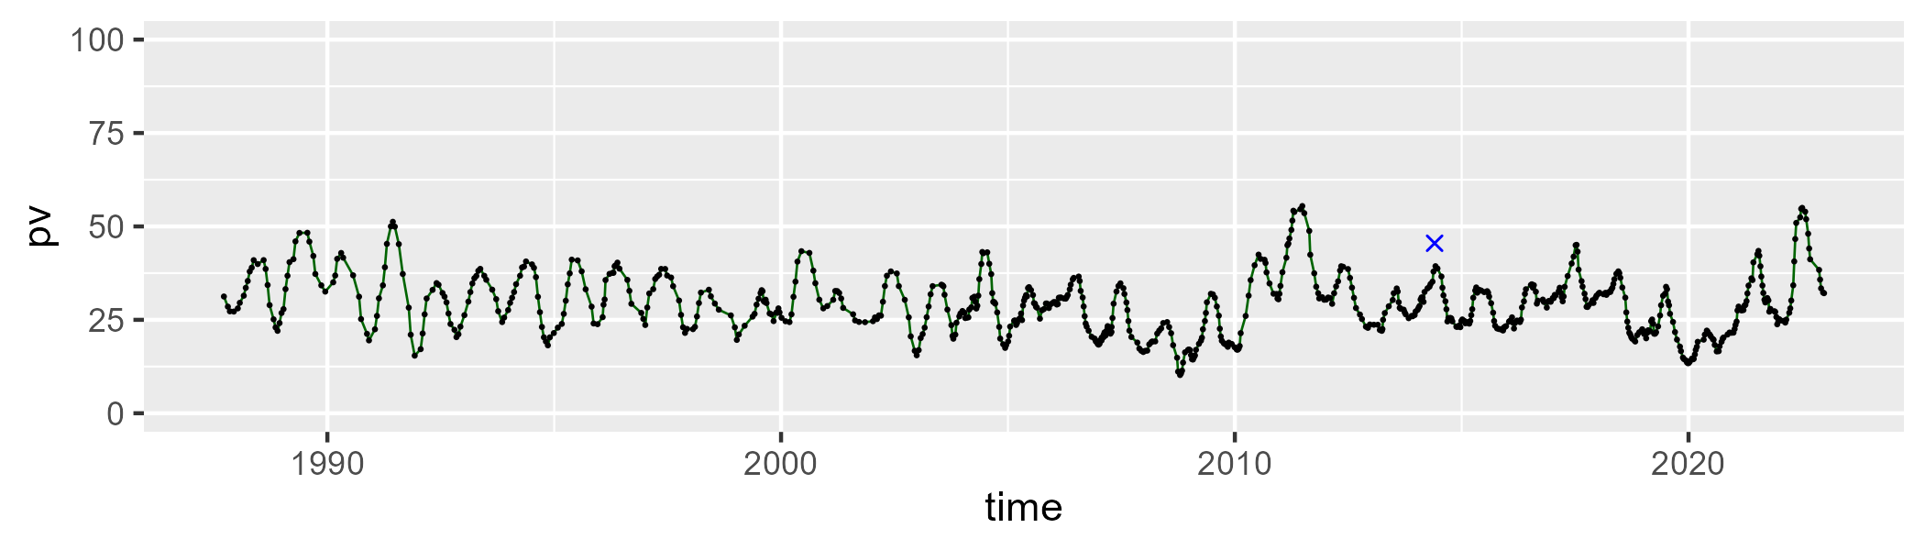

| Min. | 1st Qu. | Median | Mean | 3rd Qu. | Max. |
| --- | --- | --- | --- | --- | --- |
| 36.31199 | 51.49286 | 54.69474 | 53.6952 | 56.65413 | 63.94016 |

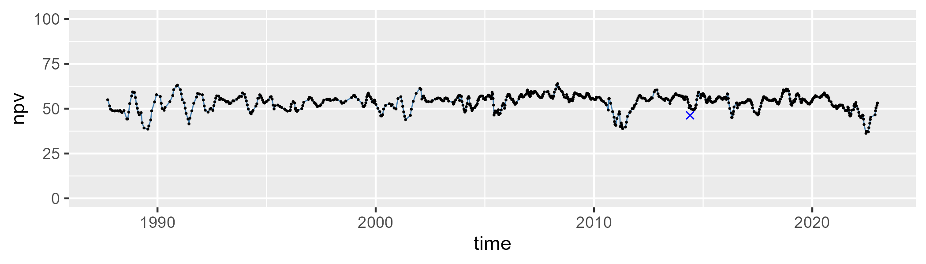

| Min. | 1st Qu. | Median | Mean | 3rd Qu. | Max. |
| --- | --- | --- | --- | --- | --- |
| 0 | 12.0713 | 15.77927 | 16.27808 | 20.53942 | 32.14765 |

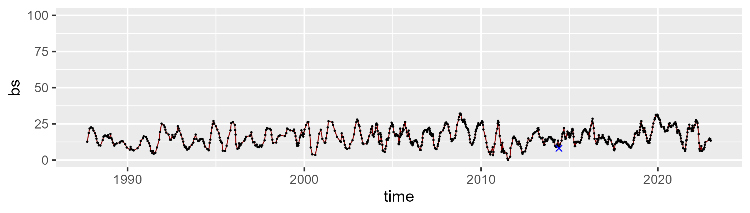

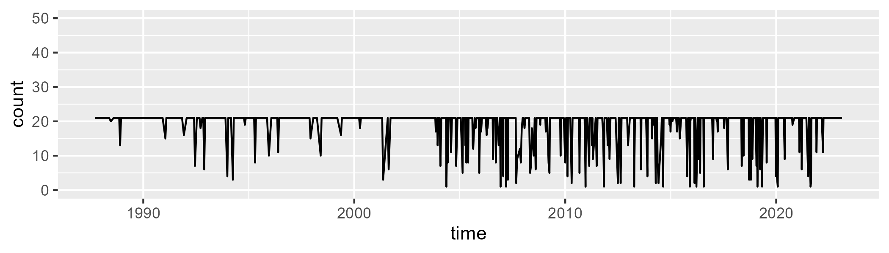

Min. : 1.00 1st Qu.:21.00 Median :21.00 Mean :19.03 3rd Qu.:21.00 Max. :21.00

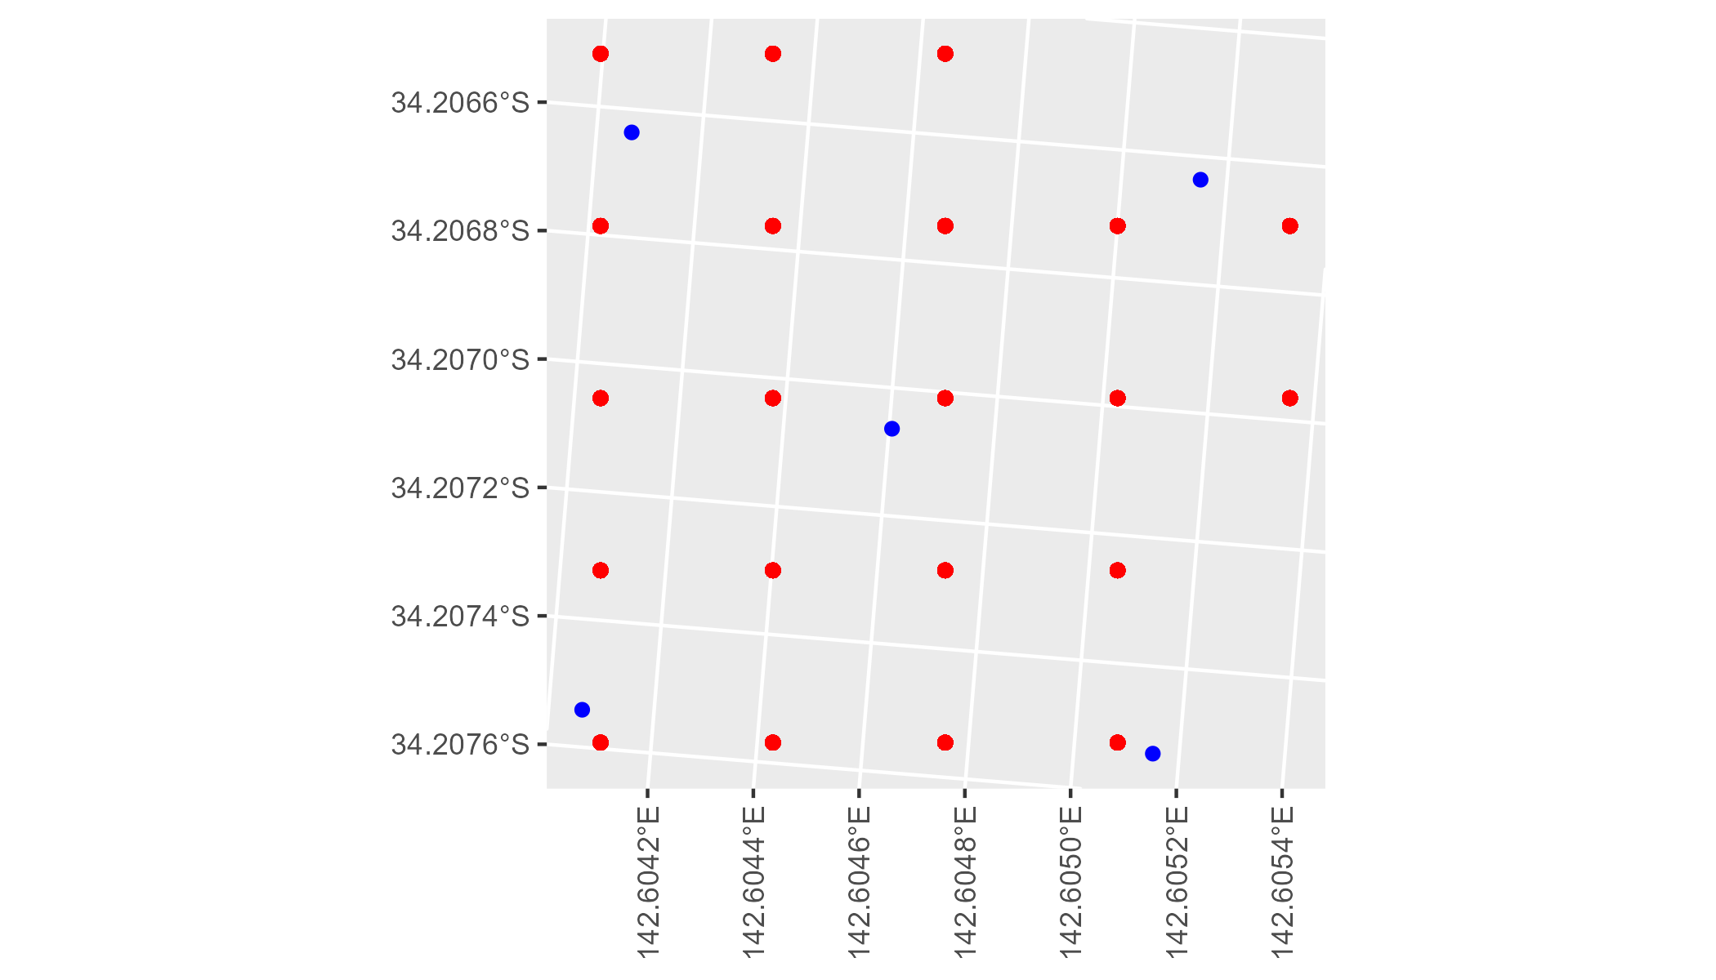

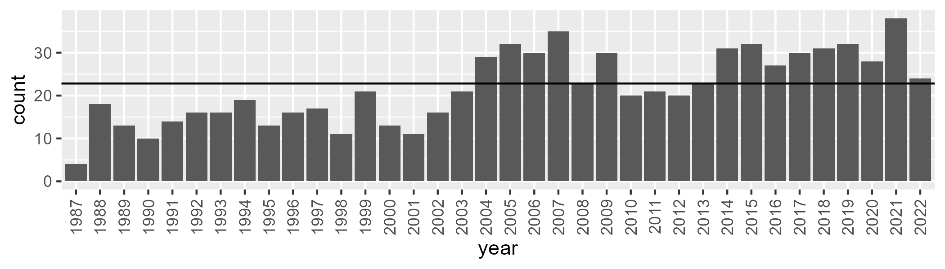

Number of samples: 785

# NSAMDD0004

| Min. | 1st Qu. | Median | Mean | 3rd Qu. | Max. |
| --- | --- | --- | --- | --- | --- |
| 9.503093 | 18.76095 | 23.11579 | 24.98672 | 29.47455 | 60.41335 |

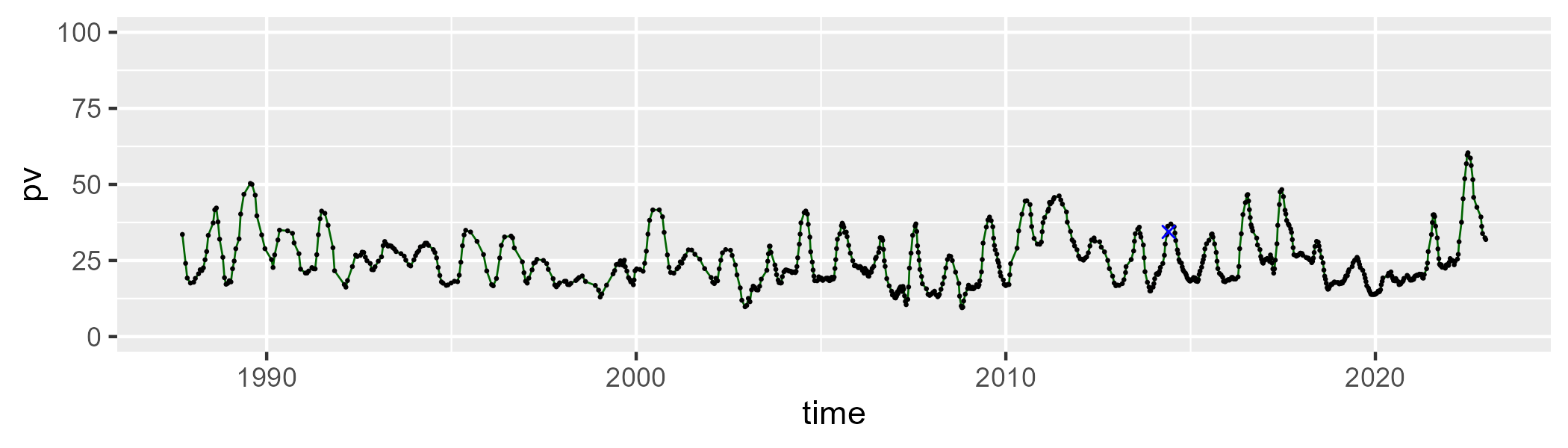

| Min. | 1st Qu. | Median | Mean | 3rd Qu. | Max. |
| --- | --- | --- | --- | --- | --- |
| 27.62002 | 52.1344 | 54.80828 | 54.14964 | 57.19455 | 65.47281 |

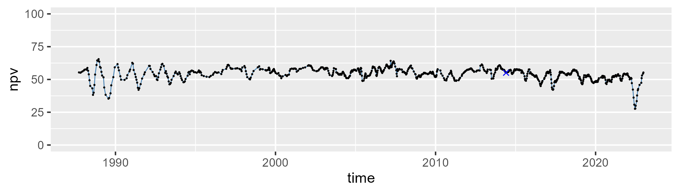

| Min. | 1st Qu. | Median | Mean | 3rd Qu. | Max. |
| --- | --- | --- | --- | --- | --- |
| 1.82169 | 14.90832 | 19.90396 | 19.76429 | 24.29329 | 38.41742 |

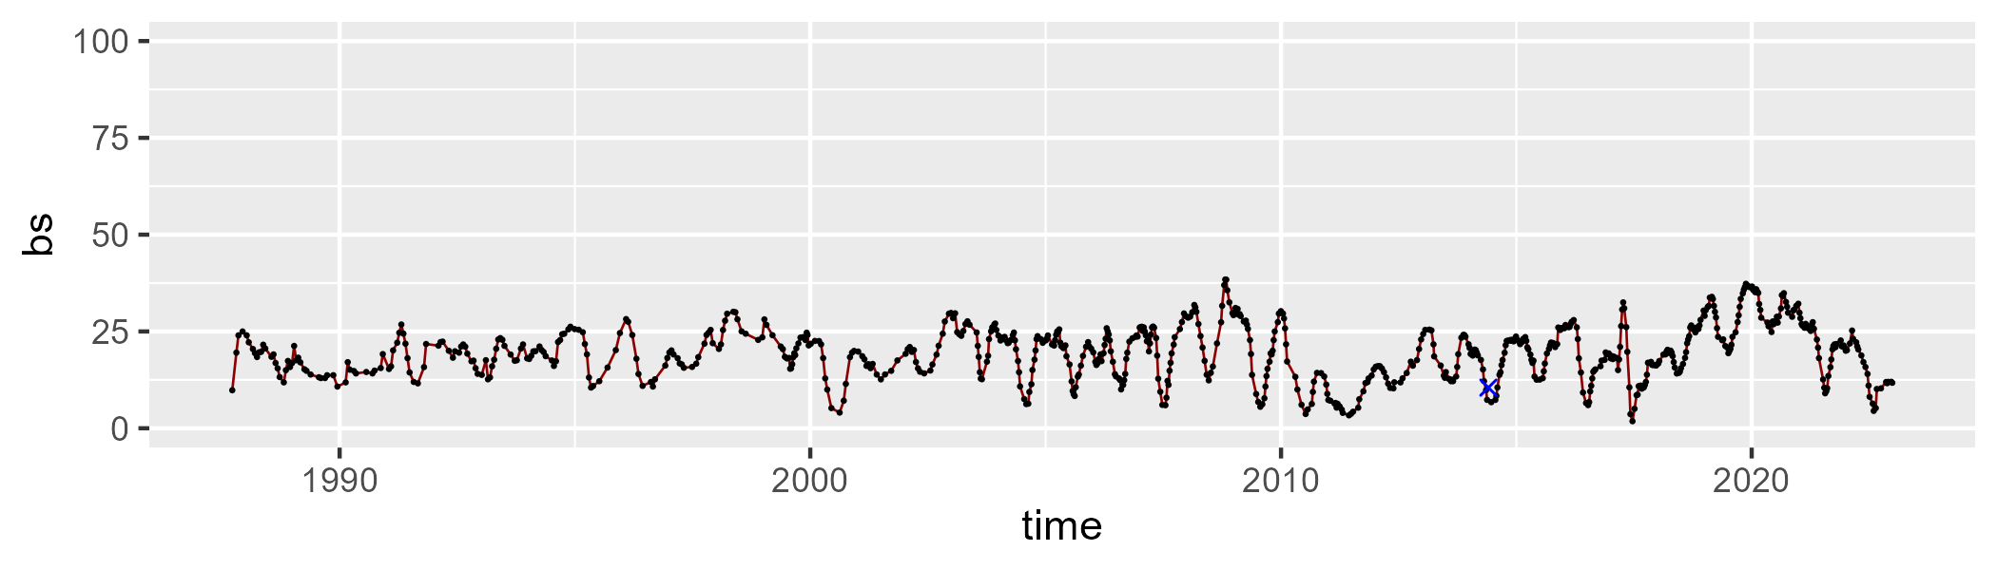

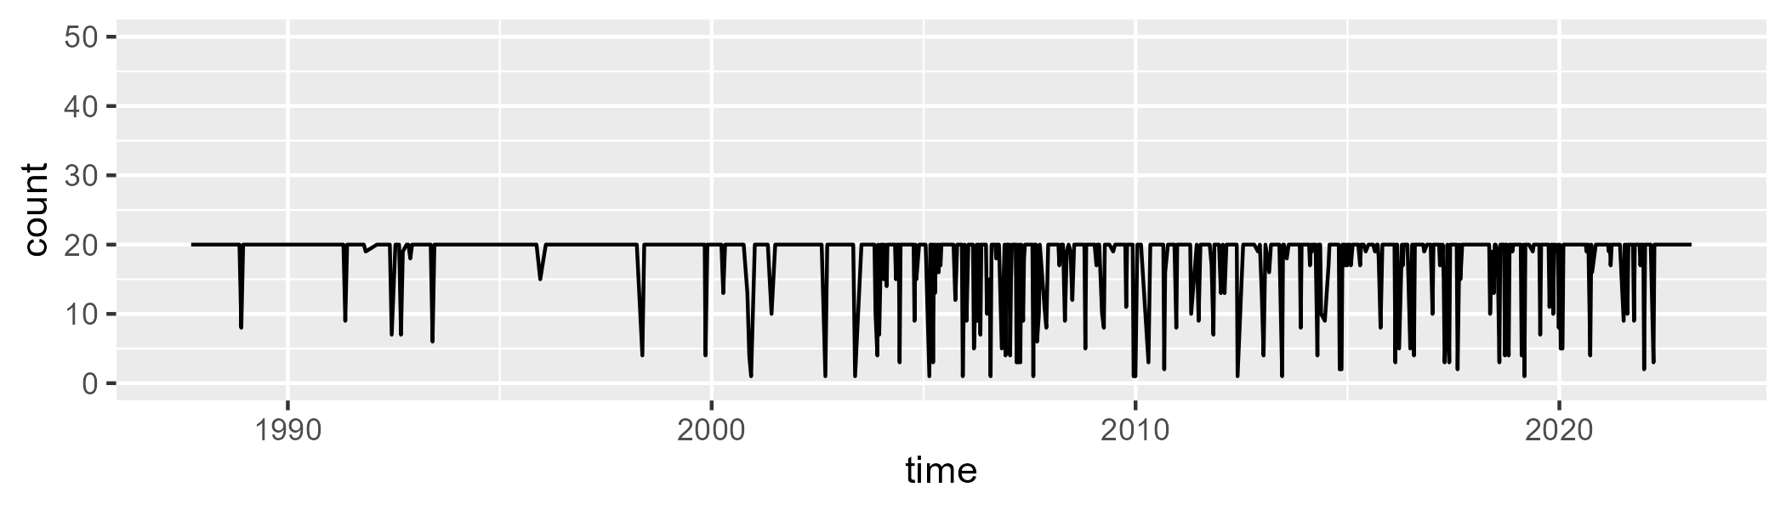

Min. : 1.00 1st Qu.:20.00 Median :20.00 Mean :18.13 3rd Qu.:20.00 Max. :20.00

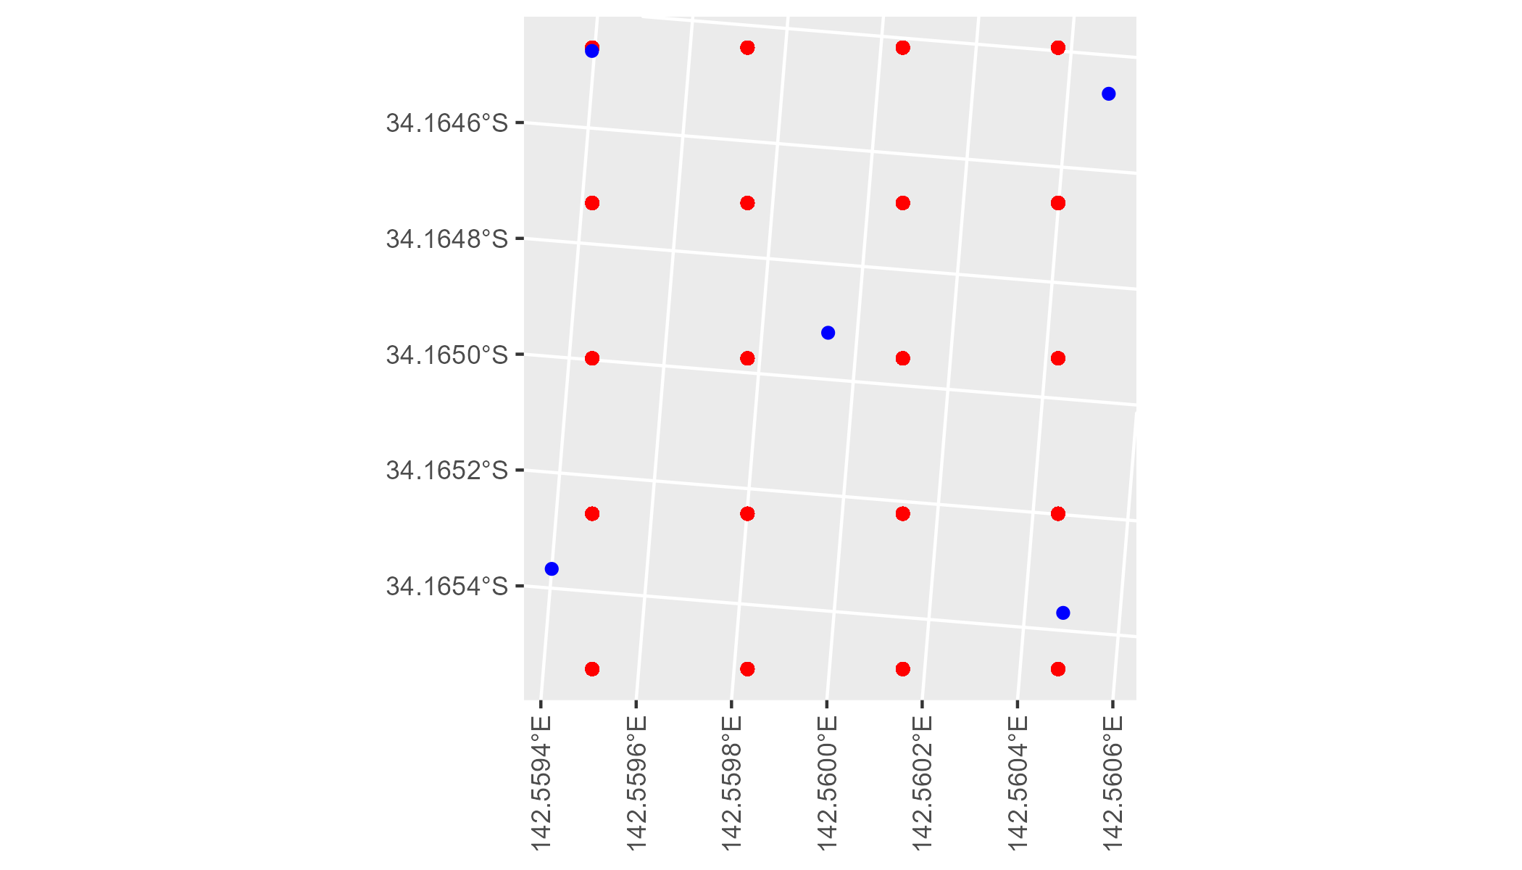

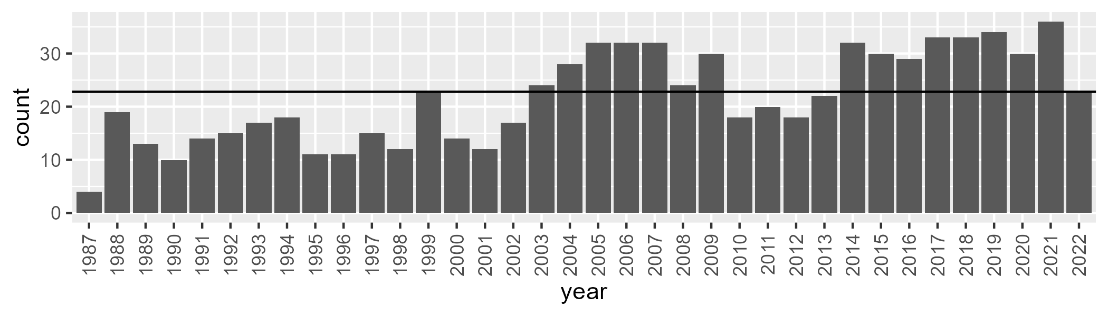

Number of samples: 785

# NSAMDD0005

| Min. | 1st Qu. | Median | Mean | 3rd Qu. | Max. |
| --- | --- | --- | --- | --- | --- |
| 12.82439 | 20.77844 | 25.11397 | 25.55255 | 29.88576 | 44.83888 |

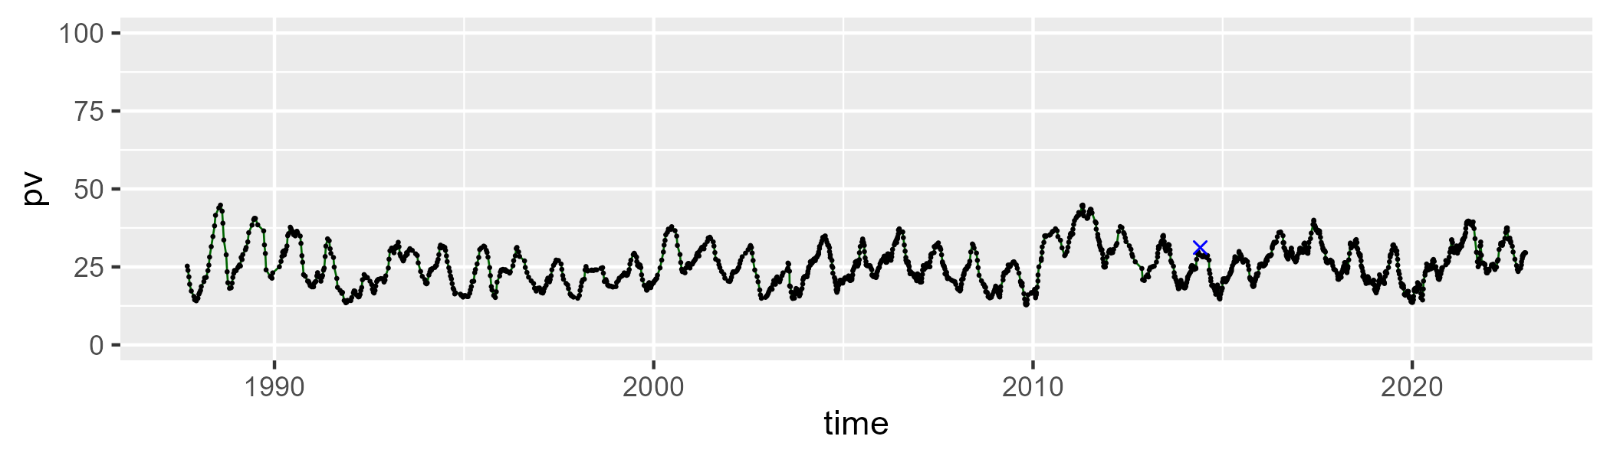

| Min. | 1st Qu. | Median | Mean | 3rd Qu. | Max. |
| --- | --- | --- | --- | --- | --- |
| 31.581 | 42.87604 | 45.48116 | 45.4131 | 48.23391 | 56.68373 |

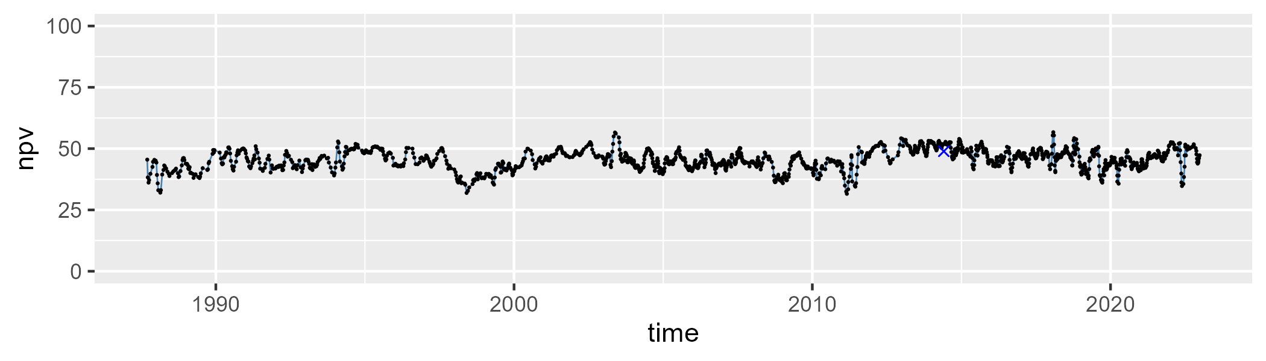

| Min. | 1st Qu. | Median | Mean | 3rd Qu. | Max. |
| --- | --- | --- | --- | --- | --- |
| 5.74732 | 21.98246 | 27.64285 | 27.70142 | 33.44358 | 48.33269 |

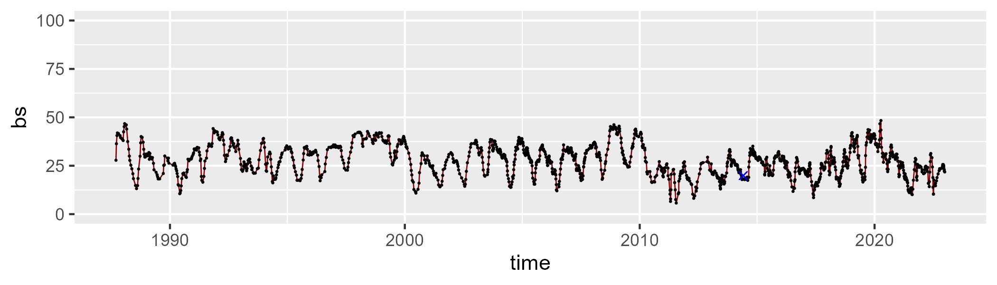

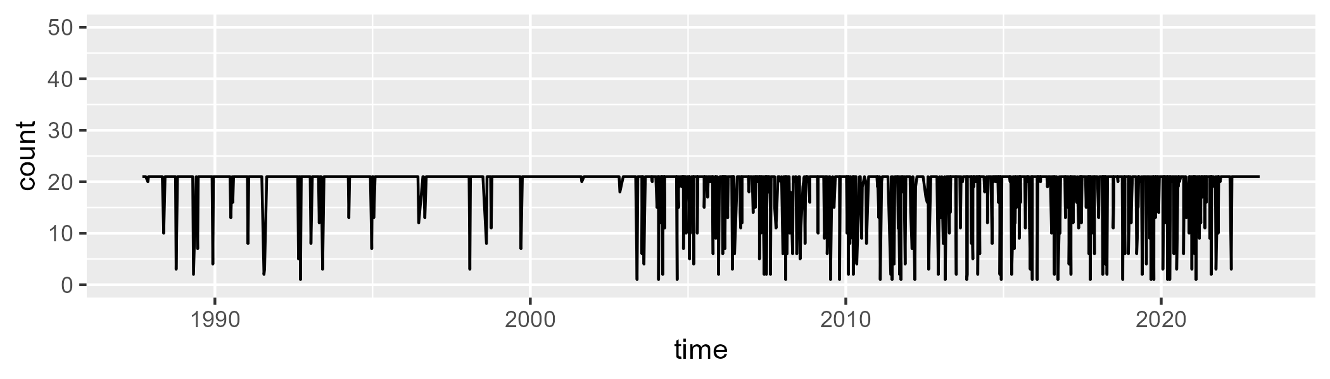

Min. : 1.00 1st Qu.:21.00 Median :21.00 Mean :19.07 3rd Qu.:21.00 Max. :21.00

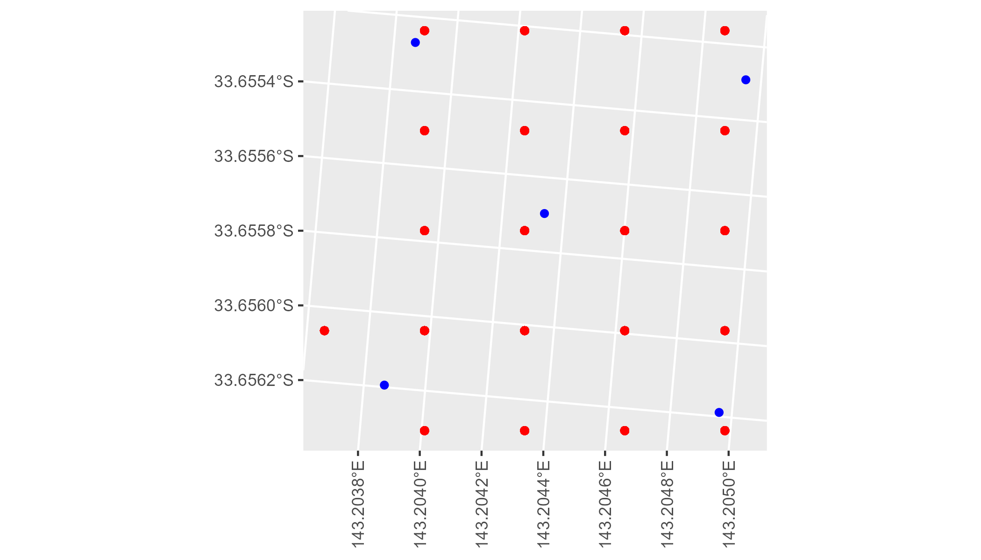

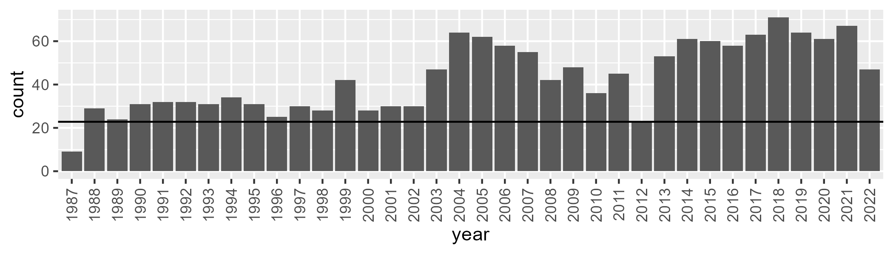

Number of samples: 1551

# NSAMDD0006

| Min. | 1st Qu. | Median | Mean | 3rd Qu. | Max. |
| --- | --- | --- | --- | --- | --- |
| 5.147049 | 13.68832 | 19.57176 | 21.5046 | 26.77345 | 61.55089 |

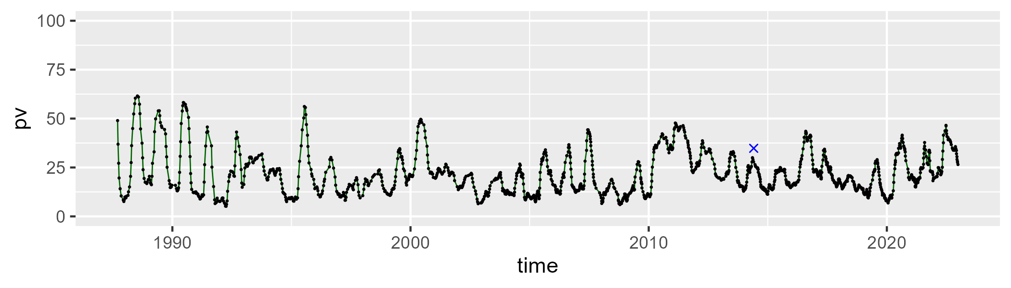

| Min. | 1st Qu. | Median | Mean | 3rd Qu. | Max. |
| --- | --- | --- | --- | --- | --- |
| 17.88258 | 46.11031 | 49.51925 | 48.98571 | 52.67187 | 68.00888 |

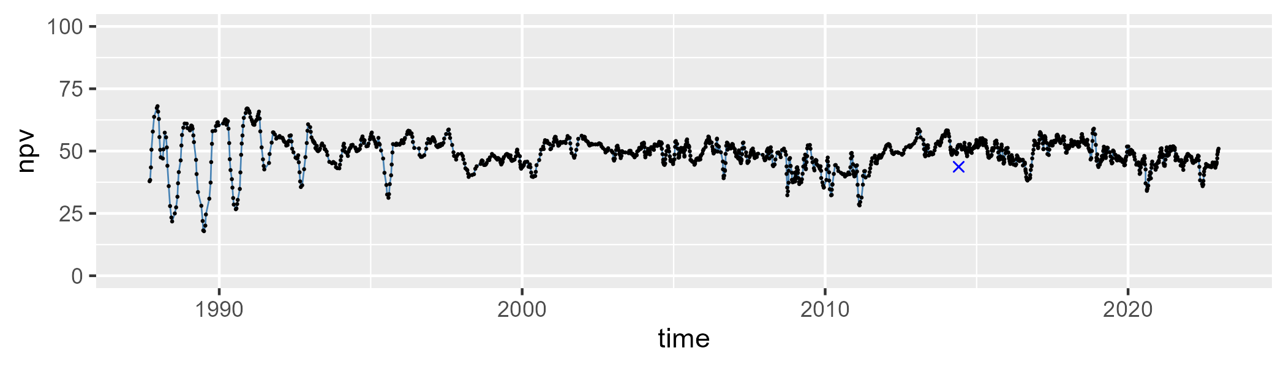

| Min. | 1st Qu. | Median | Mean | 3rd Qu. | Max. |
| --- | --- | --- | --- | --- | --- |
| 5.543639 | 21.73773 | 28.02845 | 28.19818 | 34.5014 | 59.7408 |

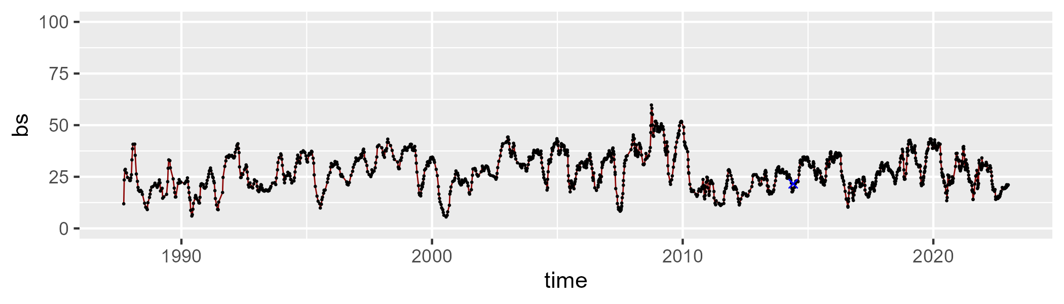

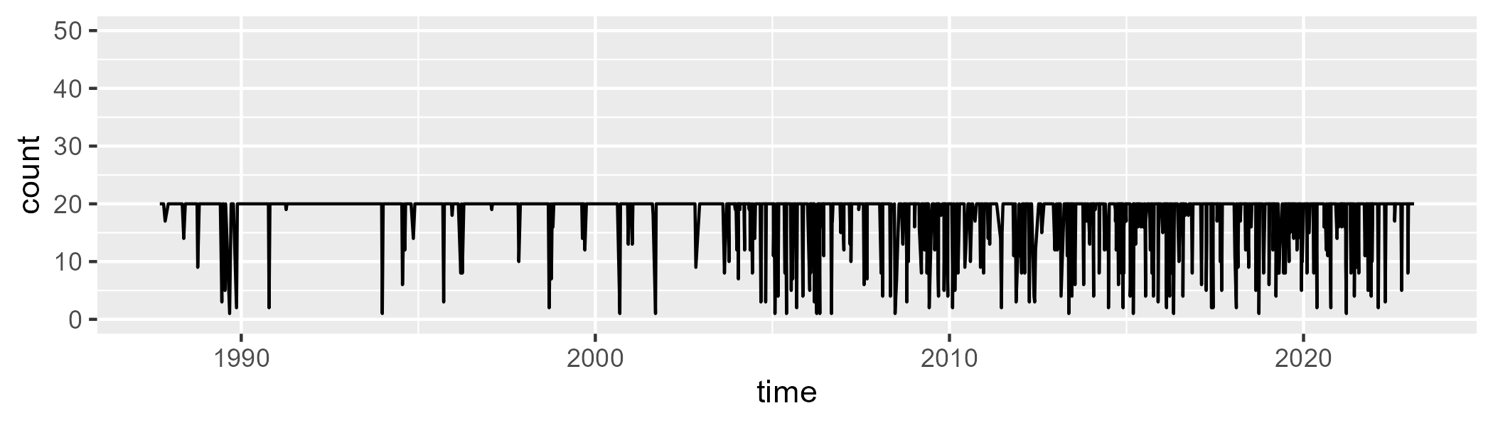

Min. : 1.00 1st Qu.:20.00 Median :20.00 Mean :18.32 3rd Qu.:20.00 Max. :20.00

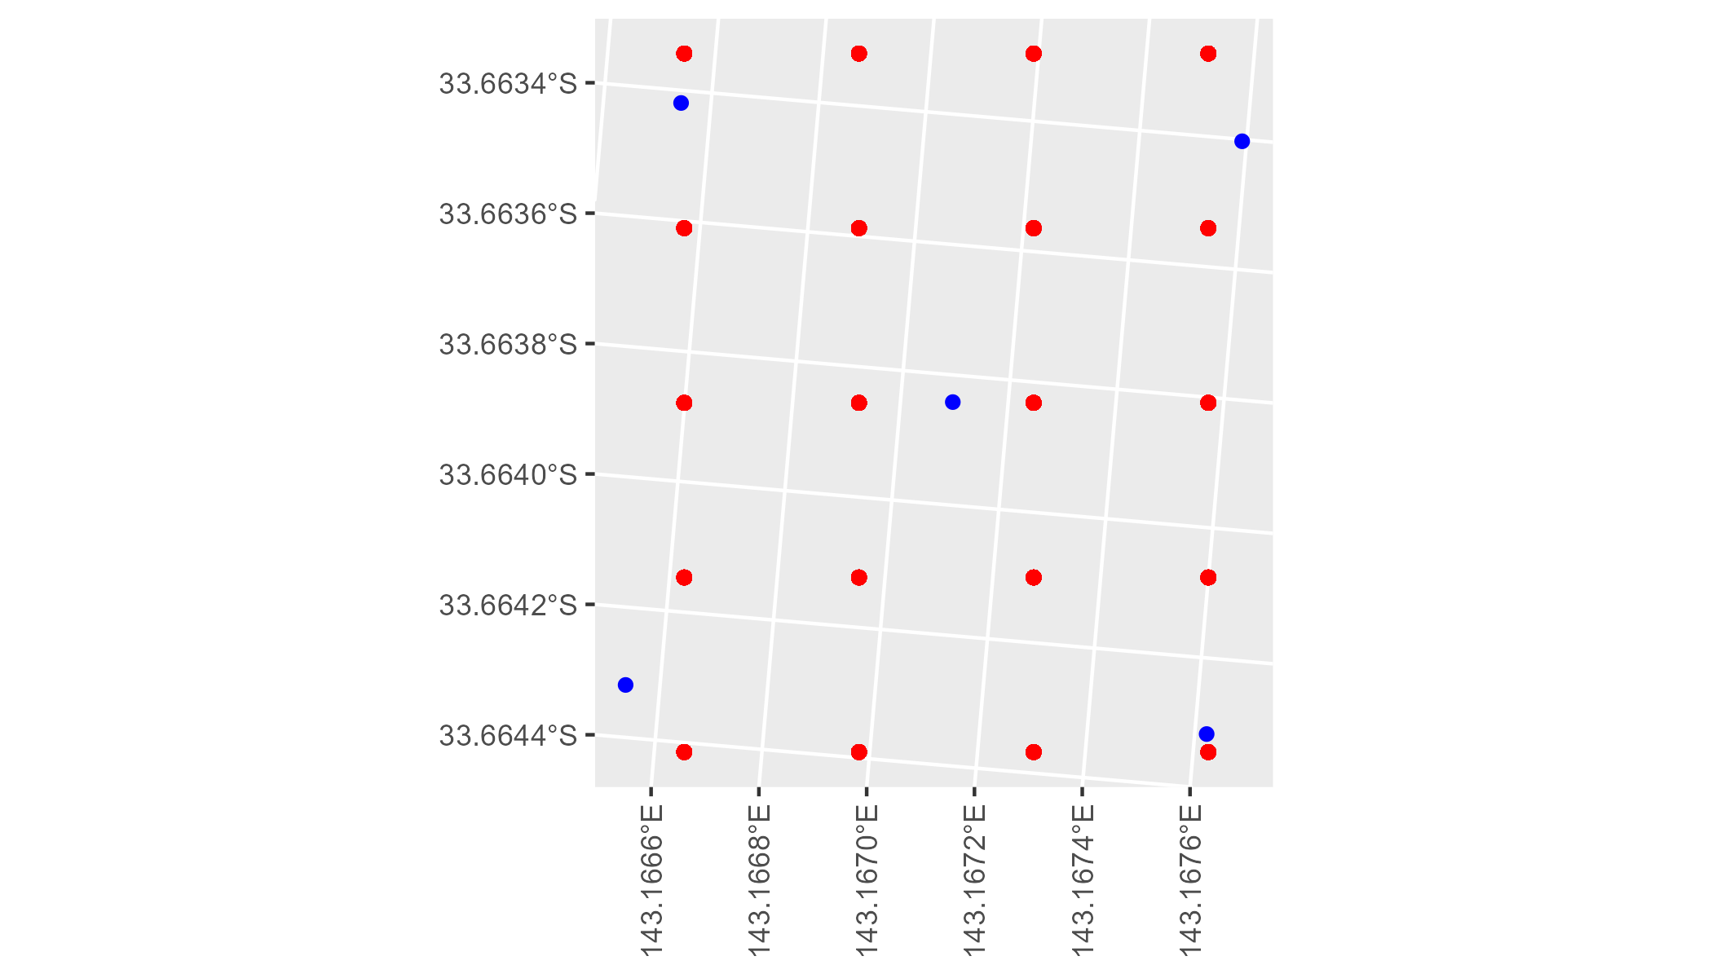

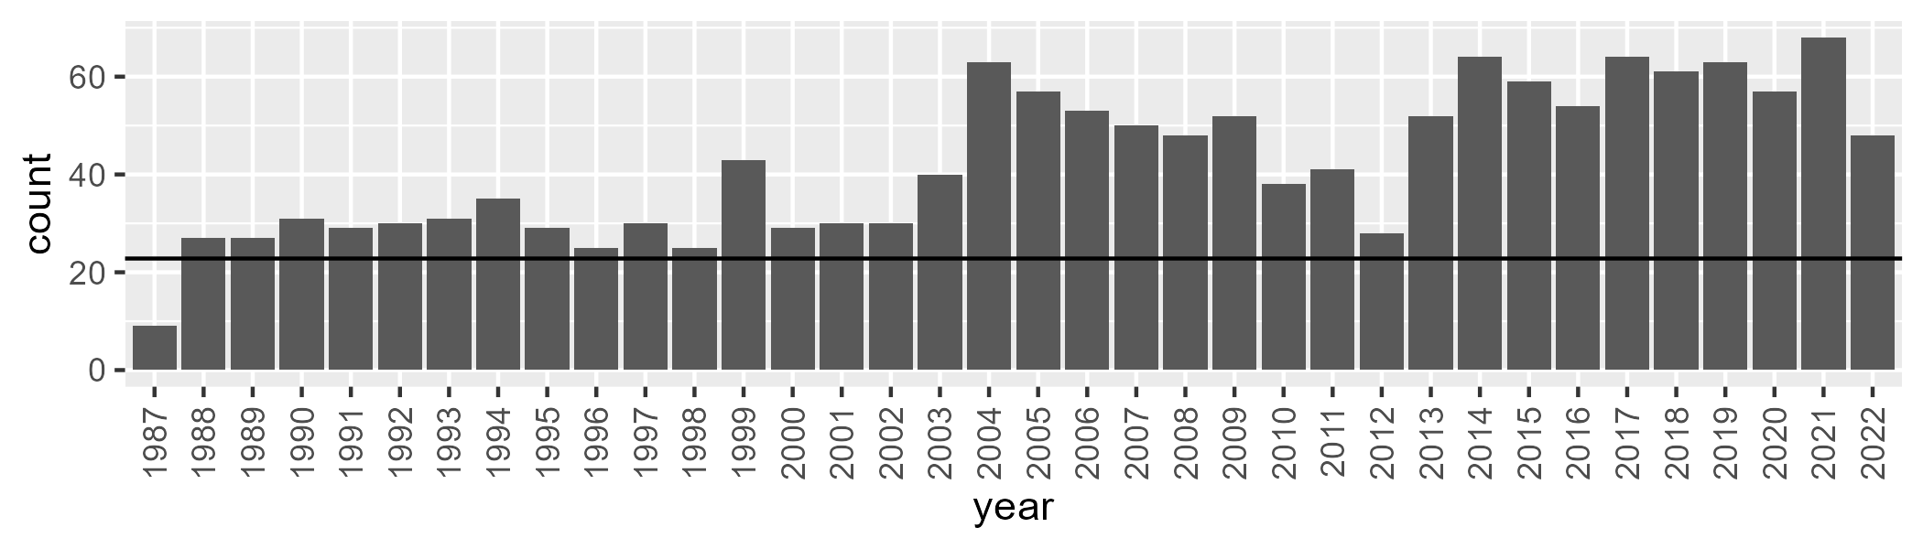

Number of samples: 1520

# NSAMDD0007

| Min. | 1st Qu. | Median | Mean | 3rd Qu. | Max. |
| --- | --- | --- | --- | --- | --- |
| 10.27402 | 16.18586 | 19.51819 | 19.98431 | 23.38085 | 33.91542 |

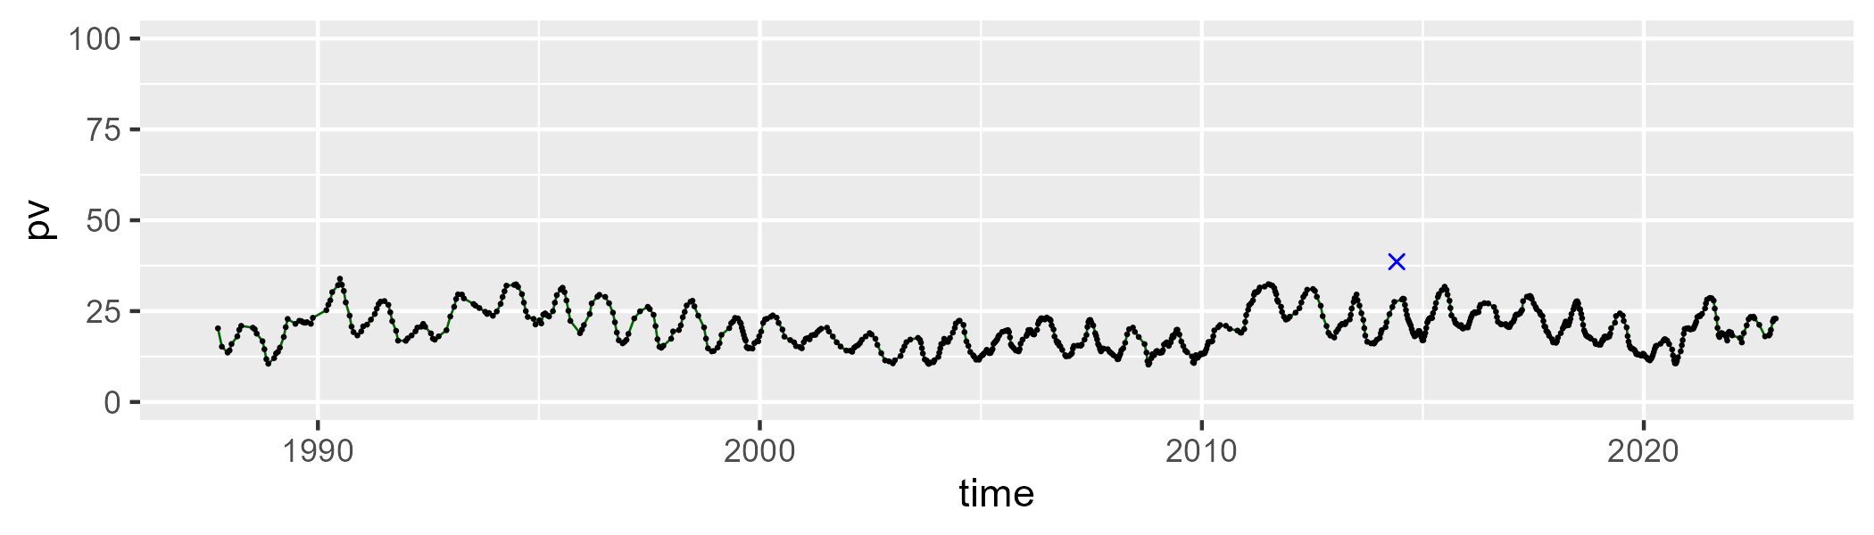

| Min. | 1st Qu. | Median | Mean | 3rd Qu. | Max. |
| --- | --- | --- | --- | --- | --- |
| 30.62247 | 39.32015 | 41.77633 | 41.60679 | 43.88152 | 53.53149 |

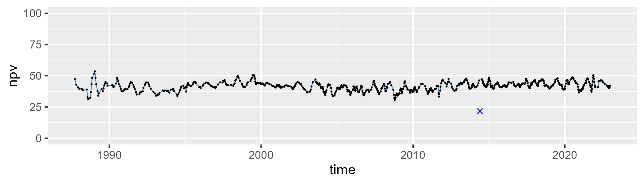

| Min. | 1st Qu. | Median | Mean | 3rd Qu. | Max. |
| --- | --- | --- | --- | --- | --- |
| 16.3318 | 32.61221 | 37.13241 | 36.98282 | 41.69534 | 57.63878 |

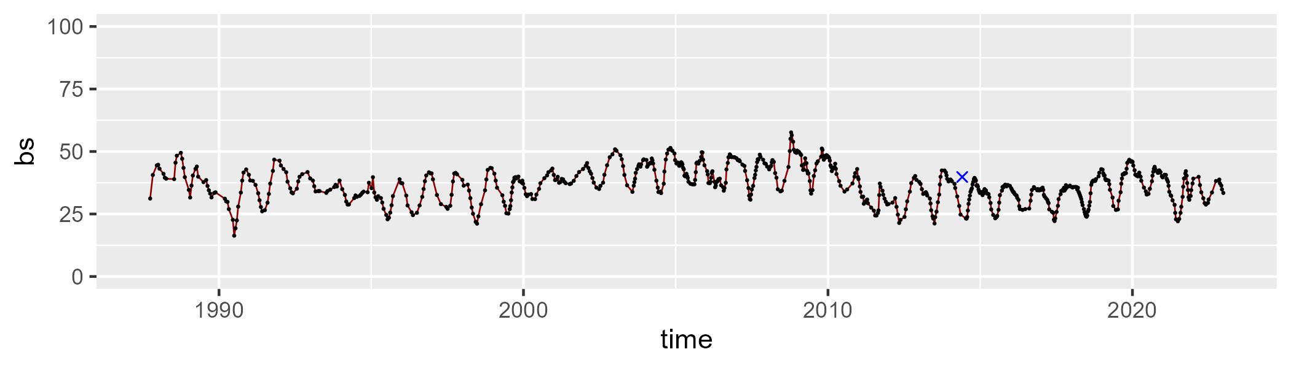

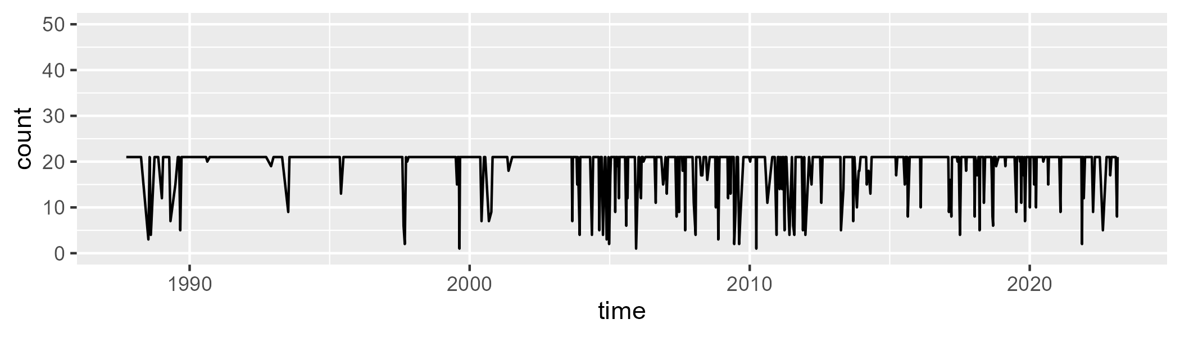

Min. : 1.00 1st Qu.:21.00 Median :21.00 Mean :19.41 3rd Qu.:21.00 Max. :21.00

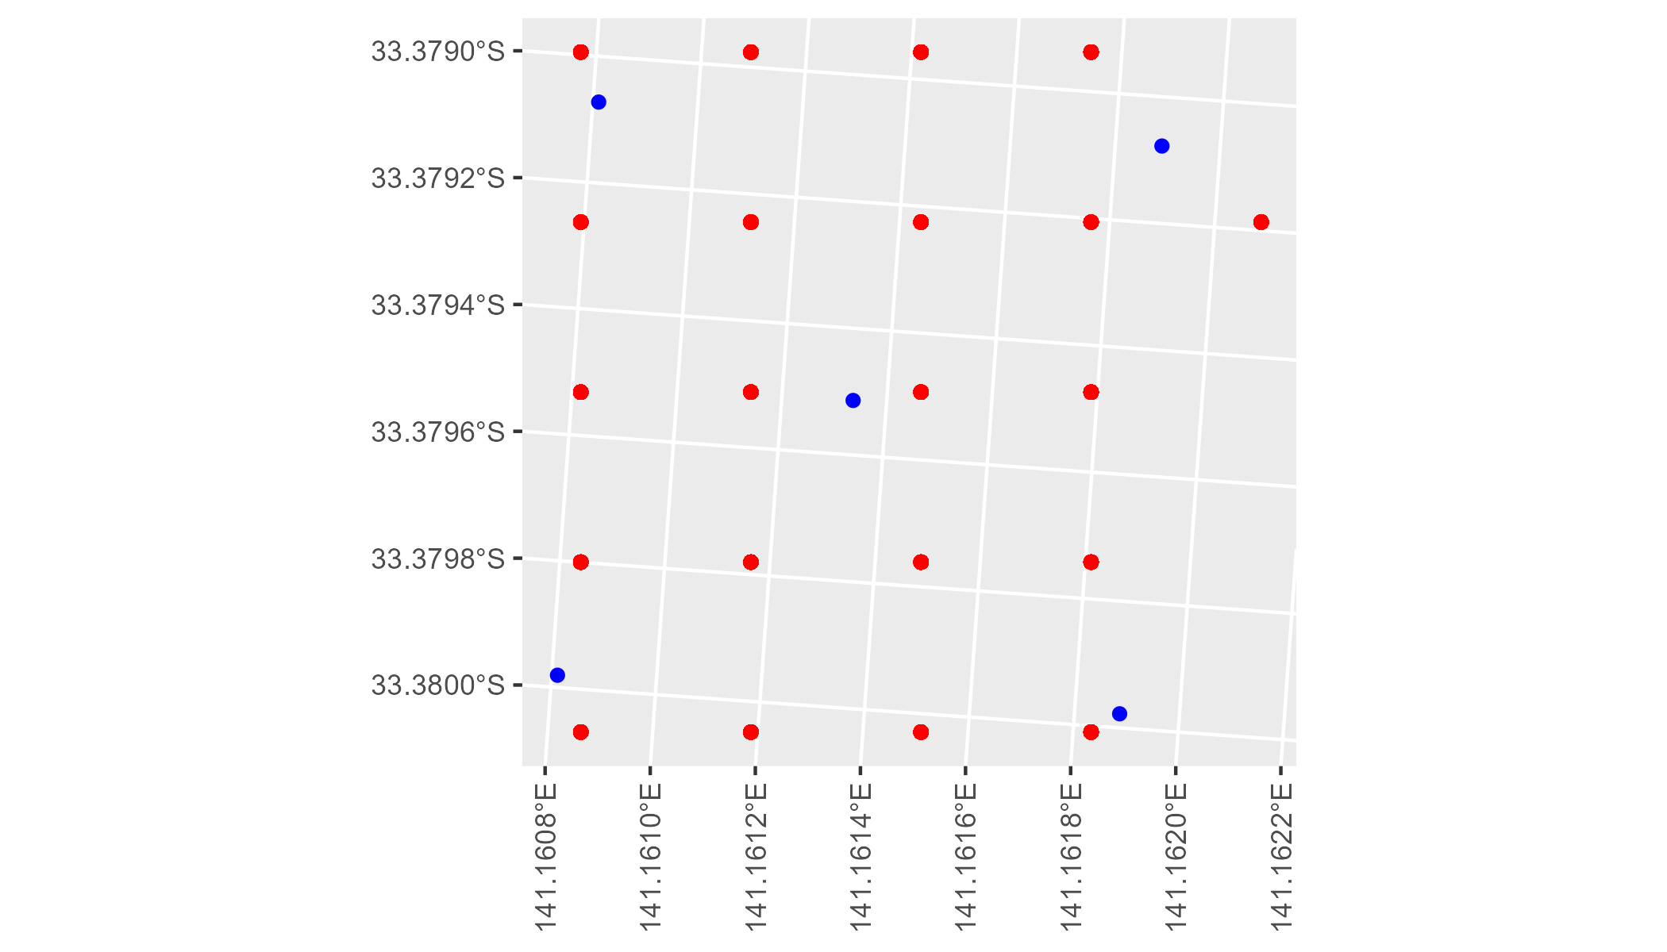

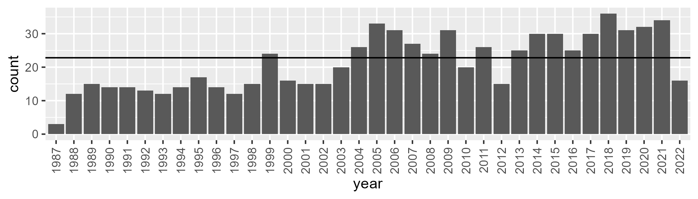

Number of samples: 767

# NSAMDD0008

| Min. | 1st Qu. | Median | Mean | 3rd Qu. | Max. |
| --- | --- | --- | --- | --- | --- |
| 6.028944 | 13.26992 | 16.10491 | 16.86136 | 19.50733 | 35.96097 |

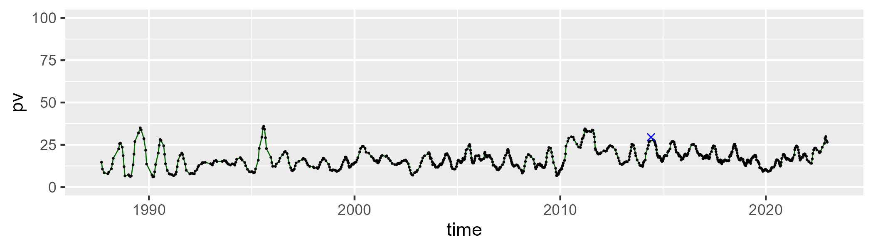

| Min. | 1st Qu. | Median | Mean | 3rd Qu. | Max. |
| --- | --- | --- | --- | --- | --- |
| 20.21317 | 40.70687 | 45.09392 | 44.15701 | 48.1513 | 56.82639 |

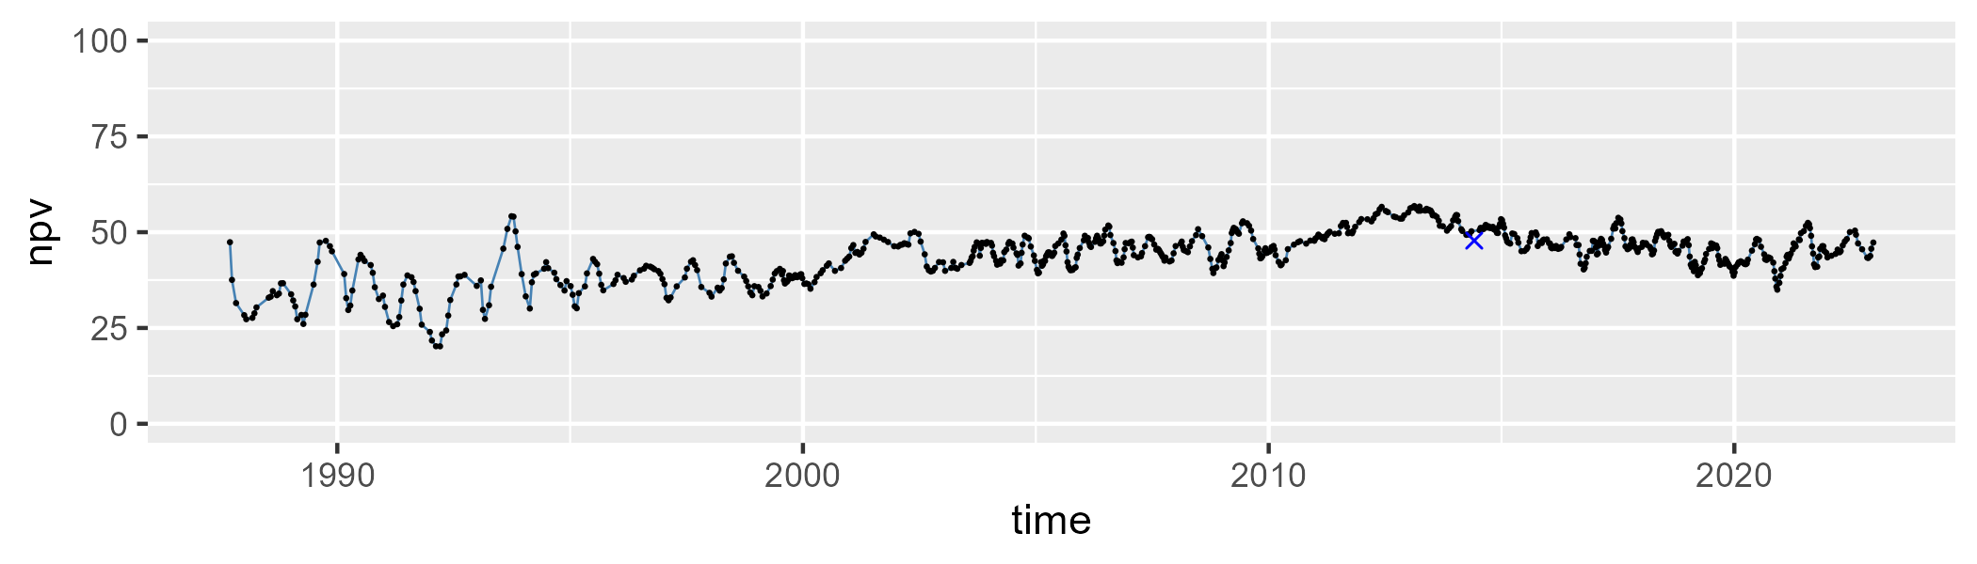

| Min. | 1st Qu. | Median | Mean | 3rd Qu. | Max. |
| --- | --- | --- | --- | --- | --- |
| 12.91585 | 30.81519 | 37.50387 | 37.61841 | 43.1924 | 70.46598 |

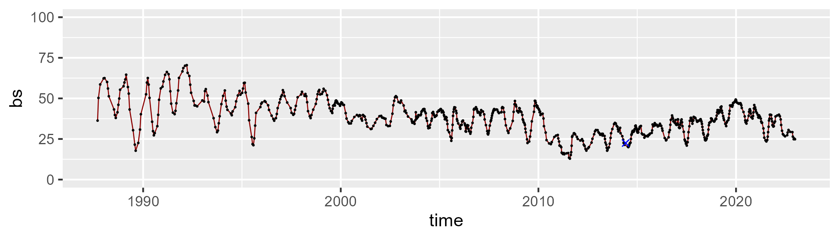

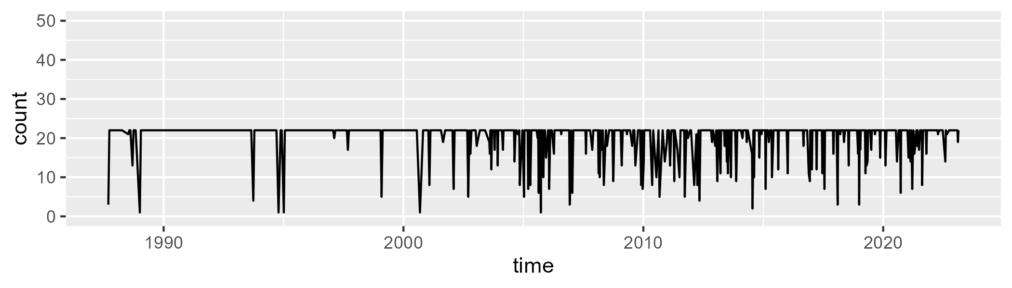

Min. : 1.00 1st Qu.:22.00 Median :22.00 Mean :20.38 3rd Qu.:22.00 Max. :22.00

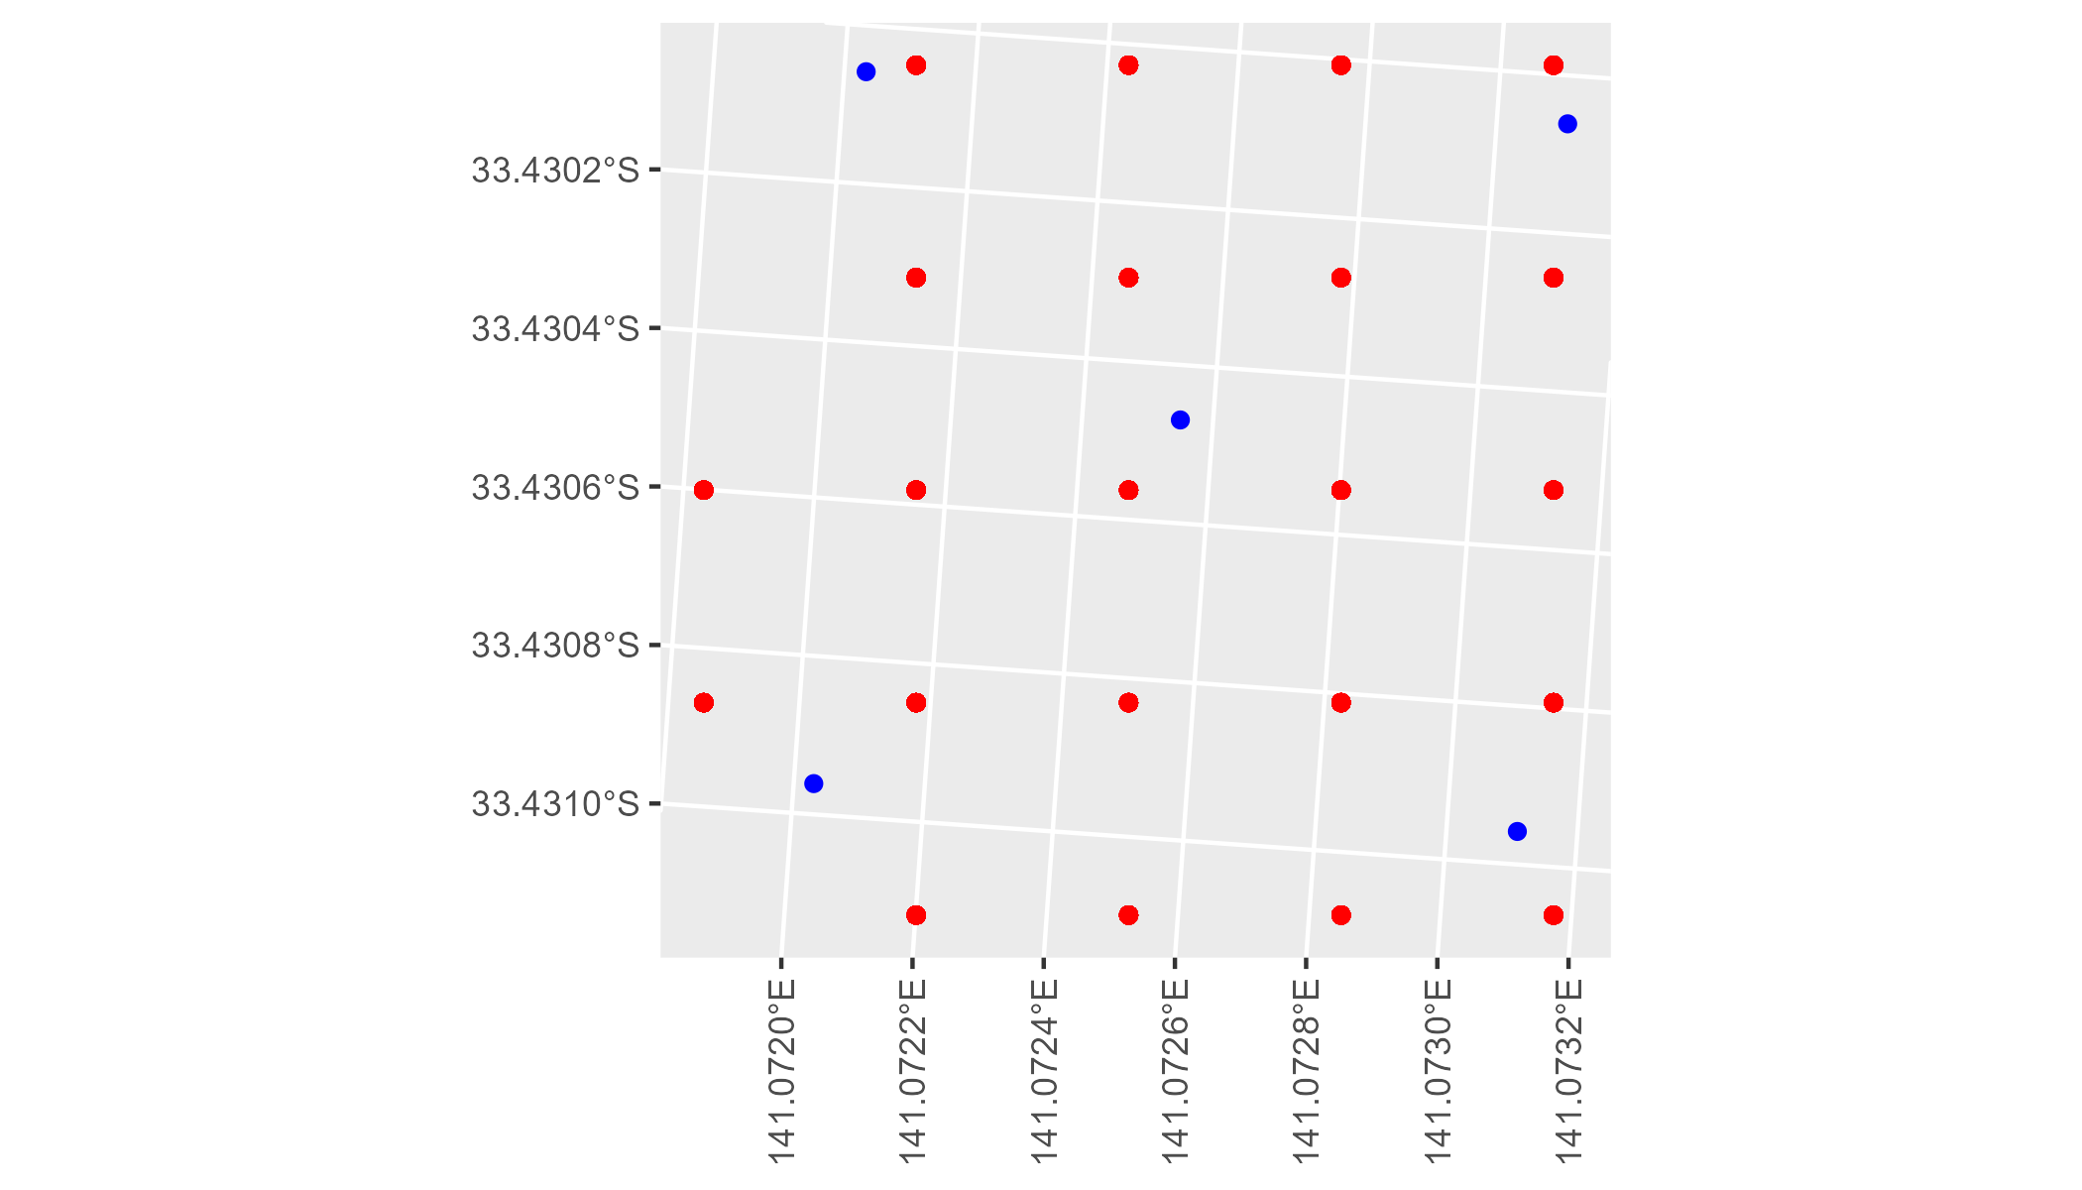

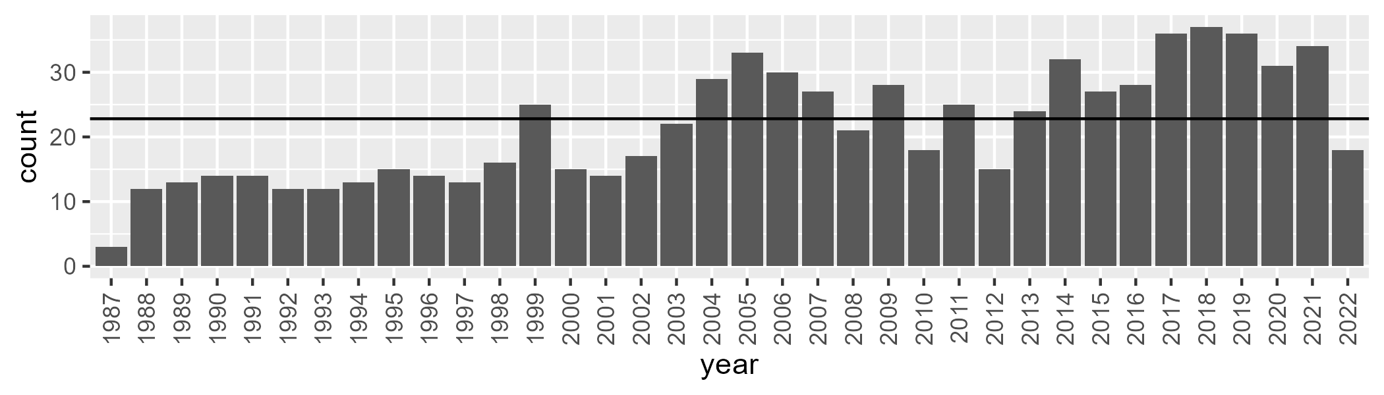

Number of samples: 773

# NSAMDD0009

| Min. | 1st Qu. | Median | Mean | 3rd Qu. | Max. |
| --- | --- | --- | --- | --- | --- |
| 8.080114 | 17.61816 | 21.47293 | 21.8629 | 25.62248 | 38.23956 |

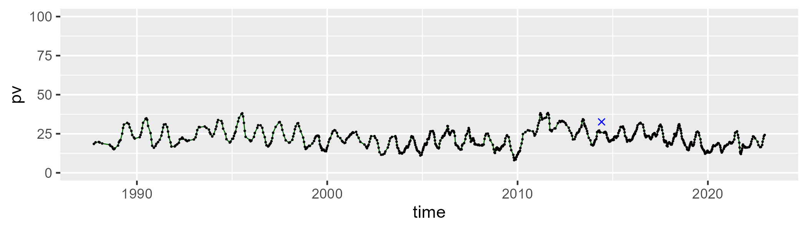

| Min. | 1st Qu. | Median | Mean | 3rd Qu. | Max. |
| --- | --- | --- | --- | --- | --- |
| 39.48212 | 48.64138 | 50.40495 | 50.34938 | 52.22615 | 59.11102 |

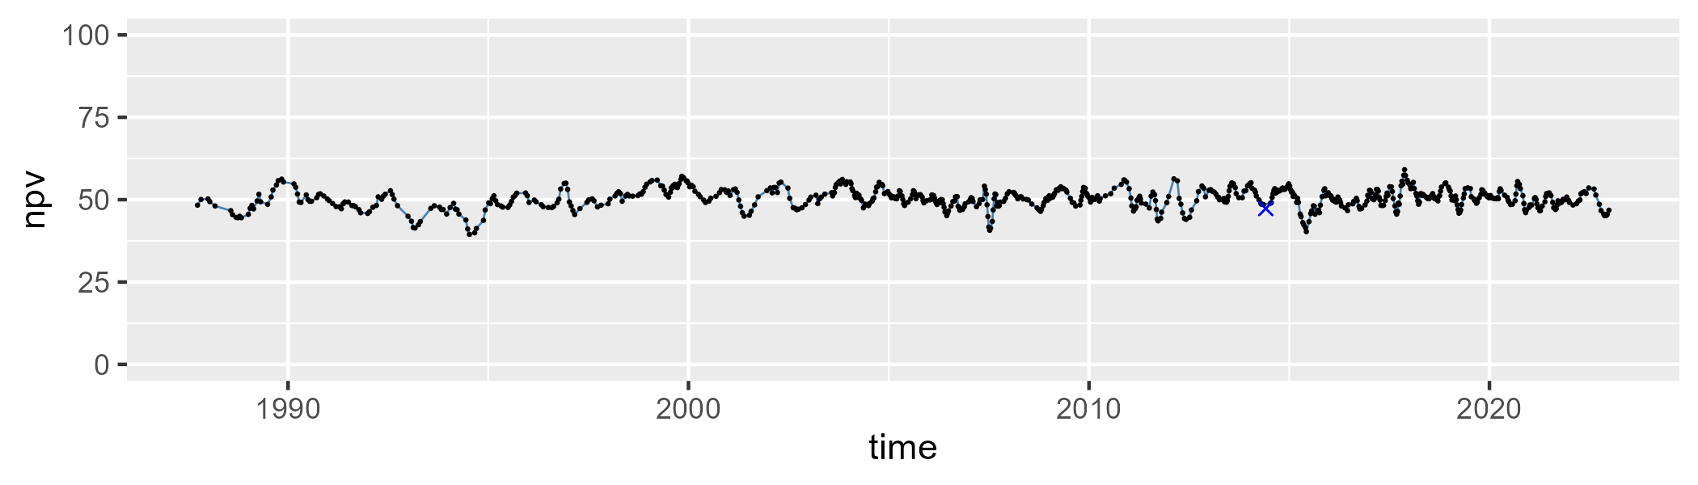

| Min. | 1st Qu. | Median | Mean | 3rd Qu. | Max. |
| --- | --- | --- | --- | --- | --- |
| 8.302669 | 22.75876 | 26.69405 | 26.53537 | 30.56337 | 39.57207 |

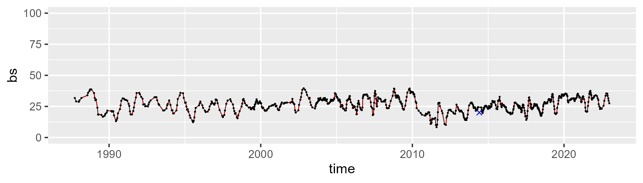

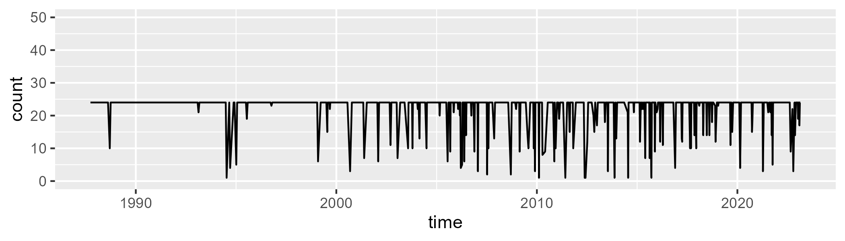

Min. : 1.00 1st Qu.:24.00 Median :24.00 Mean :22.31 3rd Qu.:24.00 Max. :24.00

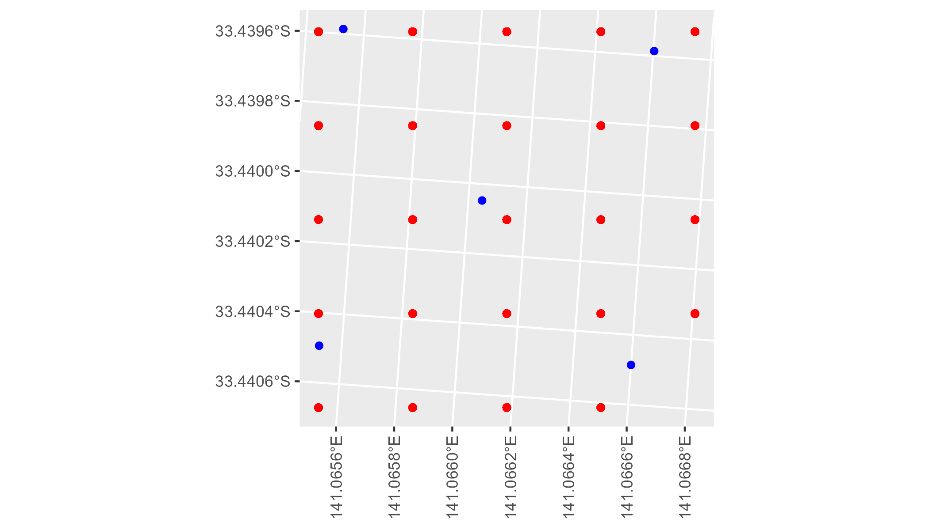

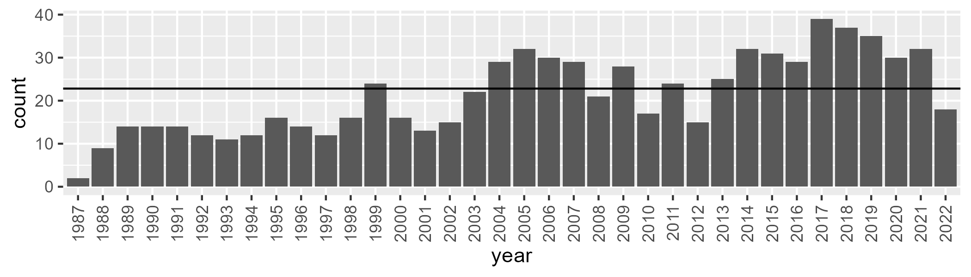

Number of samples: 769

# NSAMDD0010

| Min. | 1st Qu. | Median | Mean | 3rd Qu. | Max. |
| --- | --- | --- | --- | --- | --- |
| 0 | 9.402351 | 14.30316 | 17.81747 | 24.43842 | 61.02539 |

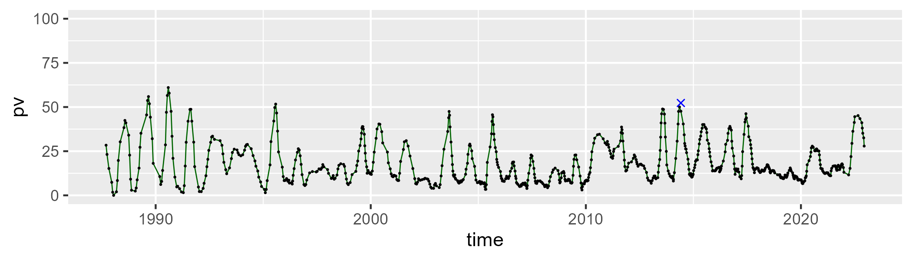

| Min. | 1st Qu. | Median | Mean | 3rd Qu. | Max. |
| --- | --- | --- | --- | --- | --- |
| 20.43746 | 38.14907 | 45.14077 | 44.54236 | 51.60913 | 66.87578 |

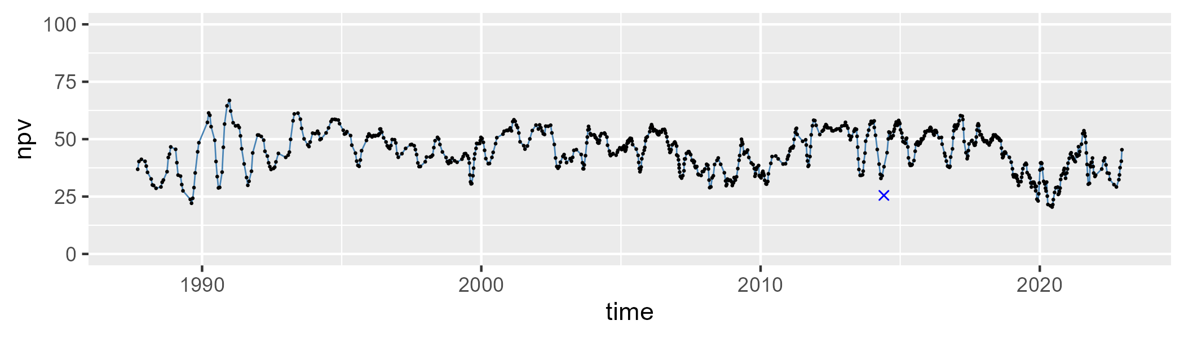

| Min. | 1st Qu. | Median | Mean | 3rd Qu. | Max. |
| --- | --- | --- | --- | --- | --- |
| 7.229691 | 27.45185 | 34.68371 | 36.24959 | 44.91224 | 66.31457 |

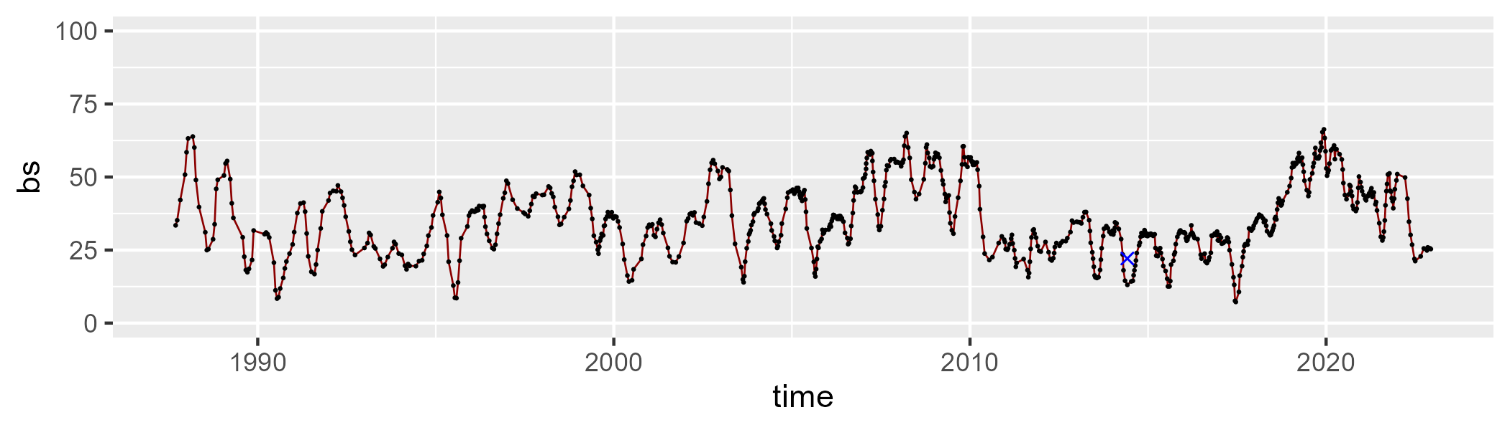

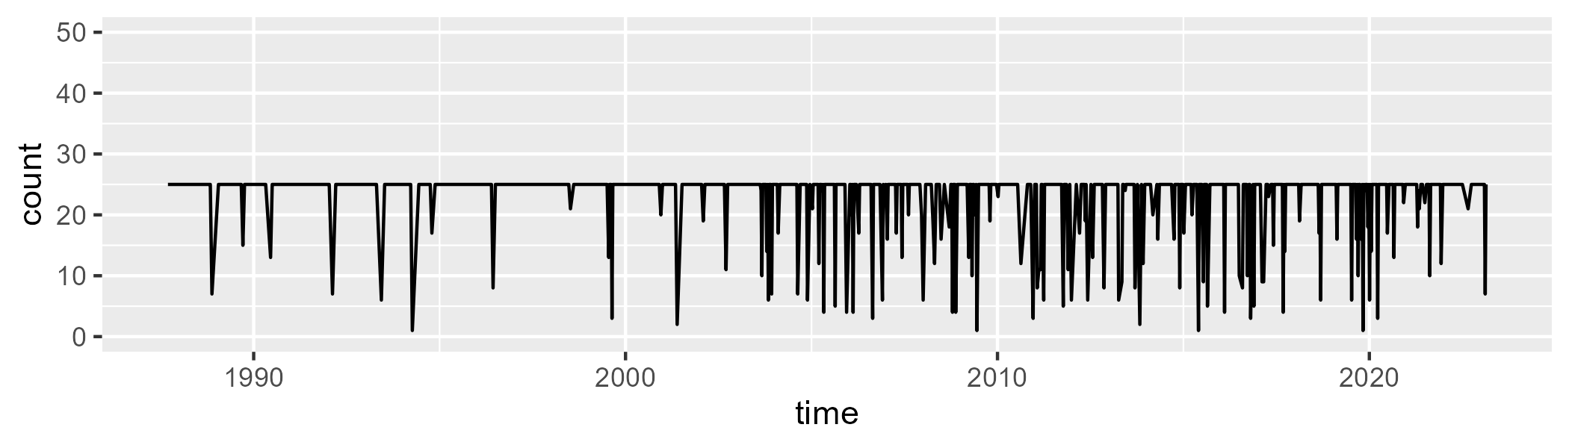

Min. : 1.00 1st Qu.:25.00 Median :25.00 Mean :23.03 3rd Qu.:25.00 Max. :25.00

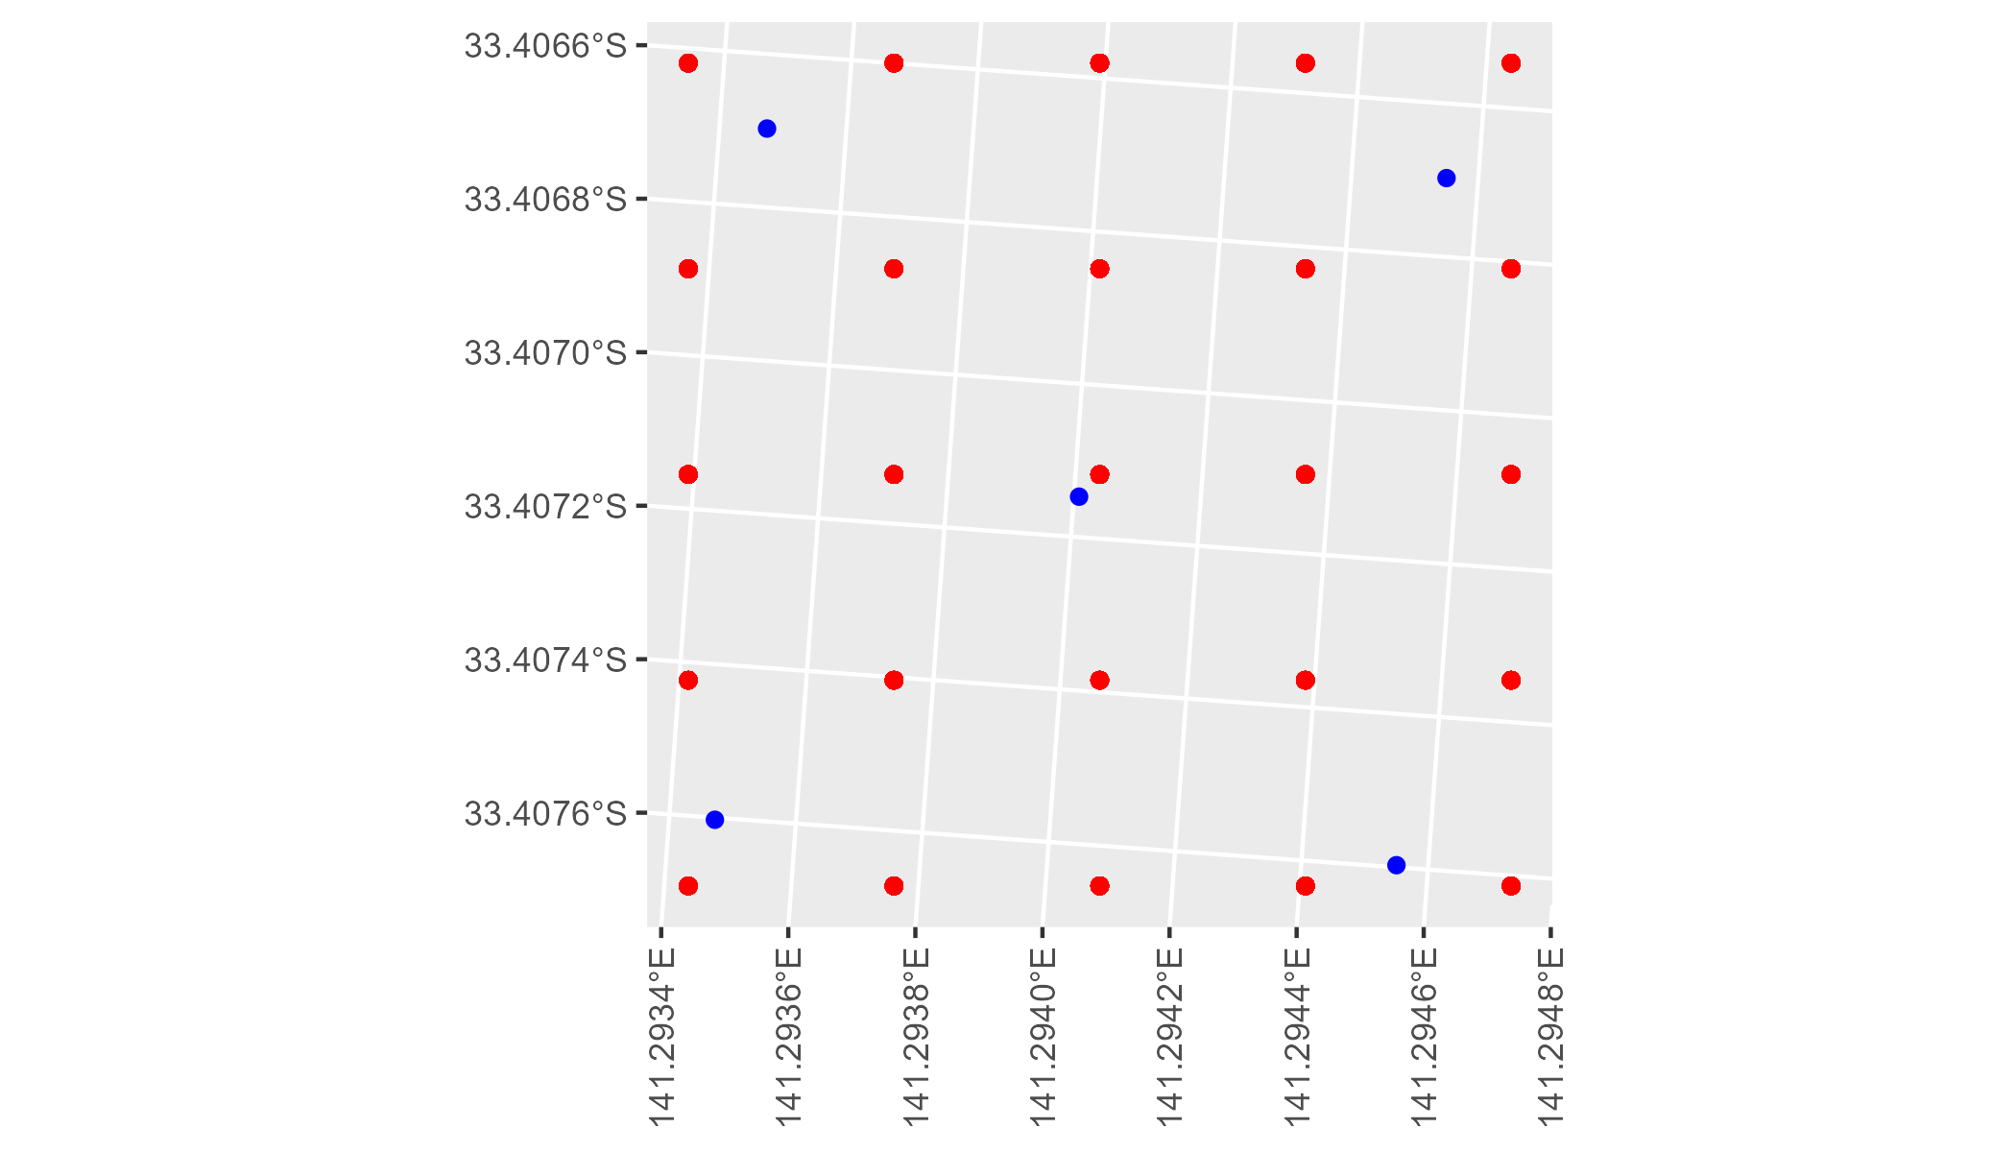

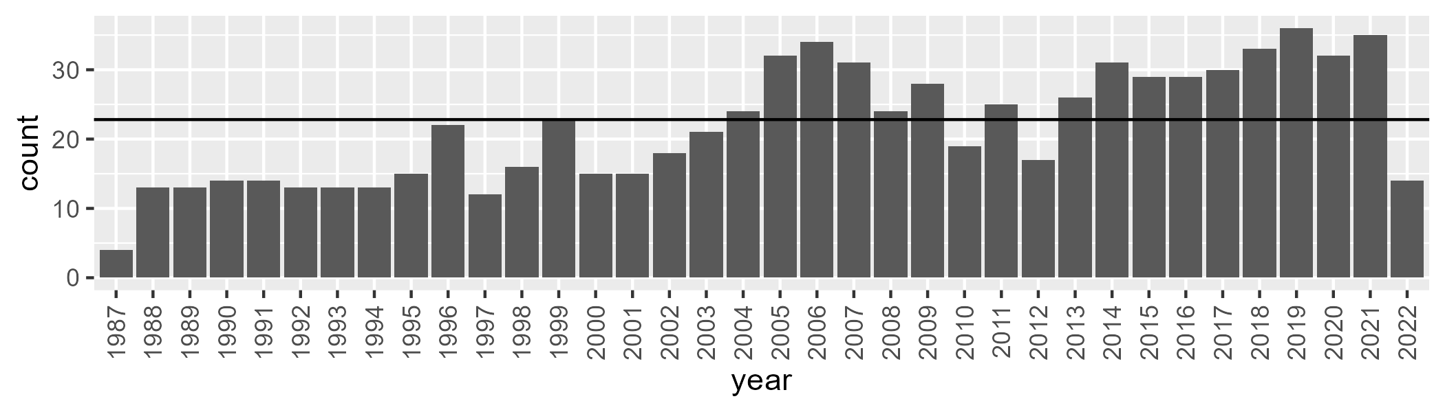

Number of samples: 783

# NSAMDD0011

| Min. | 1st Qu. | Median | Mean | 3rd Qu. | Max. |
| --- | --- | --- | --- | --- | --- |
| 4.582241 | 14.89468 | 18.25674 | 18.02987 | 21.50211 | 29.96129 |

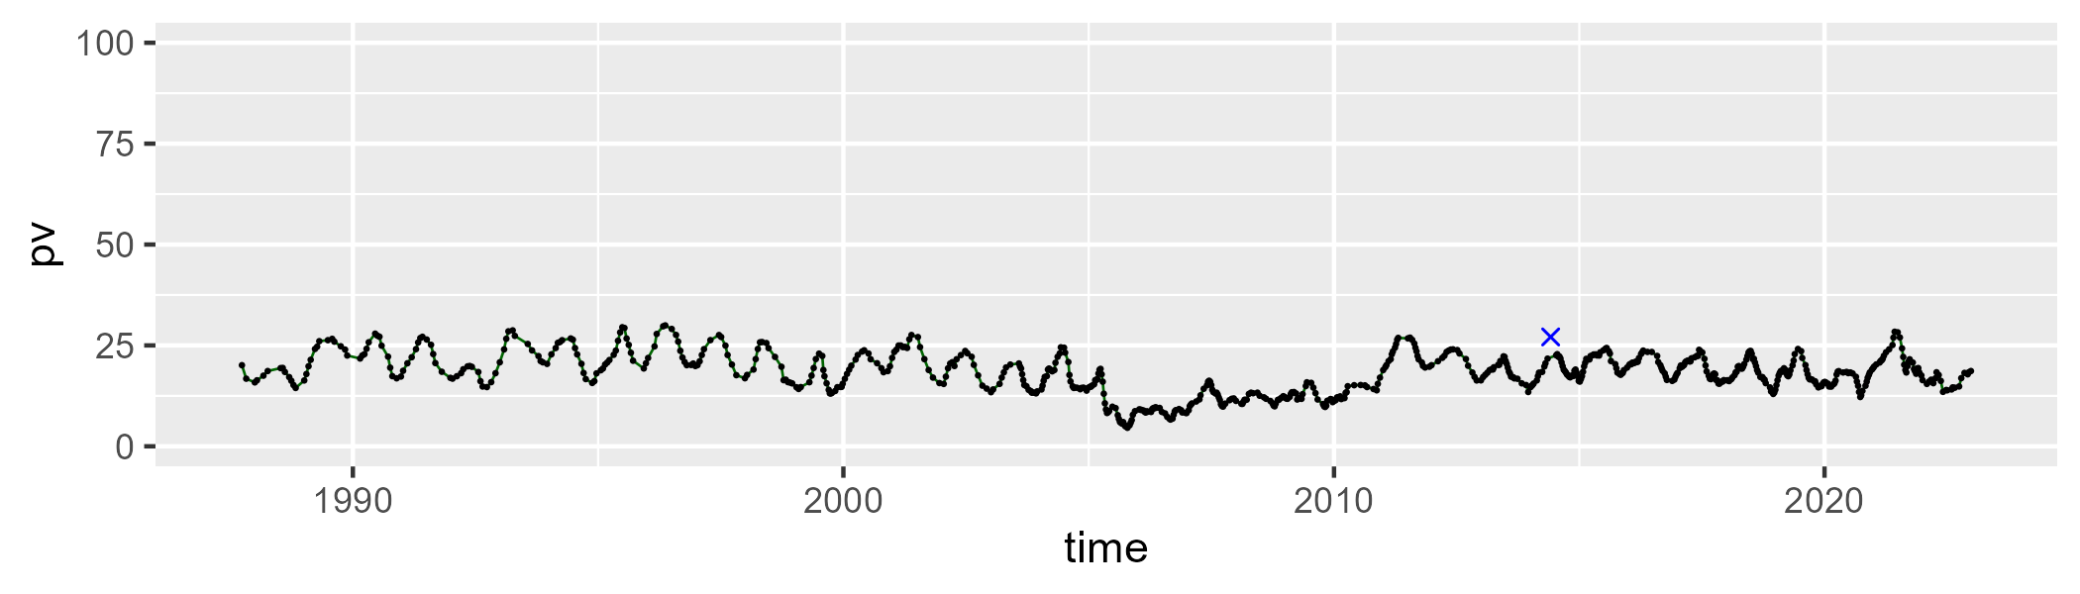

| Min. | 1st Qu. | Median | Mean | 3rd Qu. | Max. |
| --- | --- | --- | --- | --- | --- |
| 15.31558 | 29.17909 | 32.74901 | 32.92711 | 37.24929 | 45.65876 |

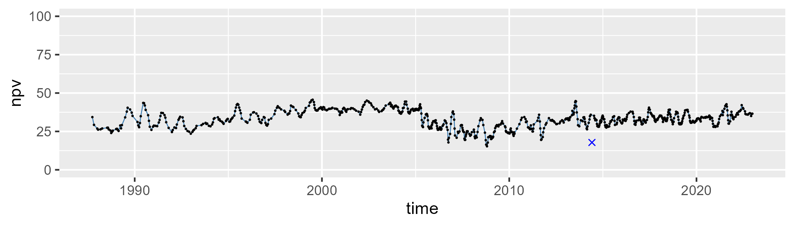

| Min. | 1st Qu. | Median | Mean | 3rd Qu. | Max. |
| --- | --- | --- | --- | --- | --- |
| 26.19048 | 42.67157 | 46.74862 | 47.49098 | 51.78081 | 72.65734 |

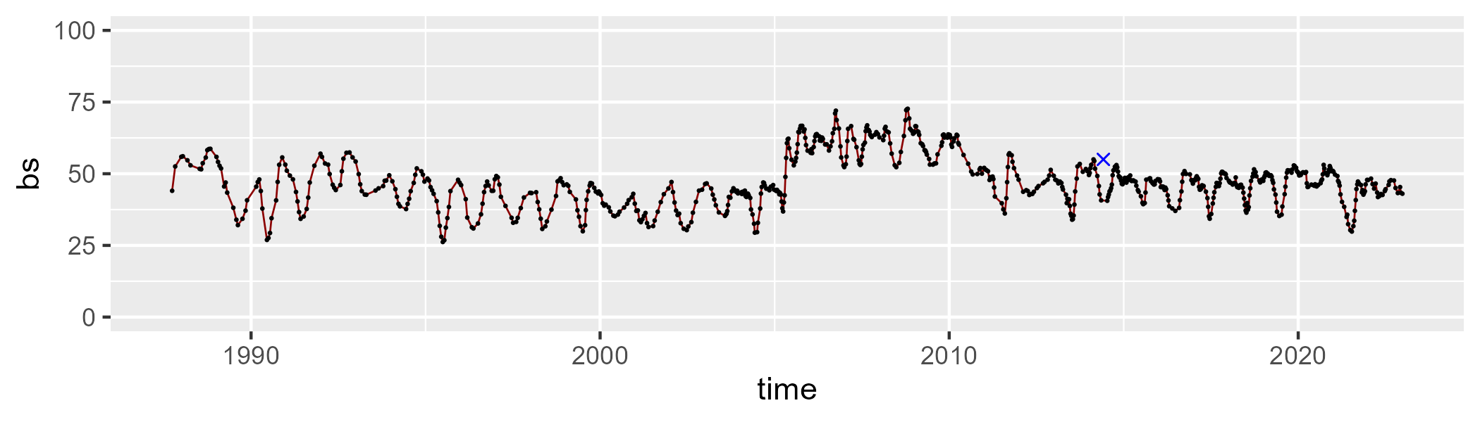

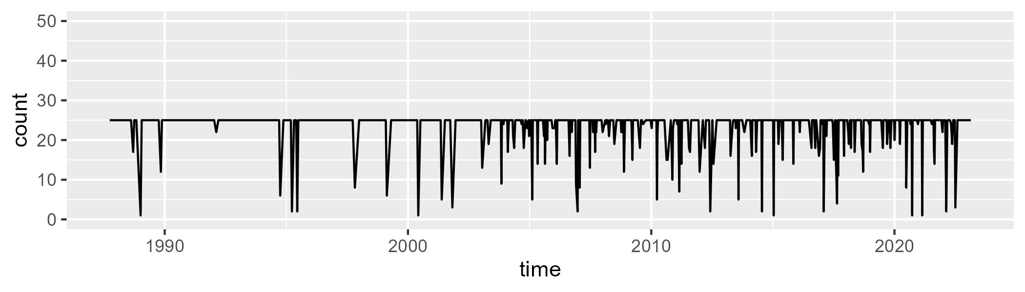

Min. : 1.00 1st Qu.:25.00 Median :25.00 Mean :23.52 3rd Qu.:25.00 Max. :25.00

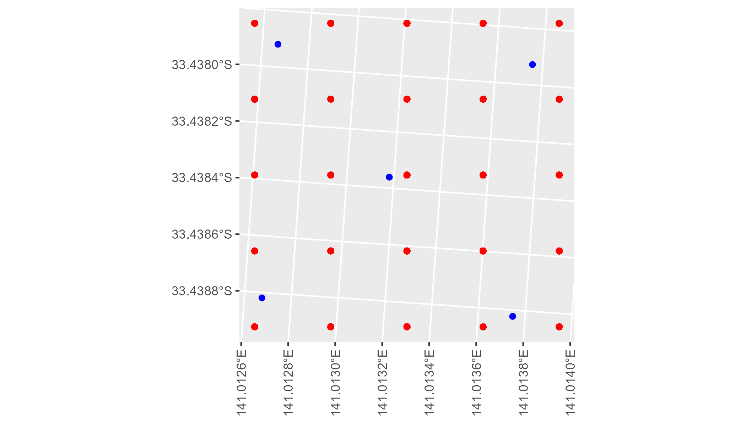

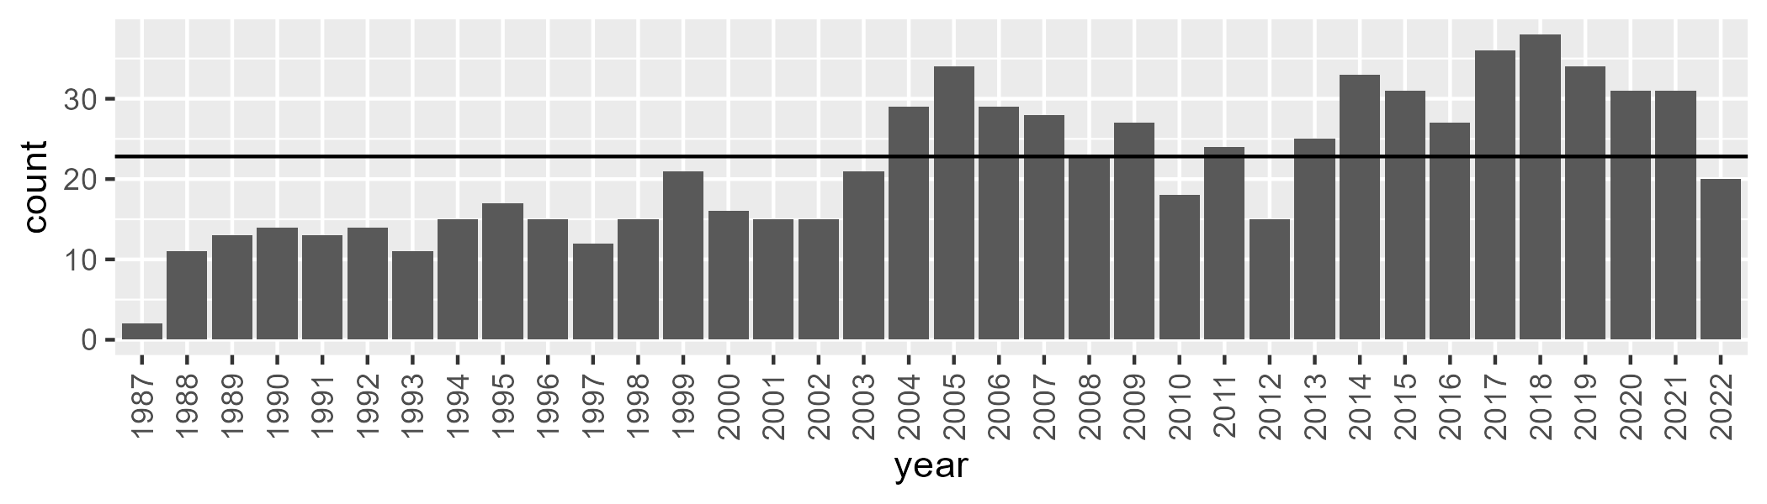

Number of samples: 773

# NSAMDD0012

| Min. | 1st Qu. | Median | Mean | 3rd Qu. | Max. |
| --- | --- | --- | --- | --- | --- |
| 0 | 0.577867 | 1.263384 | 1.513393 | 2.071567 | 8.369602 |

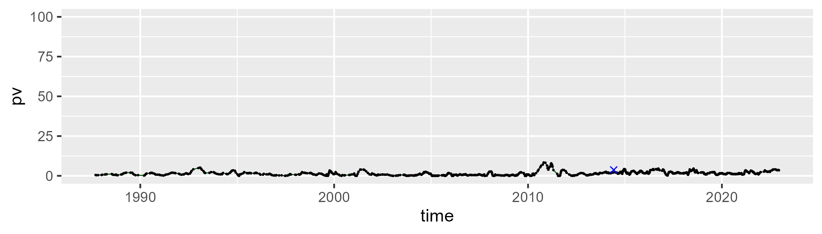

| Min. | 1st Qu. | Median | Mean | 3rd Qu. | Max. |
| --- | --- | --- | --- | --- | --- |
| 55.86994 | 75.61752 | 81.08229 | 80.79726 | 86.11937 | 103.2677 |

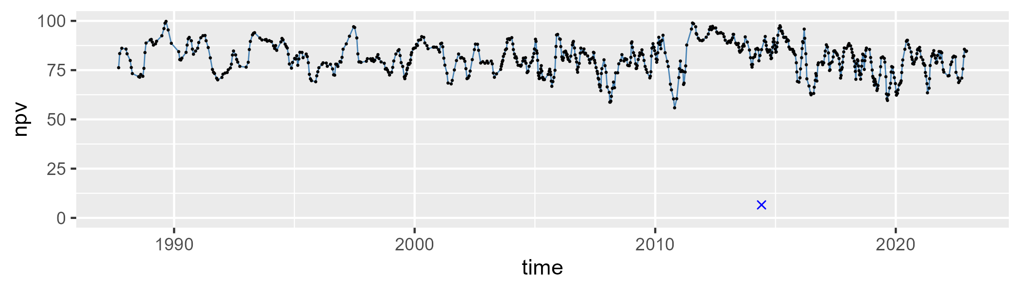

| Min. | 1st Qu. | Median | Mean | 3rd Qu. | Max. |
| --- | --- | --- | --- | --- | --- |
| 0 | 11.81381 | 16.85298 | 17.02677 | 21.82837 | 38.64179 |

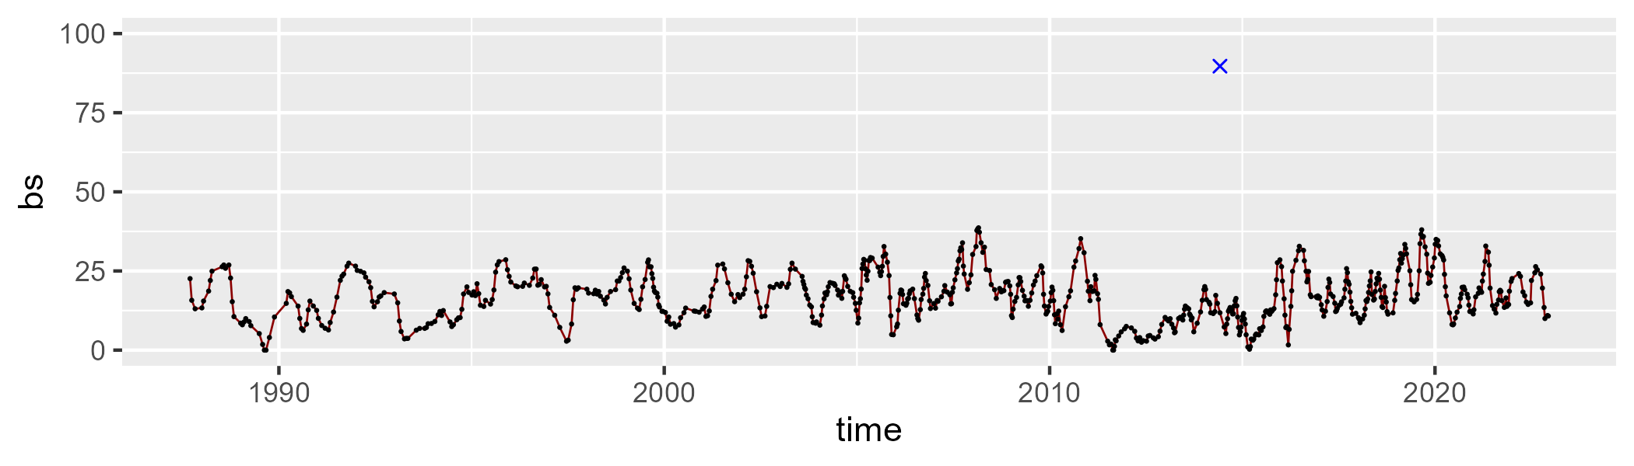

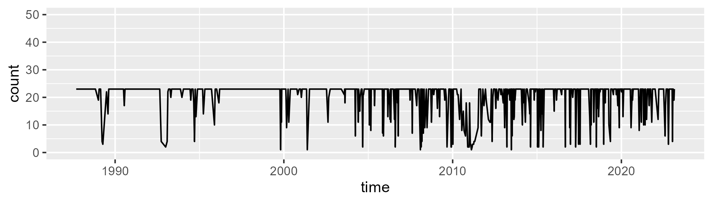

Min. : 1.00 1st Qu.:23.00 Median :23.00 Mean :20.31 3rd Qu.:23.00 Max. :23.00

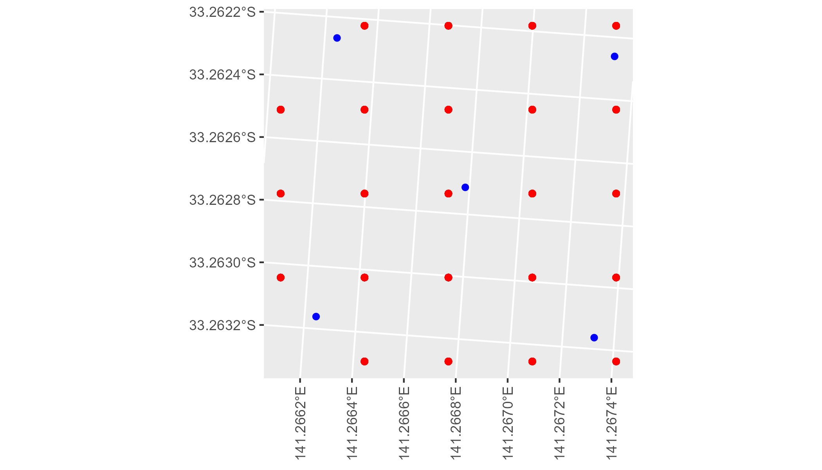

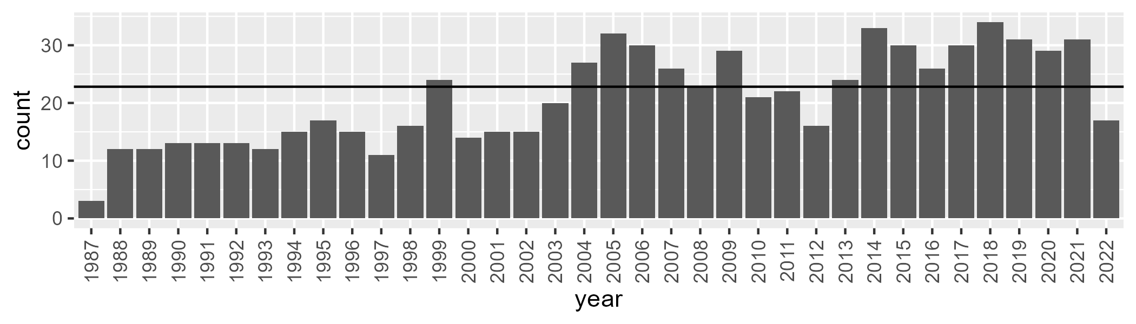

Number of samples: 751

# NSAMDD0013

| Min. | 1st Qu. | Median | Mean | 3rd Qu. | Max. |
| --- | --- | --- | --- | --- | --- |
| 10.7263 | 17.01094 | 20.22268 | 20.84395 | 23.93637 | 39.07207 |

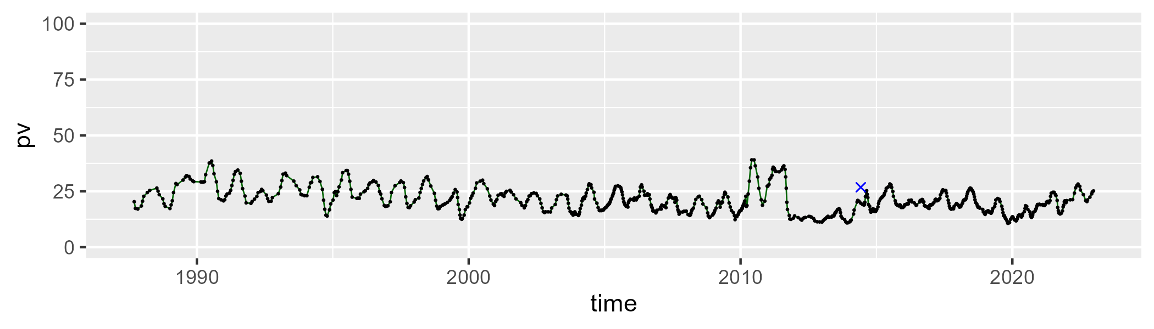

| Min. | 1st Qu. | Median | Mean | 3rd Qu. | Max. |
| --- | --- | --- | --- | --- | --- |
| 30.46732 | 39.61369 | 44.70679 | 43.58262 | 47.48252 | 52.72387 |

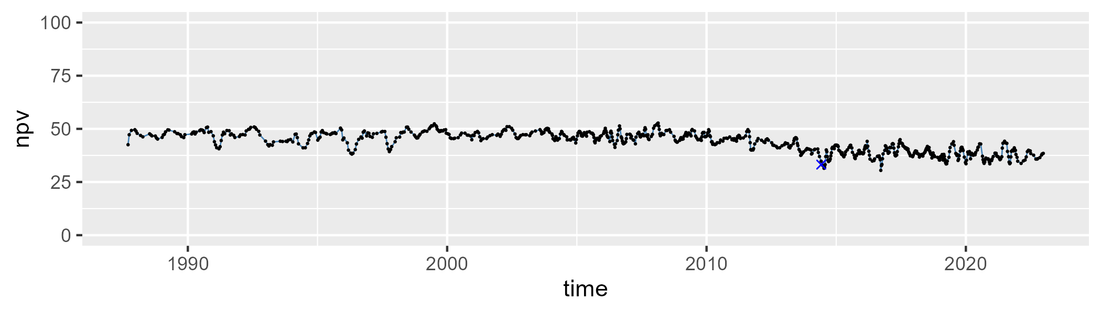

| Min. | 1st Qu. | Median | Mean | 3rd Qu. | Max. |
| --- | --- | --- | --- | --- | --- |
| 10.83608 | 28.77927 | 33.97802 | 34.19841 | 40.52349 | 51.31354 |

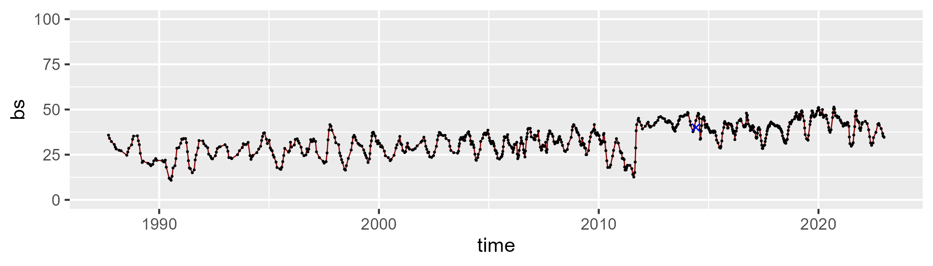

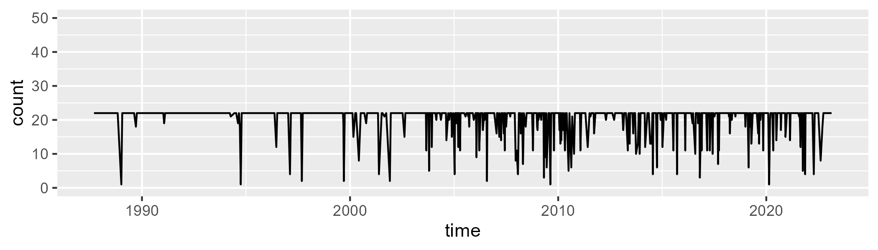

Min. : 1.00 1st Qu.:22.00 Median :22.00 Mean :20.45 3rd Qu.:22.00 Max. :22.00

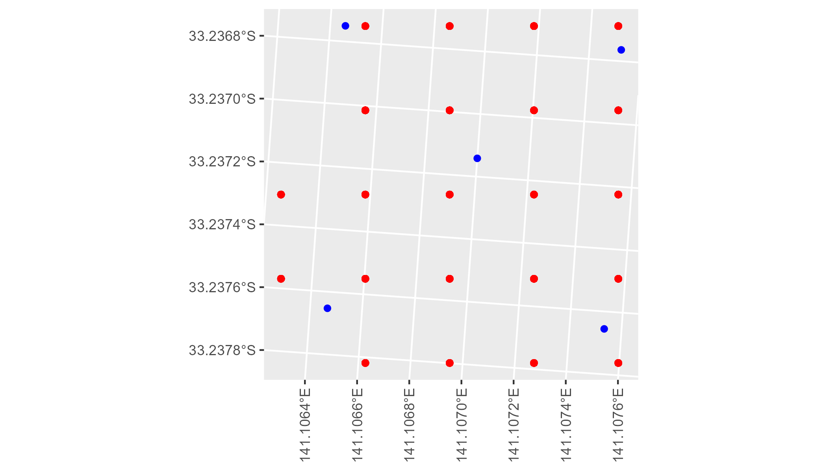

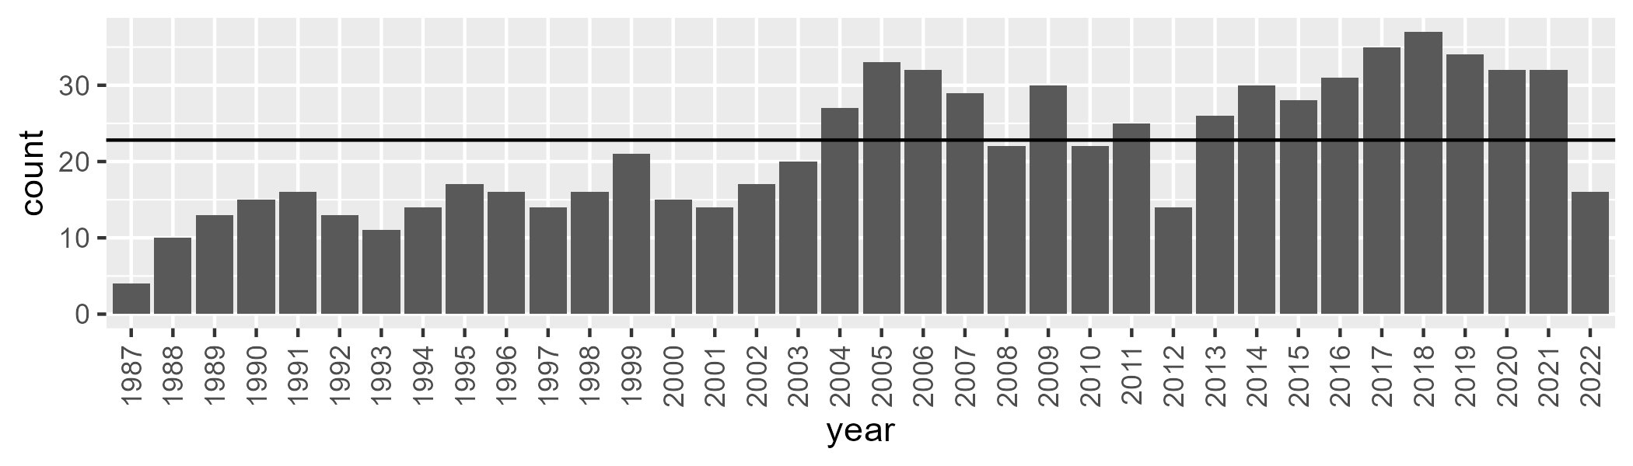

Number of samples: 781

# NSAMDD0014

| Min. | 1st Qu. | Median | Mean | 3rd Qu. | Max. |
| --- | --- | --- | --- | --- | --- |
| 10.51737 | 15.40139 | 17.91013 | 18.66483 | 21.67712 | 32.37135 |

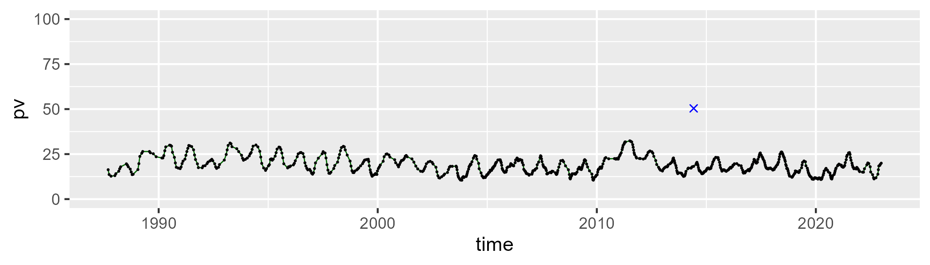

| Min. | 1st Qu. | Median | Mean | 3rd Qu. | Max. |
| --- | --- | --- | --- | --- | --- |
| 34.30613 | 43.28172 | 45.47344 | 45.17633 | 47.34498 | 53.60906 |

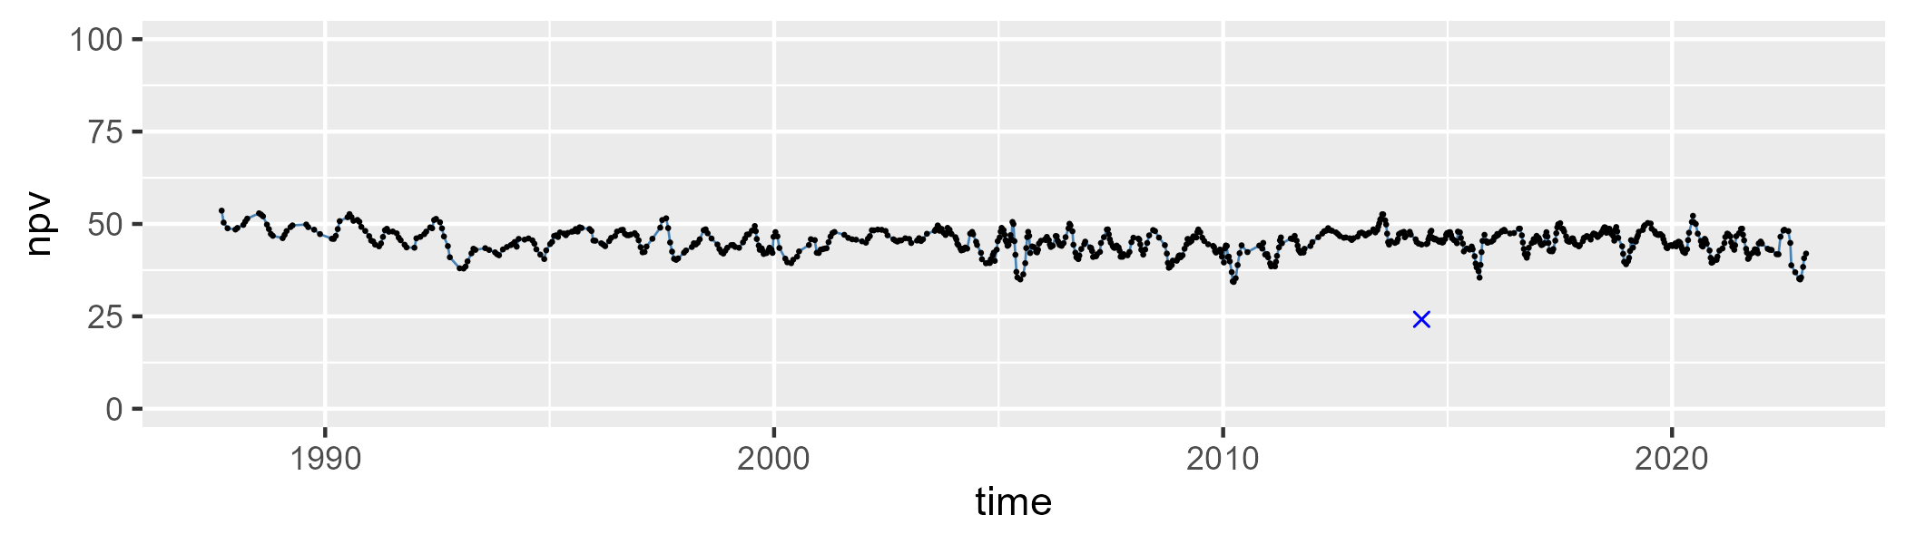

| Min. | 1st Qu. | Median | Mean | 3rd Qu. | Max. |
| --- | --- | --- | --- | --- | --- |
| 16.29259 | 31.12405 | 35.19584 | 34.78094 | 38.74348 | 49.68674 |

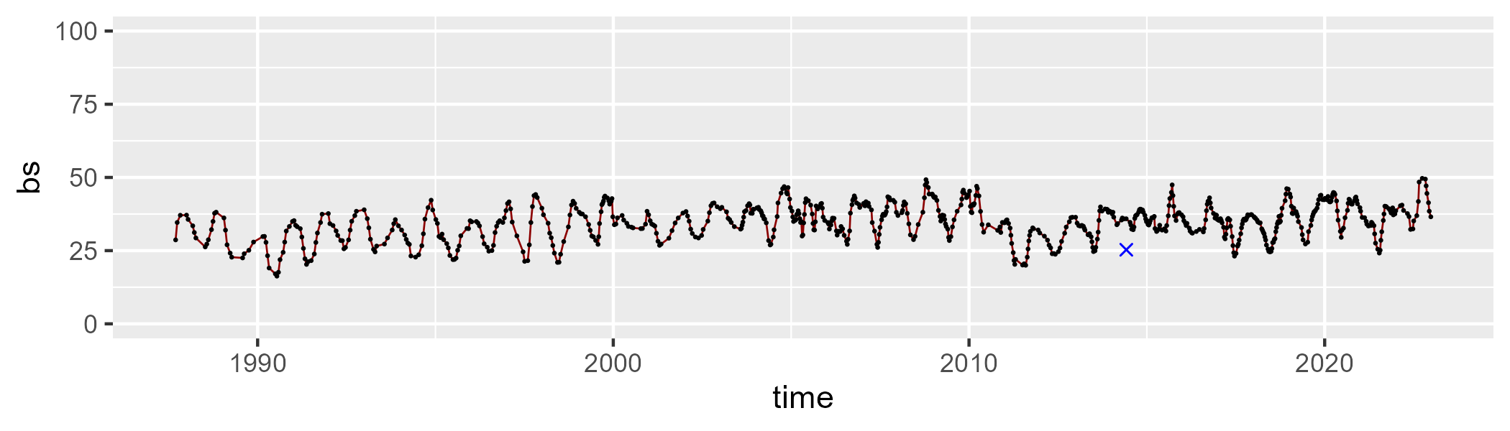

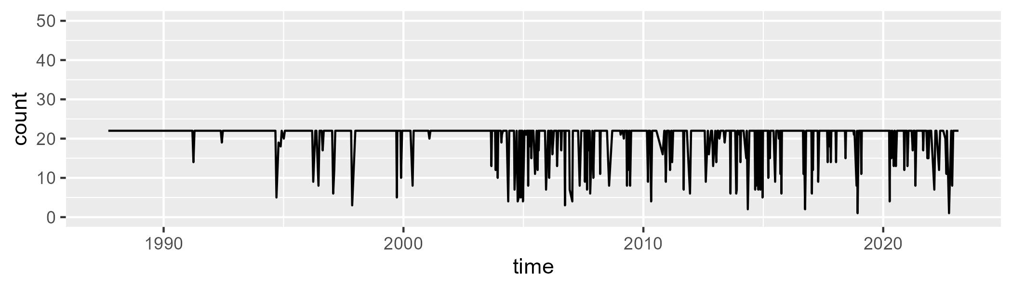

Min. : 1.00 1st Qu.:22.00 Median :22.00 Mean :20.32 3rd Qu.:22.00 Max. :22.00

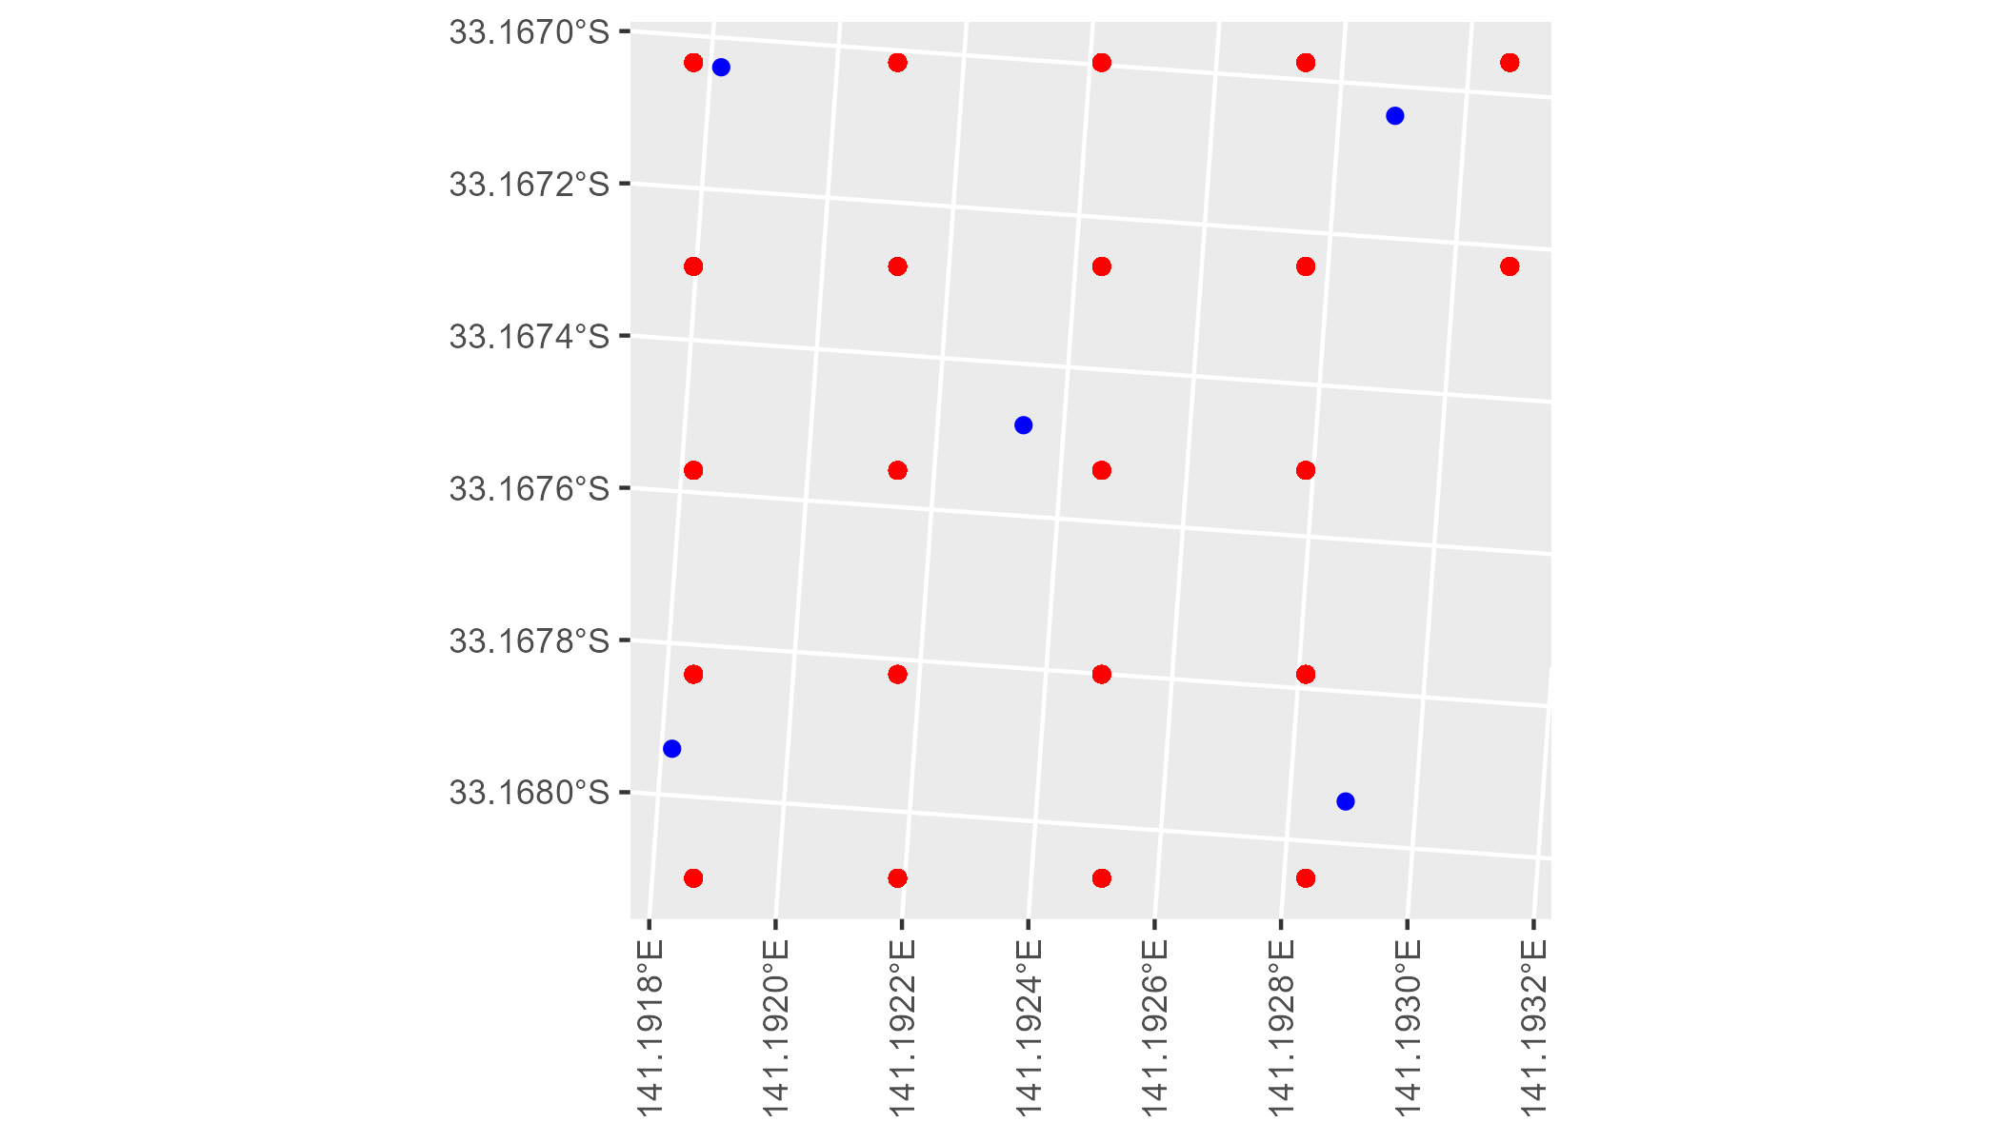

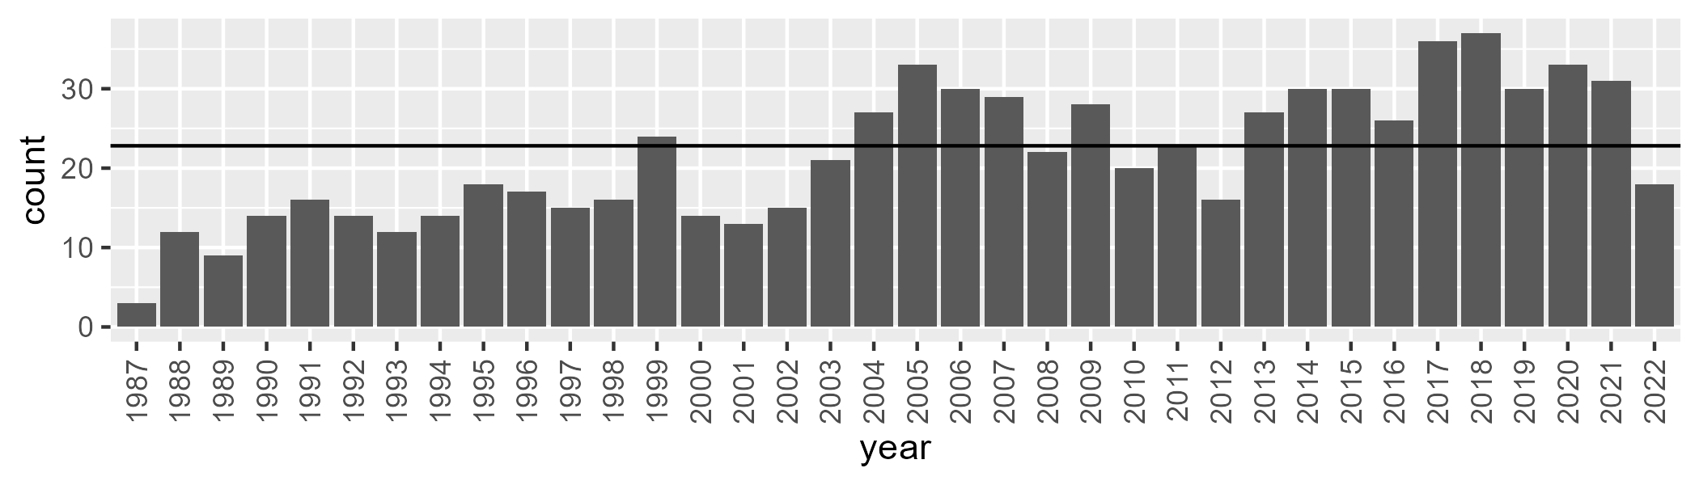

Number of samples: 773

# NSAMDD0015

| Min. | 1st Qu. | Median | Mean | 3rd Qu. | Max. |
| --- | --- | --- | --- | --- | --- |
| 10.61559 | 17.89795 | 22.17808 | 22.16067 | 25.71301 | 39.19771 |

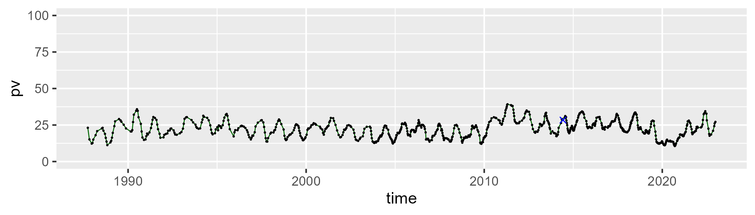

| Min. | 1st Qu. | Median | Mean | 3rd Qu. | Max. |
| --- | --- | --- | --- | --- | --- |
| 41.24208 | 51.09281 | 52.96479 | 52.79605 | 54.72103 | 63.62482 |

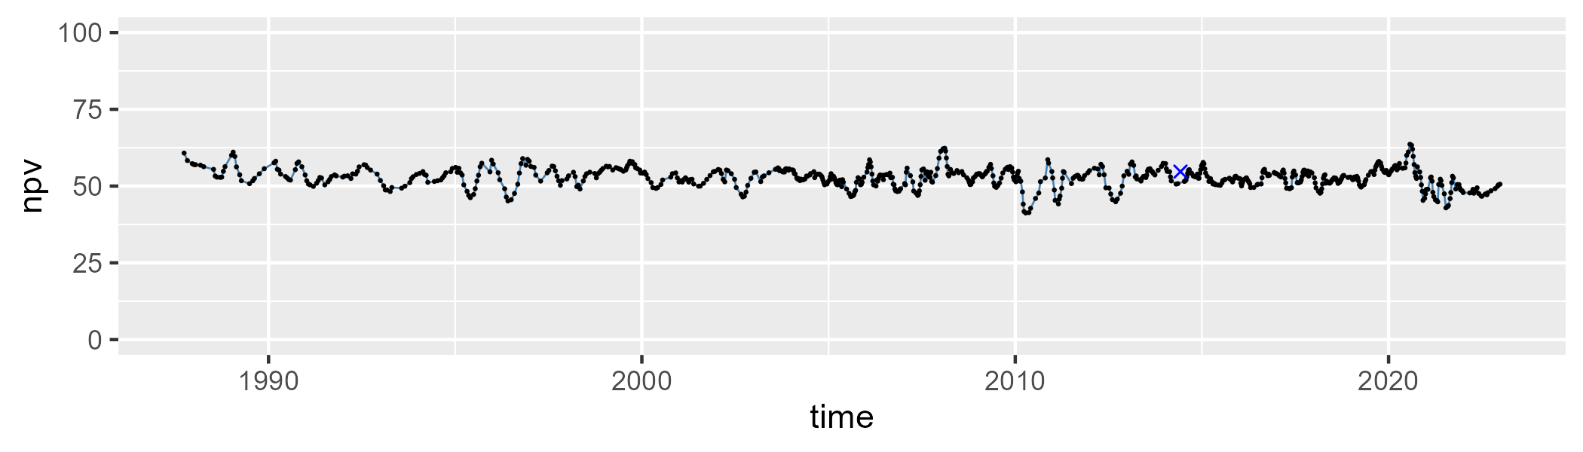

| Min. | 1st Qu. | Median | Mean | 3rd Qu. | Max. |
| --- | --- | --- | --- | --- | --- |
| 5.169862 | 20.47561 | 23.93787 | 23.8744 | 28.03052 | 36.9846 |

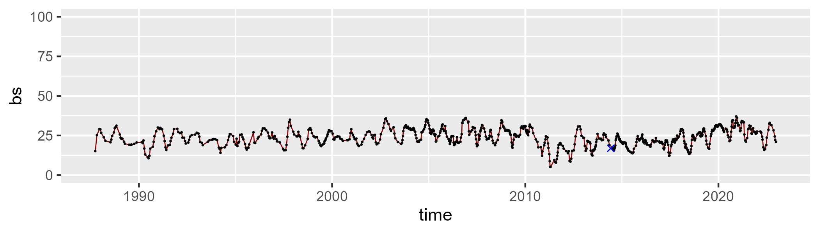

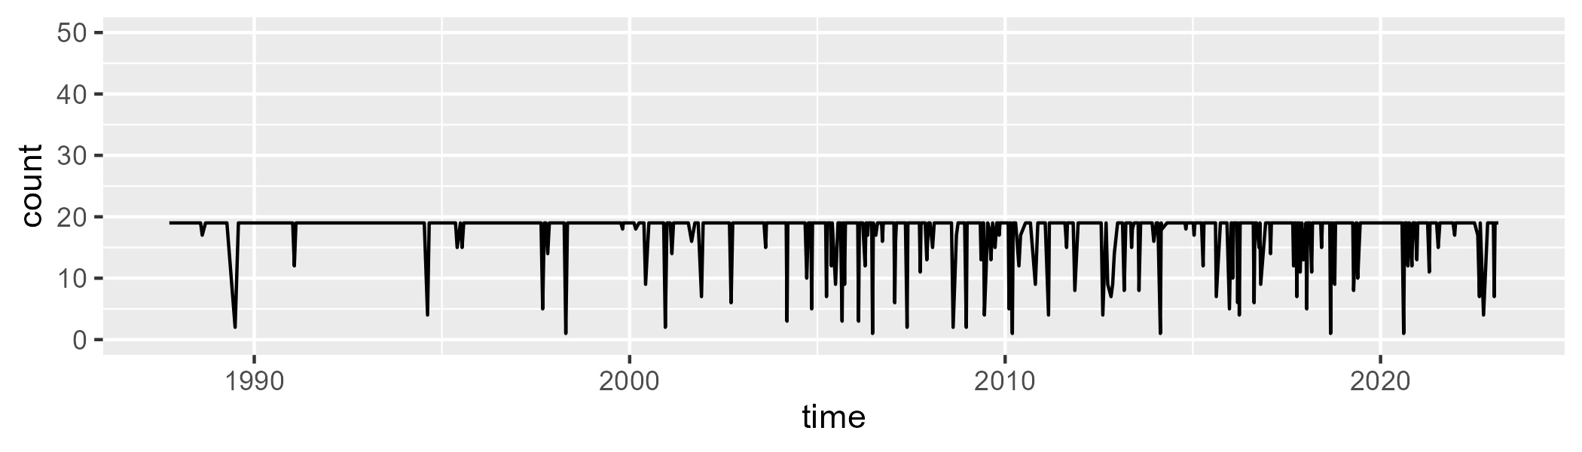

Min. : 1.00 1st Qu.:19.00 Median :19.00 Mean :17.81 3rd Qu.:19.00 Max. :19.00

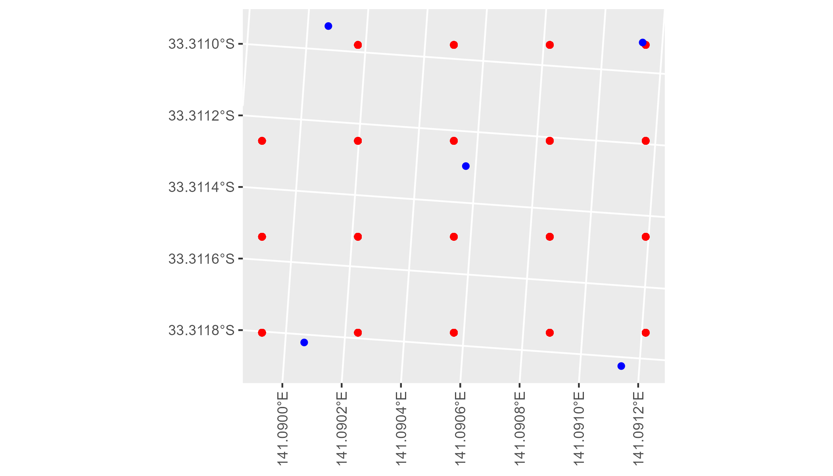

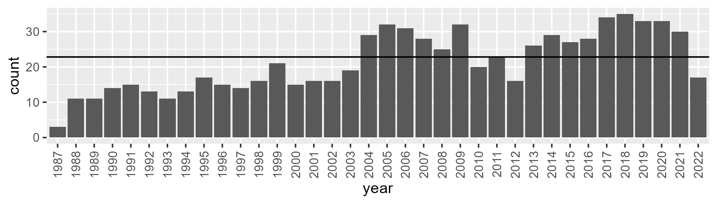

Number of samples: 768

# NSAMDD0016

| Min. | 1st Qu. | Median | Mean | 3rd Qu. | Max. |
| --- | --- | --- | --- | --- | --- |
| 0.420632 | 7.172182 | 10.21009 | 12.71157 | 16.43287 | 42.9992 |

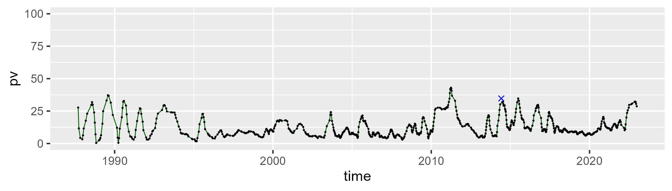

| Min. | 1st Qu. | Median | Mean | 3rd Qu. | Max. |
| --- | --- | --- | --- | --- | --- |
| 18.67595 | 37.48996 | 45.15247 | 43.92782 | 49.96865 | 70.15336 |

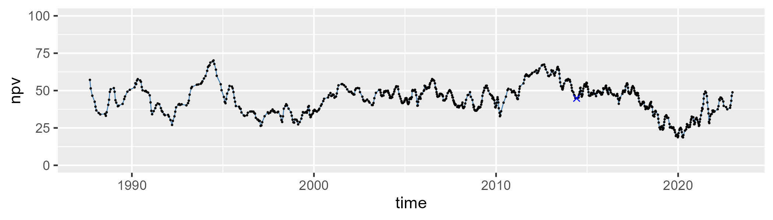

| Min. | 1st Qu. | Median | Mean | 3rd Qu. | Max. |
| --- | --- | --- | --- | --- | --- |
| 7.037715 | 32.928 | 42.45179 | 41.96658 | 51.17762 | 71.75735 |

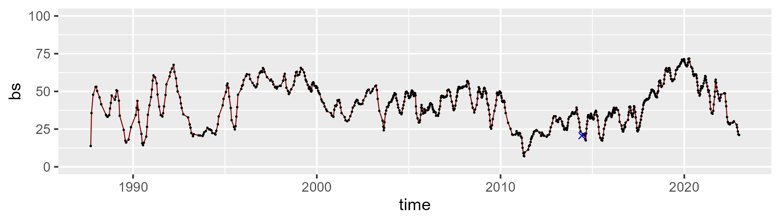

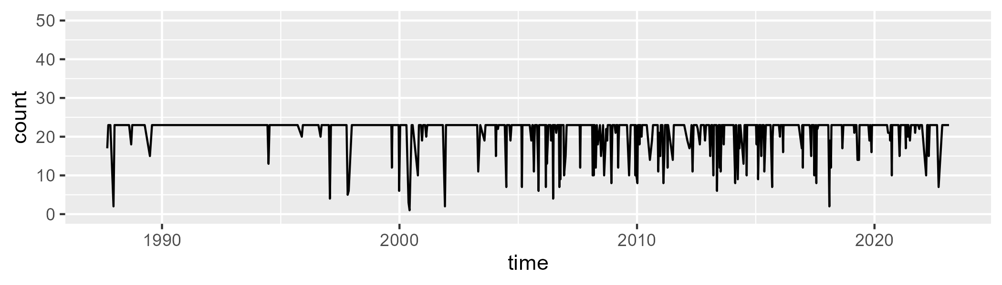

Min. : 1.00 1st Qu.:23.00 Median :23.00 Mean :21.54 3rd Qu.:23.00 Max. :23.00

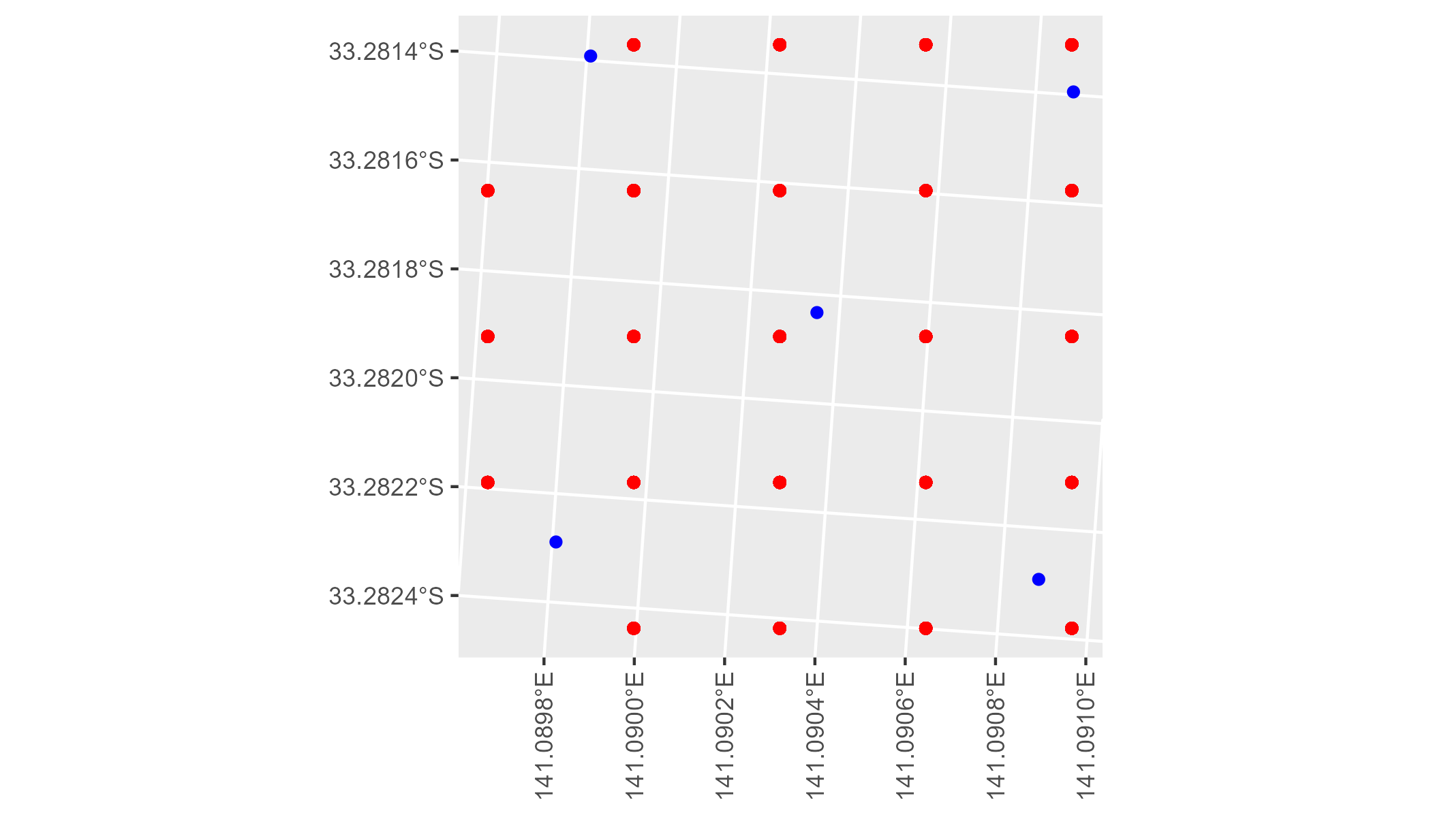

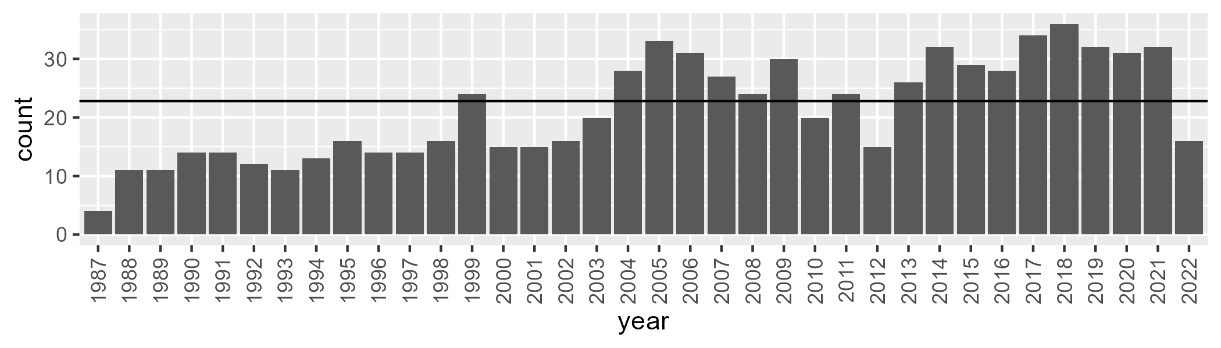

Number of samples: 768

# NSAMDD0017

| Min. | 1st Qu. | Median | Mean | 3rd Qu. | Max. |
| --- | --- | --- | --- | --- | --- |
| 15.36697 | 24.66553 | 28.91966 | 29.36359 | 33.78824 | 47.17531 |

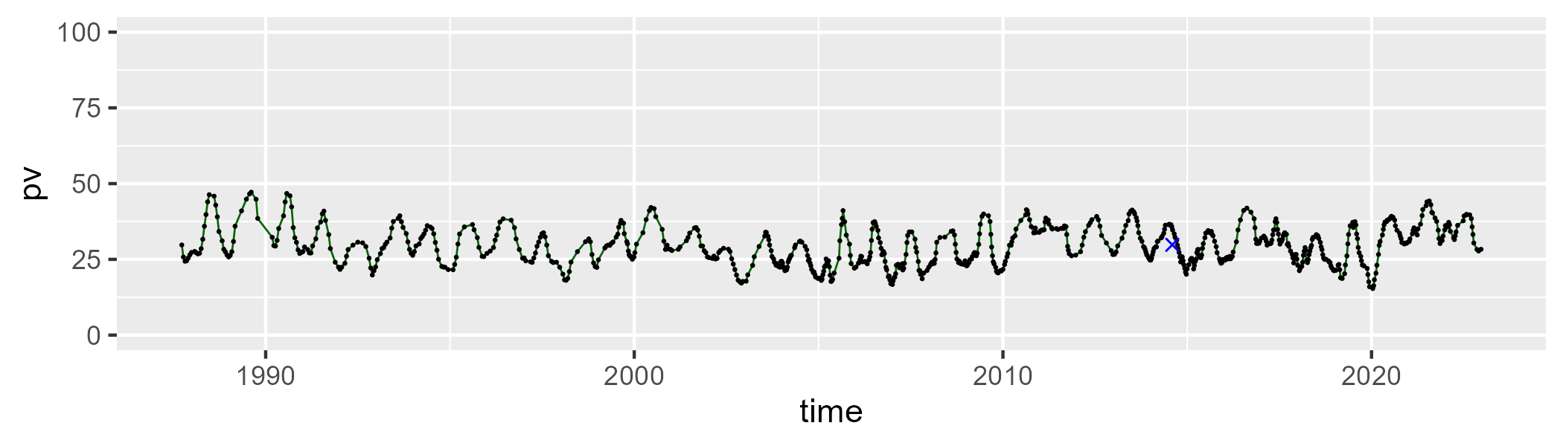

| Min. | 1st Qu. | Median | Mean | 3rd Qu. | Max. |
| --- | --- | --- | --- | --- | --- |
| 40.79144 | 51.23501 | 52.89485 | 52.74306 | 54.59631 | 59.56563 |

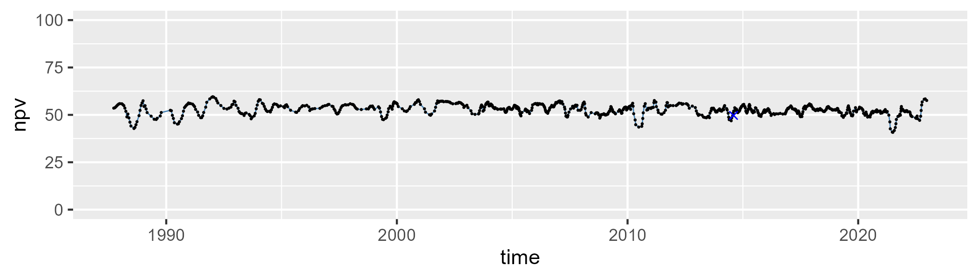

| Min. | 1st Qu. | Median | Mean | 3rd Qu. | Max. |
| --- | --- | --- | --- | --- | --- |
| 3.146543 | 12.94752 | 16.61634 | 16.7755 | 20.60694 | 31.01899 |

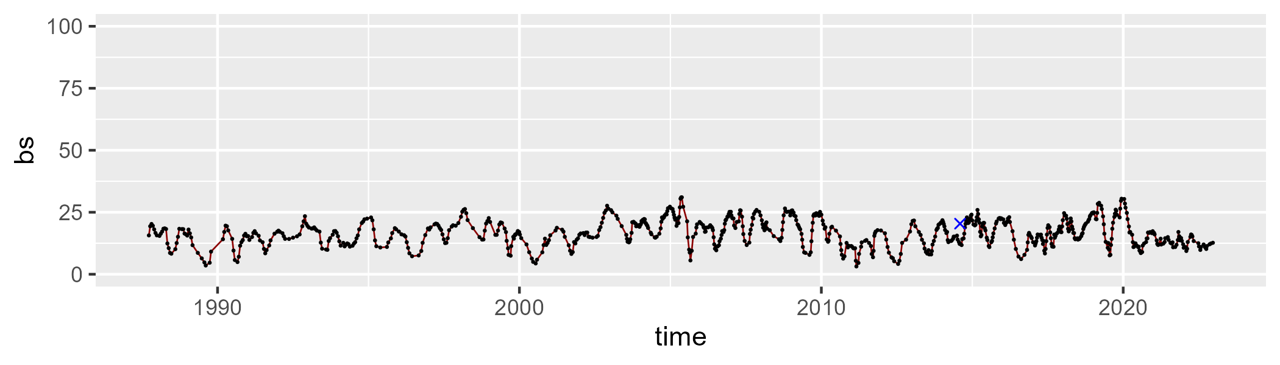

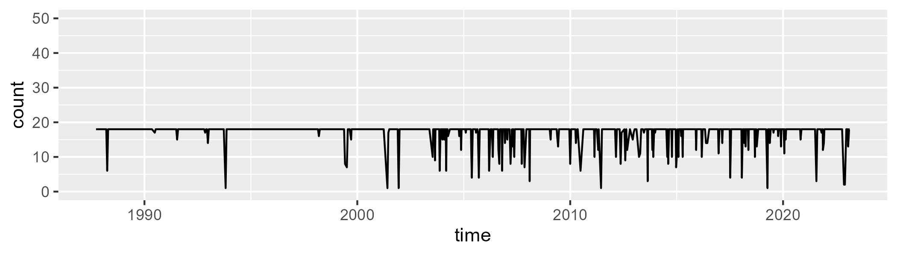

Min. : 1.00 1st Qu.:18.00 Median :18.00 Mean :17.11 3rd Qu.:18.00 Max. :18.00

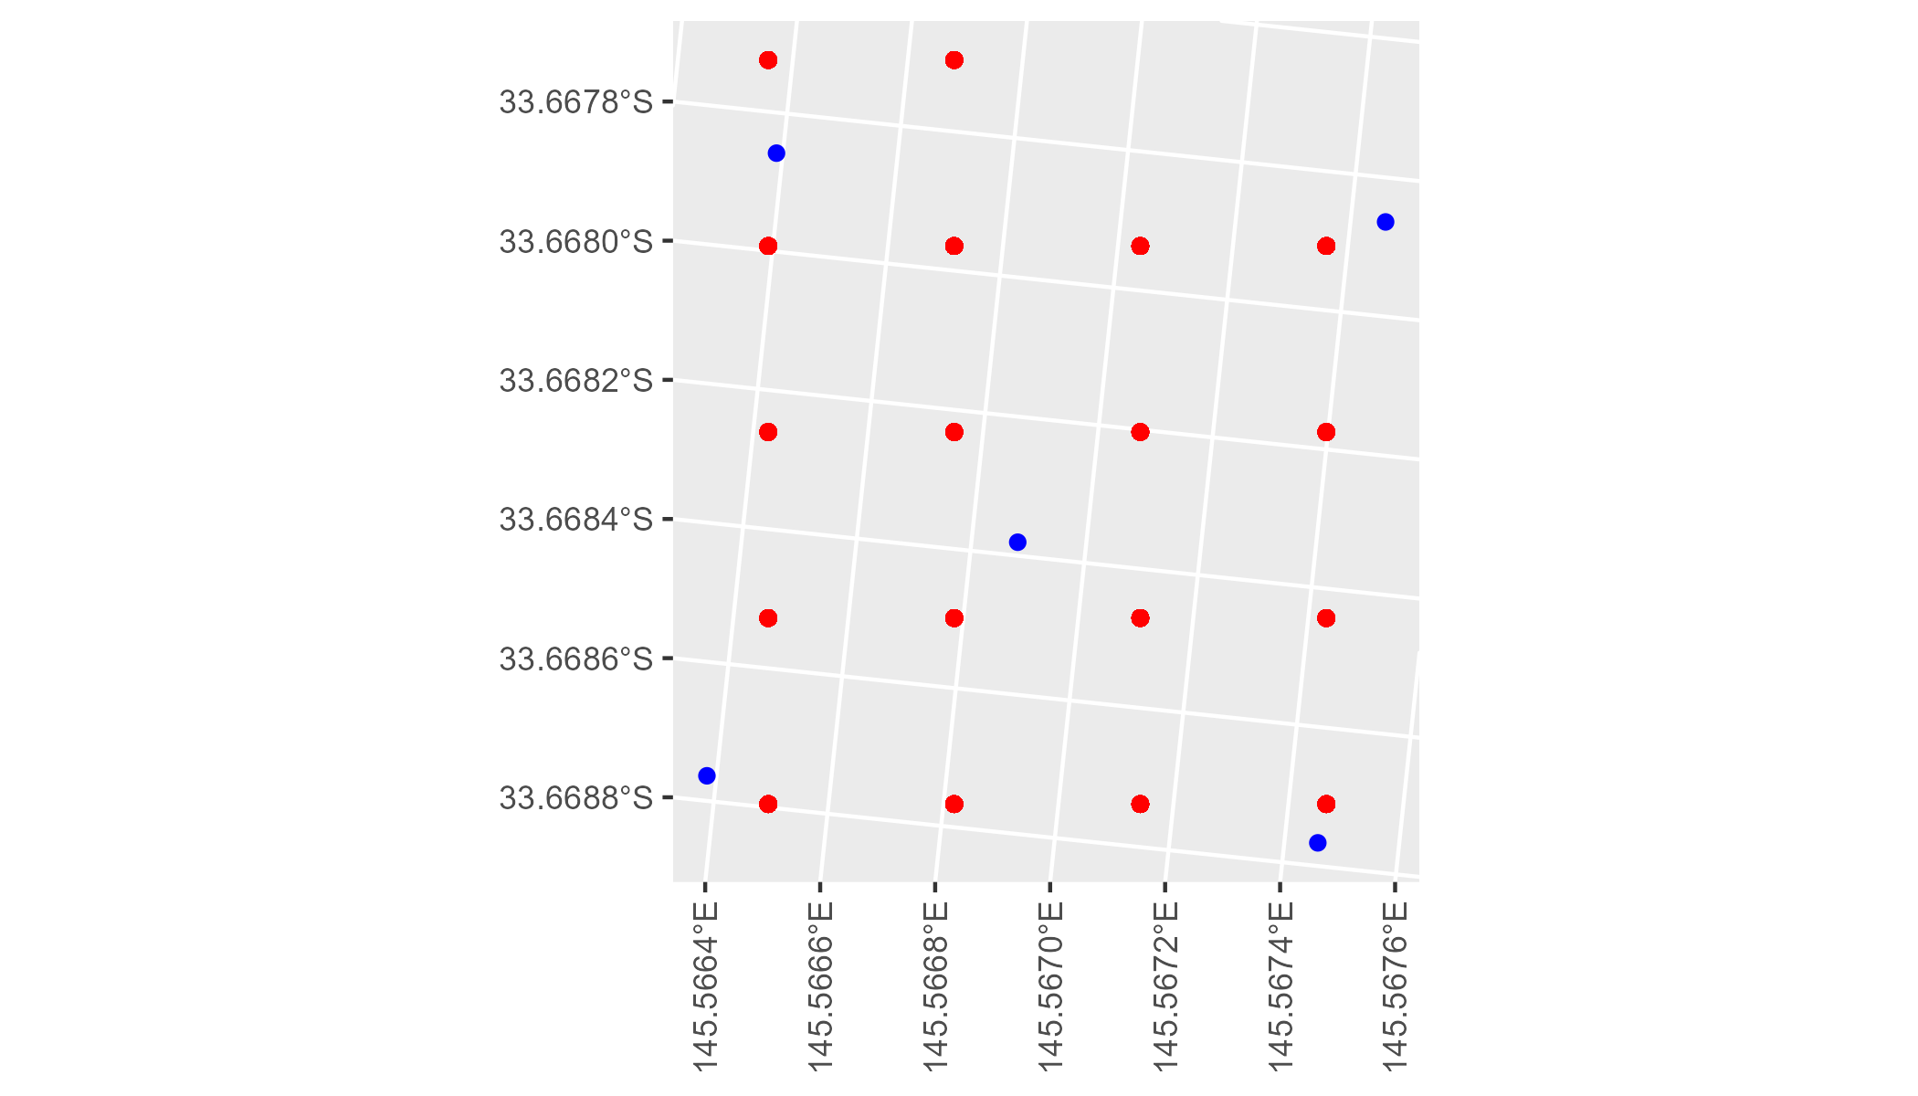

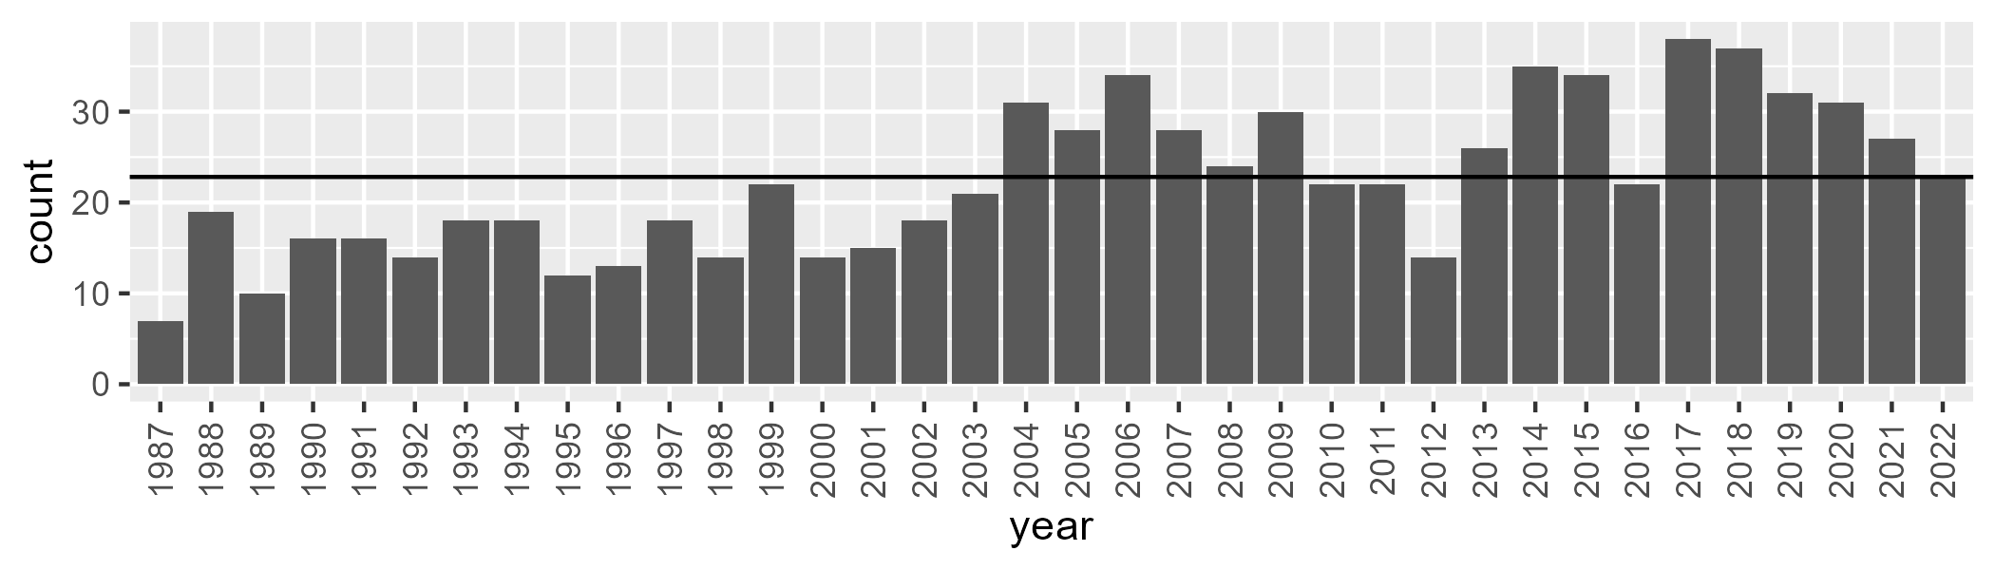

Number of samples: 803

# NSAMDD0018

| Min. | 1st Qu. | Median | Mean | 3rd Qu. | Max. |
| --- | --- | --- | --- | --- | --- |
| 20.71177 | 30.81723 | 34.93945 | 35.53506 | 40.26265 | 54.05816 |

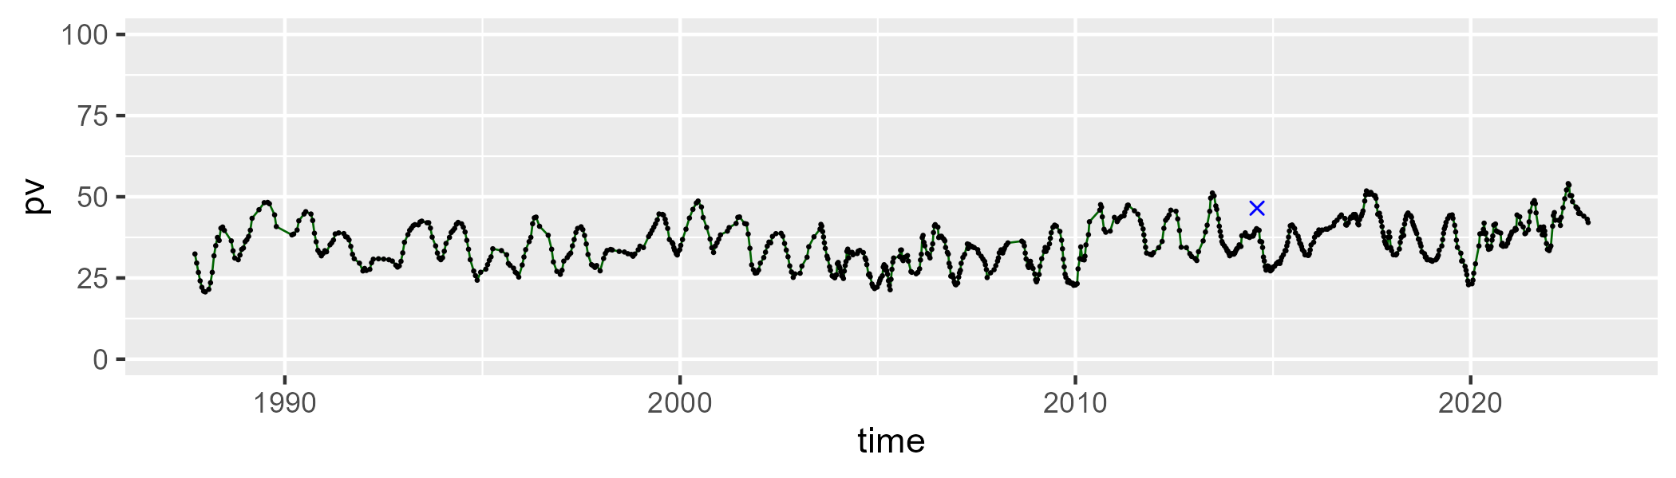

| Min. | 1st Qu. | Median | Mean | 3rd Qu. | Max. |
| --- | --- | --- | --- | --- | --- |
| 28.53012 | 46.86227 | 49.39736 | 48.88032 | 51.66204 | 57.76838 |

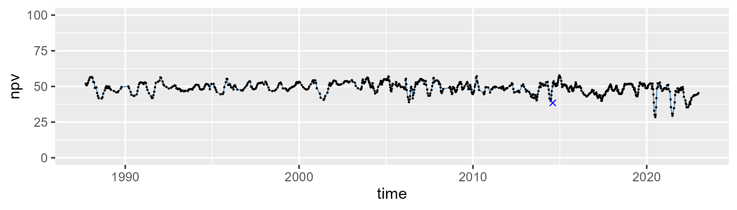

| Min. | 1st Qu. | Median | Mean | 3rd Qu. | Max. |
| --- | --- | --- | --- | --- | --- |
| 1.685392 | 10.42449 | 13.84427 | 14.37853 | 18.06827 | 36.50915 |

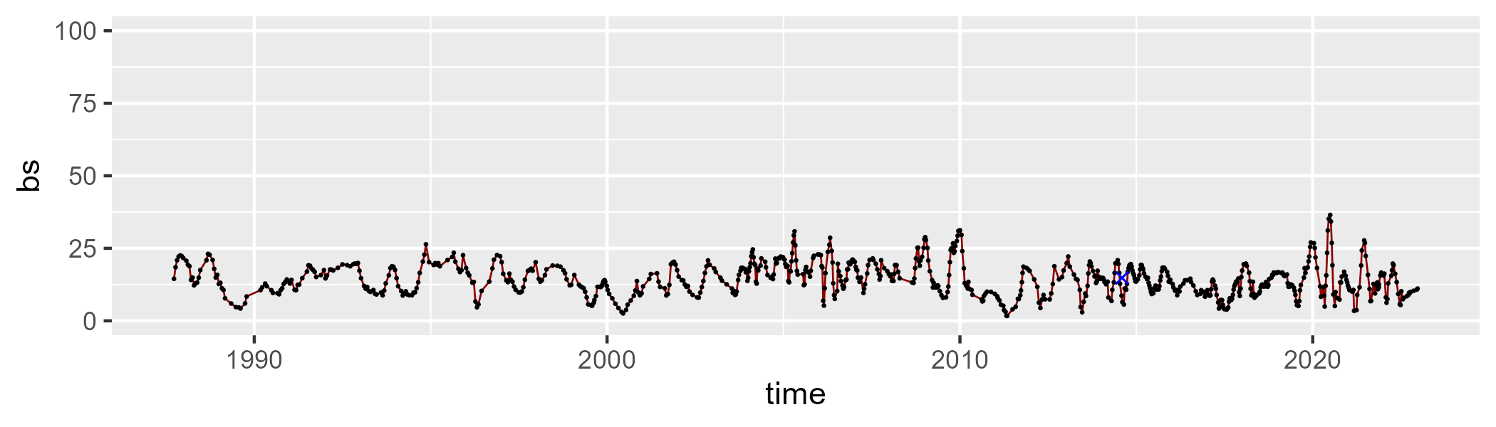

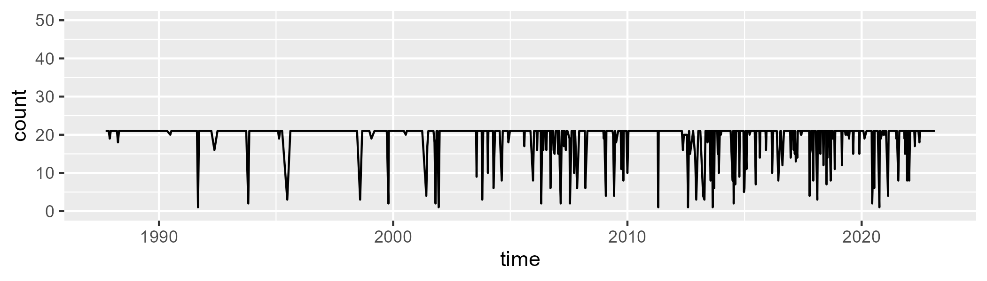

Min. : 1.00 1st Qu.:21.00 Median :21.00 Mean :19.49 3rd Qu.:21.00 Max. :21.00

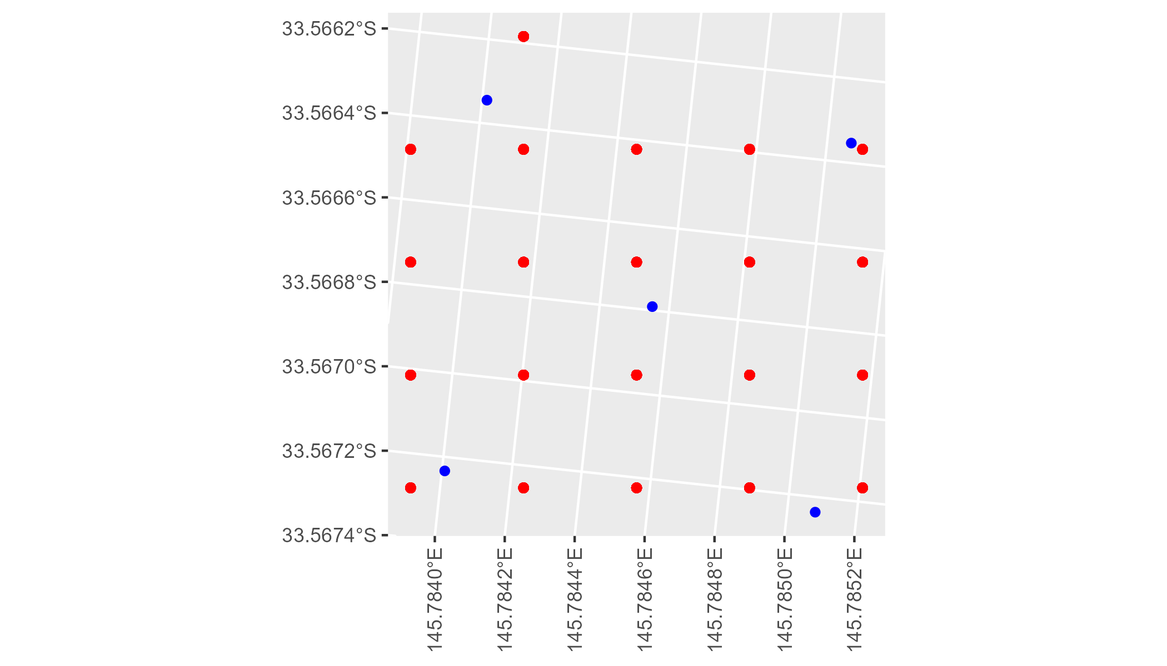

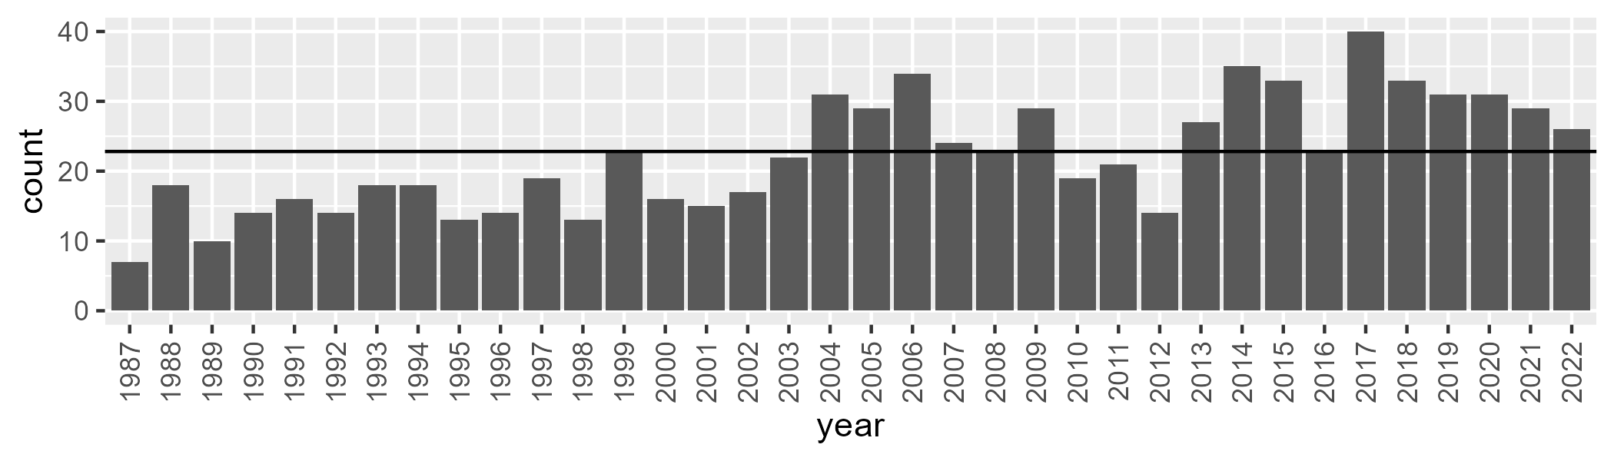

Number of samples: 799

# NSAMDD0019

| Min. | 1st Qu. | Median | Mean | 3rd Qu. | Max. |
| --- | --- | --- | --- | --- | --- |
| 0 | 9.768005 | 15.85768 | 19.6549 | 27.49217 | 71.9999 |

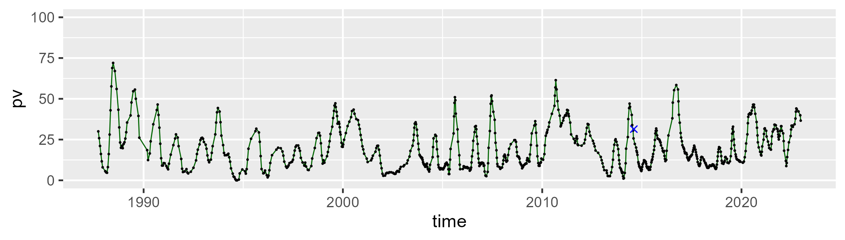

| Min. | 1st Qu. | Median | Mean | 3rd Qu. | Max. |
| --- | --- | --- | --- | --- | --- |
| 18.38918 | 41.97897 | 47.82278 | 49.55926 | 57.97905 | 82.32955 |

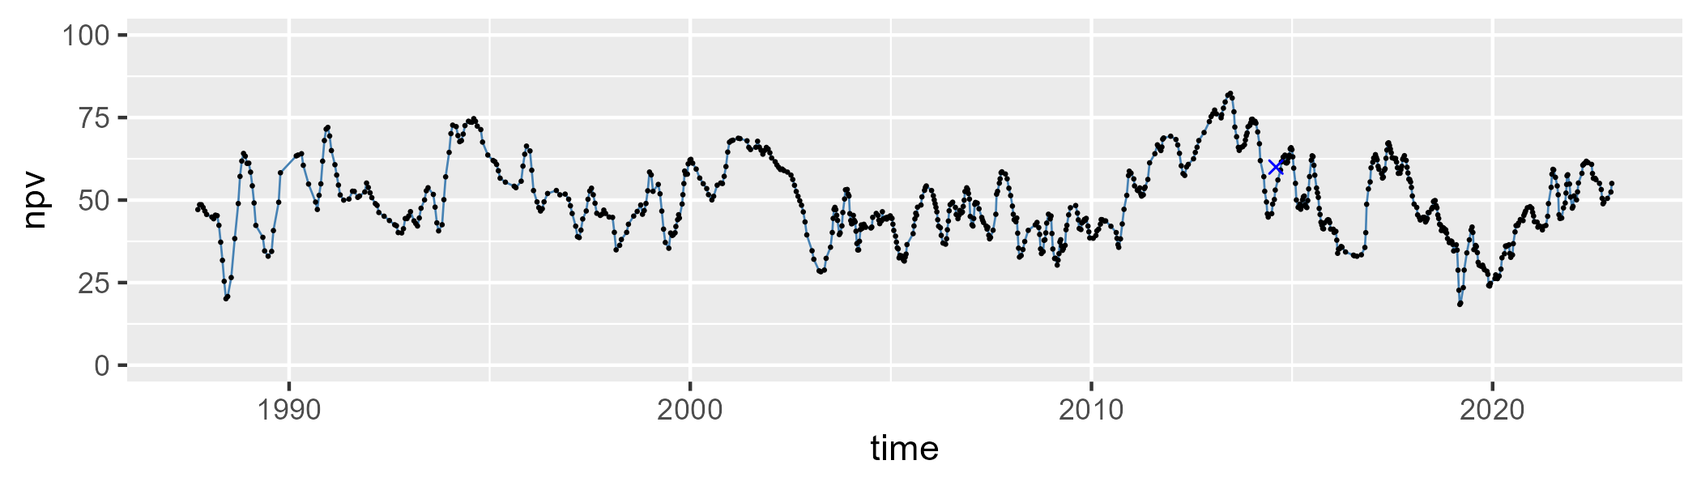

| Min. | 1st Qu. | Median | Mean | 3rd Qu. | Max. |
| --- | --- | --- | --- | --- | --- |
| 1.881523 | 17.08619 | 28.77983 | 29.57391 | 42.48361 | 65.93417 |

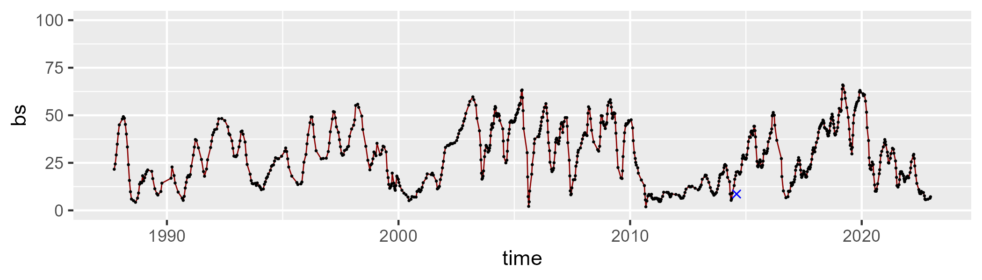

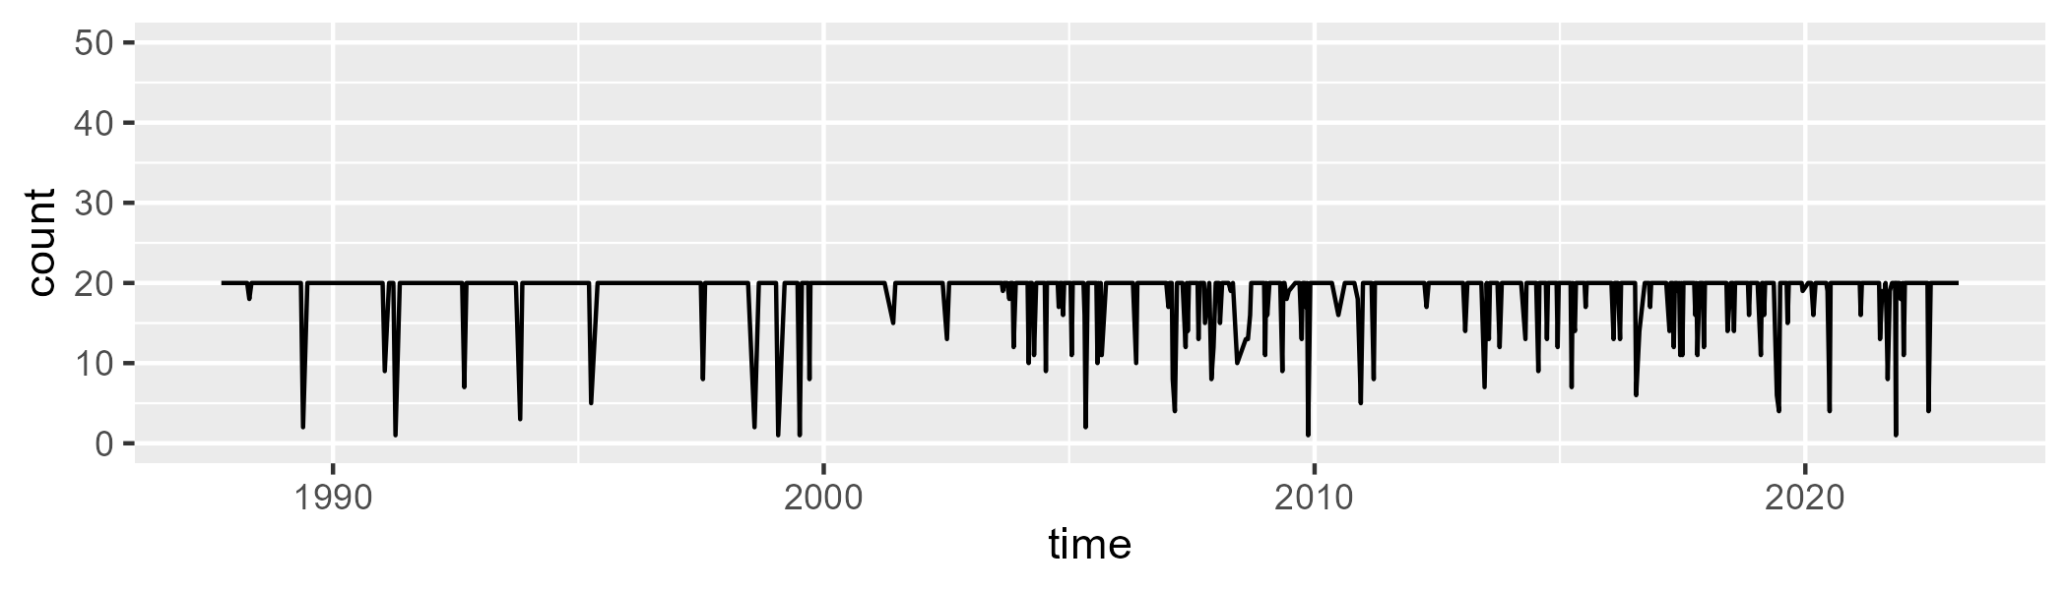

Min. : 1.00 1st Qu.:20.00 Median :20.00 Mean :18.92 3rd Qu.:20.00 Max. :20.00

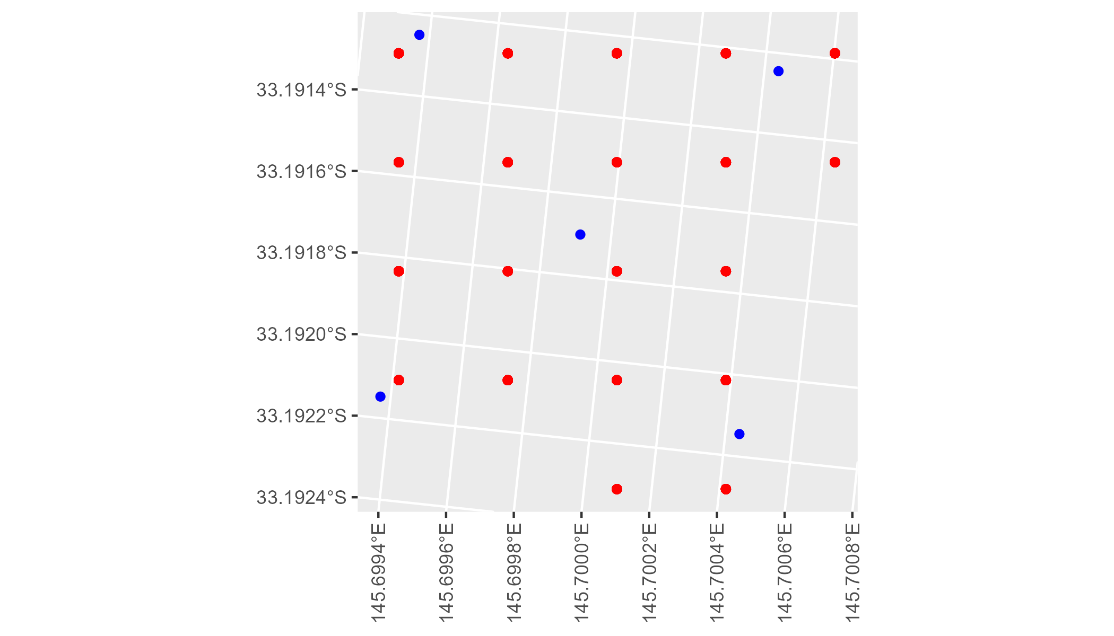

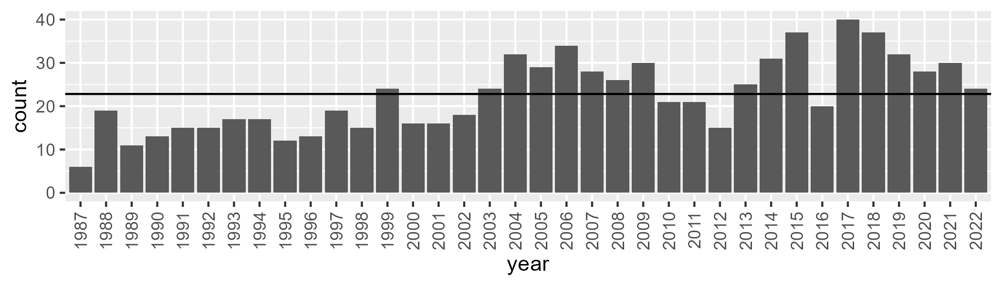

Number of samples: 810

# NSAMDD0020

| Min. | 1st Qu. | Median | Mean | 3rd Qu. | Max. |
| --- | --- | --- | --- | --- | --- |
| 10.99172 | 25.28371 | 32.0259 | 33.75623 | 40.10216 | 70.55021 |

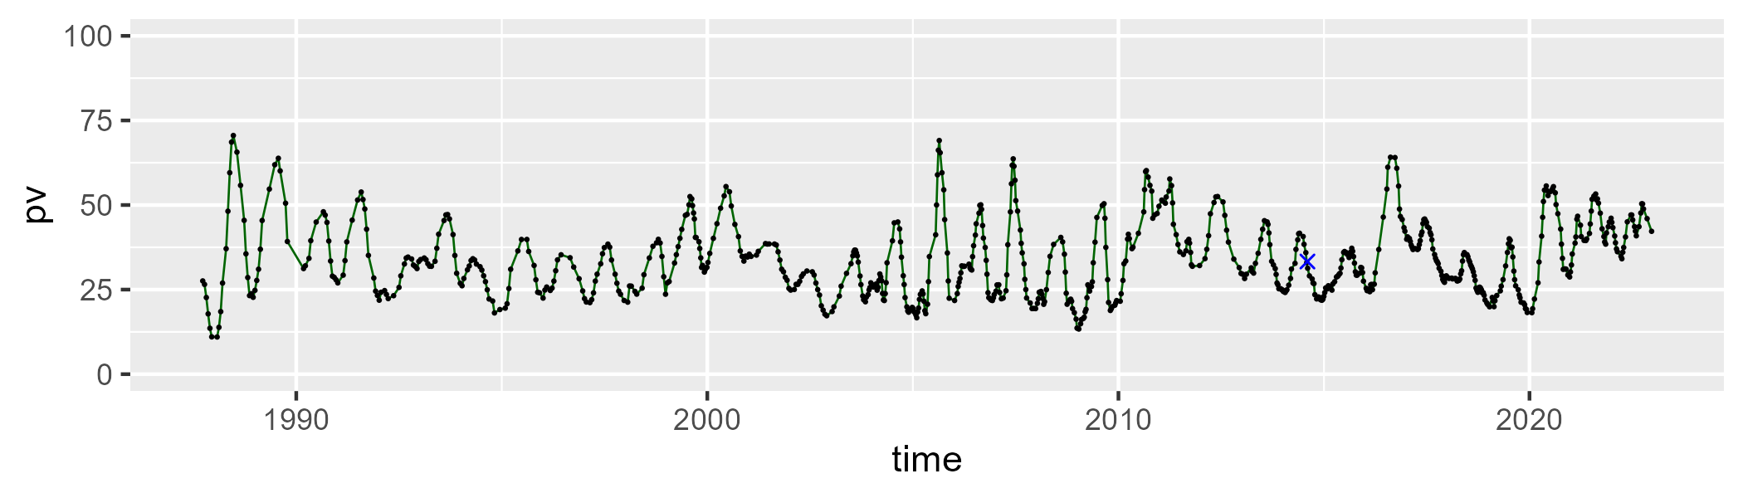

| Min. | 1st Qu. | Median | Mean | 3rd Qu. | Max. |
| --- | --- | --- | --- | --- | --- |
| 24.04856 | 45.72968 | 49.9672 | 49.58041 | 53.97019 | 66.01722 |

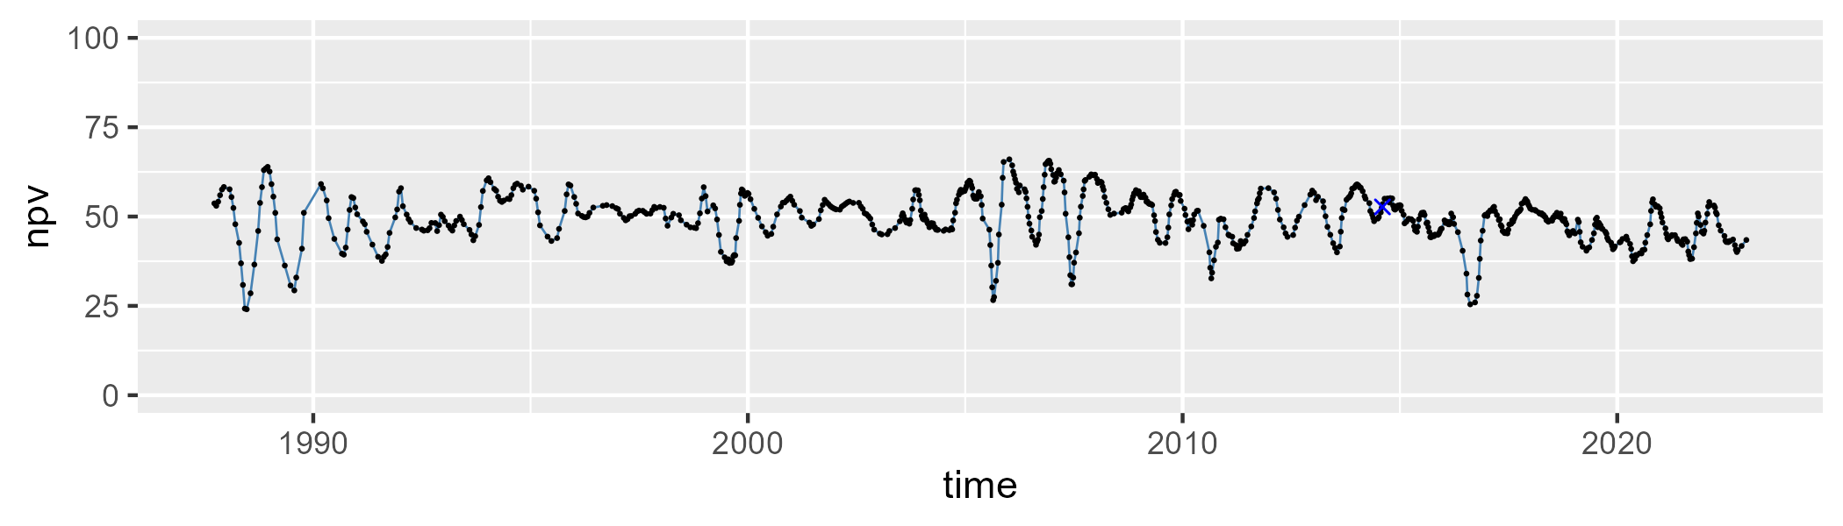

| Min. | 1st Qu. | Median | Mean | 3rd Qu. | Max. |
| --- | --- | --- | --- | --- | --- |
| 0 | 9.992306 | 14.38901 | 15.46208 | 21.08364 | 38.65322 |

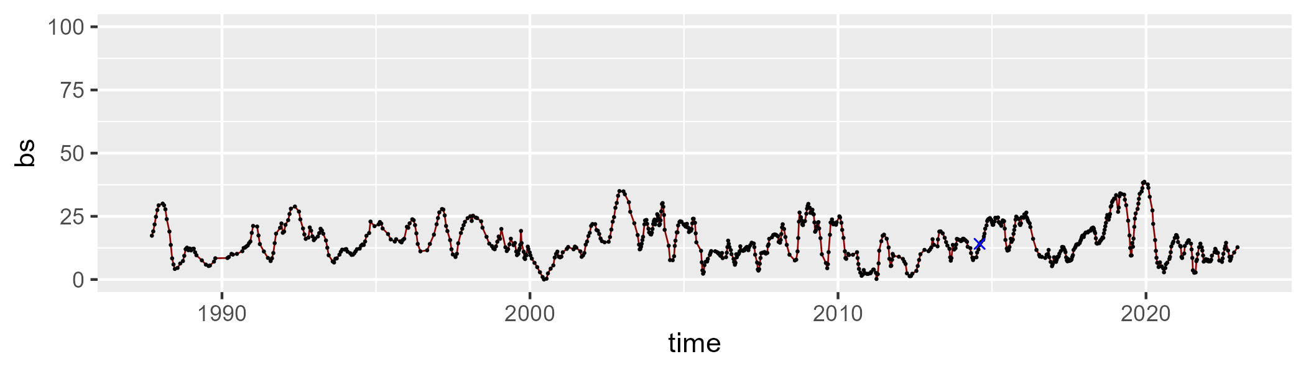

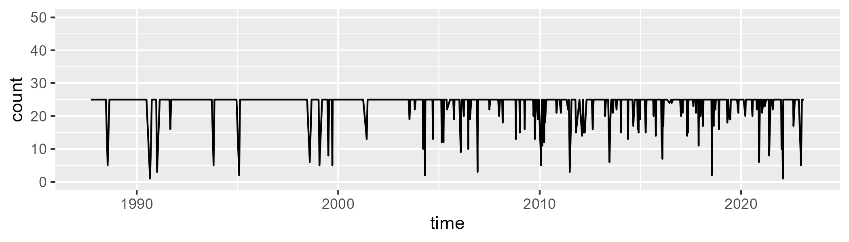

Min. : 1.00 1st Qu.:25.00 Median :25.00 Mean :23.72 3rd Qu.:25.00 Max. :25.00

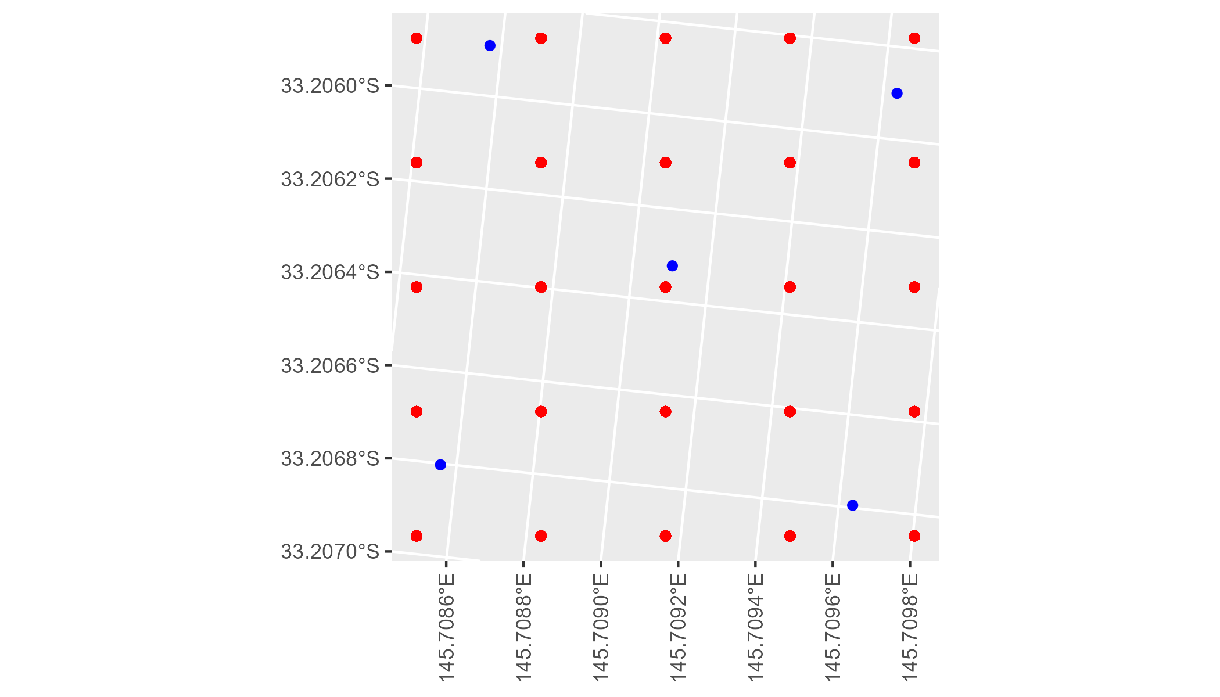

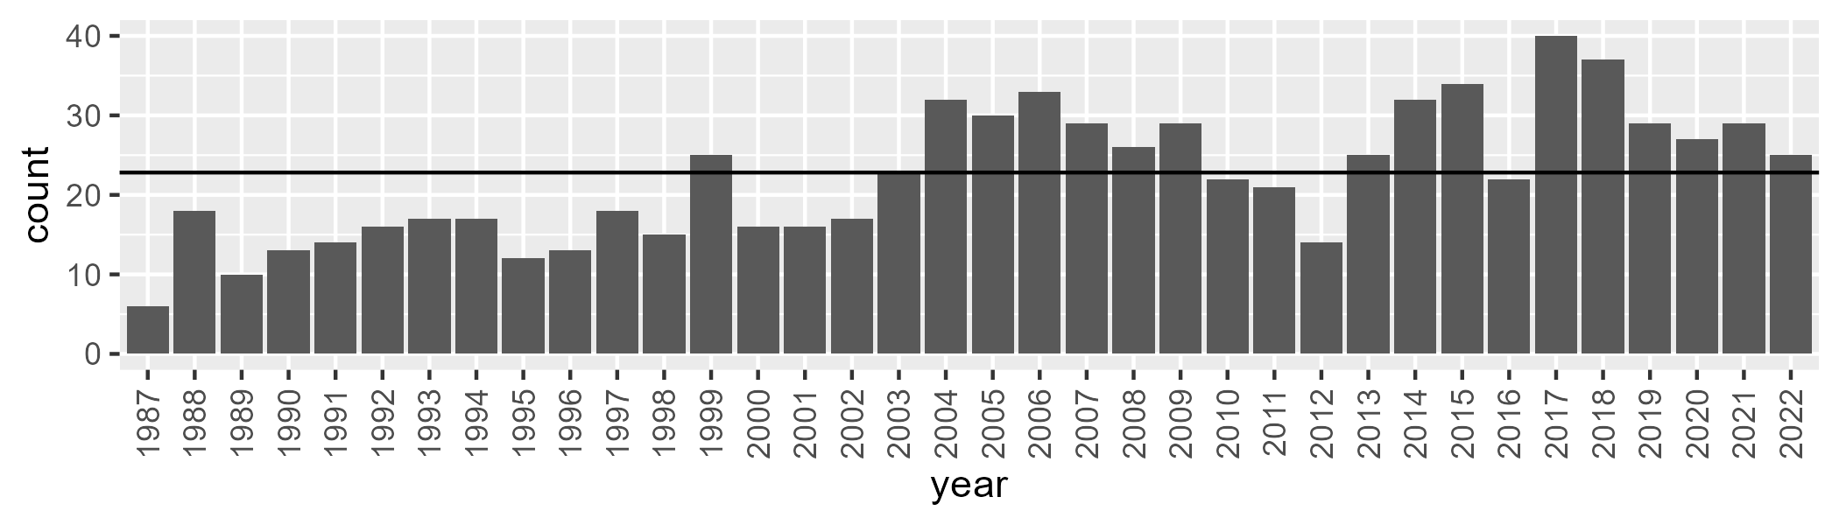

Number of samples: 802

# NSAMDD0021

| Min. | 1st Qu. | Median | Mean | 3rd Qu. | Max. |
| --- | --- | --- | --- | --- | --- |
| 13.83592 | 23.0641 | 28.66903 | 30.0416 | 35.93566 | 60.27602 |

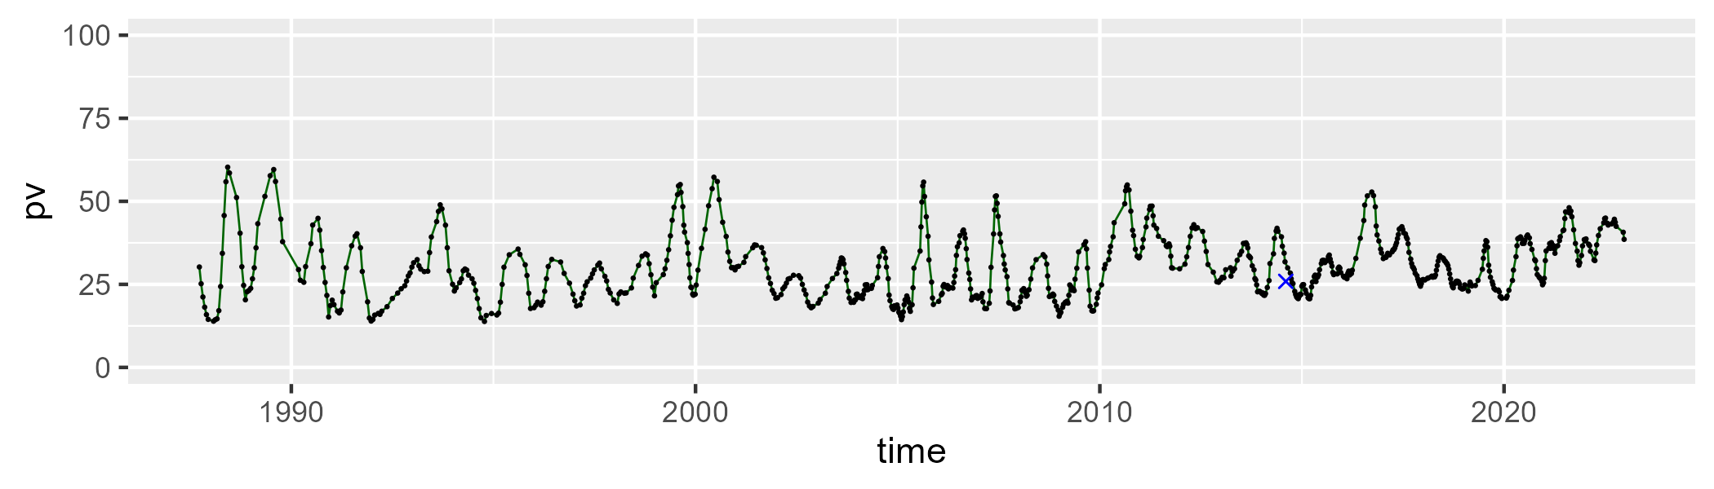

| Min. | 1st Qu. | Median | Mean | 3rd Qu. | Max. |
| --- | --- | --- | --- | --- | --- |
| 30.02646 | 46.03019 | 48.90994 | 49.23632 | 52.29528 | 66.94603 |

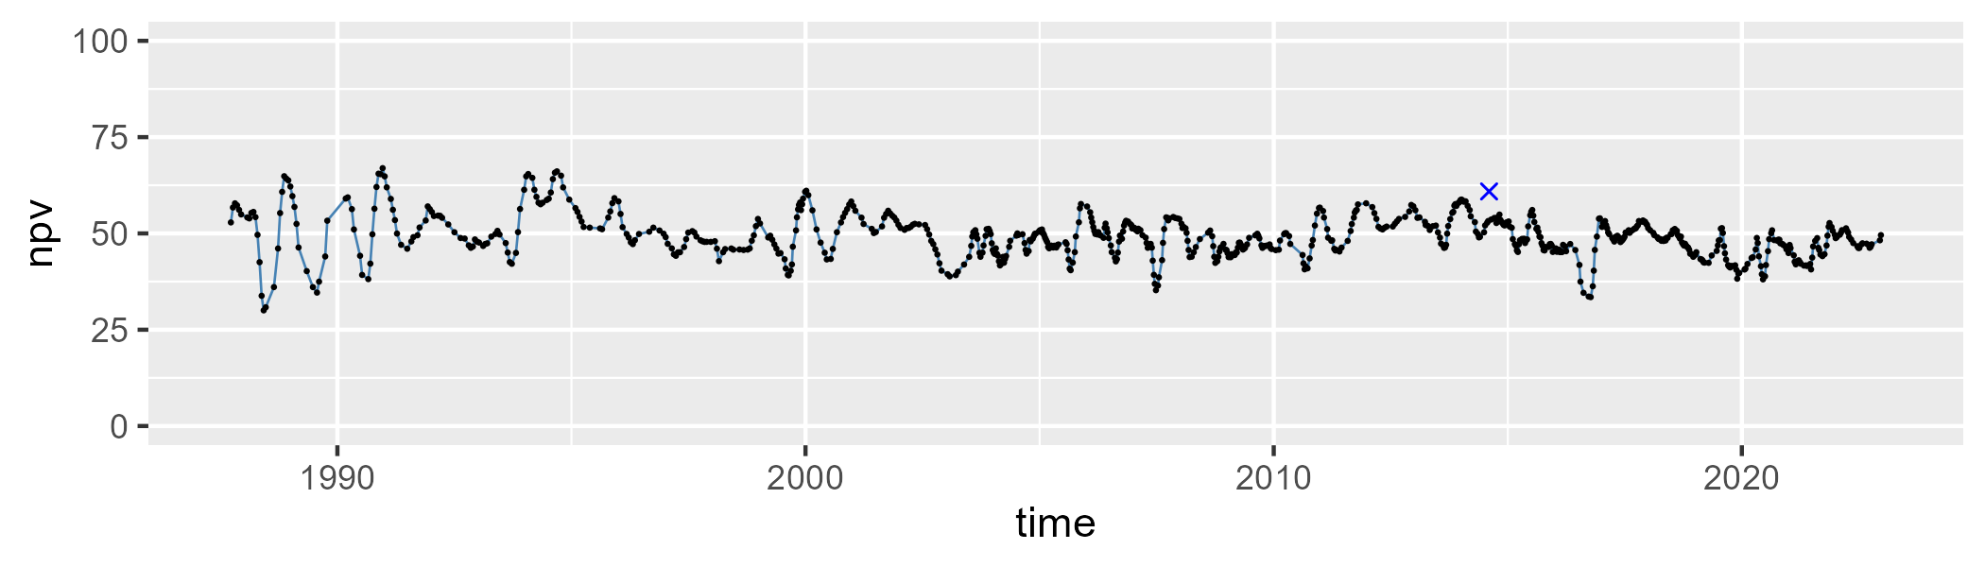

| Min. | 1st Qu. | Median | Mean | 3rd Qu. | Max. |
| --- | --- | --- | --- | --- | --- |
| 0 | 12.93124 | 18.89495 | 19.57251 | 26.28264 | 39.9925 |

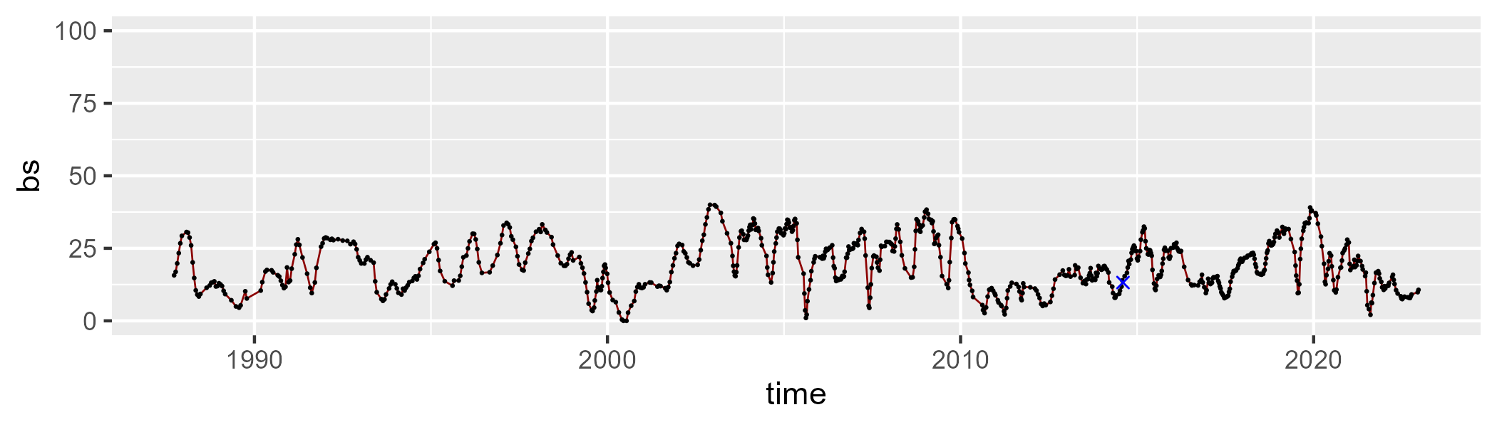

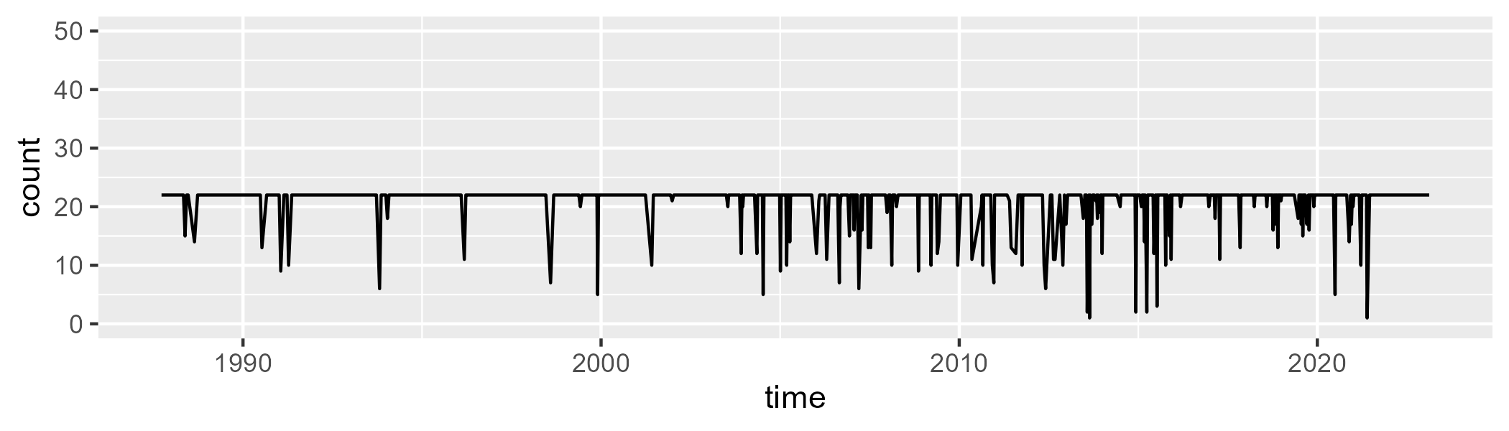

Min. : 1.00 1st Qu.:22.00 Median :22.00 Mean :20.92 3rd Qu.:22.00 Max. :22.00

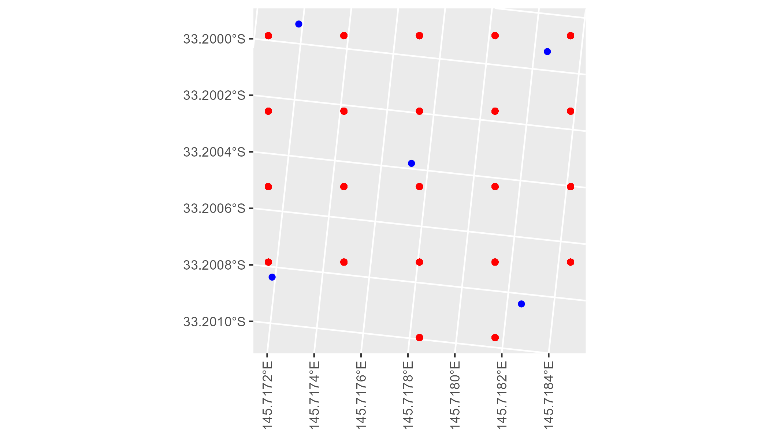

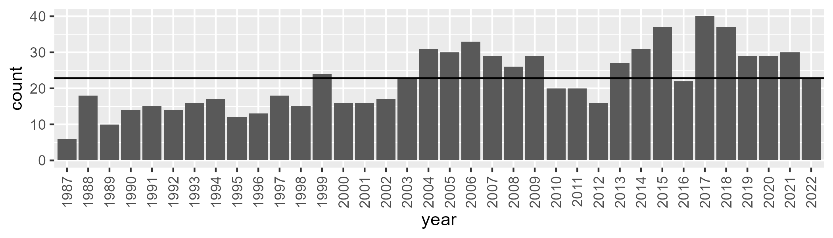

Number of samples: 803

# NSAMDD0022

| Min. | 1st Qu. | Median | Mean | 3rd Qu. | Max. |
| --- | --- | --- | --- | --- | --- |
| 15.60037 | 31.25284 | 35.83949 | 36.052 | 41.13722 | 53.71949 |

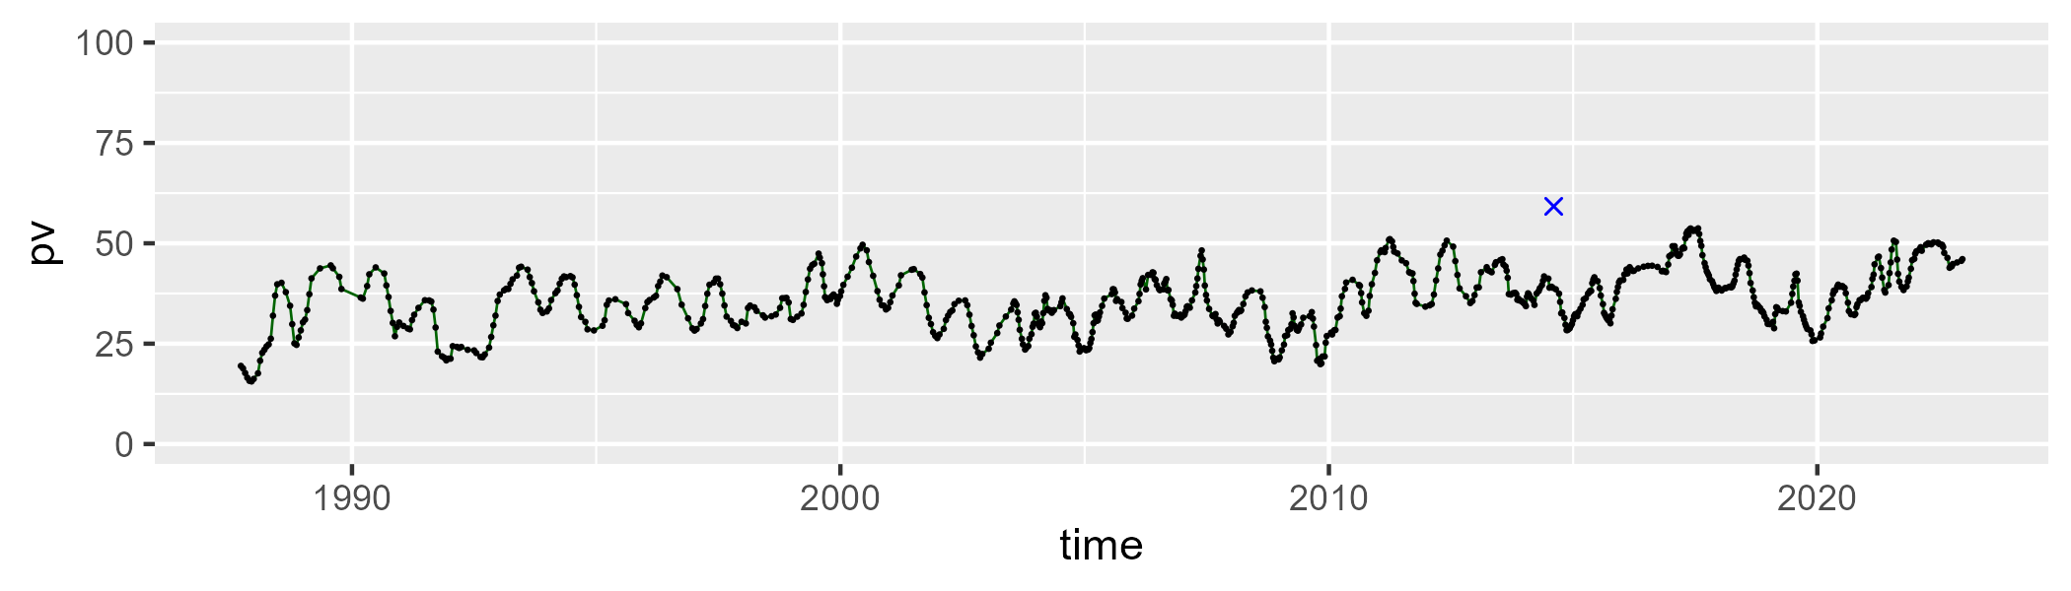

| Min. | 1st Qu. | Median | Mean | 3rd Qu. | Max. |
| --- | --- | --- | --- | --- | --- |
| 31.26573 | 47.02527 | 50.38446 | 49.57074 | 52.86442 | 64.23182 |

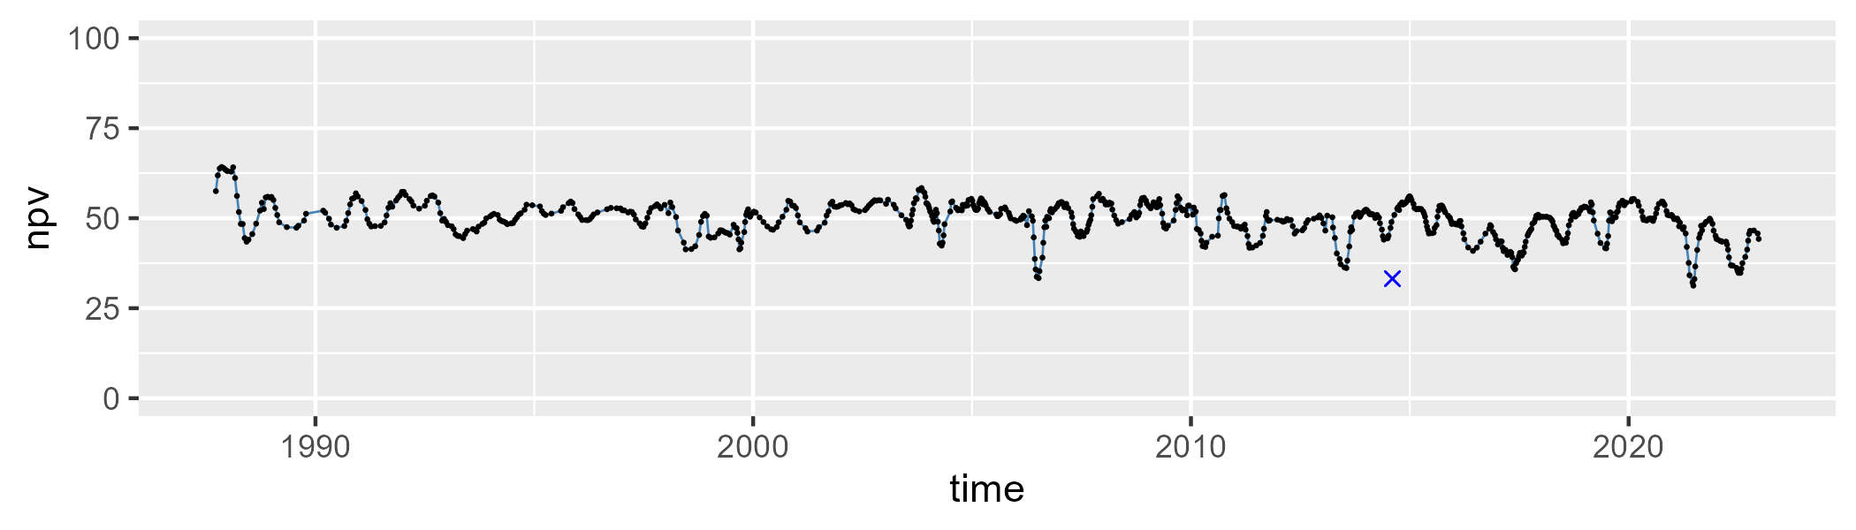

| Min. | 1st Qu. | Median | Mean | 3rd Qu. | Max. |
| --- | --- | --- | --- | --- | --- |
| 0 | 9.772058 | 12.6342 | 13.21692 | 16.19881 | 26.83397 |

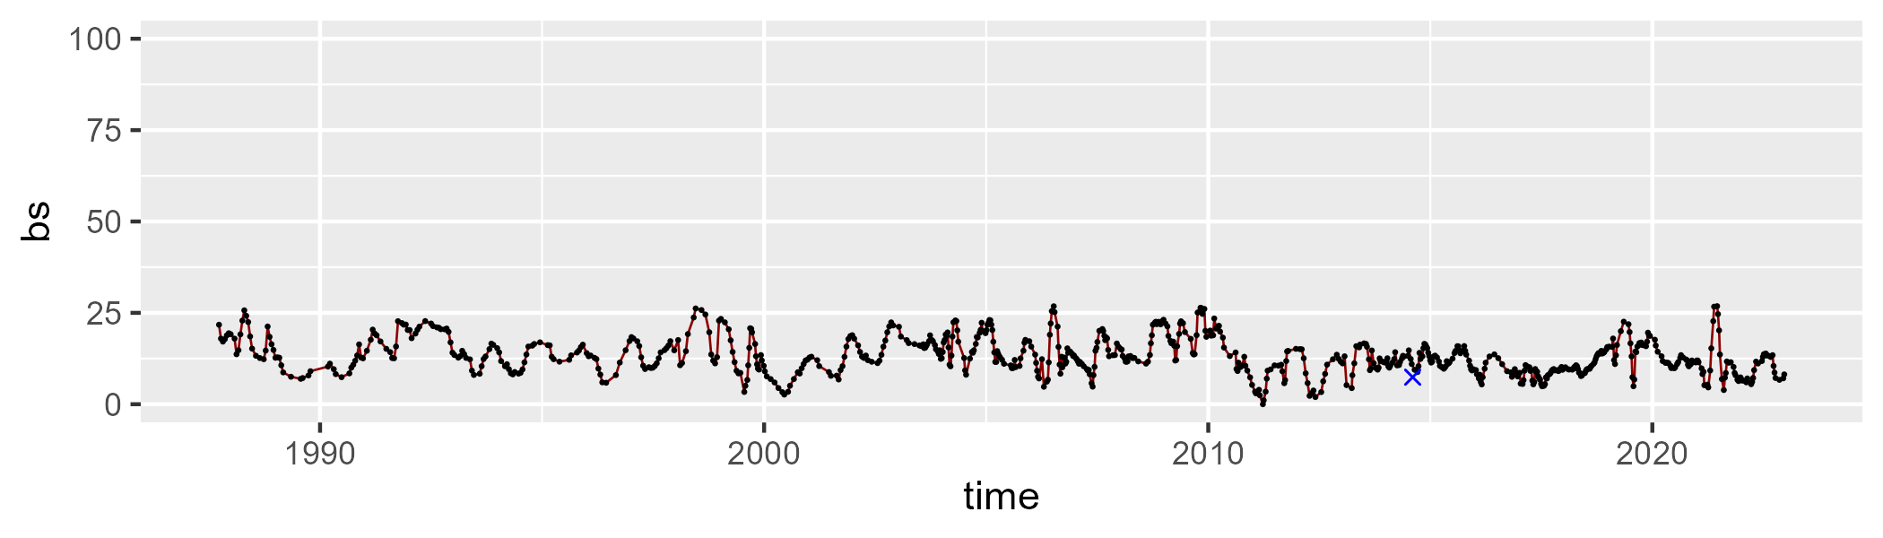

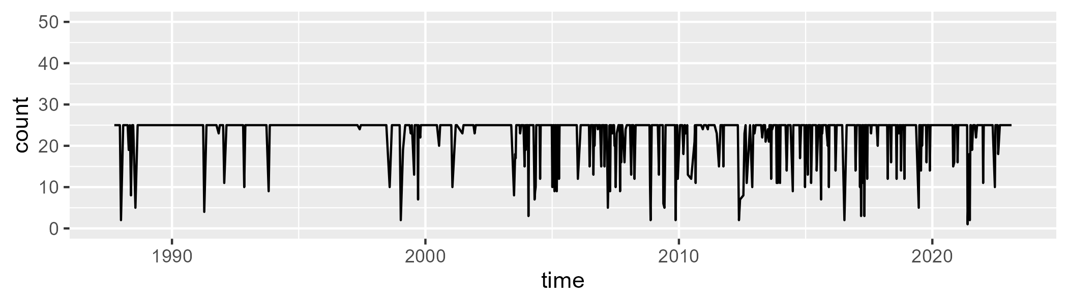

Min. : 1.00 1st Qu.:25.00 Median :25.00 Mean :23.15 3rd Qu.:25.00 Max. :25.00

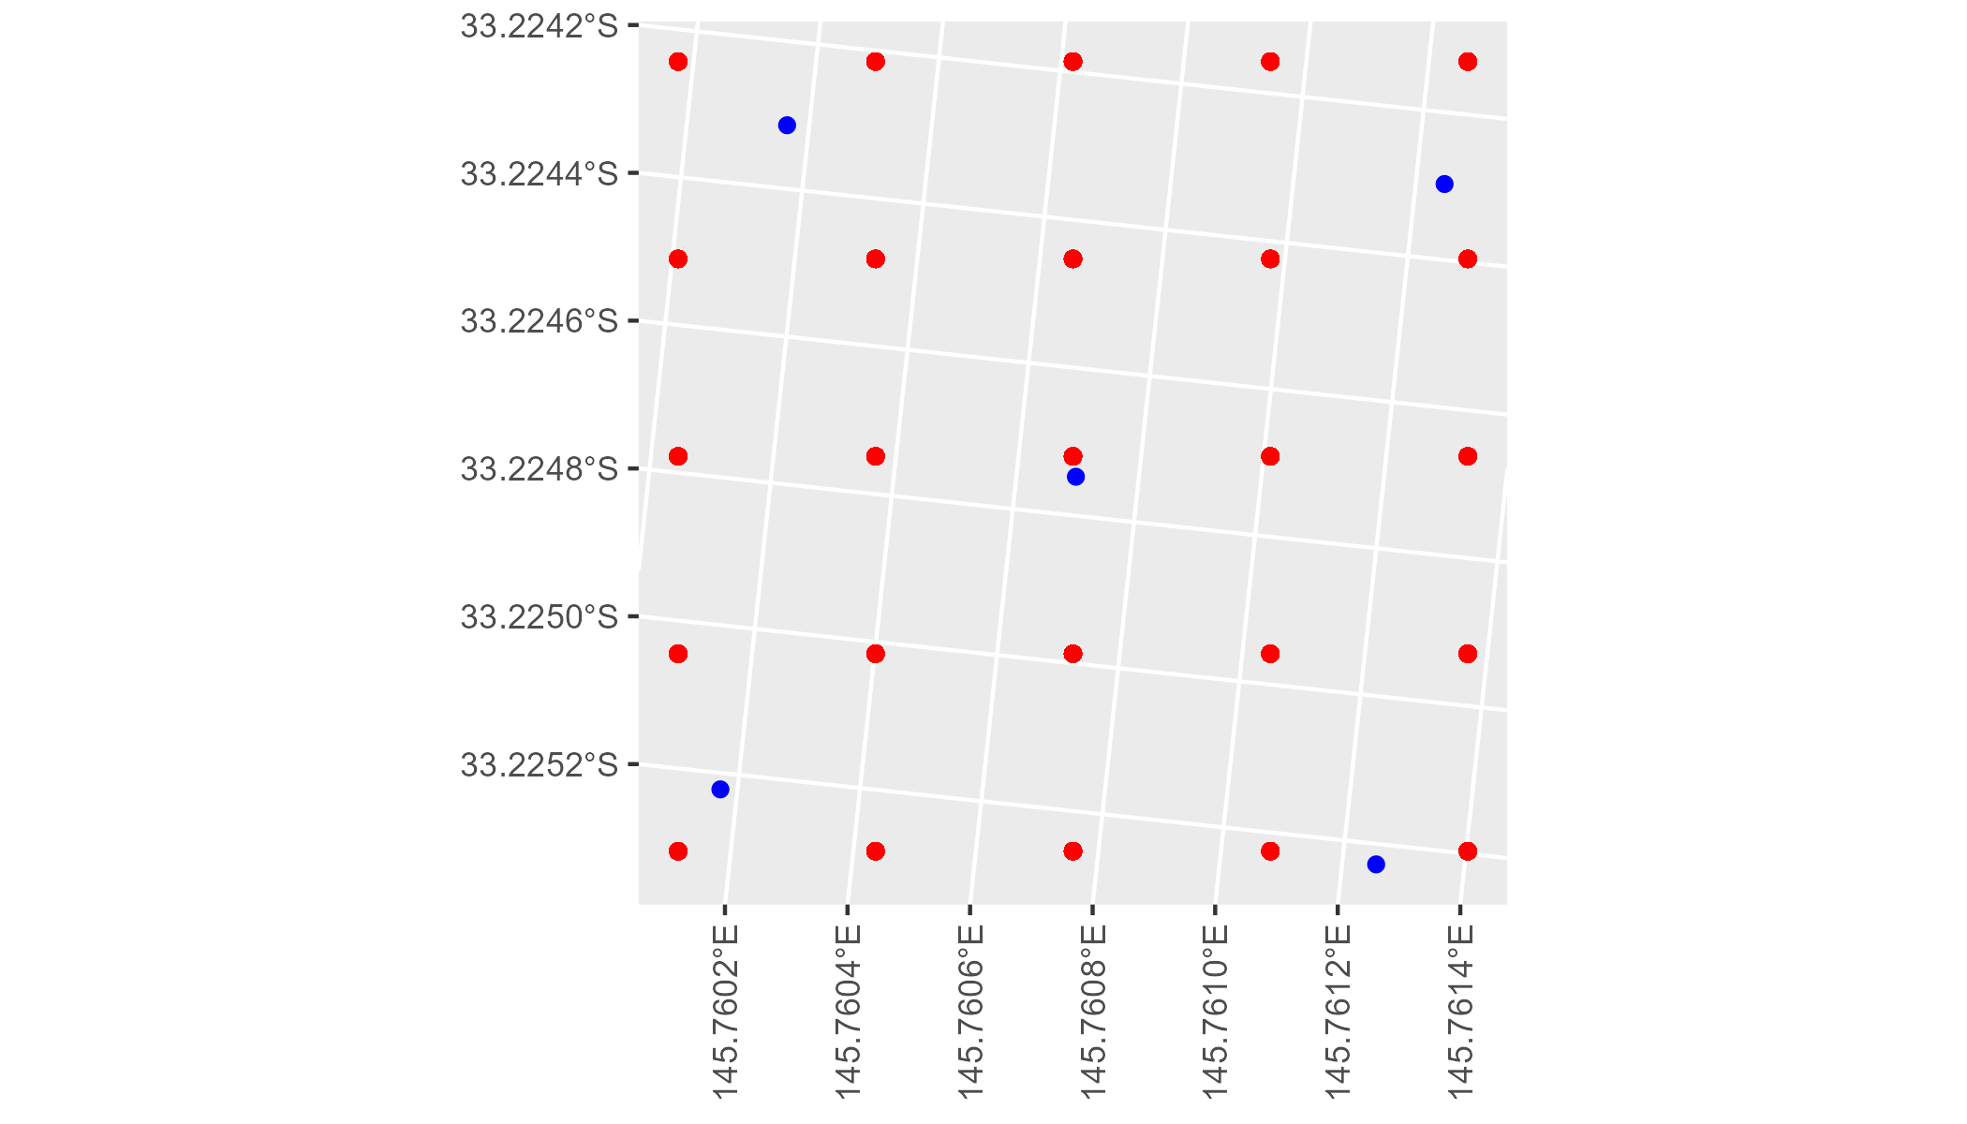

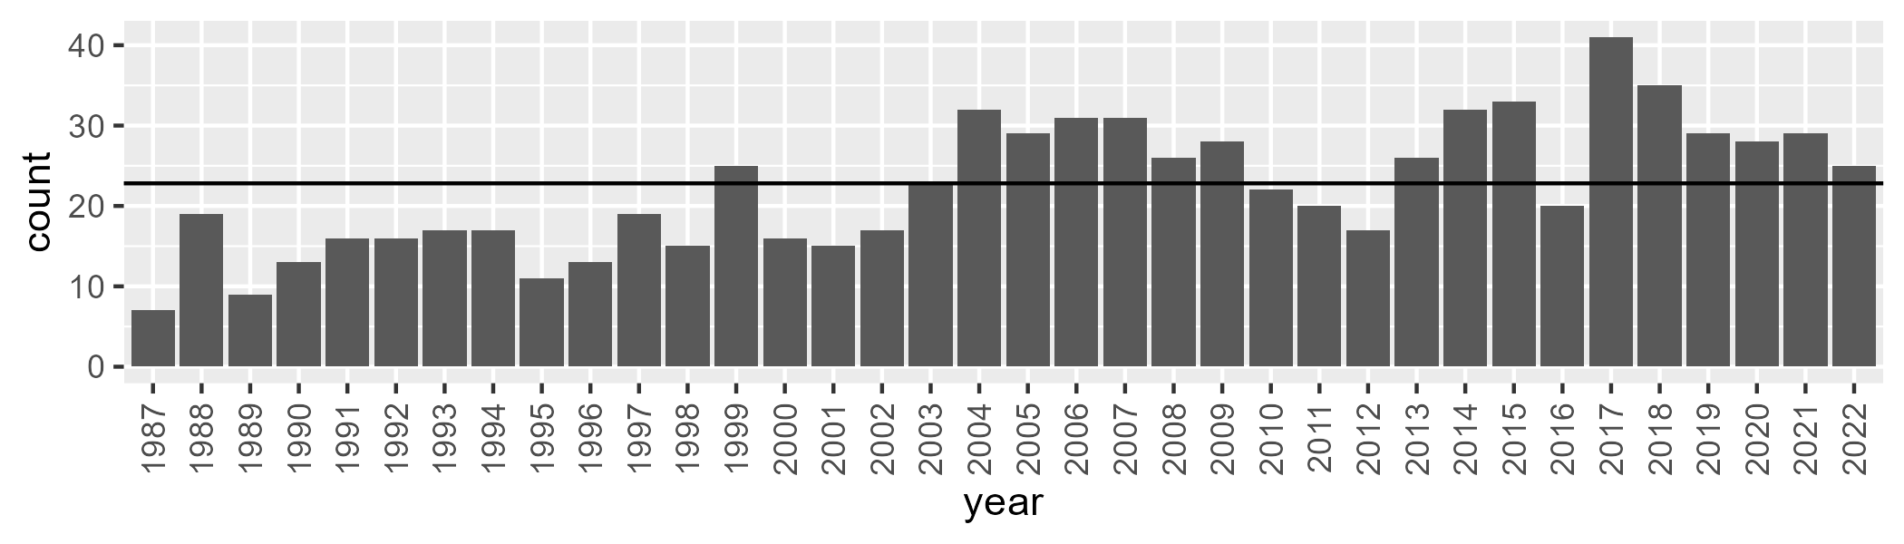

Number of samples: 802

# NSAMDD0023

| Min. | 1st Qu. | Median | Mean | 3rd Qu. | Max. |
| --- | --- | --- | --- | --- | --- |
| 7.767797 | 18.79853 | 23.63841 | 26.08675 | 32.03093 | 60.13806 |

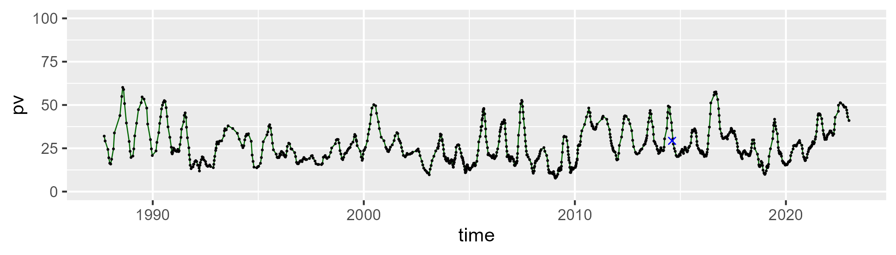

| Min. | 1st Qu. | Median | Mean | 3rd Qu. | Max. |
| --- | --- | --- | --- | --- | --- |
| 26.4742 | 51.23291 | 54.41836 | 54.01158 | 57.55173 | 68.75182 |

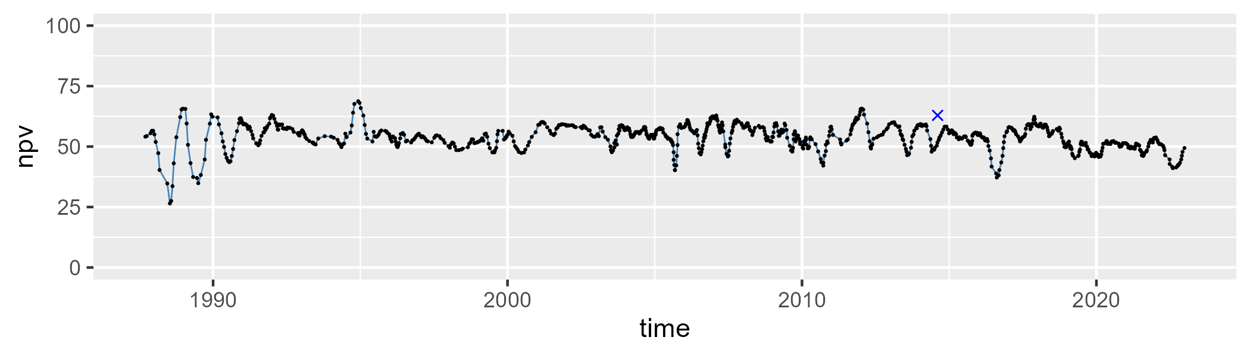

| Min. | 1st Qu. | Median | Mean | 3rd Qu. | Max. |
| --- | --- | --- | --- | --- | --- |
| 0.7664575 | 12.6471 | 18.31193 | 18.80207 | 24.83299 | 38.70538 |

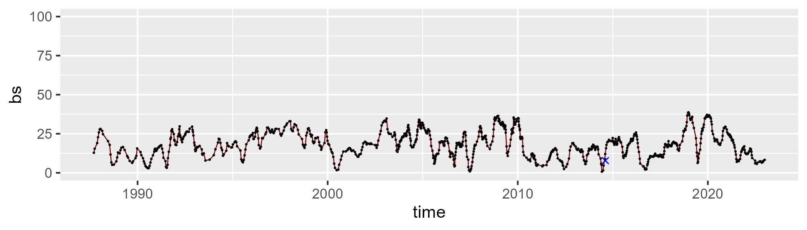

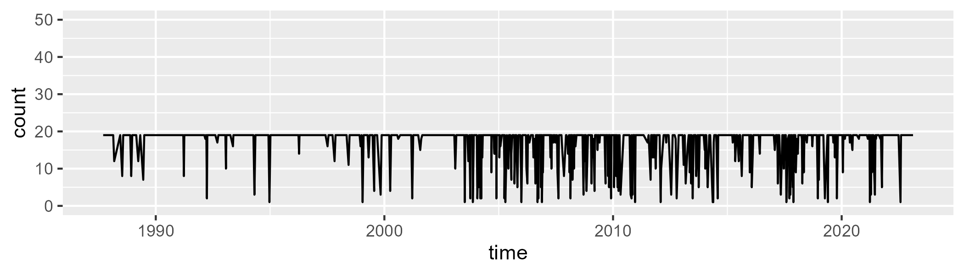

Min. : 1.00 1st Qu.:19.00 Median :19.00 Mean :17.01 3rd Qu.:19.00 Max. :19.00

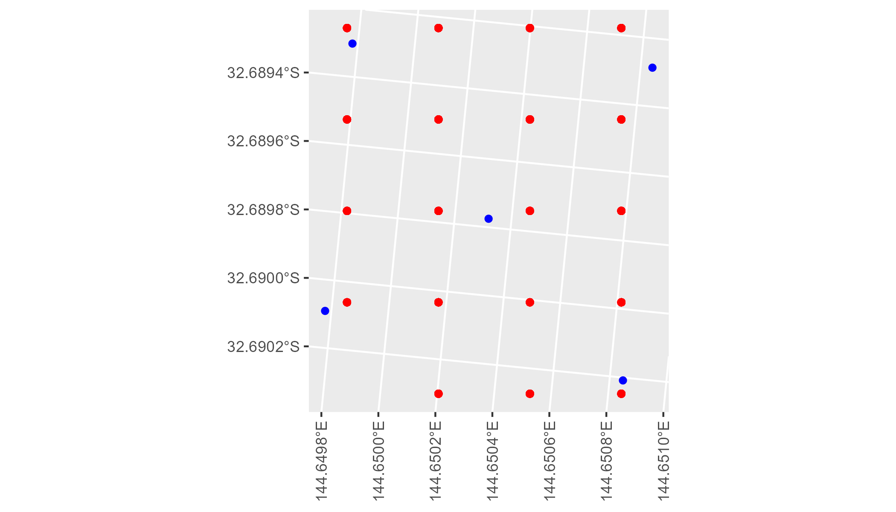

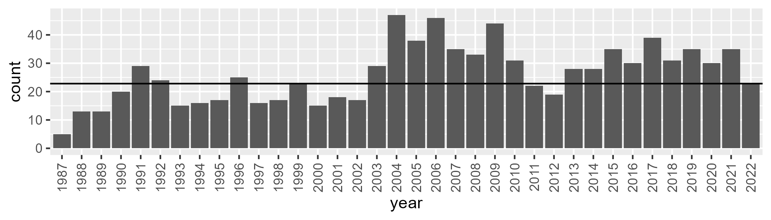

Number of samples: 941

# NSAMDD0024

| Min. | 1st Qu. | Median | Mean | 3rd Qu. | Max. |
| --- | --- | --- | --- | --- | --- |
| 1.888876 | 14.10402 | 20.50374 | 24.31192 | 32.11014 | 73.51287 |

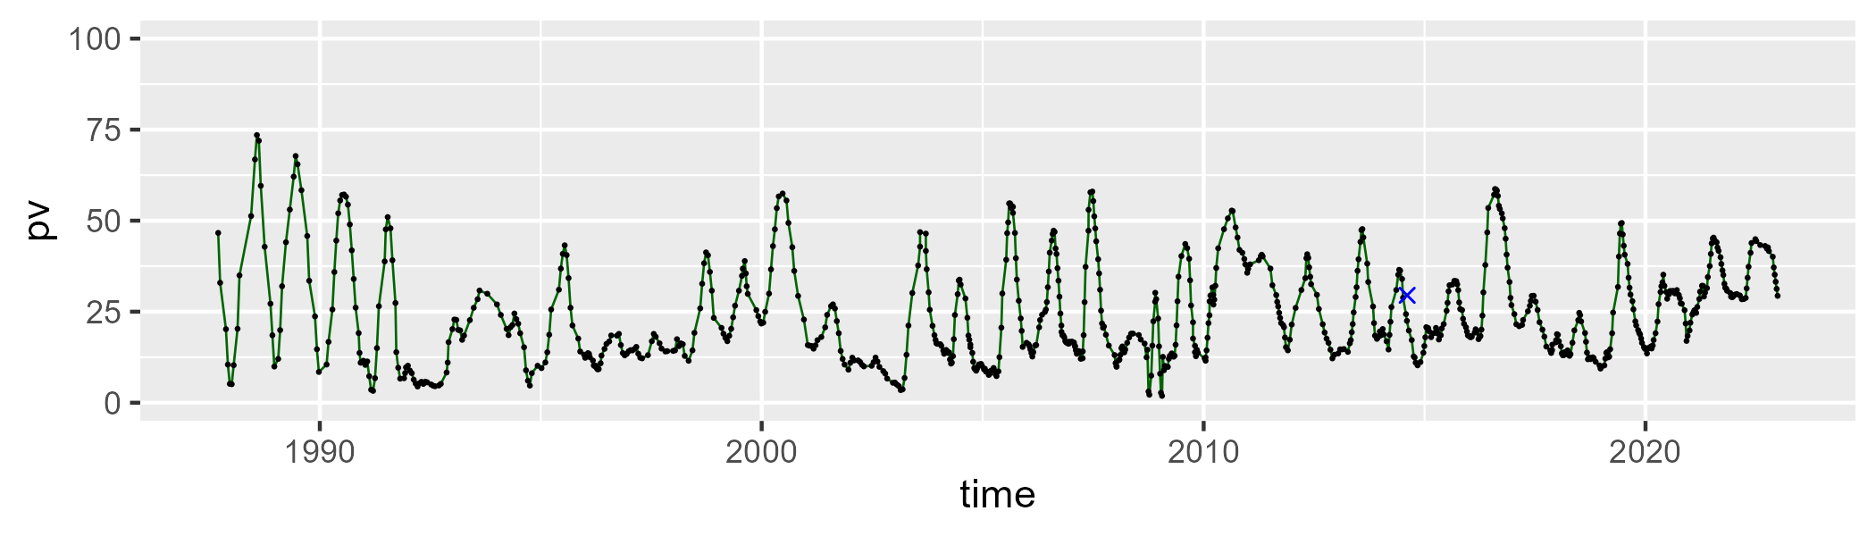

| Min. | 1st Qu. | Median | Mean | 3rd Qu. | Max. |
| --- | --- | --- | --- | --- | --- |
| 21.49857 | 49.97749 | 56.2944 | 55.42316 | 61.50517 | 79.97095 |

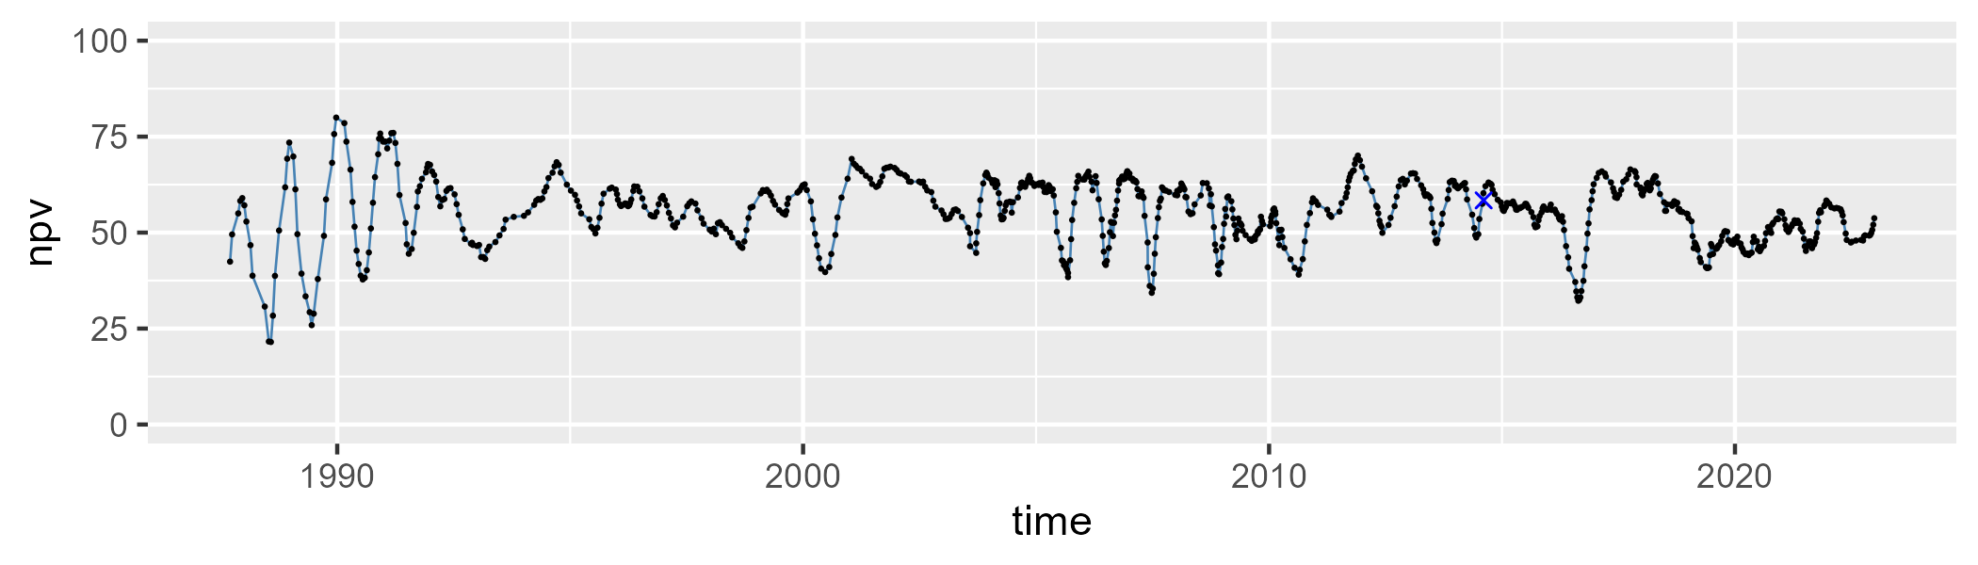

| Min. | 1st Qu. | Median | Mean | 3rd Qu. | Max. |
| --- | --- | --- | --- | --- | --- |
| 0 | 11.56684 | 18.87697 | 19.11673 | 25.6361 | 45.14129 |

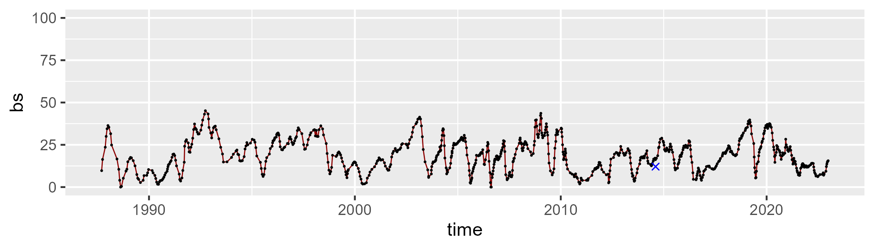

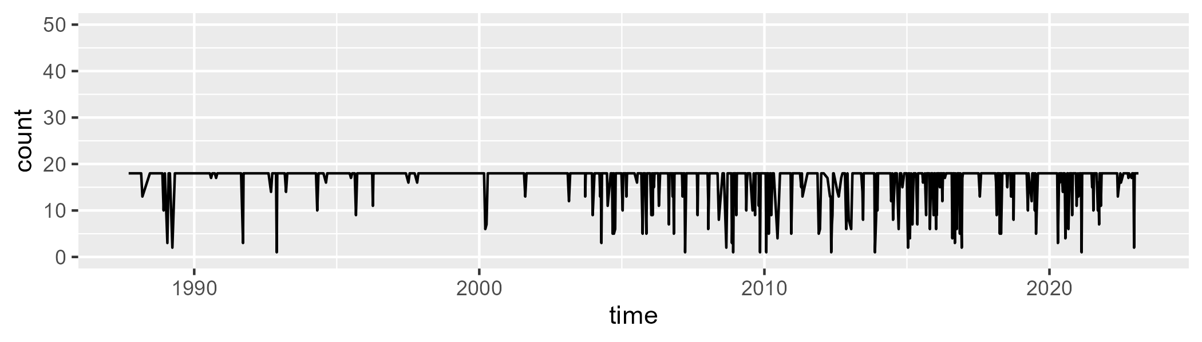

Min. : 1.00 1st Qu.:18.00 Median :18.00 Mean :16.58 3rd Qu.:18.00 Max. :18.00

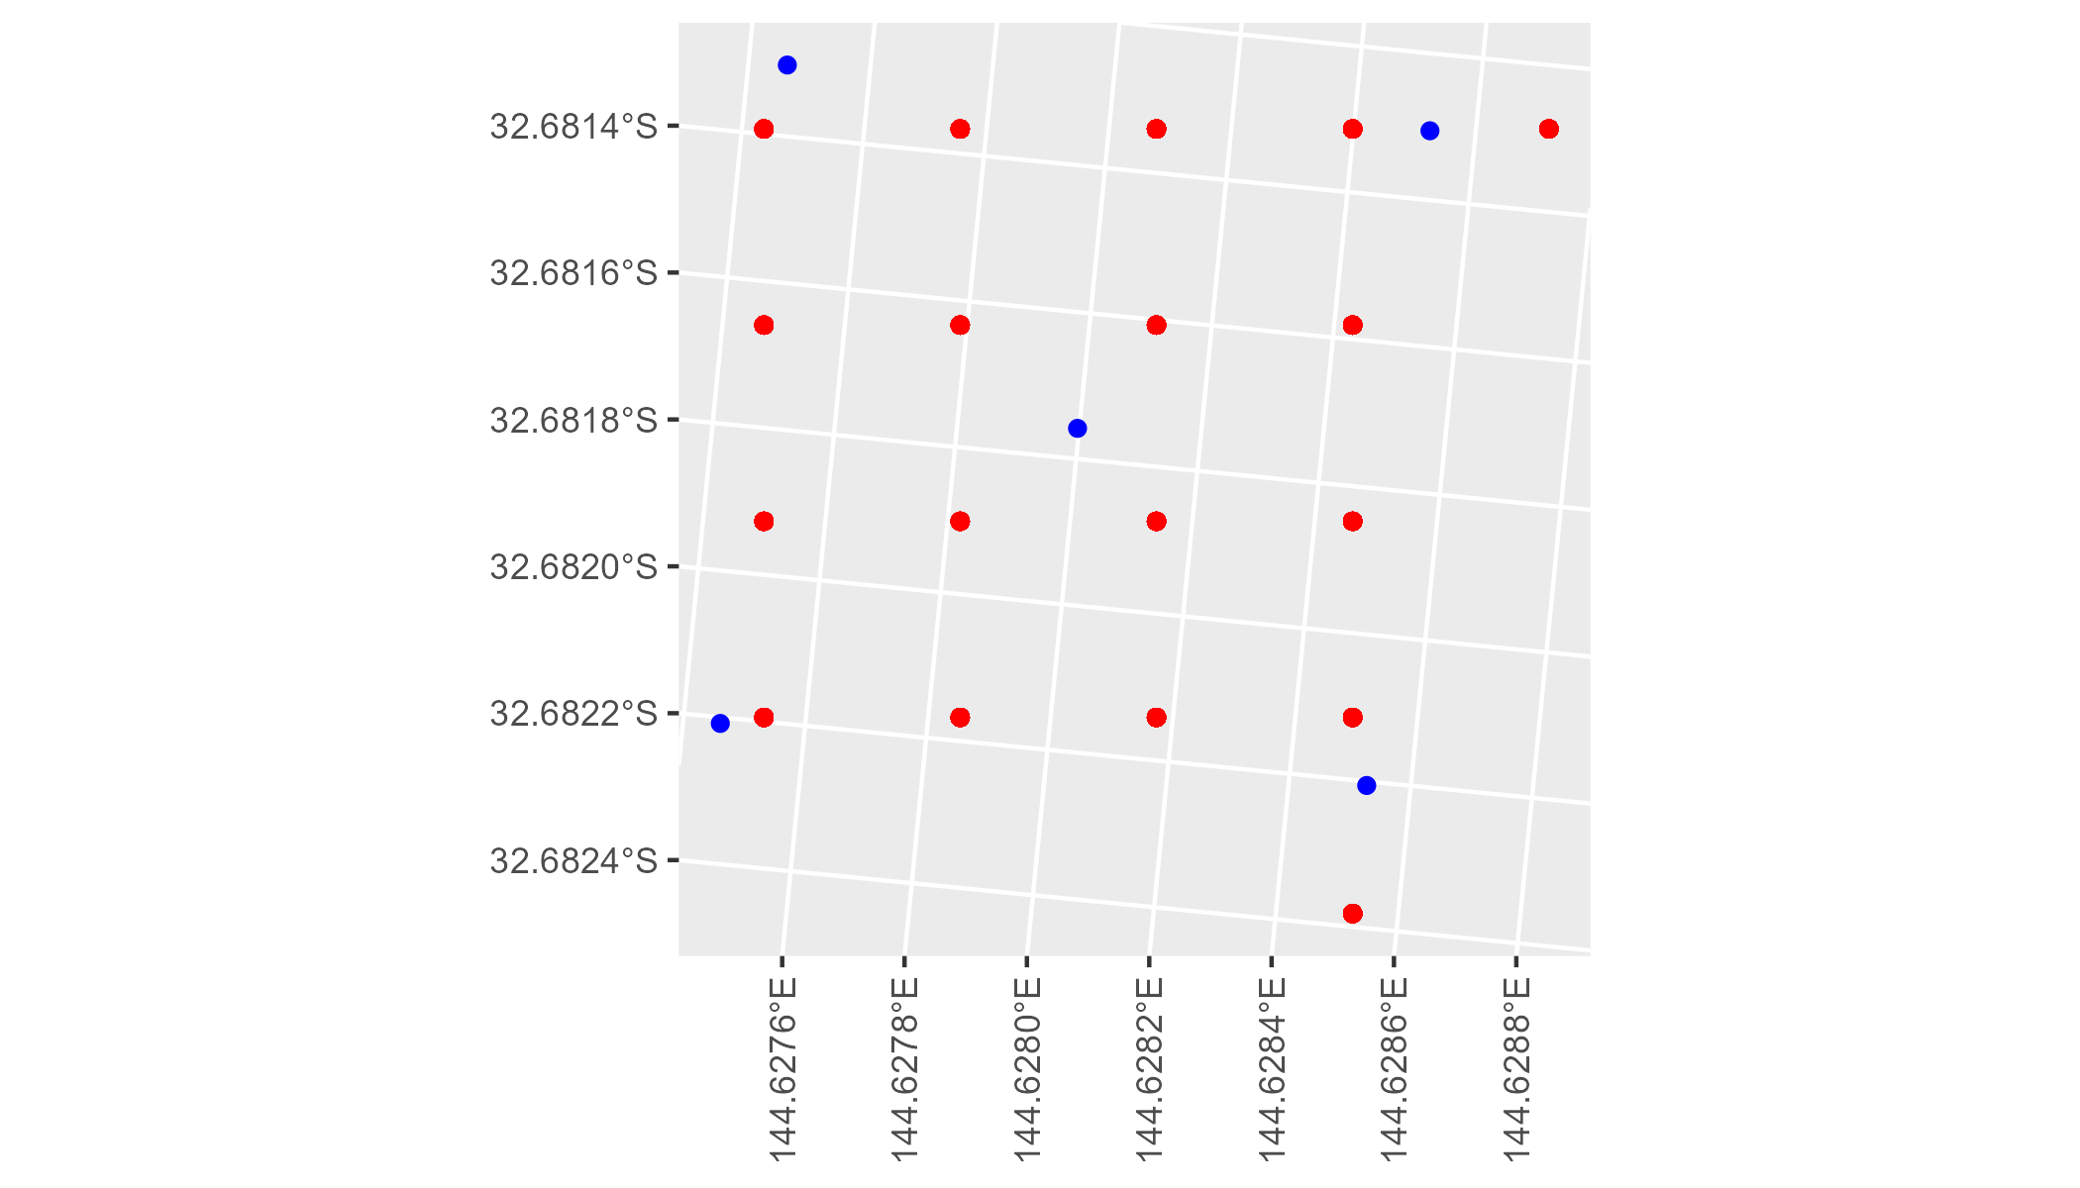

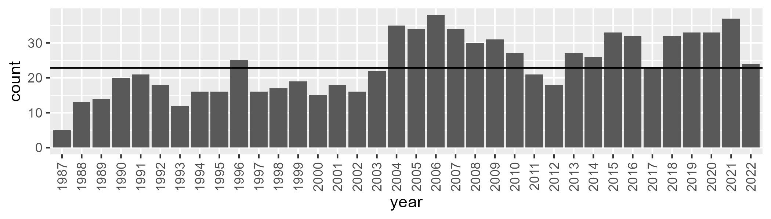

Number of samples: 851

# NSAMDD0025

| Min. | 1st Qu. | Median | Mean | 3rd Qu. | Max. |
| --- | --- | --- | --- | --- | --- |
| 10.39782 | 23.71674 | 29.58199 | 31.16926 | 38.13439 | 66.6435 |

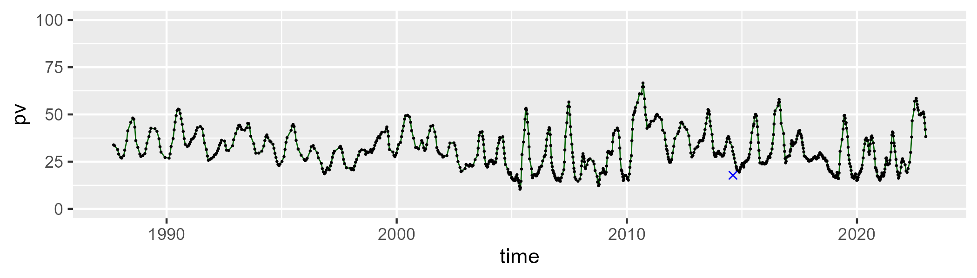

| Min. | 1st Qu. | Median | Mean | 3rd Qu. | Max. |
| --- | --- | --- | --- | --- | --- |
| 23.66826 | 44.78035 | 49.98355 | 49.40353 | 54.72835 | 62.37916 |

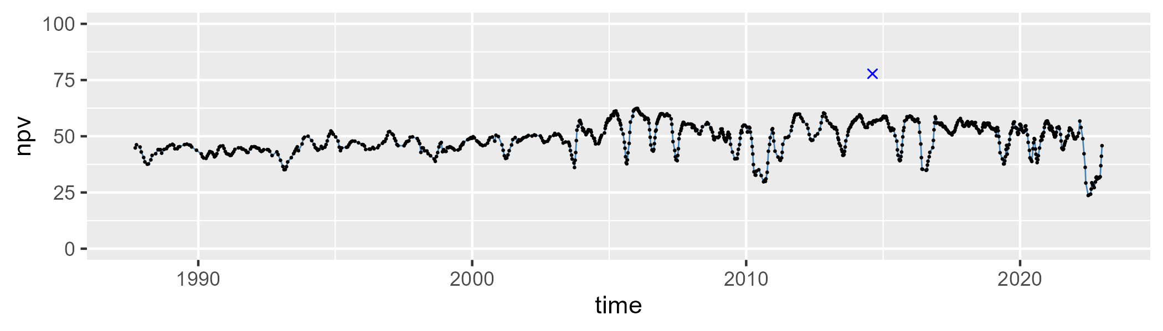

| Min. | 1st Qu. | Median | Mean | 3rd Qu. | Max. |
| --- | --- | --- | --- | --- | --- |
| 1.272299 | 13.11953 | 18.75837 | 18.18059 | 23.38043 | 35.6055 |

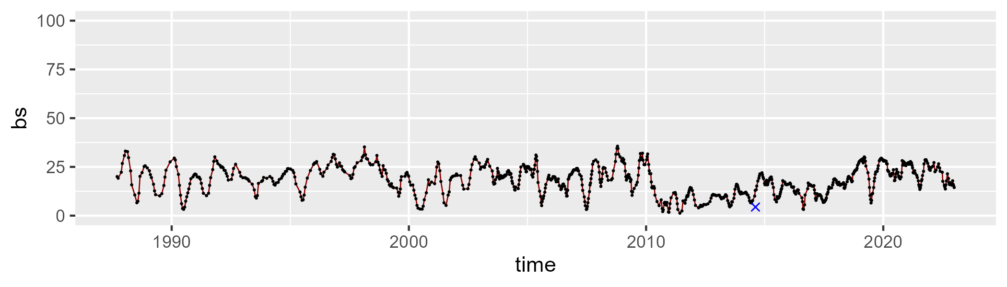

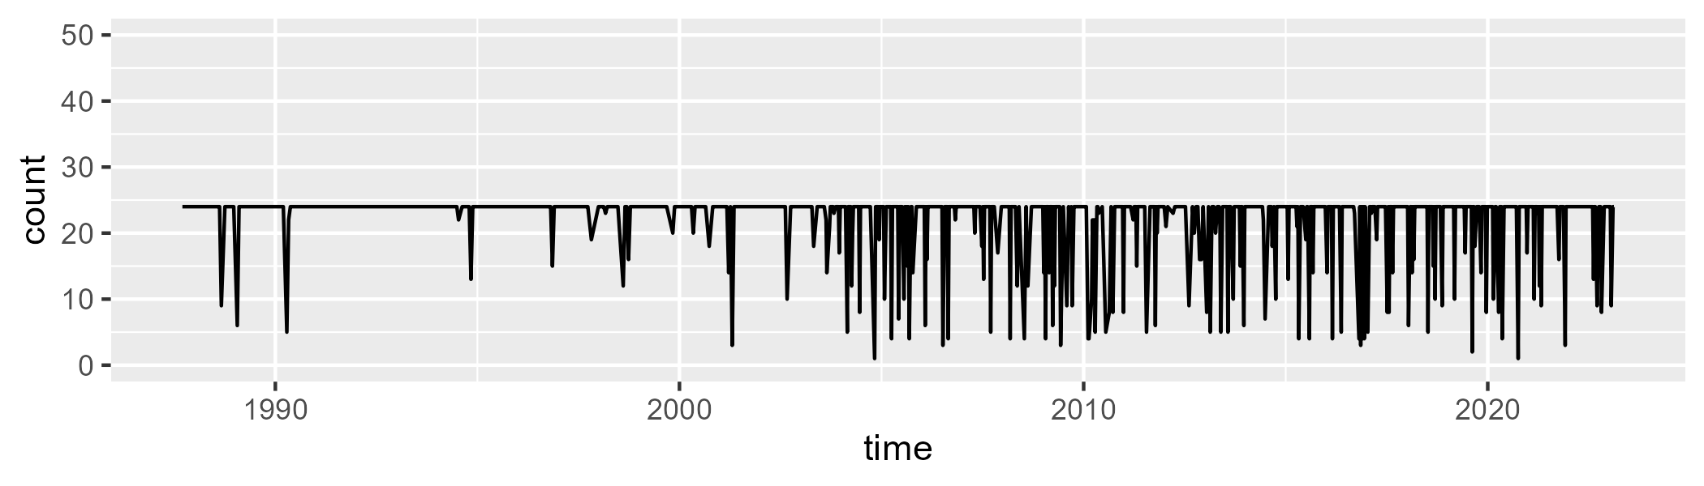

Min. : 1.00 1st Qu.:24.00 Median :24.00 Mean :21.99 3rd Qu.:24.00 Max. :24.00

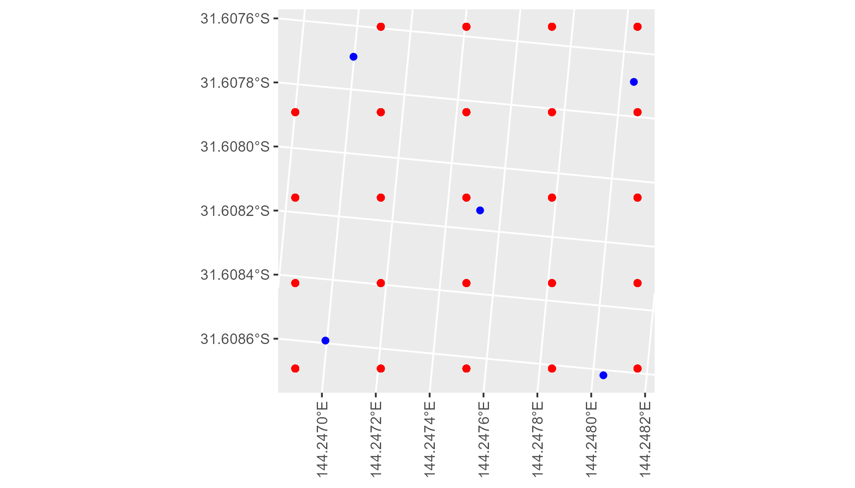

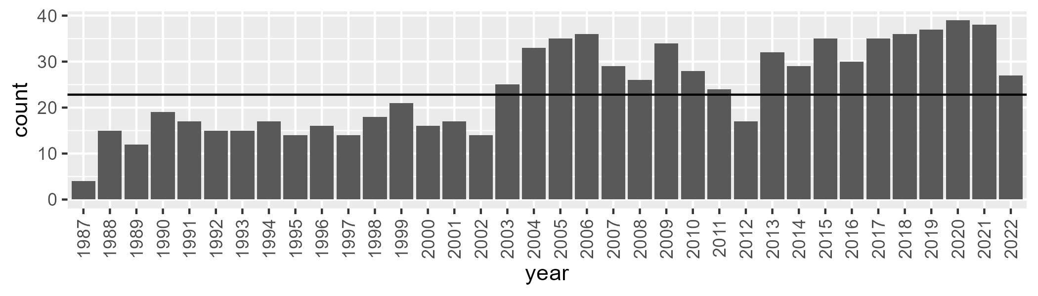

Number of samples: 869

# NSAMDD0026

| Min. | 1st Qu. | Median | Mean | 3rd Qu. | Max. |
| --- | --- | --- | --- | --- | --- |
| 0 | 8.002969 | 14.46503 | 20.5853 | 29.7646 | 86.98563 |

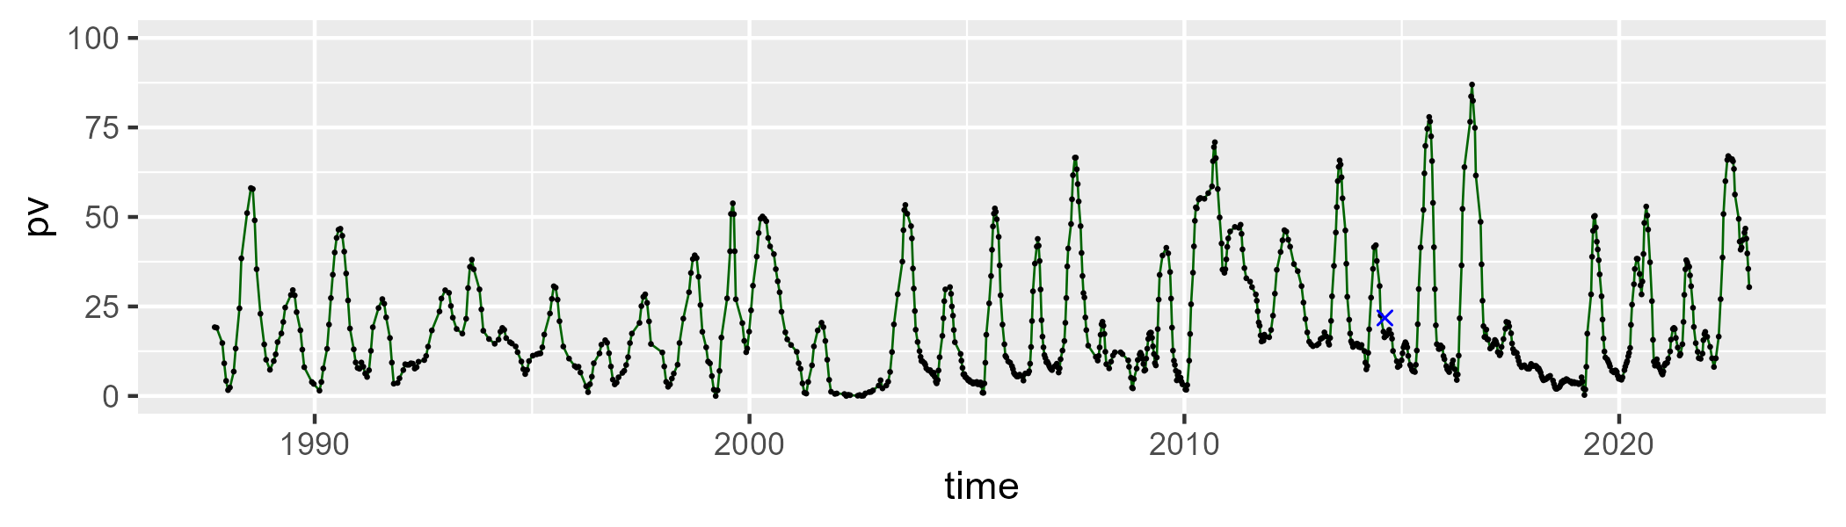

| Min. | 1st Qu. | Median | Mean | 3rd Qu. | Max. |
| --- | --- | --- | --- | --- | --- |
| 5.744138 | 41.2194 | 47.11756 | 47.46338 | 55.03685 | 80.70634 |

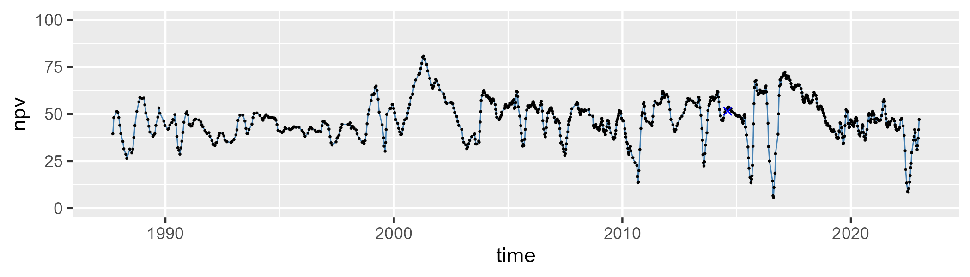

| Min. | 1st Qu. | Median | Mean | 3rd Qu. | Max. |
| --- | --- | --- | --- | --- | --- |
| 2.955693 | 20.34857 | 31.28748 | 30.6199 | 40.61311 | 62.82077 |

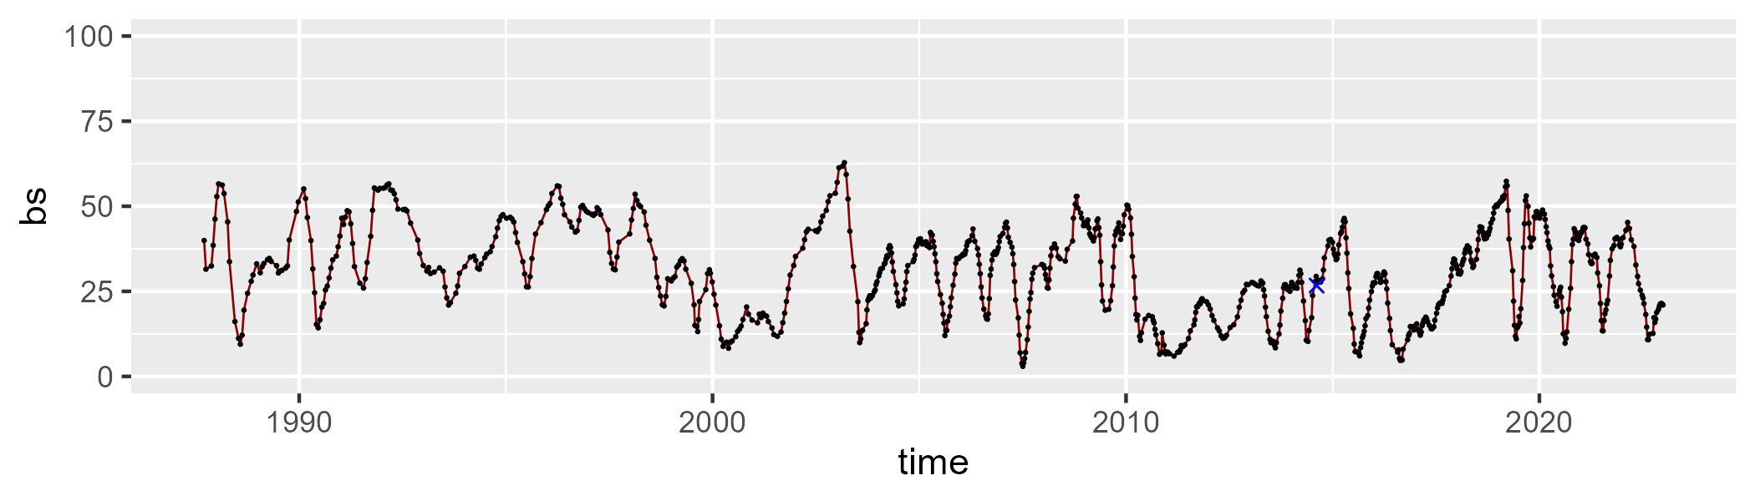

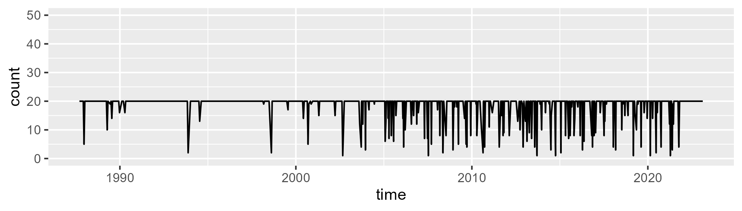

Min. : 1.00 1st Qu.:20.00 Median :20.00 Mean :18.56 3rd Qu.:20.00 Max. :20.00

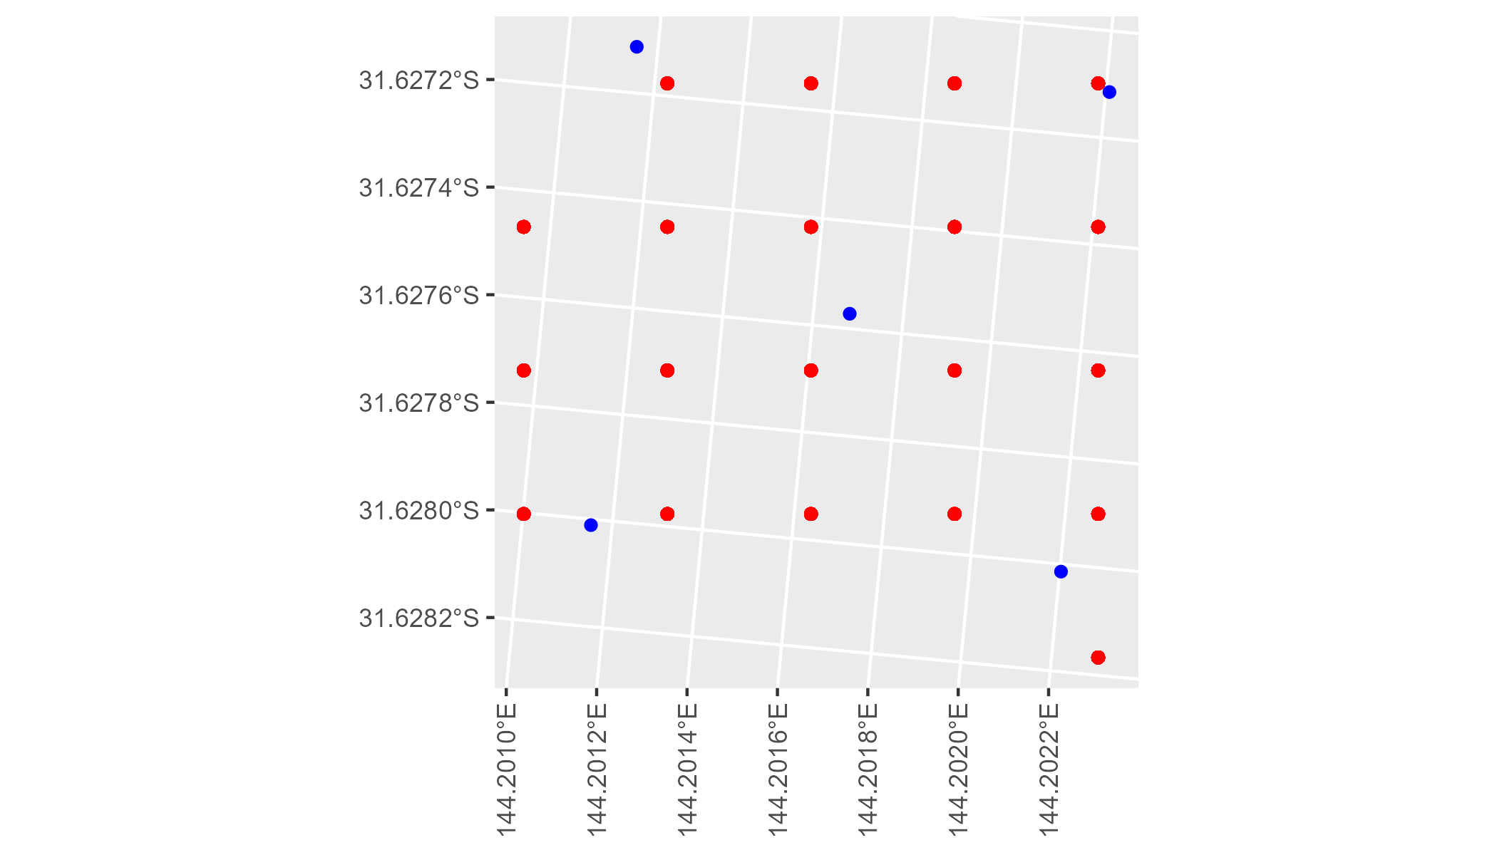

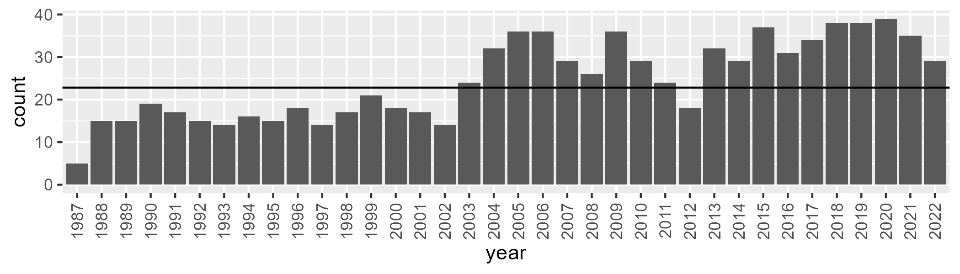

Number of samples: 882

# NSAMDD0027

| Min. | 1st Qu. | Median | Mean | 3rd Qu. | Max. |
| --- | --- | --- | --- | --- | --- |
| 3.857619 | 13.70052 | 17.42413 | 19.54445 | 24.73519 | 46.66343 |

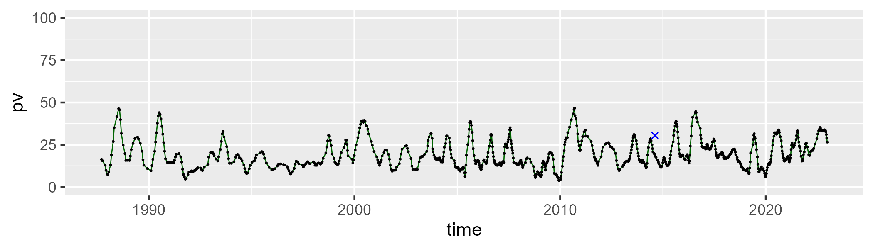

| Min. | 1st Qu. | Median | Mean | 3rd Qu. | Max. |
| --- | --- | --- | --- | --- | --- |
| 37.23895 | 48.84347 | 51.69477 | 51.31372 | 54.32556 | 66.475 |

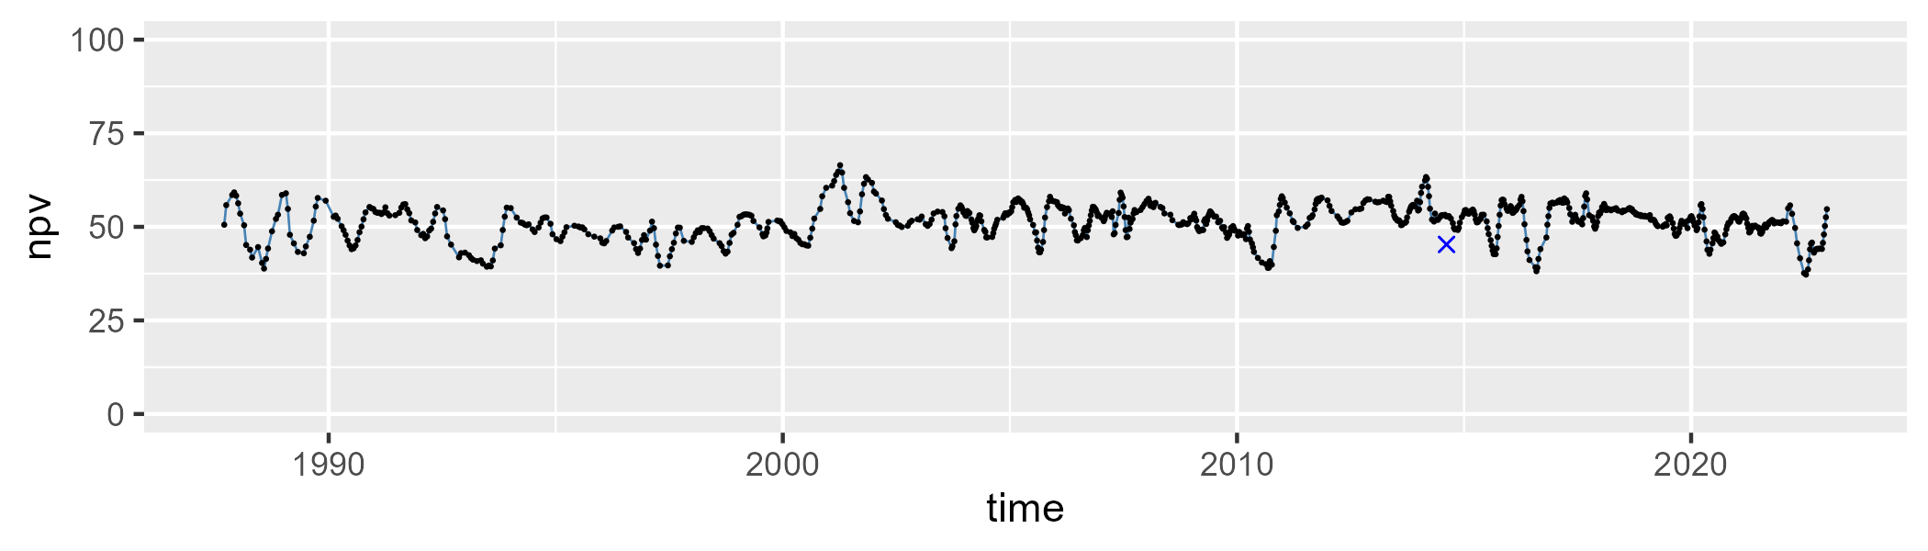

| Min. | 1st Qu. | Median | Mean | 3rd Qu. | Max. |
| --- | --- | --- | --- | --- | --- |
| 10.60233 | 22.95425 | 27.68302 | 27.85762 | 32.56656 | 46.38551 |

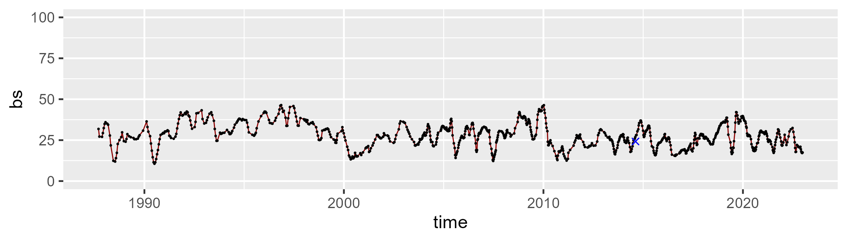

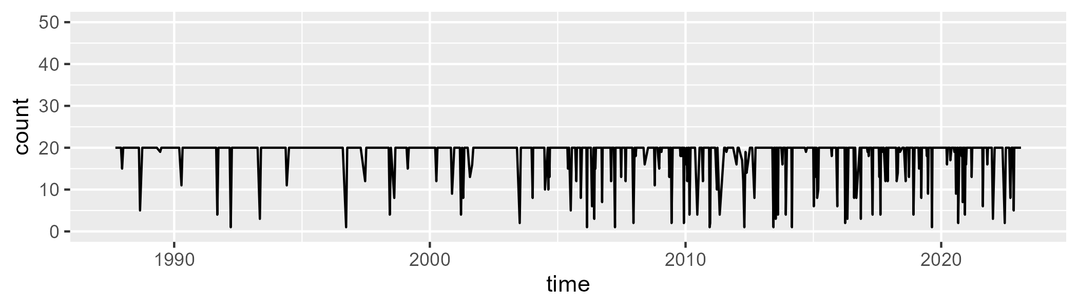

Min. : 1.00 1st Qu.:20.00 Median :20.00 Mean :18.61 3rd Qu.:20.00 Max. :20.00

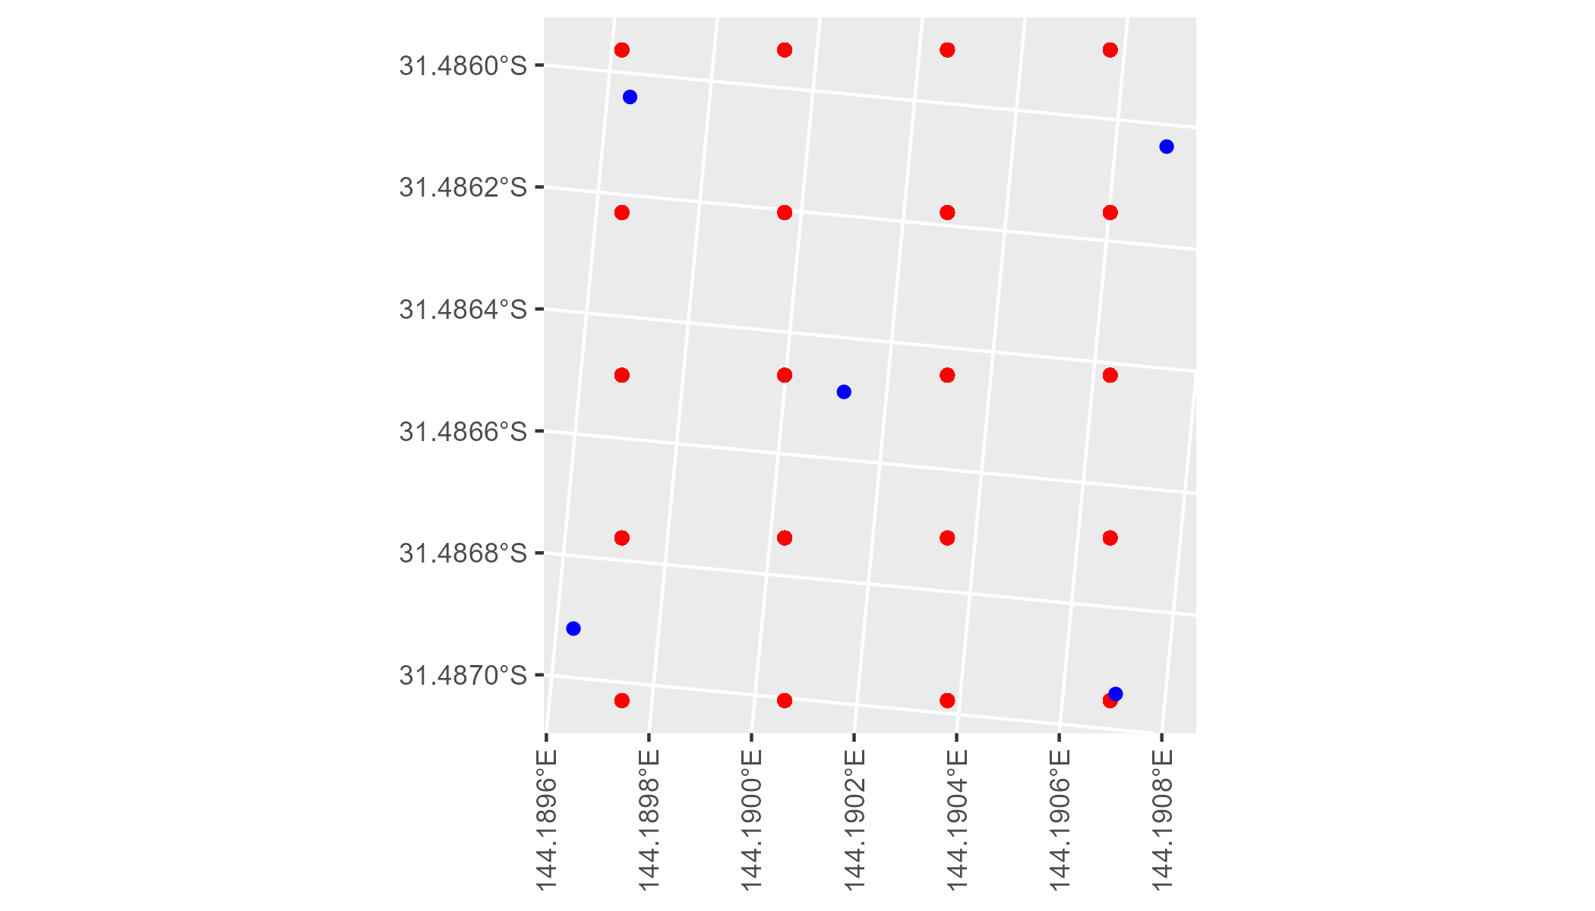

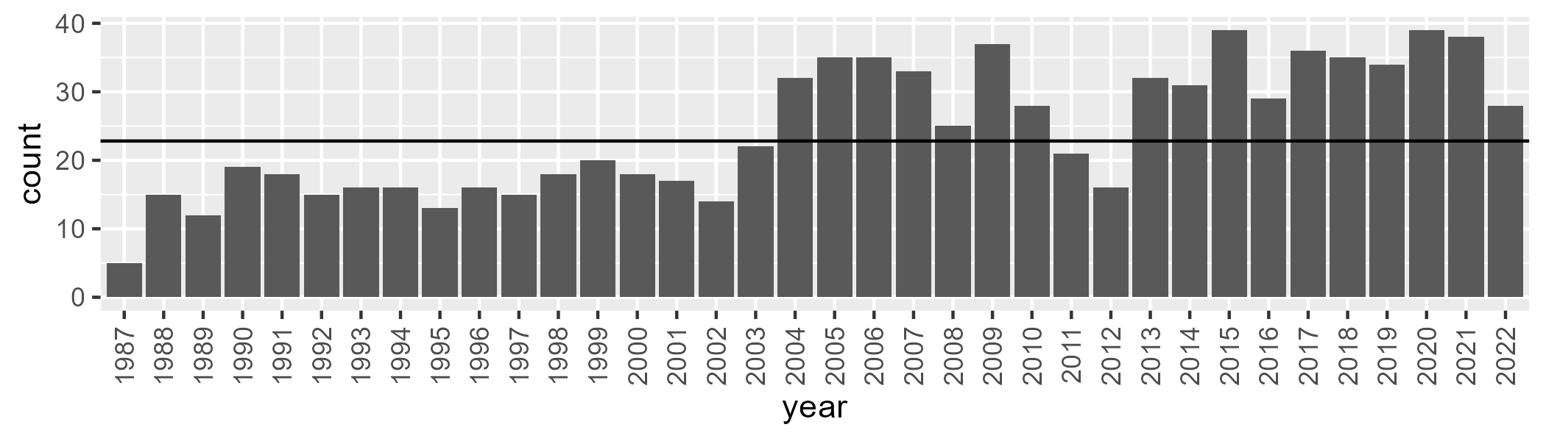

Number of samples: 872

# NSAMDD0028

| Min. | 1st Qu. | Median | Mean | 3rd Qu. | Max. |
| --- | --- | --- | --- | --- | --- |
| 1.117684 | 10.6165 | 15.83881 | 17.66886 | 22.96052 | 48.23338 |

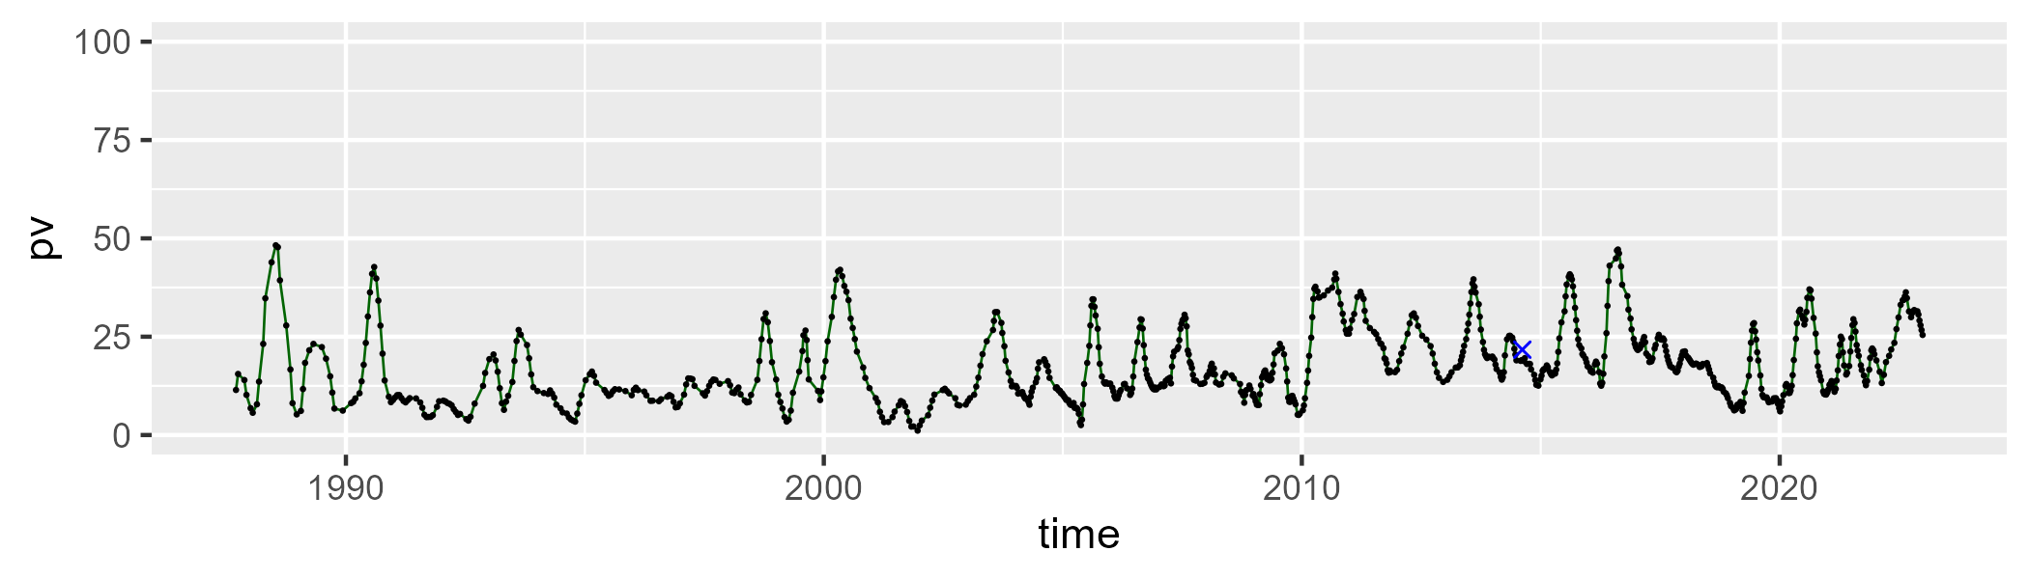

| Min. | 1st Qu. | Median | Mean | 3rd Qu. | Max. |
| --- | --- | --- | --- | --- | --- |
| 17.06375 | 36.77505 | 43.81975 | 42.33572 | 47.82109 | 71.39815 |

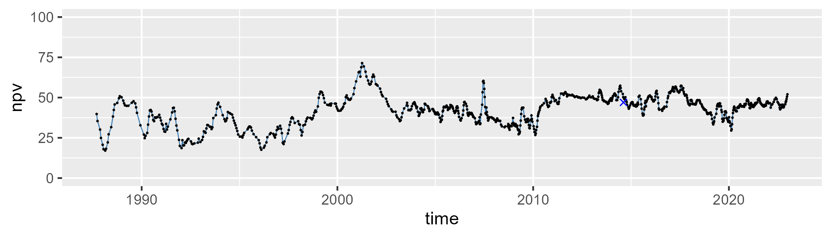

| Min. | 1st Qu. | Median | Mean | 3rd Qu. | Max. |
| --- | --- | --- | --- | --- | --- |
| 8.522398 | 27.8012 | 37.86822 | 38.70989 | 50.1669 | 74.97007 |

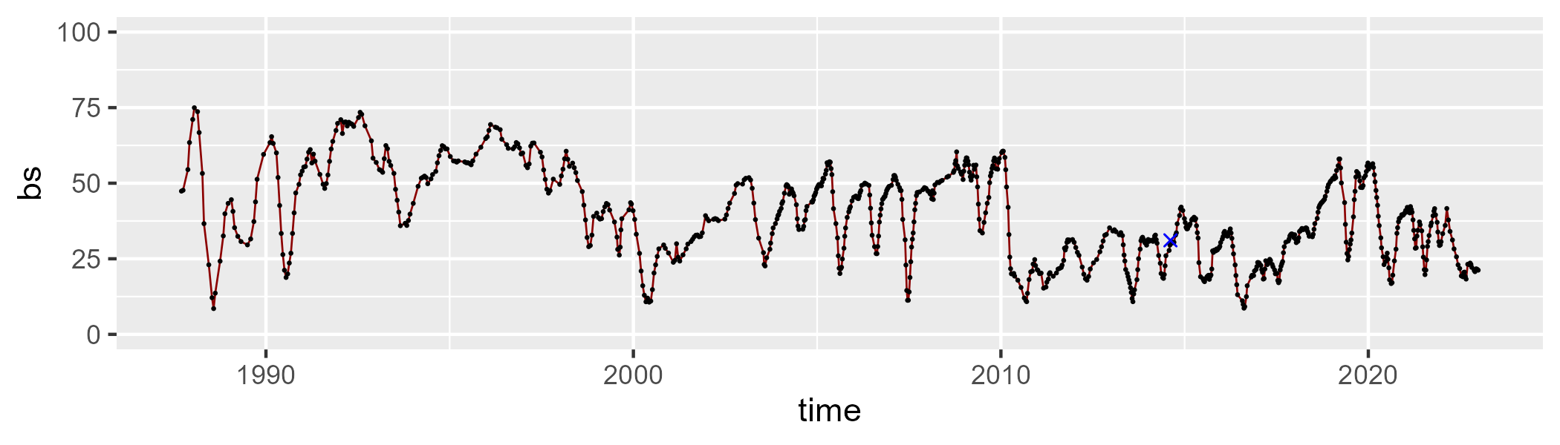

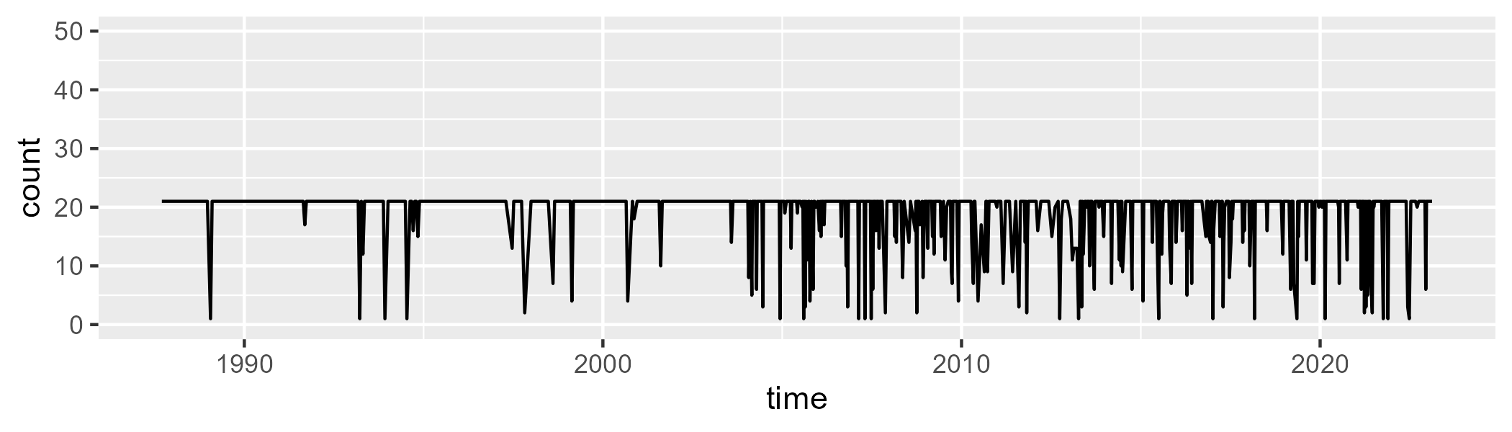

Min. : 1.00 1st Qu.:21.00 Median :21.00 Mean :19.12 3rd Qu.:21.00 Max. :21.00

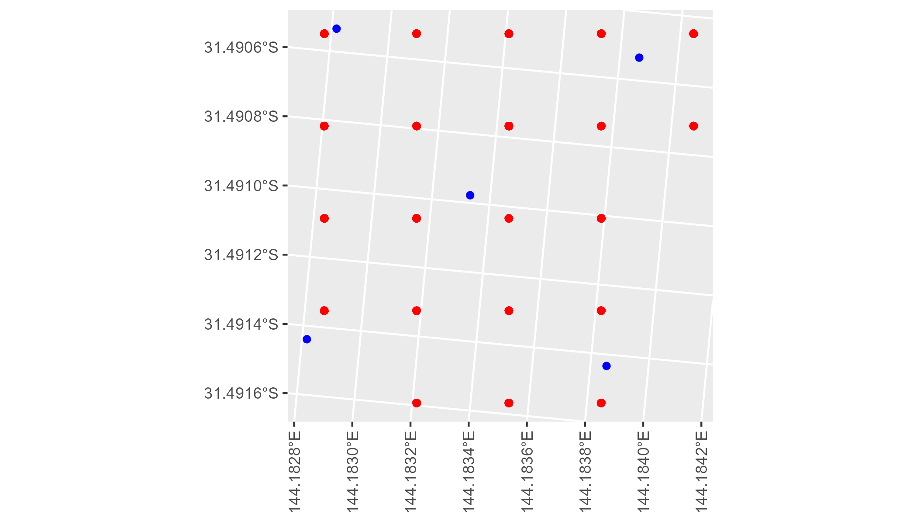

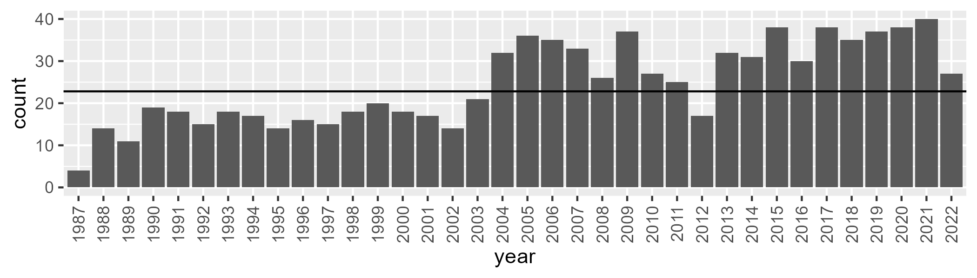

Number of samples: 883

# NSAMDD0029

| Min. | 1st Qu. | Median | Mean | 3rd Qu. | Max. |
| --- | --- | --- | --- | --- | --- |
| 1.934564 | 10.0952 | 15.62434 | 16.45485 | 21.05272 | 43.2237 |

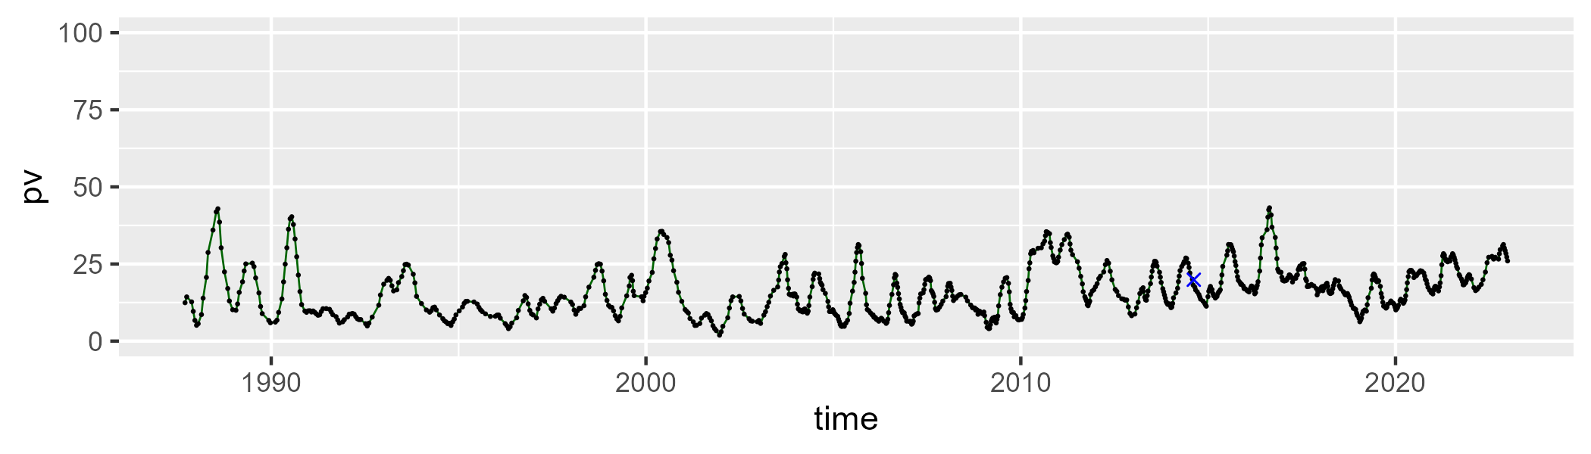

| Min. | 1st Qu. | Median | Mean | 3rd Qu. | Max. |
| --- | --- | --- | --- | --- | --- |
| 16.30683 | 34.54355 | 39.77071 | 40.84867 | 46.86141 | 65.40007 |

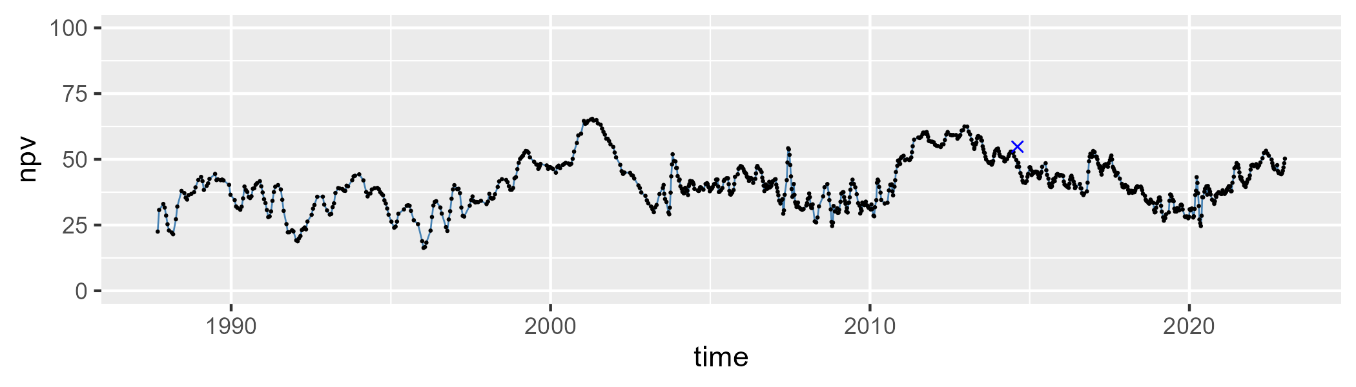

| Min. | 1st Qu. | Median | Mean | 3rd Qu. | Max. |
| --- | --- | --- | --- | --- | --- |
| 13.53538 | 30.93338 | 41.27474 | 41.31213 | 51.49407 | 73.68051 |

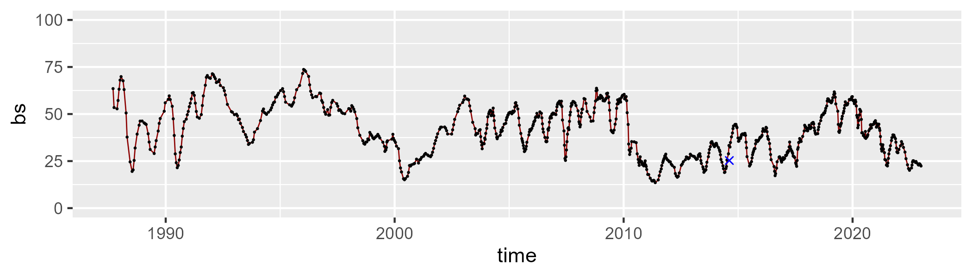

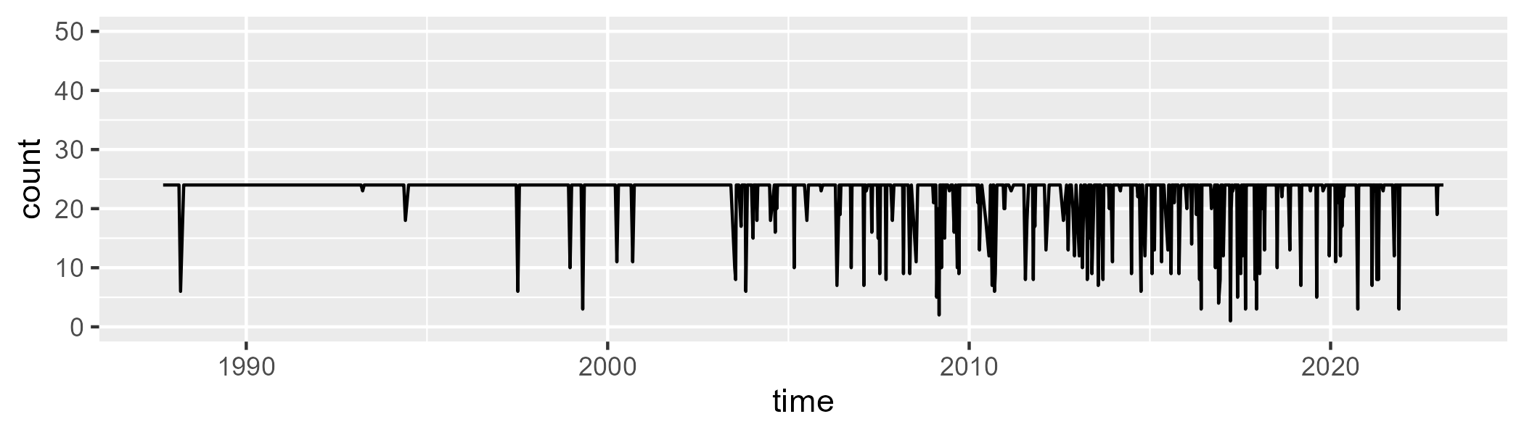

Min. : 1.00 1st Qu.:24.00 Median :24.00 Mean :22.41 3rd Qu.:24.00 Max. :24.00

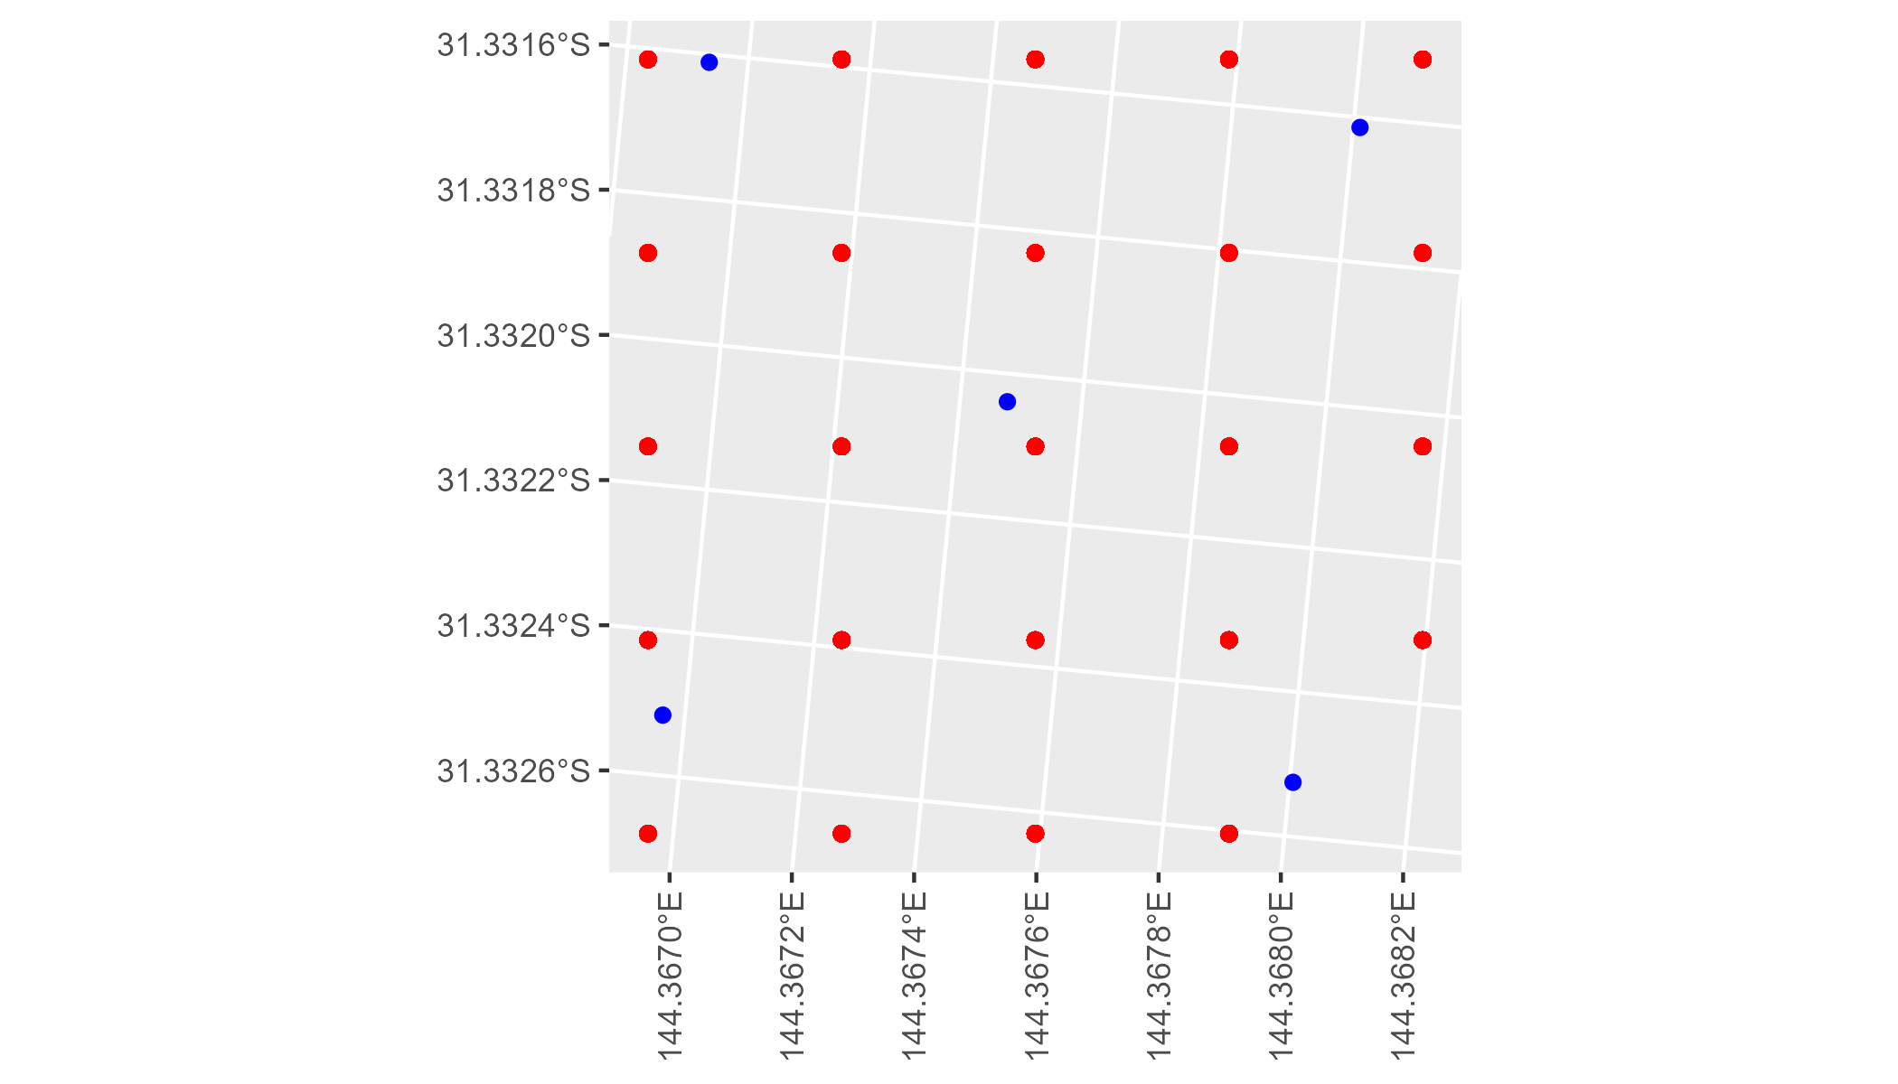

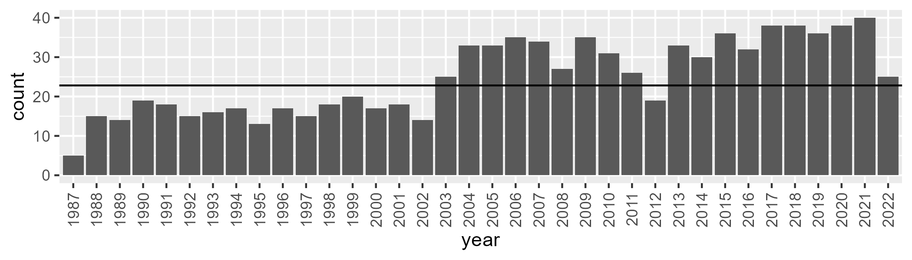

Number of samples: 895

# NSAMDD0030

| Min. | 1st Qu. | Median | Mean | 3rd Qu. | Max. |
| --- | --- | --- | --- | --- | --- |
| 9.617338 | 19.54242 | 23.95904 | 25.73391 | 30.73136 | 58.46199 |

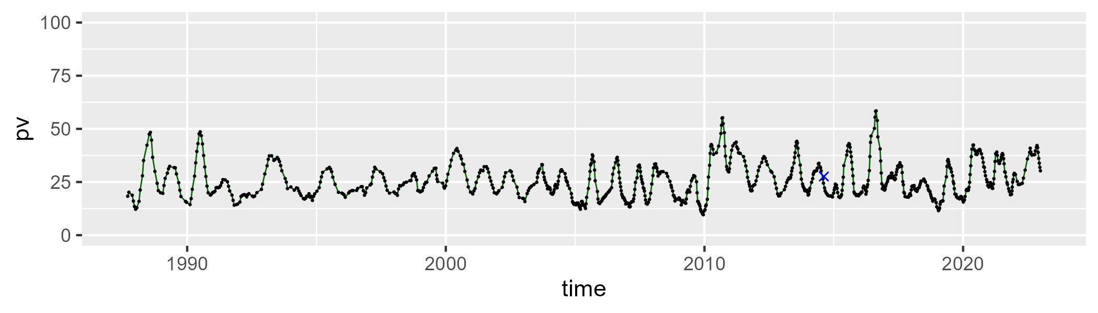

| Min. | 1st Qu. | Median | Mean | 3rd Qu. | Max. |
| --- | --- | --- | --- | --- | --- |
| 23.17803 | 37.72677 | 41.78794 | 41.41611 | 45.56792 | 58.76643 |

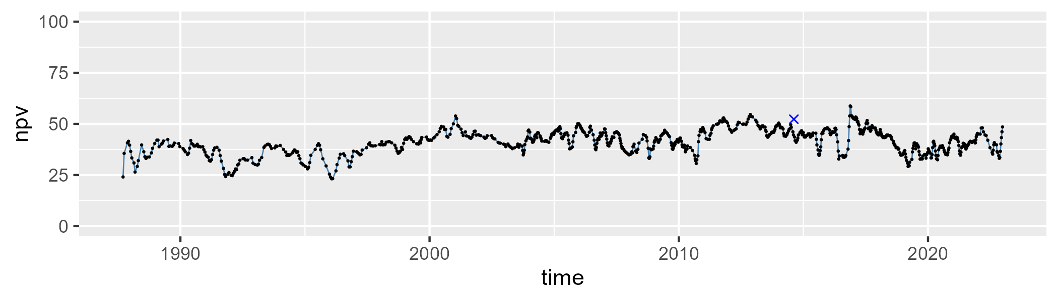

| Min. | 1st Qu. | Median | Mean | 3rd Qu. | Max. |
| --- | --- | --- | --- | --- | --- |
| 5.935924 | 24.55548 | 31.13732 | 31.4766 | 37.80202 | 60.18423 |

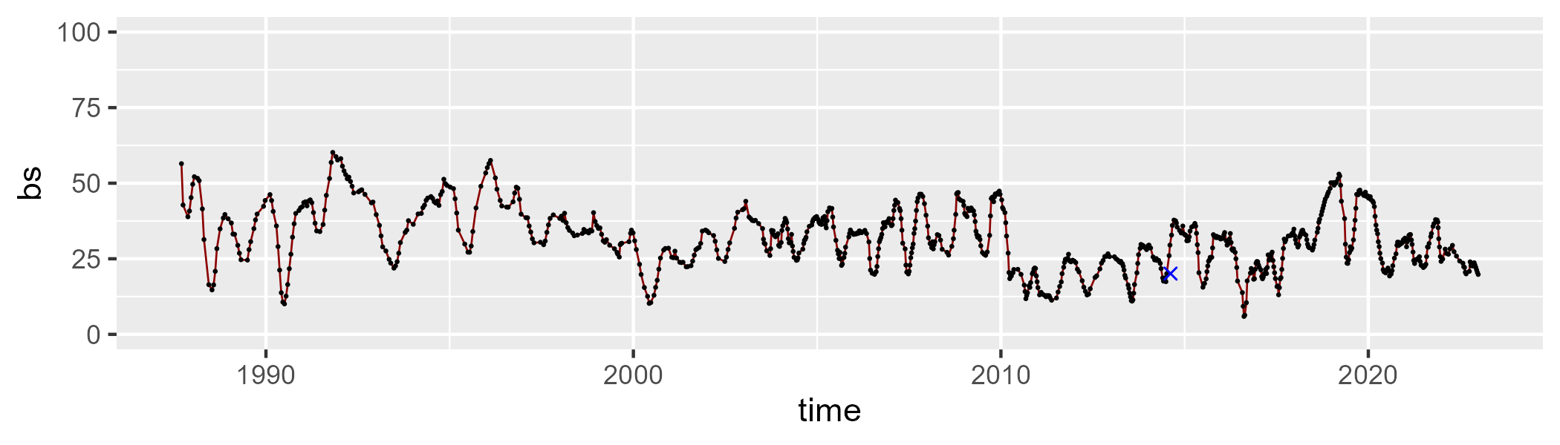

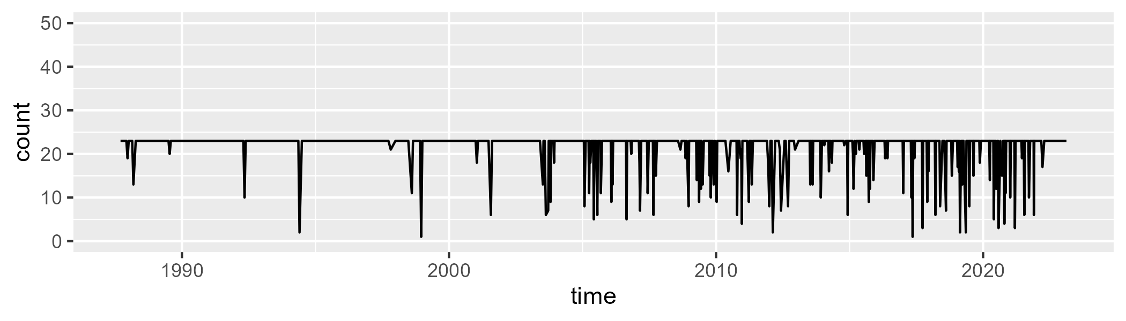

Min. : 1.00 1st Qu.:23.00 Median :23.00 Mean :21.66 3rd Qu.:23.00 Max. :23.00

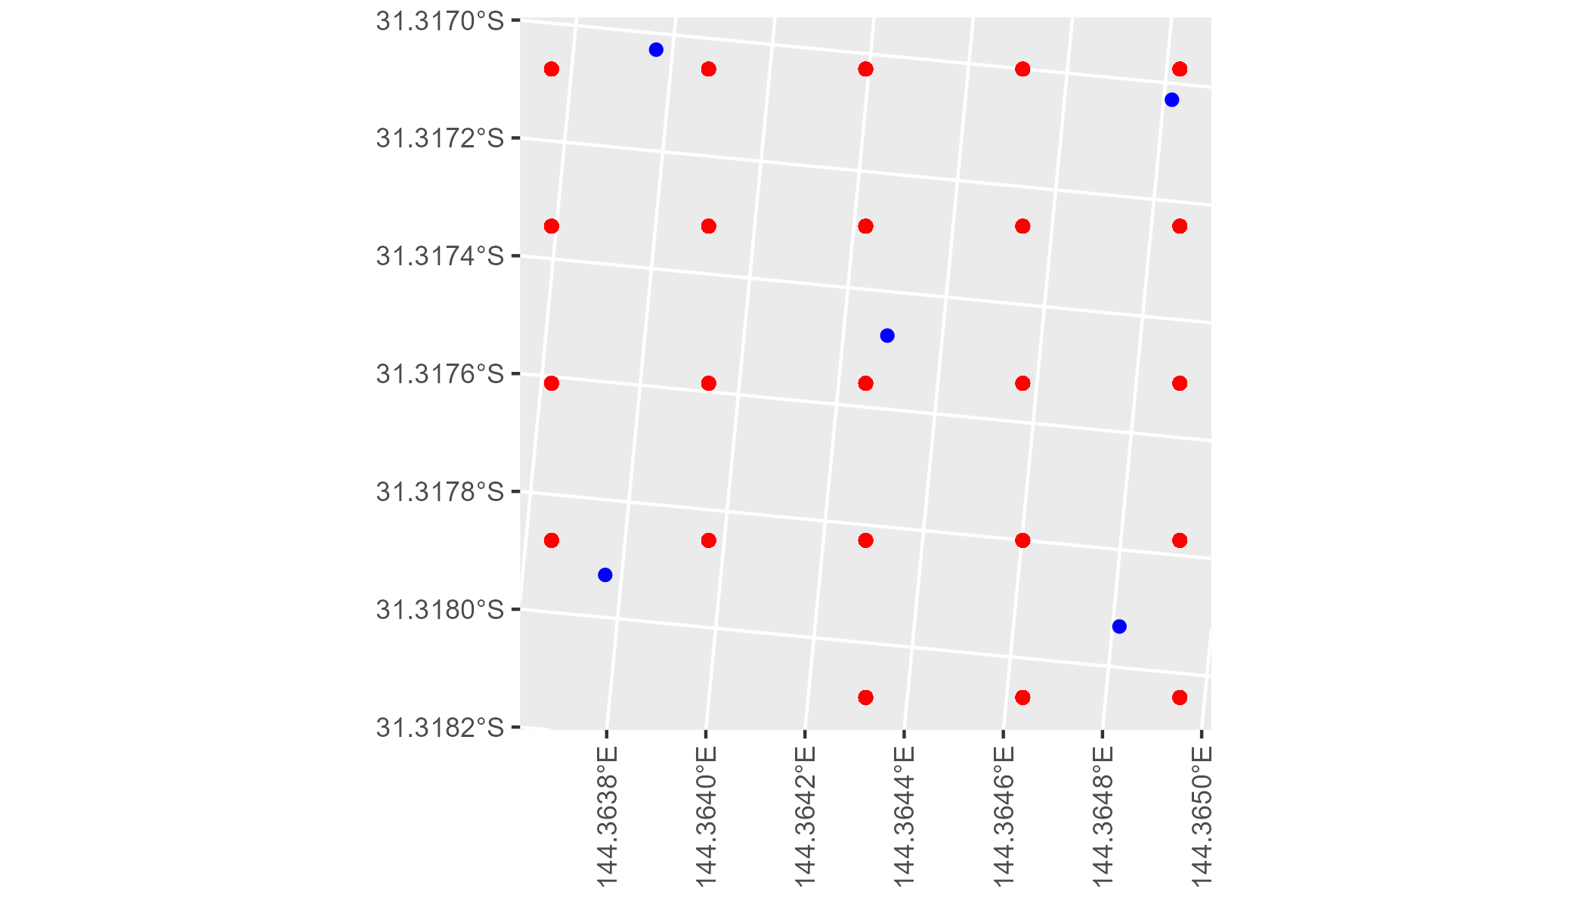

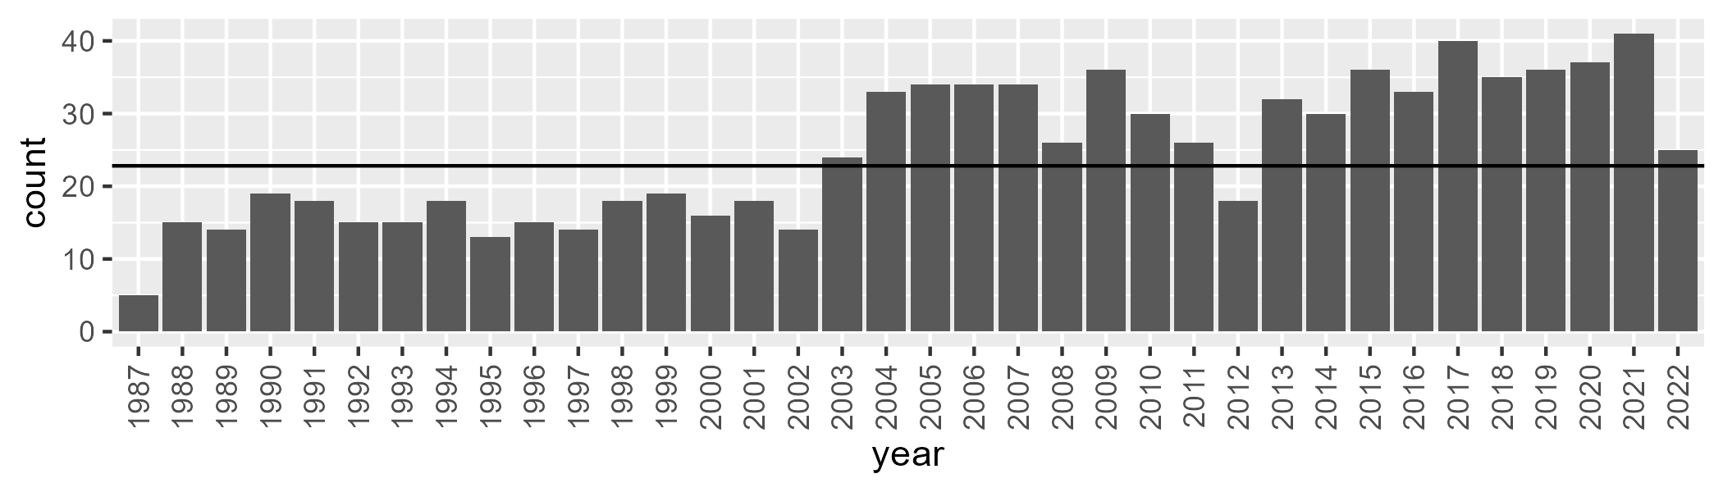

Number of samples: 886

# NSAMDD0031

| Min. | 1st Qu. | Median | Mean | 3rd Qu. | Max. |
| --- | --- | --- | --- | --- | --- |
| 14.43205 | 21.43635 | 26.51147 | 26.33497 | 30.41758 | 52.1884 |

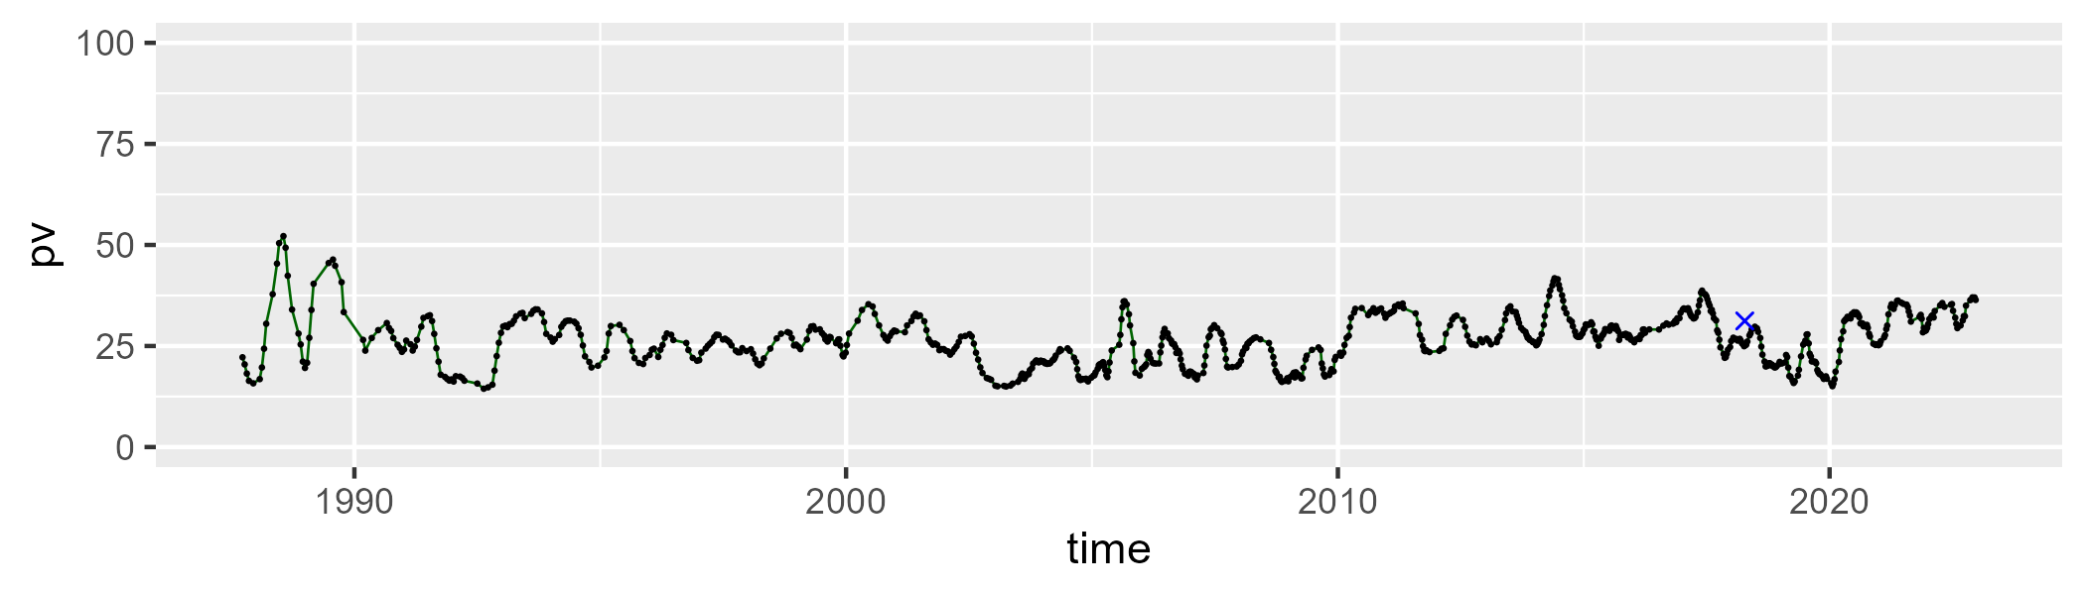

| Min. | 1st Qu. | Median | Mean | 3rd Qu. | Max. |
| --- | --- | --- | --- | --- | --- |
| 40.66646 | 47.63293 | 49.36819 | 49.2299 | 51.02769 | 56.18671 |

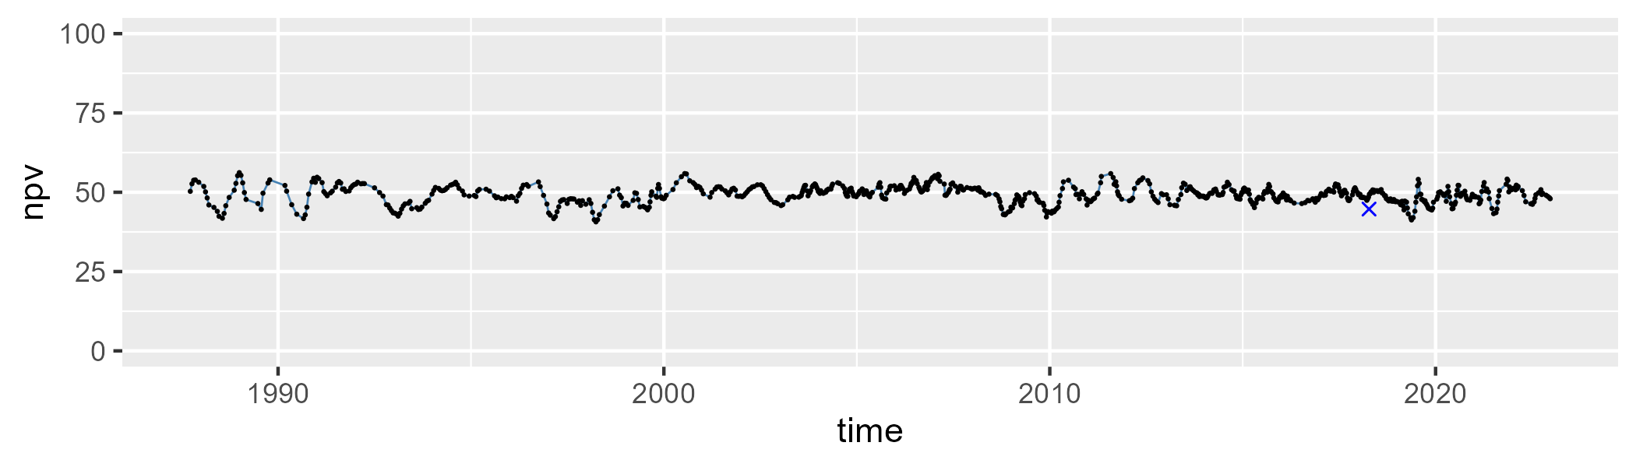

| Min. | 1st Qu. | Median | Mean | 3rd Qu. | Max. |
| --- | --- | --- | --- | --- | --- |
| 4.588276 | 18.74678 | 23.31517 | 23.2539 | 27.60777 | 39.40171 |

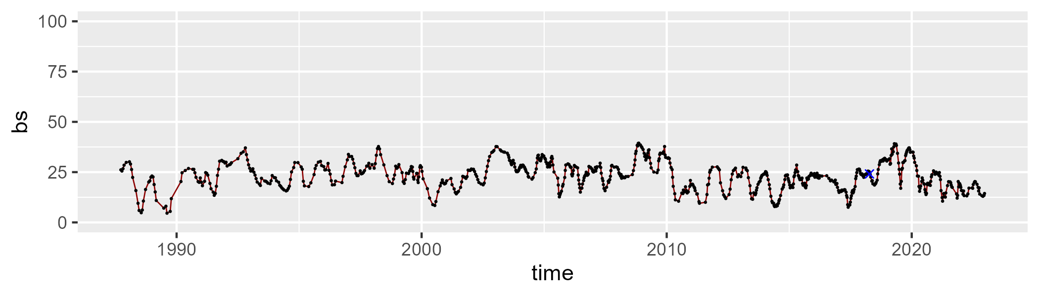

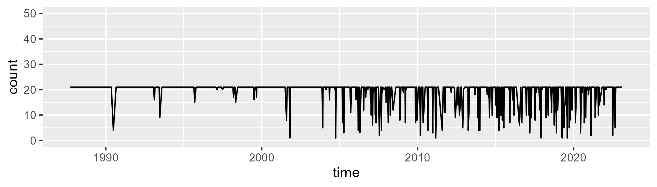

Min. : 1.00 1st Qu.:21.00 Median :21.00 Mean :19.29 3rd Qu.:21.00 Max. :21.00

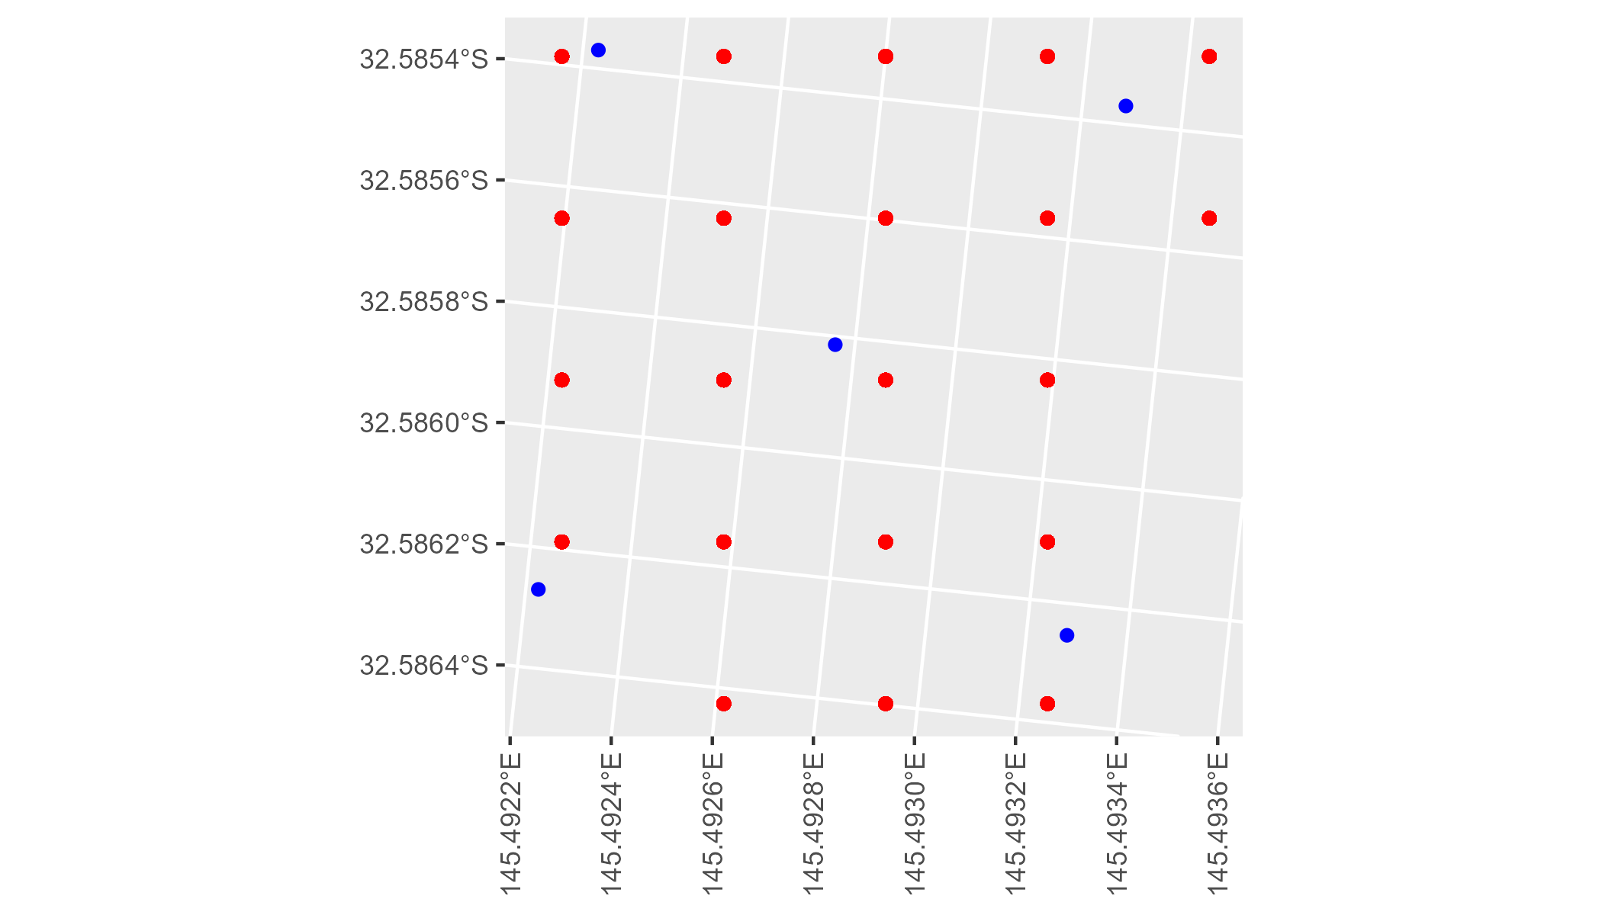

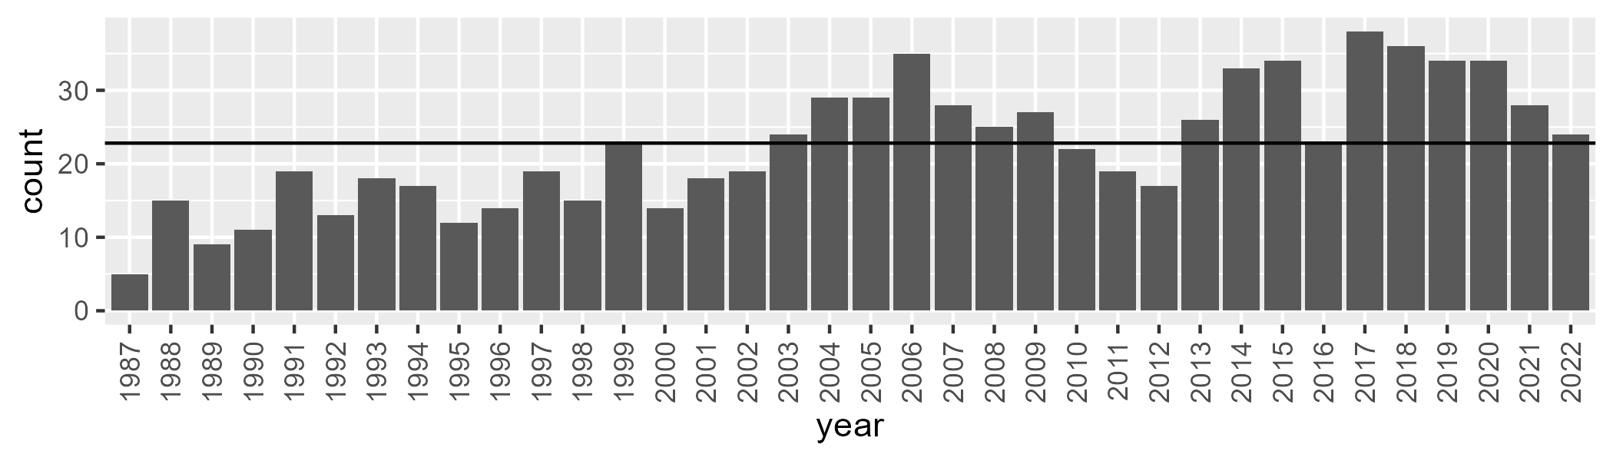

Number of samples: 806

# NSAMDD0032

| Min. | 1st Qu. | Median | Mean | 3rd Qu. | Max. |
| --- | --- | --- | --- | --- | --- |
| 12.97006 | 22.76111 | 26.90419 | 28.287 | 33.43871 | 51.09032 |

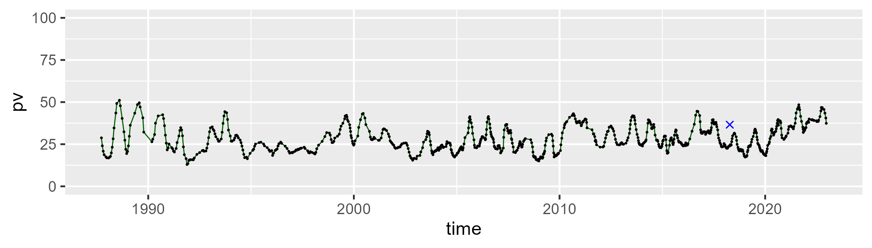

| Min. | 1st Qu. | Median | Mean | 3rd Qu. | Max. |
| --- | --- | --- | --- | --- | --- |
| 40.6234 | 51.40946 | 53.58923 | 53.22954 | 55.25838 | 65.0538 |

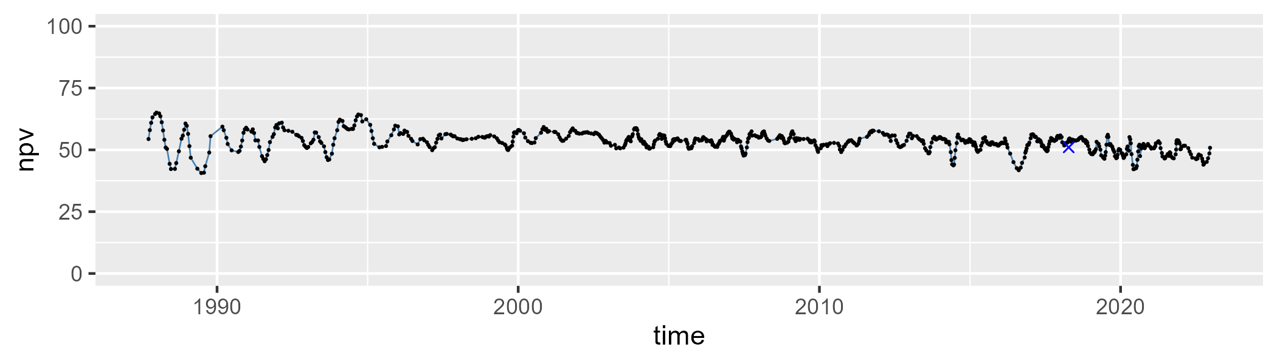

| Min. | 1st Qu. | Median | Mean | 3rd Qu. | Max. |
| --- | --- | --- | --- | --- | --- |
| 1.736509 | 12.40004 | 17.67019 | 17.41518 | 21.93583 | 33.10834 |

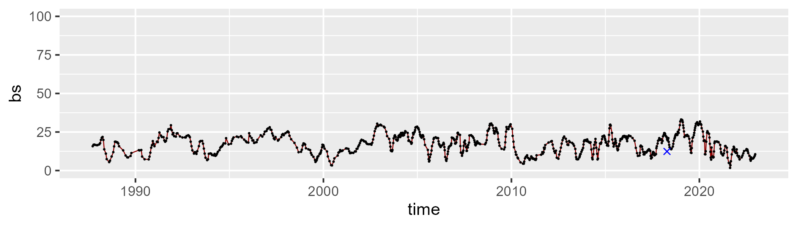

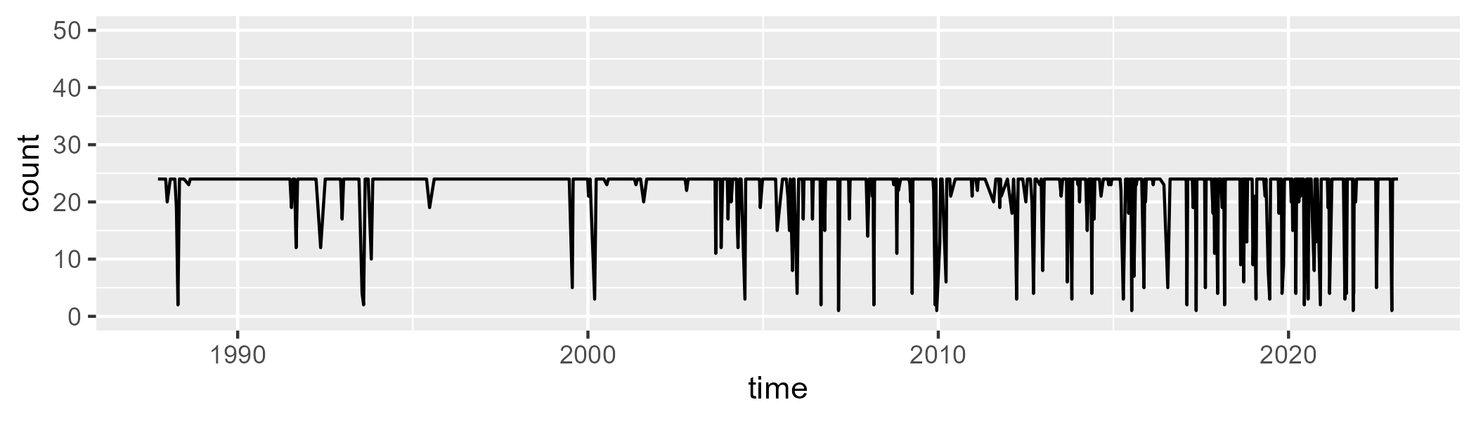

Min. : 1.0 1st Qu.:24.0 Median :24.0 Mean :22.2 3rd Qu.:24.0 Max. :24.0

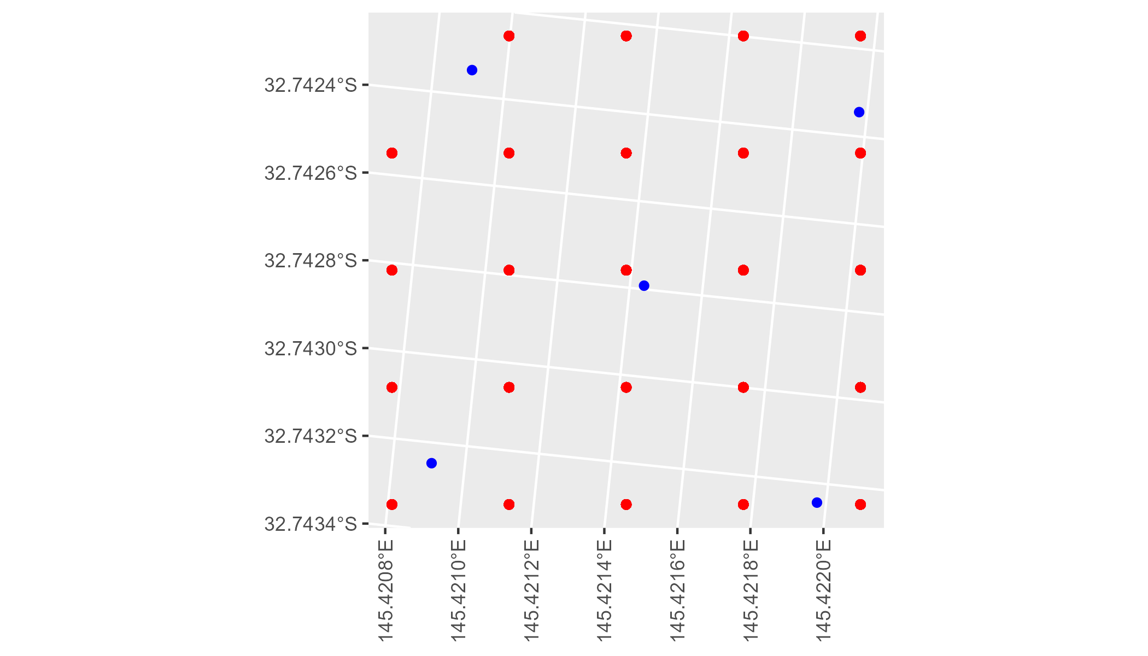

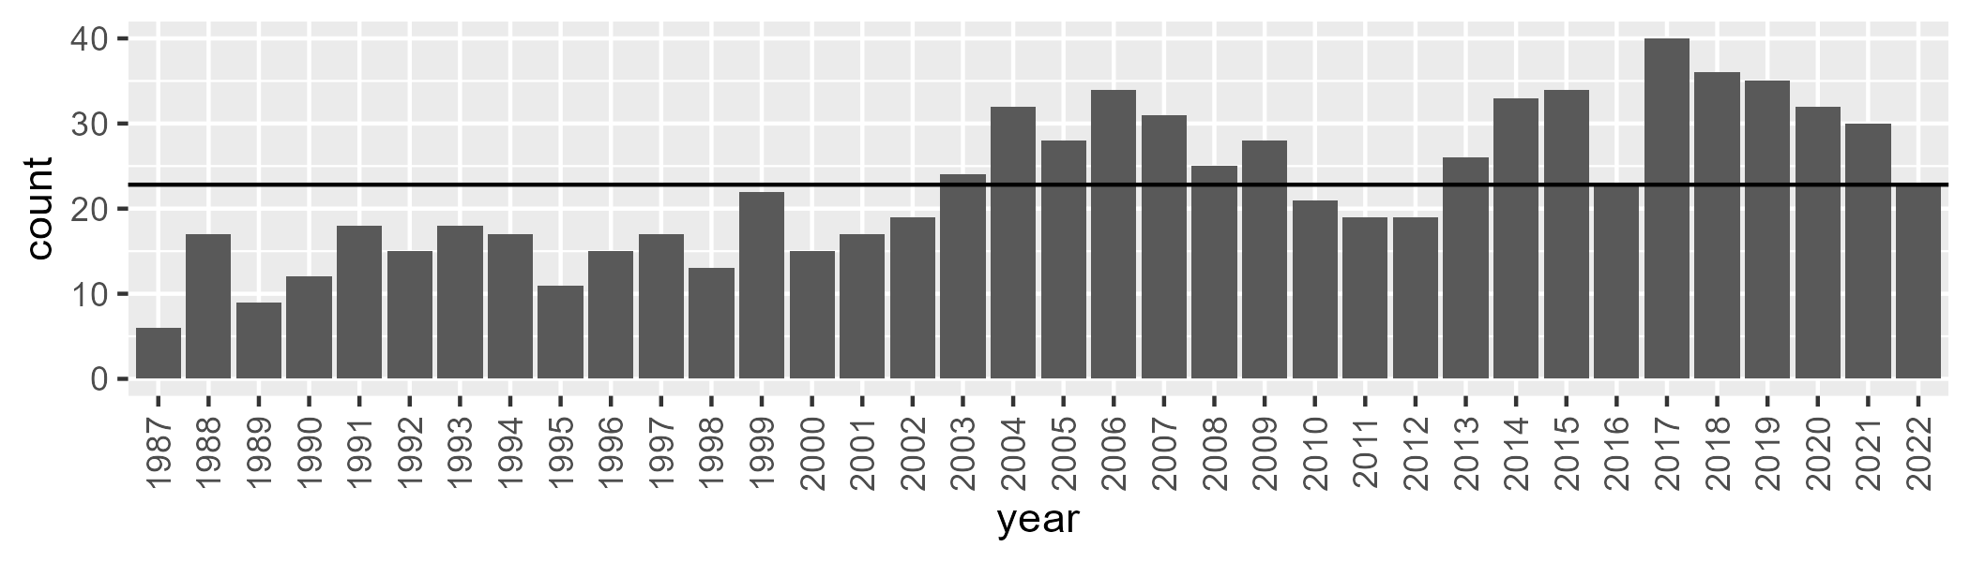

Number of samples: 814

# NSAMUL0001

| Min. | 1st Qu. | Median | Mean | 3rd Qu. | Max. |
| --- | --- | --- | --- | --- | --- |
| 9.93665 | 16.70974 | 20.11925 | 20.63114 | 23.9564 | 42.32524 |

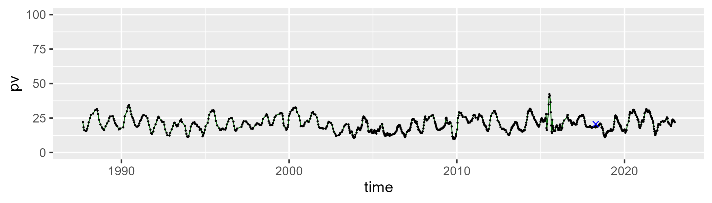

| Min. | 1st Qu. | Median | Mean | 3rd Qu. | Max. |
| --- | --- | --- | --- | --- | --- |
| 38.80073 | 46.44616 | 49.03518 | 49.32739 | 52.0583 | 60.73429 |

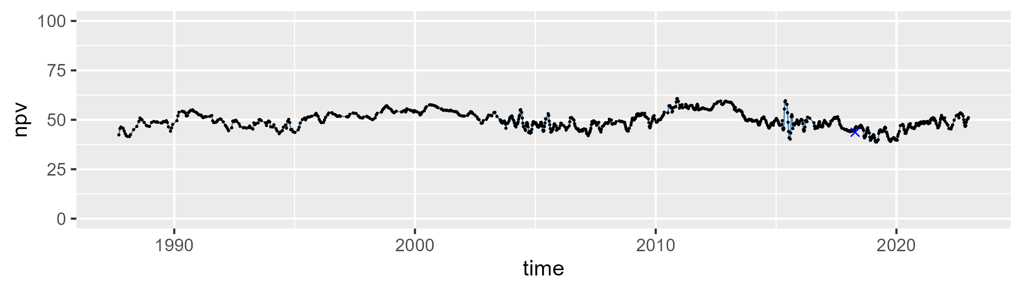

| Min. | 1st Qu. | Median | Mean | 3rd Qu. | Max. |
| --- | --- | --- | --- | --- | --- |
| 11.11304 | 23.67569 | 28.76515 | 28.85683 | 34.2186 | 45.2246 |

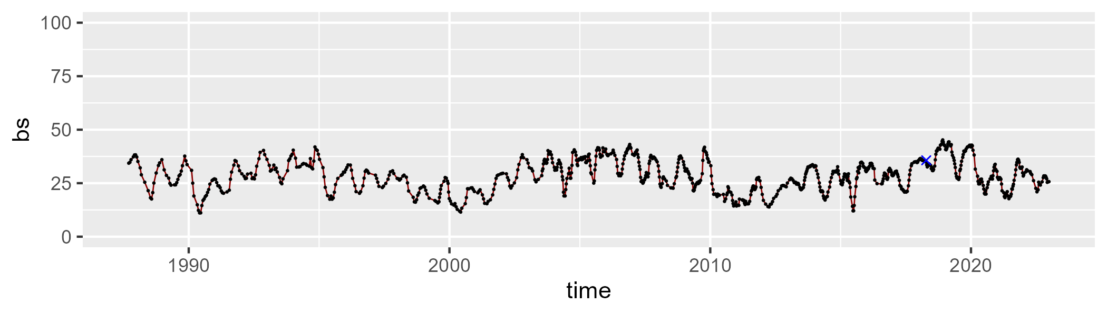

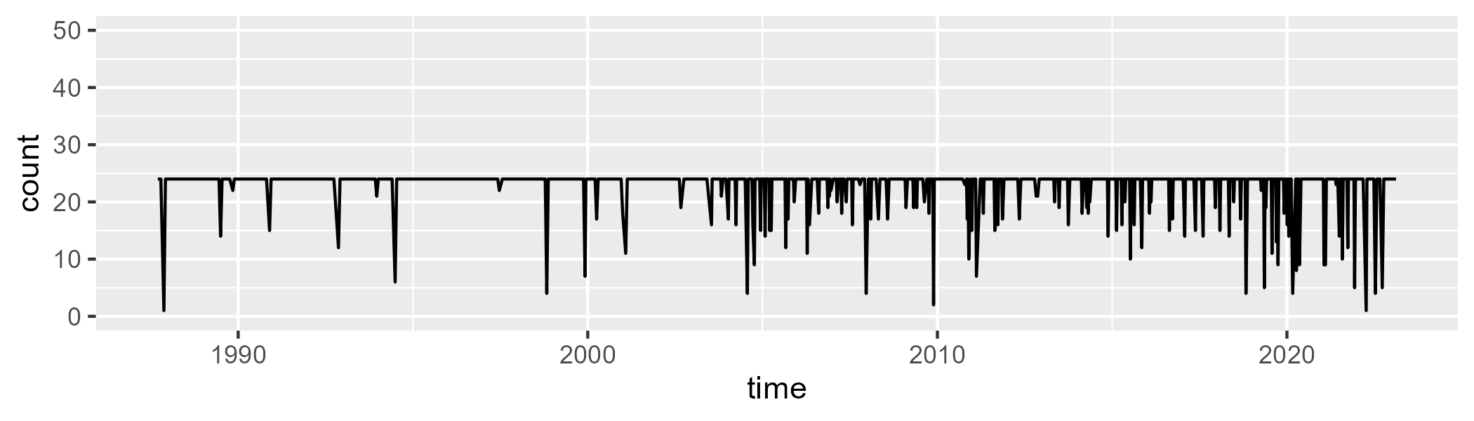

Min. : 1.00 1st Qu.:24.00 Median :24.00 Mean :22.88 3rd Qu.:24.00 Max. :24.00

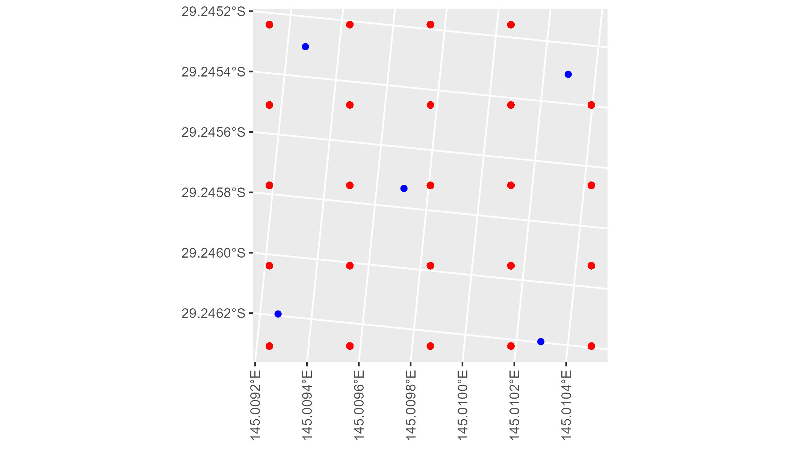

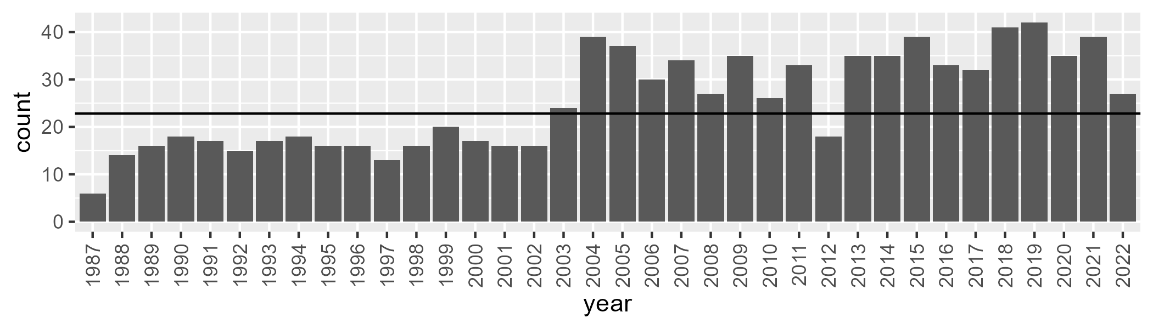

Number of samples: 912

# NSAMUL0002

| Min. | 1st Qu. | Median | Mean | 3rd Qu. | Max. |
| --- | --- | --- | --- | --- | --- |
| 8.89909 | 15.55074 | 19.17692 | 19.83949 | 23.56983 | 37.62934 |

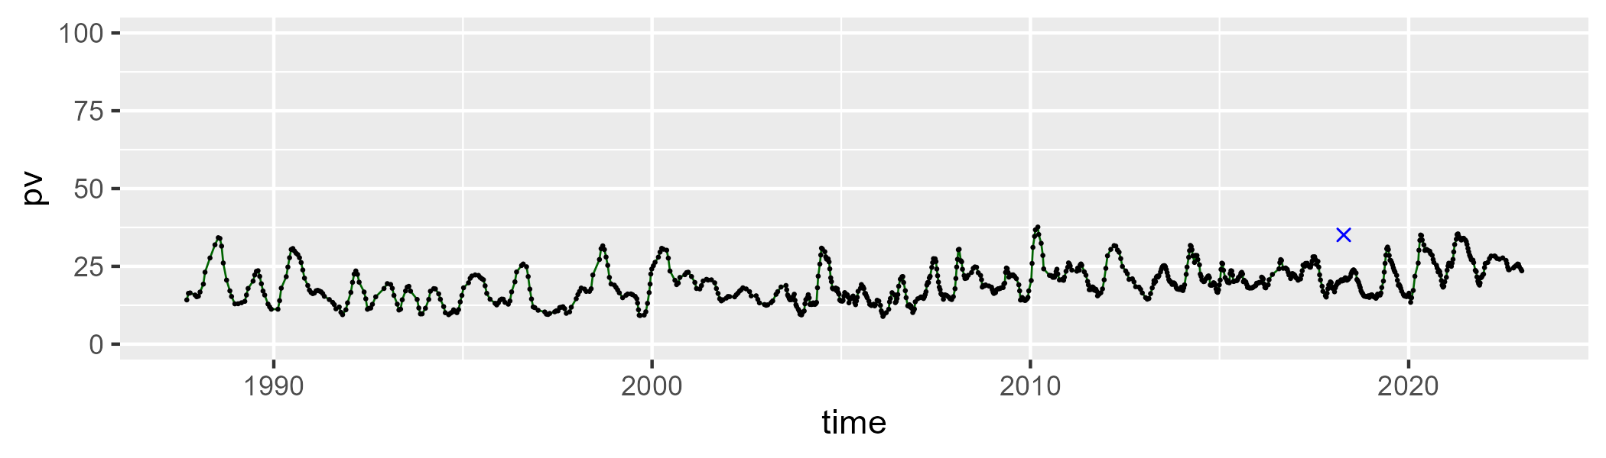

| Min. | 1st Qu. | Median | Mean | 3rd Qu. | Max. |
| --- | --- | --- | --- | --- | --- |
| 17.88211 | 37.49041 | 41.96375 | 41.31813 | 45.89755 | 58.22826 |

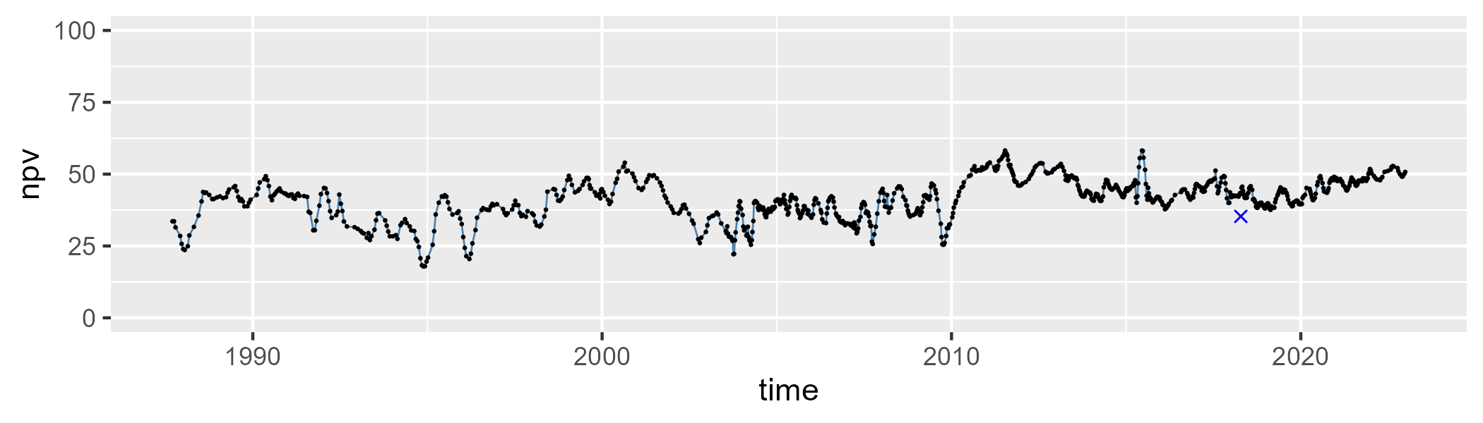

| Min. | 1st Qu. | Median | Mean | 3rd Qu. | Max. |
| --- | --- | --- | --- | --- | --- |
| 15.93656 | 29.26995 | 36.59436 | 37.48484 | 45.28501 | 70.06651 |

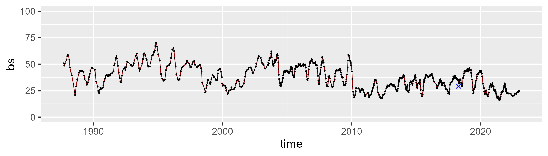

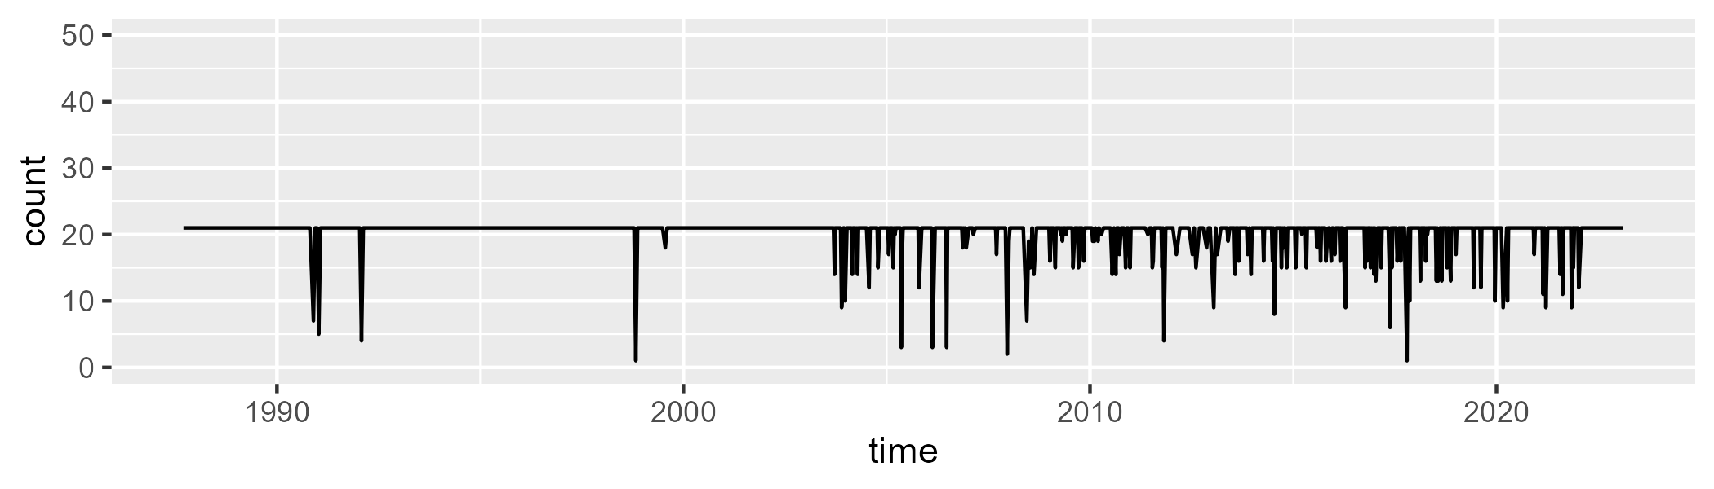

Min. : 1.0 1st Qu.:21.0 Median :21.0 Mean :20.1 3rd Qu.:21.0 Max. :21.0

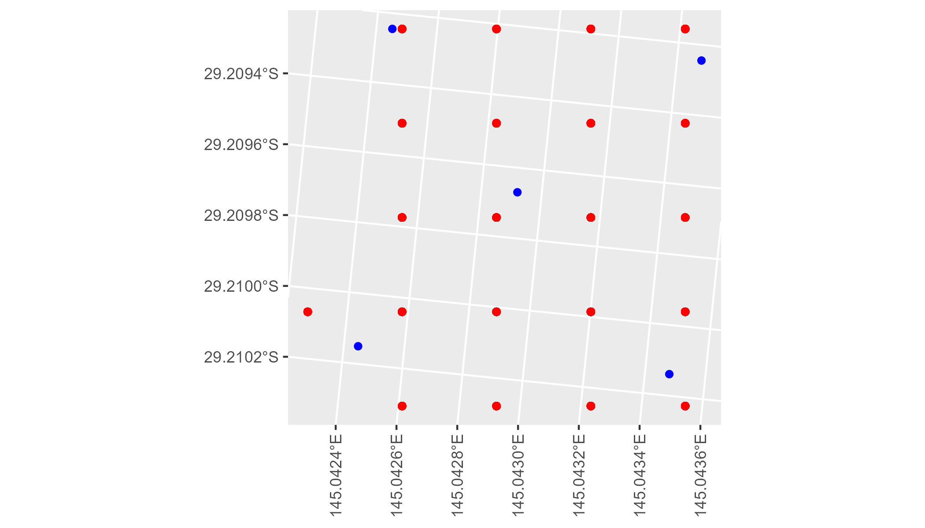

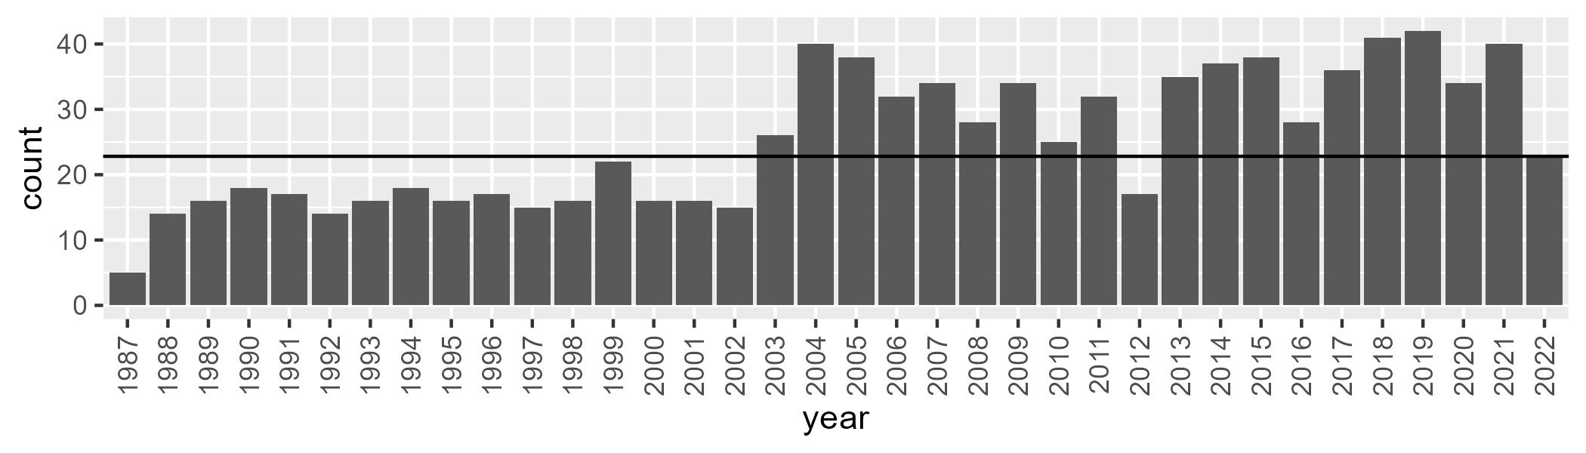

Number of samples: 911

# NSAMUL0003

| Min. | 1st Qu. | Median | Mean | 3rd Qu. | Max. |
| --- | --- | --- | --- | --- | --- |
| 5.75776 | 17.94276 | 22.40447 | 23.44947 | 28.12332 | 48.01953 |

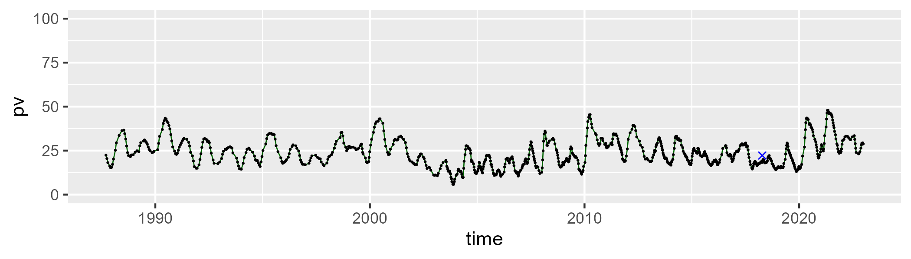

| Min. | 1st Qu. | Median | Mean | 3rd Qu. | Max. |
| --- | --- | --- | --- | --- | --- |
| 32.9549 | 42.93204 | 46.38498 | 46.13033 | 49.3076 | 61.21211 |

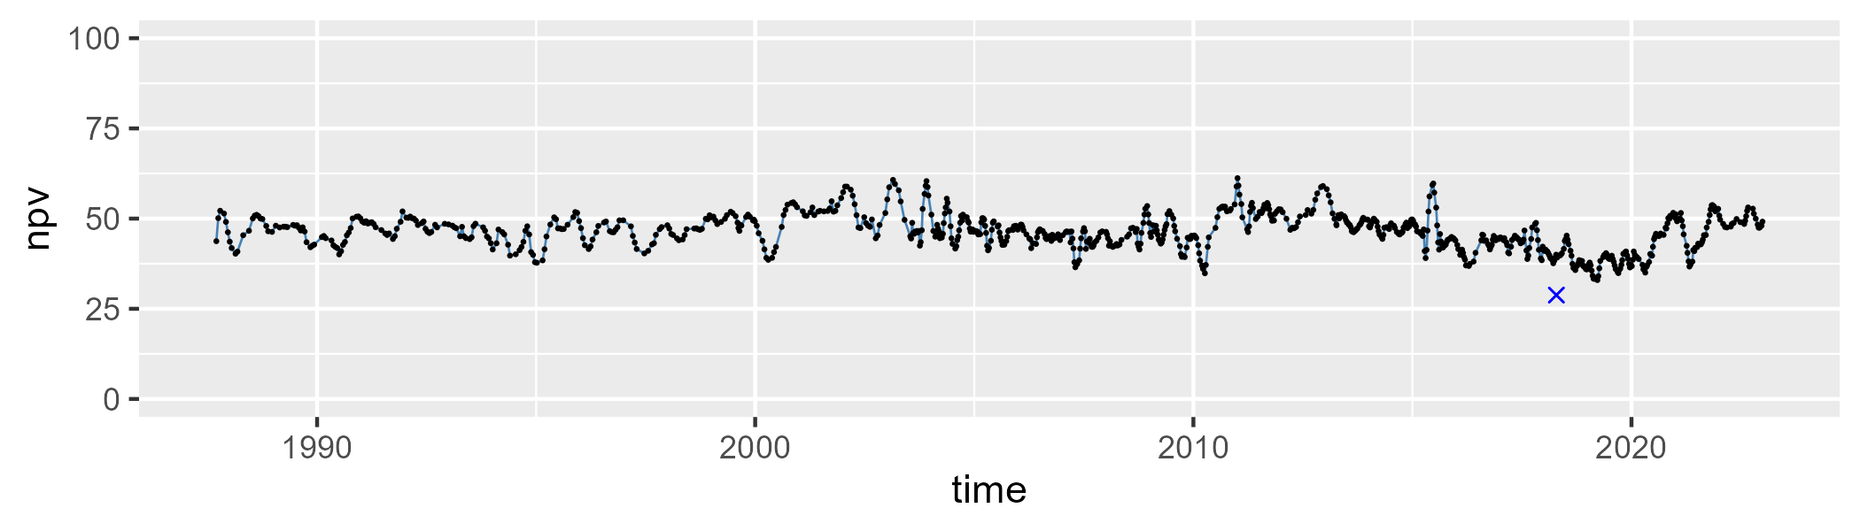

| Min. | 1st Qu. | Median | Mean | 3rd Qu. | Max. |
| --- | --- | --- | --- | --- | --- |
| 9.780058 | 21.62876 | 29.38741 | 29.09891 | 35.9851 | 50.26941 |

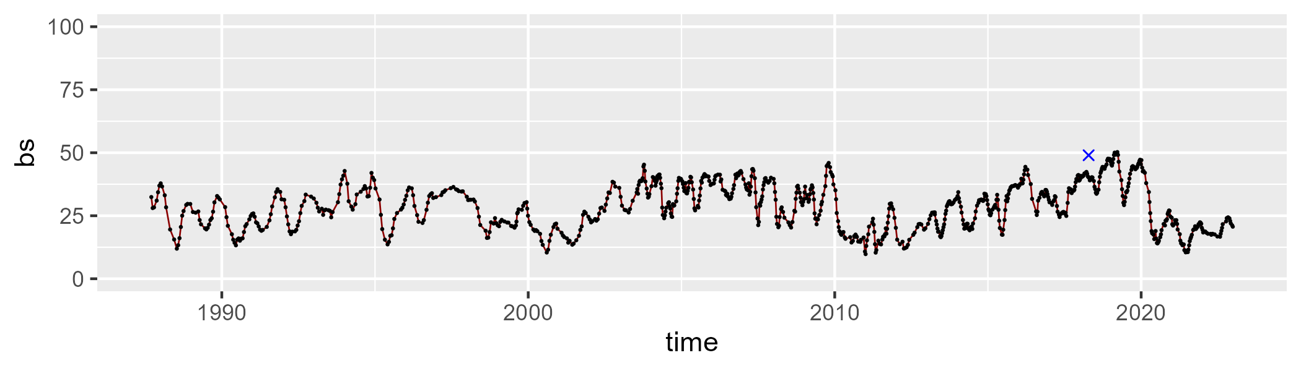

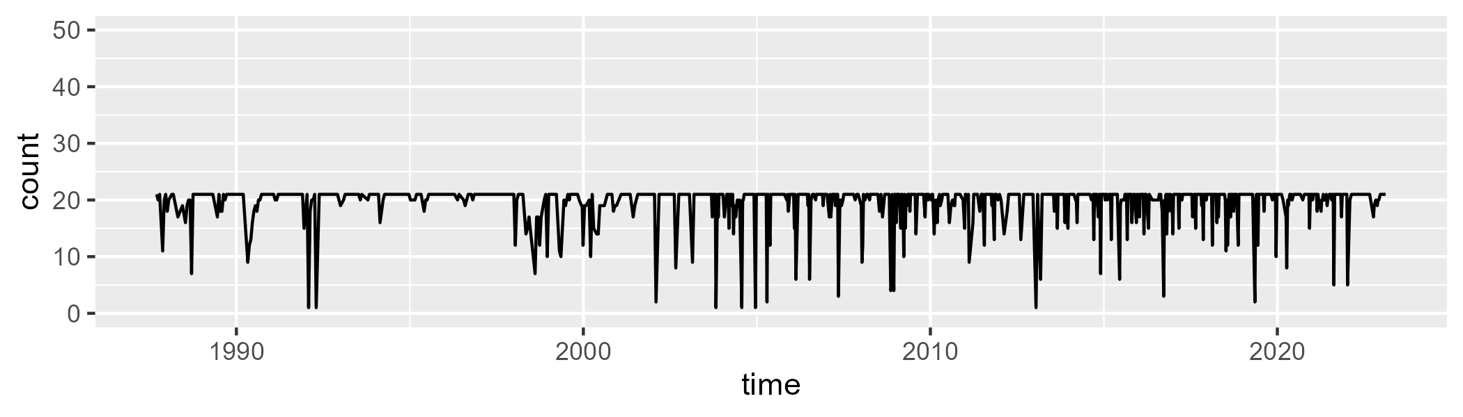

Min. : 1.00 1st Qu.:20.00 Median :21.00 Mean :19.62 3rd Qu.:21.00 Max. :21.00

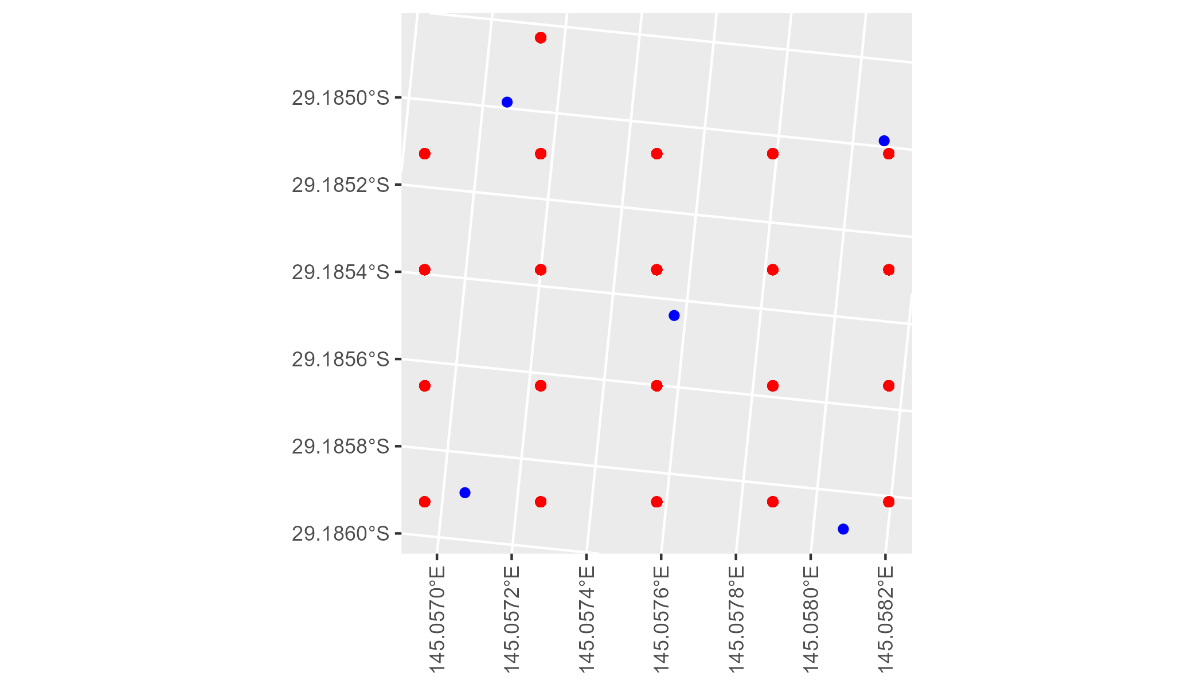

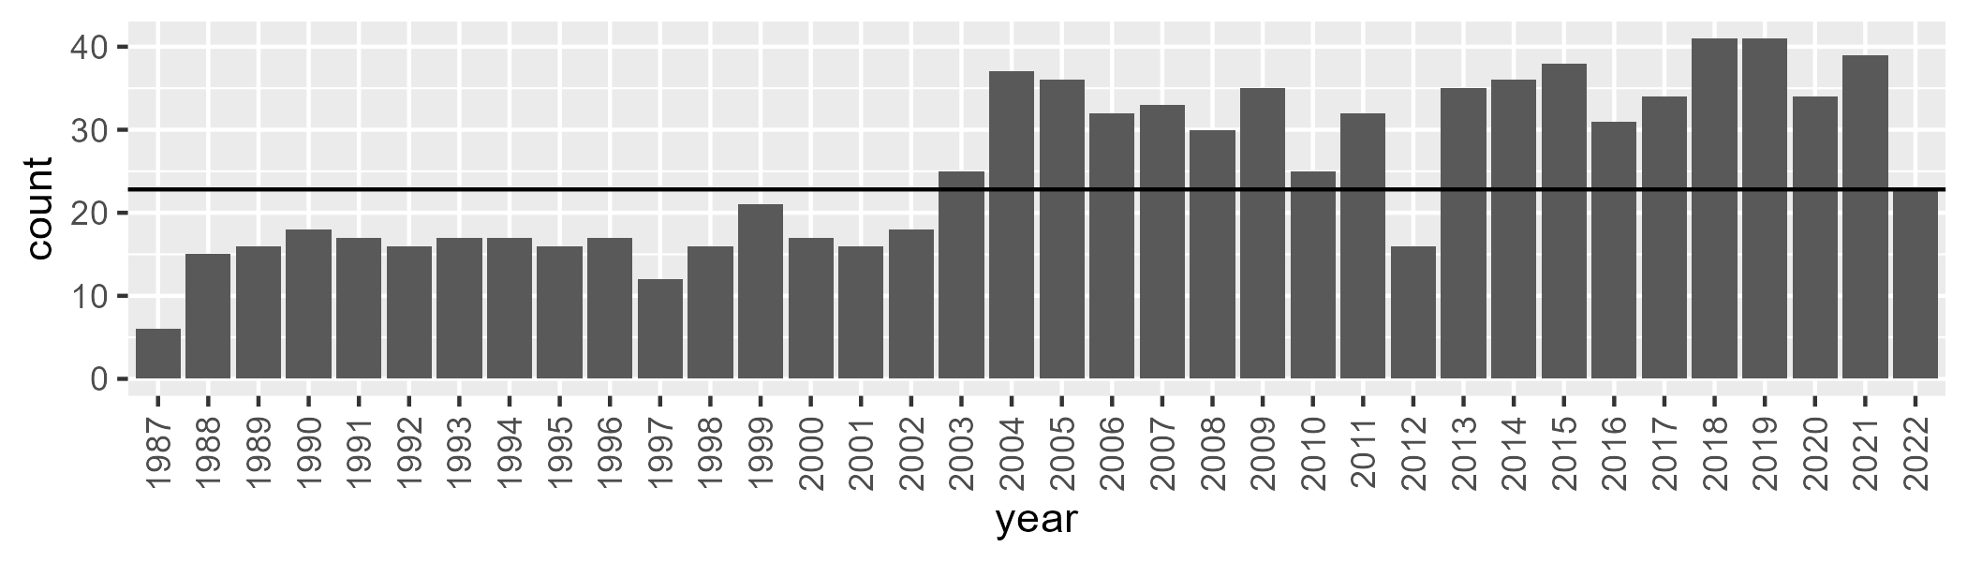

Number of samples: 908

# NSAMUL0004

| Min. | 1st Qu. | Median | Mean | 3rd Qu. | Max. |
| --- | --- | --- | --- | --- | --- |
| 2.300518 | 12.12399 | 18.69194 | 20.77624 | 27.2374 | 52.89308 |

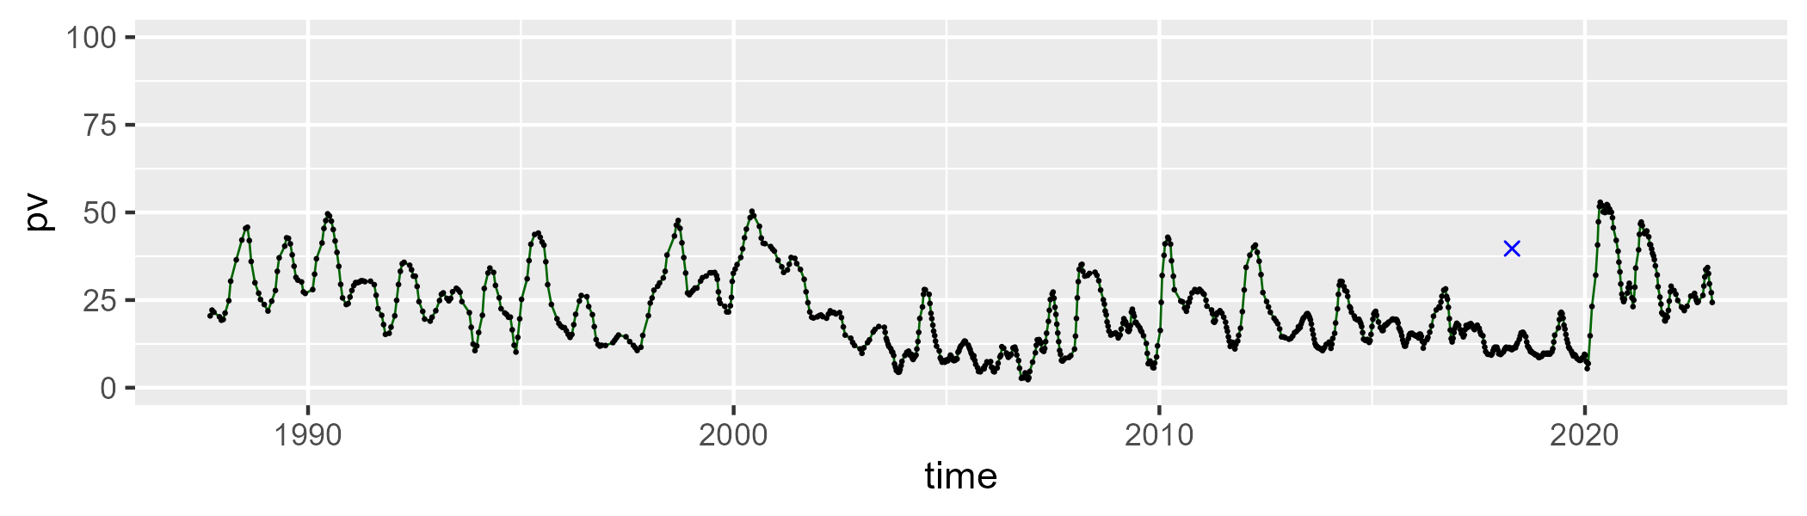

| Min. | 1st Qu. | Median | Mean | 3rd Qu. | Max. |
| --- | --- | --- | --- | --- | --- |
| 35.07859 | 52.6514 | 56.25962 | 56.21285 | 60.42659 | 70.26444 |

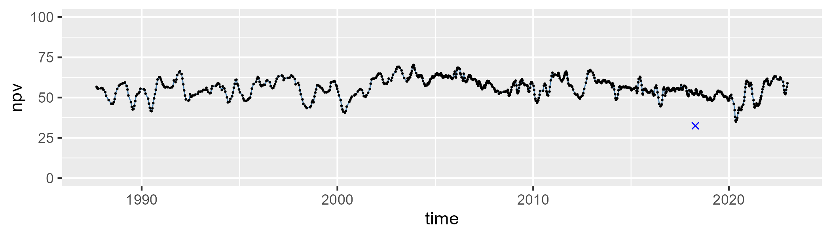

| Min. | 1st Qu. | Median | Mean | 3rd Qu. | Max. |
| --- | --- | --- | --- | --- | --- |
| 2.718497 | 14.70162 | 22.3584 | 21.84743 | 27.62208 | 42.42973 |

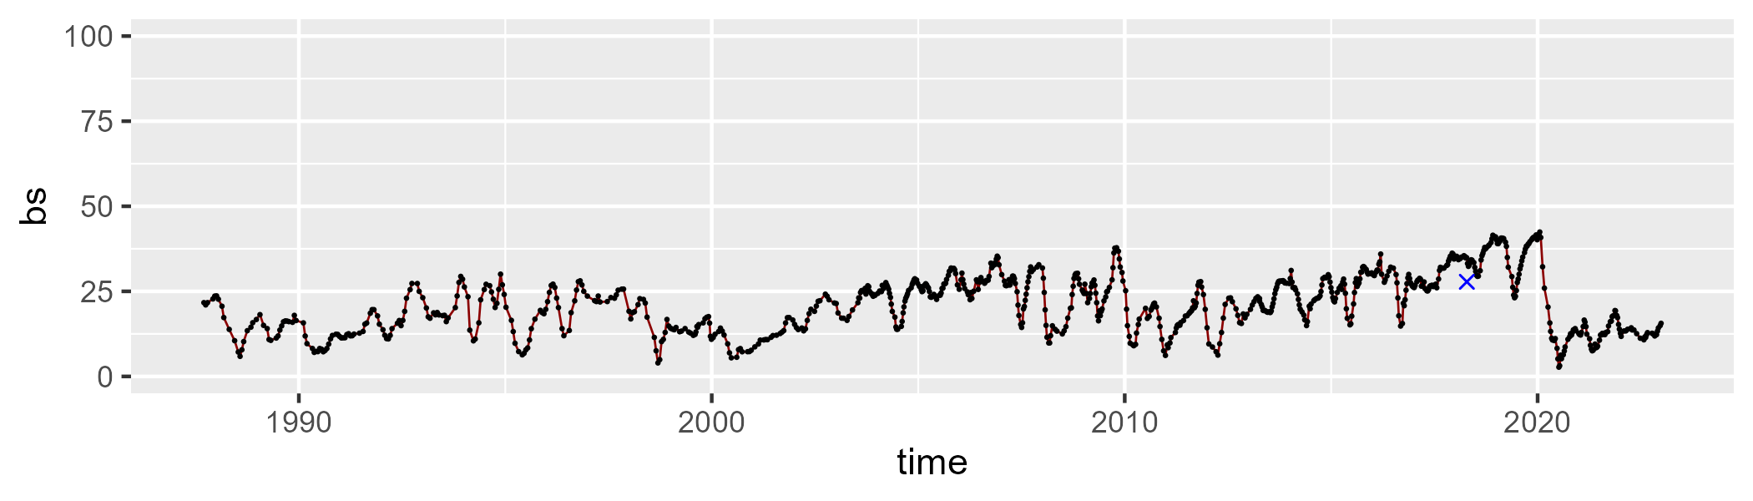

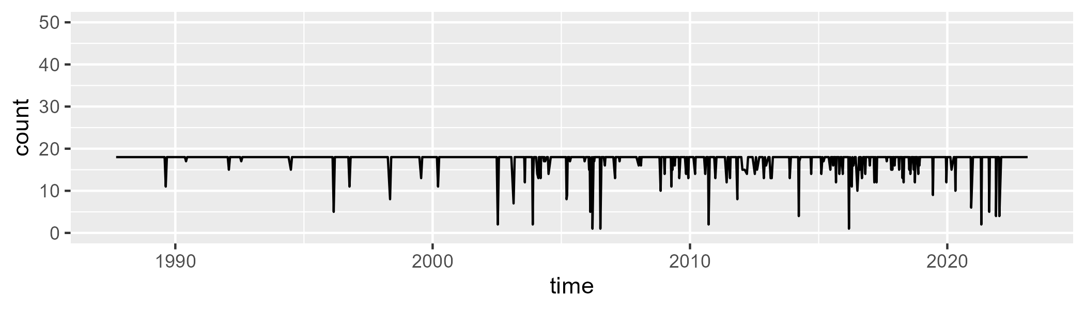

Min. : 1.00 1st Qu.:18.00 Median :18.00 Mean :17.35 3rd Qu.:18.00 Max. :18.00

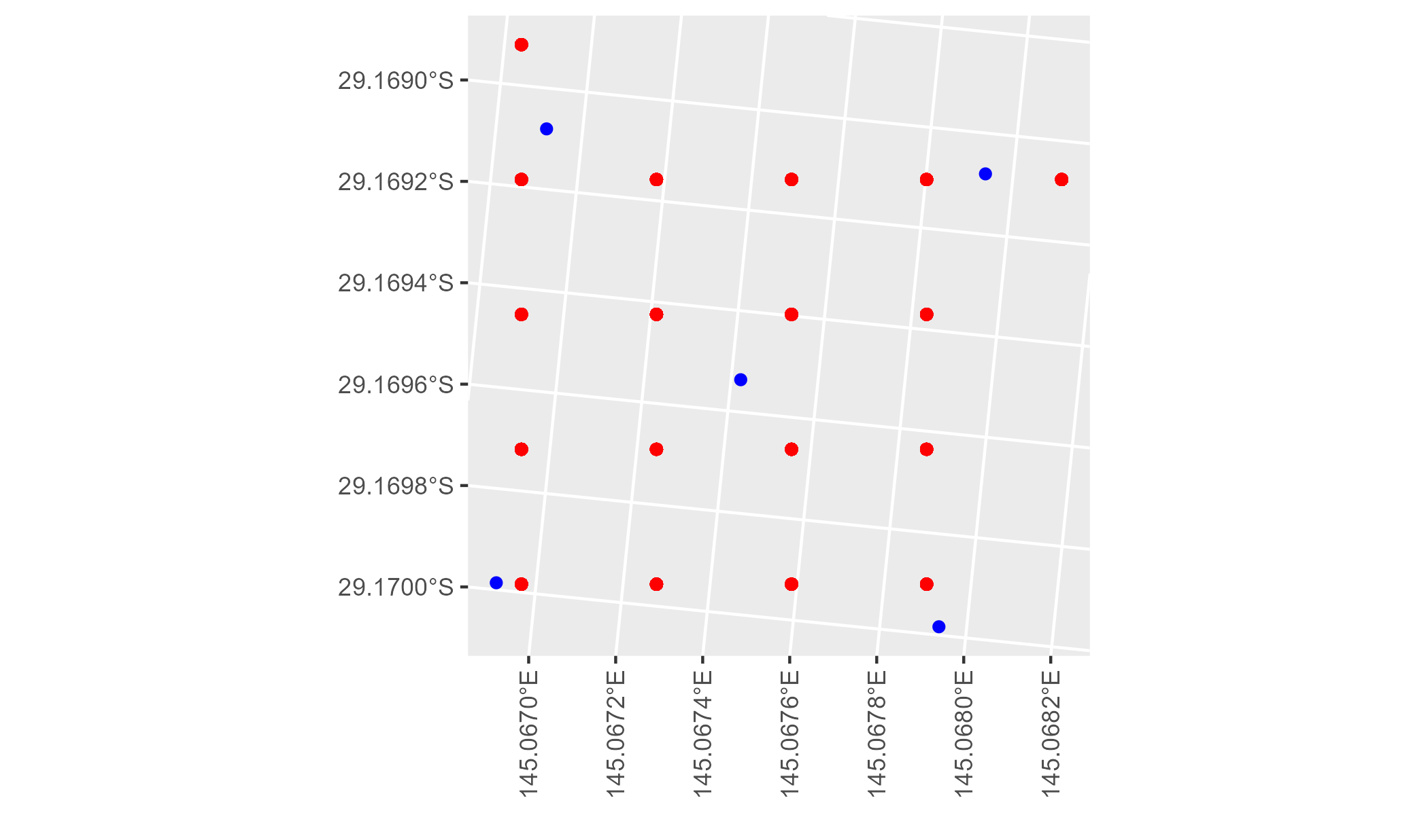

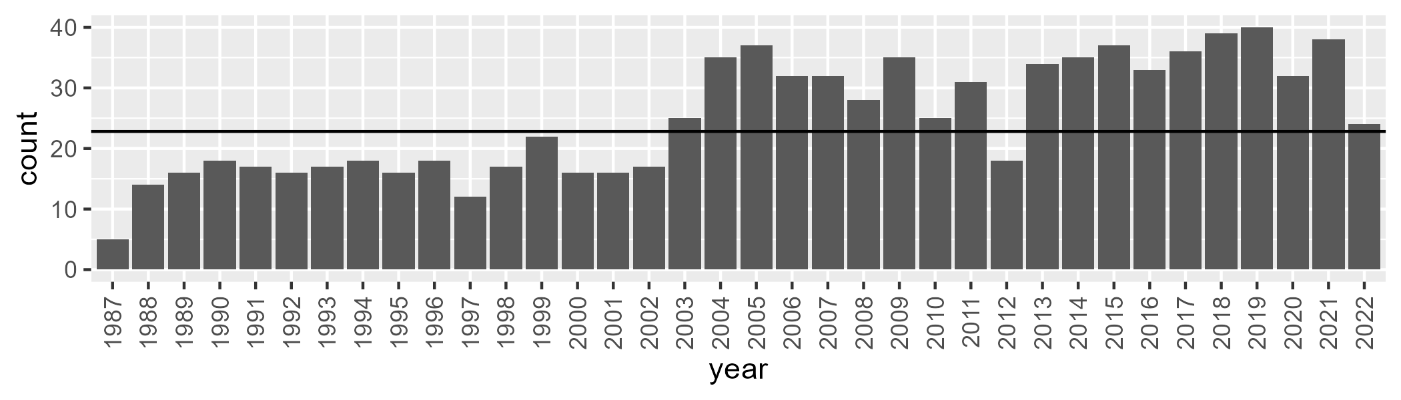

Number of samples: 901

# NSANAN0001

| Min. | 1st Qu. | Median | Mean | 3rd Qu. | Max. |
| --- | --- | --- | --- | --- | --- |
| 29.33246 | 54.18687 | 58.21771 | 57.0893 | 61.33205 | 72.66631 |

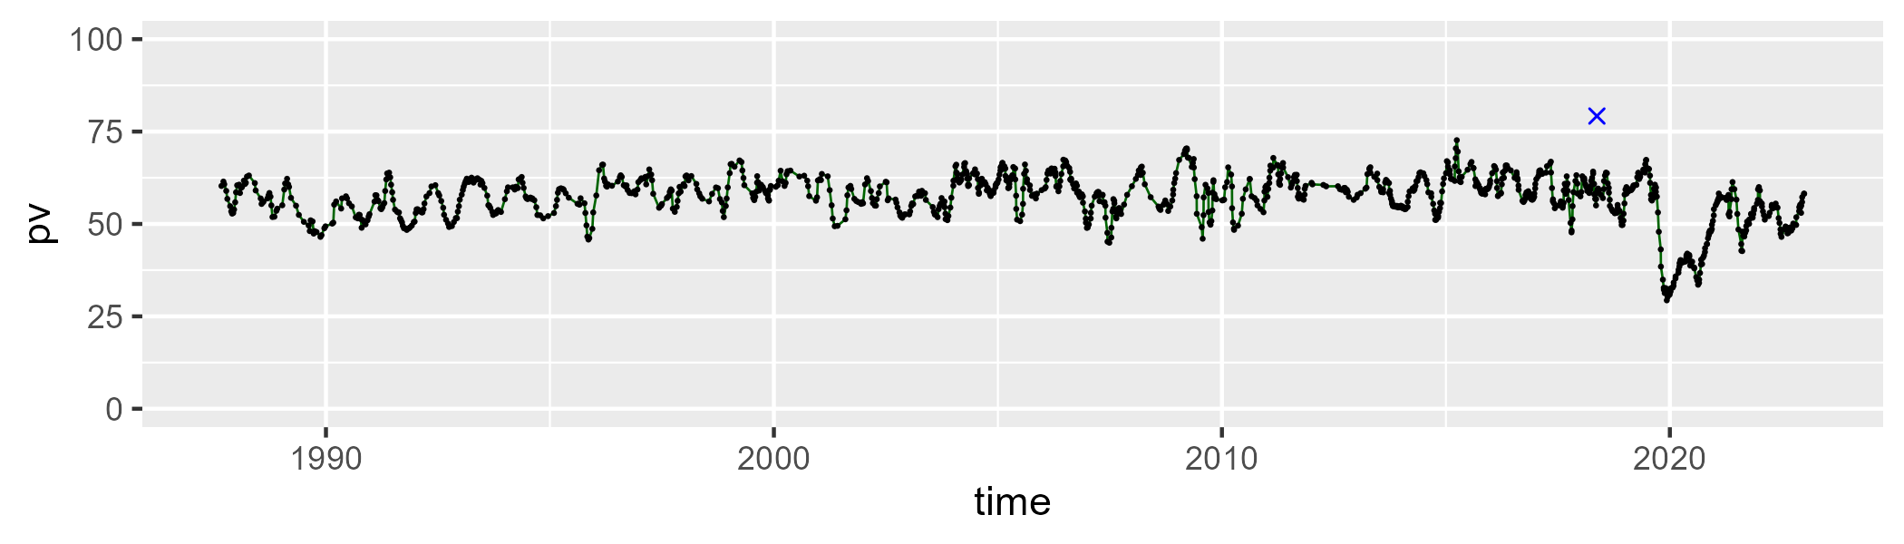

| Min. | 1st Qu. | Median | Mean | 3rd Qu. | Max. |
| --- | --- | --- | --- | --- | --- |
| 17.66674 | 31.54349 | 34.43023 | 34.67948 | 37.53576 | 53.06083 |

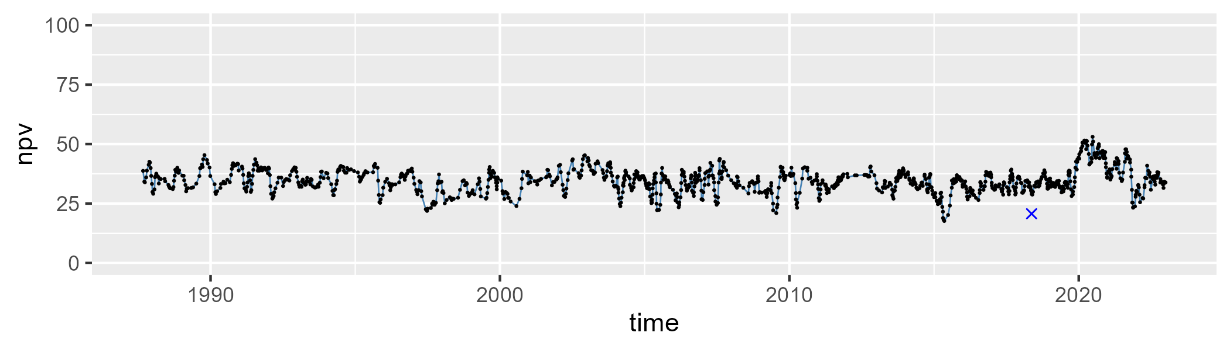

| Min. | 1st Qu. | Median | Mean | 3rd Qu. | Max. |
| --- | --- | --- | --- | --- | --- |
| 0 | 2.628103 | 5.615229 | 6.936883 | 9.776052 | 32.33605 |

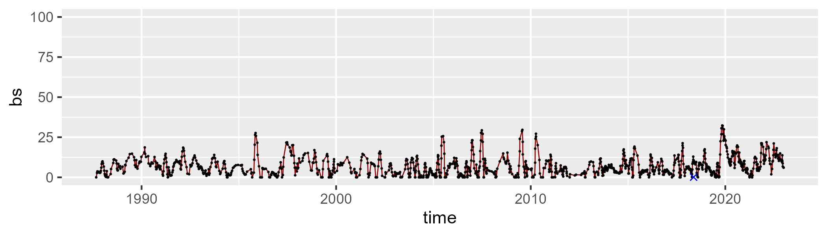

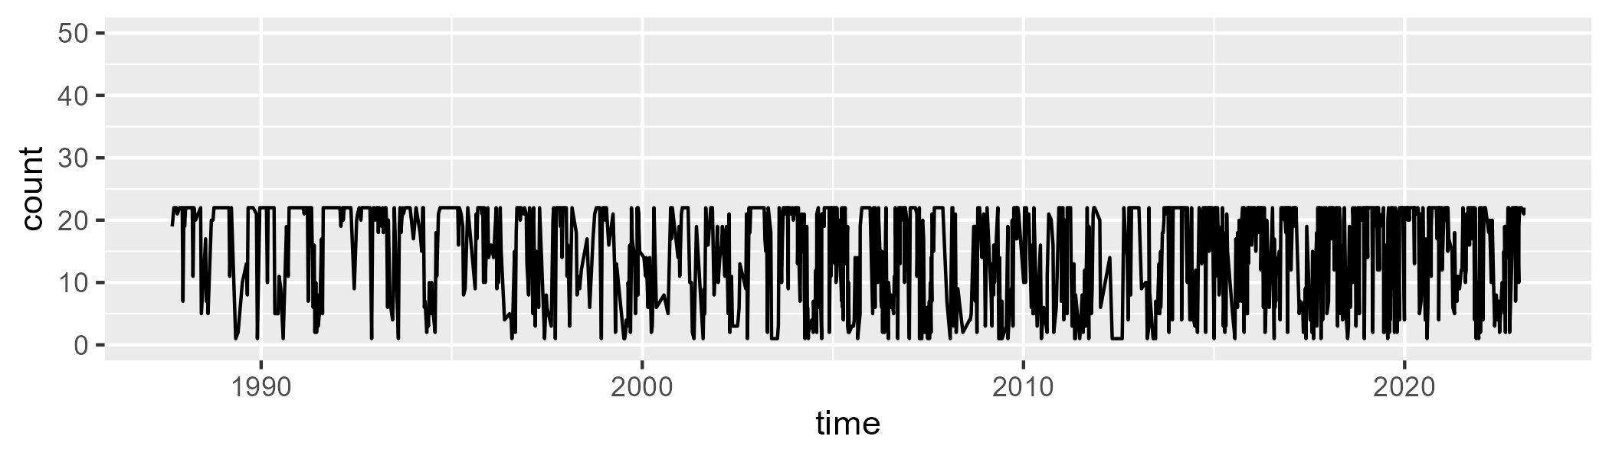

Min. : 1.00 1st Qu.: 8.00 Median :19.00 Mean :15.21 3rd Qu.:22.00 Max. :22.00

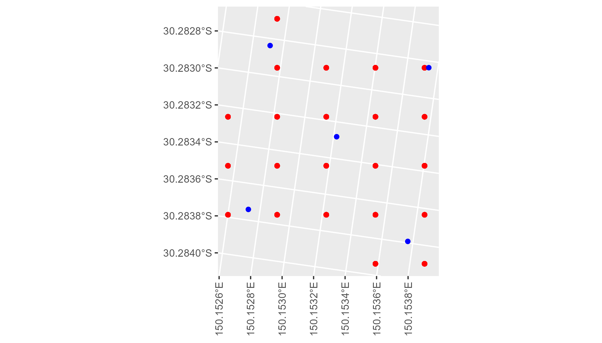

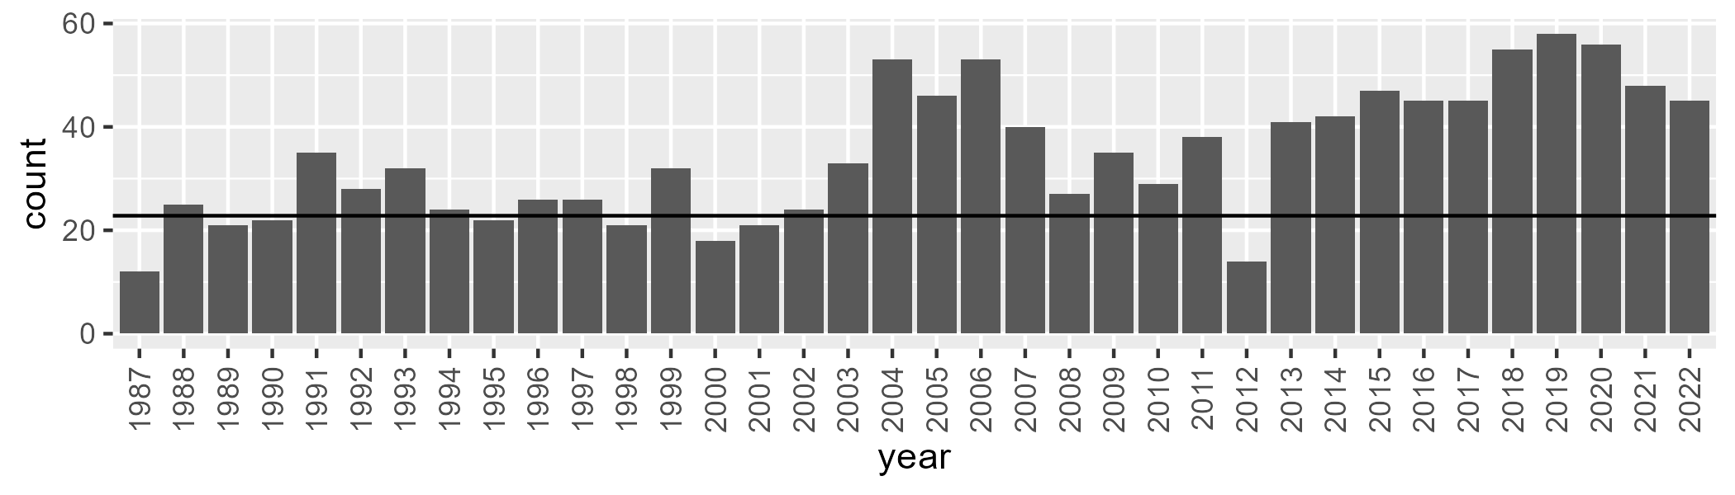

Number of samples: 1239

# NSANAN0002

| Min. | 1st Qu. | Median | Mean | 3rd Qu. | Max. |
| --- | --- | --- | --- | --- | --- |
| 27.62254 | 50.96446 | 55.10737 | 54.63202 | 59.62013 | 68.83012 |

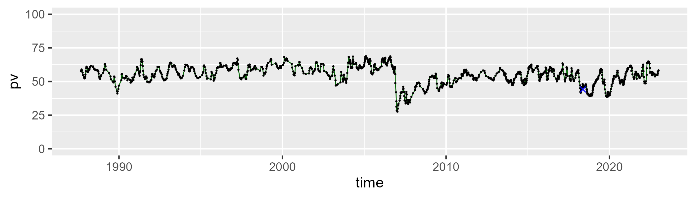

| Min. | 1st Qu. | Median | Mean | 3rd Qu. | Max. |
| --- | --- | --- | --- | --- | --- |
| 16.38789 | 32.68757 | 36.27601 | 36.35939 | 39.93007 | 56.6644 |

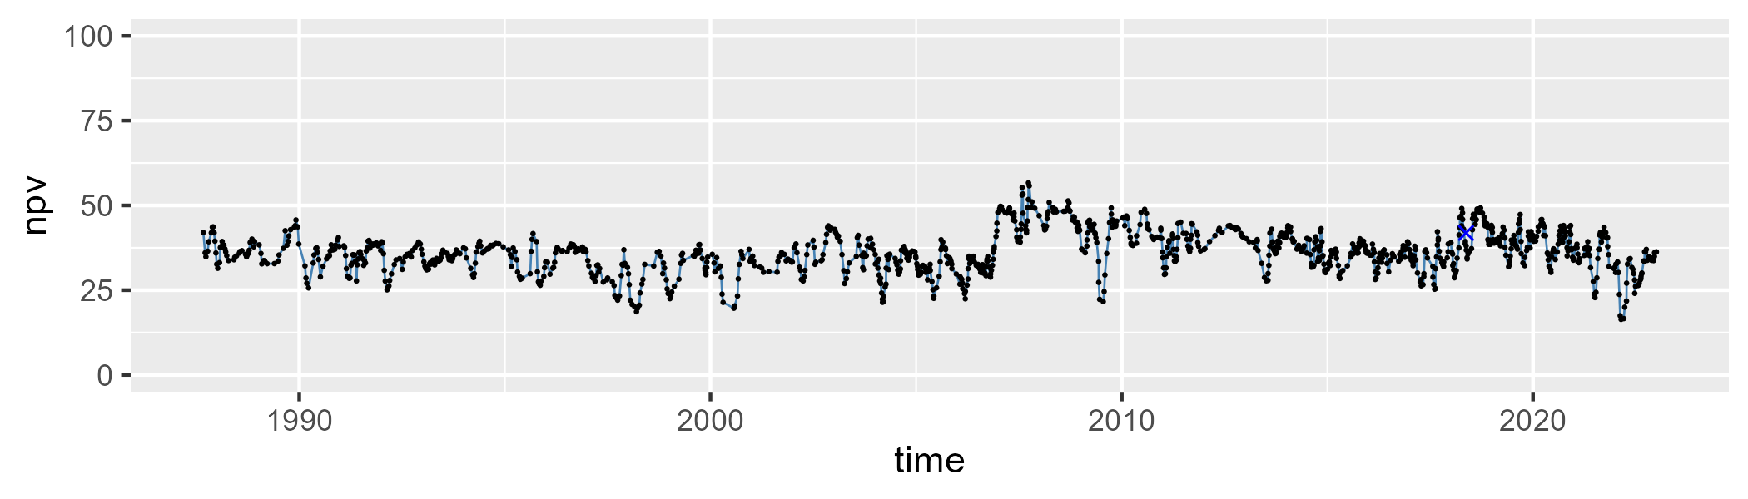

| Min. | 1st Qu. | Median | Mean | 3rd Qu. | Max. |
| --- | --- | --- | --- | --- | --- |
| 0 | 3.144988 | 6.79834 | 7.72173 | 11.02033 | 33.83245 |

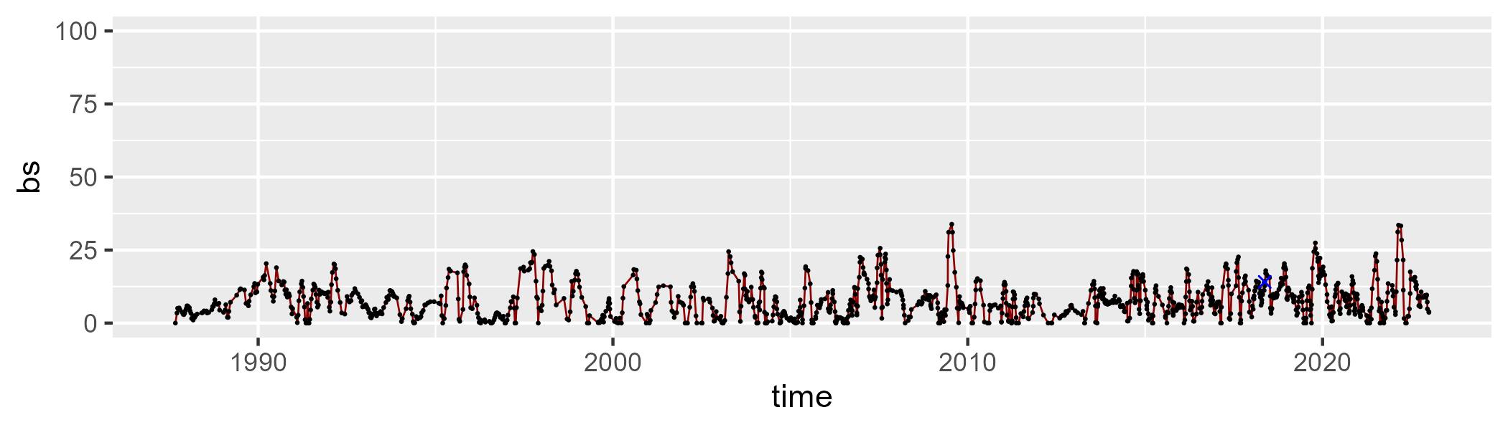

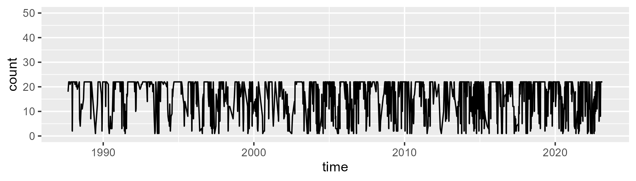

Min. : 1.00 1st Qu.:11.00 Median :21.00 Mean :16.31 3rd Qu.:22.00 Max. :22.00

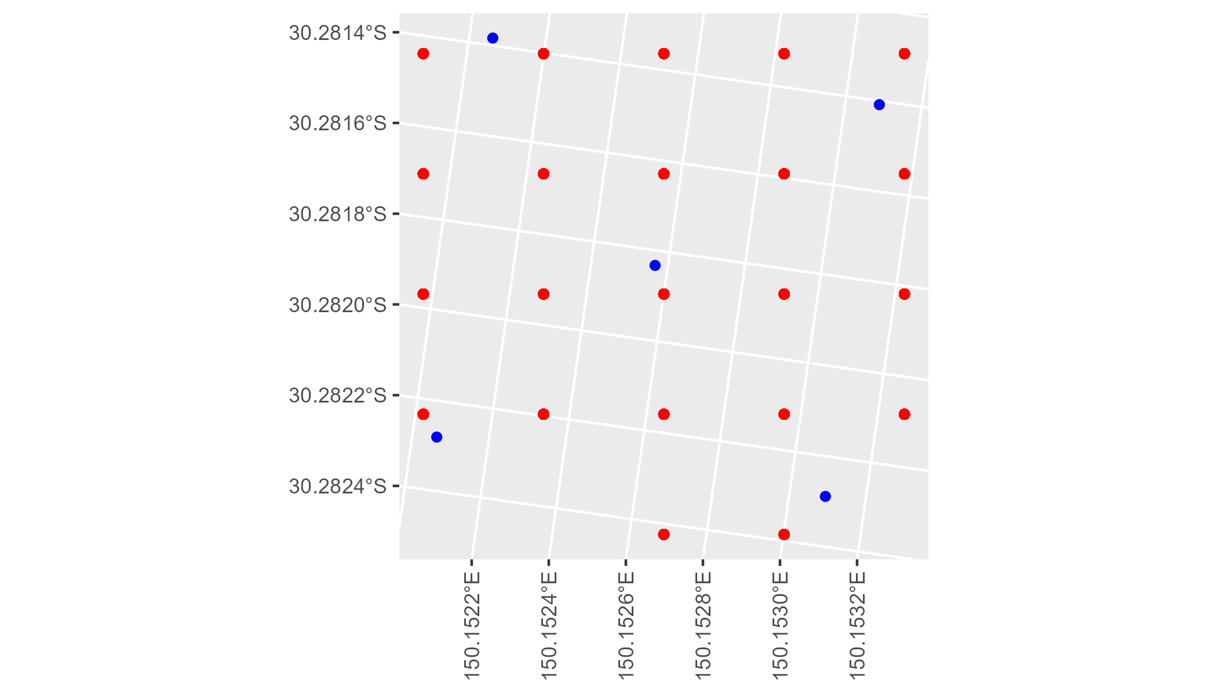

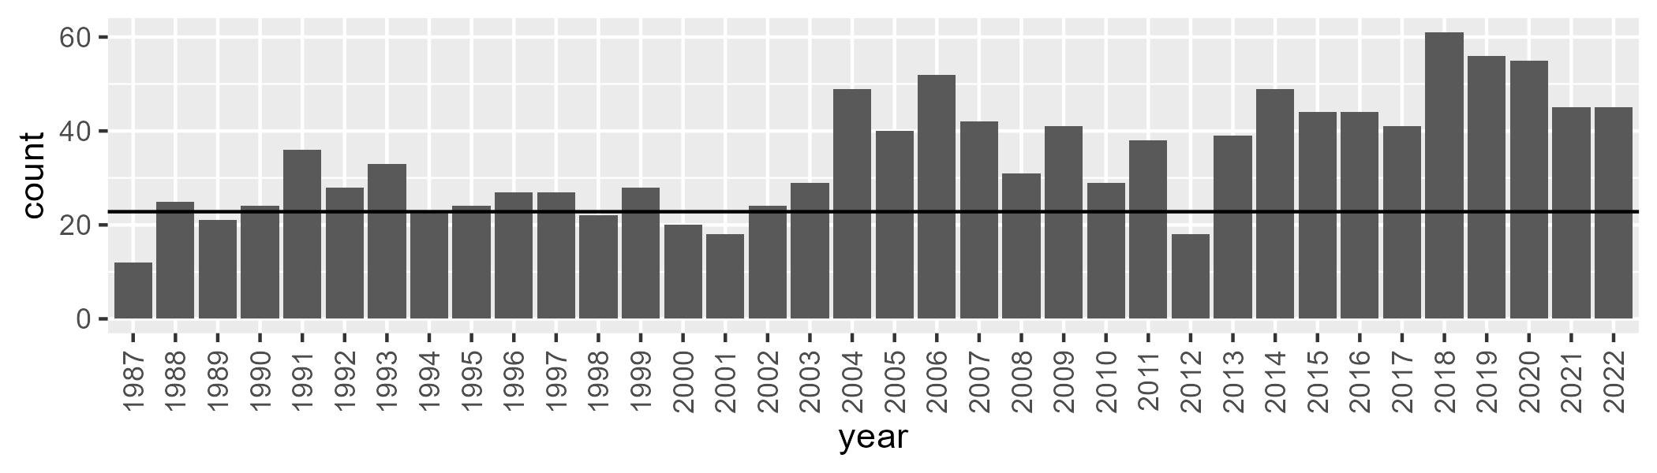

Number of samples: 1240

# NSANET0001

| Min. | 1st Qu. | Median | Mean | 3rd Qu. | Max. |
| --- | --- | --- | --- | --- | --- |
| 0.3136808 | 40.16738 | 43.75779 | 42.75412 | 46.80652 | 53.5005 |

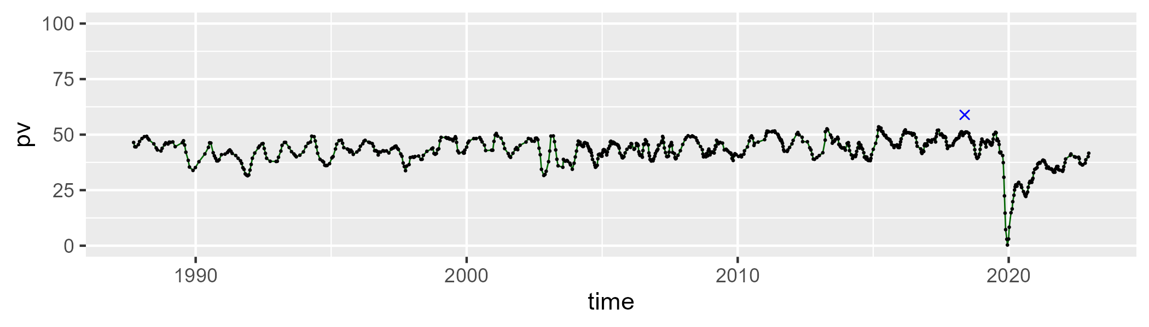

| Min. | 1st Qu. | Median | Mean | 3rd Qu. | Max. |
| --- | --- | --- | --- | --- | --- |
| 24.0687 | 42.45306 | 45.75705 | 45.23153 | 48.30643 | 55.96494 |

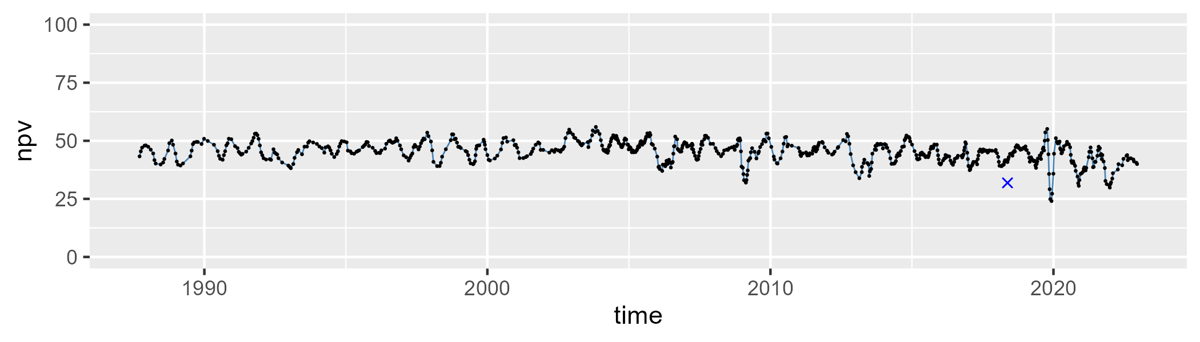

| Min. | 1st Qu. | Median | Mean | 3rd Qu. | Max. |
| --- | --- | --- | --- | --- | --- |
| 0 | 6.001969 | 8.912248 | 10.9256 | 13.32407 | 71.50852 |

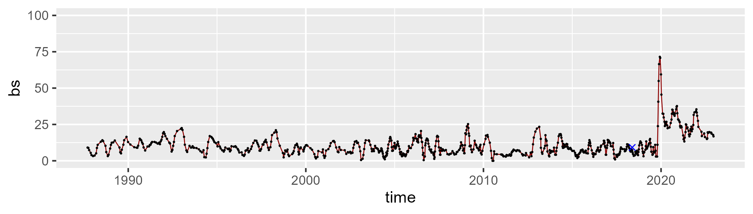

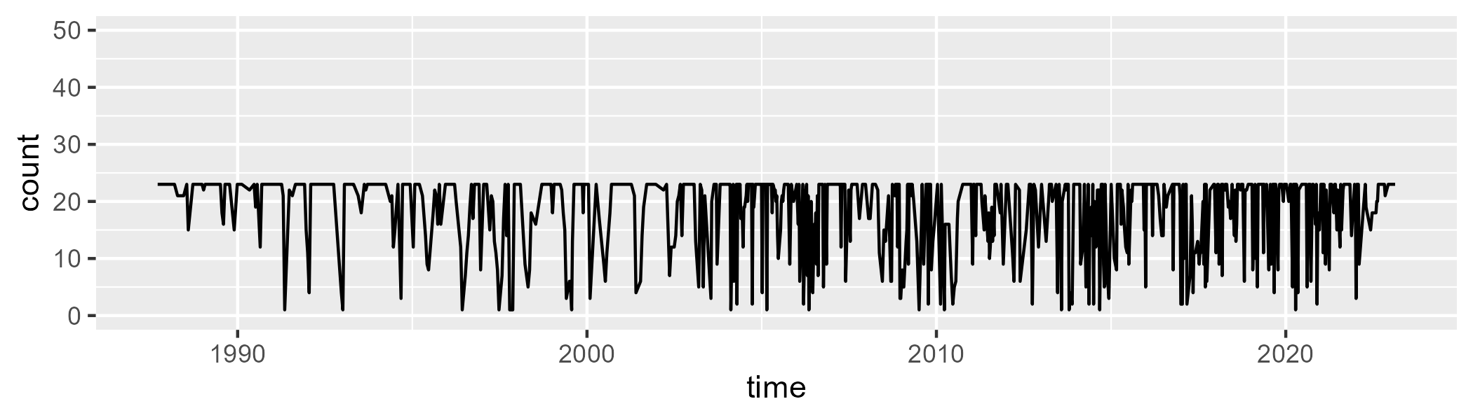

Min. : 1.00 1st Qu.:14.00 Median :23.00 Mean :18.25 3rd Qu.:23.00 Max. :23.00

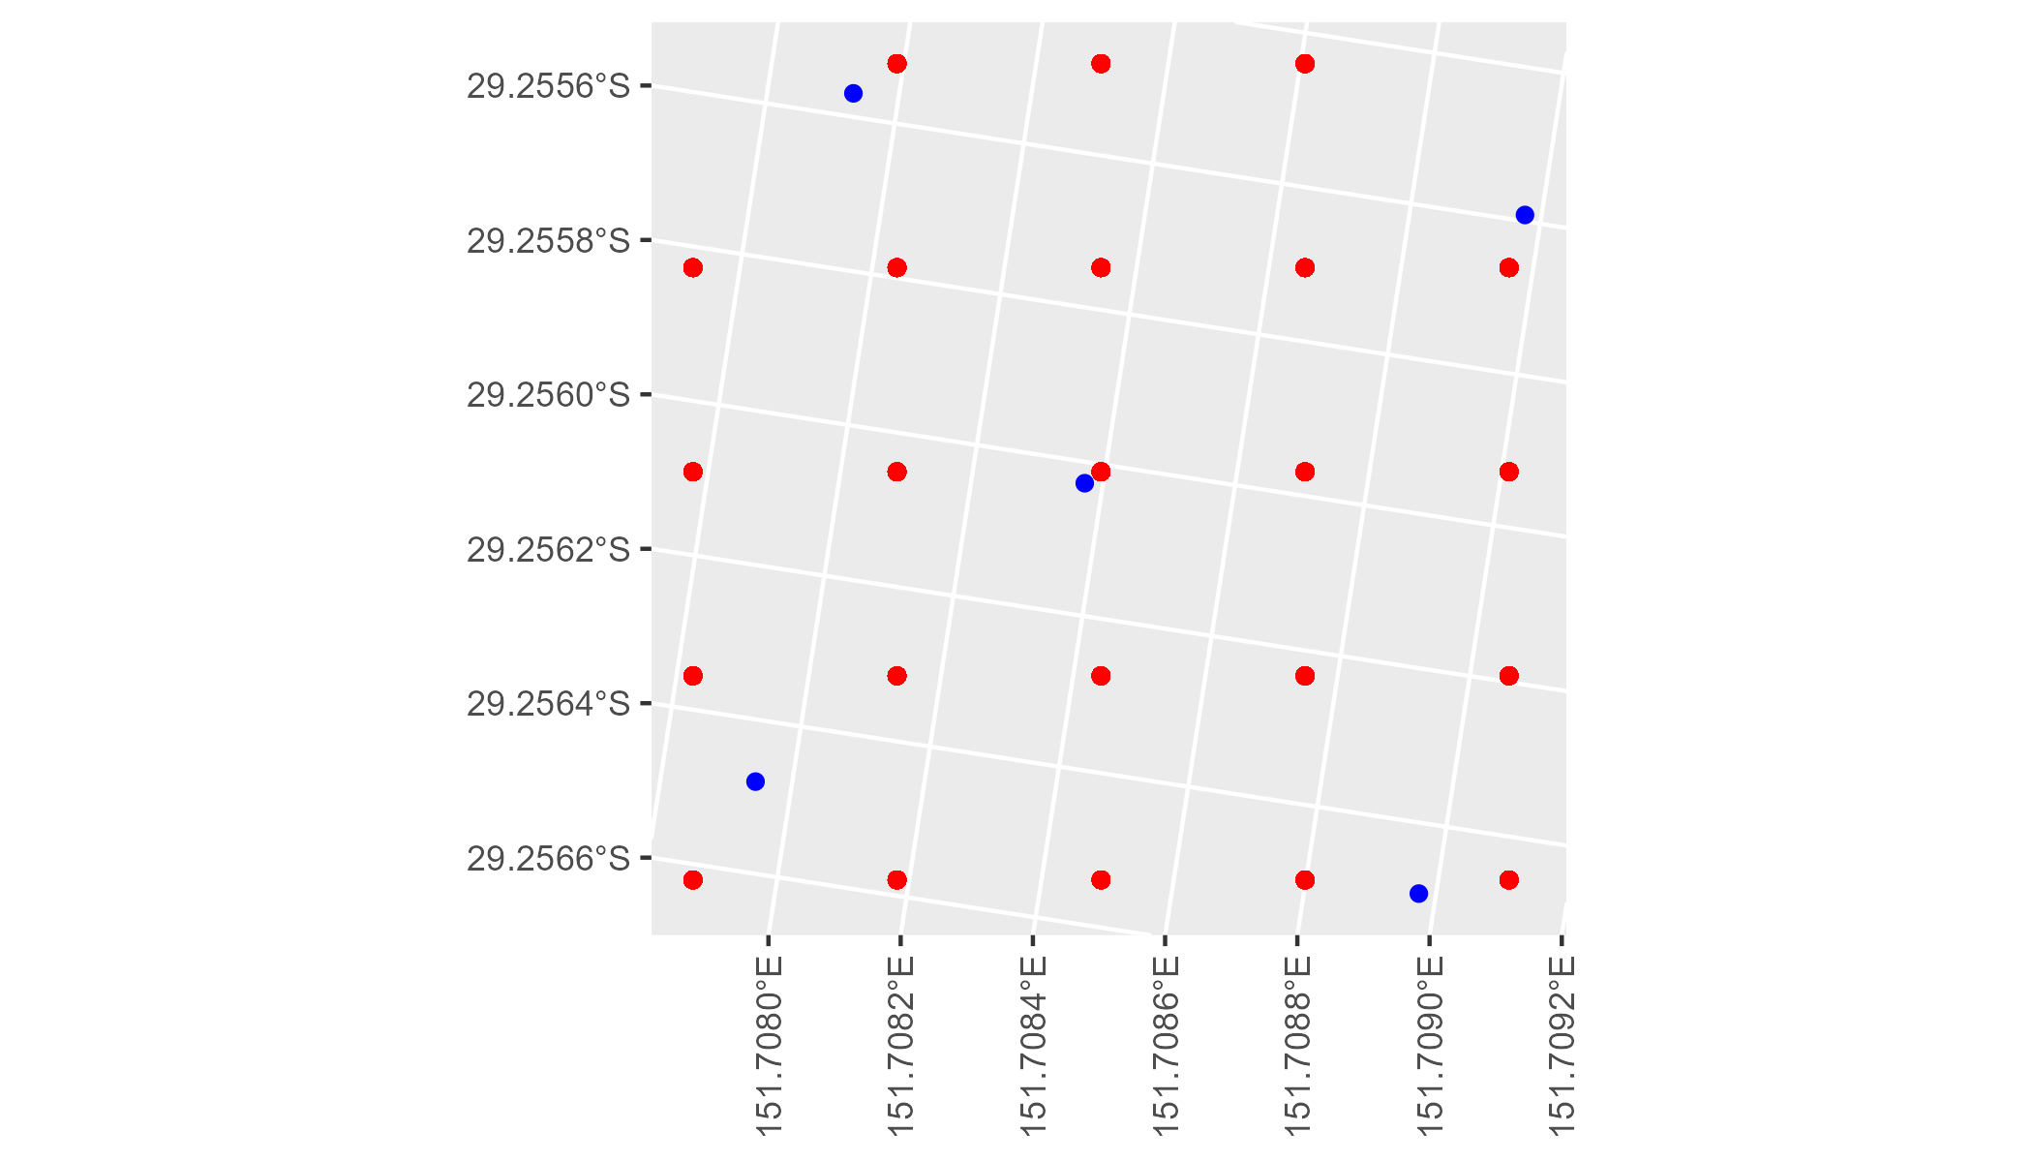

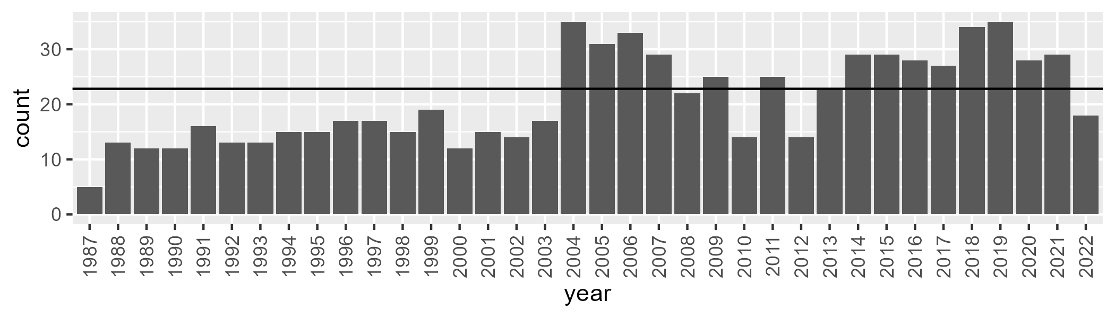

Number of samples: 748

# NSANSS0001

| Min. | 1st Qu. | Median | Mean | 3rd Qu. | Max. |
| --- | --- | --- | --- | --- | --- |
| 33.55405 | 50.41852 | 55.71578 | 55.56809 | 60.29618 | 76.1697 |

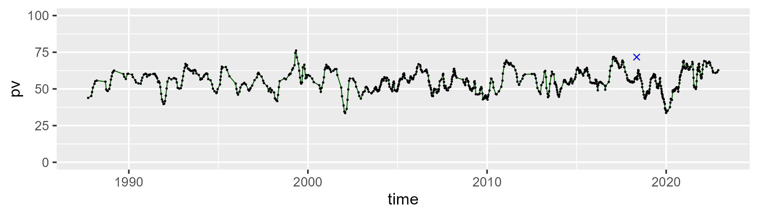

| Min. | 1st Qu. | Median | Mean | 3rd Qu. | Max. |
| --- | --- | --- | --- | --- | --- |
| 22.17321 | 32.5152 | 36.52115 | 36.71015 | 40.56468 | 60.28505 |

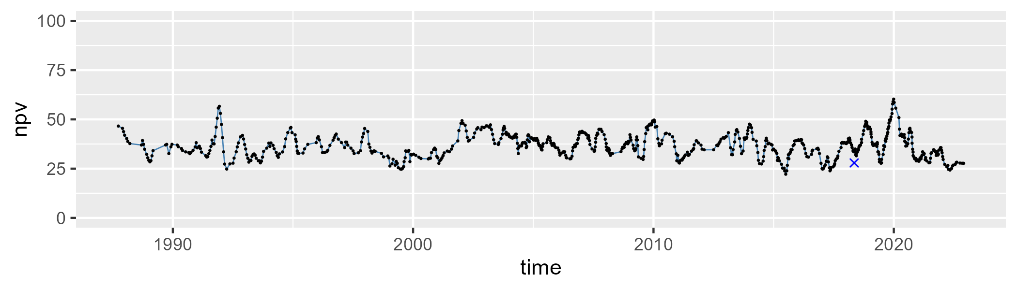

| Min. | 1st Qu. | Median | Mean | 3rd Qu. | Max. |
| --- | --- | --- | --- | --- | --- |
| 0 | 3.597891 | 5.70092 | 6.378412 | 8.347899 | 24.15201 |

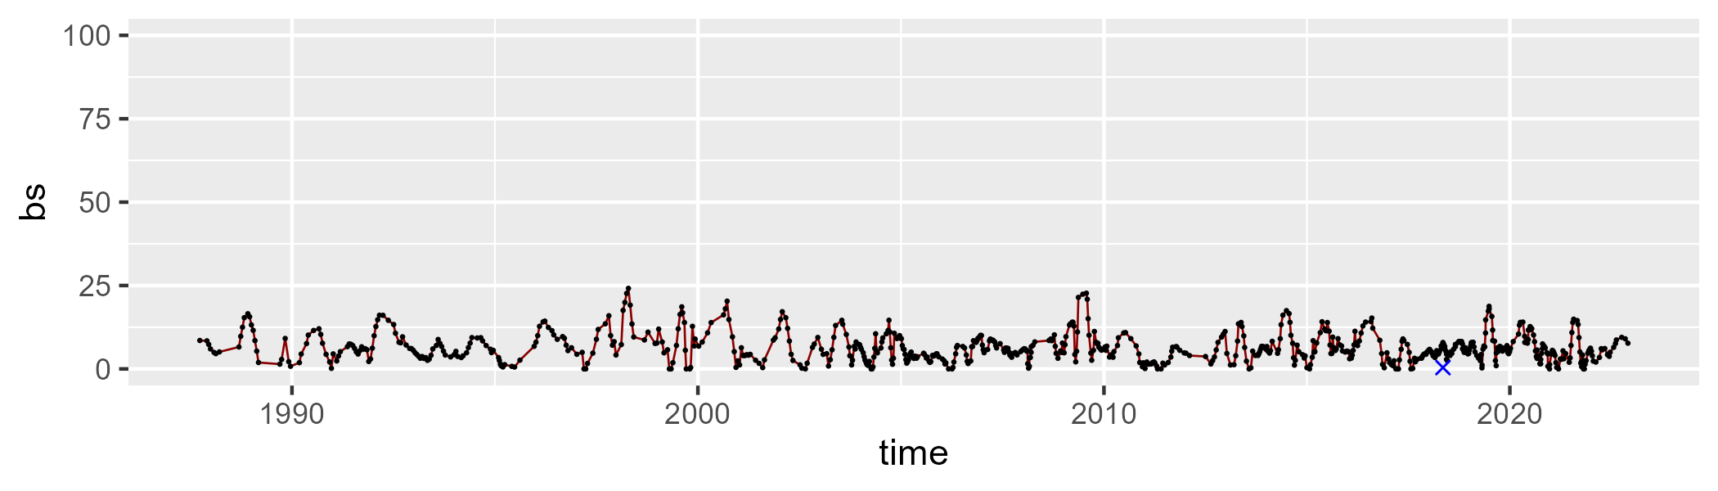

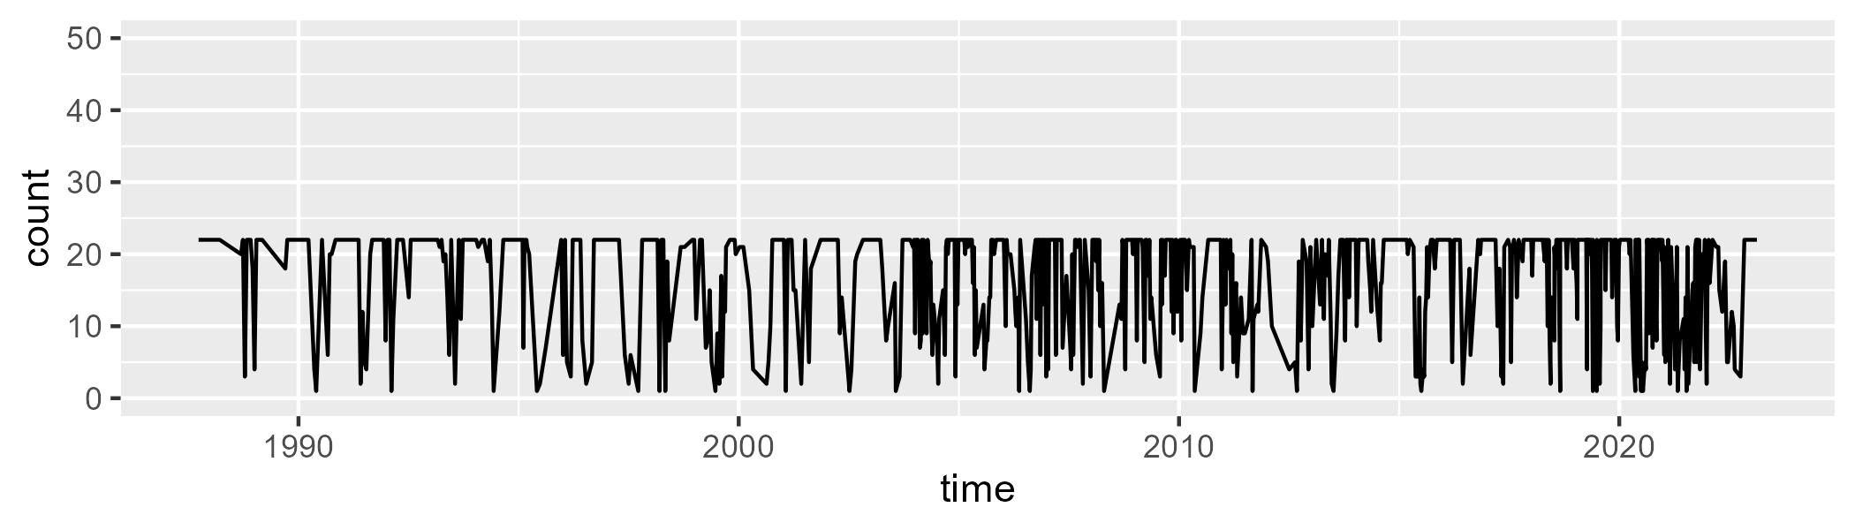

Min. : 1.00 1st Qu.:11.50 Median :22.00 Mean :16.82 3rd Qu.:22.00 Max. :22.00

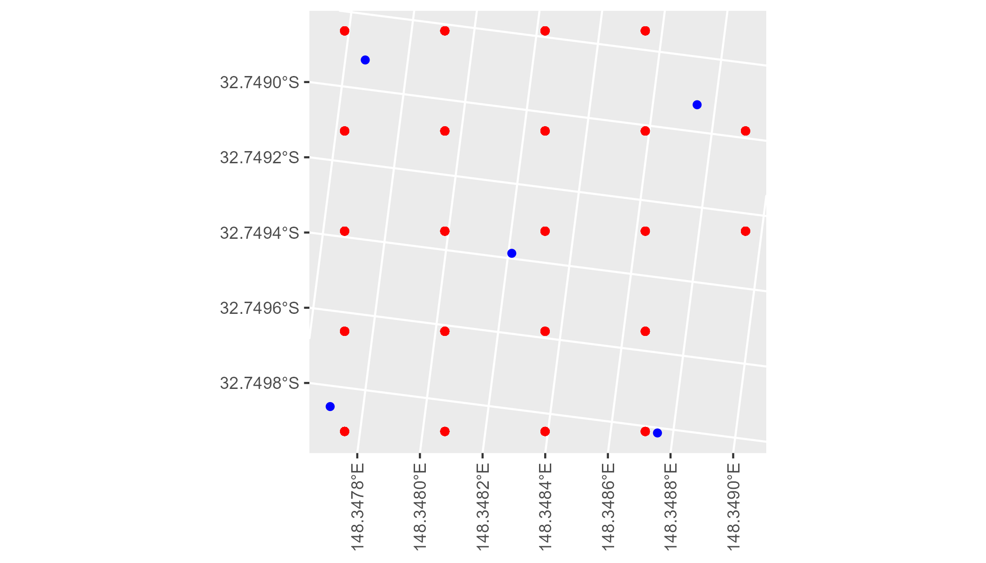

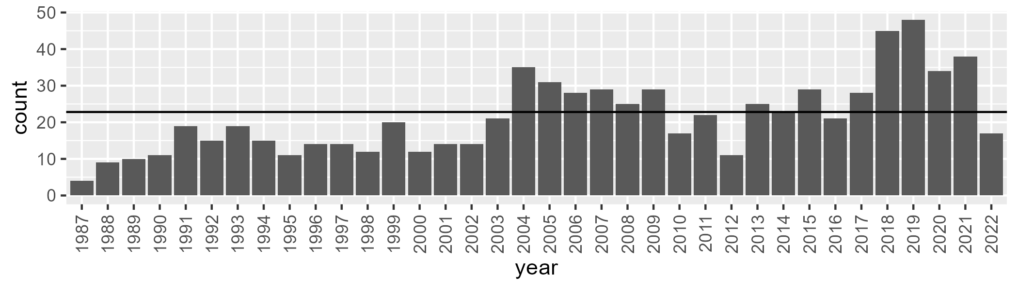

Number of samples: 769

# NSANSS0002

| Min. | 1st Qu. | Median | Mean | 3rd Qu. | Max. |
| --- | --- | --- | --- | --- | --- |
| 29.99996 | 45.47653 | 49.84523 | 49.50272 | 53.86223 | 63.49407 |

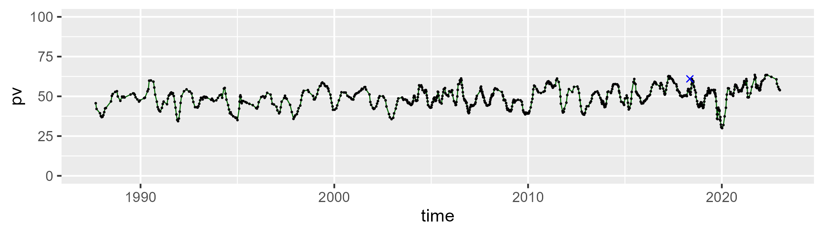

| Min. | 1st Qu. | Median | Mean | 3rd Qu. | Max. |
| --- | --- | --- | --- | --- | --- |
| 20.37602 | 36.99753 | 41.58747 | 41.27403 | 45.44926 | 57.42498 |

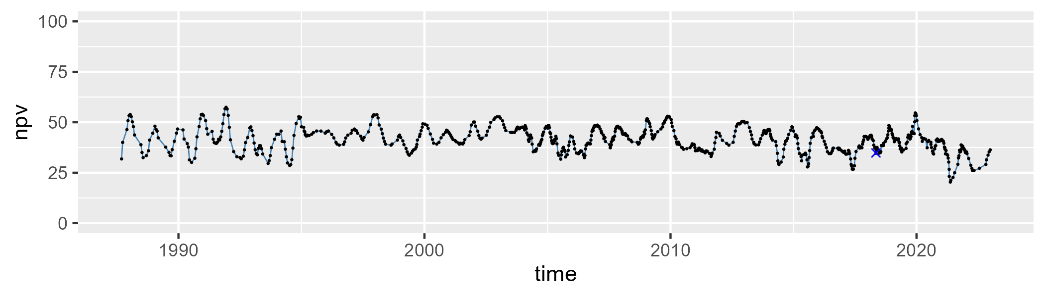

| Min. | 1st Qu. | Median | Mean | 3rd Qu. | Max. |
| --- | --- | --- | --- | --- | --- |
| 0 | 5.299518 | 7.02961 | 7.913172 | 9.525625 | 28.9433 |

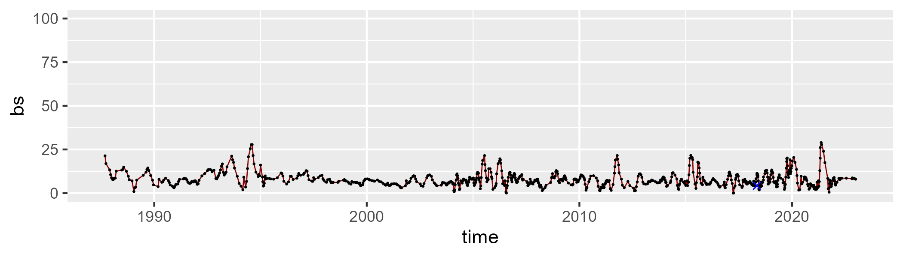

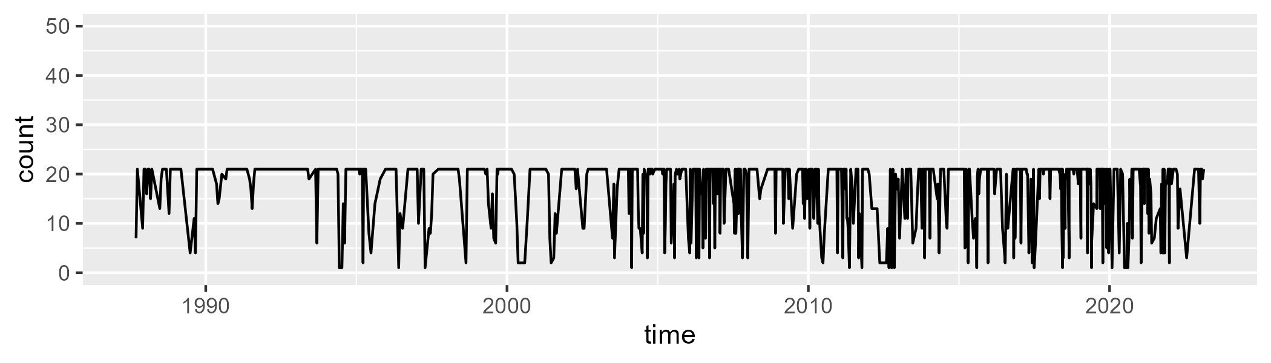

Min. : 1.00 1st Qu.:16.00 Median :21.00 Mean :17.36 3rd Qu.:21.00 Max. :21.00

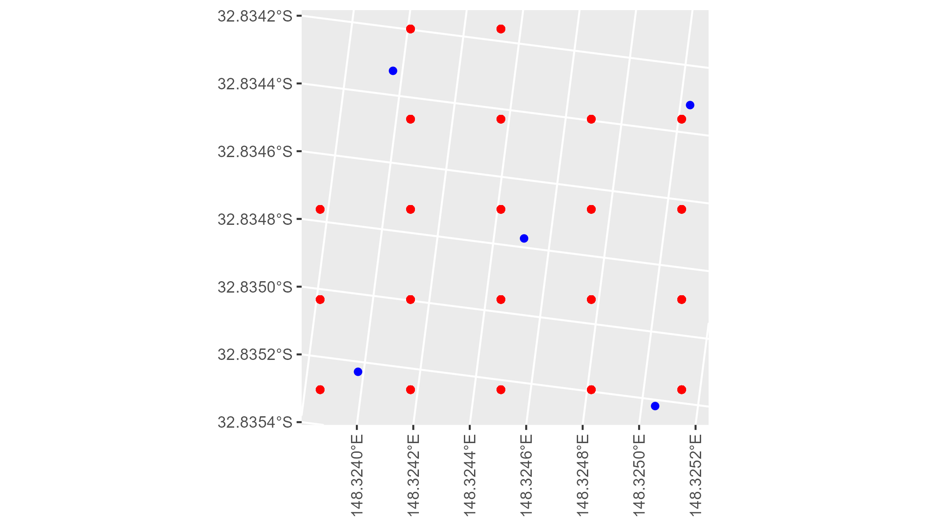

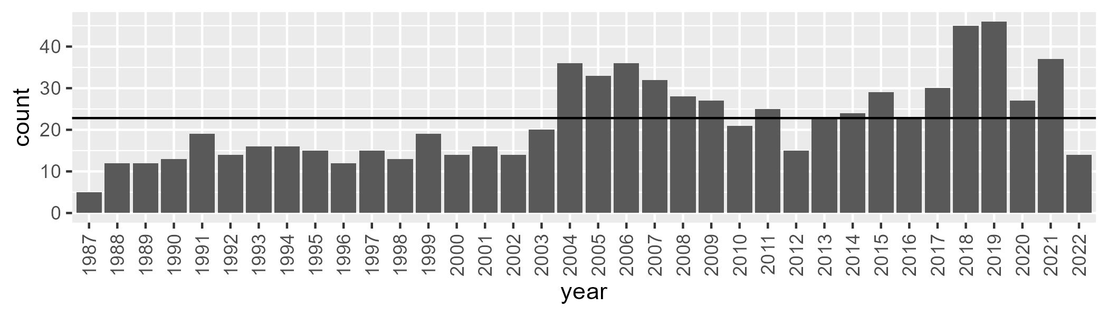

Number of samples: 796

# NSTNSS0001

| Min. | 1st Qu. | Median | Mean | 3rd Qu. | Max. |
| --- | --- | --- | --- | --- | --- |
| 28.15786 | 42.54464 | 46.0266 | 46.15575 | 49.62462 | 61.22984 |

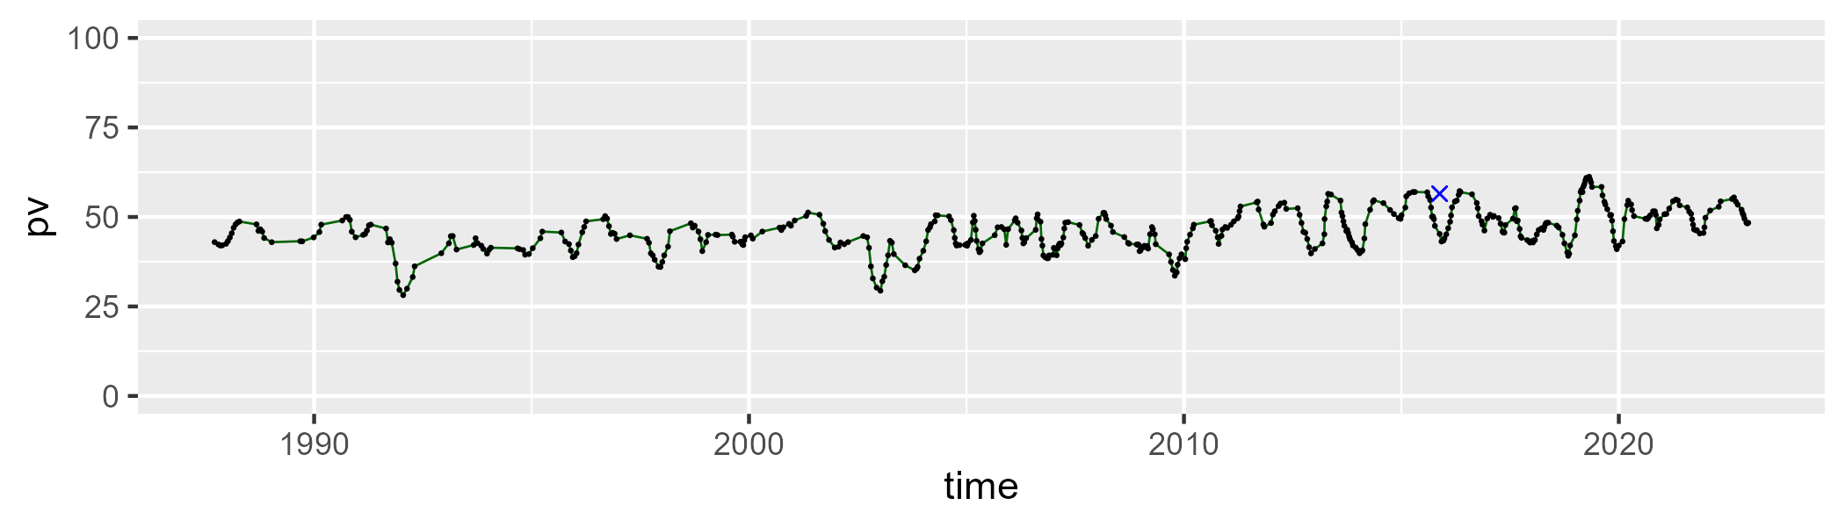

| Min. | 1st Qu. | Median | Mean | 3rd Qu. | Max. |
| --- | --- | --- | --- | --- | --- |
| 25.42623 | 38.79288 | 42.6791 | 42.15871 | 45.54406 | 60.98427 |

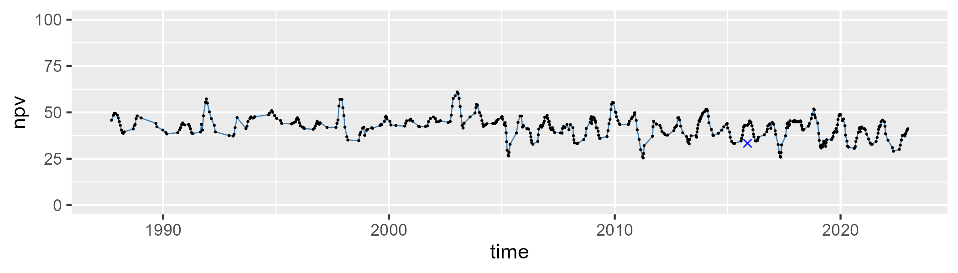

| Min. | 1st Qu. | Median | Mean | 3rd Qu. | Max. |
| --- | --- | --- | --- | --- | --- |
| 1.399528 | 7.275387 | 9.407214 | 10.3245 | 11.95661 | 31.88293 |

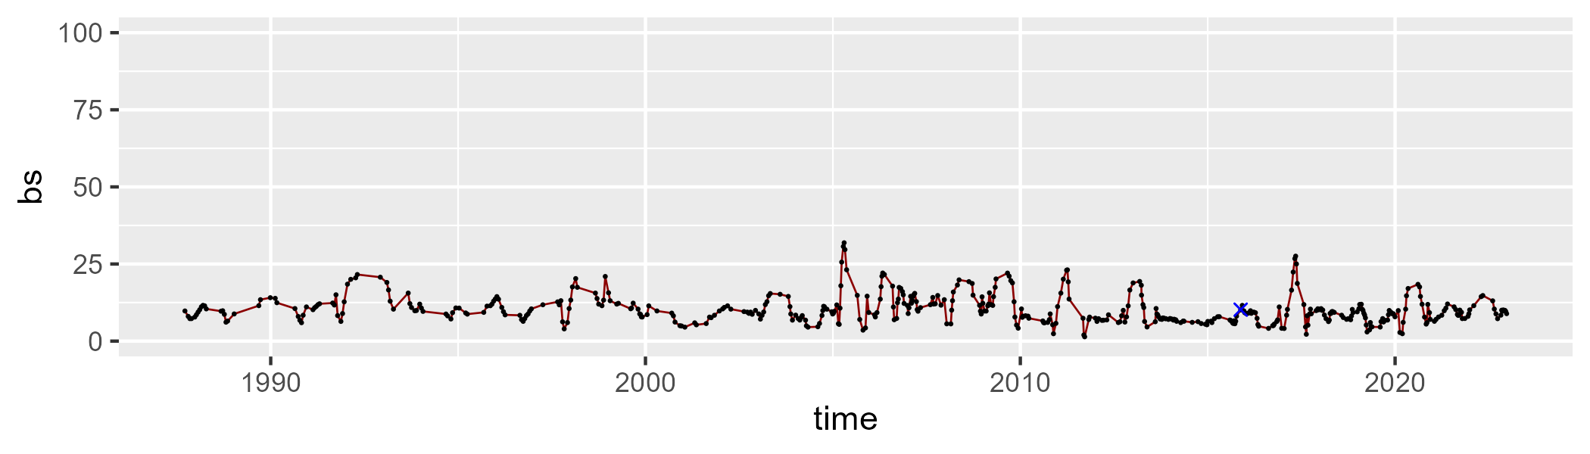

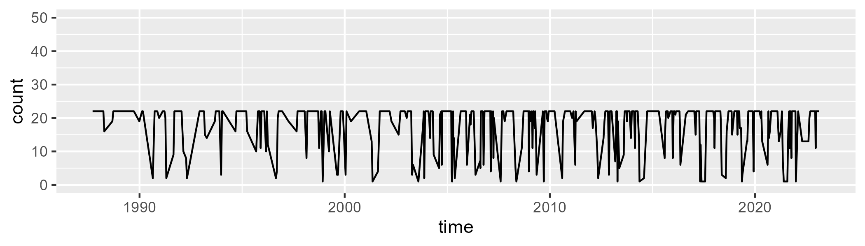

Min. : 1.00 1st Qu.:18.00 Median :22.00 Mean :18.38 3rd Qu.:22.00 Max. :22.00

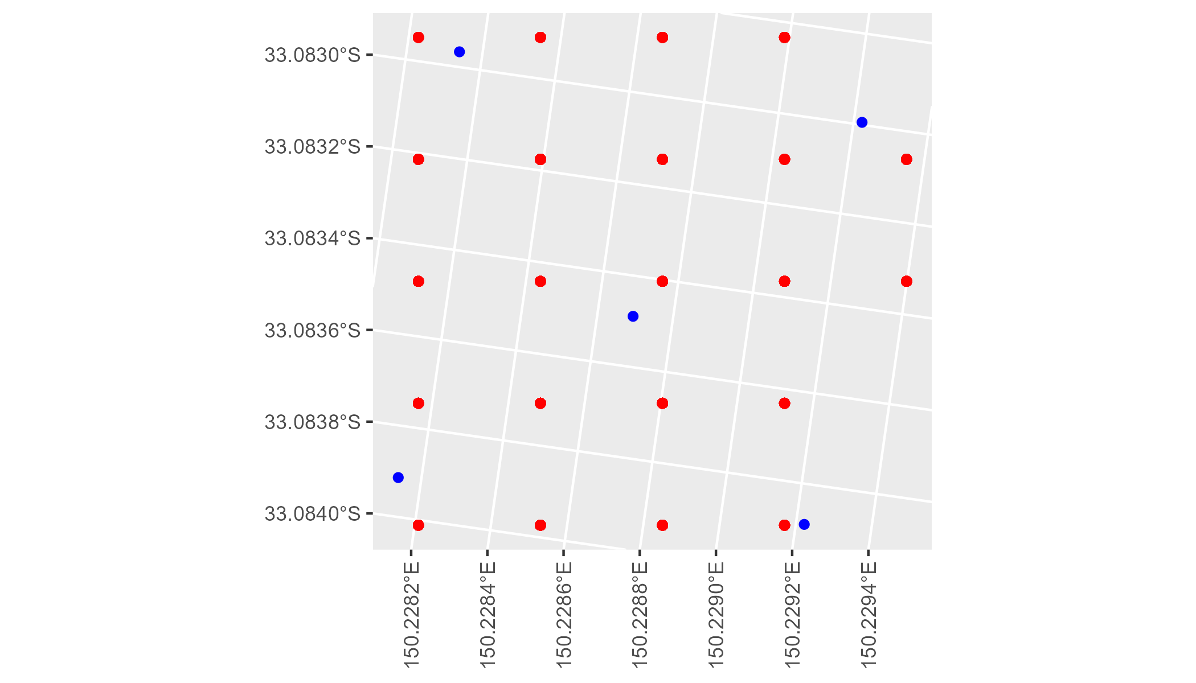

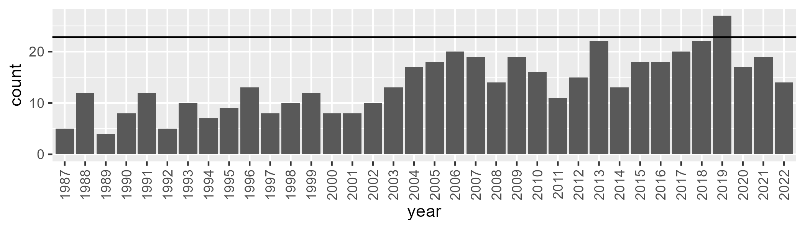

Number of samples: 493

# NSTSYB0001

| Min. | 1st Qu. | Median | Mean | 3rd Qu. | Max. |
| --- | --- | --- | --- | --- | --- |
| 11.40329 | 55.36958 | 60.53766 | 58.7106 | 64.43545 | 77.56855 |

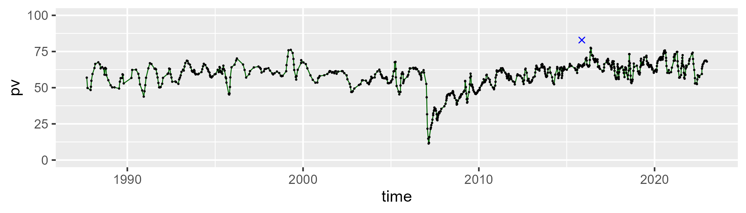

| Min. | 1st Qu. | Median | Mean | 3rd Qu. | Max. |
| --- | --- | --- | --- | --- | --- |
| 12.95508 | 26.40337 | 30.88573 | 31.12154 | 35.03231 | 55.94948 |

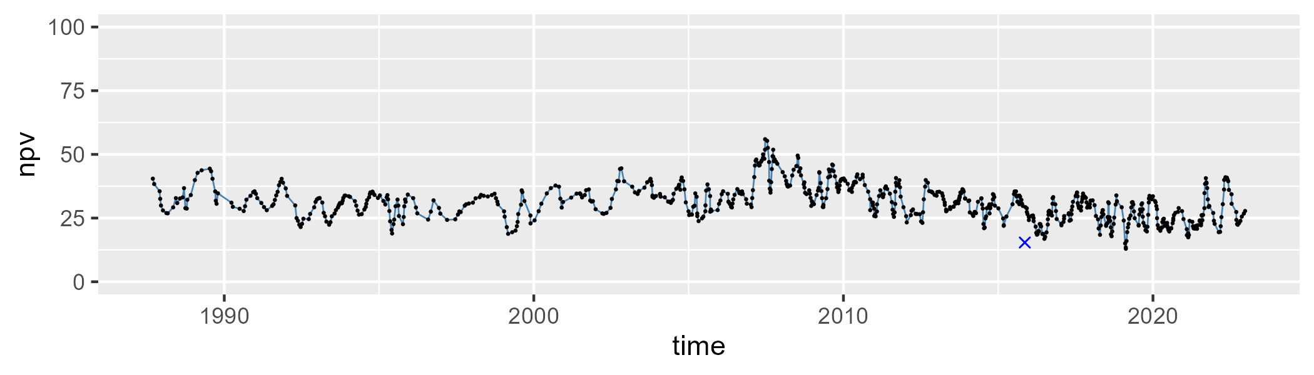

| Min. | 1st Qu. | Median | Mean | 3rd Qu. | Max. |
| --- | --- | --- | --- | --- | --- |
| 0 | 4.127248 | 7.071583 | 8.796531 | 11.38641 | 42.81518 |

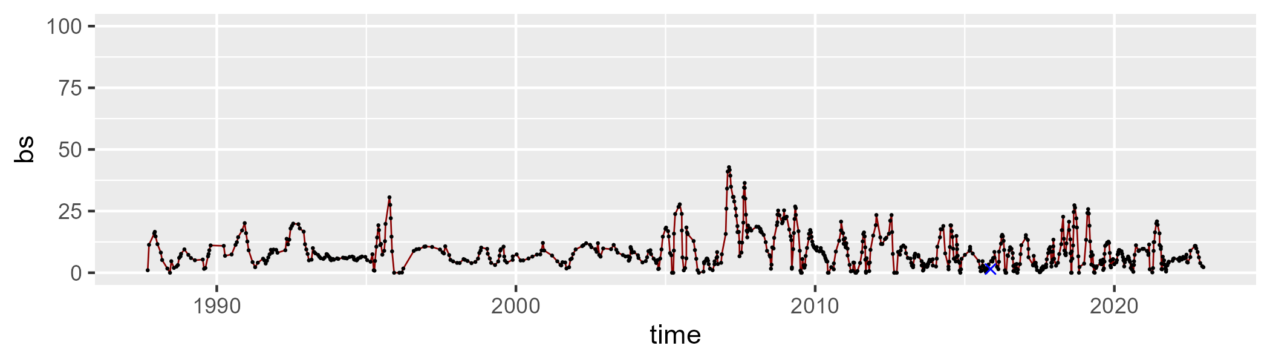

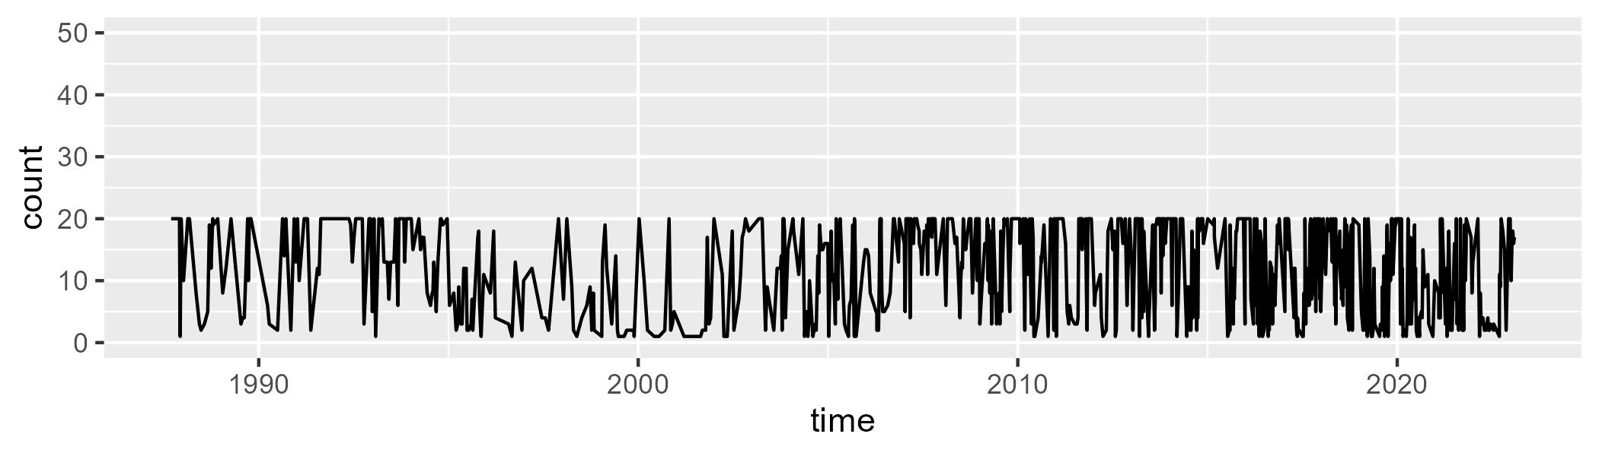

Min. : 1.00 1st Qu.: 4.00 Median :12.00 Mean :11.64 3rd Qu.:20.00 Max. :20.00

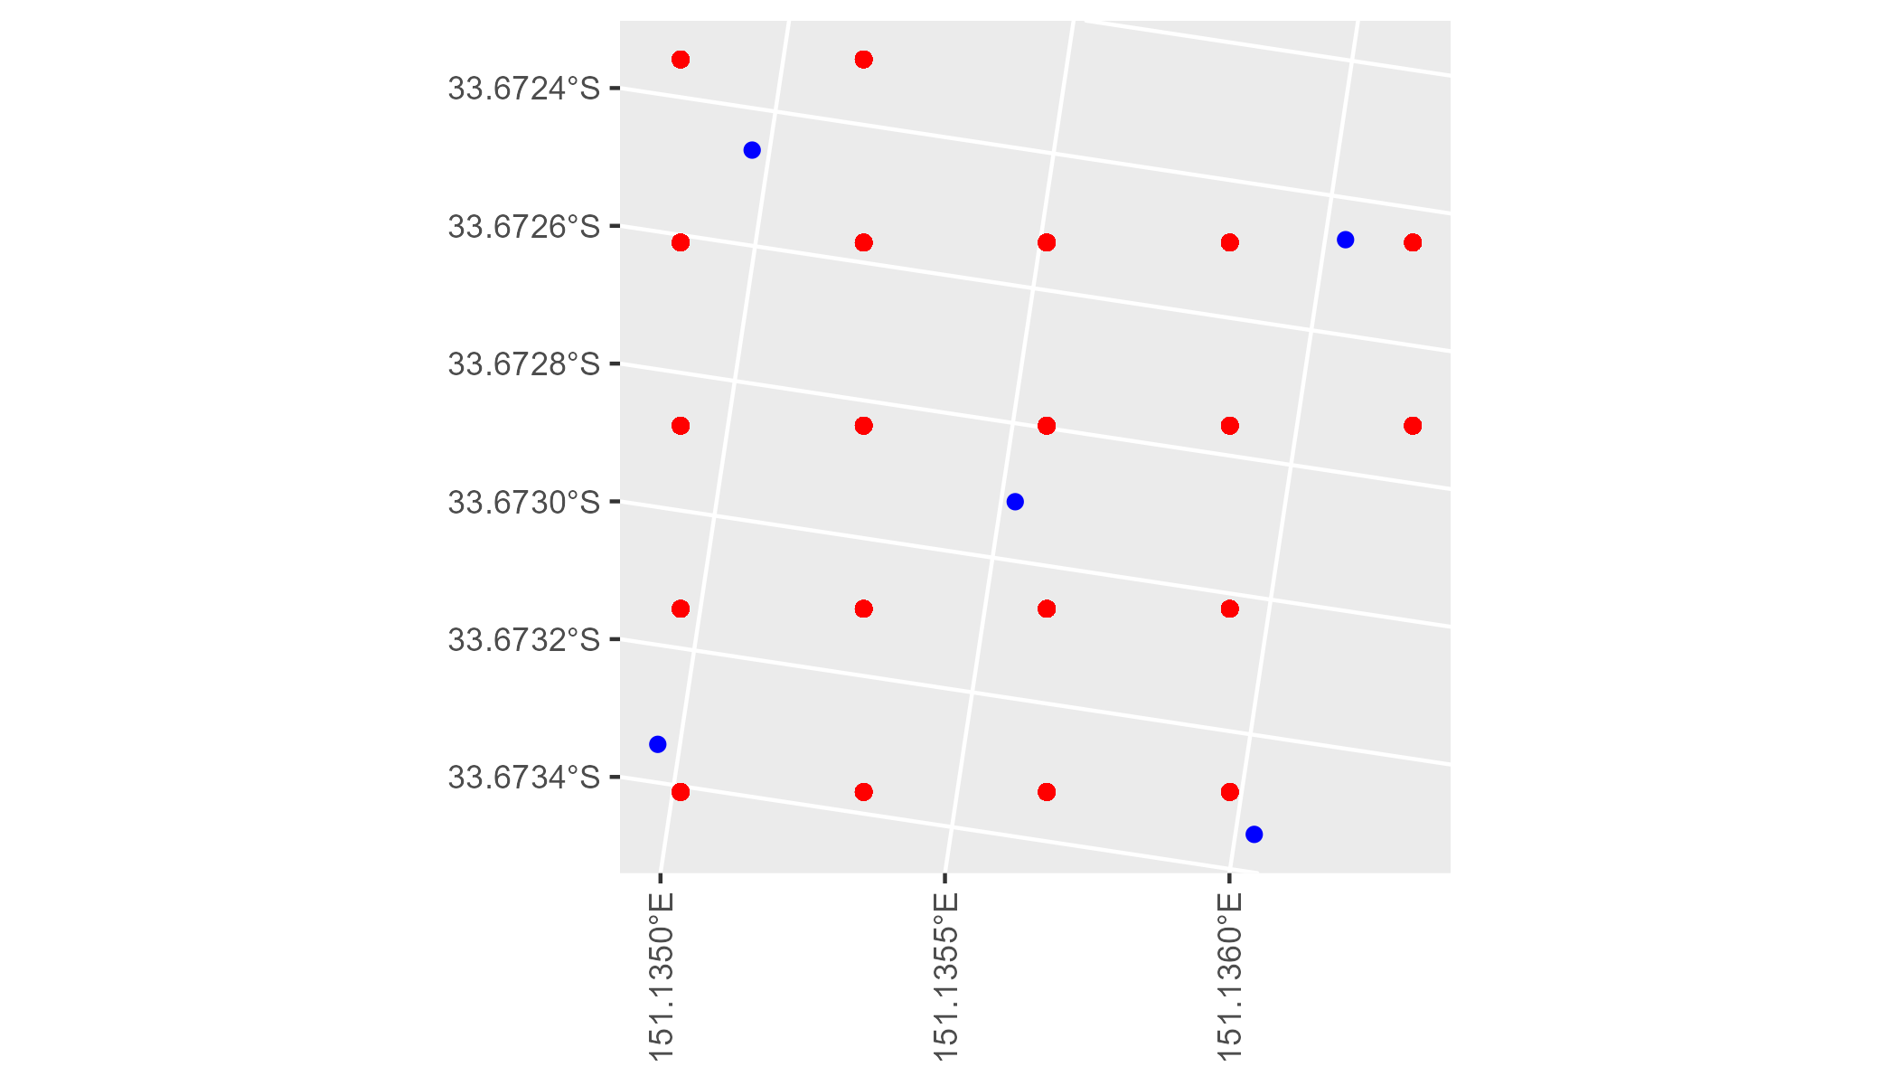

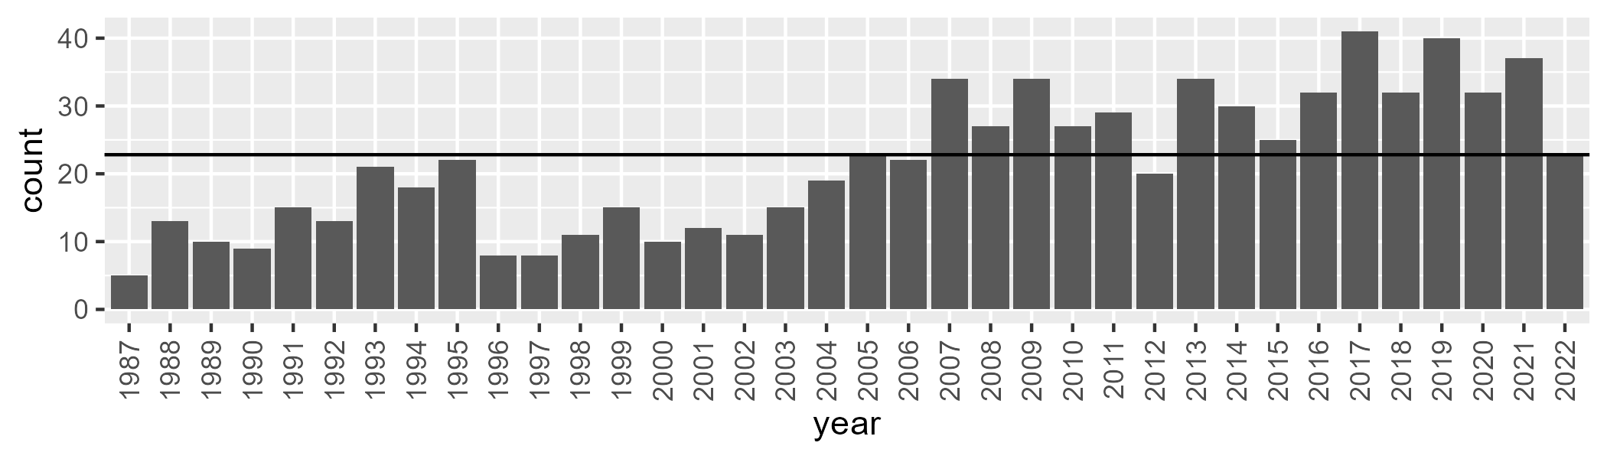

Number of samples: 777

# NSTSYB0002

| Min. | 1st Qu. | Median | Mean | 3rd Qu. | Max. |
| --- | --- | --- | --- | --- | --- |
| 41.25517 | 59.28449 | 63.31355 | 63.40489 | 68.07627 | 78.91988 |

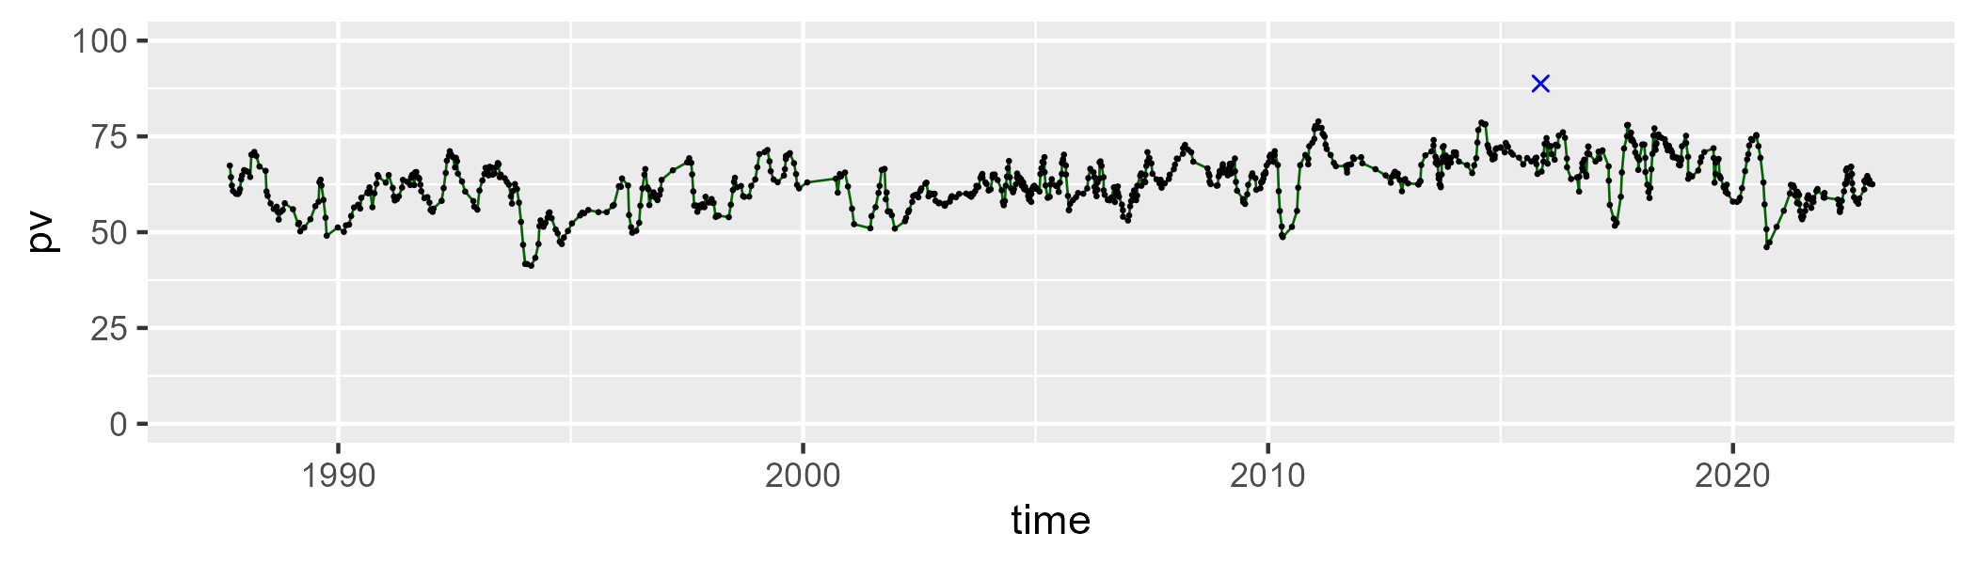

| Min. | 1st Qu. | Median | Mean | 3rd Qu. | Max. |
| --- | --- | --- | --- | --- | --- |
| 7.270665 | 24.02367 | 28.24835 | 28.01725 | 32.67541 | 46.70555 |

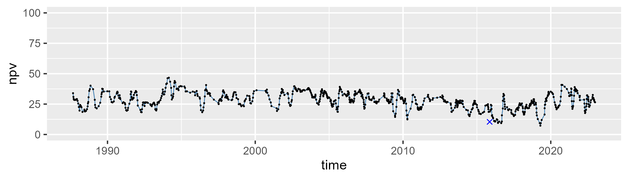

| Min. | 1st Qu. | Median | Mean | 3rd Qu. | Max. |
| --- | --- | --- | --- | --- | --- |
| 0 | 2.283201 | 5.39415 | 7.248743 | 10.63654 | 37.49234 |

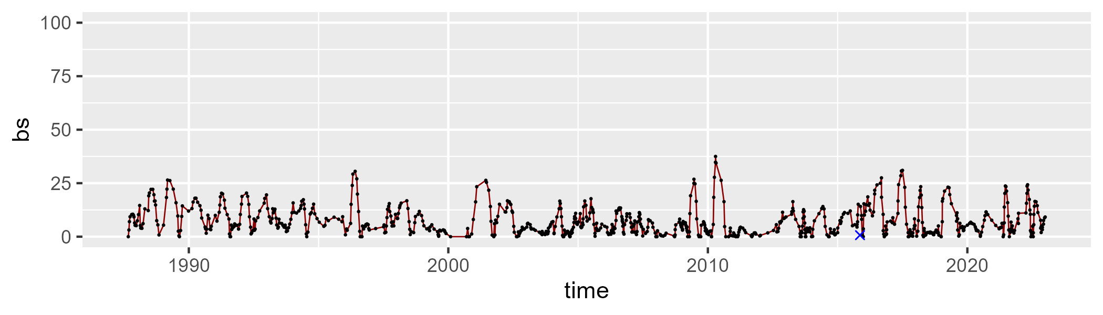

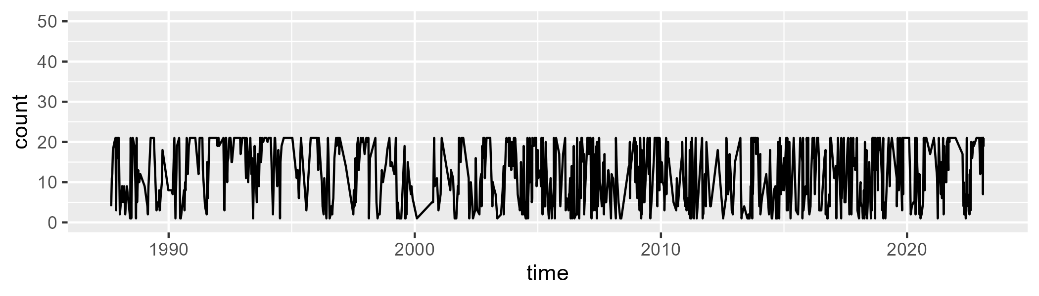

Min. : 1.00 1st Qu.: 5.00 Median :13.00 Mean :12.26 3rd Qu.:21.00 Max. :21.00

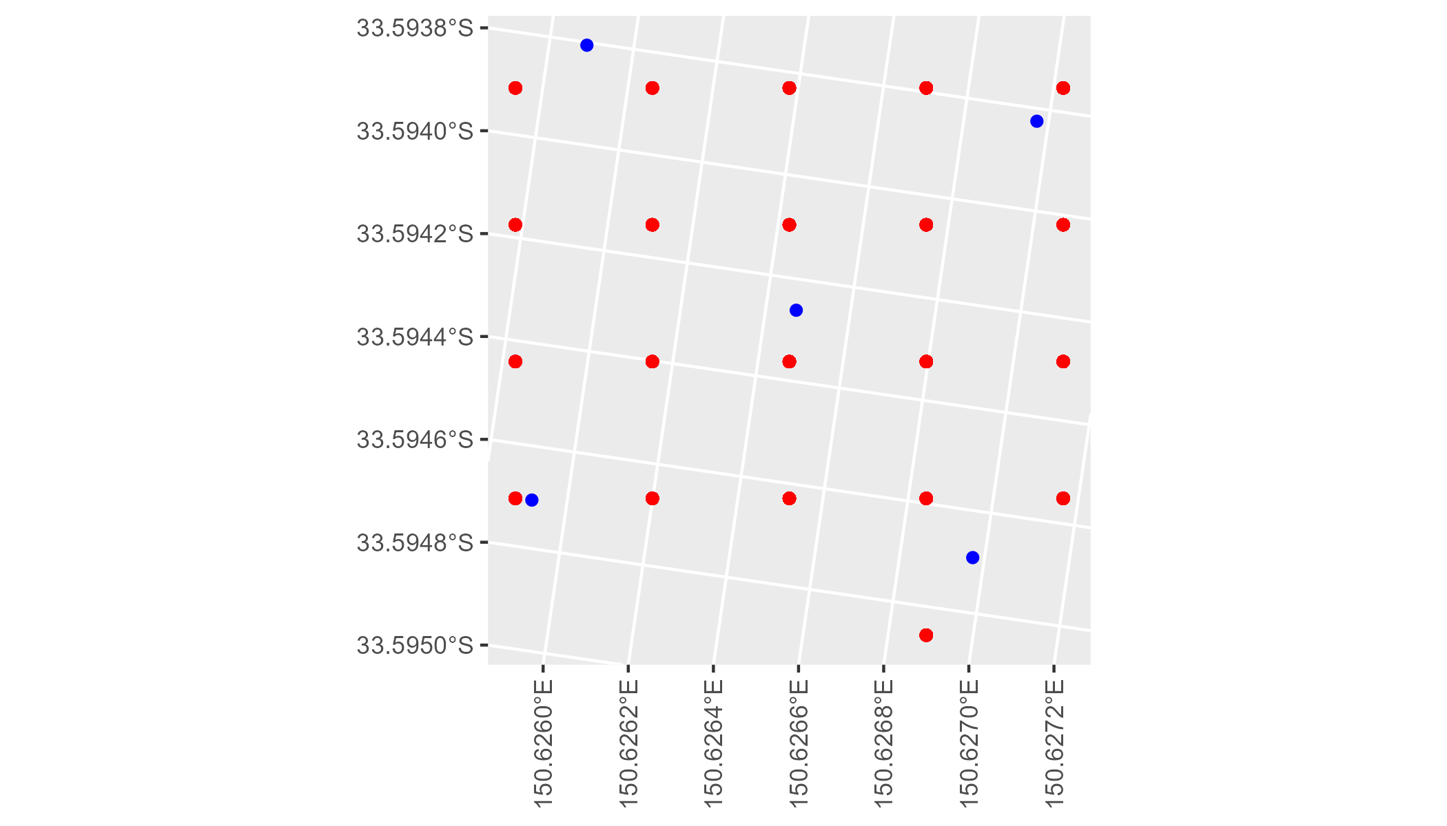

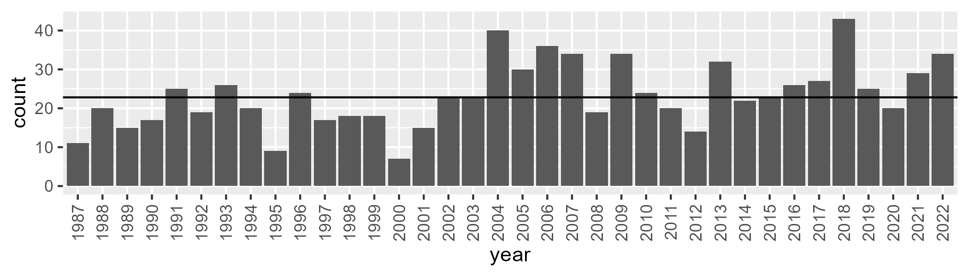

Number of samples: 839

# NSTSYB0003

| Min. | 1st Qu. | Median | Mean | 3rd Qu. | Max. |
| --- | --- | --- | --- | --- | --- |
| 11.00054 | 48.25813 | 53.01942 | 51.79268 | 57.65204 | 66.10953 |

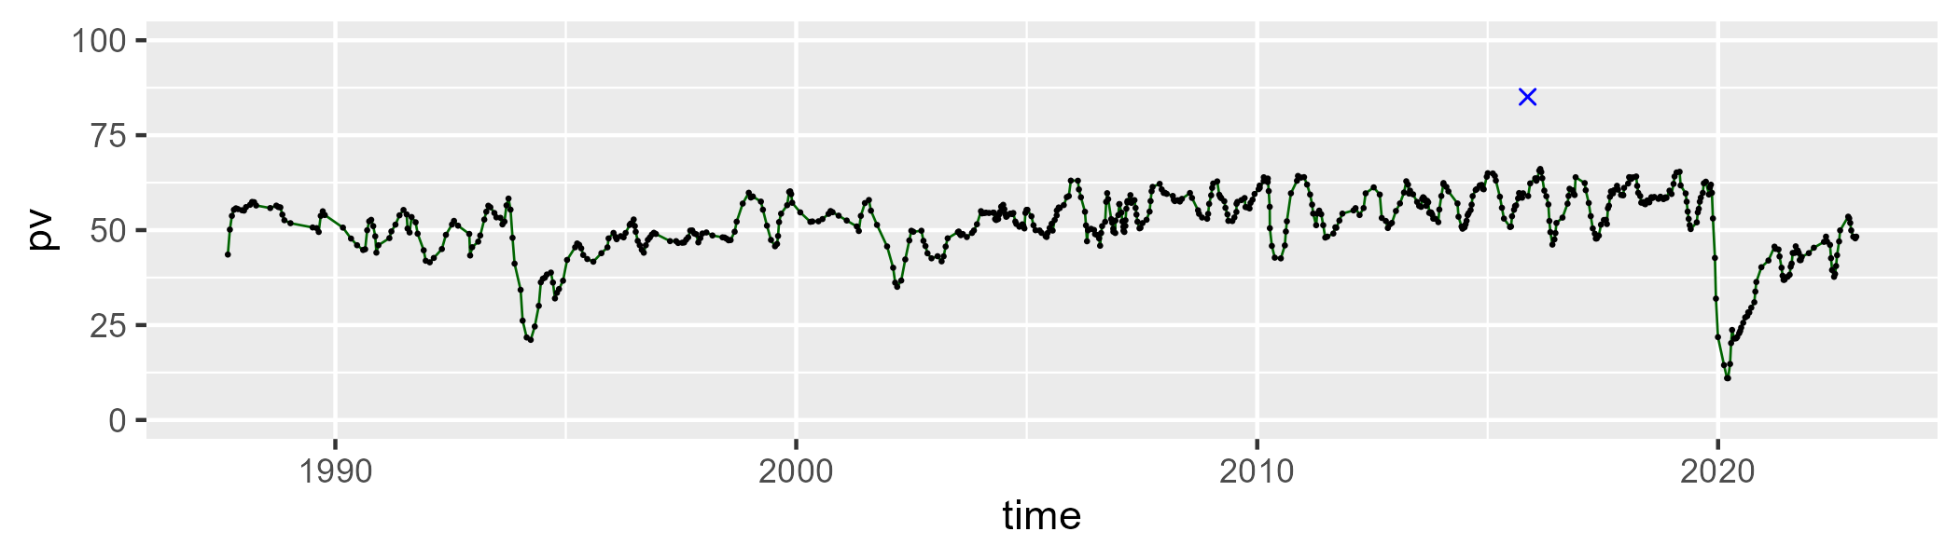

| Min. | 1st Qu. | Median | Mean | 3rd Qu. | Max. |
| --- | --- | --- | --- | --- | --- |
| 25.59457 | 33.70009 | 36.99802 | 37.2555 | 40.74949 | 53.65081 |

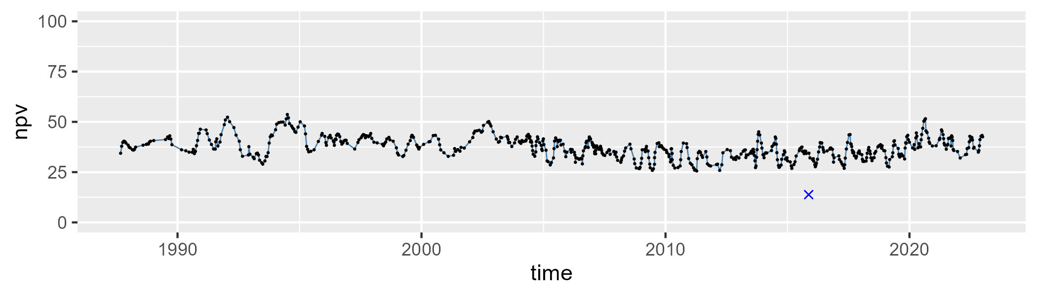

| Min. | 1st Qu. | Median | Mean | 3rd Qu. | Max. |
| --- | --- | --- | --- | --- | --- |
| 0 | 4.433141 | 7.60437 | 9.666697 | 13.21562 | 50.67064 |

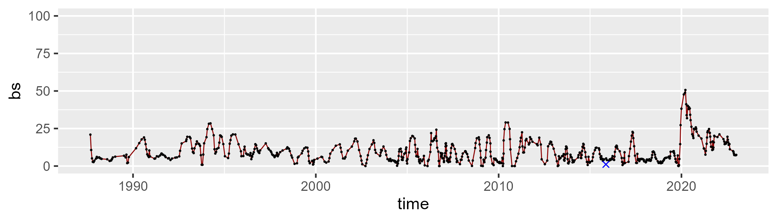

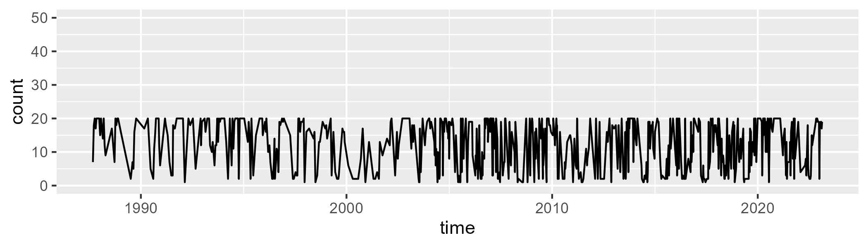

Min. : 1.00 1st Qu.: 4.00 Median :13.00 Mean :11.97 3rd Qu.:19.00 Max. :20.00

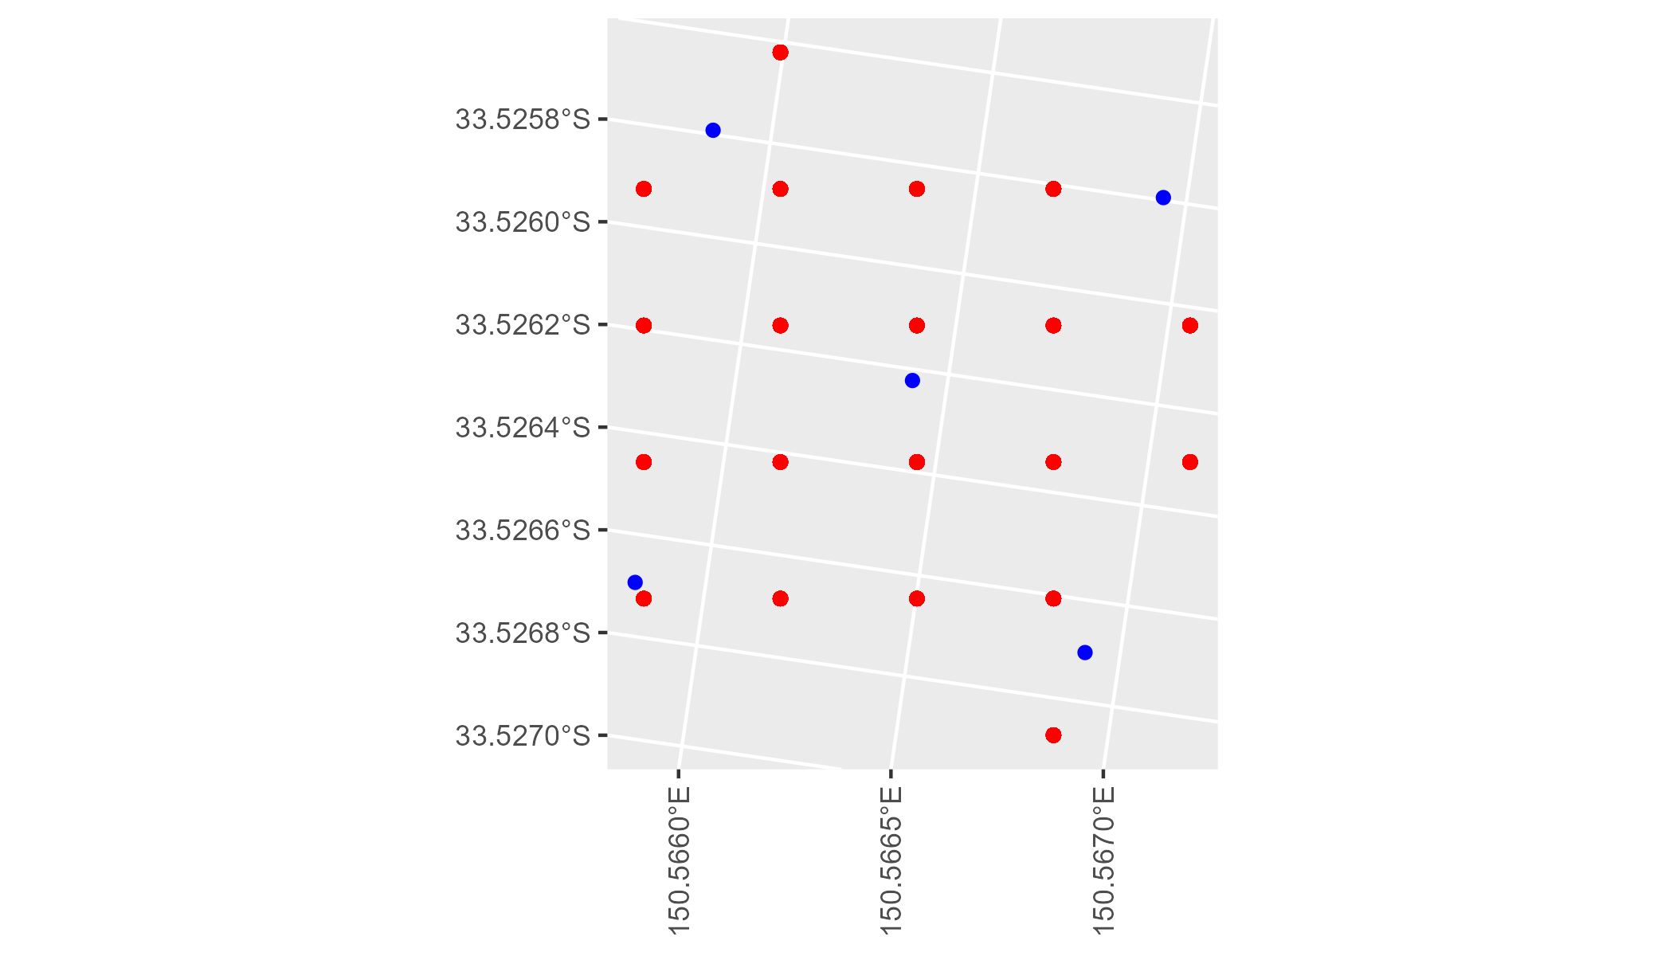

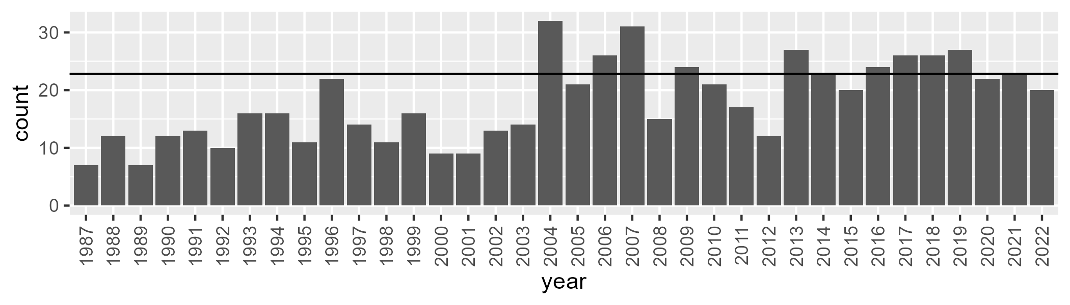

Number of samples: 649

# NSTSYB0004

| Min. | 1st Qu. | Median | Mean | 3rd Qu. | Max. |
| --- | --- | --- | --- | --- | --- |
| 37.06984 | 57.17416 | 60.75467 | 60.34622 | 63.81497 | 75.51928 |

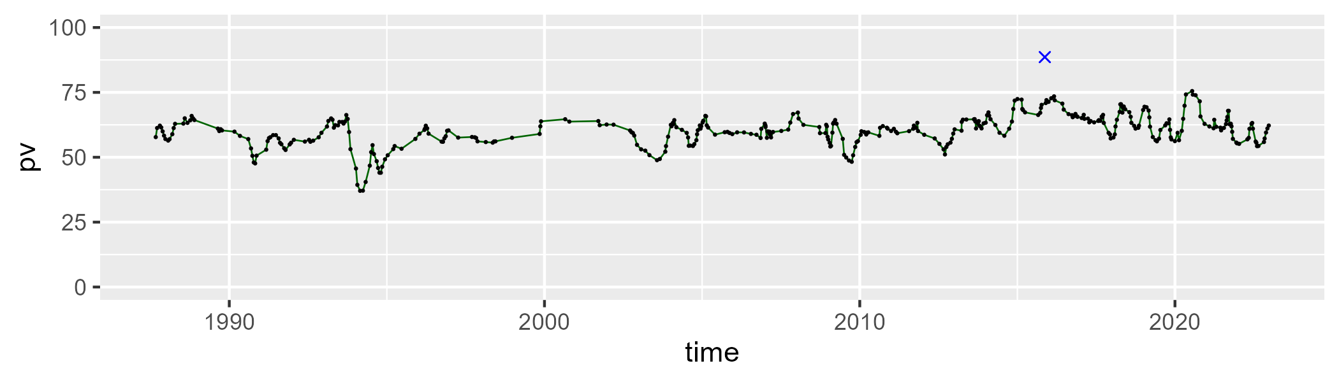

| Min. | 1st Qu. | Median | Mean | 3rd Qu. | Max. |
| --- | --- | --- | --- | --- | --- |
| 11.38725 | 27.19851 | 30.47822 | 30.51785 | 33.78208 | 45.48335 |

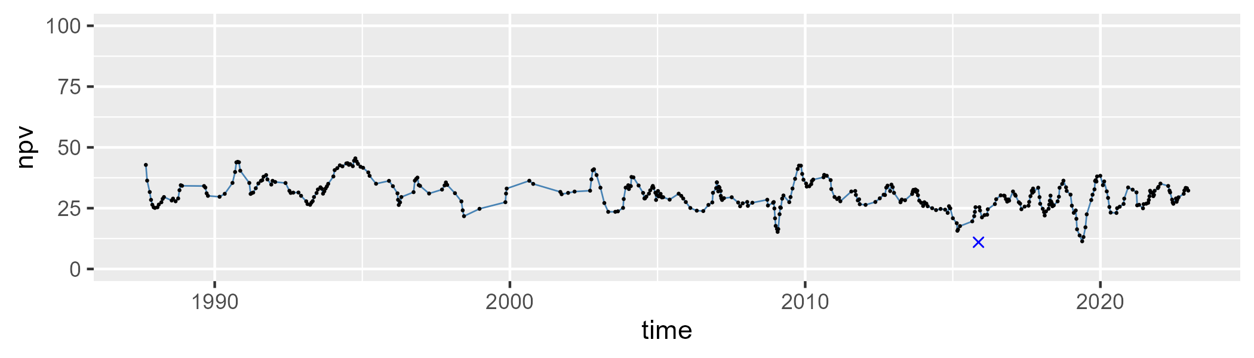

| Min. | 1st Qu. | Median | Mean | 3rd Qu. | Max. |
| --- | --- | --- | --- | --- | --- |
| 0 | 3.728679 | 6.575363 | 7.724714 | 10.29387 | 30.63875 |

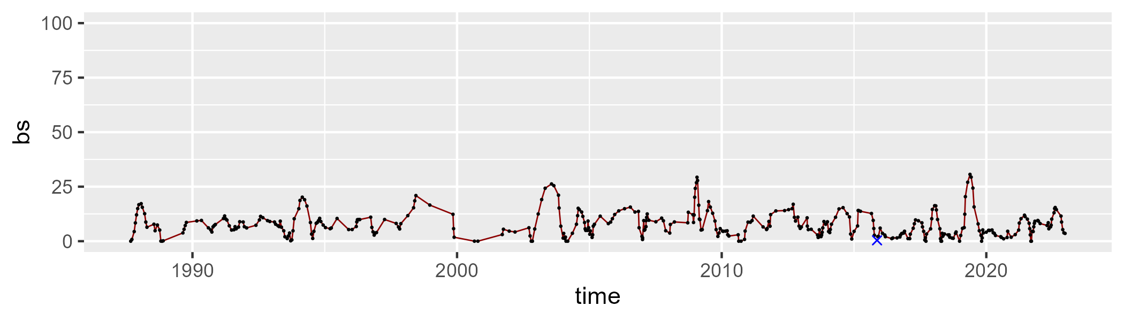

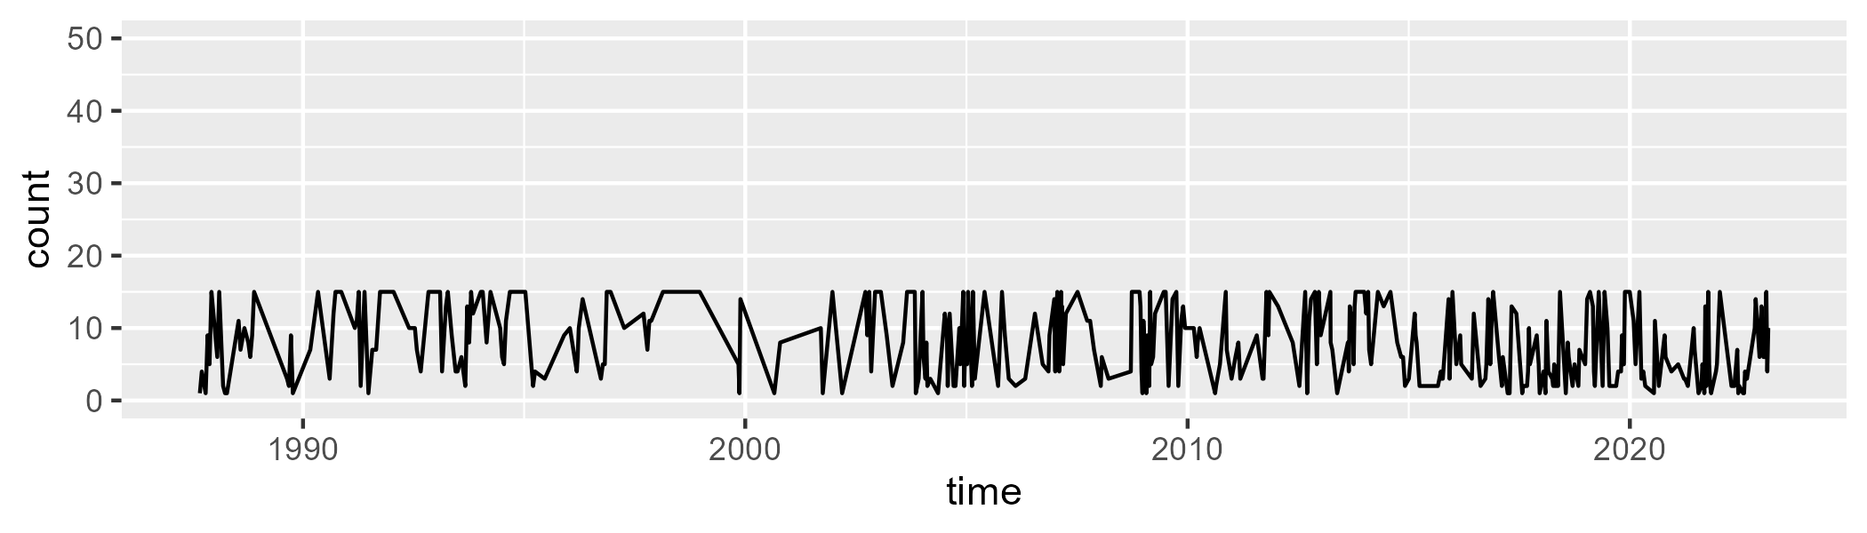

Min. : 1.00 1st Qu.: 3.00 Median : 7.00 Mean : 8.03 3rd Qu.:13.00 Max. :15.00

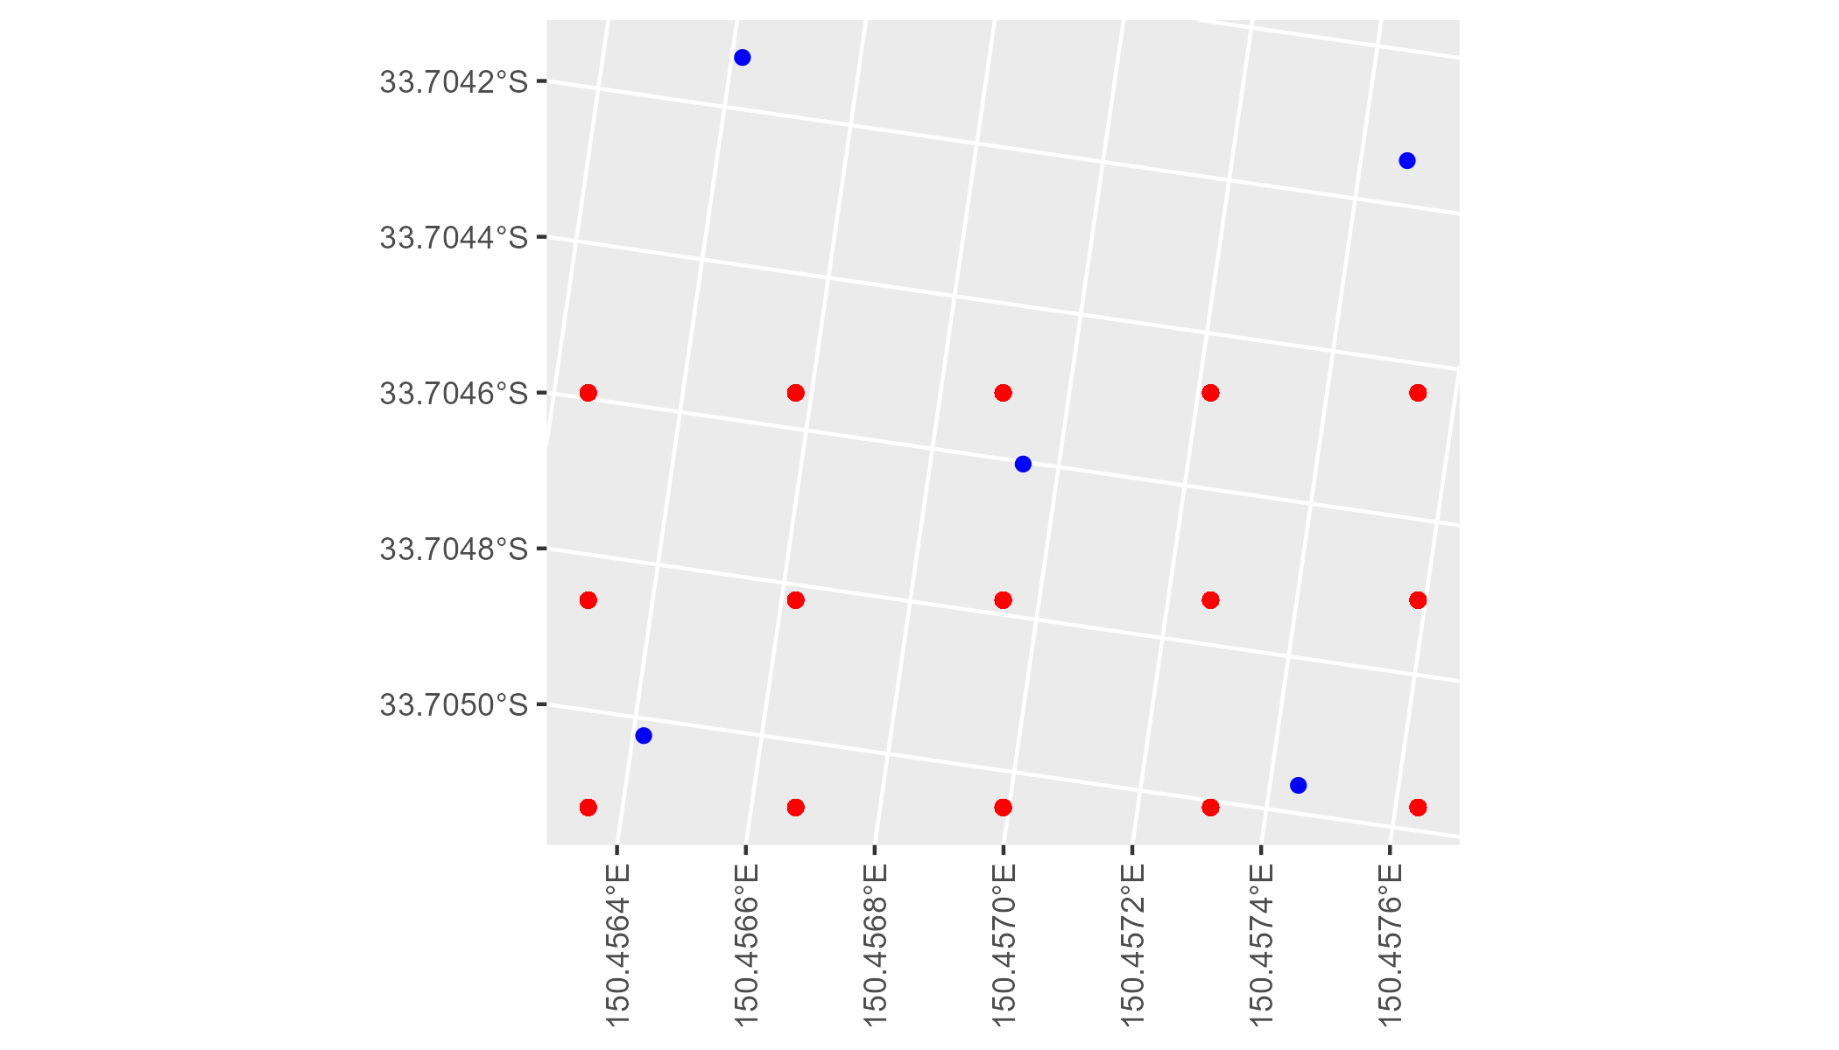

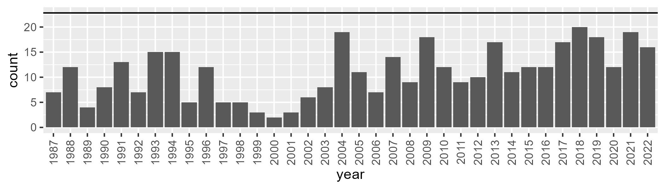

Number of samples: 393

# NSTSYB0005

| Min. | 1st Qu. | Median | Mean | 3rd Qu. | Max. |
| --- | --- | --- | --- | --- | --- |
| 21.94645 | 50.35846 | 54.16978 | 52.99725 | 57.52997 | 67.67475 |

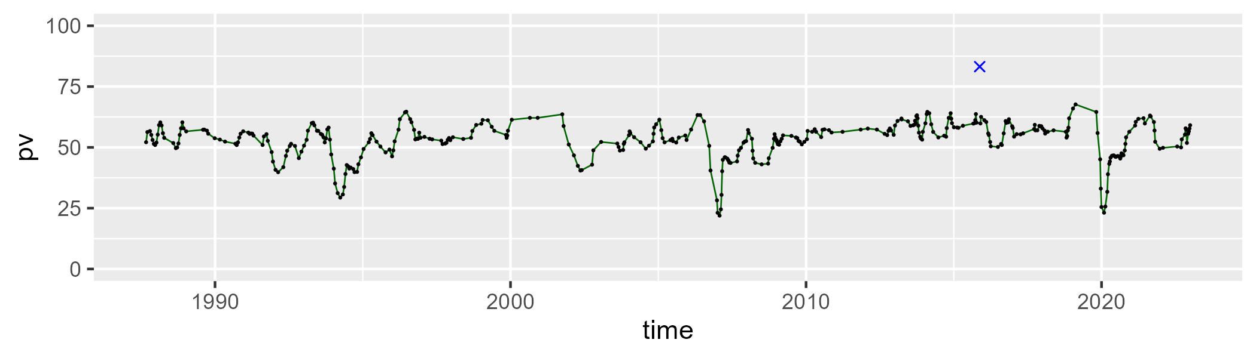

| Min. | 1st Qu. | Median | Mean | 3rd Qu. | Max. |
| --- | --- | --- | --- | --- | --- |
| 19.18618 | 30.15216 | 34.81012 | 35.1157 | 39.01157 | 54.20917 |

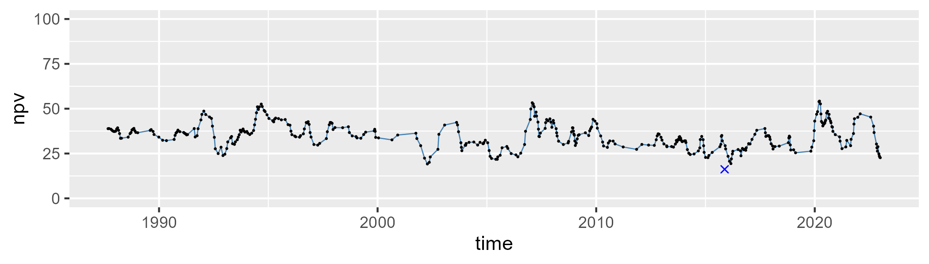

| Min. | 1st Qu. | Median | Mean | 3rd Qu. | Max. |
| --- | --- | --- | --- | --- | --- |
| 0 | 5.652142 | 8.999565 | 10.55085 | 13.81051 | 38.38994 |

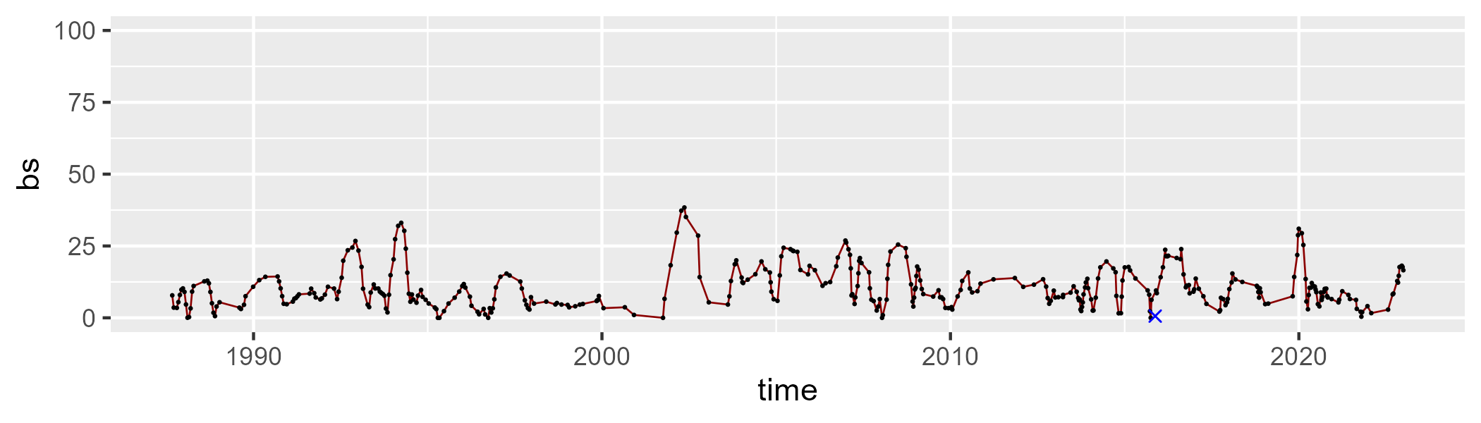

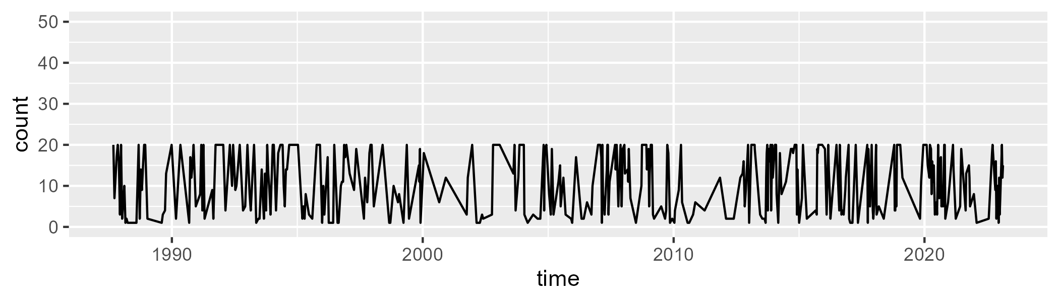

Min. : 1.00 1st Qu.: 3.00 Median :11.00 Mean :10.95 3rd Qu.:20.00 Max. :20.00

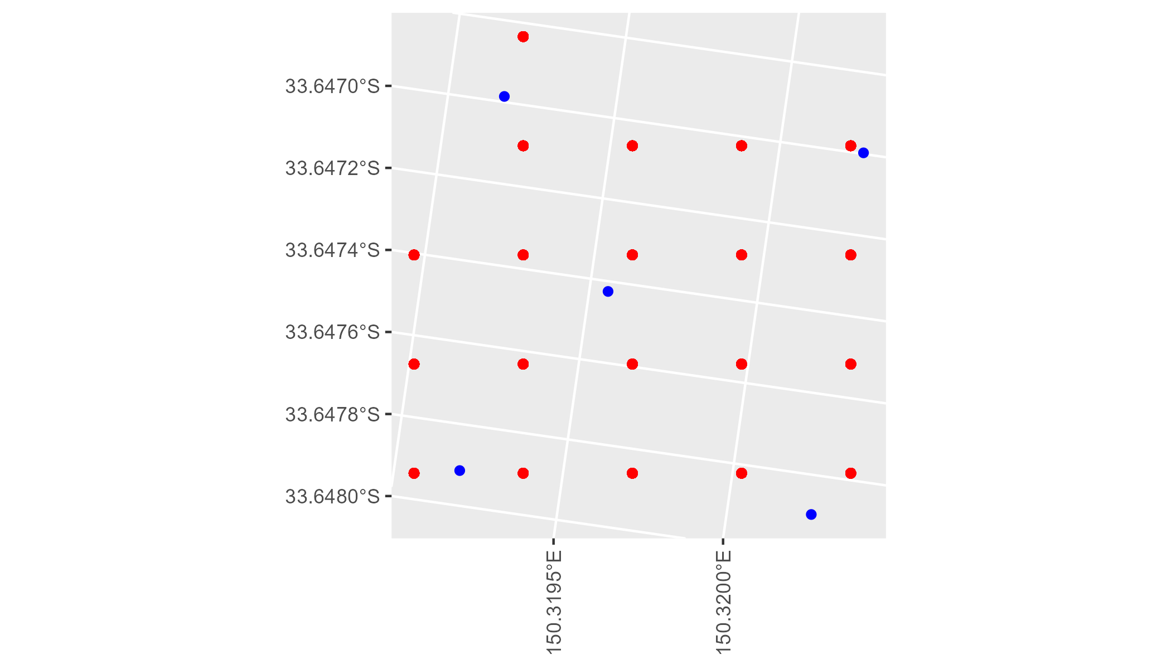

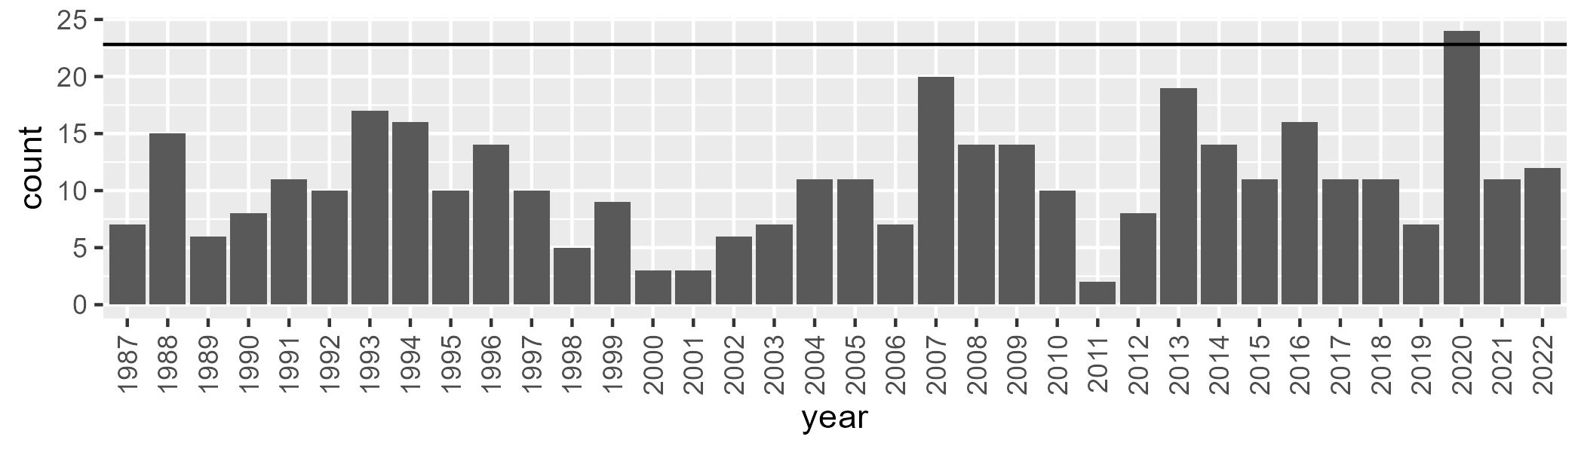

Number of samples: 390

# NSTSYB0006

| Min. | 1st Qu. | Median | Mean | 3rd Qu. | Max. |
| --- | --- | --- | --- | --- | --- |
| 3.415449 | 50.02791 | 55.4351 | 52.47474 | 59.4888 | 66.67554 |

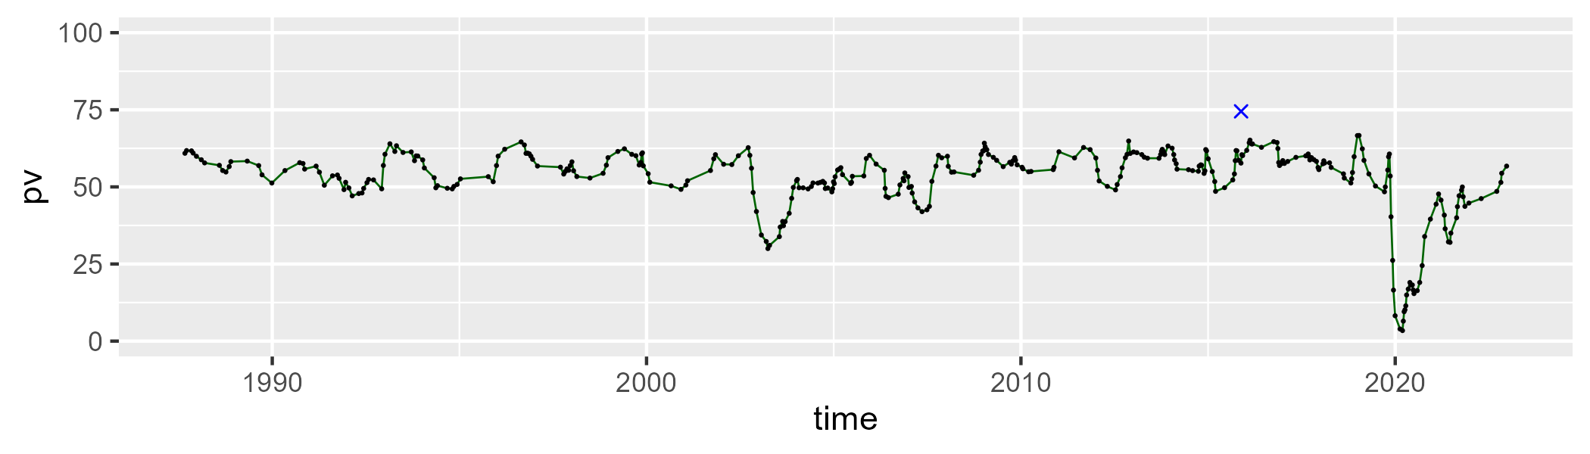

| Min. | 1st Qu. | Median | Mean | 3rd Qu. | Max. |
| --- | --- | --- | --- | --- | --- |
| 15.02906 | 29.75848 | 33.54403 | 34.62359 | 37.4329 | 57.40959 |

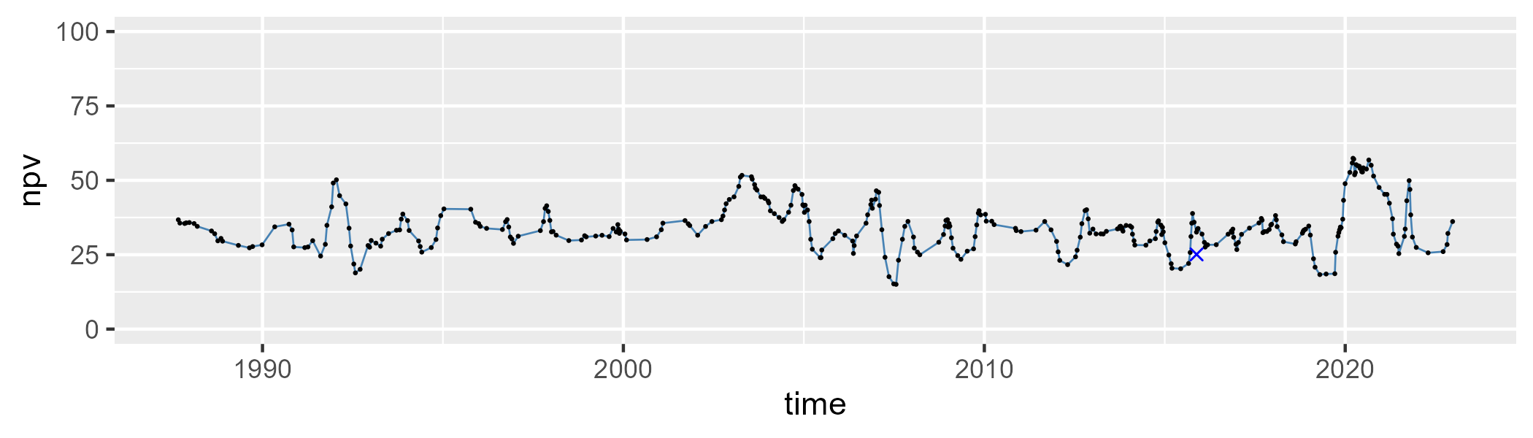

| Min. | 1st Qu. | Median | Mean | 3rd Qu. | Max. |
| --- | --- | --- | --- | --- | --- |
| 0 | 4.626 | 8.956059 | 11.61743 | 15.97863 | 42.39748 |

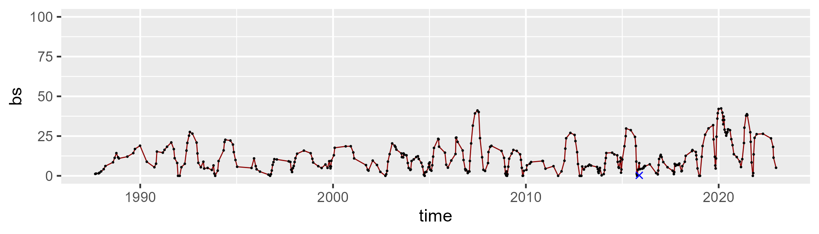

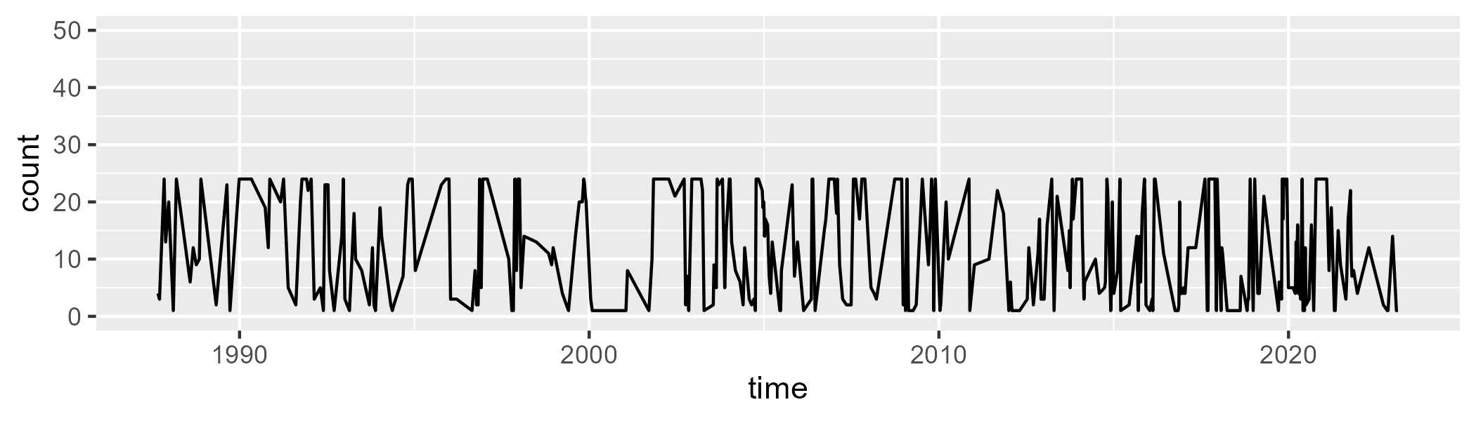

Min. : 1.00 1st Qu.: 3.00 Median :10.00 Mean :11.81 3rd Qu.:23.00 Max. :24.00

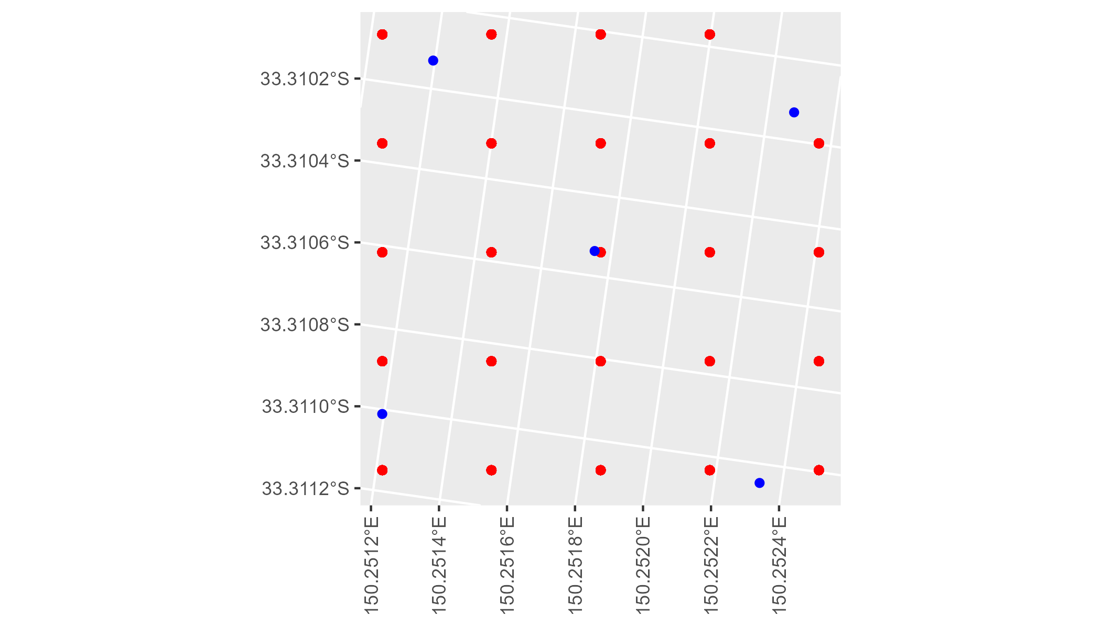

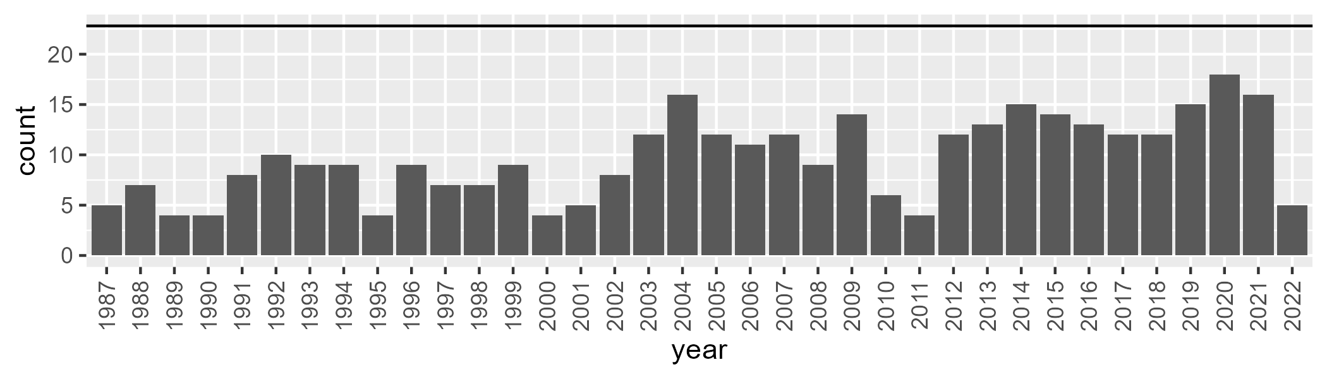

Number of samples: 350

# NSTSYB0007

| Min. | 1st Qu. | Median | Mean | 3rd Qu. | Max. |
| --- | --- | --- | --- | --- | --- |
| 10.63809 | 51.72551 | 55.15569 | 53.4673 | 57.63032 | 66.02966 |

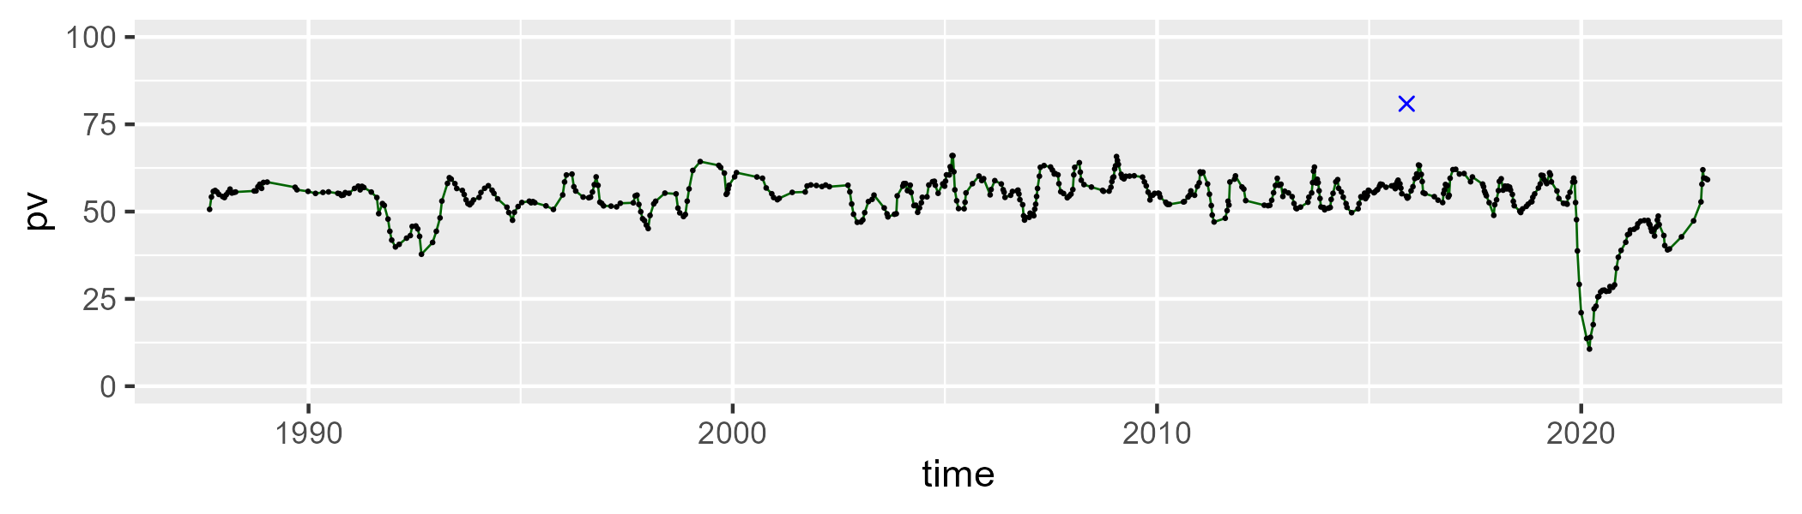

| Min. | 1st Qu. | Median | Mean | 3rd Qu. | Max. |
| --- | --- | --- | --- | --- | --- |
| 20.33896 | 32.5932 | 36.49825 | 36.61659 | 39.54976 | 58.73139 |

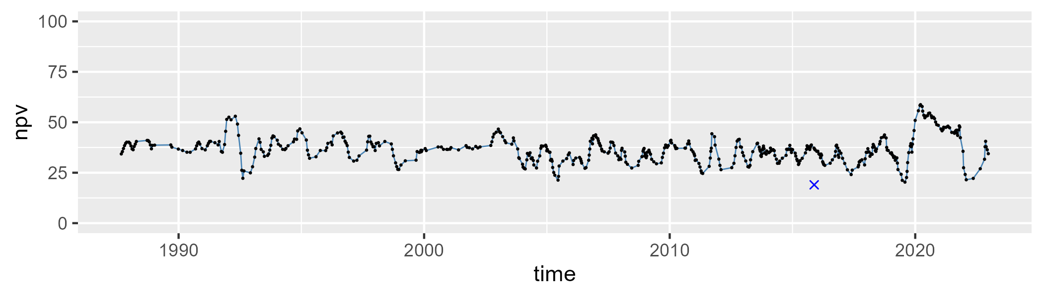

| Min. | 1st Qu. | Median | Mean | 3rd Qu. | Max. |
| --- | --- | --- | --- | --- | --- |
| 0 | 3.94244 | 7.212778 | 8.684162 | 11.89314 | 38.23181 |

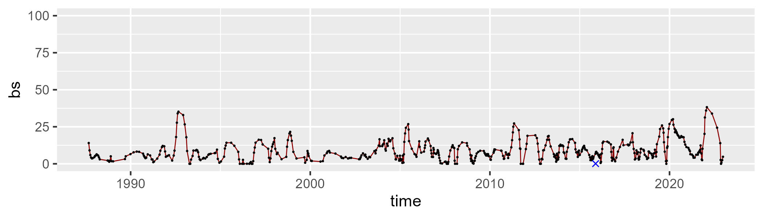

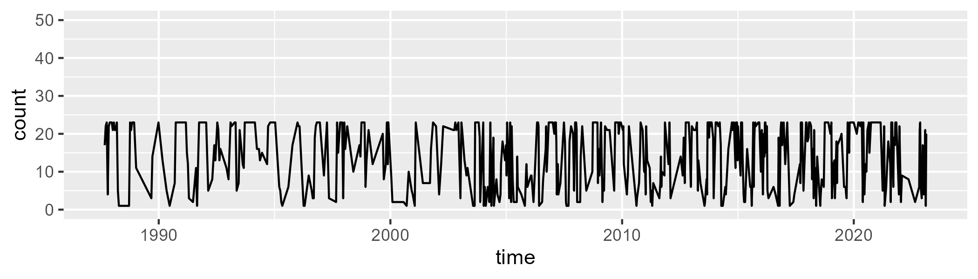

Min. : 1.00 1st Qu.: 6.00 Median :17.00 Mean :14.51 3rd Qu.:23.00 Max. :23.00

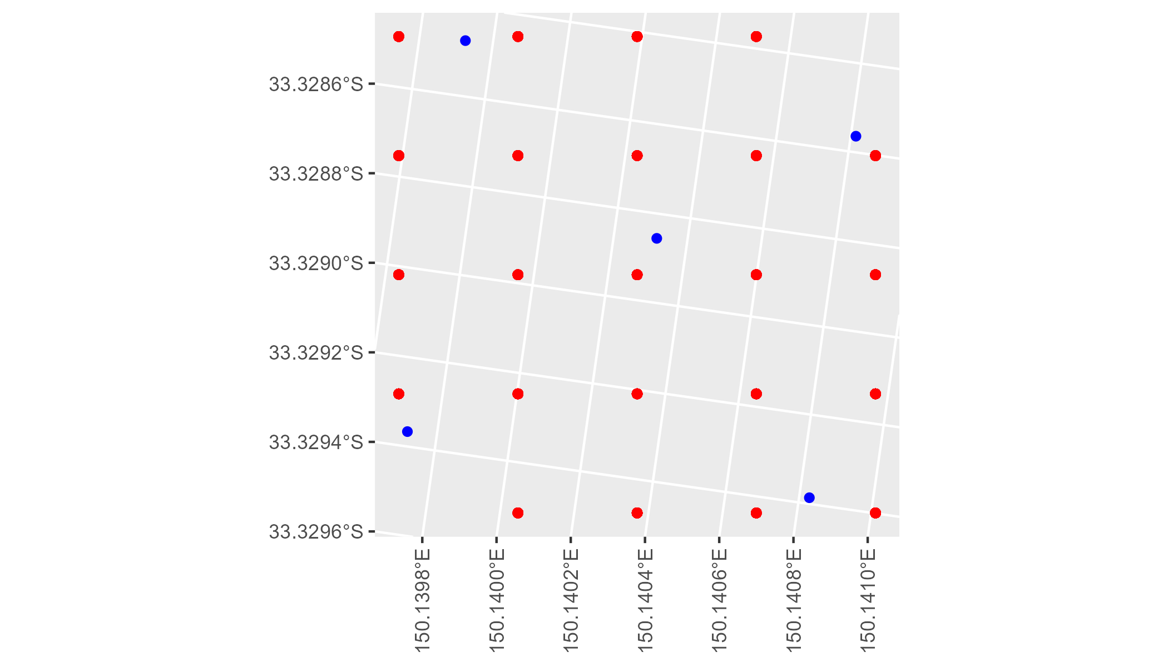

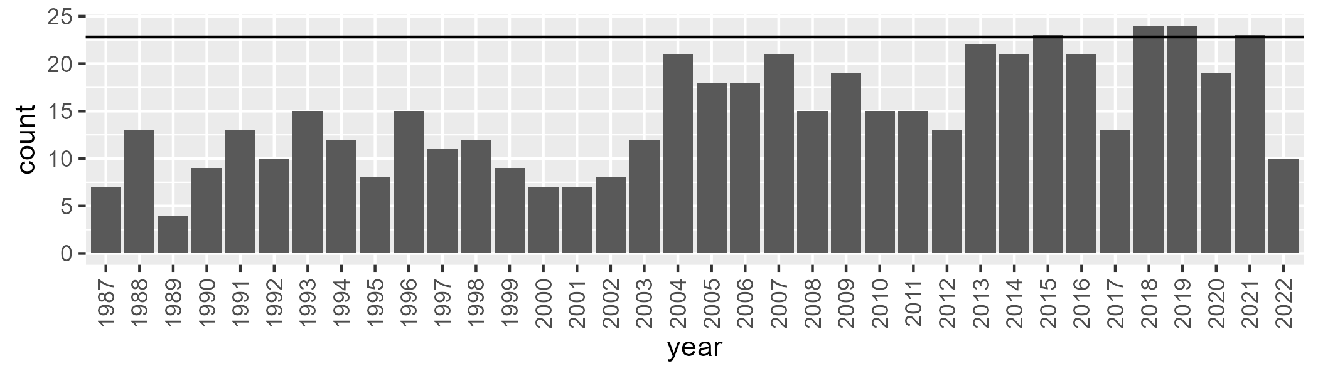

Number of samples: 527

# NSTSYB0008

| Min. | 1st Qu. | Median | Mean | 3rd Qu. | Max. |
| --- | --- | --- | --- | --- | --- |
| 14.66797 | 46.77191 | 50.74503 | 49.90035 | 54.07007 | 67.36672 |

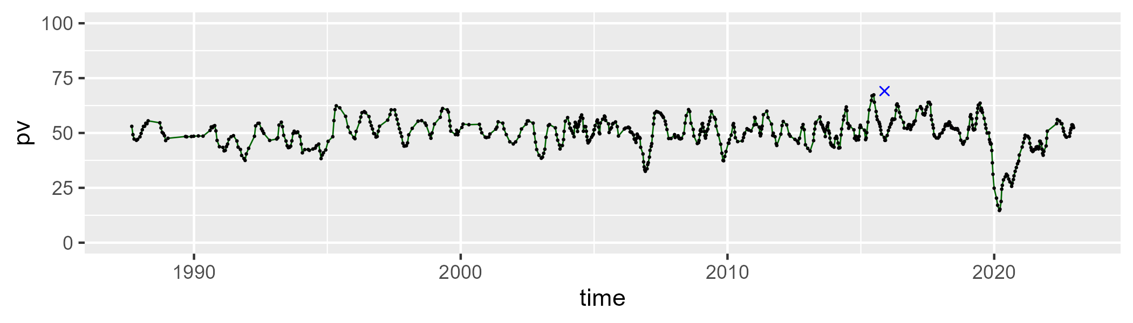

| Min. | 1st Qu. | Median | Mean | 3rd Qu. | Max. |
| --- | --- | --- | --- | --- | --- |
| 25.56221 | 35.75771 | 40.22514 | 40.20748 | 43.88884 | 63.25698 |

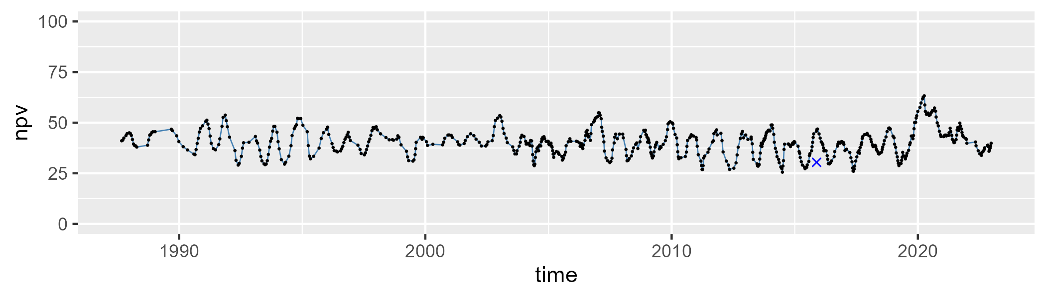

| Min. | 1st Qu. | Median | Mean | 3rd Qu. | Max. |
| --- | --- | --- | --- | --- | --- |
| 0 | 5.267975 | 7.188405 | 8.640932 | 11.36432 | 26.84505 |

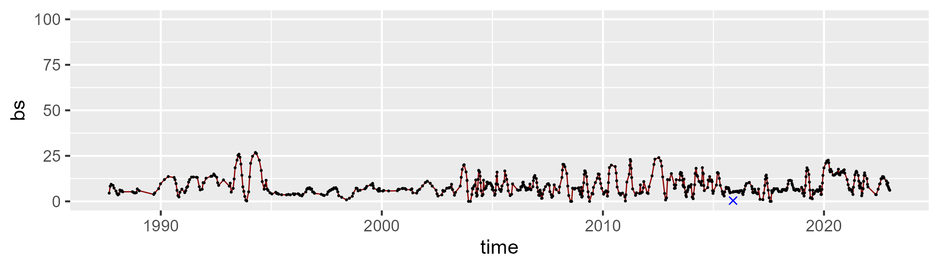

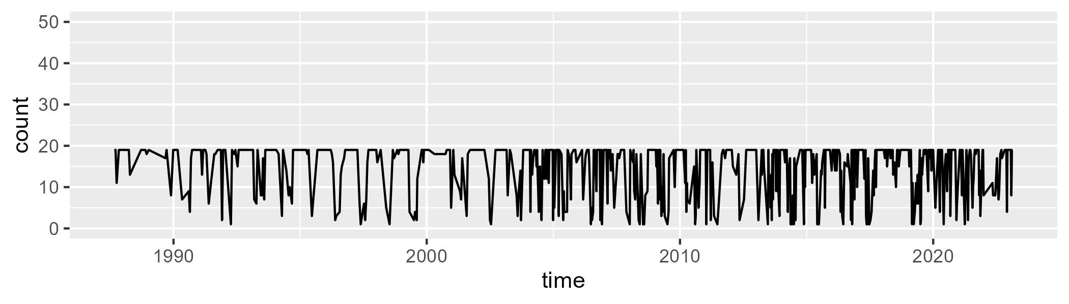

Min. : 1.00 1st Qu.:10.00 Median :19.00 Mean :14.41 3rd Qu.:19.00 Max. :19.00

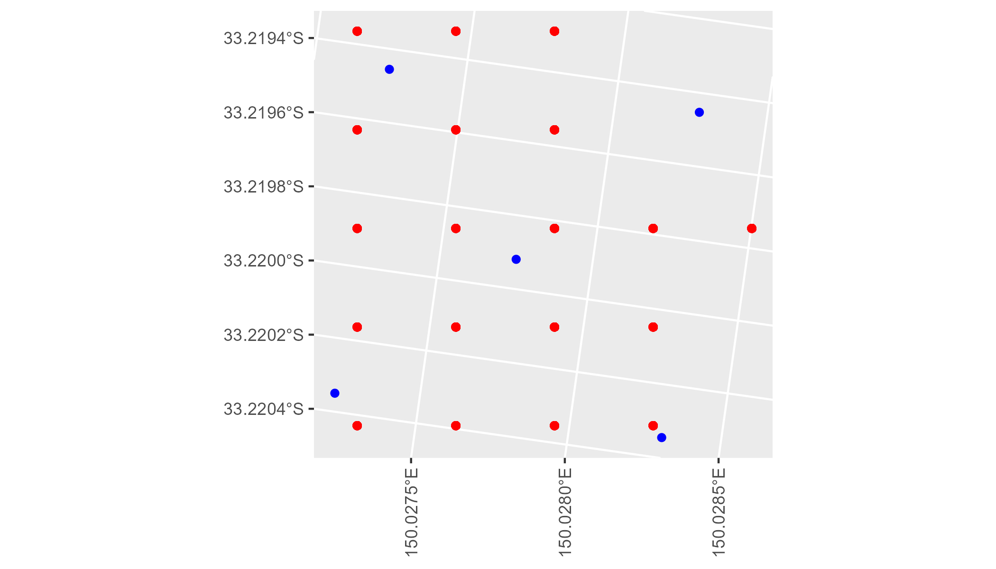

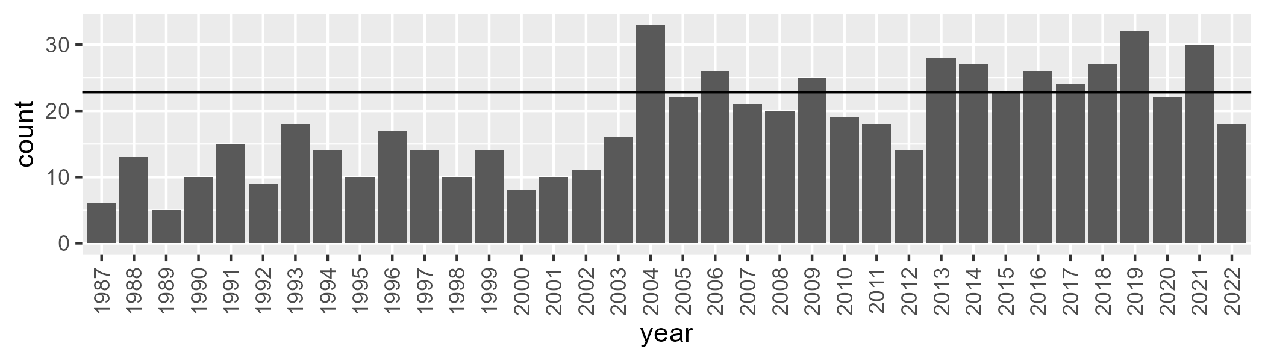

Number of samples: 655

# NSTSYB0009

| Min. | 1st Qu. | Median | Mean | 3rd Qu. | Max. |
| --- | --- | --- | --- | --- | --- |
| 14.01567 | 45.62983 | 51.72445 | 49.56335 | 55.5155 | 64.77961 |

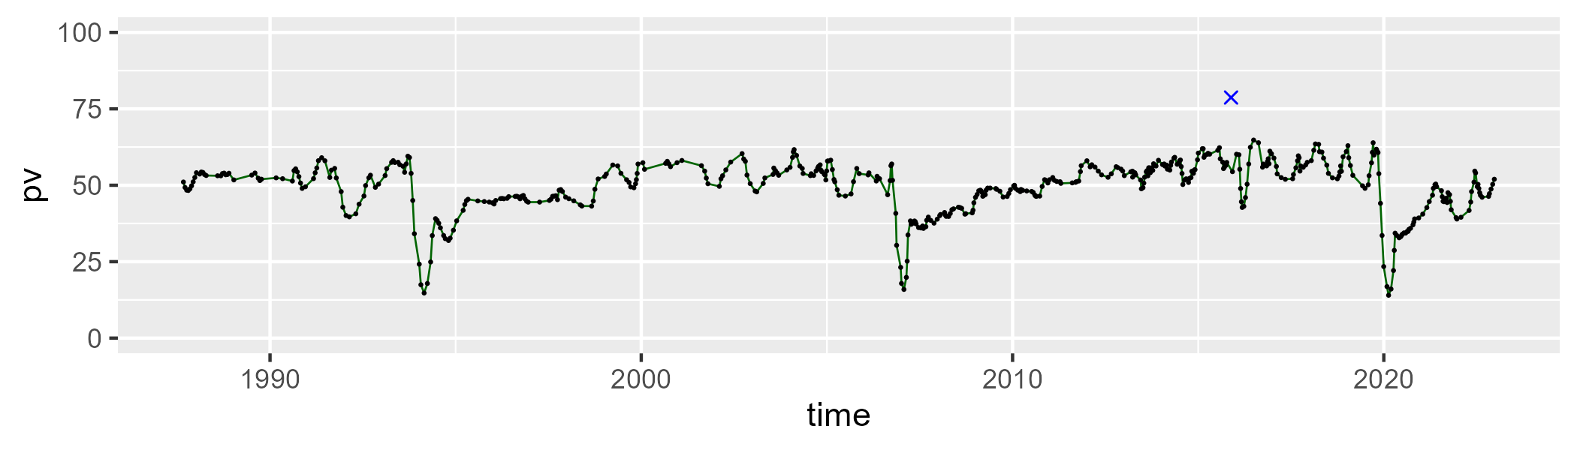

| Min. | 1st Qu. | Median | Mean | 3rd Qu. | Max. |
| --- | --- | --- | --- | --- | --- |
| 23.93582 | 34.19355 | 37.9044 | 38.90925 | 43.45095 | 55.24924 |

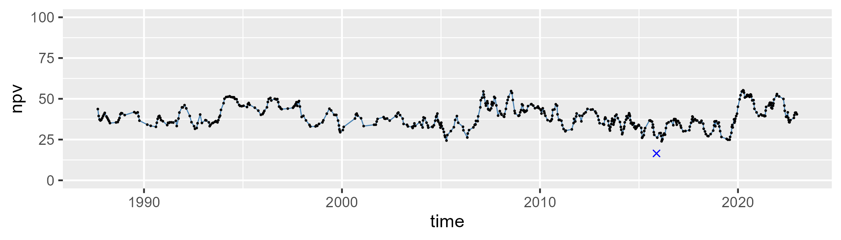

| Min. | 1st Qu. | Median | Mean | 3rd Qu. | Max. |
| --- | --- | --- | --- | --- | --- |
| 0 | 5.586062 | 9.235732 | 10.0906 | 13.57783 | 32.77193 |

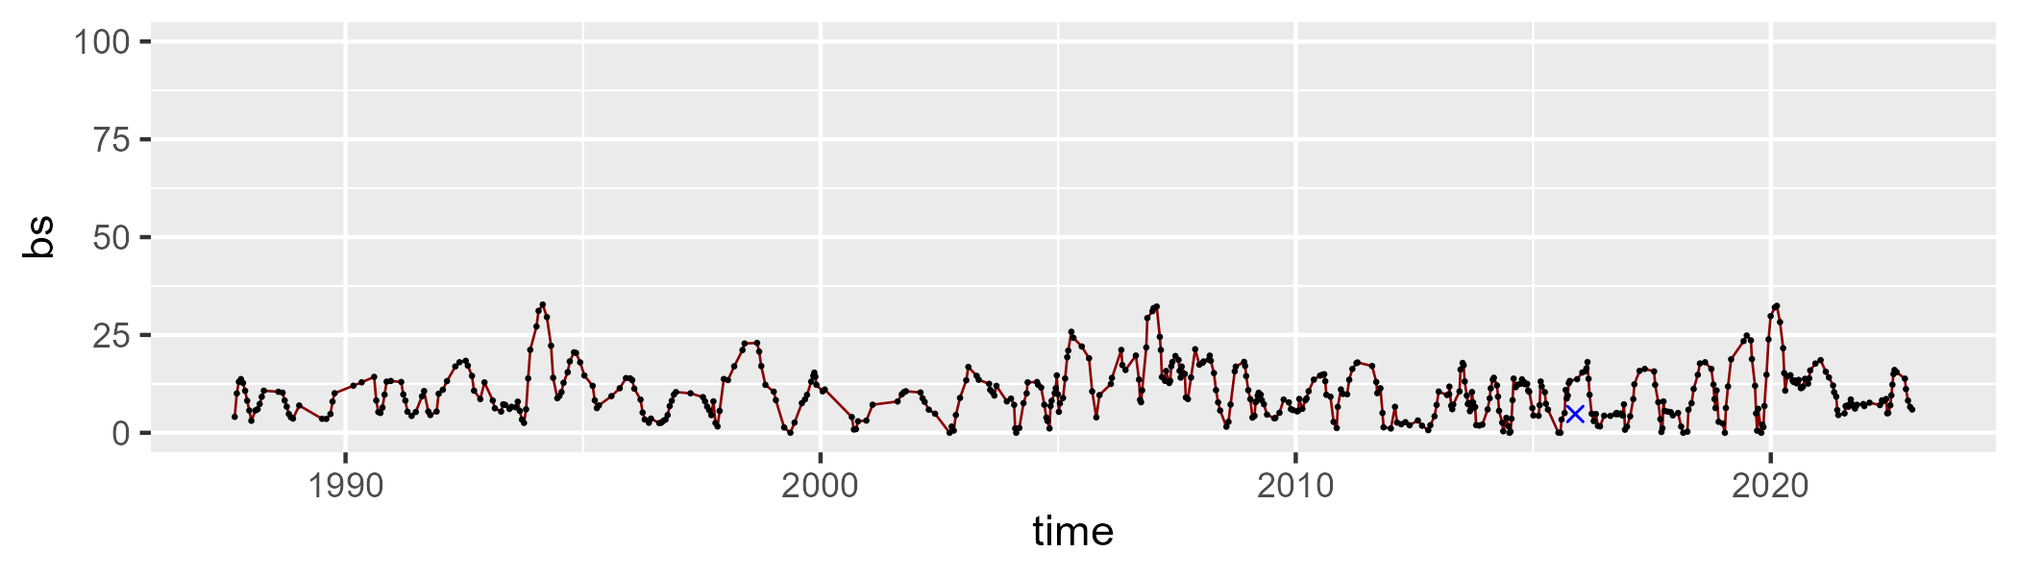

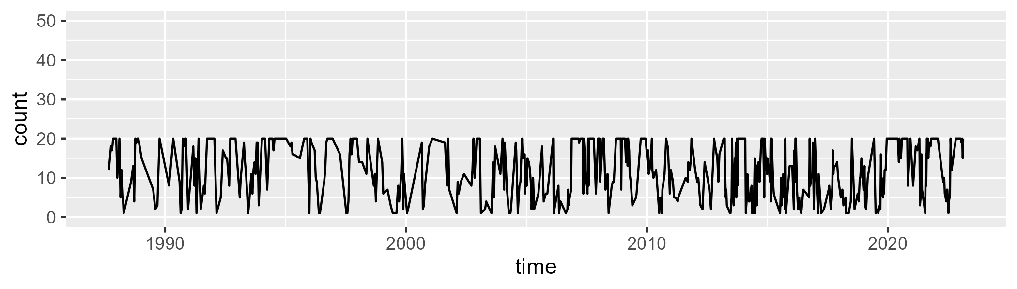

Min. : 1.00 1st Qu.: 6.00 Median :12.00 Mean :12.04 3rd Qu.:20.00 Max. :20.00

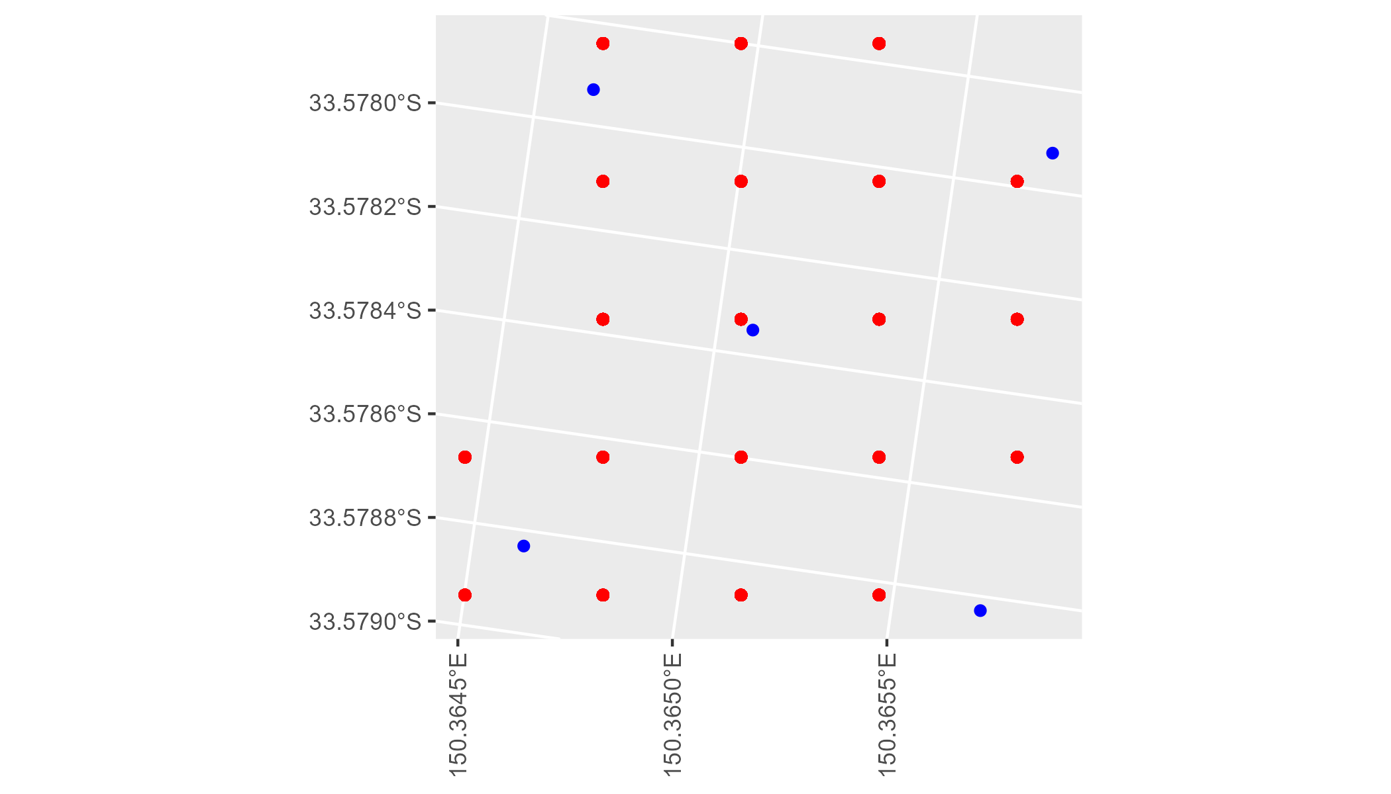

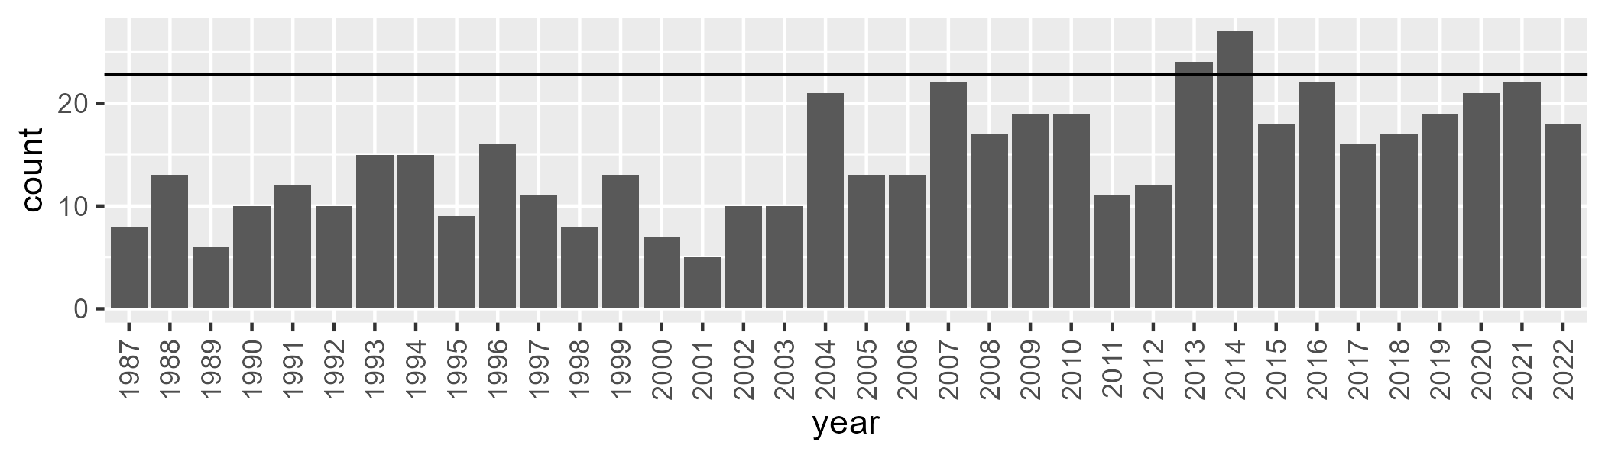

Number of samples: 529